VII. Encountering Muslim Networks: Islamic Arts and Expression

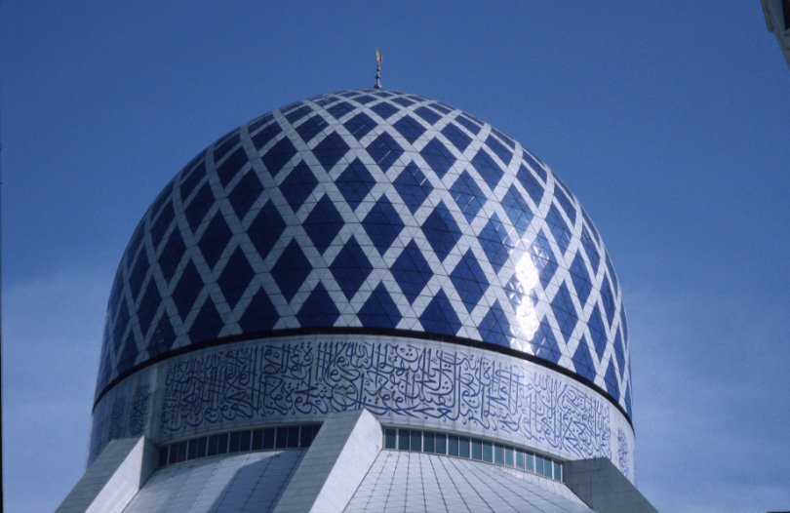

Photograph: Sultan Abdul Aziz Mosque, Shal Alam, Malaysia [© Gary R. Bunt, 2005]

It would be possible to construct various models of the influences of Islamic arts in the networking and knowledge transmission processes: for example, Qur’an-ic calligraphy, recitation styles, Islamic architecture, and the popular arts (including painting, plastic arts, and music) all play roles in the ways in which religious identities are expressed, affiliations engineered, identity markers are created, and ideas are disseminated. Only a few selected examples are presented in the confines of this module: however, the possibility exists for students to go and ‘collect’ their own examples, based on personal interests!

Arts & Architecture

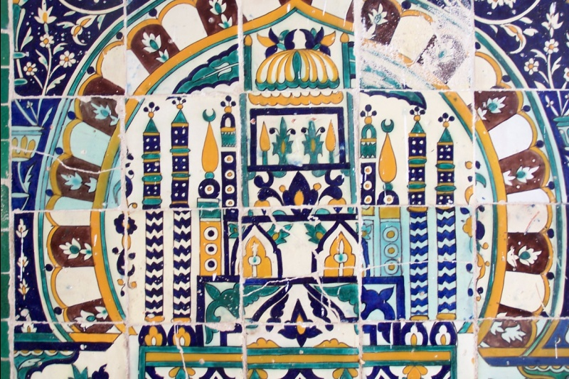

Photo: Tile detail, Abu Zama‛a al-Balaui Mausoleum, Kairouan, Tunisia [© Copyright Gary R. Bunt, 2005]

The following extracts provide an indication of the ways in which architectural influences transcended Muslim networks, with specific motifs and design elements emerging at diverse points in the Muslim worlds. Clearly, this is a significant and extensive subject, which can only be alluded to in this section of the module. There is plenty of scope for further reading. For example, see:

“The Spiritual Message of Islamic Art”, Seyyed Hossein Nasr, Islamic Art and Spirituality, Ipswich: Golgonooza Press, 1987.

Take a look at the chapter by Judith Ernst in the Muslim Networks book (which covers contemporary issues):

“Rather than defining or tracing or shoring up identities, we should try to recognize the multiple levels on which Muslims and Muslim cultures have nourished and engaged both insiders and outsiders.” (Judith Ernst, ‘The Problem with Islamic Art’, chapter in cooke & Lawrence, 130)

Then take a look at a section from one of the significant works in English on Islamic architecture: Robert Hillenbrand, Islamic Architecture: Form, Function, and Meaning, (Edinburgh: Edinburgh University Press, 1994), 31-48. [Moodle extract] This is an extensive study (600+ pages), and students are encouraged to examine a copy. The section selected is a part of a chapter on ‘the mosque’, and it relates well to this module because it alludes to the ways in which different influences were drawn upon to create Islamic religious buildings.

Further reading:

"Islamic art." In The Grove Encyclopedia of Islamic Art and Architecture. , edited by Jonathan M. Bloom, Sheila S. Blair.Oxford Islamic Studies Online, http://www.oxfordislamicstudies.com/article/opr/t276/e430

Jamila Binous, ‘Ifriqiya: Thirteen Centuries of Art and Architecture in Tunisia, Museum With No Frontiers, Ifriqiya: Thirteen Centuries of Art and Architecture in Tunisia, Brussels: Museum With No Frontiers, 2002), 51-63

The Written Word

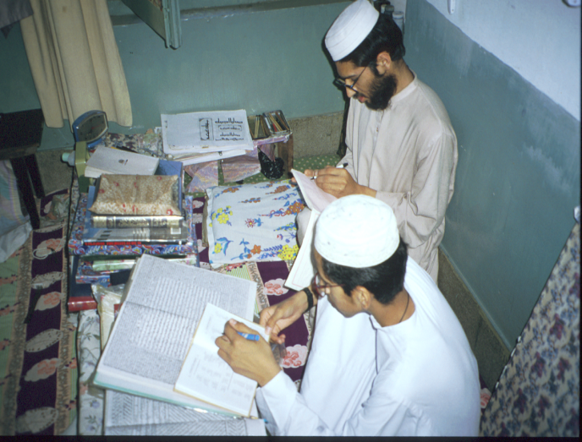

Photo: Students, Jami’a Ashrafiyya, Lahore, Pakistan [© Copyright Gary R. Bunt, 2005]

The communication and networking of religious ideas has its foundation in Islamic calligraphy, especially for the presentation of the Qur’an – which retain a consistency in diverse contexts, but also allows for the emergence of certain regional and cultural styles of expression. A general introduction to these issues is presented in Seyyed Hossein Nasr, Islamic Art and Spirituality Ipswich: Golgonooza Press, 1987, 3-14.

Then take a look at the following internet source:

Institute of Ismaili Studies, The Calligraphic Tradition in Islam http://www.iis.ac.uk/library_iis/gallery/calligraphy/calligraphy_gallery.htm

“This is an adapted and edited version of a presentation given by Dr Duncan Haldane at the opening of the exhibition “The Spirit of Islam: Experiencing Islam through Calligraphy” at the University of British Columbia, Canada on October 21, 2001.” It highlights a number of significant Qur’anic manuscripts, including the ‘Blue Qur’an’, and provides a basic overview of key factors associated with calligraphy.

Also recommended is Seyyed Hossein Nasr, Islamic Art and Spirituality, Ipswich: Golgonooza Press, 1987, 17-36. This provides a religious interpretation on the relationship between Islamic calligraphy and religious symbolism. If you want to explore this issue further, take a look at the extract from Annemarie Schimmel, Islamic Calligraphy, Leiden: E.J. Brill, 1970, 1-19. This gives an introduction to the diverse forms of cursive styles which emerged throughout Muslim networks across time. Stylistic differences are highlighted. The religious values associated with the text are presented. Note: respect should be taken in the treatment of Qur’anic script, such as the examples provided.

In relation to this theme, an example is provided of various religious manuscripts, in the article ‘Mauritania’s Manuscripts’, Saudi Aramco World, November/December 2003. This article provides an insight into the legacy of knowledge networks, through a discussion on the libraries of Mauritania: “Far from the famed West African ‘library cities’ of Fez, Tunis and Timbuktu, more than 200 family-owned libraries throughout Mauritania hold an astonishing heritage: tens of thousands of Arabic manuscripts, dating from the 10th to the 19th century. Some were brought by pilgrims returning from Makkah; others were composed or copies in local scripts by the jurists, poets and historians of the country’s schools.”

Recitation

The following extracts provide an introduction to issues surrounding the recitation of the Qur’an. It will enable to reader to consider how – despite the diversity within Muslim networks – according to tradition, the memorization and recitation of the Qur’an retained a consistency whatever the location of the individual:

Further reading

Rasmussen, Anne K. . "Tajwīd." In The Oxford Encyclopedia of the Islamic World. Oxford Islamic Studies Online, http://www.oxfordislamicstudies.com/article/opr/t236/e1084

Muhammad Ibrahim H.I. Surty, The Science of Reciting The Qur'an: A Course in ‘Ilm Al-Tajwid, Leicester, The Islamic Foundation, 1988), 15-22, 31-36

Michael Sells, Approaching The Qur’an: The Early Revelations, Ashland, Oregon: White Cloud Press, 1999, 11-13

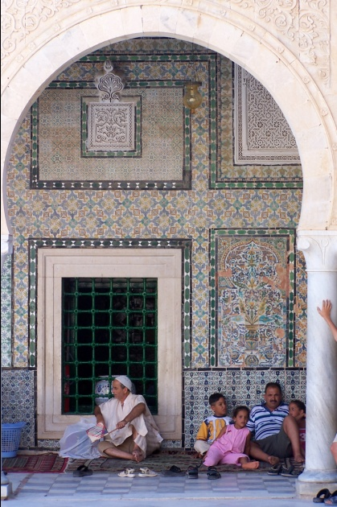

Photo: Abu Zama‛a al-Balaui Mausoleum, Kairouan, Tunisia [© Copyright Gary R. Bunt, 2005]

The World Wide Web offers some unique and informative materials on aspects of Islamic architecture. Here are some starting points:

Archnet.org provides a superb series of architectural materials, notable especially for the digital library of Islamic buildings (from mud mosques to high-tech buildings) and the various photo collections. Membership required for some sections.

Archnet
http://archnet.org/library/

A substantial archive of articles and images is located at Saudi Aramco World, Indexes: http://www.saudiaramcoworld.com/index/Subjects.aspx [to start, scroll down to ‘Architecture’ or ‘Mosques’]

Islamic Architect,
http://www.khayma.com/mehrab/English/index.htm

Museum With No Frontiers, http://www.museumwnf.org/atrium/en/aboutus_exhib_iam.html

David Talbot Rice, Islamic Art, London: Thames & Hudson, revised edition 1975

Henri Stierlin, Early Architecture from the 7th to the 13th Century (Cologne: Taschen, 2002), especially the article on the Dome of the Rock, 22-60.

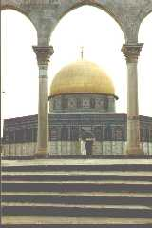

Photo: Dome of the Rock, Jerusalem/al-Quds [© Copyright Gary R. Bunt, 2005]

