Kristina Neal
HPAR4001
Ros Coard & Quentin Drew

Introduction to site

Llannllyr house is of Georgian construction built in 1830 to replace an earlier 16/17th construct that had previously been in disrepair. Situated within a working farm in Talsarn and believed to be built on the site of a Monastic Nunnery established in the 1180s by Rhys ap Gruffydd and was disillusioned in 1537. Previous excavations were conducted between 2014-2015 by UWT+SD to establish the locations of the Nunnery and previous mansion which unearthed 18th century pottery, 16th century green-glazed ridge tiles boundary walls and wood among other artifacts displaying a range of history ranging from medieval to 19th century. These present excavations were executed to envelope the student in the experience of preparation and practical archaeology, providing them with the experience of unearthing artifacts and providing them with a greater understanding of how our landscape has changed due to outside interference.

Week 1

Procedural narratives
Desceiiptions of methods and tools
Actors and actants
Photographs
Information sources
Diagrams and drawings
Outcomes

Location:
Llanllyr North East of Field 2. Located at the perimeter of the field and the stream

Narrative:
- Locations of trenches had been previously decided upon across the sight by the orgainisers due to potential archaeological interest lead from the previous years dig.
- Mapping and laying of the trenches commenced. In particular 2 trenches (trench 10 and 10b) were to expand a trench (trench 10) created the previous year where there was evidence of flint and charcoal artifacts.
- These trenches were to be placed either side of the remnants of the old trench 10 and to be named 10a and 10b. Mapping and laying of these trenches were systematic as there were present personages from the previous years dig and so collective knowledge from the documentation created from it was accesible. However these past excavators were concentrated in trench 10a leaving trench 10b concentrated with limited experience under the guidance of a mentor.
- Thereafter began the process of deturfing the soil to the mapped outline of the trench which involved the use of spads cutting segments of individual turf pieces into a tile formation, removing them and carefully stacking them ontop of one another, carefully placing them with their surfaces maintaining contact with like for like, an example of this would be turf to turf and soil to soil. This process is to protect the separate formations of each piece, thus allowing a more procise procedure to take place once we began to backfill the trench.
- Measures were taken to then trowel the first layer of the trench taking extra care to do this finely not to disturb the surface too greatly. Teams of two would sweep the top of the trench working their way backwards to the middle while the other two would sweep back from the middle towards the back of the trench. This way the ground would be lightly disturbed methodically, and greater care would be taken to document the process. Surface soil was then appropriately distributed to the side of the trench for me and another to sieve through with the use of sieves and dust pans in search for fine pieces of flint which was successful on the second day. All loose soil taken from the trench was placed in a spoil pile which was to kept neat and together within the confines of the sectioned turf.

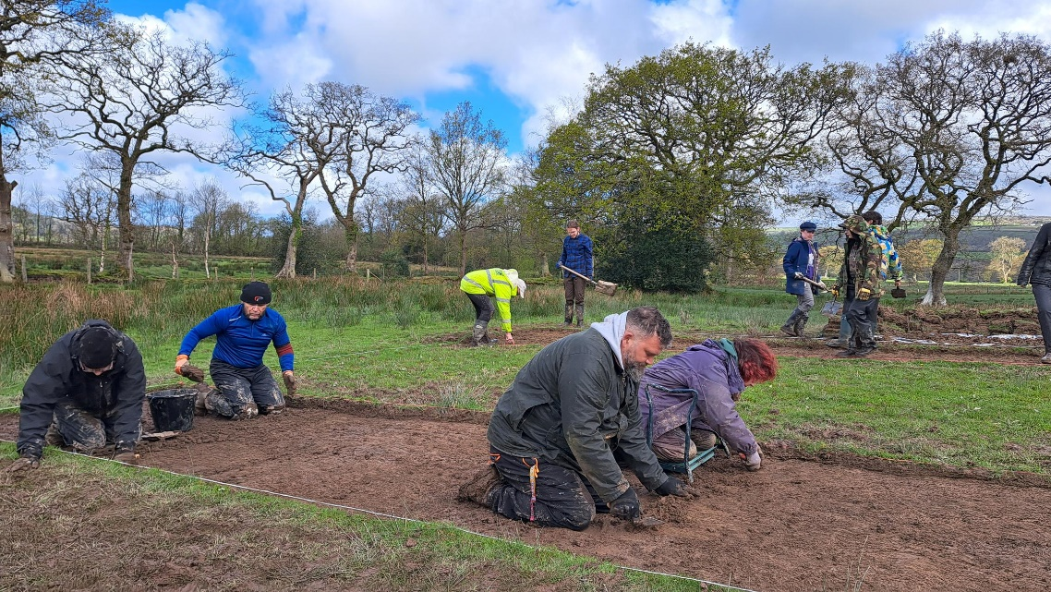
Figure 1 Beginning of light trowelling in a formation
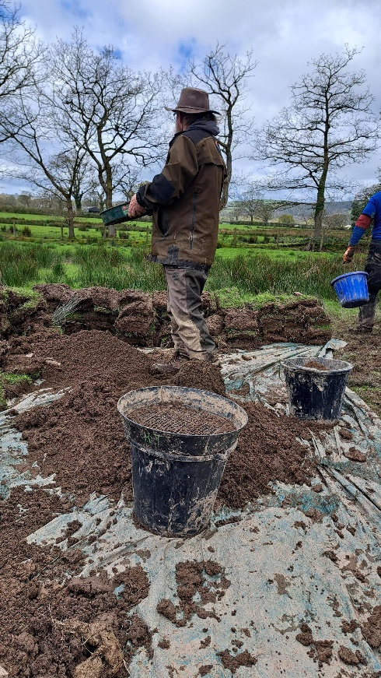
Figure 2 Sifting soil for fine artifacts at the spoil pile
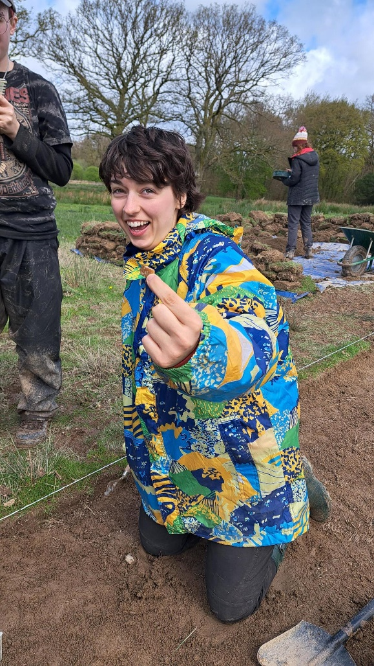
Figure 3 The first piece of flint was found
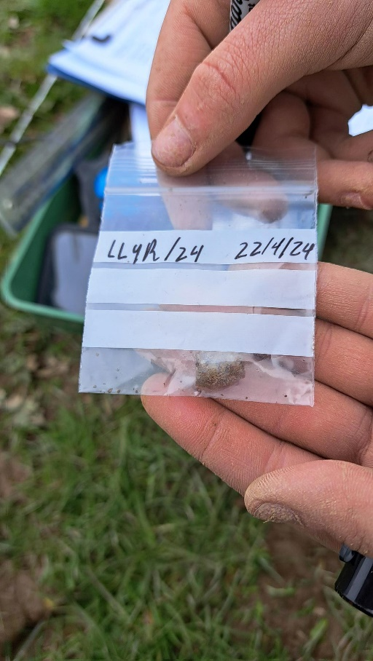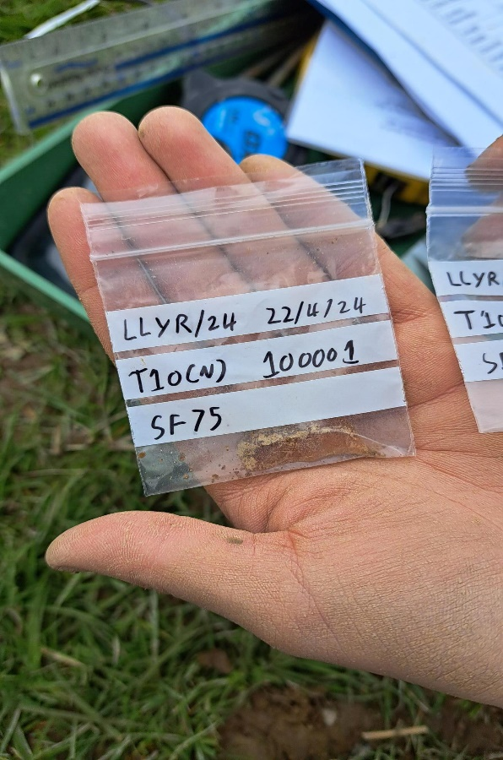
Figure 4 and 5 Trench 10a findings that were in close proximity to one another
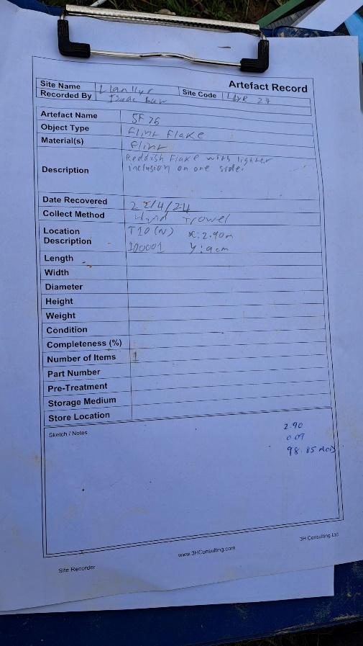
Figure 6 Recording sheet used for the finds of flint in trench 10a

Week Two
Location:
Trench 10b: West of Field 2, Llanllyr.
Located at the perimeter of the field and the stream.
Narrative:
- After a short debriefing with the supervisors who wished to recap on the previous weeks findings within the trenches and a discussion on the next procedures needed to correctly navigate the levels of excavation. The weather had remained dry and as such there was no damage or maintenance needed before we began trowelling once more.
- Trench 10b was unsuccessful at producing any flint unlike its counterpart on the other side 10a which had produced 3 pieces previously. Small fragmentation of quartz was being unearthed and fine root formations were exposed and levels of clay. However, it was apparent that our trench was heavy with charcoal deposits concentrated more in the middle facing towards the trench from the previous year. This I found less than exciting, especially as there was a new felt feeling of fun rivalry between both trench groups forming from the previous week. But It became apparent that the pattern of charcoal was forming when compared to the findings from trench 10 the previous year and with Trench 10a currently. After more excavating of this area it became conducive to the eye that the greater concentration formed in our trench held a resemblance to what we suspect was a fire pit but was as yet to be confirmed.
- Unlike the previous week where I only concentrated on sieving due to my lower back pain, this week I began to trial some trowelling with a small handheld trowel. Although uncomfortable for my knees it would produce a better understanding of the process and the importance of applying light pressure when using the trowels and good communication while working as part of a team.
- As it became apparent that different trenches due to their location, findings and work needed a redistribution of workforce for the day, so I was transferred to Trench 14 which was located at the South West of the field on lower levelled ground. This trench was significantly deeper than trench 10 and had only unearthed quartz and bedrock. Thus it became my role to assist with further removal of soil of extreme levels. This involved good levels of teamwork and communication as it was vastly exhausting. In a group of four one person would be using a mattock tool to slice into the soil, breaking and lifting it for a person to lift the segments into a wheelbarrow which when full would be taken to the spoil heap, which became to overwhelming at times for the designated area. Another person would be in control of cutting and profiling the trench by hand and documenting. With such variations in intensity, it was wise to alternate the people set to each task. With no finds to be uncovered it was left to admire the differing context of soil using stratigraphy.

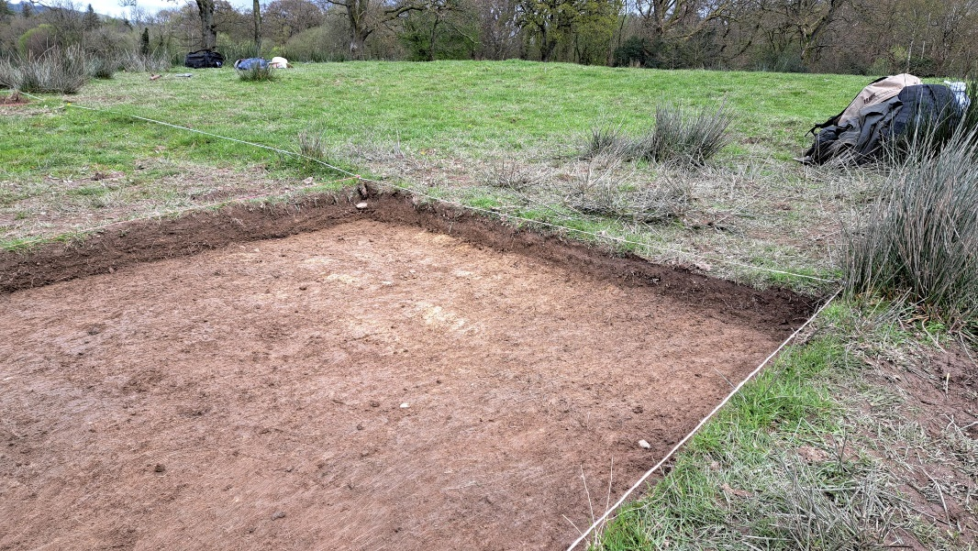
Fig 7 Trench 10b exposing levels of clay and roots
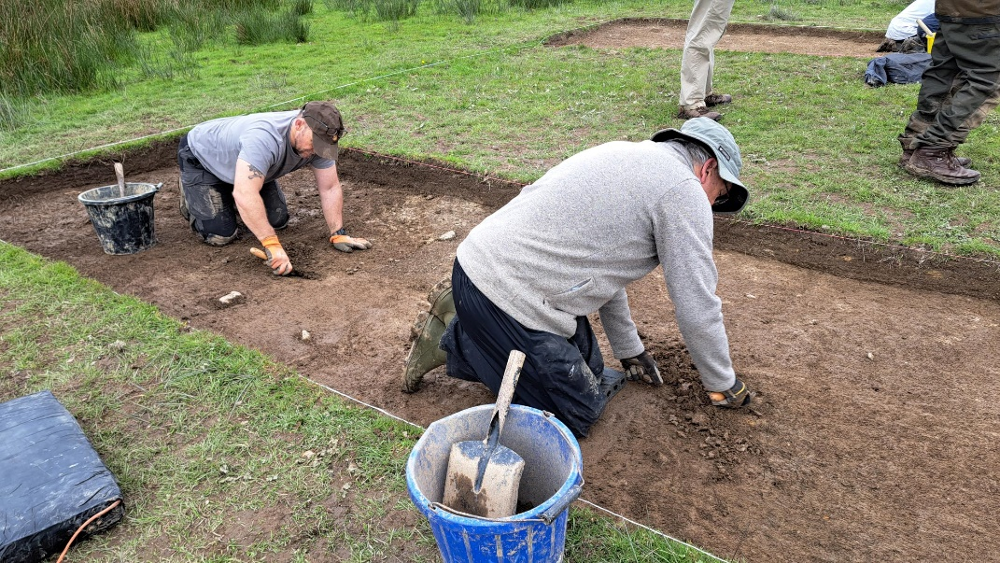
Figure 8 No significant findings. Concentrated fragments of charcoal found.
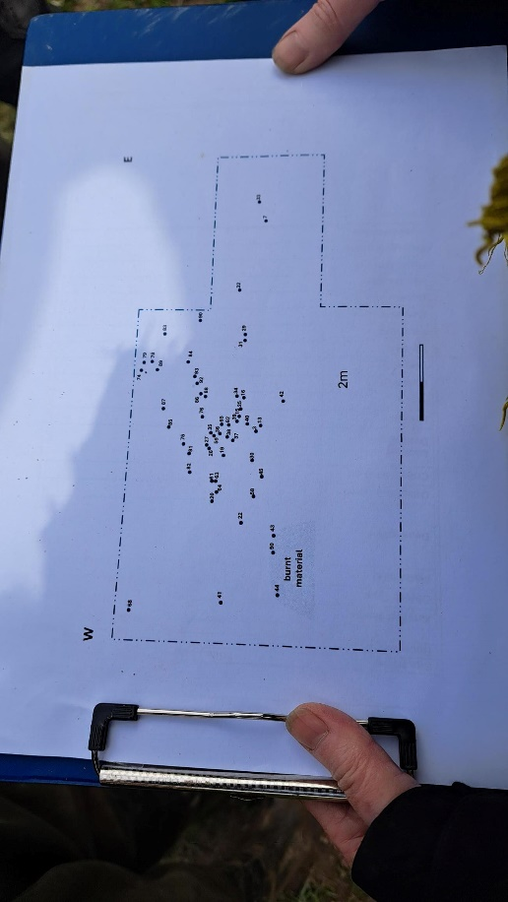
Figure 8 Documentation was created incorporating trench 10 findings from 2023 with 2024

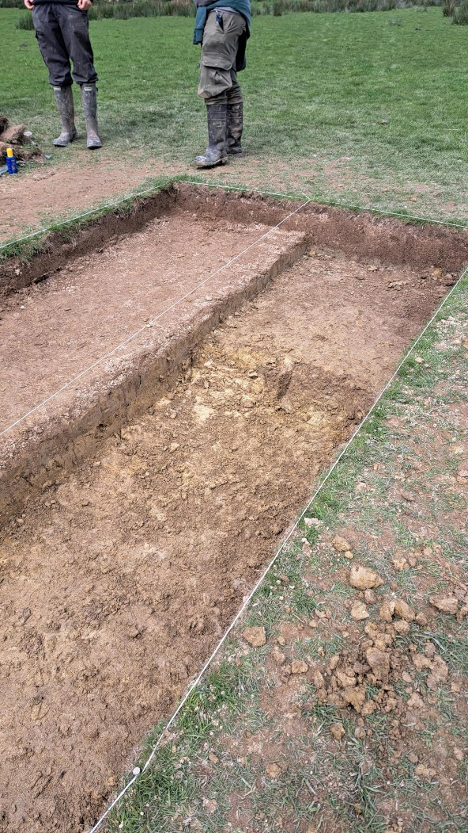
Figure 9 Trench 14 showing different context of soils

Week Three

Location:
Trench 10b: West of Field 2, Llanllyr.
Located at the perimeter of the field and the stream.
Narrative:
- The weather had begun to become unpredictable with more heavy downpours which made excavating further difficult. Leading to the start of many days concentrated on bailing out the heavy deposits of water by bucket and sponge. Although seeming tedious this was to be the only way to successfully recover the trench to a good standard without disturbing the surface and our work with minimal damage so recording could commence.
- Due to my absence, I wasn’t able to attend a lot of the experiences the team had this week including the process of extensively drawing the trench and its findings. This of course was a disappointment to myself as I felt I had not been involved in the intrinsic processes of archaeology. However my colleagues were very understanding and supportive as well as the overseers who educated me in the experiences I had missed. Amongst most activities I had not been involved in contexting, creating section drawings, scale and formatting unfortunately.
- Martin and Ros gathered the groups as a whole giving us a tour of each trench discussing their importance to the overall dig and what factual evidence they projected to us. I found this to be extremely useful to overall morale as even those who hadn’t been fortunate to of found flint were left feeling a sense of achievement, of being part of history and of the present and they remained instructive of how the last week of a dig would be managed.
- Our trench itself had not unearthed anymore signs of any flint, however Ross confirmed a pattern was forming in the spread of the charcoal found and offered her opinions on the possibility of human activity confirming our suspicions of a fire pit were justified. Cleaning up the fire pit area began by finely scraping back any clay in the pit which exposed further deposits of charcoal, this was done with a spoon as the rounded edges would not disturb or destroy the area. Pictures were further taken, documented and later soil samples were collected which I had the pleasure to become involved with.
- The last day at the site was spent returning the trench to it’s original state. This involved laying a mesh sheeting over the base layer to preserve the findings and status for the following team next year. Then began back filling it with the original soil from our spoil pile, later flattening and racking it level for the tile shaped turf to be lead back ontop.

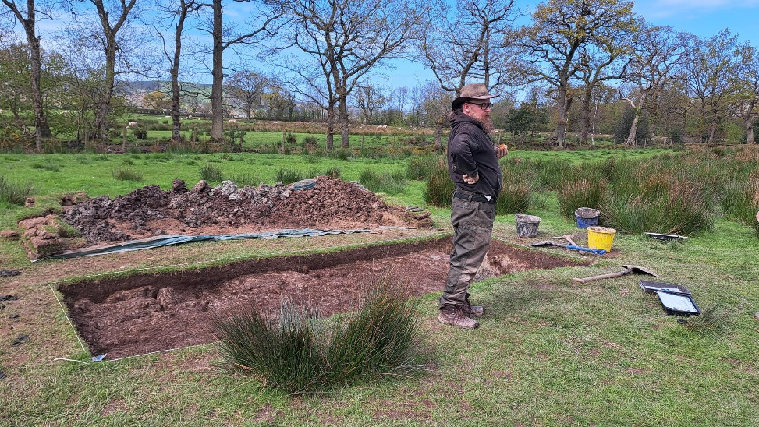

Figure10 Trench 10b showing the different levels of excavation

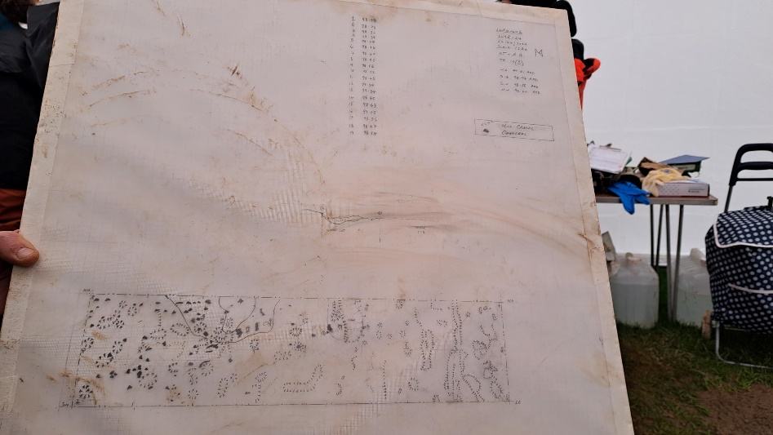
Fig 11 Detailed drawing of Trench 10b
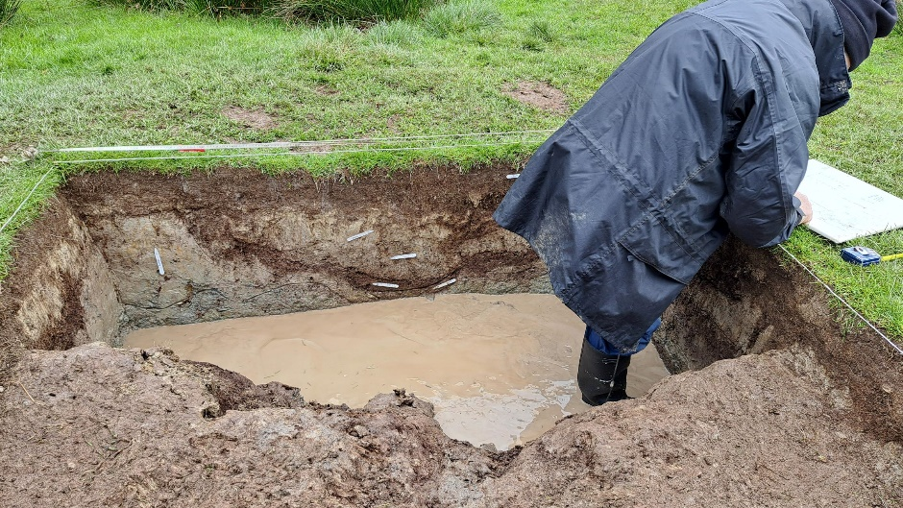
Fig 12 After the rain in a neighbouring trench showing the heigh water table

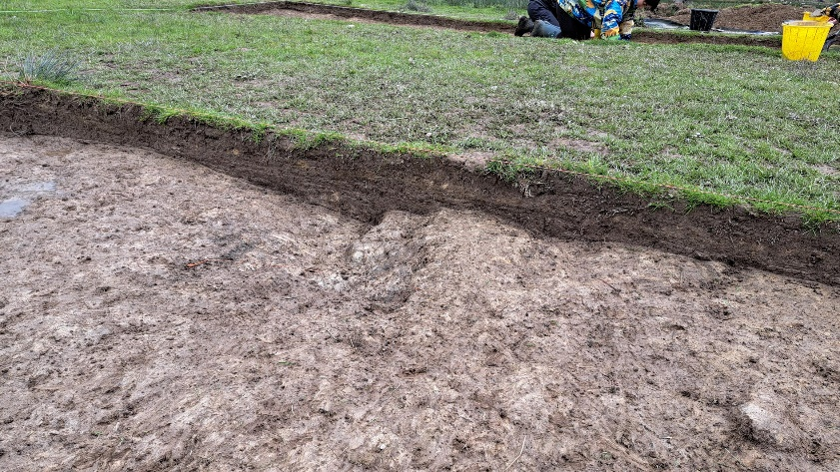
Fig 13 Trench 10b fire pit

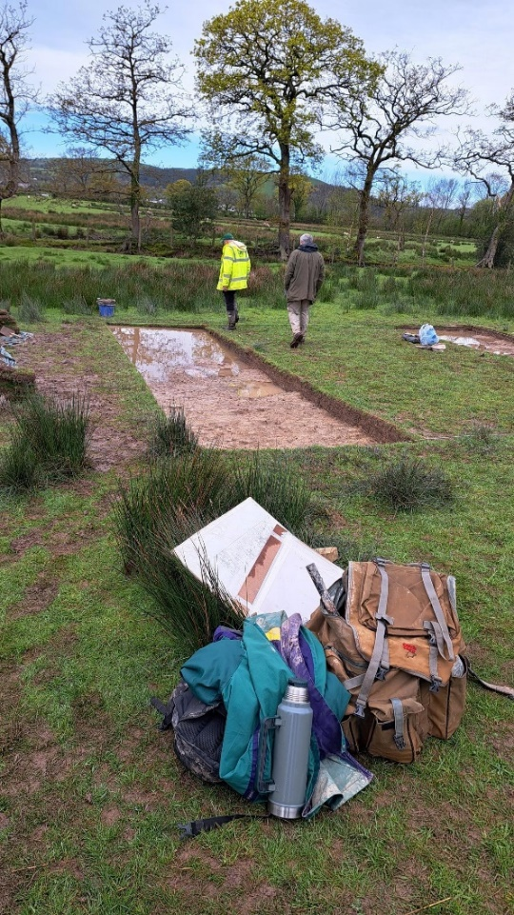
Fig 14 Showing extensive water retention in Trench 10b
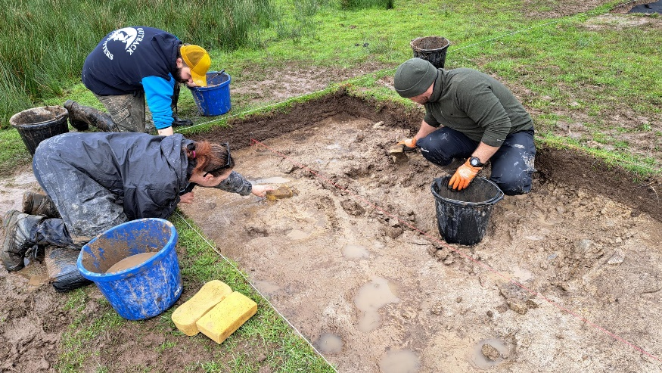
Figure 15 Trench 10b Removing water retention using sponges and buckets
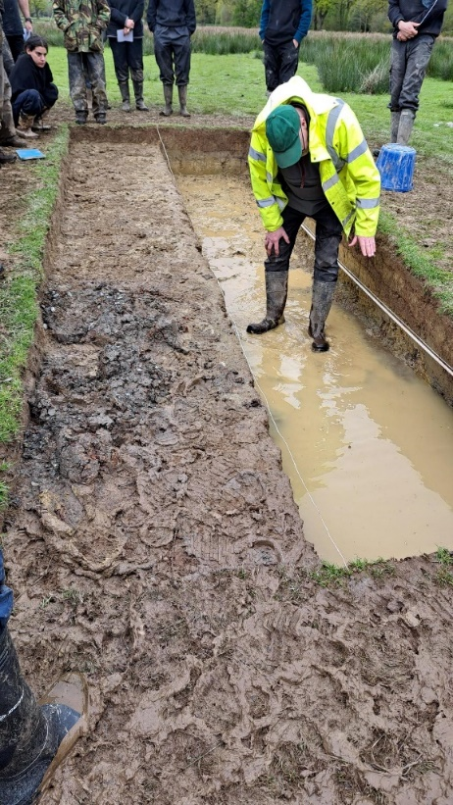
Figure 16 Martin instructing us on the progress of trench 14

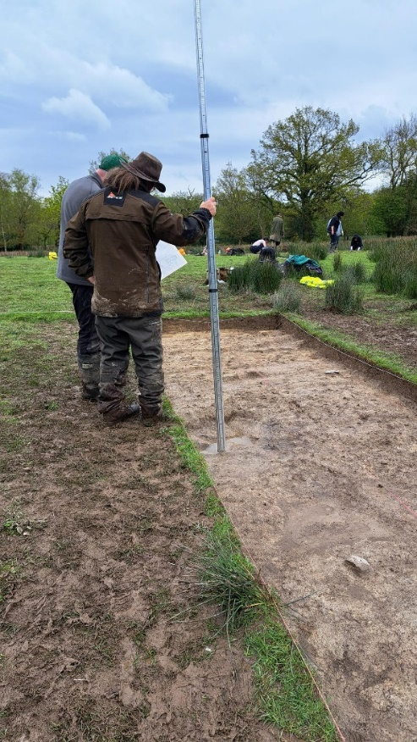
Figure 17 Discussion, measuring Trench 10b on the last day.

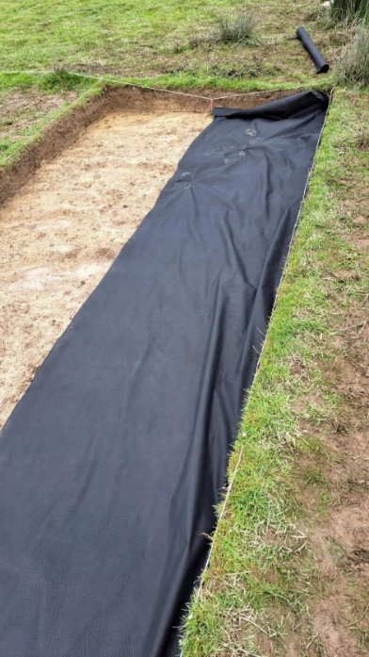
Figure 18 Black mesh cloth applied before the original soil is laid down
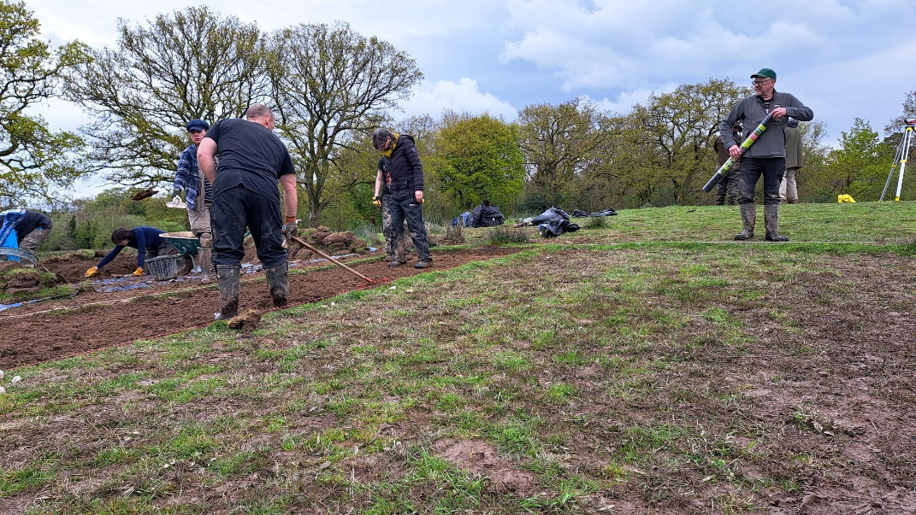
Figure 19 Backfilling the sediment dirt over the mesh cloth and wracking it over

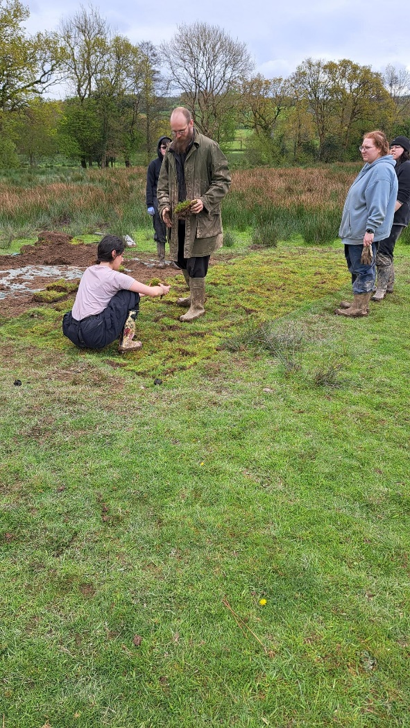
Figure 20 laying the original pieces of tiled turf down in the trench

Murphy, F. (n.d) SURVEY AND EXCAVATION AT LLANLLYR MEDIEVAL NUNNERY AND POST-MEDIEVAL MANSION, CEREDIGION, 2014-2015. [Online] Available at: https://www.dyfedarchaeology.org.uk/wp/wp-content/uploads/llanllyrreport2017.pdf.
Anon, (n.d.). Llanllyr Nunnery, Talsarn – Dyfed Archaeological Trust. [online] Available at: https://www.dyfedarchaeology.org.uk/wp/discovery/projects/llanllyr-nunnery-talsarn/.
Avon Valley Archaeological Society. (2014). Avon Valley Timeline. [online] Available at: https://avonvalleyarchsoc.wordpress.com/avon-valley-timeline/ .

