Fashion Photography

I have always been fascinated by the lure of the ‘Fashion Industry’ but never really

understood the nature of the beast, so I decided to research the history of ‘Fashion’ (The

last 70 years). I hope I can show you an insightful journey through the decades, showing not

only the different fashions but also the different ‘fashions of fashion photography’.

1950’s

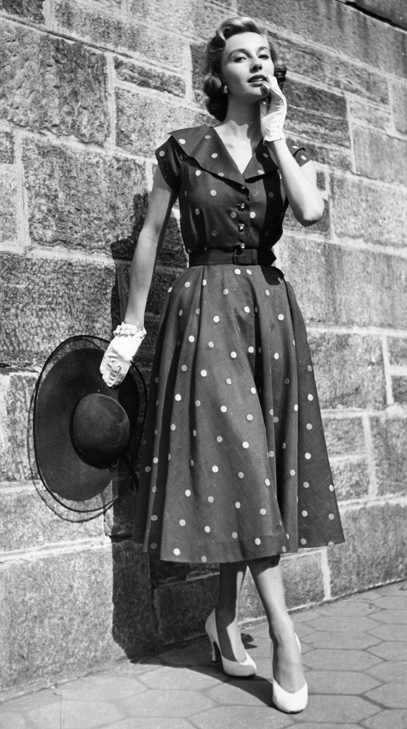
(1950S Fashion. 2018)

The fashion photography in the 50’s was very similar to how it had been since the 1920’s.

They were often in black and white, had the models in frozen, static or fixed poses, and

often had basic, plain backgrounds. These were often seen as acceptable ways to display

the clothing keeping as much attention on the garments, and not being distracted by the

models. (There were a few exceptions to this as a few photographers, Martin Munkacsi

being one, as he took fashion images of women being active, like running, and often

outdoors rather than in a studio)

('Martin Munkácsi: A Portrait in Motion', )
During this era, the fashion photograph was a representation produced by an ‘elite’

photographer wearing ‘elite’ clothing worn by an ‘elite’ model!

What these images produced were a look that was unattainable for the general public, but

they could aspire to this life, but in reality, only something for the upper class to take

seriously. This was an era where social positions were as fixed as the poses of the models

and the stiffness of the camera shots!

1960’s

(1960s Fashion: The Icons and Designers That Helped Shape The Decade. 2017)

We then entered the 60’s, and probably the biggest change in this decade was the

introduction to colour in the photography! This really opened up a new world for fashion,

as you could now, for the first time, see the actual colours of everything in an image, and

not shades of grey. I think this fact had a huge influence on the reason that the fashion

from back then was so flamboyant and bright.

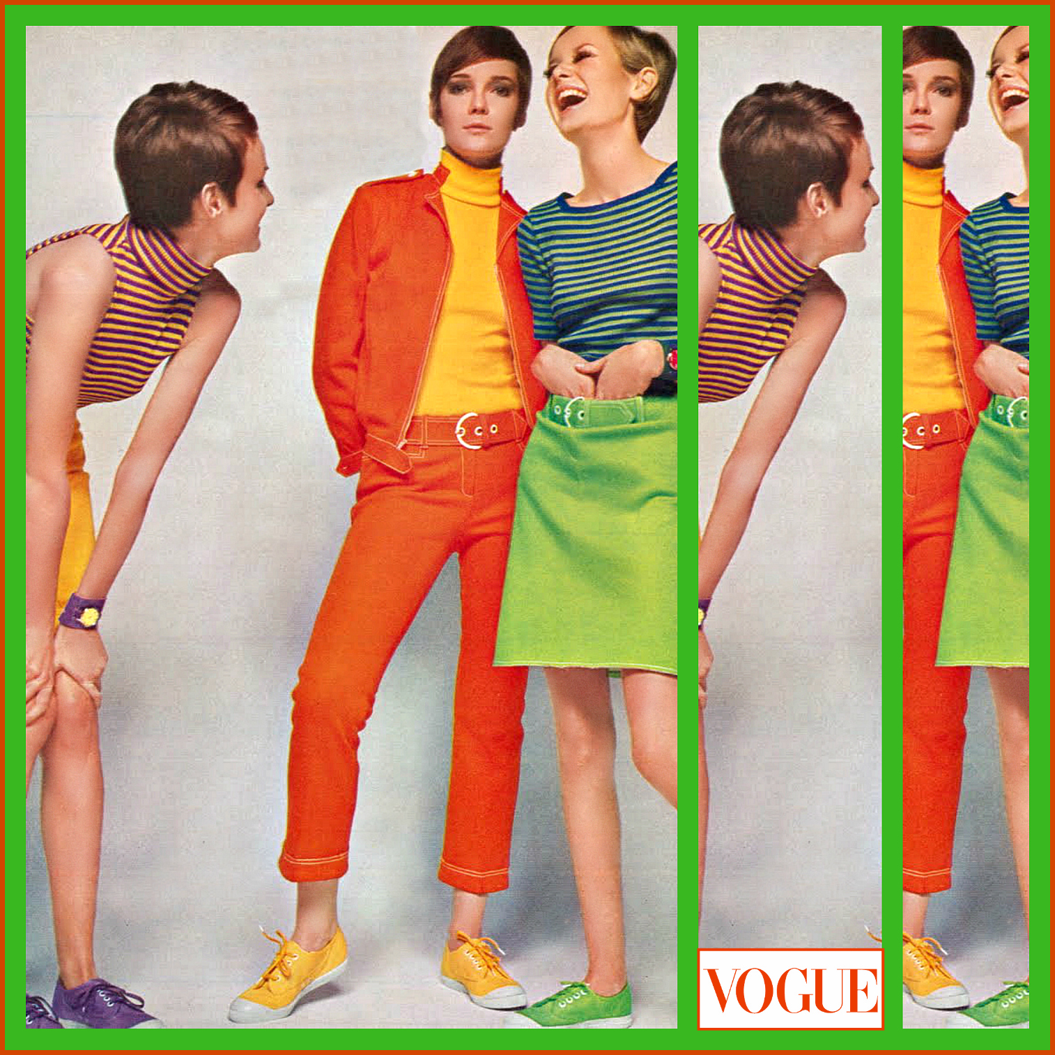
One of the fashion photographers who led the way in this field back then was David Bailey.
('Photographer David Bailey 1967 - High Low Vintage', 2014)

In the image above, he takes a fashion shot for the magazine ‘Vogue’, and in it is the iconic

model, actress and singer of that era, Twiggy! (The nickname was given to her for her thin

build!)

She would become the face of the 60’s as she captured a brand-new era, with her individual

and different look than that of a typical model. She didn’t come from an affluent

background like previous models, she came from a working background and this was the

appeal!

1970’s

The 70’s wanted to be different again, and this was helped along with the likes of the

fashion photographer ‘Helmut Newton’. Not only had the photographers taken the majority

of shoots to the outdoors (previous photoshoots were mainly done in a studio setting), and

they were given licence to experiment with their own ideas.

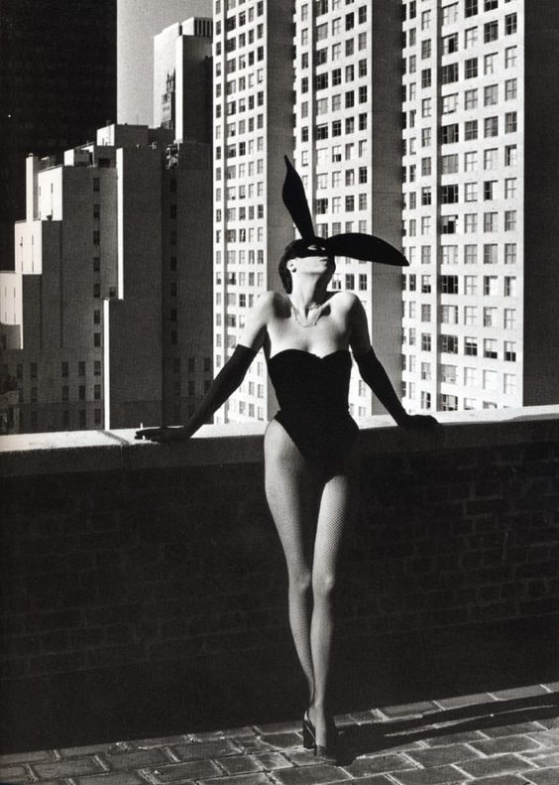
(As coelhinhas mais estilosas de todos os tempos. 2016)

This was the era of staged photo shoots, quite often over the top and full of fantasy. It

introduced sexual acts and inquisitiveness into the shots, adding a different dimension to

fashion!

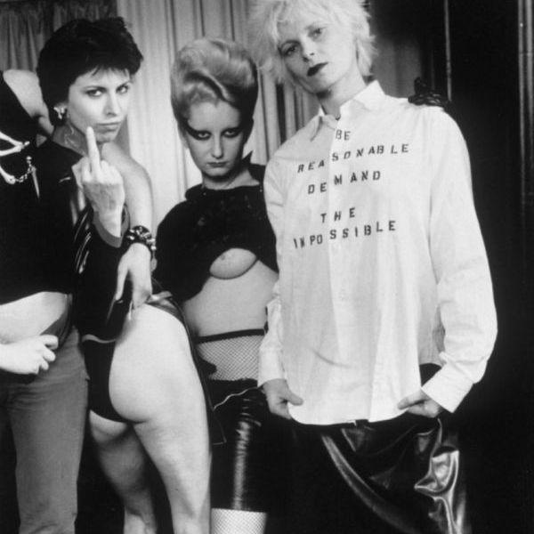
(SEX SHOP. )

Personally, I think that the fashion industry had run out of creative ideas, struggling to keep

up with the trend of reintroducing new and inspiring ideas, so this was seen as a progressive

step in an era full of anarchy!

1980’s

This era was again troubled with ideas on how to progress, however it did with the

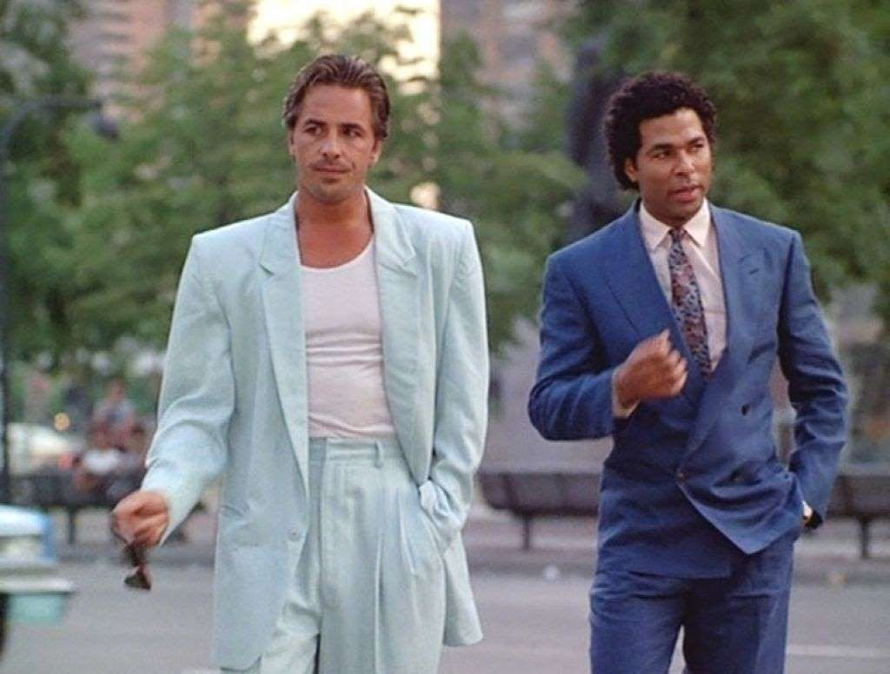
introduction of many more male models (up until now women had dominated the scene).

('27 Worst ’80s Fashion Trends', )

This was seen as an empowering move, shifting away from the typical female model,

embracing equal rights. The phrase ‘Modern Man’ was being thrown around a lot, and it

encouraged males to take more care and interest in themselves, as women had done for

decades before.

‘Images by Ritts and Bruce Weber in the 1980s where men are central to the photographs – often appearing in entirely male environments – provide evidence that a culture where men look, and women are to-be-looked-at was being transgressed.’
(Bull, 2010: 155)

On reflection, the fashion in the 80’s is often seen as the most exuberant of all decades, due

mainly to its emphasis on big shoulders and exaggerated cut, personally, I think this was the

starting point of fashion losing its way, all in the name of vanity and individualism.

1990’s

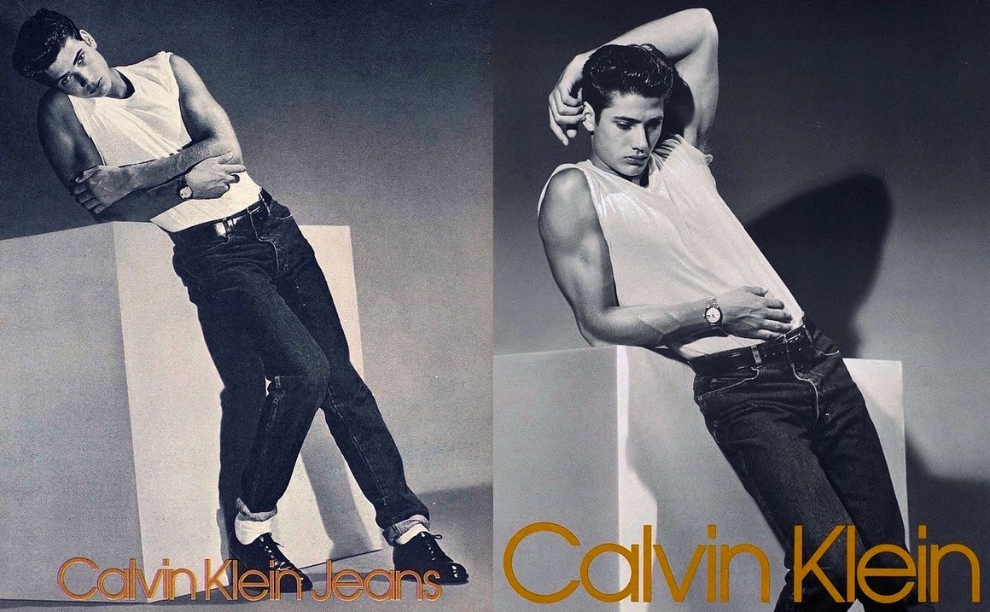
(Compain)

The 90’s carried on from where the 80’s had finished off, but this time lowering the tones

and big brash suits, and now being replaced by semi naked men, often donning a masculine

physique, often staring directly into the camera to create an intense, powerful reaction with

its watchers. It was drifting away from fantasy and the new dawn of reality was king.

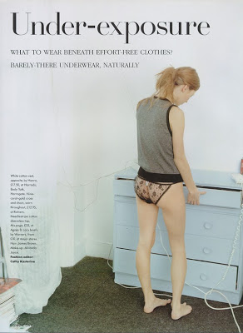
(Hat, )

This was to be the ‘Abject Realism’ decade, in complete contrast to how the industry had

been perceived before, it now empowered ‘less is best’ and ‘be yourself’.

It had a rebellious feel to it, demanding self-expression and non-conformity, it really wanted

to be the total opposite to its past, pushing as many boundaries as it could along the way.

20th Century

‘Perhaps though, fashion photography’s greatest affinity is with performance art. A performance is directed by the photographer: it is created out of three principal elements, an actor (model), dress and gesture, and crystallised by the camera.’
(Harrison 1991: 21)

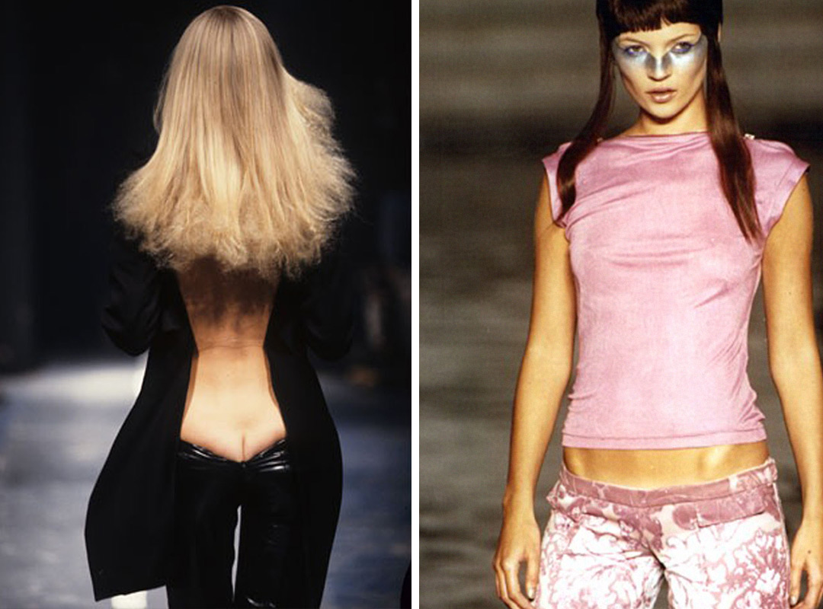
(2000s Fashion Trends: 9 Reasons the 00's Are Back for 2017. 2018)

Even though the ‘low cut’ denim trend was first introduced by the likes of Alexander

McQueen in the late 90’s (Dante Collection 1996), the catwalk trend soon caught on to main

stream fashion and it embraced the 2000’s. This was just one of many obscure and crevice

revealing fashions that took off.

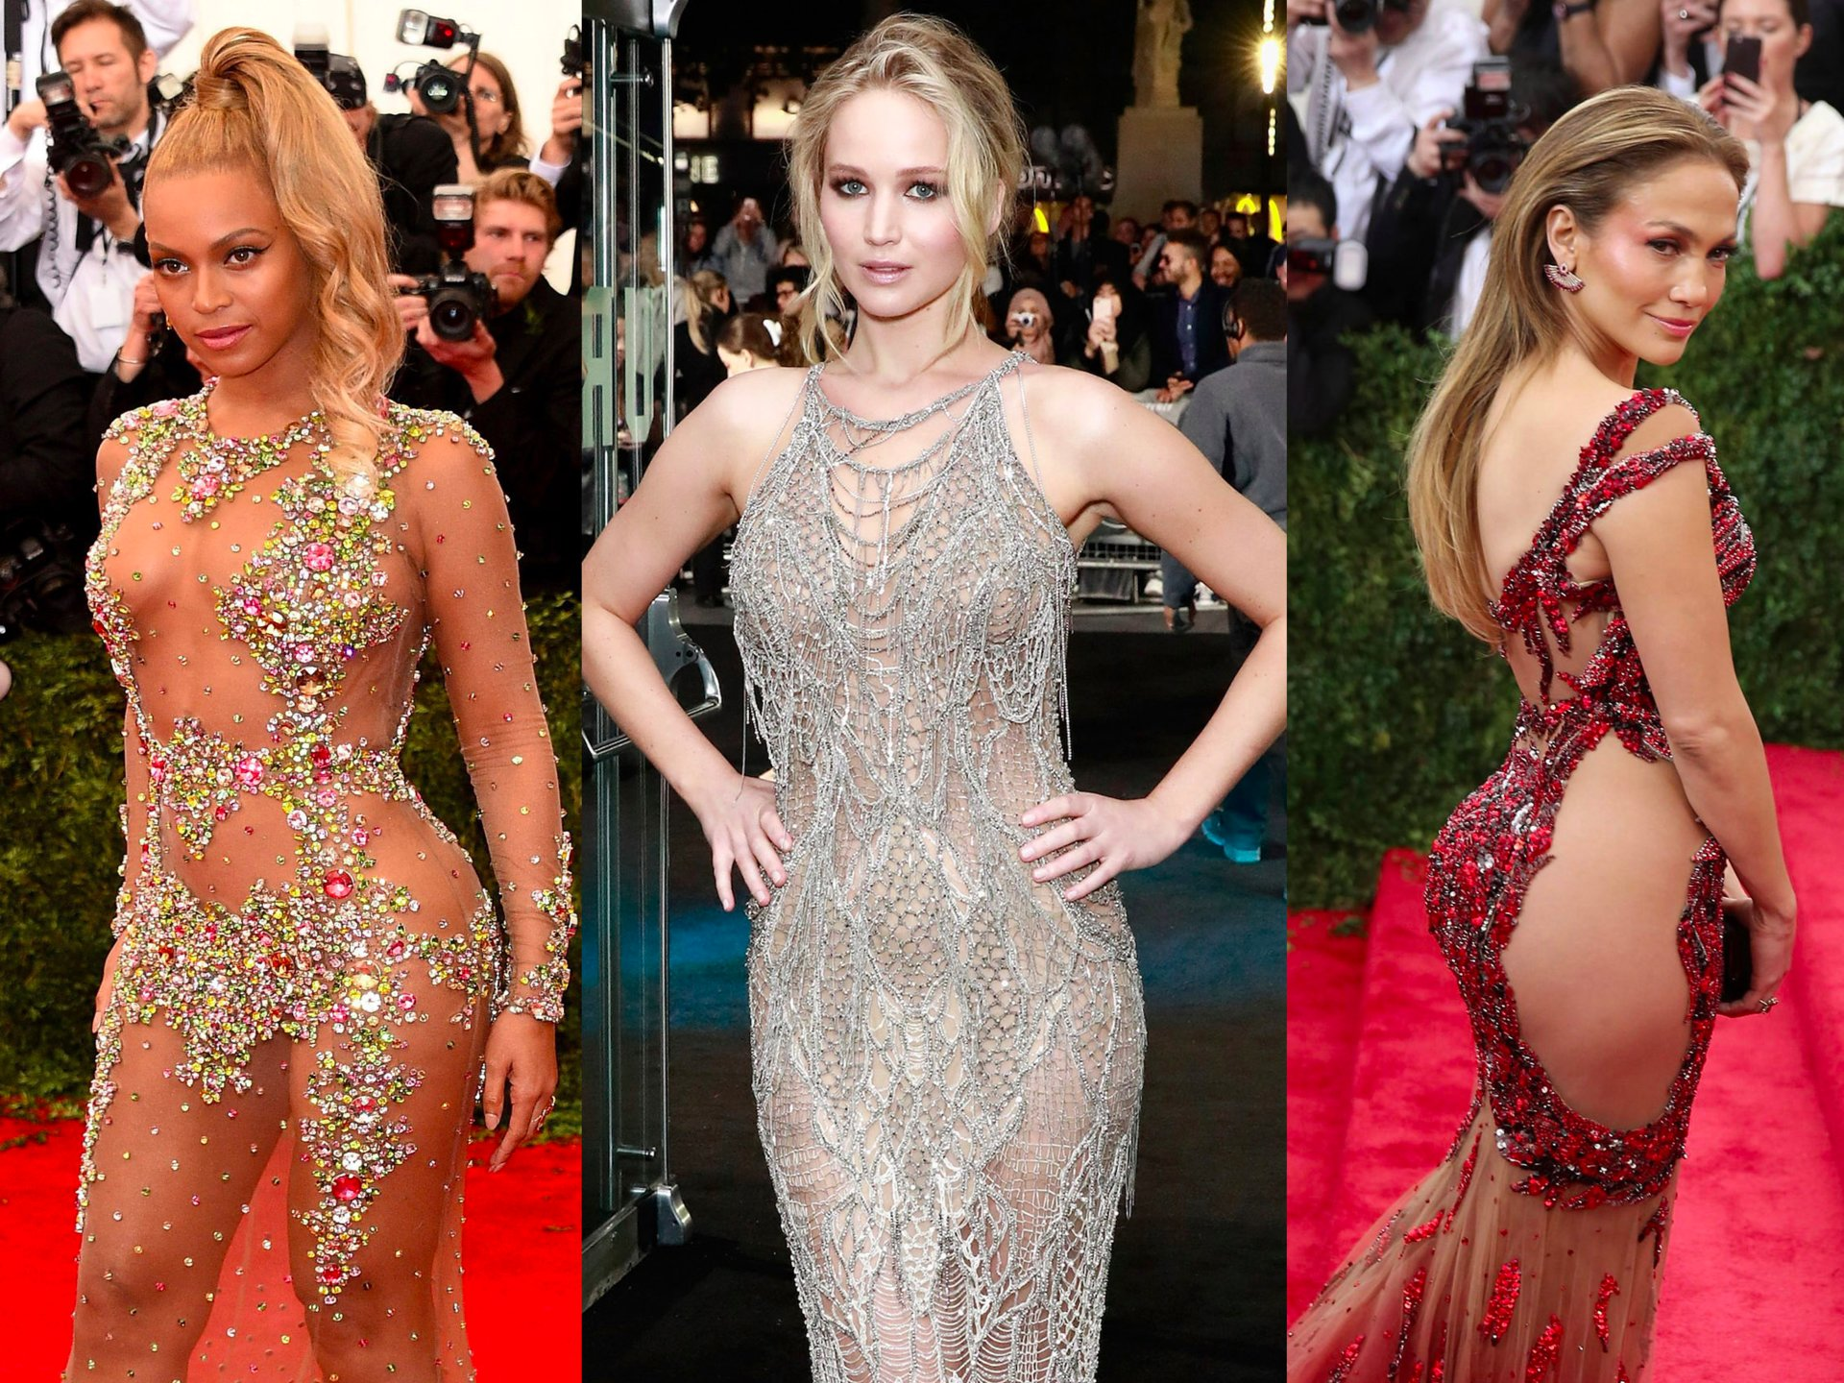
(Pantazi, )

I feel I must also comment on the trend within a trend that has occurred within the 2000’s,

and it is that of ‘digital manipulation’.

At the start of this century it became fashionably popular for the fashion industry to

‘digitally enhance’ images with the introduction of new and sophisticated computer

software. It enabled average models to be flawlessly beautiful, and trimmed off any excess

weight or curves with ease, however now I feel that we have yet again moved away from

this trend, as it was often seen as improper and insulting to the average person, so I feel we

have now entered the phase of ‘less is more’ and subtlety has certainly become the norm.

I think it has been an educational journey for me, through the last 70 years of fashion history,

as it has not only shown me the various styles and trends, but more importantly I feel I now

understand the industries need to reinvent itself every decade or so. It has shown the

importance to keep coming up with new and ingenious ways to keep fashion interesting and

appealing to the up and coming generations.

1950S Fashion. (2018) Available at: http://getreallikes.com/1950s-fashion/1950s-fashion.html (Accessed: May 7, 2018).
1960s Fashion: The Icons And Designers That Helped Shape The Decade. (2017) Available at: http://www.marieclaire.co.uk/fashion/1960s-fashion-icons-designers-trends-34260 (Accessed: May 7, 2018).
2000s Fashion Trends: 9 Reasons the 00's Are Back for 2017. (2018) Available at: https://www.highsnobiety.com/2017/04/17/2000s-fashion-trends/ (Accessed: May 7, 2018).
'27 Worst ’80s Fashion Trends', . Available at: http://www.vintag.es/2017/04/27-worst-80s-fashion-trends.html (Accessed: May 7, 2018).
As coelhinhas mais estilosas de todos os tempos. (2016) Available at: http://idsetters.com.br/as-coelhinhas-mais-estilosas-de-todos-os-tempos/ (Accessed: May 7, 2018).
Bull, S. (2010) Photography. London: London : Routledge.
Hat, B.F. 'Under-exposure, by Corinne Day featuring Kate Moss- Vogue UK June 1993', . Available at: http://lemontartletsandwinegums.blogspot.com/2010/01/underexposure-by-corinne-day-featuring.html (Accessed: May 7, 2018).
'Martin Munkácsi: A Portrait in Motion', . Available at: http://reelfoto.blogspot.com/2012/02/martin-munkacsi-portrait-in-motion.html (Accessed: May 7, 2018).
Pantazi, K.R., Chloe The 34 most daring dresses celebrities have ever worn. Available at: http://www.thisisinsider.com/celebrity-daring-dresses-red-carpet-2017-2 (Accessed: April 26, 2018).
'Photographer David Bailey 1967 - High Low Vintage', (2014) High Low Vintage, -09-27T19:32:33+00:00. Available at: http://highlowvintage.com/2014/09/27/photographer-david-bailey-1967-high-low-vintage/ (Accessed: May 7, 2018).
SEX SHOP. Available at: https://www.kidsofdada.com/blogs/magazine/11950453-sex-shop (Accessed: May 7, 2018).

