Q. Are museums institutions of cultural and collective memory? Discuss if this assumption would be correct or not. How did this idea change over time?

A museum's definition and expectations are ever changing in modern society, and have done at many times throughout history. Museums as institutions have various purposes and meaning to each individual that visit them, thereby finding a definition that is applicable to all aspects of a museum and all visitors is rather difficult. Before discussing the impact cultural and collective memory has had on museums, we must first discuss the meaning of museums and how this has developed. According to the International Council of Museums (ICOM),

A museum is a non-profit, permanent institution in the service of society and its development, open to the public, which acquires, conserves, researches, communicates and exhibits the tangible and intangible heritage of humanity and its environment for the purposes of education, study and enjoyment.

Most recently, at the ICOM general assembly, a vote was to be held to decide a new definition of museums; however, the vote was postponed, so the definition as decided at the 2007 EGA remains the official definition. Although today’s museums are inspiring institutions filled with the wonders of the world, museums can be traced to the earliest of civilisations, for example ancient Mesopotamia. The earliest recorded museum was supposedly discovered by an archaeological expedition to ancient Babylonia by British archaeologist Leonard Woolley in 1925. This discovery, that was regarded as the world’s first museum, is still highly debated today, but this find may have been curated by a member of the royal family of Ur; princess Ennigaldi- Nana, daughter of the Babylonian King Nabonidus. However, it can be argued whether this could be seen as a museum as the concept of a museum today would not have existed in ancient times. Nonetheless, a more accurate representation of the objects found in Ennigaldi- Nana’s ‘vault’ may be that it was the princess’ personal collection. However as these were organised and grouped together by region and time period in which they were obtained, with each object carrying a label, it is possible to argue this was the world’s original museum.
In the UK the Museum Association states that museums ‘…enable people to explore collections for inspiration, learning and enjoyment. They are institutions that collect, safeguard and make accessible artefacts and specimens, which they hold in trust for society’. Although the typical idea associated with collections is that they are held within an institution, it is possible to trace the act of collecting and exhibiting objects or items to a much simpler existence. For example, it can be argued that the act of any person, whether a small child or a grown adult, making a specific decision to collect something such as shells from a beach or trinkets from destinations and display it for others to admire can be seen as a form of a personal museum, something that matters to the individual. The ideas of cultural and collective memory are a crucial aspect of museums as without the ideas of memory, how these impact the physical act of viewing and learning something when visitors enter a museum would not allow for the connection between the past and present. When discussing the impact that cultural and collective memory has on museums, we must first outline the main principles of these theories and how the ideas have changed over time.

Collective memory can be used to describe a body of knowledge that is shared within a number of people from common experiences. Maurice Halbwachs (1887-1945), a French sociologist, first developed the concept of collective memory, suggesting that memories of one person can only be understood in terms of a collective group of people that shared the same experiences, thereby unifying them under one concept. Halbwachs suggested that collective memory, how a group of individuals remember a specific event or person, is a socially constructed concept that without this social element such memories wouldn’t exist, therefore the idea of communication between individuals is the basis of collective memory. Furthermore, collective memory can construct a notion of a shared or national identity as it is reliant upon giving significance to locations where memories and collections of individuals and activities take place.

Moreover, a number of scholars throughout history have tried to explore the idea of collective memory; the most important of these were Sigmund Freud and Carl Gustav Jung. However, Freud and Jung, although taking their inspiration from Halbwachs’ work, did not look at the creation of collective memory through the use of social life, but from the depths of the human unconscious mind. Another significant contribution made to collective memory or to memory studies in a more general term was Aby Warburg, who was an art historian. Warburg suggested that collective memory can be applied not only to the memories created within the mind of individuals, but the physical objects that are associated with memories of a specific a group of people or a specific event in time. Although this idea of memory can be considered alongside the studies of collective and cultural memory, Warburg gave it the term ‘social memory’. Warburg’s work allowed for the transition from collective memory into cultural memory; although the term ‘cultural memory’ was not used until later scholars, the application of memory being associated with past civilisations did begin at this time, which later developed into what we today recognise as cultural memory. An example of this use of connection between collective memory and the past is most prominent in Thomas Mann’s four ‘Joseph’ novels, which deals with people living in Egypt and Palestine during the Bronze Age.

Cultural memory in its most basic form is the idea that memory is not of an individual but that it can be applied to past civilisations, as memories can be built up and put together to create culture. This type of memory is a form of a collective memory which is shared with a number of people, and conveys to these people a cultural identity. Memory studies, standing alone up until the 1920’s, suggested that memory was a singular experience that could only be associated with an individual. With the variety of developments discussed above, early forms of memory were analysed and explored in terms of collective memory, and through the use of collective memory, cultural memory was developed. Although ideas of cultural memory may have existed throughout many instances in memory studies, the term ‘cultural memory’ was coined by Jan Assmann, Professor Emeritus of Egyptology at the University of Heidelberg. Assmann took collective/ cultural memory ideas previously coined by Halbwachs and other scholars, and used their framework to apply these principles to ancient civilisations, therefore suggesting a new type of cultural memory. One of Assmann’s most important quotes within this subject was ‘We are what we remember which is another way of saying that we are nothing other than the stories we can tell about ourselves and the past’.

Cultural memory can be considered with a variety of things such as the personal memories, memories associated with institutions and iconographic images that can connect a group of individuals within a society. Assmann suggests that cultural memory can be portrayed by repeated use of images; text or physical items within a specific civilisation can be used to create and convey that society’s self- image. This type of memory can be deduced into three different aspects. Firstly traces: the physical material left behind by a civilisation that we today can use to suggest ideas about the culture, therefore creating memory. Another type that can be used are messages, which can be asserted to be the meaning of specific events, and how these were contextualised for past societies. The idea of messages suggests that meaning (cultural memory) can be taken from specific events, how the people who witnessed these events perceived them and how it impacts on the culture at a later time. Finally, the last principle is the idea of memory itself, the principle that suggests that memory as we, as individuals, remember it may not be the same as how a society remembers its past. These principles can be used to convey cultural memory from the past to modern day.

At a conference in 2013, entitled ‘Communicative and Cultural Memory’, Jan Assmann and his wife and research partner, Aleida Assmann, spoke about the subject of memory and memory studies and how these principles have changed throughout history. Assmann suggested two key principles that have been the focus of his work for many years. Firstly the idea of cultural memory, which he suggested was centred around the principle of ‘objectified memories’ that are kept within each individual and then passed on from generation to generation. The second principle was the idea of ‘communicative memory’ which was centred around the means whereby memories on a normal interaction are communicated through oral tradition. Communicative memory was originally established to differentiate between Halbwachs’ theory of ‘collective memory’ and Assmann’s ‘cultural memory’.

Furthermore, with discussing the main principles of both collective and cultural memory, it becomes evident that the idea of memory in its many forms has a direct impact on museums and associated institutions. If we address personal memories as stories, and in order for them to be discussed as ideas of cultural memory, they need an institution equipped to deal with them. For example, it is not the individual that is the subject of cultural memory but rather the memories captured that will impact civilisation. Cultural and collective memory concepts can be argued to have had an impact on ancient civilisations, although it is unclear to what extent they were conscious of such ideas.
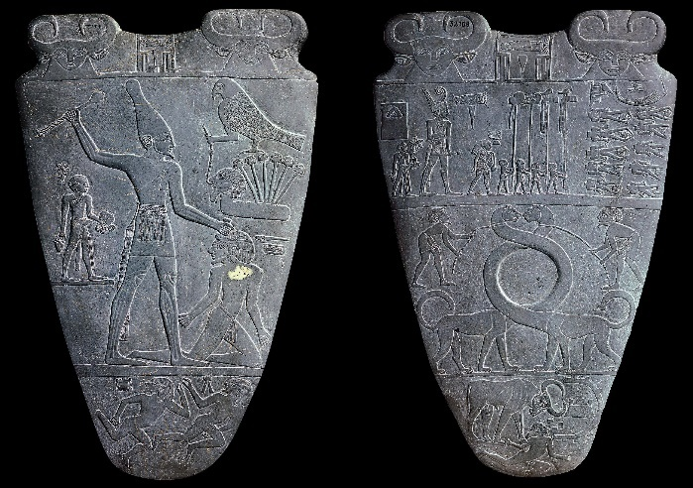
The theory of cultural memory in its entirety was created to suggest that memory cannot only be applied to the present and to the individual but to the past and ancient civilisations as a whole.

When looking at ancient Egypt there are many examples of cultural memory that can be discussed; one of the most significant is the discovery of the Narmer palette. This object, a thin cosmetic palette, has been attributed to pharaoh Narmer, arguably the first pharaoh of a unified Egypt. The palette depicts Narmer smiting the enemy with a mace head, thereby defending Egypt from chaos and upholding the right order of Maat. This artefact can be argued to be one of the most important objects within the history of ancient Egypt, as it is said to be depicting the first moment of unification of Upper and Lower Egypt. This piece of iconography can be used as an example of cultural memory as this object captures an idealising image, something that may not have necessary happened in real life but it is an image all individuals associated with this civilisation can take meaning from. The iconography of the Pharaoh smiting the enemy, the idea that to be Pharaoh one must be able to protect Egypt from all enemies, was passed on through generations and this is a representation that makes up a significant part of this culture’s heritage. Many may argue that objects of this nature within all civilisations can be associated with cultural memory, however this is false: it is not the object that holds specific connotations for the culture, it is the image of iconography, the meaning and significance these images have for the people it is associated with.
Figure 1: Narmer Palette.

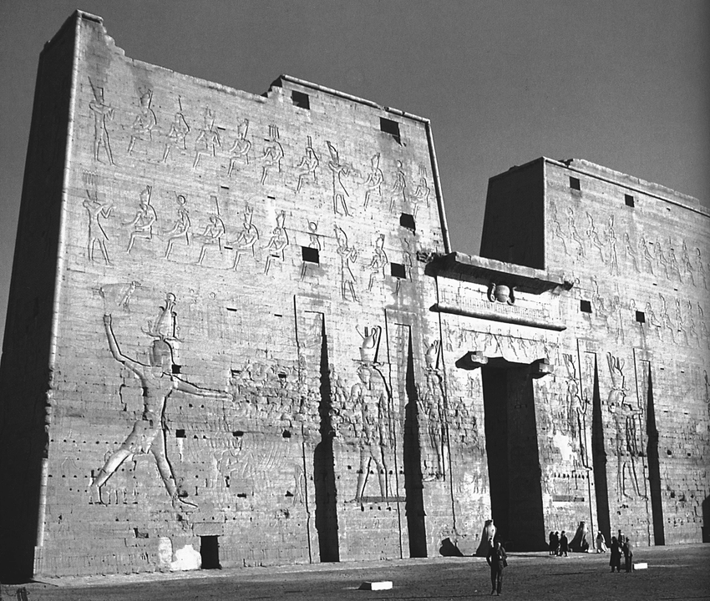
Another example of cultural memory can be taken from the end of ancient Egyptian history, from the Ptolemaic period. This example of the Pharaoh smiting the enemy, which suggests the importance of this image for the Egyptian people, began in the early pre-dynastic period and remained as significant until the end of ancient Egyptian history. This scene, taken from the Edfu temple, located in Upper Egypt, close to the modern day Aswan dam, shows Pharaoh Ptolemy XII smiting various enemies, thereby protecting Egypt from the chaos of the outside world, and upholding the right order of Maat. We can assert that by the continued use of this image for the duration of ancient Egyptian history, that it is one of the key identities to what it was to be Egyptian, therefore it was a shared identity within this culture. Considering this information, we can be certain that the use of this iconographic image is an example of cultural memory.
Figure 2: ‘Pylon at Edfu Temple’.

In conclusion, when considering the idea that museums are institutions of cultural and collective memory, it is important to understand that the ideas of memory are ever changing, so it is hard to determine for museums as a whole where cultural and collective memory can be applied to their function. Although we cannot be certain of the use of the ideas of cultural and collective memory within the earliest examples of museums, there is evidence to suggest use in more modern museums. Through looking at examples of cultural memory within this paper it becomes evident that cultural memory mainly exists within settings such as museums and other heritage institutions, as museums allow for the converting of individual memory into cultural memory, something that has meaning to a wide variety of individuals. Moreover, like cultural memory, which was created out of the use of collective memory, it could be argued that collective memory does reside in museums purely on that basis. Nonetheless, collective memory does take place within a museum setting as memory can be shared throughout various individuals, but it is important to suggest that unlike cultural memory, collective memory can be seen in varieties of different institutions and settings outside the heritage and museum sector.

Bibliography

Arnold, D. & Shafer, B.E., 2005. Temples of ancient Egypt, London: I.B. Tauris.
Assmann, J. (1995) ‘Communicative and Cultural memory’ In Cultural Memories Springer, Dordrecht.
Assmann, J. (2002) ‘The Mind of Egypt: History and Meaning in the Time of the Pharaohs’, Metropolitan Books.
Assmann, J. (2011) ‘Cultural Memory and Early Civilisation, Writing, Remembrance and Political Imagination’ Cambridge University Press
Astrid Erll, Ansgar Nünning (Hg.), Cultural Memory Studies. An International and Interdisciplinary Handbook, Berlin, New York 2008, S. 109-118 (109)
International Committee of Museums, (n.d) ‘Museum Definition’, Standards Guidelines. Available at URL: https://icom.museum/en/resources/standards-guidelines/museum-definition/ [Accessed on 12/05/20]
James V. Wertsch & Henry L. Roediger III (2008) Collective memory: Conceptual foundations and theoretical approaches, Memory, 16:3, 318-326, DOI: 10.1080/09658210701801434
Meckien, R. (2013) ‘Cultural memory: the link between past, present, and future’, Institute of Avdanced studies of the University of Sao Paulo Website. Available at URL: http://www.iea.usp.br/en/news/cultural-memory-the-link-between-past-present-and-future [Accessed on 19/5/20]
Museum Association (1998) ‘What is a Museum’. Available at URL: https://www.museumsassociation.org/about/frequently-asked-questions [Accessed on 18/05/20]
The European Museums Network, (n.d) ‘The World’s Oldest Museum’. Available at URL: http://museums.eu/highlight/details/105317/the-worlds-oldest-museums [Accessed on 16/05/20]
Weadock, N, P. (1975) ‘The Giparu at Ur’, Iraq, Vol. 37, No. 2, P. 101-128.
Women in Archaeology, (2019) ‘Ennigaldi-Nana, the desire of the Moon-god and Curator of Ur’. Available at URL: https://womeninarchaeology.com/2019/11/27/ennigaldi-nana-the-desire-of-the-moon-god-and-curator-of-ur/ [Accessed on 23/05/20]

Images
Figure 1: Narmer Palette, Wikipedia Page. Available at URL: https://en.wikipedia.org/wiki/Narmer_Palette [Accessed on 29/05/20]
Figure 2: Clarysse, W. (2012) ‘Pylon of Edfu Temple’, Egyptian Religion and Magic in Papyri. Available at URL: https://www.researchgate.net/figure/Pylon-of-the-Edfu-temple-showing-King-Ptolemy-XII-smiting-the-enemies-Photo-by-W_fig1_297477271 [Accessed on 29/5/20]

International Committee of Museums (n.d).
Ibid
The European Museums Network (n.d).
Weadock, N, P. (1975) 101.
Women in Archaeology, (2019).
Museum Association (1998).
Wertsch, V, J. & Roediger III, L, H. (2008) 318.
Erll, A. & Nünning, A. (2008) 109.
Erll, A. & Nünning, A. (2008) 110.
Erll, A. & Nünning, A. (2008) 109.
Ibid
Erll, A. & Nünning, A. (2008) 110.
ibid
ibid
Erll, A. & Nünning, A. (2008)110.
ibid
Erll, A. & Nünning, A. (2008) 109.
Assmann, J. (2011).
Assmann, J. (2002) 9.
Assmann, J. (1995) 132.
Meckien, R. (2013)
ibid
ibid
Erll, A. & Nünning, A. (2008) 110.
Assmann, J. (2002)17
Arnold, D. & Shafer, B.E. (2005) 207

