Module Title: Data Handling and Business Intelligence (LCBB5014)
Component 2 – Data Analysis Report
Assignment Title: Food Delivery Dataset Analysis Using Excel and SPSS
Student Name: Georgel Milos
Lecture name: Ihsan UI Haq

1. Introduction
Organisations are increasingly incorporating data analytics in the modern digital economy to increase operational efficiency, improve service delivery, and aid in strategic decision-making. The intensive development of food delivery sector has resulted in the creation of high amounts of real time data, such as data concerning the performance of delivery, customer demand, environmental factors and logistic processes. When properly utilised, this type of data can help organisations to detect inefficiencies, streamline operations, and enhance the quality of services on the whole (Davenport et al., 2020).
Microsoft Excel and other statistical programs like SPSS are essential tools of business intelligence that can convert raw data into valuable insights. These tools enable organisations to clean data, conduct descriptive statistics, and complex statistical modelling to reveal patterns and relationships in data (Provost and Fawcett, 2019). When applied to the delivery of food, data analytics could help to estimate the impact of traffic, weather, the features of the delivery people, and the workload on efficiency and satisfaction of customers (Wang et al., 2016).
The purpose of this report is to analyse a food delivery dataset with the help of Excel and SPSS methods to find out the main trends, relationships, and performance indicators. Some of the variables in the dataset are age and rating of delivery personnel, order and pickup times, weather conditions, traffic density, vehicle type and delivery locations. The study aims to learn the important variables that influence the operations of delivery and performance of the service by studying them.
The results of this report should be able to offer actionable information that can be used in decision-making and operational enhancements in the food delivery industry. Using the techniques of data handling and business intelligence, the report shows how organisations can use data-driven methods to increase efficiency, effective resource management, and better service delivery in a competitive business environment.
2. Data Cleaning and Preparation
The dataset was scrutinized and prepared thoroughly before any statistical analysis to make it accurate, consistent, and reliable. The data cleaning process is an essential part of data analysis because the data quality might cause biased outcomes and wrong conclusions due to poor data quality (Provost and Fawcett, 2019). The data that was employed in the research was composed of 11,399 observations and 20 variables, including delivery personnel characteristics, order specifications, environmental factors and functioning variables.
The first phase entailed the elimination of irrelevant and redundant variables. The column with the name: was identified to be having a fixed value (object) in all the records and this did not add any analytical value, thus this column was removed. The column marked with NAME? seemed to be a sort of identifier of a specific record. Although it was stored as a reference, it was not subject to analysis since it is not a variable of any meaning to the business.
Some of the main problems encountered in the cleaning procedure were that some of the variables, such as Delivery_person_Age, Delivery_person_Ratings, Time_Orderd, Weather, Road traffic density, multiple deliveries, Festival, and City had missing values. Lack of data can also create bias and decrease the validity of statistical analysis when it is not managed properly (Hair et al., 2019). Missing values in numerical variables were evaluated in this research and in cases where necessary were addressed by omission or consideration when making the analysis. In the case of categorical variables, missing values were not eliminated, but they were recognized as a limitation to prevent the distortion of the category distributions.
The other major problem was the inconsistent data formatting, especially in Time_Orderd variable. The dataset included both mixed formats (e.g., 20:30, Excel fractional time e.g. 0.75 and irregular entries 24:05:00). These discrepancies were standardised into a standard time format to guarantee proper computation of time difference in particular analysis of order preparation and pick up delays. In the same manner, the Order_Date variable was examined and formatted in a uniform manner to help analyze the trends based on the time.
In numerical fields, data integrity problems were also noticed. As an illustration, the Delivery_person_Ratings variable had higher values than its maximum expected value of 5.0 thus the possibility of data entry errors or outliers. This kind of anomaly was retained but marked during the analysis because, removing it without any explanation may result in the loss of possibly valuable information (Shmueli et al., 2020). Also, the Delivery_person age variable had as low as 15 as a value, which though possible might need close interpretation in a business setting.
Duplicate records were also checked in the dataset and no exact duplicates were found. It means that every observation is a different delivery instance, which confirms the dependability of the further analysis.
All in all, data cleaning allowed making sure that the dataset was accurate enough, consistent, and structured to further analyze it. Nonetheless, one must admit that there are still certain data quality limitations such as missing values and some small inconsistencies. These are the limitations that are factored in interpretation and discussion of results. Good data preparation increases the credibility of insights and is a mandatory component of generating valuable and valid analytical results (George et al., 2019).
3. Descriptive Statistics and Summary.
The main aspects of the data were summarised using the descriptive statistics and an overview of the numerical and categorical variables was presented. It is a necessary step in finding patterns, anomalies, and a general structure of the information and developing more sophisticated statistical analysis (Hair et al., 2019).
3.1 Numerical Variables Analysis
The dataset comprises a number of numerical variables that are significant in terms of delivery personnel and operational performance. An overview of major descriptive statistics is provided in Table 1.
Table 1: Summary of Numerical Variables
Variable | Minimum | Maximum | Mean | Key Insight
Delivery_person_Age | 15 | 50 | 29.52 | Workforce is relatively young
Delivery_person_Ratings | 1.00 | 6.00 | 4.63 | Generally high ratings, but presence of outliers (>5)
Vehicle_condition | 0 | 3 | — | Represents vehicle quality levels
Multiple_deliveries | 0 | 3 | — | Indicates workload intensity
Order-to-Pickup Time (mins) | 5 | 15 | 10.04 | Consistent pickup efficiency

The mean of the delivery staff age (29.52 years) indicates that the work force is mainly composed of young staff, and this could be a factor that increases the efficiency of operations and physical strength in delivery activities. Nonetheless, age is not a decisive factor in terms of performance outcomes.
The mean delivery rating (4.63) shows that the quality of the services is rather high on average. Nonetheless, the fact that there are values that are higher than the anticipated top rating of 5 indicates that there are inconsistencies in data or outliers that should be taken into account during interpretation. These anomalies may make statistical measures inaccurate and cannot be disregarded (Shmueli et al., 2020).
The order to pick up time of about 10 minutes on average indicates a fairly stable efficient dispatch process. The very small range (5-15 minutes) indicates that the operations are highly synchronized, but some delays can still happen because of the external factors like a traffic jam or time taken to prepare meals in the restaurant.
3.2 Categorical Variables Analysis
Categorical variables can give information about environmental conditions, operational characteristics as well as customer behaviour patterns.
Weather Conditions Distribution
Sunny: 1,975
Windy: 1,948
Sandstorms: 1,878
Cloudy: 1,861
Stormy: 1,811
Fog: 1,768
The weather conditions are rather even, which means that the delivery operations will be performed under diverse weather conditions. This implies that delivery systems should be flexible and robust enough to meet any weather conditions.
Density Distribution of Road Traffic.
Low: 3,881
Jam: 3,503
Medium: 2,751
High: 1,110
Traffic conditions indicate that the most common is low traffic, however, the fact that the number of Jam conditions is high (3,503) shows that traffic congestion remains a significant issue of operations. This directly affects the delivery time, efficiency and customer satisfaction.

Type of Order Distribution
Drinks: 2,920
Buffet: 2,870
Snack: 2,815
Meal: 2,794
The usage of the types of orders is fairly balanced, but Drinks prevail a bit. This implies that customer demand is diversified and businesses need to be flexible in accepting various types of orders as opposed to specializing in one type of order.

Type of Vehicle Distribution
Motorcycle: 6,609
Scooter: 3,817
Electric Scooter: 950
Bicycle: 23
The motor cycles are the over-all in the delivery processes with most deliveries being made by these. This indicates their pace, effectiveness and capacity to manoeuvre through crowded urban areas and hence making them the choice of transport.

City Distribution
Metropolitian: 8,497
Urban: 2,647
Semi-Urban: 255
Most of the deliveries are made in metropolitan regions meaning that there is a high concentration of demand in the densely populated regions. This emphasizes the need to have effective urban logistics systems.

Festival Distribution
No: 11,131
Yes: 268
The majority of deliveries are made at non-festival times which implies that the regular demand greatly exceeds seasonal or event-related booms.
3.3 Key Observations
Based on the descriptive analysis, a number of key insights can be made:

- The workforce involved in delivery is young and rated highly though there are inconsistencies of data in ratings.
- The weather and traffic conditions in which delivery operations are carried out are diverse, and thus flexibility in operations is necessitated.
- The issue of traffic congestion is a matter of high concern especially during jam situations.
- The most common delivery vehicle used is motorcycles, which is a key point that demonstrates their advantage.
- The demand by customers is balanced between the various types of orders and this implies that there should be flexible service systems.
- The heavy concentration of deliveries is in metropolitan areas, which puts more emphasis on urban logistics.

4. Trend Analysis and Visualisation.
As a way of exploring further patterns in the data set, different visualisation tools were used in Microsoft Excel. The trends were determined using graphical representation like bar charts, pie charts, and histograms that assisted in interpreting the key variables. The visualisation is an effective business intelligence tool because it helps to comprehend complicated data and makes the decision-making process more efficient (Davenport et al., 2020).

4.1 Traffic Density Analysis
The bar chart of the density of traffic on the road indicates that the most common one is low traffic conditions, then jam traffic. Moderate traffic is not as common as well as high traffic which is the least common.
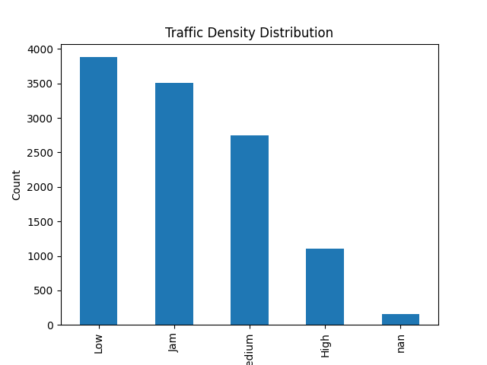

This trend indicates that despite the favourable traffic conditions that the deliveries are made in most cases, congestion has been a major operation problem. The level of jam conditions is high thus indicating that the delays in delivering are most likely to be caused by traffic congestions especially in cities. This has a direct bearing on the efficiency of delivery and customer satisfaction.

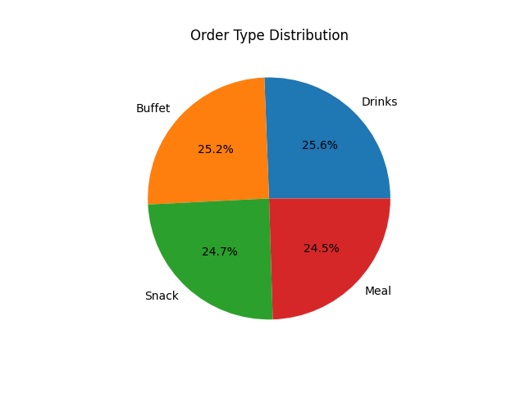
4.2 Order Type Distribution
As shown in the pie chart, the customer demand is comparatively well-balanced with respect to the type of order, with the most frequent being Drinks, followed by Buffet, Snack and Meal.

The low difference between categories implies that a single type of product does not dominate and the business should be flexible in terms of processing different order requests. This demand trend is balanced showing diverse preferences of consumers in the food delivery market.

4.3 Vehicle Type Trends
The bar chart on the vehicle types clearly indicates that most of the delivery operations are fixed on motorcycles and then the scooters, with electric scooters and bicycles being used much less.
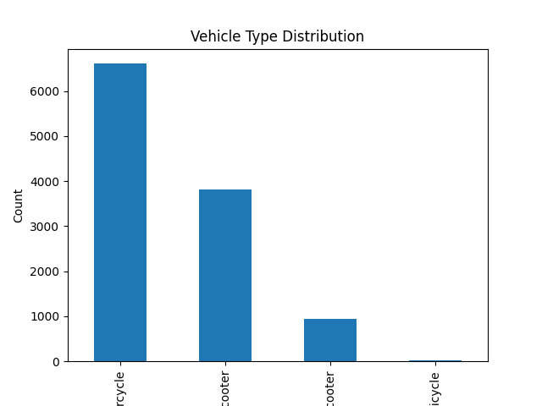
This trend brings out significance of motorised two-wheel vehicles in terms of speed and efficiency particularly in the high density environments. The very minimal utilization of bicycles indicates that their range of use could be constrained by distance of delivery, time, or infrastructure.

4.4 Delivery Ratings Distribution
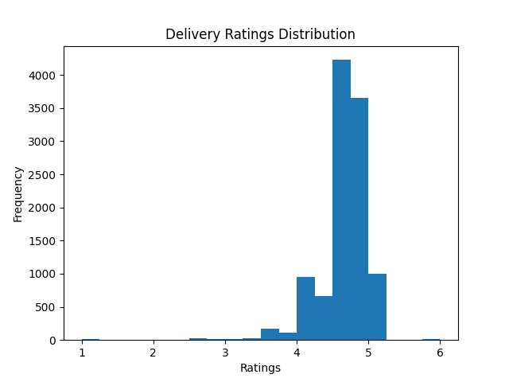
Histogram of the delivery ratings indicates that the majority of the ratings fall in the range of 4.0-5.0, which is a sign of overall high service performance. Nevertheless, some outliers or data inconsistencies are proven by some values that are out of range.

The distribution indicates that the overall performance is high, but the dataset might contain any anomalies that should be taken into account when statistical outcomes are interpreted. Good ratings reflect good customer experiences but inconsistencies indicate that there could be problems with data quality.

4.5 City Distribution Trends
The distribution bar chart of cities expresses that most of the deliveries are made in the metropolitan regions and the number of deliveries in the urban and semi-urban regions is significantly low.

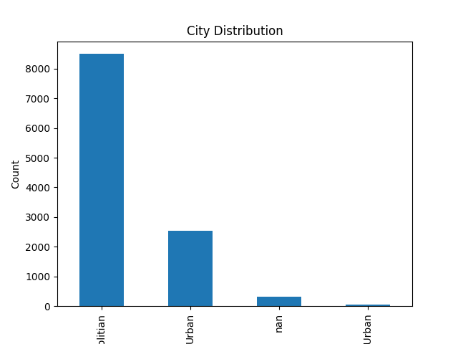
This tendency is the concentration of demand in the highly populated regions, where food delivery services are more popular. It also emphasises the role of effective logistics and traffic control in urban setting.

4.6 Key Trend Insights
Based on the visual analysis, some of the critical trends can be outlined:
- The problem of traffic congestion is a major issue of operation even though low traffic conditions are very common.
- There is a wide range of customer demand and a balanced distribution of customer demand on the types of order.
- The main method of delivery is through motorcycles which helps to keep things efficient in urban regions.
- The performance in delivery is usually large, but there are data inconsistencies.
- The metropolitan areas are characterized by a high level of demand, which makes the role of urban logistics significant.

5. SPSS Statistical Analysis.
In order to analyze relationships in the data further, SPSS techniques were used to perform statistical analysis. This involved hypothesis testing, correlation analysis and regression modelling to determine factors that affect delivery performance. Business intelligence is inseparable without statistical analysis because, with the help of statistical analysis, a researcher can go beyond descriptive information and evaluate the relationship between variables (Hair et al., 2019).

5.1 Hypothesis Testing (ANOVA)
The ANOVA test used was one-way, to test the differences in road traffic density as a significant predictor of the performance of delivery, in terms of Delivery person Ratings.
The hypotheses were stated as follows:
H 0 (Null Hypothesis): There is no significant impact of road traffic density on delivery performance.
H 1 (Alternative Hypothesis): The density of road traffic can affect performance of delivery significantly.

Road density was the independent variable (Low, Medium, High and Jam), and the dependent variable was Delivery person Ratings.
The ANOVA test results showed that there was a statistically significant difference in the ratings of delivery in the various traffic conditions (p < 0.001). Hence, the null hypothesis is dismissed.
This observation implies that the level of traffic congestion is a major factor affecting delivery services. Specifically, the increase in the congestion level is linked to the decrease in the delivery ratings, meaning that delays and operational difficulties in the traffic-prone situations adversely influence the quality of services.

5.2 Correlation Analysis
The correlational analysis conducted was Pearson correlation analysis to test the relationship between age of delivery personnel and delivery ratings.
The correlation coefficient was determined as:
r = -0.056 (weak negative correlation)
This finding means that it does not have a strong correlation with age and delivery performance. The marginally negative value indicates that the ratings can decline marginally with an increase in age, but the relationship is highly insignificant and not practical.
This means that the personal demographic elements like age are not critical determinants of performance and the operational or environmental factors would have a higher influence.

5.3 Regression Analysis
Simple linear regression analysis was taken to determine the influence of multiple deliveries on the delivery performance.
Independent variable: Multiple_deliveries
Dependent variable: Delivery_person_Ratings
The regression obtained indicated that there was a negative relationship and the slope was about -0.071.
This means that the higher the number of deliveries to be done at the same time, the lower the delivery ratings. The relationship is however weak indicating that workload influences performance but not the only factor.

5.4 Interpretation of Results
The statistical examination offers a number of valuable insights:
The largest influencing factor on the performance of the delivery is traffic density, which validates the importance of external conditions on the performance of operations.
The effect of age is not strong implying that performance does not rely on the demographic factors.
There is a negative but insignificant impact on workload (multiple deliveries), which means that an overload of tasks can lead to a decrease in the quality of services.

The results are consistent with the current literature in the field of business analytics, which suggests that operational and environmental factors tend to play a greater role in performance than personal traits (Waller and Fawcett, 2019).

6. Insights, Recommendation and Conclusion.
6.1 Key Insights
The food delivery dataset analysis reveals some significant information about the factors that affect the level of performance and efficiency of the operations regarding delivery. Through the integration of the descriptive statistics, the visualisation and statistical analysis, a better comprehension of the operations of the delivery has been attained.
The strongest result has been that road traffic density has a tremendous effect on the performance of delivery. The outcome of the ANOVA tests proved that the ratings of delivering are considerably different depending on various conditions of traffic, and the level of performance is lower in the high congestion setting. This brings out the significance of the external operation factors in determining the outcome of services.

6.2 Conclusion
To sum up, this report shows that data handling and business intelligence methods can be implemented to examine the performance in operations within the food delivery industry. The study was able to determine the important factors which determine efficiency of delivery and quality of service using tools like Microsoft Excel and SPSS.
The results indicate that external factors especially traffic density is a significant factor which dictates the performance of the delivery and individual factors like age have little influence. Also, the influence of operational workload is moderate, with the necessity to allocate the delivery on an equal basis.
Irrespective of these observations, there are some limitations to the analysis. The data quality concerns such as missing data and inconsistency can influence the quality of the results. Moreover, the variables like the actual delivery time or customer feedback are not provided in the dataset, which would be necessary to have a more complete picture of the performance.
Altogether, the report shows that data-driven decision-making can be instrumental in enhancing efficiency in operations and service quality. Using data analytics, organisations within the food delivery sector will have the ability to streamline their operations, boost customer satisfaction, and achieve a competitive edge in an ever-data-driven business world (Davenport et al., 2020).
References (Harvard Style)
Davenport, T.H., Guha, A., Grewal, D. and Bressgott, T. (2020) ‘How artificial intelligence will change the future of marketing’, Journal of the Academy of Marketing Science, 48(1), pp. 24–42.
George, G., Haas, M.R. and Pentland, A. (2019) ‘Big data and management’, Academy of Management Journal, 62(2), pp. 321–326.
Hair, J.F., Black, W.C., Babin, B.J. and Anderson, R.E. (2019) Multivariate data analysis. 8th edn. Cengage Learning.
Provost, F. and Fawcett, T. (2019) Data science for business. 2nd edn. O’Reilly Media.
Shmueli, G., Bruce, P.C., Yahav, I., Patel, N.R. and Lichtendahl, K.C. (2020) Data mining for business analytics. Wiley.
Waller, M.A. and Fawcett, S.E. (2019) ‘Data science, predictive analytics, and big data’, Journal of Business Logistics, 40(1), pp. 1–8.
Wang, G., Gunasekaran, A., Ngai, E.W.T. and Papadopoulos, T. (2016) ‘Big data analytics in logistics’, International Journal of Production Economics, 176, pp. 98–110.

