Student number - 1807876

BA hons Illustration

Word count - 1509

Tutors. Julia Lockheart, Gwenllian Beynon, Scott Smith, Martin Bush and Ryan L. Moule, Rob Jones

Ways of Perceiving- The Curation of an Imagined Exhibition

The exhibition that will be curated and imagined by myself is titled ‘The Tortured Artist’. This will be a shocking exploration of a classic stereotype created by the media, which started hundreds of years ago. This stock character is so well known that the titles origin and when it was first created is undetermined. it is almost seen as a fact of life. The characteristics of this stereotype would commonly be known in modern times as someone suffering from mental illness. This is a field of knowledge that has grown immensely in recent years but the actual insight into conditions of the mind such as schizophrenia, bi-polar disorder and the like are still limited to the unaffected onlooker. Just like in the past, we cannot truly understand or experience these conditions unless we have been there ourselves. The one thing that has stayed consistent is how we react to the artworks of the ‘mad’ and feel true emotions from their brush strokes and creation, be it frightening, funny, sad or just simply weird. The aim of this exhibition is awareness featuring works of both positivity and darkness to draw the spectator into the mind of the unique and personal conditions. The late and great Bryan Charnley once said “We are all victims of insanity” (Charnley, 1991) and in one way or another this is still true.

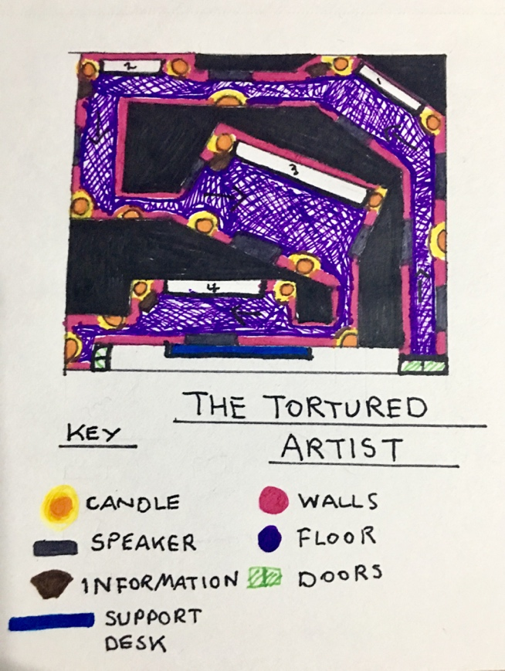

Figure 1: Map of The studio layout

The tortured artist exhibition will take place in a rented studio in SA1 Swansea. This will be the perfect setting for such an exhibition, as a small box studio will be ideal to create tight spaces and dim lighting. After great research into mental illness and the effects of schizophrenia, the one feeling that is common throughout people’s experience is feeling trapped and in the dark about what will happen next. In order to highlight this, my choice of spatial formatting will be crucial to leaving a lasting impression on the visitor. This curation is also designed to create positive awareness so warming and calming candle light will be used to guide the path of the exhibition. The walls will also be a calming purple, which is often used in health spas and mental health facilities to help the guest to feel more relaxed. The colour will also be a crucial part of the exhibition as colours can make a lasting effect on our psyche and the way we perceive situations.

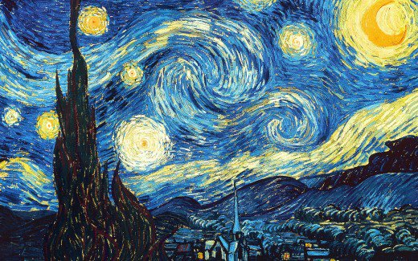

Figure 2 The Starry Night Oil on canvas 73.7 cm × 92.1 cm (Van Gogh, 1889)

The first image that the spectator will be confronted with will be the well-known image ‘The Starry Night’ by Vincent van Gogh, a beautiful scene of an imagined village combined with the views seen from the window of the asylum that he was committed to. Van Gogh moved into the asylum voluntarily after he very famously cut off his own ear. Whilst there he confirmed to the staff that he had heard a voice in his ear that said “kill him” so in an impulsive act he tried to silence that voice by committing this brutal act upon himself. This image has been chosen to welcome the viewer, it will most likely be familiar to them yet they may not know the story behind it. The fact that it is so relevant to mental illness might surprise the guest, getting them to question the artist behind many works that they feel familiar with.
According to the 2008 survey by the National Alliance on Mental Illness, 64 percent of the public are misinformed about mental illness, especially on the symptoms and effects of the disorder schizophrenia (Nami.org, 2008). I hope this image will clear the mind of the viewer. They will hear a song that will play on loop throughout the exhibition, and along with the dimly lit room it will create a calming but uneasy ambience that will suck the spectator into this world of ‘madness’ and create the feeling that perhaps you should look behind you as the hairs on the back of your neck stand up. The song that will play throughout the show is ‘Zima’ (Winter) by Matrang, a Russian musician of Vladikavkaz in the north Caucasus region that creates ambient electronic beats with short lyrics and bold meanings. The vocals are deep and the music is swift. It includes metaphorical lyrics about life going too fast, going from young to old, happy to sad and fresh to depressed, but what is most important is that the majority of attendees will not understand the Russian lyrics, just as they do not know the minds of the damaged, they will only be able to feel the song, guess it’s lyrics and meaning. It’s not being told.

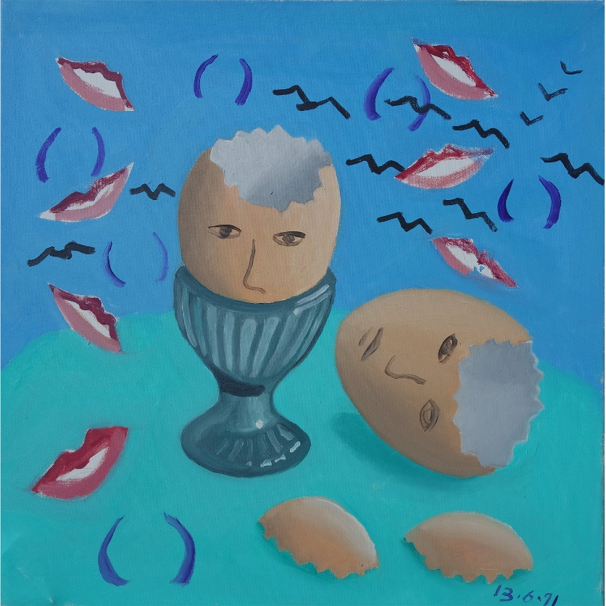
Figure 3 Self Portrait #13 oil on canvas, 51 x 51 cm (Charnley, 1991)

The next turn in the studio will lead to the bizarre yet beautiful creation by Bryan Charnley. Self-portrait #13 is a charming and humorous piece with which I hope to expose the next characteristic of the ‘tortured artist’ or as it would be known now- schizophrenic. This characteristic is that of humour, the bizarre and the ability to mask strange thoughts inside and obscure meanings with a paintbrush. Charnley is a diagnosed paranoid schizophrenic who suffered from suicidal thoughts and a delusion regarding telepathy that affected him on a daily basis. When one analyses this painting, you can dissect the meaning. The egg is the brain, it has been cracked and the bird figures are his thoughts and delusions flying away into the sky. To belittle this free feeling, the grins of others are ever present in the sky, watching and judging.
This exhibition is designed to educate the viewer into realising that the mentally ill are valuable, and also to expel the myth that schizophrenia is a split personality disorder. A 2015 study by Ralph Ryback M.D. showed that the majority of the public believe that schizophrenia means ‘split personality’ yet it has been proven that this is not part of this condition. It is a disorder of thought that can affect the sufferer in many different ways, be it having unrealistic beliefs, paranoia or more rarely hearing and seeing things that are not there. The ‘Tortured Artist’ stereotype is merely a creative expression of these different delusions, ideas, fears and convictions. Charnley once described his art and health by saying “I came across the idea of art as a form of exorcism” and “Painting is pain with a tea and music such sweet sympathy” (Charnley 1991) This expresses his pain and also the idea of why someone with emotional issues would become an artist. It is a type of therapy for the deepest wounds.

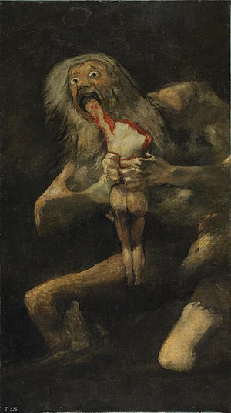
Figure 4 Saturn Devouring his son (Goya, 1823) Oil mural 143 cm × 81 cm (56 in × 32 in)

As the exhibition continues on the viewer will be boldly confronted by this shocking, powerful and frightening piece by Francisco Goya. This will remind the viewer of the dark reality of the pain that can afflict the suffer of mental illness. Although the intention is not to frighten the public with the dimly lit room and atmospheric sounds, it is to educate and shock. Many art lovers will know the beautiful and regal work of Goya but many will not know about his later series of his private ‘black paintings’. He did not create this series for public view, they were found on the walls of his home after his death. Goya had been suffering with his mental health after a fever had struck him some years before. A lesser known fact is that Illnesses of the physical kind can often trigger mental illness, such as paranoia, depression and anxiety. Fever, syphilis, head injury and many more are commonly known conditions can ignite these issues in the unlucky few. The intention of including such a shocking feature at such a large size is to make people realise that anyone at any moment in time, even someone of great prestige could be hit by mental illness and become confronted with judgement and ridicule, which is just what happened to Goya in his winter years.

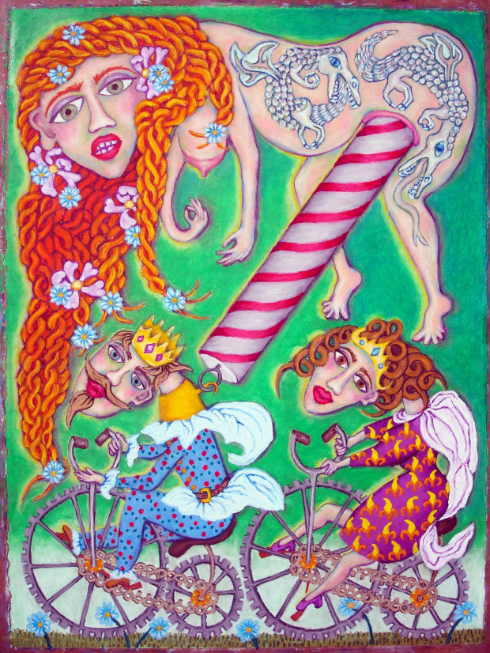
Figure 5- Elegant Solution (Sorenson. K) 2015

The final contribution to this exhibition will be this comic yet disturbing acrylic piece by Karen Sorenson, a diagnosed Paranoid schizophrenic and awareness campaigner for mental illness and the well-being of others suffering with these conditions. Sorenson’s work is the perfect piece to finish the exhibition on as she stands for everything this curation was designed to achieve. She promotes art as therapy for the mentally ill and this is also supported by many respected psychologist’s, as it is seen as a peaceful and non-threatening form of treatment for those with mental health issues (Heenan,D 2007).
In conclusion I feel that this curation for mental health awareness will educate the public on how it feels to be mentally ill, how to understand the mentally ill and also help others to realise the much loved sentiment that you can ‘Turn your wounds into wisdom’ (Winfrey, O) Behind every artwork, every artist has a story, some may be bright, others may be as dark, deep and disturbing as one could bare to imagine, yet most float in-between. Brilliant minds are riddled with issues, as brilliant things are the result of much pain and hardship. Most importantly, one should never assume that the stock character, the ‘Tortured Artist’ isn’t going to be you.

Bibliography

Apa.org. (2014). [online] Available at: https://www.apa.org/pubs/journals/releases/lhb-0000075.pdf [Accessed 4 May 2019].

Appignanesi, L. (2008). Mad, bad and sad. London: Virago Press.

B, C. (2019). Puppet Schizophrene – Bryan Charnley. [online] Bryancharnley.info. Available at: https://www.bryancharnley.info/bondage-heads/_0002_puppet-schizophrene/ [Accessed 6 May 2019].

Burton M.D., N. (2012). Schizophrenia and Creativity. [online] Psychology Today. Available at: https://www.psychologytoday.com/gb/blog/hide-and-seek/201203/schizophrenia-and-creativity [Accessed 4 May 2019].

George, A. (n.d.). The curator's handbook.

Gogh, V. and Bernard, B. (2000). Vincent by himself. London: Little, Brown.

Gogh, V. and Leeuw, R. (1997). The letters of Vincent van Gogh. London: Penguin.

Heenan, D. 2007. Art as therapy: an effective way of promoting positive mental health? Disability and Society. 32 (1)

Leader, D. (2012). What is Madness? Penguin Books.

Loeb Stepanek, S., Ilchman, F. and Tomlinson, J. (2014). Goya. Order and disorder. Boston: Museum of Fine Arts.

Nami.org. (2008). [online] Available at: https://www.nami.org/schizophreniasurvey [Accessed 4 May 2019].

Nichol, L. and Neary, J. (n.d.). A series of unfortunate stereotypes.

Patel, A. (2010). Music, Language, and the Brain. New York: Oxford University Press, Incorporated.

Perry, J. (2011). Schizophrenia and the mind. [online] Philosophy Talk. Available at: https://www.philosophytalk.org/blog/schizophrenia-and-mind [Accessed 3 Jan. 2019].

Werner, Alfred (1972). Pascin: 110 Drawings. New York: Dover.

Zima/Зима. (2018). [Online] Vladikavkaz. Available at: https://www.youtube.com/watch?v=-HoQ5_JBsJY [Accessed 3 Nov. 2018].

