Understanding and Engaging in the Customer Experience
BMSW103

Olu Adegbite
Rumena Khanom
1809546

Introduction 2
What is customer experience? 3
What is Sustainability? 3
What are ethical policies? 3
Marketing Ethics 4
Ethical Issues 5
Quality models 7
What is a quality management model? 7
Examples of quality management models 8
The Baldrige Model (MBNQA) 9
The Deming Prize 10
The Deming Prize Criteria 10
The ISO Quality Management Standards 12
Conclusion 14
References 15

Introduction

The essence of this report is to critically evaluate the benefits of an organisation, where individuals can fully develop by using unique tools and strategies at their disposal and meet their respected outcomes, by creating a detailed development plan, carried out to ensure that their needs are met within the workplace, marking out their every target and goals that have been assigned through the management process of the company.

What is customer experience?

Customer experience is when you have the urge to deliver and fulfil your customer’s needs to their fullest satisfaction, whilst ensuring that they have the utmost intention to come back as a returning customer and all the while have a good shopping history to remember. It is crucial in any business industry that the customer and their needs are to be put forth immediately because that one shopping experience, based on how their needs and issues are handled, will keep a professional image of the company that is running behind the scenes as well as make the customer happy knowing that each and every member of staff is catered to making their consumers feel at ease.

What is Sustainability?

Sustainability is a form of development used to meet the desired needs of the (UCLA) present generation whilst preserving the ability of future generations to come and meet their designated needs.

What are ethical policies?

Ethical policies also known as ethical codes of conduct is a legal document which defines the core requirements Tatum, M (2021) to how an organisation will socialise and interact with each other in order to sell, produce and advertise goods. This is put in place to ensure that no matter who your suppliers or vendors are, communication is key and that all clients matter, meaning that any services that are made within that specific company is handled thoroughly with precaution and are to stay within the legal law of conduct.

Marketing Ethics

Marketing ethics are the very morals and values of an Zigu (2011) organisation to which are required to be adhered during any form of marketing communications. Whether it is a brand or the company itself, marketing ethics are used for marketing strategies to promote and advertise specific goods related to that organisation. However, any claims that do not support the legal rights to the advertisements portrayed, is classed an unethical behaviour, and falls under the line of false allegations. Also, another way to simply define marketing ethics is by stating that it is a field that is surrounded with constant activity related to McMahon. M (2021) promotion and development around the standards of the industry that work and practise services that sell and produce certain goods.

Some of the criticisms of marketing can have a significant impact on individual customers such as unreasonable prices, high pressure selling, deceptive practises, planned obsolescence, poor service to disadvantaged customers and being shady and unfaithful by the uses of unsafe products and services under the concepts of higher marketing strategies.

Ethical Issues

During this topic, four ethical issues will be discussed in depth and how they are apparent in an organisation and how they affect the customer relationships.

The first ethical issue to be discussed is discrimination and harassment within an organisation. The workplace is one of the main places an individual would have to face some form of discrimination and it can be due to several reasons for example, discrimination can occur due to your (AllAssignmentHelpUK, 2017) race, your ethnicity, your religion, your background, or the type of group you surround yourself with and this can all be observed through your own members of staff that work alongside you in the organisation. This can affect a customer's relationship by making them feel uncomfortable to speak out in front of everyone and not want to return. On the other hand, harassment can take a toll both physically, mentally, and emotionally. This type of issue within the workforce can be occurred due to some of the same reasons stated above, your gender, religion, background, ethnicity, and your disability. People often behave this way through visual aids, rude and juvenile behavioural acts, intentional and sexual comments are often made through verbal language, which all result in (AllAssignmentHelpUK, 2017) utter humiliation and embarrassment. In terms of a customer's relationship, this can cause great offense because this type of behaviour can have a significant impact on their mental health and give the company both a bad name and an unprofessional image.

The second ethical issue to be considered is keeping employees safe within the company. It is considered a mandatory procedure to ensure that each organisation is up to date on their health and wellbeing and that all safety rules are put in place and monitored on a daily. Tasks such as risk assessments and safety drills are required for everyone’s benefits to ensure that every member of staff is safe whist they are working throughout the day. Accidents in an organisation for example, in a retail industry (Bizfluent, 2010) with any electrical equipment, items of clothing lying around, or any acts of hygiene are put in place and must be adhered to, to establish a safe working environment, meaning because these are classified as common problems, leaving clothes on the ground, dealing with technical faults and issues, and not practising hygiene rules will put employers as well as customers at risk due to negligence of others, which is why it’s a legal act of procedure that needs to be put in place to avoid any shortcomings in the business, whilst keeping customers loyal and content.

To continue, the third ethical issue to be raised is product safety and how companies choose to advertise and create products that can be harmful towards their consumers. For every product that is produced, there is a legal requirement for a Stojanovic. S (2017) document to be made so it acts as a form of proof as to what is in the product, how it was made and the reason behind the manufacturing, a documented process of the entire establishment. Depending on what the initial product is, an organisation must ensure that everything that is being produced is of high quality and is checked for any harmful ingredients or substances that could potentially put their consumers lives at risk. By doing this, not only are you following a legal procedure which is mandatory in all cases of an industrial organisation, but also strengthening the standards of the product by verifying whether it is of appropriate use or can be considered disposable if not having met the specific requirements of safety.

Furthermore, the final ethical issue to point out here is the use of social media. As we are aware, technology is becoming more advanced by the second and will be the leading tool for future generations to come, which will render menial tasks obsolete. Social media helps a company stay in contact with their consumers and customers by keeping up to date with all genral enquiries and complaints. It is crucial for the management team of the company to White; S. (2019) observe what their employers are posting about their company online and if the feedback is positive regarding their products of service. One issue that needs to be raised is the personal ethics of when an employee is using social media in the workplace for their personal reasons and not focusing on creating a professional image of the company they are working for and this is known as unethical and unprofessional behaviour in the workplace. Such form of behaviour should be discouraged within the organisation and be dealt with immediately. To use an example to support my statement, when running a business online especially through one of the top social media platforms known as Instagram, all employers need to be aware of the differences between personal and professional and that having to manage a business online requires a lot more dedication, understanding, knowledge and a driven mind to satisfy their consumers interests. Social media is also an effective marketing tool that is used by every organisation to further reach out to their customers and every staff member should be reminded that it takes arduous work and full-time commitment to complete a customer's needs at the end of the day.

Quality models

What is a quality management model?

Top quality management models are an accomplishment of (Managementstudyguide.com, 2015) both the management and the employees to ensure that the organisation is delivering high quality products to their consumers by exceeding and satisfying their customer's needs. This type of model encourages and motivates employees in the workplace to drive more further to perform on an exceptional and higher level of conduct. Based on this model, client feedbacks and desires are most fundamental when it comes to defining and executing unused procedures to convey key items than competitors, thus surrendering higher incomes and benefits to the organisation overall.

Examples of quality management models

- Malcolm Bridge Criteria for Performance Excellence
- ISO quality management standards
- Deming Application prize
- European Foundation for quality management (Muzo Bacan, 2017)

The Malcolm Baldrige National Quality Grant (MBNQA) is a grant built up by the U.S (Asq.org, 2017) Congress in 1987 to raise awareness and mindfulness of quality administration and to recognise U.S companies that have executed effective quality administration foundations of bodywork.

The effect of using the Baldrige criteria for Implementation Excellence can be disparaging in creating strides quality, decreasing costs, and getting to become the ultimate showcase pioneer. As the Baldrige system proliferates, (Q3edge Consulting Pvt Ltd, 2019) separation through exhibit of best execution is the basics for survivability and maintainability.

The Malcolm Bridge framework consists of six main categories displayed in the image below.

The Baldrige Model (MBNQA)
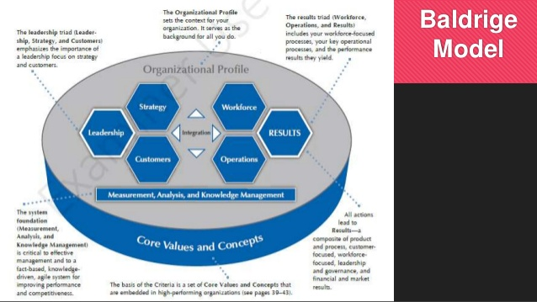

What each category highlights are the characteristics they play within the model itself and how they can be utilized within an organisation. The model is built upon compatible and implanted practises found in higher achieving organisations. The centre values Hobcraft, P. (2017) and design are the establishment for coordination key trade conditions within a result-oriented system that produces a premise for activity and constructive criticism. When using the Baldrige as your administration framework, it will facilitate you to come to a decision on which of these devices will be the most reliable advantage to your specific organisation.

Out of the eleven core aspects and values of Bridge’s criteria, customer driven excellence is more than a necessity because for a consumer to be relieved with their experience, everything lies between the quality of the product and service to which organisations must ensure that all client requirements are taken care of to the highest of standards, Dr LM Foong (2006) and to further guarantee that those same consumers will be returning to the organisation whilst keeping that customer supply chain in place and going.

The Deming Prize

The Deming Prize is one of the most noteworthy grants to achieve on Total Quality Management. It was confirmed up in 1951 in honour of the late Dr. Williams Edwards Deming who provided for Japan’s expansion of measurable quality control after the World War II. His contributions Saferpak (2002) made an enormous difference in Japan which resulted their items of quality in being recognised for the most noteworthy in the world.

The Deming Prize Criteria

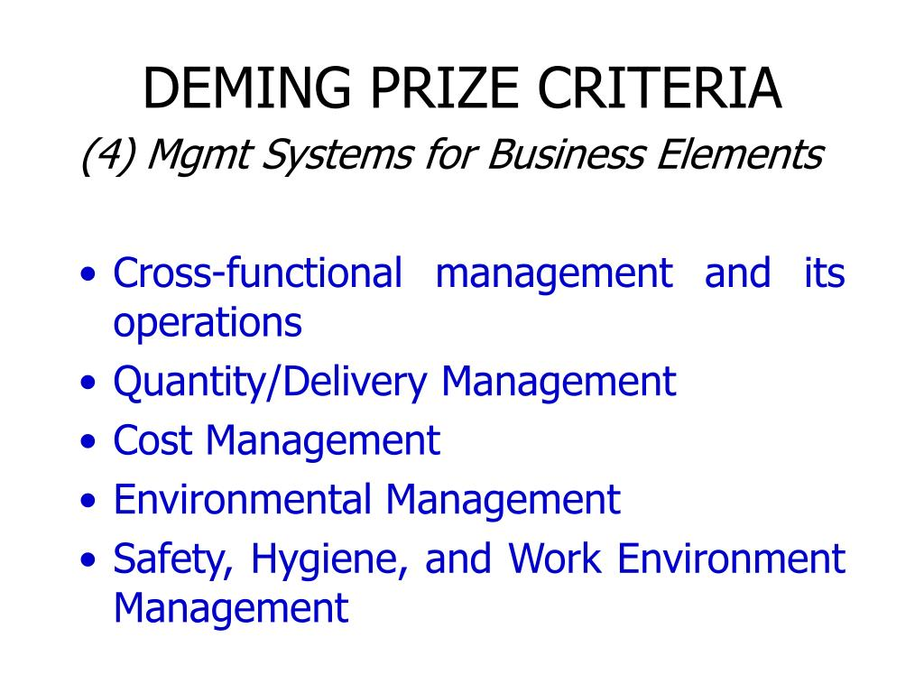

The Deming prize was built up to grant trade substances and identities that performed excellently within the quality control. Within the evaluation of the quality grant, the show concentrates ion specific issues that point to quality administration hones. The centre IvyPanda (2020) regions of concentration incorporate the association and operation, the approach, collection, and utilisation of data and the investigation of data. Based on the image above, the Deming prize was made up of four different business elements, cross functional management and its operation, quantity and delivery management, cost management, environmental management, safety, hygiene, and work environment management. All these key elements listed above, display the importance of how an organisation is run smoothly and the type of operations that need to be put in place for an organisation to be working collectively and maintaining a professional image at the same time.

The ISO Quality Management Standards

The iSO 9001 is the universally recognised Quality Management System (QMS) www.bsigroup.com standard that can take advantage of any sort of organisation out there in the world. This qualified administrative framework will assist you to persistently screen and oversee quality across your commerce so you will be able to distinguish regions for enhancement.

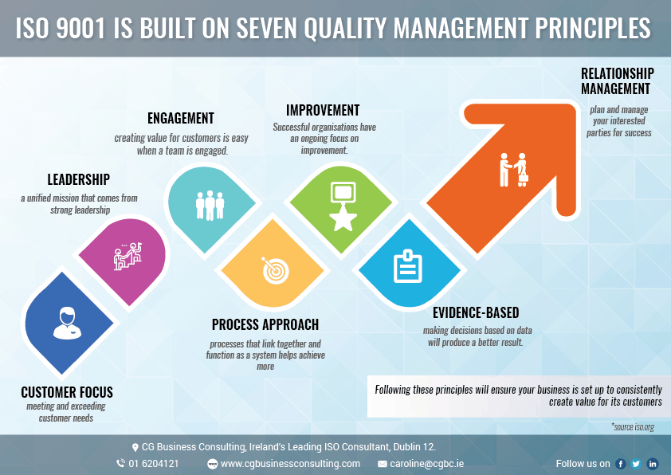

This system is built on seven quality management principles which are leadership, engagement, improvement, relationship management, customer focus, process approach and evidence based, all which are evident and displayed in the image above.

Firstly, customer focus which most organisations tend to focus Bywater.co.uk more directly at their clients and must comprehend their client's needs and should ought to meet their customers full requirements with ease and diligence.

Secondly, leadership meaning captains of the top administration set up Bywater.co.uk solidarity of reason and course of the association. They must ensure to make and keep up the inner environment in which individuals can end up completely included in accomplishing the organisations goals and objectives.

Thirdly, engagement of people and the people on all kinds of levels are the working essence of an organisation Bywater.co.uk and their full inclusion empowers their capacities to be successfully utilised for the company’s advantage and thud allow the association to achieve their goals as well as their current objectives.

To continue, the fourth principle is process approach and by this it means that a wanted result is accomplished Bywater.co.uk well through unique exercises and resources related to the subject as part of the management process. This method is approached by the plan do check at (PDCA) cycle and risk-based training of the mind.

Related to this topic in hand, the fifth principle to be discussed is improvement. By continuously enhancing your skills within the organisation, you are strengthening your core objectives and goals that have been put forth in place, Bywater.co.uk thus enabling you to remain this constant behaviour as an objective to move forward and allow the company to use it to its advantage.

Furthermore, the sixth principle of the ISO management is evidence-based decision making. Effective choices are based on the investigation of information and data analysis. It is vital to form choices based on the realities, arrange changes, and confirm the viability of later.

Finally, the last principle of the ISO management standards is relationship management. An association and its interested parties are forbidding and are commonly useful relationship upgrades the capacity of both to form esteem. Communication is certainly key to keeping up the excellent work within the organisation and moving on forward to improve the administrations framework.

Conclusion

In conclusion, this report gives the reader an in-depth knowledge about customer experience, sustainability, and ethical policies within an organisation and how each is connected to customer relations. Also, this report analyses the depth of ethical policies in an organisation and how it affects customers and their relationships as consumers with employers. To add on, each model and theory that has been used in this report, such as the Malcolm Bridge Criteria for Performance Excellence, the ISO quality management standards, and the Deming Application prize has been constructed with a detailed explanation as to how they all function from a business perspective of opinion. To conclude, what I would personally recommend is that with any organisation, it is important to create a plan to stay on top of all marketing strategies and competition. Based on the three models that were used in this report, I would have to say that Malcom Bridge’s Criteria for Performance Excellence is a useful business tool to understand the essence of how to excel well in the business industry, in his theory he has a handful of insightful ways on how to remain and maintain well within your organisation and make the decision-making process easier.

References

AllAssignmentHelpUK (2017). Describe the Potential Effects of Discrimination. [online] Allassignmenthelp.co.uk. Available at: https://www.allassignmenthelp.co.uk/blog/describe-the-potential-effects-of-discrimination/.

Asq.org. (2017). What is the Malcolm Baldrige National Quality Award (MBNQA)? | ASQ. [online] Available at: https://asq.org/quality-resources/malcolm-baldrige-national-quality-award.

Bacan. M (2017). Total quality management models. [online] Available at: https://www.slideshare.net/gustavobarbecho/total-quality-management-models

Bizfluent. (2010). List of Ethical Issues in Business. [online] Available at: https://bizfluent.com/list-6850278-list-ethical-issues-business.html.

Bywater Training. 7 Quality Management Principles ISO 9001:2015 Diagram. [online] Available at: https://www.bywater.co.uk/resources/7-quality-management-principles/7-quality-management-principles-iso-9001-2015/#:~:text=7%20Quality%20Management%20Principles%20ISO%209001%3A2015%20Diagram%201

Dr LM Foong (2006) EzineArticles. Malcolm Baldrige Values and Concepts Part 2 - Customer Driven Excellence. [online] Available at: https://ezinearticles.com/?Malcolm-Baldrige-Values-and-Concepts--Part-2----Customer-Driven-Excellence&id=208226

HRD Connect (2019) A guide to organisational management models and strategies. (2019). hrdconnect.com. [online]. Available at: https://www.hrdconnect.com/2019/11/04/a-guide-to-organisational-management-models-and-strategies/.

Henshall, A. (2017). How to Use the Deming Cycle for Continuous Quality Improvement | Process Street | Checklist, Workflow and SOP Software. [online] Process Street. Available at: https://www.process.st/deming-cycle/.

Hobcraft, P. (2017). The Baldrige Framework: In Pursuit of Excellence. [online] Hypeinnovation.com. Available at: https://blog.hypeinnovation.com/the-baldrige-framework-in-pursuit-of-excellence.

IvyPanda (2020) Free Essays Quality Management Model: Deming Prize - 825 Words | Essay Example. [online] Available at: https://ivypanda.com/essays/quality-management-model-deming-prize/

Malcolm Tatum (2021) Info Bloom. What is an Ethics Policy? (with pictures). [online] Available at: https://www.infobloom.com/what-is-an-ethics-policy.htm#:~:text=Also%20known%20as%20a%20code%20of%20ethics%2C%20an

Managementstudyguide.com. (2015). Total Quality Management Models. [online] Available at: https://www.managementstudyguide.com/total-quality-management-models.htm.

Mary McMahon (2021) www.wise-geek.com. What are Marketing Ethics? Available at: https://www.wise-geek.com/what-are-marketing-ethics.htm

Q3edge Consulting Pvt Ltd. (2019). Malcom Baldridge Performance Excellence -Q3edge Consulting Pvt Ltd. [online] Available at: https://www.q3edge.com/malcom-balridge-performance-excellence-framework/

Saferpak (2002). Contact - Saferpak.com. [online] www.saferpak.com. Available at: https://www.saferpak.com/deming_prize_art1.htm

Stojanovic. S (2017) 16949Academy. IATF 16949 product safety requirements and how to meet them. [online] Available at: https://advisera.com/16949academy/blog/2017/09/20/ensuring-product-safety-according-to-iatf-16949/

UCLA Sustainability. What is Sustainability? [online] Available at: https://www.sustain.ucla.edu/what-is-sustainability/.

White, S. (2019). Ethical Issues: Its importance in an Organization. [online] AllAssignmentHelp.com - Best Academic Helper US and Australia. Available at: https://www.allassignmenthelp.com/blog/ethical-issues-its-importance-in-an-organization/.

Zigu (2011). Marketing Ethics Definition | Marketing Dictionary | MBA Skool-Study.Learn.Share. [online] MBA Skool-Study.Learn.Share. Available at: https://www.mbaskool.com/business-concepts/marketing-and-strategy-terms/14260-marketing-ethics.html.

www.bsigroup.com. ISO 9001 Quality Management System Explained. [online] Available at: https://www.bsigroup.com/en-GB/iso-9001-quality-management/#:~:text=ISO%209001%20is%20the%20internationally%20recognized%20Quality%20Management

