


FINAL YEAR PROJECT
(SHARIF FATH - 1701105)

TABLE OF CONTENTS:
CONTENTS | No.
CHAPTER 1 – INTRODUCTION | 3 - 4
CHAPTER 2 - RESEARCH & REVIEW OF LITERATURE | 4 - 9
CHAPTER 3 - RESEARCH AND/OR DEVELOPMENT METHODOLOGY | 9 - 16
CHAPTER 4 - DESIGN & IMPLEMENTATION | 17 - 31
CHAPTER 4 – ANALYSIS | 32 - 37
CHAPTER 5 – EVALUATION | 38 - 39
CHAPTER 6 - CONCLUSIONS AND RECOMMENDATIONS | 39
CHAPTER 7 – REFLECTION | 40
REFERENCES | 41 - 43
DEMONSTRATION DEMO | 44
APPENDICES | 44 - 46

CHAPTER 1 – INTRODUCTION
The project is about building an interactive website where users would Post Insight, opinions, videos, and preferences.
The website would be used by different people and family members to post their ideas and comments on questions posted.

Aims for the project:
The aim of this project is to develop the ability to learn new technologies and different ways of writing a software using technologies like JavaScript and ajax to read data from a web server. The main aim is to design a frontend that is easy for the users to use and the design must be responsive to desktops, laptops, tablets, and mobile phones.

Objectives for the project:
- To learn JavaScript, it would take around 30 hours to learn, using the JavaScript books and other online sources.

- Following these simple steps to design the frontend:
  - using Canva (Canva is a graphic design platform that allows users to create social media graphics, presentations, posters, documents, and other visual content.) to design the logo.
  - using CSS, JavaScript (ajax), and HTML to build user interface.
  - get informed by doing research about how to build a friendly frontend.

- Software engineers are the first line of security when it comes to cybersecurity. The abilities to use secure programming practices can prevent hackers to attack the software. So, by using Django for the backend is a good choice because the framework is maintained. Django provides tools and documentation to prevent common mistakes that is causing security problems.

- Allowing the companies and users to view the data without showing personal data of the user to the company and following General Data Protection Regulation (GDPR).

- Building a secure software is very important goal, and the goal is to implement encryption, hashing, load balancing and monitoring, password token, logging, configuration.

- The main goal of this project is to create an Interactive website where Members of the Public would Post Insights, Opinions, Needs and Preferences.

Expected Result:
The expected result should be a web application that allows people to communicate each other and post Insights, Opinions, Needs and Preferences.

Project Gantt chart:
A Gantt chart represents activities that needs be done to finished before the deadline. The Gantt chart is attached in appendix.

Following chapters:
The following chapter is focusing on research and review of literature, chapter three also covers development method chosen to build the website and research methodology.
The report also has a chapter that focuses on the design of the website and after designing the solution to the problem, then would be implementing the design using tools.

CHAPTER 2 - RESEARCH & REVIEW OF LITERATURE

Introductory paragraph:
This chapter mainly focuses on research and review of literature and there are few topics that is related to the project that needed to be researched and then reviewed. The first topic that is researched is about designing responsive website and two paper were reviewed.
The second topic of this chapter is about security and we all know that security is very important part of web application. This chapter manly focuses on how to build secure web application.

Designing responsive website:
The website that would be building should be responsive, and before reviewing paper, the readers should understand what responsive website is. So, responsive designing is a method that allows the content and elements of the website to dynamically change so it can match the screen size without hiding the content of website. The main aim of the paper is to assess the user experience quality of responsive web design on mobile devices.
According to the author(s) [1] if the website uses these following points is considered responsive:
- Flexible grid
- Flexible images
- Media queries
Media queries allows the software engineers to define certain resolution ranges as conditions, the software engineers can write CSS code that changes the layout of the website depending on the device the user is using. By using this it would give the user better visual experience to website users.
In 2012 google start recommending responsive web design to companies that were going to build a mobile website so websites can adapt to many browsers’ resolution. This is good thing for software engineers because they don’t need to waist a lot of time and they don’t have to maintain multi websites.
In the paper they stated that the benefit of responsive web design is that the website can adapt its layout to the browser size and it also changes the fonts, images, and other elements size, so this is allowing the users to read the content of the website without doing any horizontal scrolling to see the other hidden content.
According to this paper, the main goals of responsive design is that the layout must adapt to different screen sizes, from large screen desktop to mobile screen. Responsive design can resize the images to suit the user screen resolution and serving up lower-bandwidth images to mobile phones. Responsive design also simplifies page elements for mobile users and providing users larger finger-friendly links and buttons when using the website through a mobile phone.
The main reason that responsive design is exist is that the mobile use is growing and according to the paper there are more people using mobile devices to access the web then those who using computer desktop or laptop. The author of the paper found out that November-2010, visitors to web-based email sites declined 6%, where the number of the users were accessing their emails through mobile phone and the use of mobile phone has increased to 36%. Because of the internet growth steven jobs released the first mobile phone and after that it was hard to deny the impact the mobile phone had on the internet.
Because of the mobile use growth, teams must design the websites for mobile first and mobile first is now days a new way of designing websites it is spreading fast. The idea of mobile first is about designing the website for mobile phones first. According to the paper designer must first design the mobile version first, how the will website looks like and act in a mobile browser.
There are techniques that developer could use, so the website can be responsive and one of the most important techniques that is useful, so the designer can achieve responsive web design is called flexible grid. The main thing it does is that it allows the designer to create a layout where all element is based on the percentage width and basically all your elements in the layout can be then resizable in relation to one another.
There are many methods that is the paper is covering such as making the images responsive and another method that is useful is using the max-width attribute which is invented by a man called Richard Rutter.
Media queries is another method that a developer can use, and this method is very important because without this technique is impossible to achieve the goal of responsive design [2].
When it comes to comparing the two papers above, they both have the same approaches to solve an equally difficult problem. (second paper references) The second paper has whole chapter that focuses on the mobile-first approach, which means designing for mobile screen and working your way up desktop screen. Both papers described that if a software engineer want to build responsive website, must use methods like flexible grid, media queries and they stated that media queries are very important part of responsive design.
Secure web application:
This paper focus on how to build secure web applications, and it helps software engineers to write a secure web application. The paper describes technical components and process and managements issues that software engineers need, when he/she wants to design, build, and maintain secure web application.
The authors of the paper, they have gathered a lot of high-level security principles that is useful when designing system.
The author stated that user’s input, and output should be checked to make sure that users are not abusing the system. The correct way of validating input and output is to allow only openly defined characteristic and drop all other data. According to authors if the system requires the user to input numbers, then any data that is not numbers is not valid.
Author stated that before building the software, it should first be designed in such a way that users can only use the system privilege they need. For example, if a user account doesn’t need to update and delete others comments then shouldn’t have that privilege.
Authentication is the process that allows system to recognise a user identity. The system can recognise user by their username and password. When the user is authenticated, something called session token is stored in user browser and it does this because it allows browser to send a unique string each time a request is being made.
According the authors of the paper there are two types of Authentication the first one is a user authentication which is the process of checking that a user is who they claim to be and second one is entity authentication is the process of checking if an entity is who it claims to be.
All passwords and username should be stored in database, so the system can used in an authentication process and passwords should be hashed with a simple hash algorithm [3].
This paper has many chapters that focuses on how to secure web application and the paper has chapter that describes the OWASP web application security testing methodology and according to the paper it shows developer how to test vulnerabilities within the application.
A web application security testing is method of analysing the security of the system, this method focuses only analysing the security of a web application and testing for vulnerabilities has process that involves an active analysis of the web application for any vulnerabilities.
According to the paper the test is divided into 2 phases and the first one is understanding the web application is logic and the tools that the developer is using, so you can gather information. For example, the developer can use HTTP proxy to see all HTTP requests and responses. After when the engineer gathers information, he/she should know all the access points of the application. The second phase is that the tester starts to look for vulnerabilities that could be in the web application.
HTTP has many methods that is useful for performing actions on the web server and each method is designed to help software engineers in deploying and testing HTTP application. These HTTP methods can have a security issues that could be risk for a web application because these methods can allow an attacker to modify the files stored on the web server.
The web application has authentication which means the project has a process that allows the user to log in into the system and testing the authentication system, understanding how it works and using the information that gather to find vulnerabilities and using encryption algorithm is also important.
According to this paper, most of the security issues is usually from validate input that is coming from the user or environment before using. This security issue can lead to a major vulnerability in web applications [4].
To compare the two papers above, the guidance that the two papers offer is similar, even though the second paper has covered a lot of vulnerabilities that the application could face, but they both have same outcome. They both described that the data that comes from user should never be trusted and should always validate inputs.

Web Site Design and Development Process:
According to this paper, it explains the process and what the engineer needs to do while he/she is building the web application and the paper stated that each web project has four phases: preparation, planning, design, and development.
The first phase is preparation, before starting the development process, the engineer needs to start thinking about what he/she want and important parameters like time because the project must be finished before the deadline. The paper stated that the developer should have meeting with her/his team. The paper stated that the software engineer needs to think about the purpose of the website and the audience, gathering samples of websites that they like. During the meeting they need discuss what they need, goals, options and the paper also stated that they review the timeline of the project.
The next phase is that the software engineer must decide on the scope of the project, and developer need to put their requirements together, determine a site outline. the developer needs to collect all the important assets such as images, written content, and database. The paper stated that developer should also create project plan that explains the scope of the project and expectation, also the developer needs to detailed schedule with deliverables and timelines.
After planning phase, then start the designing process with the home page wireframe and start designing how would all the elements would need to appear on the page and how they would function. After when the designer approves the wireframes, then the designer starts to design the user interface using your own content and all its elements. After designer approve the design of the home page, then designer need to design other pages with unique content.
After when the site is fully designed, then the developer can start developing the site so the user can visit and use. Build the site using the design and install back-end features like database connectivity [5].
According to this second paper there are 6 phases when developing a site and the first phases is information gathering. The paper stated that to design a successful web site, software developer must first gather information and the first phase is very important one because it involves a solid understanding of the product that software engineer is creating. It is important that the developer come up with a lot of questions such as asking the purpose and gaols of the website.
The next step is planning, after software engineer gathers all the information, she/he needs, it is time to put together a plan for the web site. This second phase it focuses on planning and the paper stated that the developer should create site map that has a list of all the main topic areas of the site. The map will be used as guide as what content will on the website, and the users of the website must be kept in mind while designing the website. It stated that a good frontend allows users to navigate easily through the website. While the project is in the planning phase, the developer should decide what technologies should be implemented.
The third phase is the designing phase where the designer determines the look and feel of the website. It stated that is very important to know who your target audience are and while in this phase is also important to have communication with your team, so designer can talk about the design of the website and exchange ideas. After when the designer finish designing, and the designer have approved it then the developer start developing.
Phase four is the development phase which means is the phase where the website itself is created. In this phase the developer should takes all the individual graphic elements from the design and use them to create the actual website. The first thing the developer start is by first developing the home page and then followed by other pages. Phase four involves on writing code and a successful web application requires an understanding of front-end web development. This phase also involves writing valid HTML5 and CSS3 code, so the developer can see the how the website looks and feels.
Phase five is the testing and delivery phase where the developer tests the complete functionality such as forms, as well as testing with different web browsers. In the phase five the developer test all the code written for the website and making sure the site meets the current web development standards and then host the website in a live server.
The last phase is important for long term product, because once the developer creates the website, she/he must maintain the website by adding new features [6].
When it comes to compering the two paper above, they both trying to solve the same problem which is designing and developing a product. It is described on both papers that first thing the developer do is gather all the information she/he need and then they can move to the next step which the planning. But the second paper focuses on testing the system before hosting it online, and this step is very important.
Summary of the review:
To achieve the goal of building a website that is well design and responsive have reviewed papers that is related to the project, because the paper focus on how to build a responsive web design in both desktop and mobile device.
When the developer is building a responsive website, the developer could face the problem of depending on different device sizes and resolutions. The way that a developer can fix this problem is by design for desktop home page, as well as every other page, and then adapting them for the most popular screen sizes and dimensions. This excludes all the other screen sizes that are not very popular, and this could be a problem.
There are papers that reviewed focused on the steps that the developer takes when a developer is building a secure web application and it describes technical security issues that a developer could face when she/he is building web applications.

CHAPTER 3 - RESEARCH AND/OR DEVELOPMENT METHODOLOGY
Before design and implementation of the project, it was asked to follow a range of methodologies to generate the solution to the idea.
Research Methodology:
Qualitative Research Methodology that involves of collecting data has been used as the project has an aim of designing a frontend that is easy to use and the design also must be responsive.
The main aim that qualitative research is used is to understand the social reality that people experiencing. Qualitative research has many methods including observations, face-to-face interviews, asking people questions to generate discussion among a group of people, collecting existing data in different forms and open-ended questions.
Qualitative researchers they often consider themselves “instruments” in the research because of the data they have recorded or have seen, and analyses are filtered through their own personal lens [7].
To gather data will be surveying users in the form of questionnaire and around 5 users will be surveyed. The survey will also be useful in the requirements gathering of the project for understand the users’ feedback on the features they would like the platform to have and gathering other features that they are being offered by the other social media platforms and what improvements users would like to propose.
Advantages:
The main advantage of using qualitative research methods is that they help the researchers to gain an insider’s view of the field which they are researching.
Qualitative research is flexible which means data collection and analysis process can be improved as new ideas occur. When new data collection occurs, it occurs in real-word context.
Qualitative research can provide insights which means it can provide detailed descriptions of users’ experiences and feelings.
Qualitative research allows researchers to uncover novel problems that they wouldn’t have thought.
Disadvantages:
Qualitative research has few disadvantages and the first one is that in the real-world setting often makes qualitative research unreliable.
Researchers might have difficult time to draw generalizable conclusions because the data may be biased [7].
There are different types of evaluation methods and the one that will be using in this project is to compare the application that was build for this project to other application such as twitter.
When it comes to statistical analysis a platform known as SurveyMonkey [8] will do the statistical analysis.
Development Methodology:
For years project management teams were using the traditional approach of strict planning, process, and documentation. Now days Agile management has become one of the popular methodologies and a study from PwC stated that agile project is 28% more successful than traditional projects. To finish the project before it is deadline, need to use rapid application development and according to the lucidchart (RAD) is an agile project management strategy which is popular in the software development.
The benefit of using a RAD is because it allows the developer to create fast project, and this is the reason that many software engineers use RAD. RAD allows software engineer to focus on the implementation stage and it minimises the planning stage. When software engineer reduce the planning time and he/she focus the implementation stage, RAD allows the project managers (supervisor) to accurately measure progress and communicate in real time and the result of using RAD is great because of the faster development, and effective communication.

RAD follows these four main phases:
The first phase is the requirements planning, this phase is very important because is equivalent to the project scoping meeting. In the requirements planning phase is where you determine the purpose and expectations for the project.
Software engineer could breakdown this phase into small stages:
- The first stage is doing research on the problem the developer is trying to solve.
- The second stage gathering the requirements for the project.
- The third stage getting approval from the supervisor.
Getting approval from the supervisor is very important because it allows developer to avoid miscommunications and issues that she/he could face in the future.
Once the project requirements planning is finished, then software developer can move into building out the user interface. During this phase, the designer gets feedback from users to make sure that their needs are being met at every step in the design process.
In phase 3, the designer takes the prototypes from the design phase and he/she build their fully functional site based on the design. This phase has the following steps, first the developer does the Preparation for rapid construction, then he/she start coding and while also doing system testing.
The last phase is the implementation phase where the developer tests the system and the developer look for bugs in the system and by this phase, she/he need to have the finished product that goes to launch [8].
The advantages of using RAD in this project:
RAD has many advantages just like other methods that we use in software development and here is the list of advantages that RAD has.
The fist advantage is that it allows the developer to start the development faster because it is highly iterative, and the developer achieve the goal quicker.
During the development process things often change and RAD gives a framework where these midstream changes are encouraged, and these changes made quickly in the development process.
The advantage of using RAD is that it allows programmers to have a less errors in the code which means your testing time is shorter. By the time the developer finish developing the software she/he will have a software that was already tested.
When a programmer is developing an application using RAD, she/he can release a new version of that software faster and it can be done quickly.
If a team of programmers are using a waterfall in a project and a new technology emerges that they might want use in the project, is very hard to use that technology because there is too much risk and work to go back and change the requirements. But with RAD they can immediately try that new technology and test [9].

The disadvantages of using RAD in this project:
One of the main disadvantages of RAD is that it can only be useful for smaller projects. If the software engineers are not committed to delivering the software before the deadline, RAD is projects can fail.
While developer is using RAD in their project it might reduce the features due to time, where features are pushed to letter version to finish a release in short period.
When developer is using RAD in your project is hard to track down the progress and problems because there is no documentation to demonstrate what has been done [10].
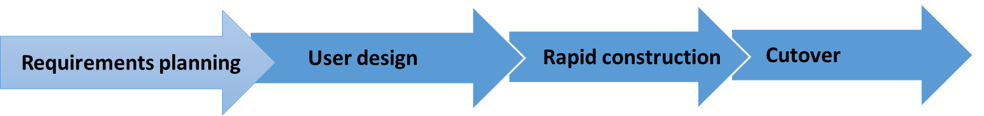
Diagram RAD process:

Building the website with Django:
According to the Author, Django is high-level python web framework that allows software engineers to develop clean, pragmatic design. The framework is built by experienced software engineers, so it lets developer focus on writing the website without needing to reinvent the wheel. Django would allow the developer to take application from concept to completion as quickly as possible. Django also focus on the security and helps software engineers to build well secure app.
The author of this paper stated that as he learned more about the popular framework, he was comparing it to PHP, the popular web programming tool. The author (Nick McCullum) used other WordPress sites in the past and WordPress is built by using PHP.
Here are the main differences between the Django framework and the major PHP framework:
- Django focuses on security and it has built in security practices to help programmers save time during development.
- When a programmer is using Django, she/he needs to know about python and MVC.
- With Django anything that software engineers want to do it, it must be done with code.
- Django requires technical knowledge.
Instagram uses Django for their backend according to the author and we know that Instagram has millions of users, if it good enough for Instagram, then it is certainly good enough for the project [11].

JavaScript – AJAX:
According to the author ajax is technology that allows developers to build web application to improve the performance and interactivity, it also makes the frontend responsive. Having experience with ajax, Ajax is software engineers dream, because it allows developers to read data from a database after the page is loaded, it can also update all the web content without reloading the page and it also allows programmes to send a request to the web server in the background.
The good thing about Ajax is that it has the advantage of using dynamic HTML, which consists of HTML, CSS and then the developer can use with JavaScript to glue together with the document object model.
The author stated it also uses mark-up language to encode data for transfer between server and browser or client application [12].
Django REST framework:
To create user friendly web application, had to create REST APIs. A REST API is standardized way to provide data to other applications. Once the developers create the API, the other applications can then use the data however they like.
The key options of a REST API requests are the following:
GET: It return data from the API based on the endpoint user visit.
POST: It adds new data to the database.
PUT: Allows you look for a data at the URL endpoint you provide. If that data that you were looking for is in the database, then it updates. if not, then it creates a new data.
DELETE: It delete a record from the database.
PATCH: It update data.
What API does is that it formats the data that is in the database and The API handles querying the database and formatting that data into static response, most of the times the format is JSON.
REST API allows the front end to talk to the backend without reloading the page and the way that it works is by writing a JavaScript code and the API allow the JavaScript code to consume information from the database.
The main reason to use Django REST framework in this project is because it is easy to write the serialization.
According to the author, Django ORM is like a librarian user can request the information they need, so it basically saves time for you, so the developers don’t have to worry about the business logic of the application and don’t have to worry about the low-level implementation details. Django ORM handles all that work for you [13].

React VS JavaScript
Now days creating web applications are becoming increasingly hard, because of the new tools and libraries like react have been created to speed up the process [14]. But the question is how is web app development with react different than developing an app with just plain JavaScript?

What is react?
React is an open-source front-end JavaScript library, it was created by Jordan walke in 2011 and that time Jordan walke was working for Facebook as a software engineer. React was first used on Facebook’s News Feed in 2011 as an early demo. In 2012 Instagram was created using React.js. React.js allows developers to create compose complex frontend from small and isolated pieces of code known as components.
React.js uses JSX is an XML-like syntax extension for JavaScript, so can basically write the HTML code in a JavaScript file and this is a great advantage because it’s easier to read the code [15].

What is JavaScript?
JavaScript is a text-based programming language, and it can be used on the front-end and server side. It makes the web pages interactive. Developers can use plain JavaScript to create applications without libraries and the language doesn’t set any rules about how data can be defined, how the fronted can be changed [14].
Summary:
React is very useful framework, because of its ability to break down the complex frontend and it also allows software engineers to work on individual components. By using plain JavaScript in the project, it will give you the same experience, this project will be using JavaScript to develop the website and the reason is that there isn’t enough time to learn react.
Summary of software tools used:
When it comes to building the backend, it was used a framework known as Django and in this report will outline the main features, including some of the advanced functionality that this framework offers. This report will cover the main building blocks of Django.
Django is a web framework that allows software developers to write rapid development of and maintainable websites and this framework is built by experienced developers.
Django can work with any client side and it also can work with any format such as HTML, JSON and XML. When it comes to security Django allows software developers avoid the common security mistakes.
Django uses a URL mapper, so it can redirect HTTP request to the right view based on the request URL and URL mapper allows the software developers to data through the URL such USERID, then it can pass the data to the view function.
The view file can handle the request, that was receives by the URL requests and then it sends the responses. Views file access the data that was requested by the user through models and then formatting the response to templates.
Django works with a file known as models and this model file has python objects that represent as data base tables.
The project has template folder that can be stored the HTML files and when user makes a request to a URL the view then can dynamically populate data using the model file.
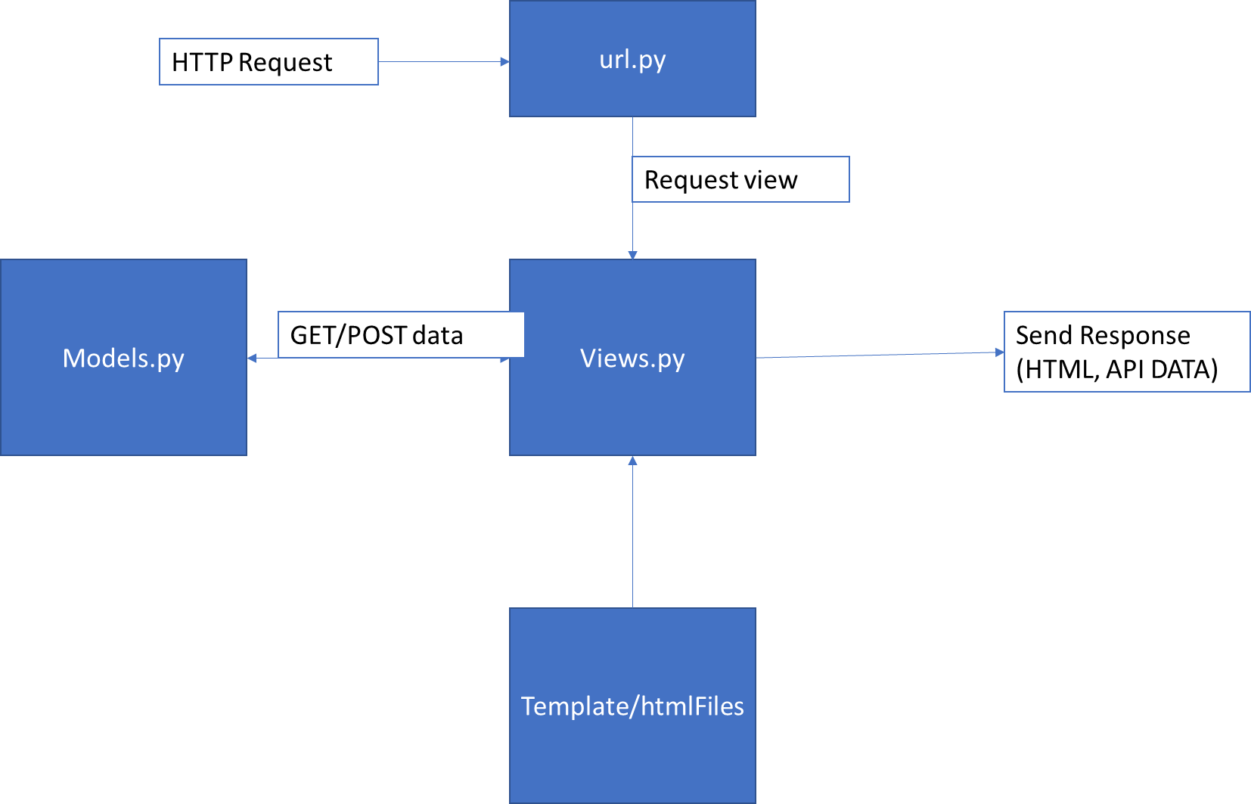

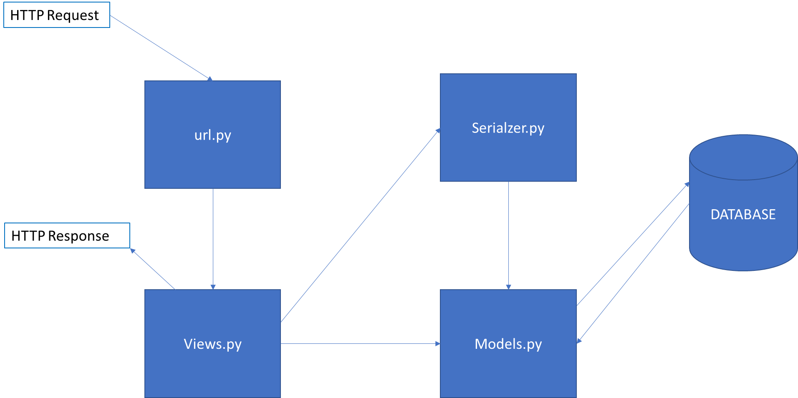
To make the application more responsive and user-friendly, it used a technology known as Django REST framework. REST framework allows developers to create API and it was used because the users can make a request without reloading the page for example if a user wants to comment a post, the user can leave a comment and then that comment will be saved in the database. REST framework can return JSON data and the way that it works is by writing model serializers, then the view will display data.

It was used a Hypertext Markup Language known as HTML and the HTML files was stored in the templates folder and when a user requests a page, a view function will send back response to the user.
To style the pages it was used a technology known as CSS, and CSS is a style sheet language used for describing the presentation of the HTML pages. CSS framework called bootstrap was used in this project.
It was used JavaScript so the data that comes from the API can be read/write without reloading the page.
To store data, it was used a free and open-source relation database management system known as PostgreSQL.

CHAPTER 4 - DESIGN & IMPLEMENTATION:
This section is the main part of the project, it describes the way that the application was designed and implemented.
Design:
When working on the design of this application, it was wireframed using paper and pen to just have an idea how the application interface would look like. After doing a prototype design for few pages of the application, then start designing the logo using a free platform called canva [16] and the logo is very simple it has very light blue, there is screenshot bellow. As you can see the logo doesn’t have a lot of colours and it was done in this way because we wanted to use the same colours in the application.
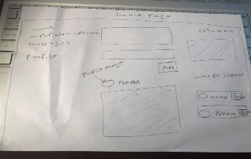
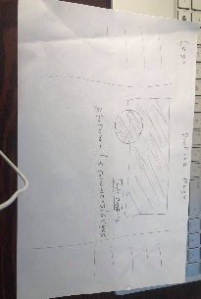

Here is early stage of the user-interface design
Logo

The design processes that were used in this project starts with sketch designing few pages, without using colours but because is just a sketch so we don’t want to spend a lot time something that might not be useful into the project. It was done this to see how the layout would look like on paper, before coding the website because it takes a lot time writing the HTML, CSS and don’t want to spend a lot time rewriting code that was already written.
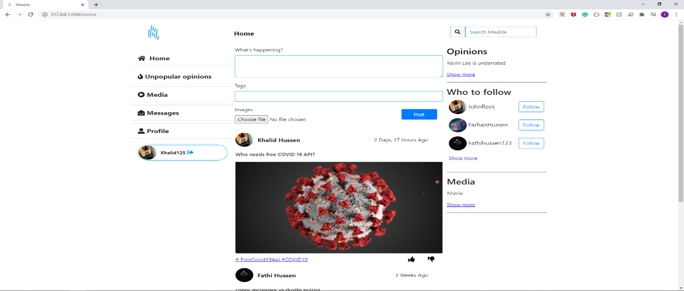
The website has three layouts, when a user accesses the application from a desktop it shows the user all three layouts. The left layout has all the navigation buttons that allows users to access other pages of the application, the middle layout renders out the posts, videos and opinions posted by users and the right layout as you can see the screenshot bellow it shows the user the all the other users, he/she can follow.
Designing is not just designing an attractive user-interface, the designer must think how the user-interface will look like on different screens such as desktop, tablet, and phone screen. So, the early stage of design it was chosen to put the content in meddle layout and that is the main layout. So, to make the application responsive when a user access the application through tablet or phone, the right layout and left layout is hidden using media queries. There is screenshot bellow, that show how the user-interface looks on different screen sizes.
When a user accesses the application from small screen(1024px).
When a user accesses the application from large screen(1440px).
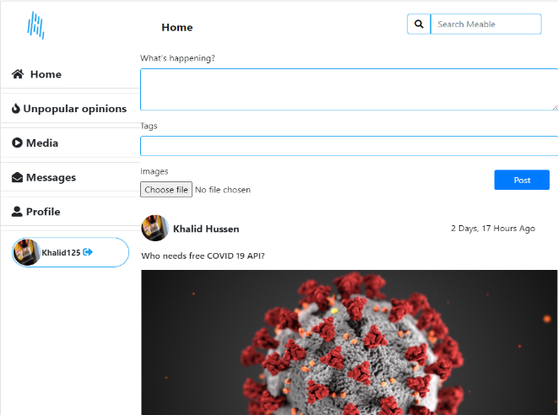
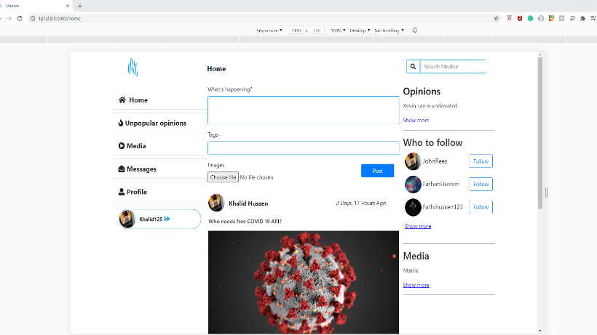

When a user accesses the application from tablet (768px). The navigation buttons there were moved to the bottom.
When a user accesses the application from phone (425px).

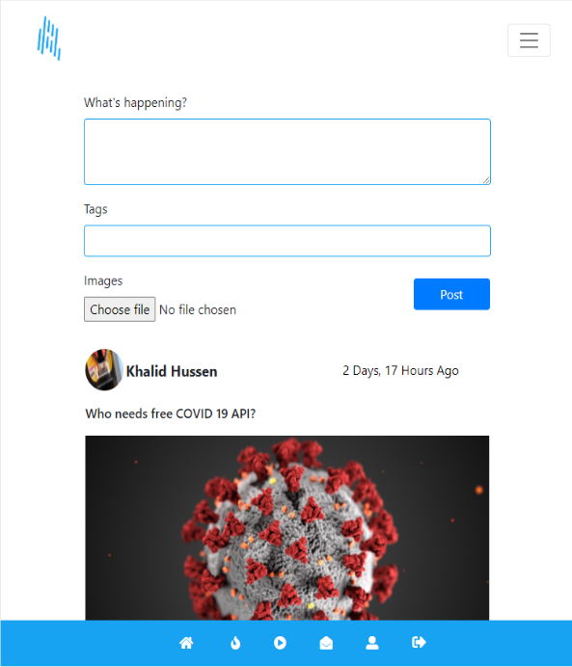
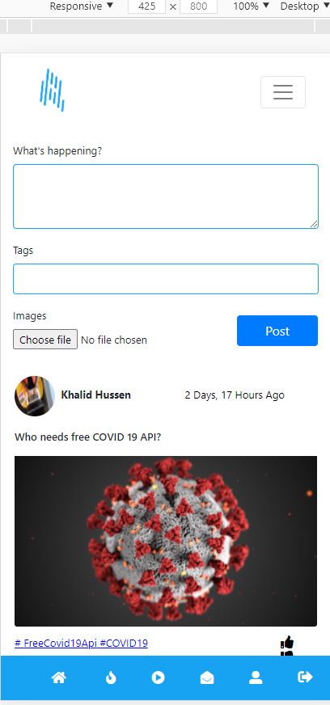

Implementation:
After designing the user-interface, the project needs it to be implemented. This section describes how the project was build, tools and techniques used. The difficulties that were faced during the development process and how those difficulties were overcome.
Functional Requirements:
Functional requirements are the application features or the highly-level statements that the system should have. These functional requirements are the developers’ job to implement to allow the users to accomplish their tasks and is very important that these functional requirements are clear because functional requirements describe the system behaviour under specific conditions [17].
This project has a lot requirements that was collected at beginning of the project and bellow there is the key requirements of the software system designed for users to use.
Number. | Requirements | User Role
1 | A user shall be able to sign up. | User only
2 | A user shall be able to login and log out of the system. | User only
3 | A user shall be able submit a post with image and text. | User only
4 | A user shall be able to dislike or like a post. | User only
5 | A user shall be able to follow other users. | User only
6 | A user shall be able submit an opinion. | User only
7 | A user shall be able to disagree or agree other opinions submitted by other users. | User only
8 | A user shall be able to message other users | User only
9 | A user shall be able to leave comments the posts that was posted by other users. | User only
10 | A user shall be able to see who goes on his/her profile page. | User only
11 | A user shall be able to submit a video. | User only
12 | A user shall be able to leave comments the videos that was posted by other users. | User only
13 | A user shall be able to click the heart icon to like a video. | User only
14 | A user shall be able to leave comments the videos that was posted by other users. | User only
15 | A user shall be able to delete / edit, comments, posts, opinions, and videos that belongs to the user that posted. | User only
16 | Users shall be able to use the search bar to search posts, opinions, and videos. | User only
17 | User shall be able to click a hashtag to see all posts/ opinions that has the specific hashtag. | User only
18 | The admin shall be able to access everything that was posted by all users and admin shall be able to edit/ delete. | Admin only

The requirements were discovered using a survey to collect requirements from users to understand what features they would like the system to have, some of them was added in process of the development in face-to-face interview with users.
System design diagrams:
A system diagrams is a visual model of a system which means it describes the way that the behaviours and interactions of the system [18].
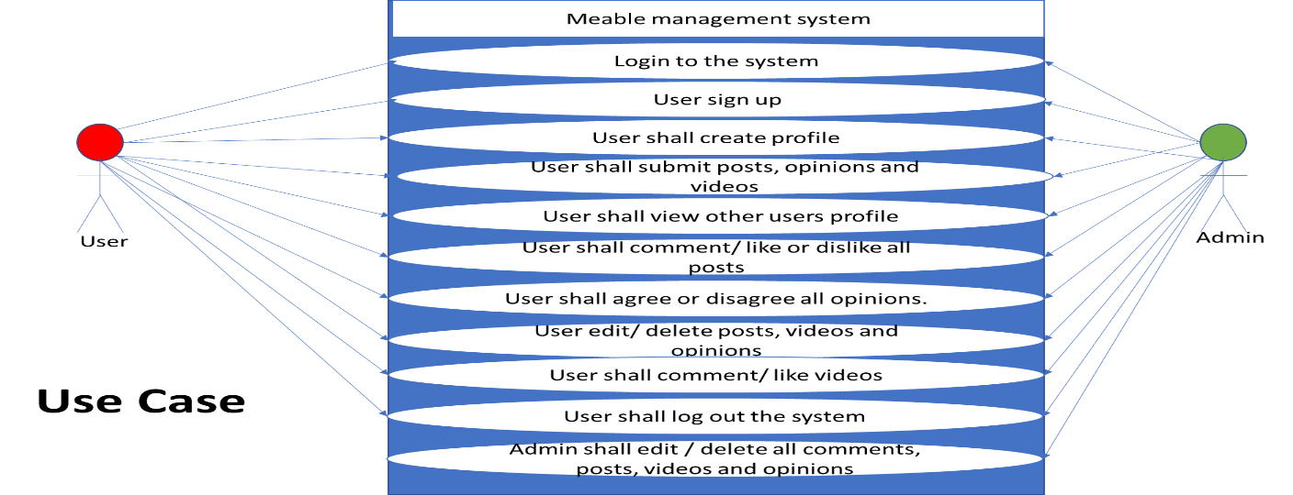
This system design diagrams don’t just tell how the system works but it also shows the way it works, software developers aware that a picture is worth thousand words and it can be very easily understand how the system works.
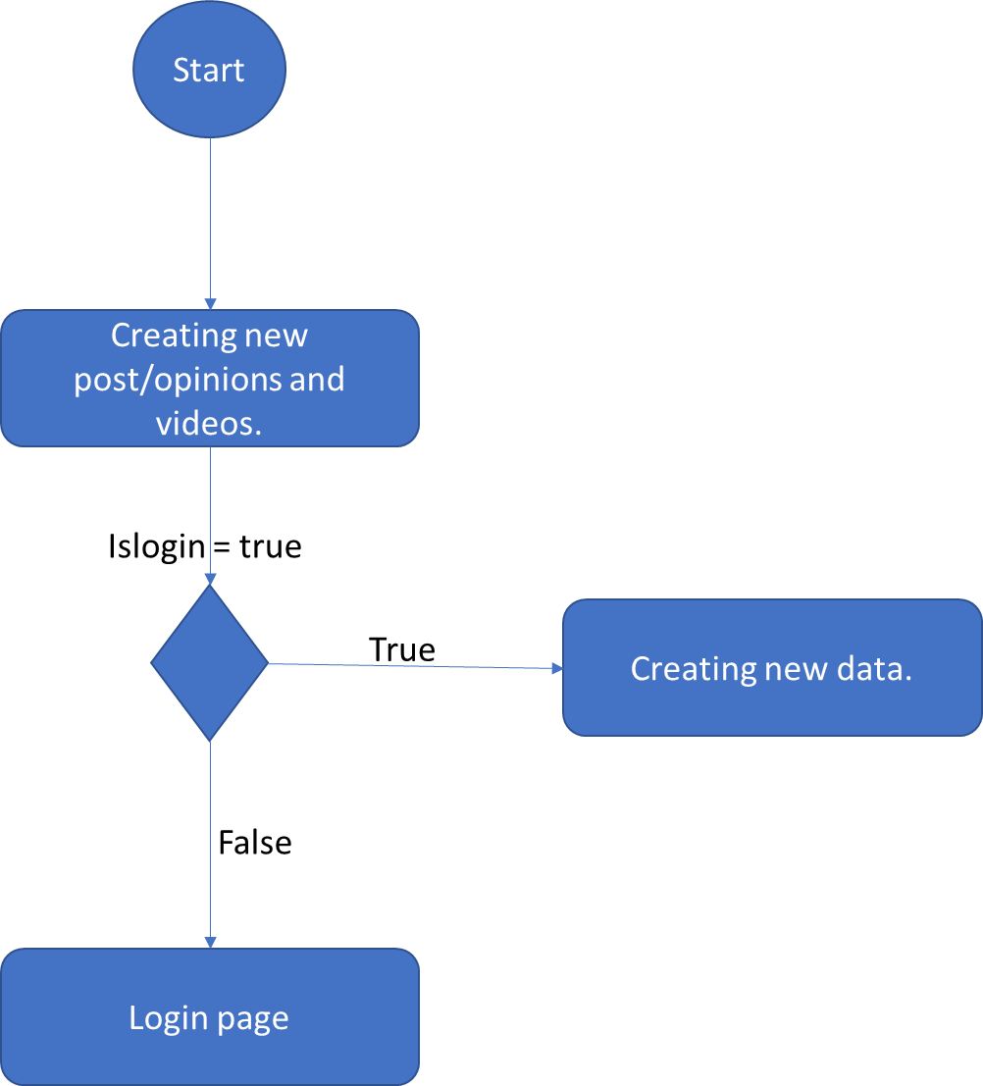
These flowchart diagrams show the use case behaviours of the system and the diagrams represent the flow of the system one activity to another activity for certain use case.
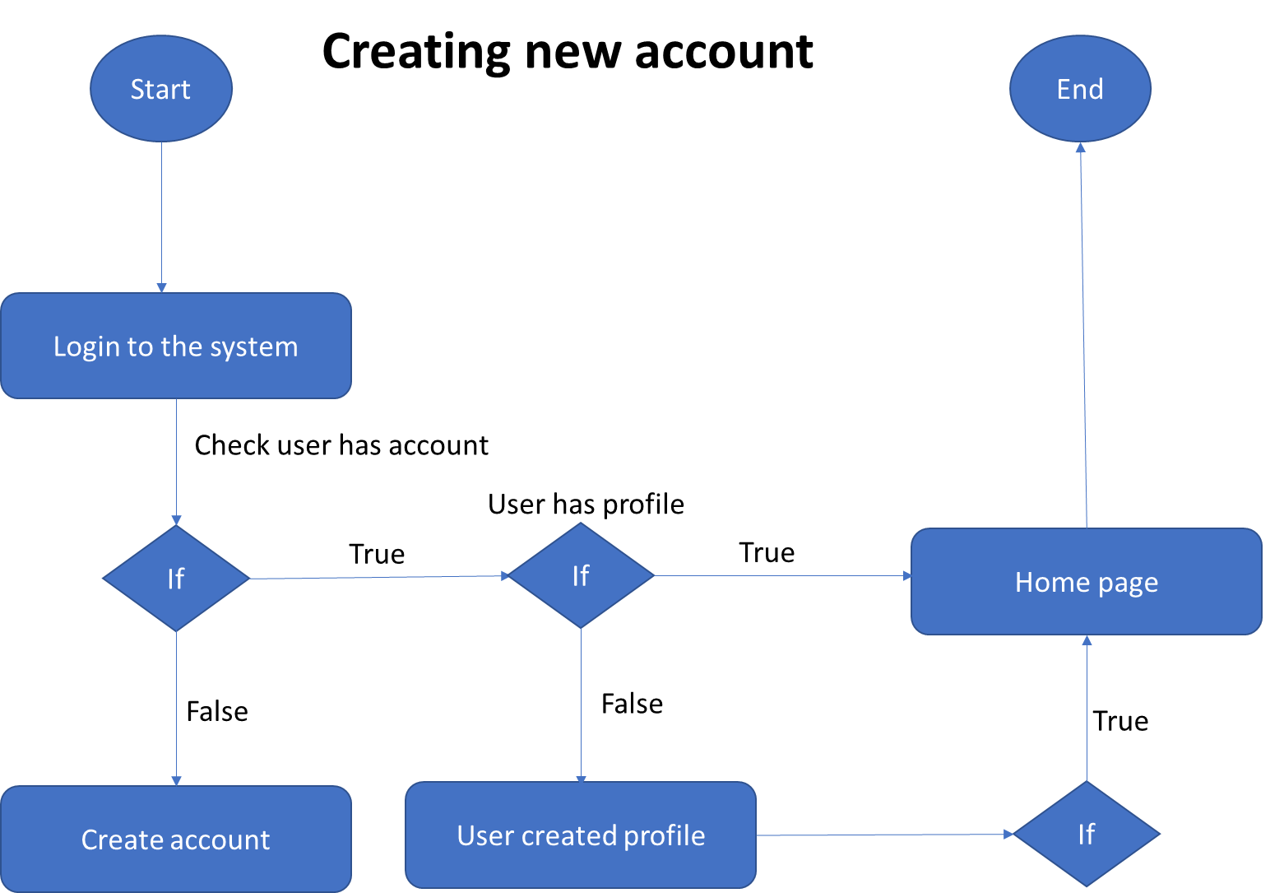

Prototypes Interface:
When a user goes to the application, the first thing he/she see is the login page and if the user has an account, he/she can login. If the user doesn’t have an account, then they can create new account.
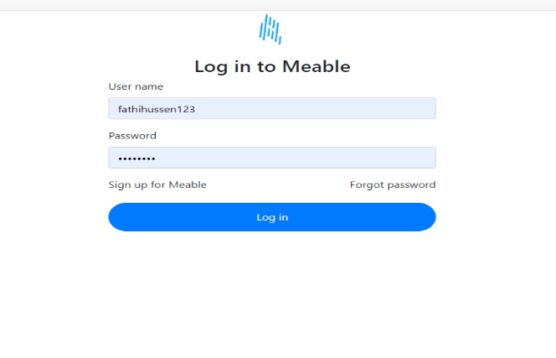
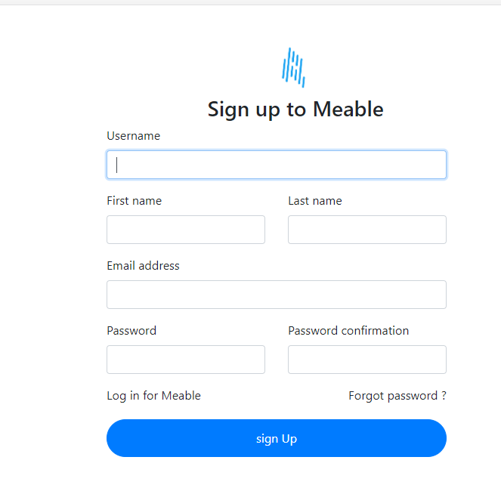

When the user creates new account, the system will take the user to the profile page allow them to create new profile and then redirect them to the home page.
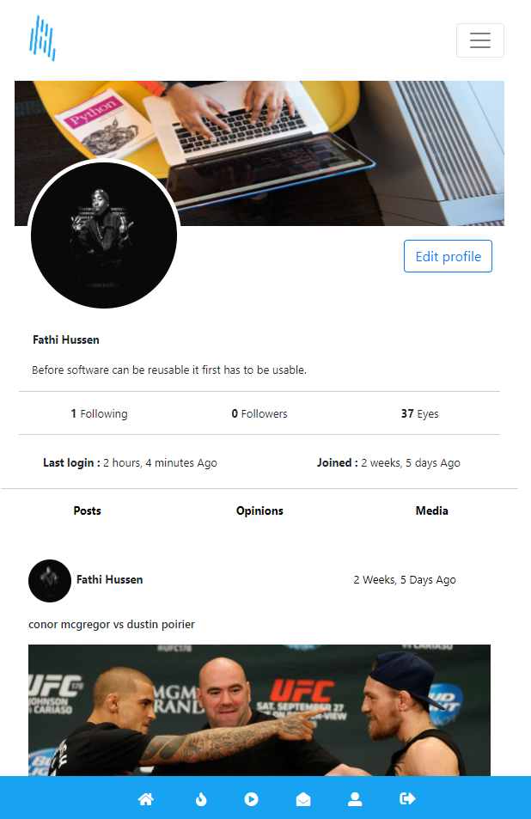

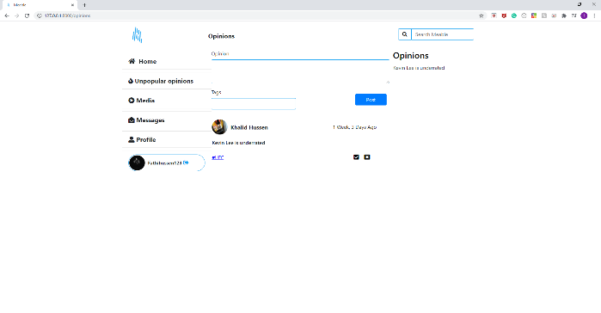
Home page allows users to create new posts and render out the old post that was created by other users she/he follows. The user can use this form to create new post and click post to save the data. It goes for the same to create new opinions and videos. If you look at the left screenshot, as you can see the users can like a post or dislike and users can also agree or disagree with an opinion from other users.
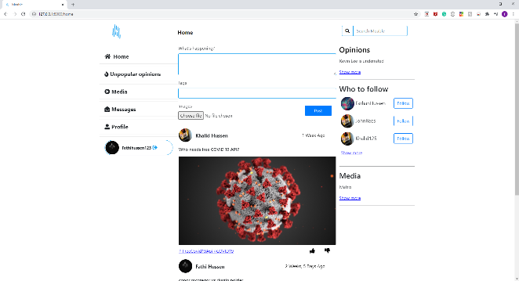
Users can click on the posts to leave a comment or to view the number of likes and dislike that post has and bellow there is screen shot.
Users can also click on an opinion created by other users to see how many people that agreed with her/him.
Users must click on the video they would like to play, then the application will allow the user to play the video and allow them to leave comments.
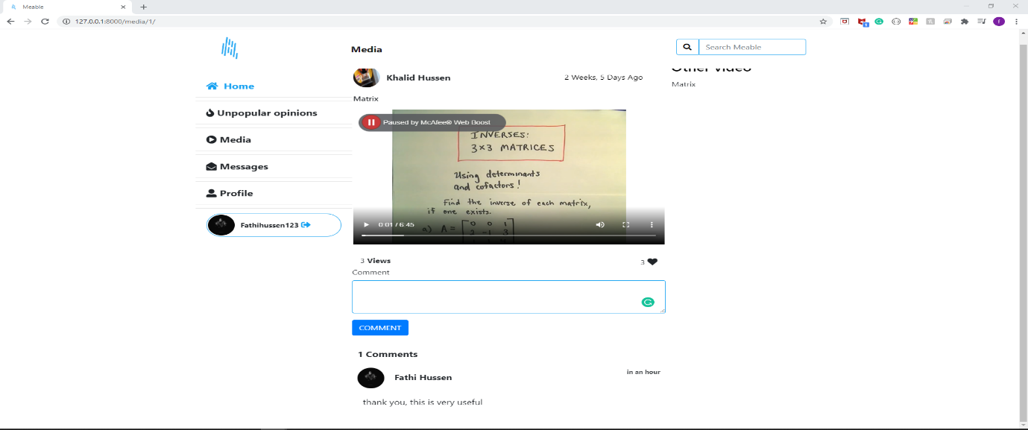
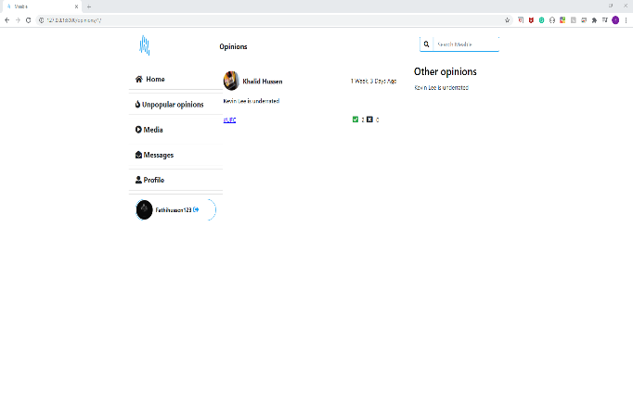
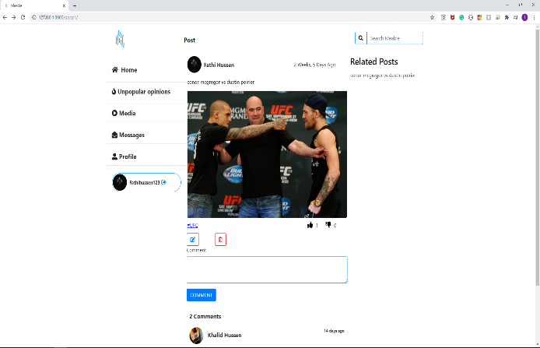
Non-functional Requirements:
Non-functional requirements are the system attributes such as security, reliability and including the response times. Found out that non-functional requirements make sure the usability and effeteness of the application [19].
The key Non-functional requirements of this social media application created for users to use, there are presented below.
Number | Requirements
1 | The user data such as user personal data, all the posts, videos, opinions, comments, and all other data as well as the admin details should be all stored in the database in secure way.
2 | Any data that the user is storing to database should be properly validated using Django form validators.
3 | When the user inputs on the login form shall be verified by checking if the user has an account in the database.
4 | When a new user creates an account, the password shall be properly hashed using Django hashing algorithm before saving the password to the database.
5 | When a user clicks on a video show the user how many views that video has
6 | Show the date that a data was saved into database.
7 | User shall view all the posts, videos and opinions posted by the users she/he follows.

Problems or successes while coding the software:
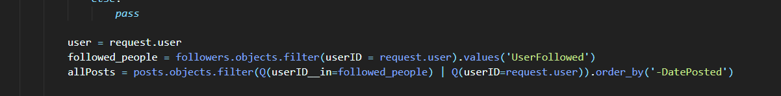
The early stage of building this application was having the problem of show the users the people they followed their posts and to do this have to make query to the database that is targeting the followers the table and post table. After reading the Django documentation and doing a lot of research, found the answer from a website known as stackoverflow. This issue now is fixed, users can view all posts from people they follow [20].

Users might like to submit their posts, opinions with hashtag and the application gives the users this feature. Users can even click on a hashtag to flitter out all the other posts and just target all the posts with specific hashtag. As you can see the screen shot below that function takes two arguments the first one is request and the second is tag (hashtag name). It then passes tag name in to post table targeting only the posts with that hashtag name.
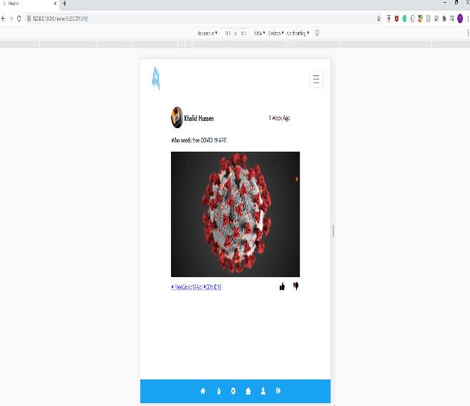
Look at the URL page, it was clicked (#COVID19) and it render out this post because this is the only post that has the tag name of (#COVID19).
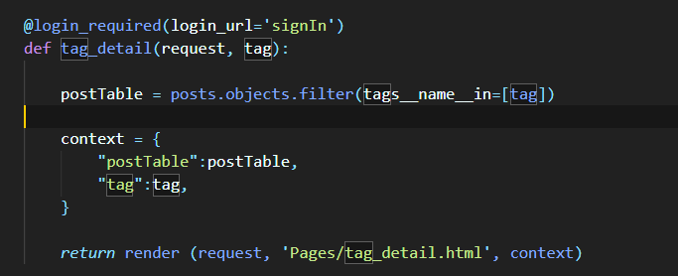
When a user likes a post, she/he can like that post once which means a user can like or dislike many posts, but one user can not like one post more than once. To allow users to like or dislike posts by clicking the buttons, it was used two different programming language. The first one that was used is python, it helped the developer to create the backend operations and it was also used JavaScript to handle the calls without reloading the page. The JavaScript code takes URL endpoint and when the user clicks on the like button the event listener is firing up to add the data to the database.
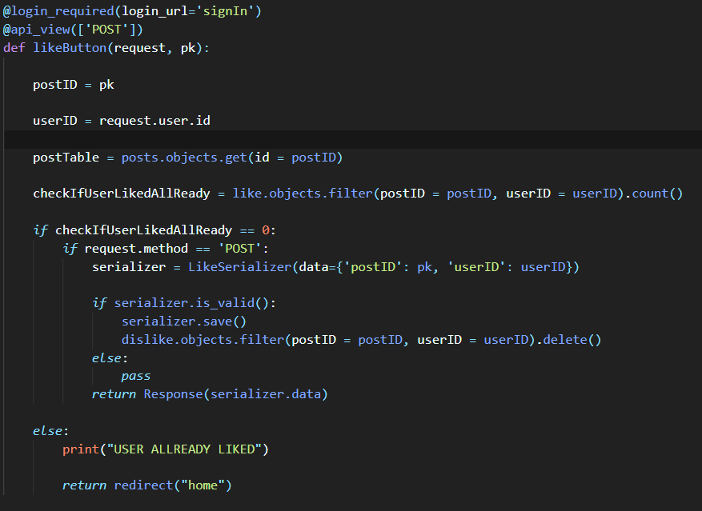
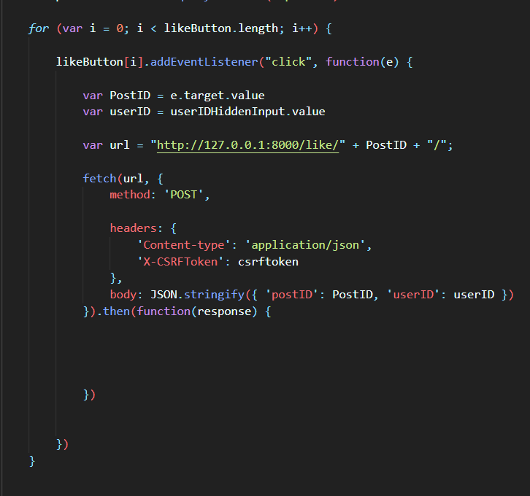

The aim of the project to build a responsive application using the findings of the literature review, found that to make the application responsive it was used different methods that allows the content and elements of the website to dynamically change so it can match the screen size without hiding the content of the website.
The application is responsive now because it was used the following methods:
- Flexible grid (bootstrap offers the flexible grid)
- Flexible images (bootstrap offers the flexible images)
- Media queries (the media queries were written from scratch)

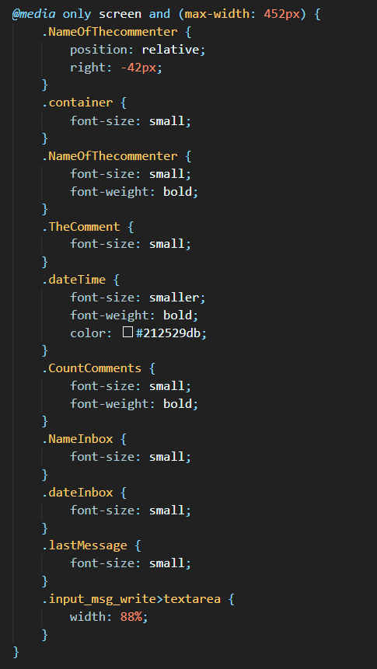

Unit testing:
Unit testing is the type of software testing where the developer tests an individual software component, and this is done to validate each unit of the software code performs as expected. Unit testing is done when the application is in the coding phase and is done to just verify its correctness. [21]
Number | Test description | Result (Pass / Fail)
1 | Posts have like and dislike button, when a user clicks on it a JavaScript function should store the user details and posts details. | pass
2 | The application allows users to comment post when user writes a comment. The user should click the comment button to save the comment. | pass
3 | When a user clicks on hashtag it should take the user all the posts, opinions that has that hashtag. | pass
4 | Users can access opinions that was posted by other users, and a user can agree or disagree with an opinion. When a user clicks on the agree or disagree button it should save the user details. | pass
5 | When a user clicks on a video, the application should save the user details on the view table to show other users the number of views that a video has. | pass
6 | The application allows users to click heart icon if the user likes the video, when a user clicks on it should save the user details and the video that the user liked. | pass
7 | Users can leave comments on videos, comments should be viewed by other users. | pass
8 | JavaScript function should render the inbox data from the database. | pass
9 | Messages between two users should be saved into the database. | pass
10 | A user should be able to view other users’ profile, and there is python function that renders all the data of that user. | pass
11 | JavaScript function should save the user details in the eyes table when a user goes to another user profile. | pass
12 | The follow/ unfollow button should allow users to follow and unfollow each other. | pass
13 | A JavaScript function should return the number of users following and the number of users followers user has. | pass

System testing:
In the project handbook it was asked to do system testing on the application that was build, so system testing is a level of testing that validates the complete and fully integrated the application. System testing is done because the system needs to be evaluated the end-to-end system [22].

No. | Functionality tested | Date of exec | Brief Description | Result (Pass / Fail)
1 | Allow users to register to the application | 01/04/2021 | Users should be able to register by entering their (username, firstName, lastName, email and password). | pass
2 | Login to the system | 01/04/2021 | Users should be able to login by entering their username and password. There is python function that checks if That username and password is in the database. | pass
3 | Allow users to post image with a text and hashtag | 01/04/2021 | Users should be able to use the form and click the post button to save the post. | pass
4 | Allow users to post opinions with a hashtag | 01/04/2021 | Users should be able to use the form and click the post button to save the opinion. | pass
5 | Allow users to post video with a text description | 01/04/2021 | Users should be able to use the form and click the post button to save the video. | pass
6 | Allows users to create and edit their bio, profile picture and cover photo. | 01/04/2021 | Users can use the profile form to create profile. If the user already has a profile, then the user can edit it and click save changes. | pass
7 | Log out of the system | 01/04/2021 | Users can log out by clicking the log out button, the system will log out the user and application will redirect the user to the login page. | pass

Usability testing:
Found that usability testing is a way to found out if the interface works by asking users to use the system to find out how will the system responds while actual users using. Using this method is very important in the project because it evaluates how easy the application is when users are using it. This method known as usability testing is used to make sure that the system doesn’t have any issues and if there is a bug in the system then that bug needs to be fixed before the project deadline. System testing can be done in different ways, but the way it was done in this project was allowing users to use the system and users will be testing a different range of services and functionalities of the application [23].
After when each user uses the system by completing different tasks, then each user will do the usability testing survey. The usability testing survey was conducted to 5 users, the questions that was completed by the users they were multiple-choice questions, and it was used a platform known as SurveyMonkey [24].
A link of usability testing survey will be in appendix of this report.
Here is are the questions that was completed by the users and they all listed below:
- I think that I would like to use this system frequently
- Strongly disagree
- Disagree
- Neutral
- Agree
- Strongly agree

- I found the system unnecessarily complex
- Strongly disagree
- Disagree
- Neutral
- Agree
- Strongly agree

- I thought the system was easy to use
- Strongly disagree
- Disagree
- Neutral
- Agree
- Strongly agree

- I think I would need the support of a technical person to be able to use this system
- Strongly disagree
- Disagree
- Neutral
- Agree
- Strongly agree

- I found very confident using the system
- Strongly disagree
- Disagree
- Neutral
- Agree
- Strongly agree

In this report will show the results below and the results was calculated and analysed by SurveyMonkey [24] using graphical representation. Will be going through all 5 questions, and their results.
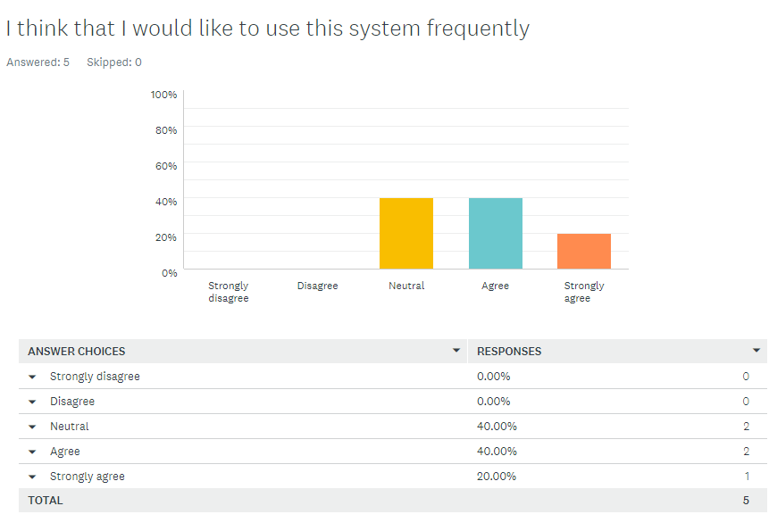
The first question is asking the users if they would like to use the system frequently and all 5 users answered this question. According to the result two users have chosen the option of neutral which means they might or might not use the system. There is other two users that have chosen the option of agree, and there is one user that have chosen the option of strongly agree.

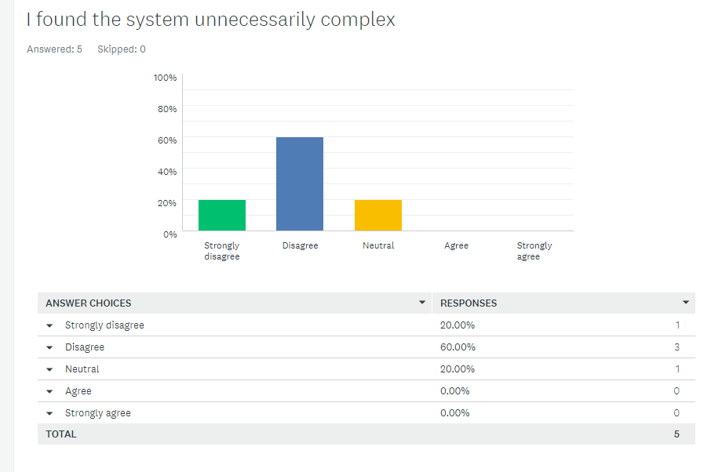
The second question is asking the users if they found the system unnecessarily complex and 5 users answered this question. According to the result one user have chosen the option of strongly agree, three users have chosen the option of disagree and one selected the option of neutral.

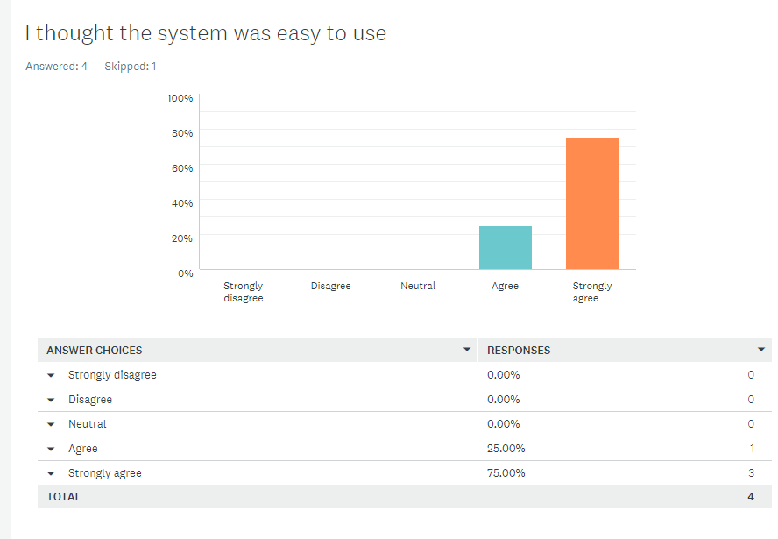
The third question is asking the users if they found the system easy to use, 4 users answered this question. According to the result one user have chosen the option of strongly agree.
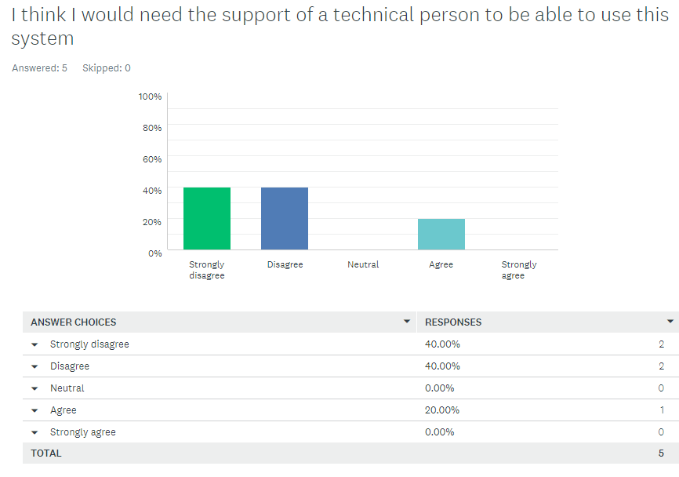
The fourth question is asking the users if they would need a support of a technical person to be able to use this system, 5 users answered this question. According to the result two users have chosen the option of strongly disagree, two other users have chosen the option of disagree and one user have chosen the option of agree.
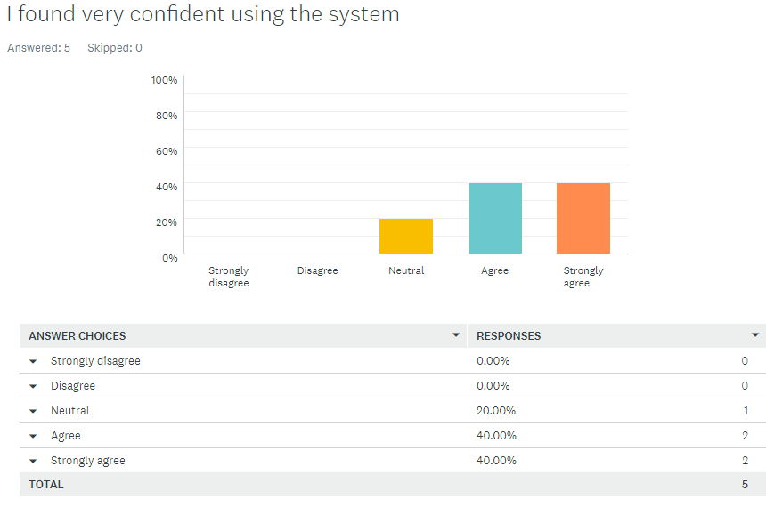
The fifth question is asking the users if they found very confident using the system, 5 users answered this question. According to the result one user have chosen the option of neutral, two other users have chosen the option of agree and two other users have chosen the option of strongly agree.
CHAPTER 4 – ANALYSIS:
In this chapter it was asked to analysis the survey that was done for the project, and each question in the survey is going to be analysed below. Will be going through the results, showing the results diagrammatically.
The survey has 10 questions in the form of questionnaire, was conducted to 5 users and some of the users are from the uwtsd some of them outside the university.
A link of the survey will be in appendix of this report.
The first question is asking the users what their names are, 5 users answered this question by entering their names and below there is the list of names.
- Matthew
- Amy
- Ross
- Kaylie
- Abdi Rahman

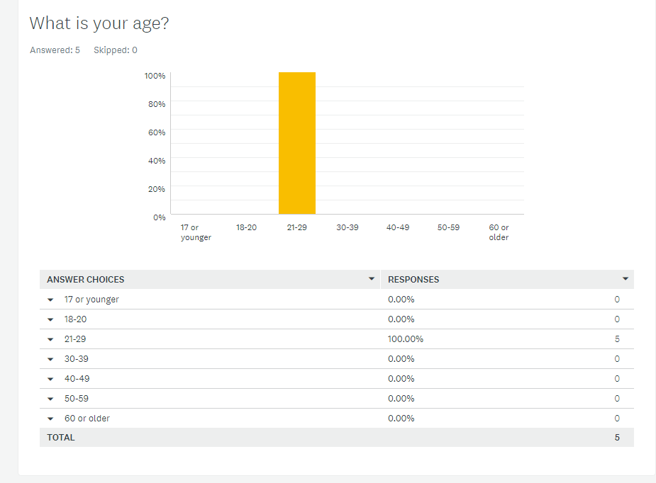
The second question is asking what their age range is, all the users their age range is between 21-29 and this is what were expected because in general, you should be 18 to enter university.
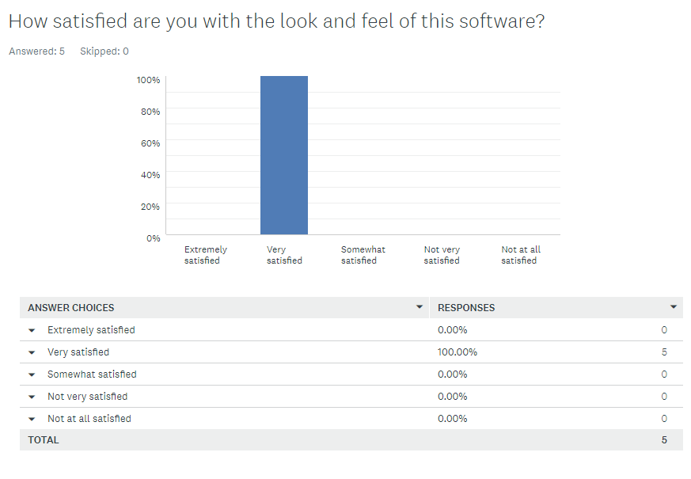
The third question is asking how satisfied they are with the look and feel of the software, 5 users answered this question, and all five users are satisfied with the look and feel of the software. This result was expected because it was used the findings of designing responsive website from literature review.
The fourth question is asking if the software was easy to use, five users answered this question, and they all think that the software was easy when they were using.
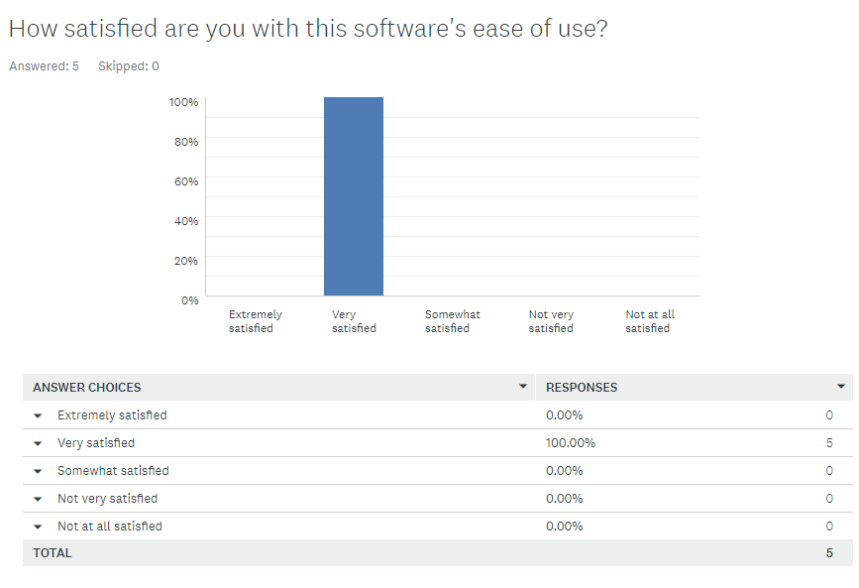
According to findings of designing responsive website from literature review, it stated that visitors to web-based email sites declined 6%, where the number of the users were accessing their emails through mobile phone and the use of mobile phone has increased to 36%. To create software that targets users who access websites through mobile applications, it was needed to find out the number of users that use mobile phones. The question that was asked the users was how they access social media platforms and options were the following.
- Smartphone
- Tablet
- PC
All the five users said that they access their social media through mobile phone and this result was expected as said before it was in the findings of designing responsive website from literature review.
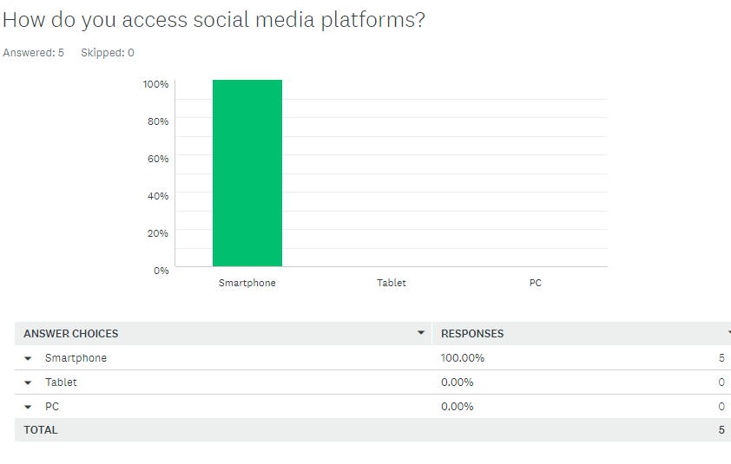

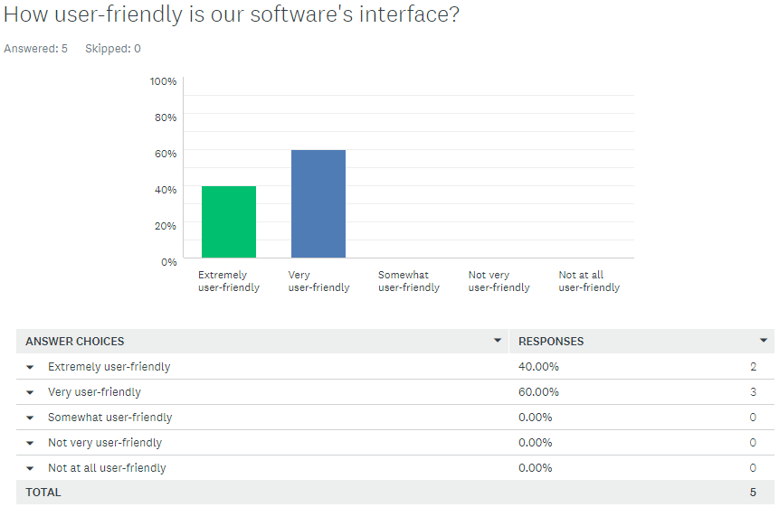
The sixth question is asking users how user-friendly the software interface is, 5 users answered this question. According to the results 2 users stated that the software interface is extremely user-friendly, and three more users stated that that the software interface is very user-friendly. This result was expected because a lot time was spent designing the interface.
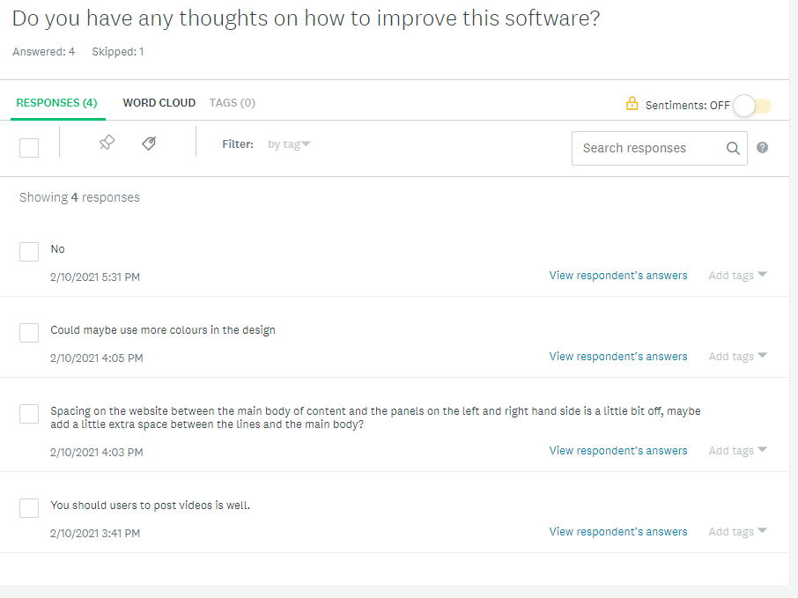
The seventh question is asking users if they have any thoughts on how to improve this software, 4 users answered this question. Below there is a screenshot showing all the responses from users. As you can see one user requested that we should allows users to upload videos, and after receiving this response it was added this feature that allows users to upload videos to the system.
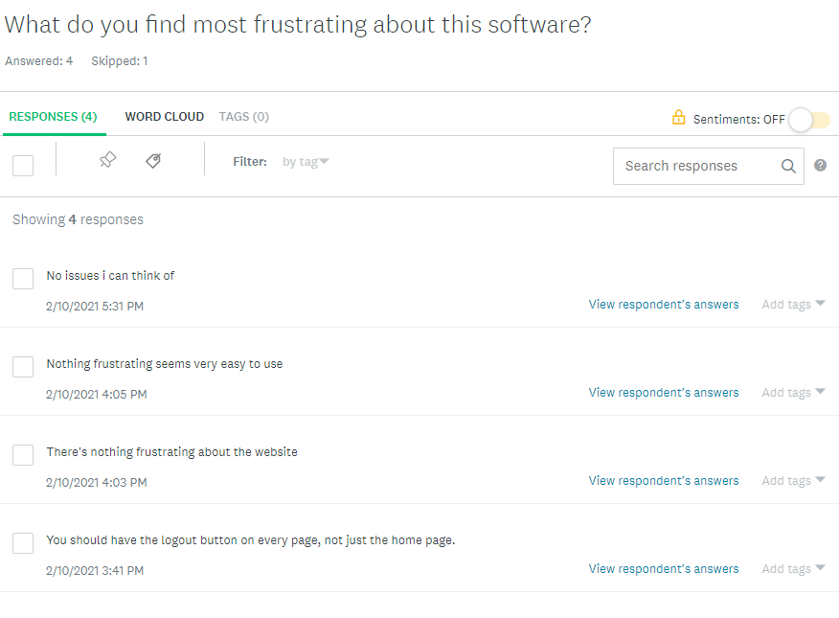
The eighth question is asking users what they found most frustrating about the software, 4 users answered this question. According to the results 3 users stated that there is nothing frustrating about the software, but one stated the application should have log out button on every page and now it was added log out button on every page.
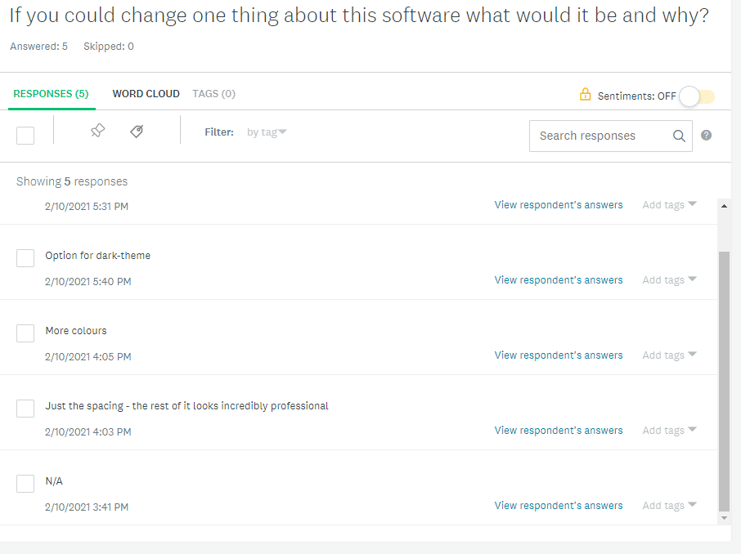
The ninth question is asking users if they could change one thing about the software what it would be and why, 5 users answered this question. As you can see users would like the application to have more colours.
The last question is asking users what other products they use to accomplish similar tasks and why, 5 users answered this question. Below you can find the results.
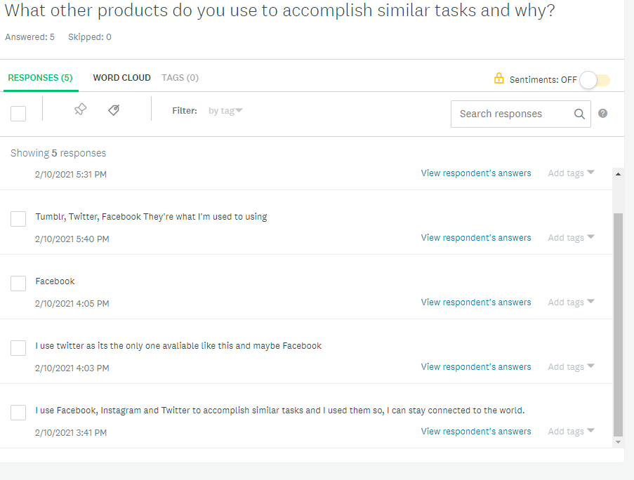

CHAPTER 5 – EVALUATION:
This is the evaluation chapter where you compare the application that was build to other social media platforms. The application that was build for this project has many features just like Twitter, so will go through the list of the features that Meable(the name of application that was built for this project) offers and will also talk about the list features that Twitter offers.
This application that has been build for the final year project is web-based application and is social media application that allows users to sign up to use the application. This application was created to allow users to stay connected with each other.
Twitter is as American microblogging and social networking which allows users to post, and users can stay connected using messages as “tweets”.
Meable offers a feature known as hashtag flitter which means you can click on a hashtag ad the system will render posts/opinions with that hashtag name.
Twitter also offers this feature, and they allow users to click on hashtag, their system will show users tweets that have the specific tag name. This was the feature that the users acknowledged as one of the most useful features and they thought that it was hard to implement.
Meable allows users to follow/unfollow each other just like Twitter, users can view the number following and followers user has by going to the profile page.
No. | Objectives | Met
1 | To learn JavaScript, it would take around 30 hours to learn, using the JavaScript books and other online sources. | y
2 | Using Canva (Canva is a graphic design platform that allows users to create social media graphics, presentations, posters, documents, and other visual content.) to design the logo. | y
3 | To using Django for the backend is a good choice because the framework is maintained. Django provides tools and documentation to prevent common mistakes that is causing security problems. | y
4 | Allowing the companies and users to view the data without showing personal data of the user to the company and following General Data Protection Regulation (GDPR) | y
5 | To build a secure software is very important goal, and the goal is to implement encryption, hashing, load balancing and monitoring, password token, logging, configuration. | y
6 | To create an Interactive website where Members of the Public would Post Insights, Opinions, Needs and Preferences. | y

The main aim of this project is to develop the ability to learn new technologies and different ways of writing a software using technologies like JavaScript and ajax to read data from a web server. The main aim is to design a frontend that is easy for the users to use and the design must be responsive to desktops, laptops, tablets, and mobile phones. These aims were met, because when it comes to the website. The website is responsive which means you can access the application from any device.
If were to do this project again, would use react.js for the frontend instead of using JavaScript to talk to the server and redesign the logo to something that has meaning or using the name of the application (Meable) as logo.

CHAPTER 6 - CONCLUSIONS AND RECOMMENDATIONS:
This social media website is very interactive website where users would post insights, opinions, videos, and this application offers similar features just like Twitter. The application offers many features that the other social media platforms don’t offer.
The project had an aim which is allowing users to access the application from different devices and each device has its own screen size. To achieve this aim research needed to be done to build a responsive website and it was found that using responsive design is a method that allows the content and elements of the website to dynamically change so it can match the screen size without hiding the content of the website.
In this project qualitative research was done which involved a conduct of a survey in the form of questionnaire to five users. After when users done the survey then the results were analysed by a platform call SurveyMonkey [24] and the important requirements were identified.
When the project implementation was done, then usability testing was done by users to find out if the system has any bugs. The same users who did the first survey which was done at early stage of the project to gather requirements also did the second survey which is the usability testing. The results that were received during usability testing were very positive because users used the system during the usability testing, and it was helpful feedback.
Writing software is never complete, and the process of development is never finished because very day new technologies are coming out. A JavaScript framework known as react.js was first option when it come building the frontend, but doing a lot of research, it wasn’t a good idea to use this library instead it was used plain JavaScript. Due to the unavailability of resources, and limited timescale for the project.

CHAPTER 7 – REFLECTION:
I am very passionate about building software that could be used by millions of people and particularly interested in the development of building dynamic websites using backend programming languages, building dynamic mobile application, and learning new frameworks. My whole academic years, I was trying to learn new programming languages and frameworks that could help me in the process of building software. When it come to building a software for my final year project, I already had a lot of technical knowledge when it comes writing coding for my project. During this project I realised that you don’t have reinvent the wheel which means you don’t have waste a great deal of time writing a code that was already written because everything you want to do there is a library or framework out there for you to use it.
The main aim of this project was to prepare me for tasks that may encounter in the workplace when I graduate. During this project taught me how to write a technical report that is well organised according to professional standards and it taught me that how to gather information that is useful and how to use the information you gathered from research.

References

[1] | D. H. a. A. N. H. Devita Mira Lestari, "Analysis of User Experience Quality on Responsive Web Design from," 2014. [Online]. Available: http://citeseerx.ist.psu.edu/viewdoc/download?doi=10.1.1.445.9288&rep=rep1&type=pdf. [Accessed 9 Dec 2020].
[2] | J. Roosevelt C. Mosley, "courses.isds.tugraz.a," 06 Dec 2011. [Online]. Available: https://courses.isds.tugraz.at/iaweb/surveys/ws2011/g3-survey-resp-web-design.pdf. [Accessed 10 Dec 2020].
[3] | D. E. W. H. S. T. T. S. A. R. G. M. R. P. K. M. N. T. A. K. Mark Curphey, "A Guide to Building Secure Web Applications," [Online]. Available: https://www.radford.edu/jcdavis/classes/it325/lecturematl/security/OWASPGuideV1.1.1.pdf. [Accessed 05 Jan 2021].
[4] | owasp.org, "owasp.org," [Online]. Available: https://owasp.org/www-project-web-security-testing-guide/assets/archive/OWASP_Testing_Guide_v4.pdf. [Accessed 6 Jan 2021].
[5] | finance.uw.edu, "Web Project Process," [Online]. Available: https://finance.uw.edu/c2/sites/default/files/C2_Web_process.pdf. [Accessed 10 Jan 2021].
[6] | ctinetworks, [Online]. Available: http://www.ctinetworks.com/documents/cti-creative-website-process.pdf. [Accessed 11 Jan 2021].
[7] | scribbr, "An introduction to qualitative research," 19 June 2020. [Online]. Available: https://www.scribbr.com/methodology/qualitative-research/#:~:text=Qualitative%20research%20involves%20collecting%20and,generate%20new%20ideas%20for%20research.. [Accessed 20 Jan 2021].
[8] | lucidchart, "lucidchart," [Online]. Available: https://www.lucidchart.com/blog/rapid-application-development-methodology. [Accessed 25 Jan 2021].
[9] | kissflow, "13 RAD Benefits, Including the Ones You Haven’t Thought Of," 31 Oct 2018. [Online]. Available: https://kissflow.com/rad/benefits-of-rapid-application-development/. [Accessed 25 Jan 2021].
[10] | guru99, "What is RAD Model? Phases, Advantages and Disadvantages," [Online]. Available: https://www.guru99.com/what-is-rad-rapid-software-development-model-advantages-disadvantages.html. [Accessed 25 Jan 2021].
[11] | N. McCullum, "freecodecamp," 13 MAY 2020. [Online]. Available: https://www.freecodecamp.org/news/i-built-a-members-area-on-my-website-with-python-and-django-heres-what-i-learned/. [Accessed 25 Jan 2021].
[12] | L. Paulson, "ieeexplore," 10 Oct 2005. [Online]. Available: https://ieeexplore.ieee.org/abstract/document/1516047/authors#authors. [Accessed 5 Feb 2021].
[13] | B. Garner, "medium," 17 May 2019. [Online]. Available: https://medium.com/swlh/build-your-first-rest-api-with-django-rest-framework-e394e39a482c. [Accessed 1 Feb 2021].
[14] | C. Achard, "framer," [Online]. Available: https://www.framer.com/blog/posts/react-vs-vanilla-js/. [Accessed 1 Feb 2021].
[15] | W. Leung, "medium," 22 Oct 2020. [Online]. Available: https://medium.com/weekly-webtips/react-basics-whats-the-difference-between-javascript-and-jsx-604dd224b1cf. [Accessed 1 Feb 2021].
[16] | canva, [Online]. Available: https://www.canva.com/en_gb/. [Accessed 2 Feb 2021].
[17] | 29 May 2018. [Online]. Available: https://www.altexsoft.com/blog/business/functional-and-non-functional-requirements-specification-and-types/#:~:text=Functional%20requirements%20are%20product%20features,system%20behavior%20under%20specific%20conditions. . [Accessed 10 Feb 2021].
[18] | deseng, [Online]. Available: https://deseng.ryerson.ca/dokuwiki/design:system_diagram. [Accessed 10 Feb 2021].
[19] | scaledagileframework, 10 Feb 2021. [Online]. Available: https://www.scaledagileframework.com/nonfunctional-requirements/#:~:text=Nonfunctional%20Requirements%20(NFRs)%20define%20system,system%20across%20the%20different%20backlogs.&text=They%20ensure%20the%20usability%20and%20effectiveness%20of%20the%20entire%2. [Accessed 20 Feb 2021].
[20] | [Online]. Available: https://stackoverflow.com/questions/53803106/django-query-how-to-find-all-posts-from-people-you-follow. [Accessed 25 Feb 2021].
[21] | [Online]. Available: https://www.guru99.com/unit-testing-guide.html . [Accessed 25 Feb 2021].
[22] | guru99, [Online]. Available: https://www.guru99.com/system-testing.html#:~:text=SYSTEM%20TESTING%20is%20a%20level,a%20larger%20computer%2Dbased%20system.. [Accessed 25 Feb 2021].
[23] | [Online]. Available: https://www.experienceux.co.uk/faqs/what-is-usability-testing/. [Accessed 20 Mar 2021].
[24] | surveymonkey, [Online]. Available: https://www.surveymonkey.co.uk/welcome/sem/?program=7013A000000mweBQAQ&utm_bu=CR&utm_campaign=71700000059189067&utm_adgroup=58700005405718088&utm_content=43700049188975073&utm_medium=cpc&utm_source=adwords&utm_term=p49188975073&utm_kxconfid=s4bvpi0ju&lang. [Accessed 20 Mar 2021].
[25] | A. TWIN, "investopedia," 20 Sep 2020. [Online]. Available: https://www.investopedia.com/terms/d/datamining.asp#:~:text=Data%20mining%20is%20a%20process,increase%20sales%20and%20decrease%20costs. [Accessed 15 Oct 2020].
[26] | S. McLeod, "simplypsychology," 2019. [Online]. Available: https://www.simplypsychology.org/qualitative-quantitative.html. [Accessed 20 Oct 2020].
[27] | [Online].

DEMONSTRATION DEMO:
YouTube link: https://www.youtube.com/watch?v=y9MoY57_BCQ
APPENDICES:
APPENDICES – 1: Questionnaire for the final year project:
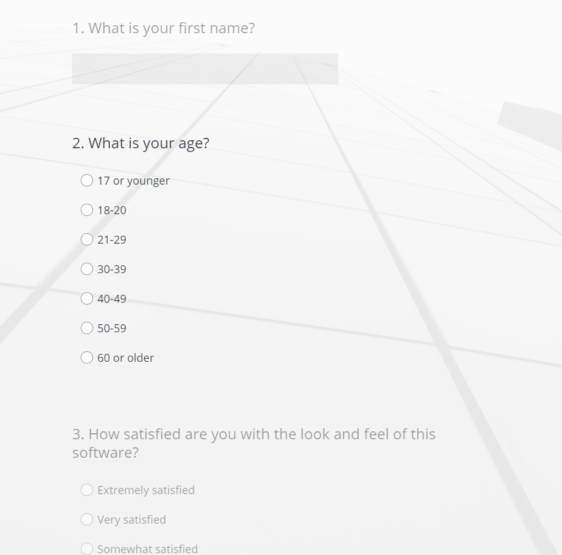

Link: https://www.surveymonkey.co.uk/r/DDLN8SJ

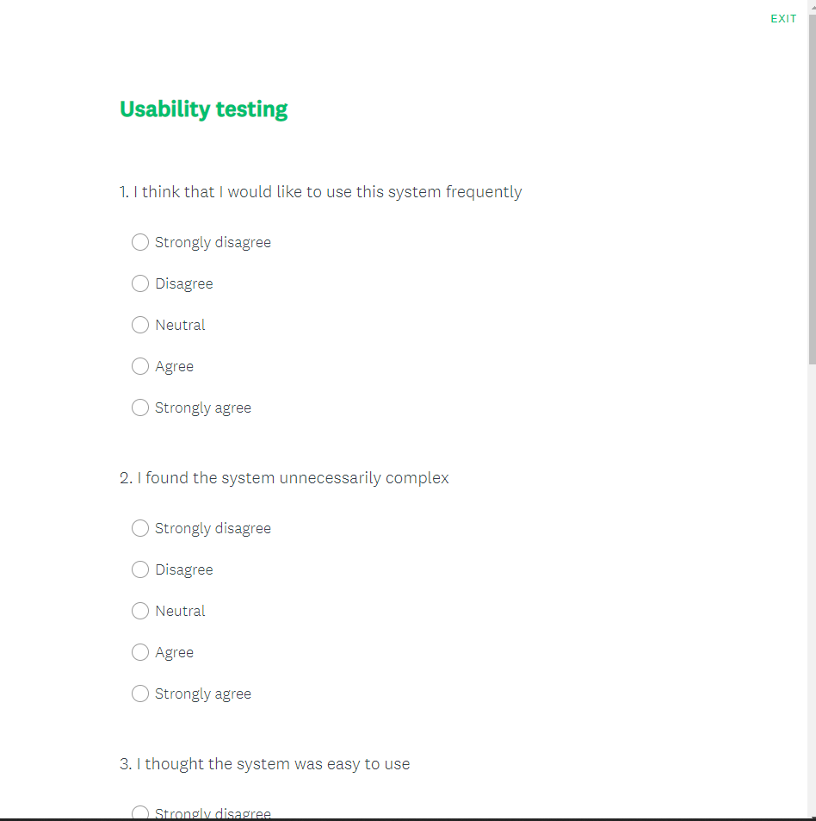
APPENDICES – 2: Usability testing:

Link: https://www.surveymonkey.co.uk/r/MBLTT7L

APPENDICES – 3: Gantt chart


