

MARIN ZAHARIDOV

08.05.2020

School Management

  - SYSTEM

School System  - Subtitle  CONTENT |  | Module Code – ACCC5004  WEB DEVELOPMENT
01  Introduction  02  Research  03  Test  04 Evaluation  05 References  06 Appendix  07 Conclusion | Introduction  We need to create a website that support dynamic content by using a programing skills and languages.  The website it is a student system that provide to the students option to sign for course or different modules, to be graded for the course when it is completed. Every module has a teacher.  By using a database all the information about the student and there grades must be recorded to be shown latter if needed or stored. Everyone can have a option to search for courses or a information about different modules.  .
Research:
Php frameworks – system of packages that gives you around your code structure to have a better functionality for your website. The way to create applications by standard.
All the functions that you use you can use it again. When you need data you just call that function.
Frameworks can simple the web creating process.
For example the site that create :
- You start from creating <!DOCTYPE html >
- For every new page or subpages you have to use the same form and the same HTML form
- By using the frameworks you save a lot time
- Do not have to worry for start up file and the loading files.
- Add new features.
With the framework you can use different new patterns, attached with extra resources. By using php frameworks I can extend my website structure.
There is some differences between frameworks and libraries. The libraries like the frameworks can be used as many times you want and when you need it .They have good defined API (application programing interface).In the libraries you can have a full control of the patterns in contrast the framework is made to follow specific pattern to make the process easy.

Most of developers use for there projects a different frameworks. Lets say that in a matter of fact when you need a “library” you have to requested, but if you need a framework then she will make automatic request. The framework is simple but less flexible. You can use wen you creating a web applications. If you want to create a phone applications it will be more useful to connect with libraries.
The MVC is for Model View Controller.
- Database management
- Routing
- Authentication
- Authorisatio

HOW I START ?
First I need to install XAMPP Server. For Actions I need to start the service for Apache and MySQL. After that I create a database for my web system. My webpage is simple it has a home page. On the home page I have information about the courses and news from latest schools and education systems. Other page is for courses itself and different modules. All new students can enroll for a module that they desire. Also I have a page with the grades of students that pass there modules.

All the information is in the database. For every html file I need to design the style by using style sheet with the same file name. In this file you can change the colors, backgrounds, add background style, font-size and other options.

To create the html file and to loaded as a web page I need to use a code editor program. (Media, 2016)
There is a lot options about these editors. Now I start with some tags. Declare the type and the html tag <html>.
The content is separated by 2 sections : the “<head></head>” and the “<body></body>” . So in the head tag there is the information about the site, information about the style file. Body tag is the main tag. More often used tags are ‘name tags and meta’. Important for the page is the title. In the body I used couple of <h1> for a title and <h2> for subtitles. Also I used some paragraphs <p>. The HTML allows only one space in every sentence. With the <br> we separate the info on new row. When I use <b></b> I choose my text to be bold. The <i> stands for italic style.
The links tag are to go between the pages or browse. I need to use a href value for every link that I use. I add some images by using <img src=”location of the file”/100x150>. By using the border I make border line in the information that I have and for some buttons also. List of all information by <li> tag.

The css gives the style for the whole page. On the top of the page I start like a said with main title ,which in my css file it will be the header. After that I have a content separate by two tags: #nav and #main and the bottom is the #footer tag. If I want to gain more flexibility for my website I have to use separate ‘css files’.For every tag in use in the main html file I use {}. By different commands I choose the background colors , size , borders , text-decoration. (CSS Work, 1999 ) For most of the tags its important to set the margin and the paddings. (contributors, 2020)
The rest of the pages is similar on the main page ,so in this case I change the information provided in the main html home page. When everything is done ,and I have all the style commands ready, I can connect with the database. In my web pages I use redirecting to another page. Important part of the web project in html are :
- <div></div>
- <article></article>
- <aside></aside>
- <section></section>
In many forms the division names can be the same. All semantic tags can be modified, updated and changed in different ways.
To create a form the tag is <form method=”post”>….</form>.
When the content of the page is done, I create some headings.
In my project I used some anchor tags. (HTML Tutorial, 2020)
<a href=”index.html”>Title</a>
Anchor tag can be used to link the different pages or it can be url source from another web content.
It is important to have in the web page a ‘image’ or ‘video’. To ensure that the image file will be loaded I have to put all the images in one folder an to show the image source location. (Dracup, 2016)
For example: <img src=”../pictures/newimage.jpg” alt=”information about he image ” height= “” width=””>.
In the html form I can create tables. For each table you can create different numbers of columns and rows.
The tables tags part from any table:
- <thead> : the head of the table and is located on the top;
- <tbody>: body of the table -main content;
- <tfoot>: foot of the table and the location is on the bottom;
- <th>: header for any table – data;
Example:
“ <table> <tr> <td>Row 1 - Column 1</td> <td>Row 1 - Column 2 </td> </tr> <tr> <td>Row 2 - Column 1</td> <td>Row 2 - Column 2</td> </tr> </table>” (HTML.com, 2017)

When all pages and login form is created I need login validation.
“In the body of the login page we create a labels for the ‘username’ and ‘password’. In script file I have to add some validations about the username and the password” (Dev, 2019).
All the files forms(html, php, styles, images ) have to be in one folder which it has to be copied in XAMPP folder. XAMMP by default is running on localhost. In phpMyAdmin you can set up a password. Create a new database and after create tables where I choose the number of columns. Every table start with the ID where is automatically signed as a primary key. When you make the relationships for the tables, next step is to set the foreign key. For every data you insert I have to choose the data type.

When I create the database I have to make the tables that I am going to use in my project. All the information need to be the same.
By using the phpMyAdmin and MySQL database its easy to attach new information. All the information added can be shown in the the database. (Help, 2018)
When all tables and data is inserted it is possible to update, delete add new information. From phpMyAdmin its easy to set up a new user.
Important step in the project is to connect the database with the html form. When connection is made in php file I write a statement for the connection itself:
- (“$db=mysqli_connect(‘dbserver’,’dbusername’,’dbpassword’,’dbname’) or die(‘Not Connected’)”);
- Next step is to perform a MySQL query that read data from the table we used in my case: student.
Using while loop on the page will be displayed that information is stored successfully. When query is done should close the connection to the database.

XAMPP Control panel:
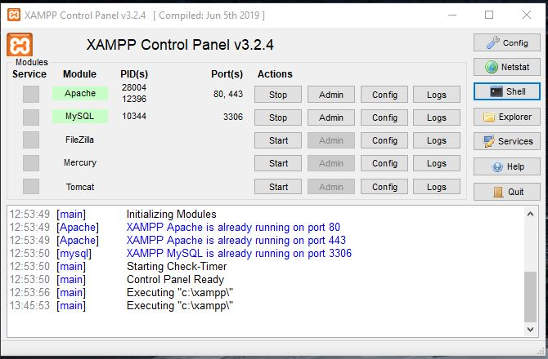

Testing: For my test I will provide some of the code pages and how they are connected.
Here you can see that for my web page I am using ATOM. This is very to use html editor program.

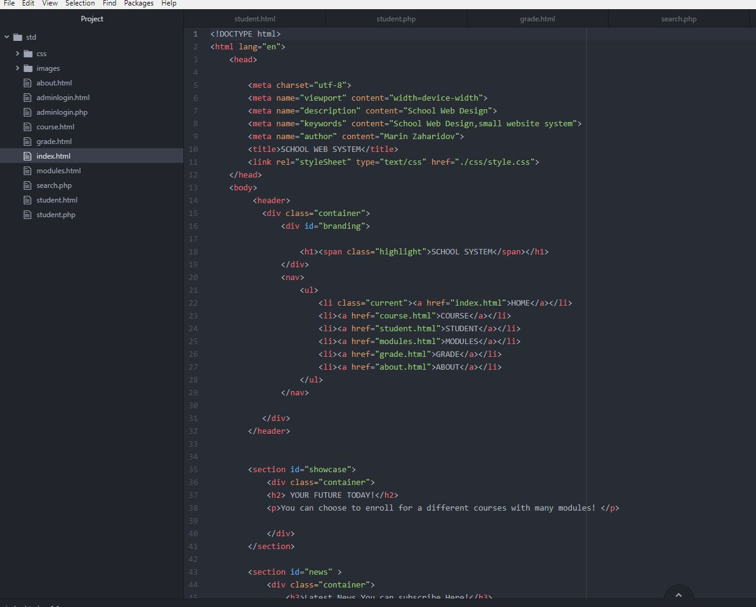
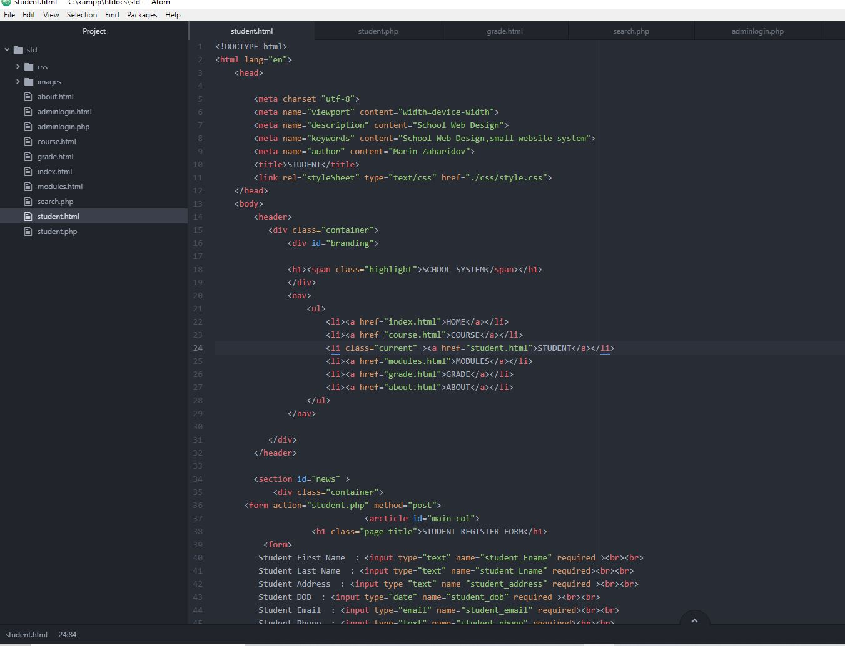

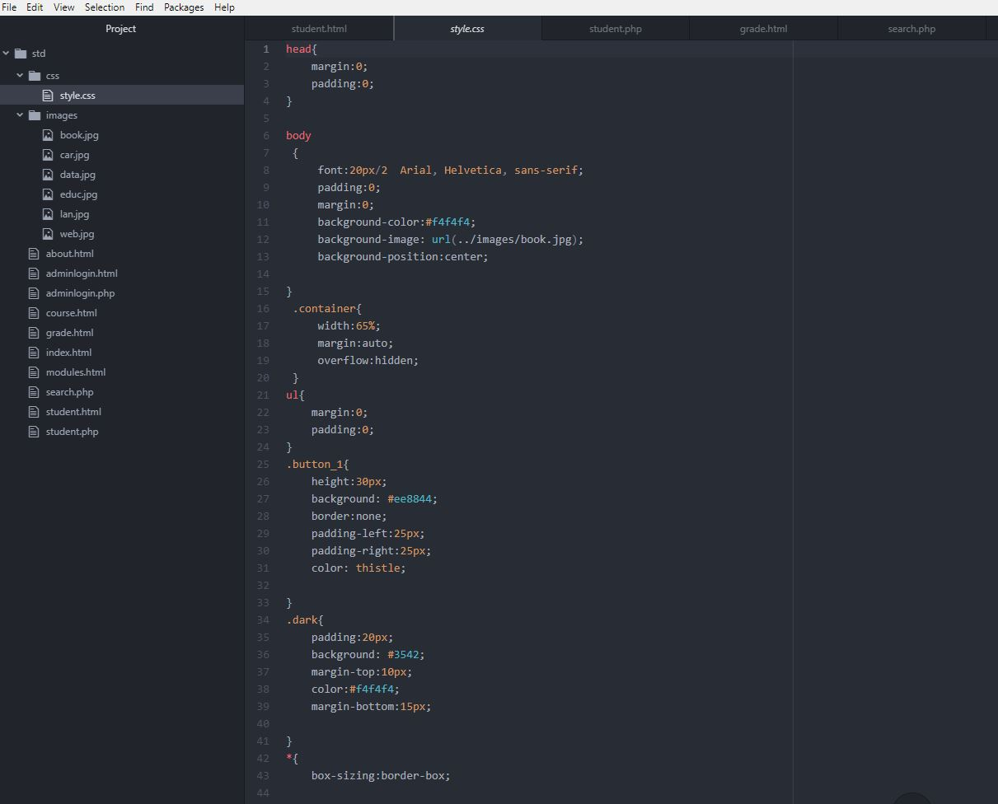

Testing: When the page is loaded it will first go to admin login and after is the home page. Its require to add details to see validation.

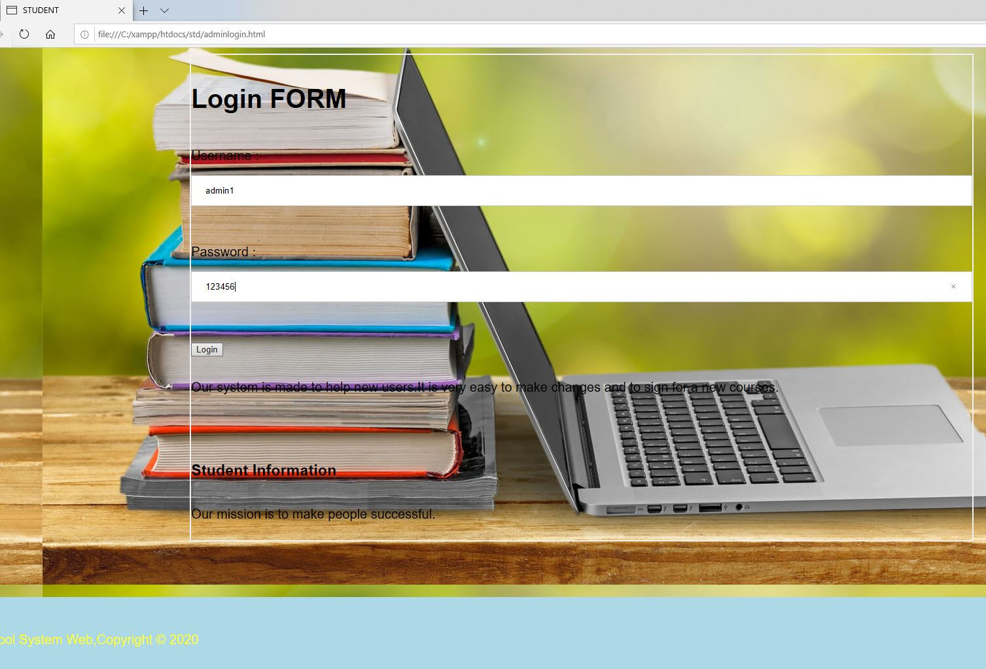

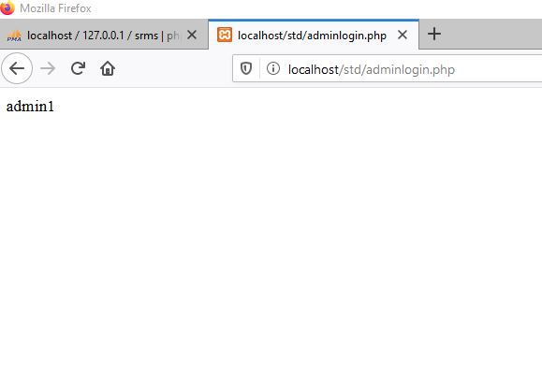

Testing: After login page it is automatically load the home page of my website.

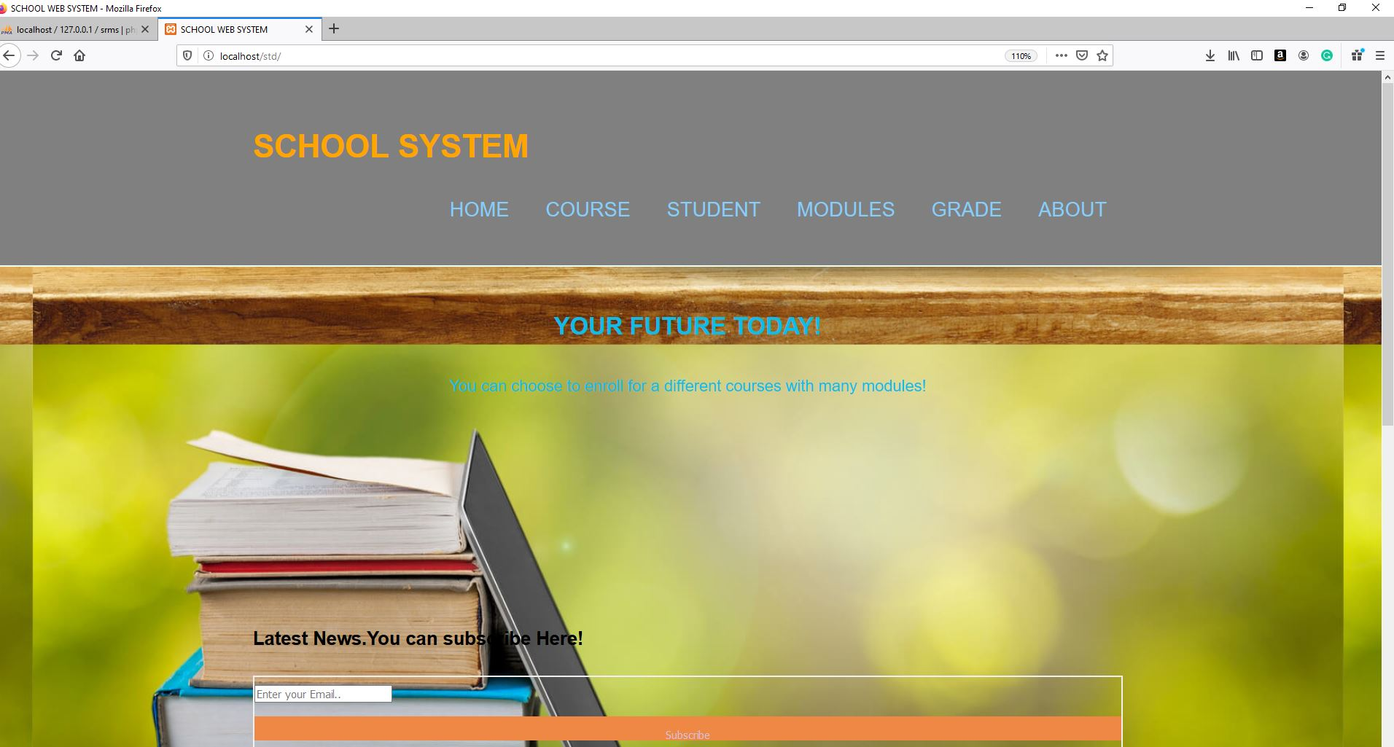

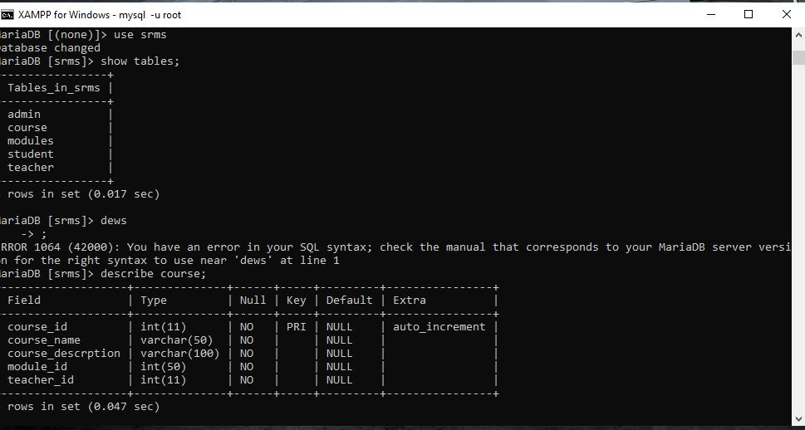
Some of the results in the database :

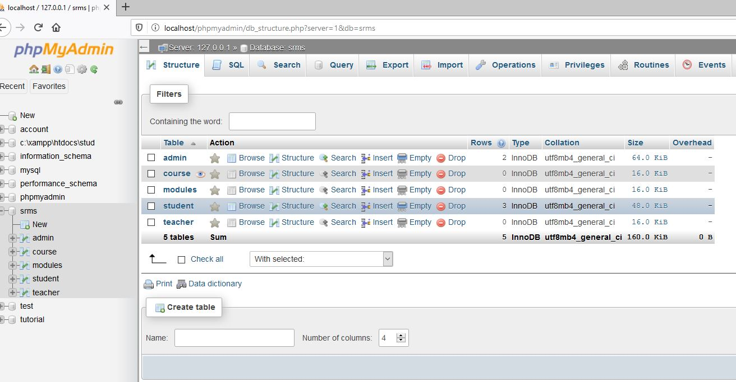

Main table in the database is Student:
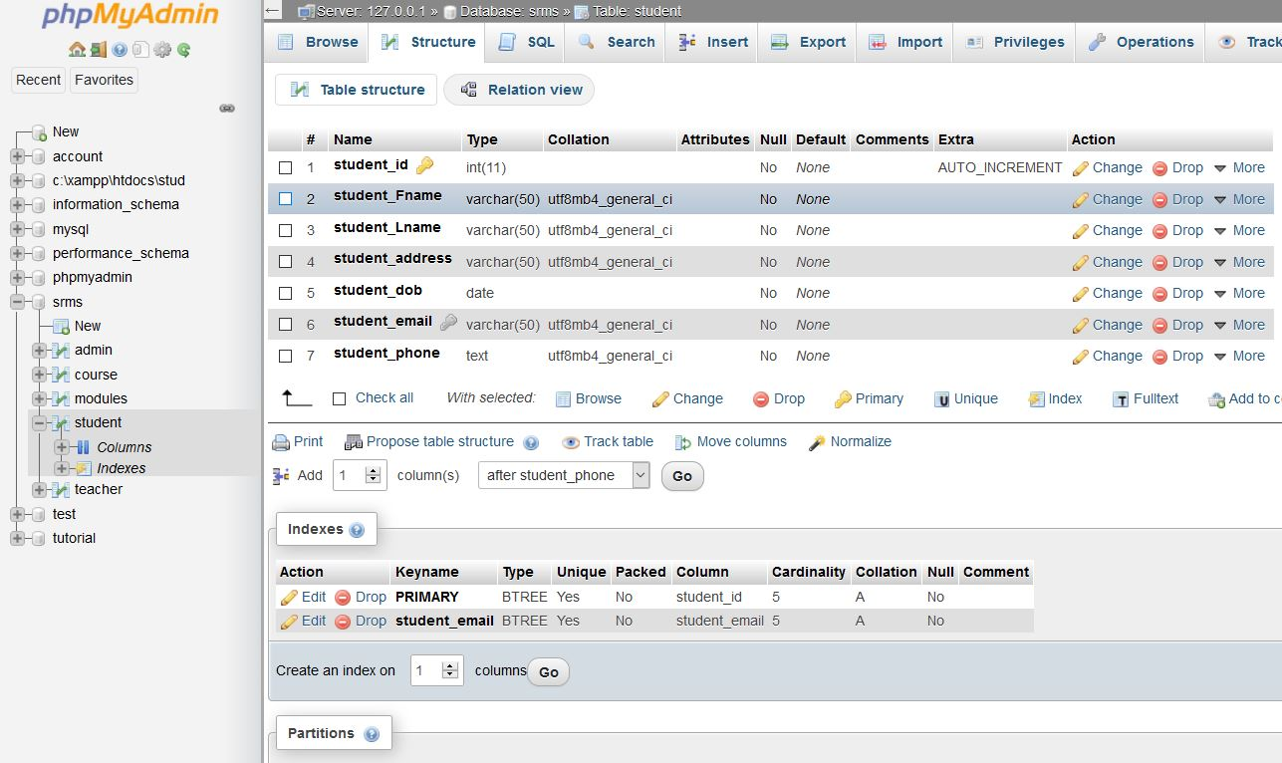
When I add new student its show me that all data is inserted succesfully: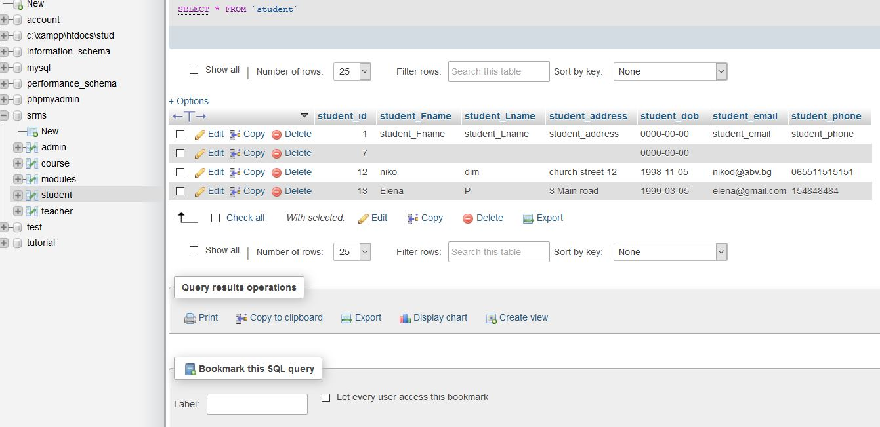

Information for the tables in my database:
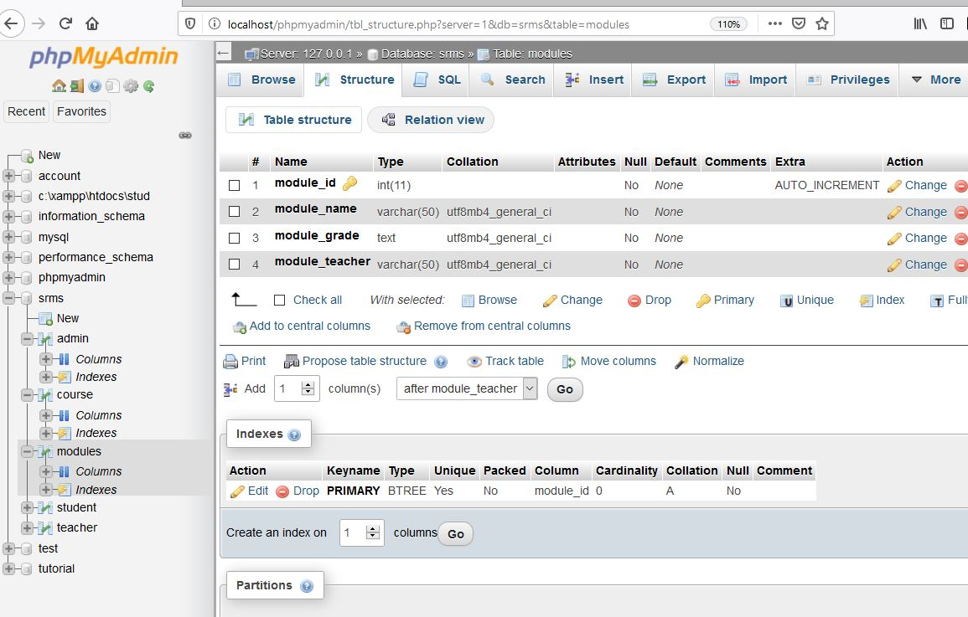
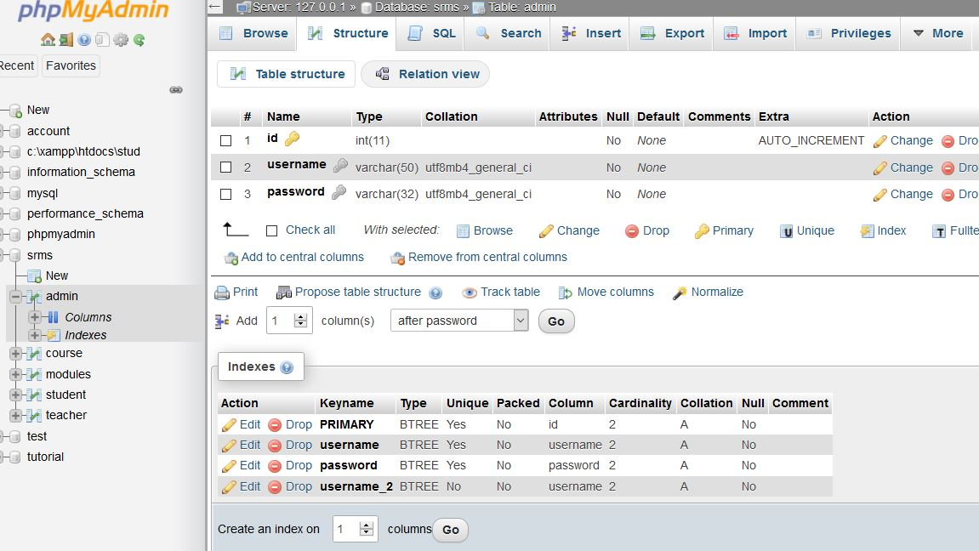

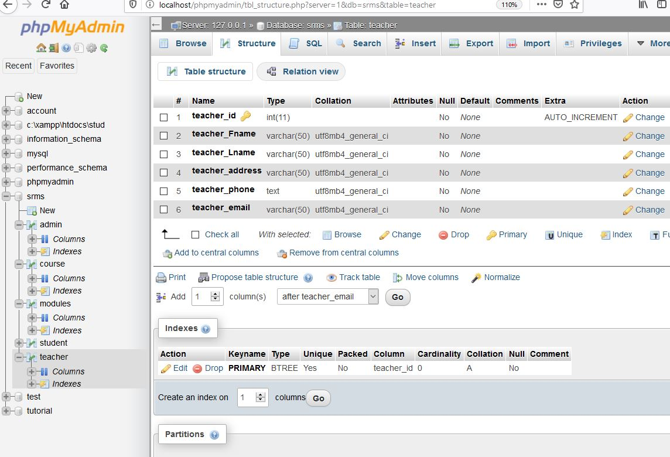

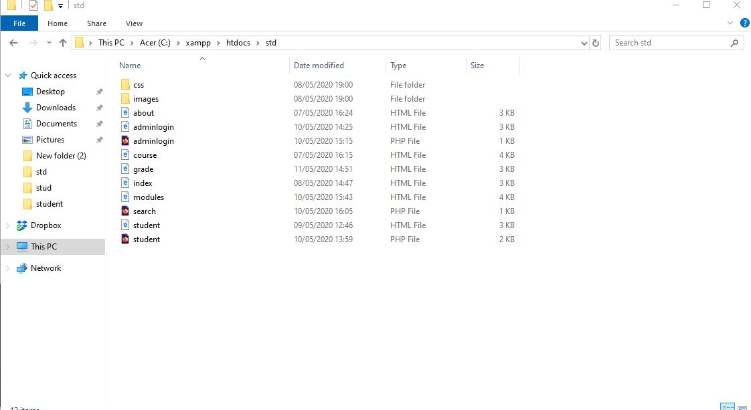

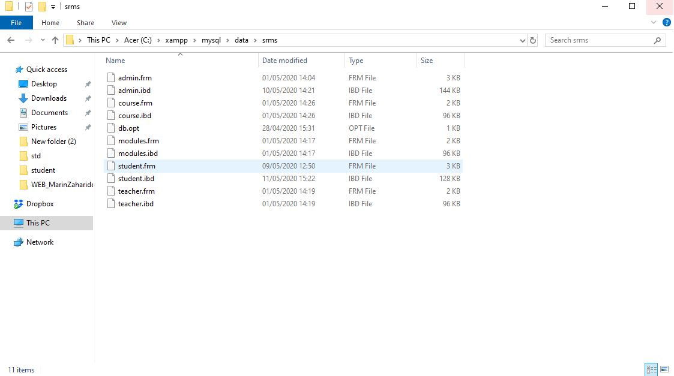

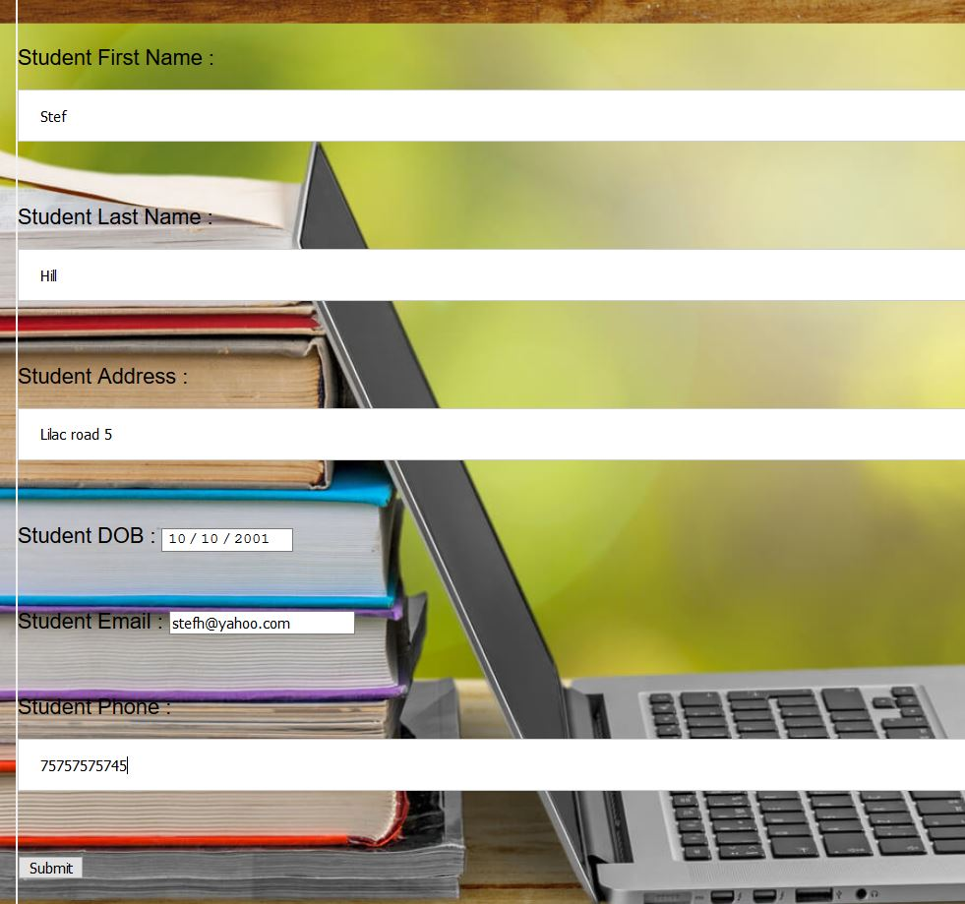

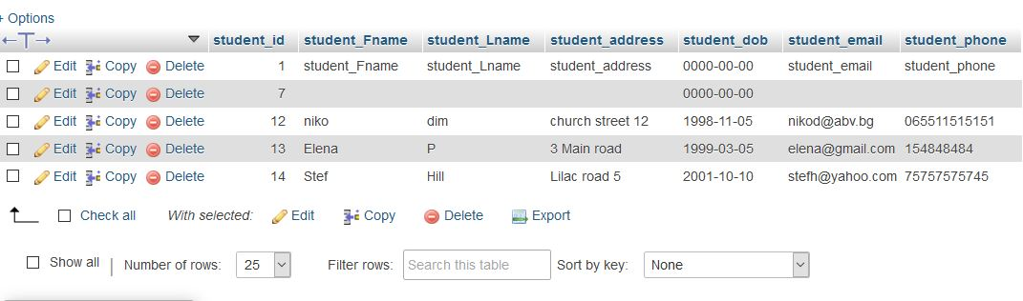

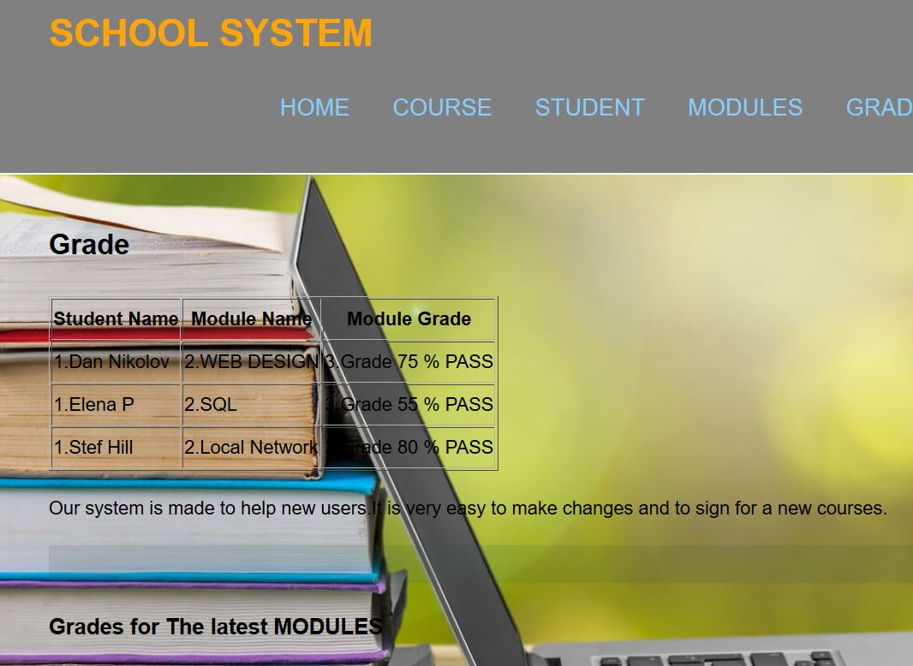

Conclusion :

Almost every webpage is using html, and whether you are creating a website or running one ,to understand what is going behind the scenes is very important. You need to have some experience but you want to start learning there is a lot of information and tutorials how to do it from scratch.

HTML is very important and take a special place in the work of many developers and web designers. You can think for the HTML like is structure of the web page and cooperate with JavaScript , the web page is created to perfection. If you want to have a career in web development or to make incredible web pages you have to start with HTML. In this case you will have all the skills to be a part of web developers future.

References
- contributors, M. (2020, Jan 9). HTML and CSS problems. Retrieved from Handling common HTML and CSS problems: https://developer.mozilla.org/en-US/docs/Learn/Tools_and_testing/Cross_browser_testing/HTML_and_CSS
- CSS Work. (1999 , April ). Retrieved from meyeaarweb: https://meyerweb.com/eric/articles/webrev/199904.html
- Dev, W. (2019, june 18). Html by javascript validation. Retrieved from youtube.com: https://www.youtube.com/watch?v=In0nB0ABaUk
- Dracup, J. (2016, Feb 11). youtube. Retrieved from Connecting to a MySQL Database & Displaying Records on a Web Page: https://youtube.com/how-to-connect-to-a-mysql-database-with-php/
- Help, L. (2018, April 5). Insert data into database from html form. Retrieved from youtube: https://www.youtube.com/watch?v=PU2UEv_T8G8
- HTML Tutorial. (2020). Retrieved from w3schools: https://www.w3schools.com/
- HTML.com. ( 2017, August 21). HTML.com. Retrieved from HTML.com: https://html.com/#ixzz6M8Tped00
- Media, T. (2016, Dec 25). Build An HTML5 Website. Retrieved from youtube: https://www.youtube.com

