Assessment Component: Individual report- Expansion of Walmart in Australia

Programme: Master of Business Administration
Module: Strategic Management
Module Code: LCMB7003
Student ID: 2418577
Student Name: ANISH GULAMNABI SAIYAD
Lecturer Name: Zulfiqar Khan

Table of Contents
Introduction 4
Task 1: Walmart Expansion to the Australian Market 5
1.1 Evaluating the Strengths of Walmart Through VRIO 6
1.2 Porter's Diamond Model for Australia as a Market Expansion 8
Task 2: Strategic Analysis of Macro-Environmental and Competitive Landscape 13
2.1 PESTLE Analysis 13
2.2 Competitive Landscape Through Porter Five Forces 15
2.3 Effectiveness and Limitations of the Models 18
2.4 Challenges for Walmart in Australia 18
Task 3: Market Entry Strategy for Competitive Advantage 19
3.1 BCG Matrix for Walmart’s Global Retail Portfolio 19
3.2 Effectiveness of Ansoff Matrix 21
3.3 Market Entry through Acquisition 22
3.4 Market Entry Through Strategic Alliance 23
3.5 Implementation of the Strategy 23
3.6 Maintaining Competitive Advantage 24
Task 4: Performance Evaluation Framework 25
4.1 The Balanced Scorecard 26
4.2 Framework on Implementation and Monitoring 30
4.3 Balanced Scorecard Effectiveness and Limitations 30
5. Recommendations and Conclusion 32
Recommendations 32
Conclusion 33
References 34

Introduction
In the modern global business setting, multinational organisations actively seek new opportunities to achieve growth and gain a competitive advantage. Strategic expansion of business into international markets allows companies to expand their operations, tap into new customer bases, and enhance their global presence (Bose, 2025). This report provides a wide-ranging organisational expansion plan for Walmart, one of the largest retail companies in the world. The evaluation in the report focuses on the potential market entry of Walmart into Australia by assessing its internal capabilities and external conditions. Moreover, the report critically analyses the readiness of the company for international expansion and the suitability of the Australian retail sector to achieve sustainable growth.

Task 1: Walmart Expansion to the Australian Market
Walmart is a multinational retail company founded in 1962 by Sam Walton and it is widely known by the audience for its everyday low prices business model (Walmart History, 2025). The company operates on a vast and diversified network of physical stores and a large e-commerce presence. The company has the largest revenue in the world and it reported the revenue of $48.01 billion in fiscal year 2024 (Walmart Report, 2024). The supply chain has enabled Walmart to expand to different parts of the world, such as Latin America, Asia, and Europe. The company has developed a strong market presence and logistics networks in these areas.
However, the company has been struggling to conquer the challenges in certain markets despite its massive international experience. It includes the challenges such as the high level of local competition and variation in consumer preferences. In contrast to it, the long-time emphasis of Walmart on affordability, technological implementation, and sustainability is an advantage to the company, as it can provide easy entry into new markets (Ji, 2025). Australia can be an appealing market in the next stage of expansion of Walmart as it offers a stable political situation, an advanced economy, and digitally active customers.
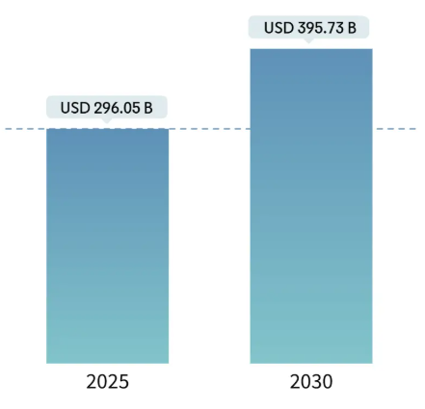
Figure 1: Australia Retail Sector Market Size
(Source: MI, 2025)
The Australian retail industry is one of the oldest and the stable in the Asia-Pacific region (DGCISKOL, 2020). The country has good conditions to attract multinational retailers due to the high disposable income, robust infrastructure. Moreover, the use of and spread of the internet and digital technology has also increased the business opportunities. The retail market revenue of the Australian retail industry is $296.05 billion as of 2025 and it is forecasted to reach $395.73 billion by 2030 (MI, 2025) (Refer figure 1). Economic stability, transparent business regulation and favourable trade relations of Australia with the United States also allow Walmart to seize the opportunity (USA Embassy, 2025). Walmart can create value for consumers in Australia and improve its global presence by using its expertise in supply chain and low-cost operations.

1.1 Evaluating the Strengths of Walmart Through VRIO
The VRIO model evaluates internal strengths that give an organisation a long-term competitive advantage (Amaya, et al., 2024). The four components, namely, value, rarity, imitability and organisation, are used to decide the temporary or long-term success based on the resources. Walmart has several key internal strengths in its brand name, economies of scale, integration of supply chain, and technological innovation.
Table 1: VRIO Analysis
Resource / Capability | Valuable | Rare | Inimitable | Organised | Competitive Implication
Global Supply Chain Network | Yes | Yes | Difficult to Imitate | Yes | Sustained Competitive Advantage
Brand Reputation and Customer Loyalty | Yes | Yes | Difficult to Imitate | Yes | Sustained Competitive Advantage
Advanced Retail Technology and Data Analytics | Yes | Yes | Moderate | Yes | Sustained Competitive Advantage
Human Resource Expertise and Leadership Culture | Yes | No | No | Yes | Competitive Parity
Financial Strength and Global Capital Access | Yes | No | No | Yes | Temporary Competitive Advantage
From the above table, it is analysed that the global supply chain of Walmart is one of its strongest advantages. The products sourced by the company worldwide are cheap and allow it to offer competitive prices (Wood, 2025). Its advanced logistics system has helped to have effective inventory management and minimise waste. This is an excellent competency and hard to imitate by competitors, and provides a long-term competitive advantage. The other important asset is the brand name of Walmart and it allows the company to sustain customer loyalty (DCunha, 2022). This kind of reputation increases consumer confidence in new markets and it is hard for rivals to imitate.
In the last few years, Walmart has advanced significantly in technology and data analysis, introducing the elements of artificial intelligence, automation, and predictive analysis into its operations (Brunda and Aithal, 2025). These tools help to improve customer experience, decision-making, and efficiency. This ability is moderately difficult to imitate due to the level of technological integration and capital investment. Additionally, the financial strength of Walmart gives it the flexibility to expand into new markets and maintain operations in the initial stage (Walmart Report, 2024).
Even though the supply chain of Walmart is its core strength, competitors such as Woolworths also possess advanced logistics. It means that the capability of the company would not remain fully inimitable in Australia.

1.2 Porter's Diamond Model for Australia as a Market Expansion
The Diamond Model was created by Porter and it assists in understanding why certain countries in one country are competitive than other nations with the same industries (Afshar and Shah, 2025). It assesses the national conditions in four key variables of factor conditions, demand conditions, related and supporting industries, and firm strategy, structure, and rivalry, as well as the functions of government and chance. The application of this model describes why Australia is a favourable market in which Walmart can expand its operations. The graph below depicts the GDP growth projection of Australia, making it favourable for Walmart.
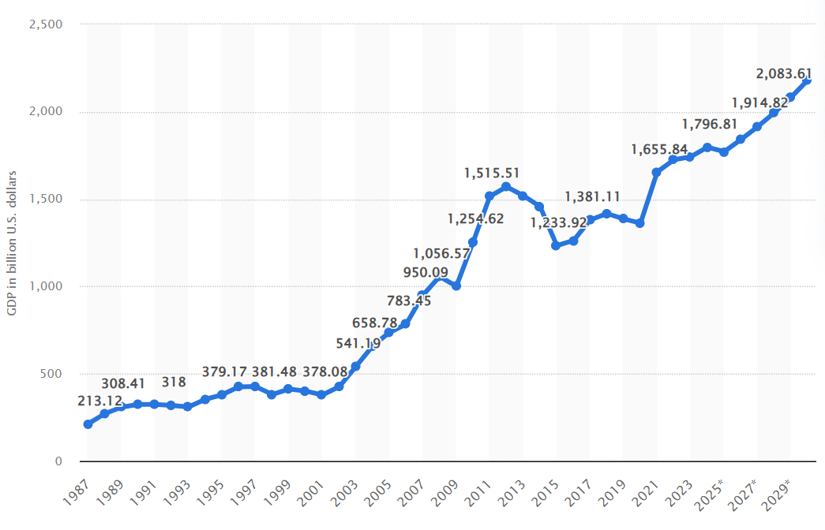
Figure 2: GDP of Australia
(Source: Statista GDP, 2025)
Factor Conditions
It includes the resources of a country that are necessary in a competitive industry. Australia has a well-established skilled labour forced, modern logistics networks and it has access to advanced technologies. Its transport and port facilities of Australia is also good and allowing for easy distribution and importation of the products. There is also a strong level of digital infrastructure in the country and it supports the activities of e-commerce (SBC, 2021). These advantages align with the omnichannel retail strategy used by Walmart. The figure below represents the gross value added by the retail industry of Australia during 2015-2024.
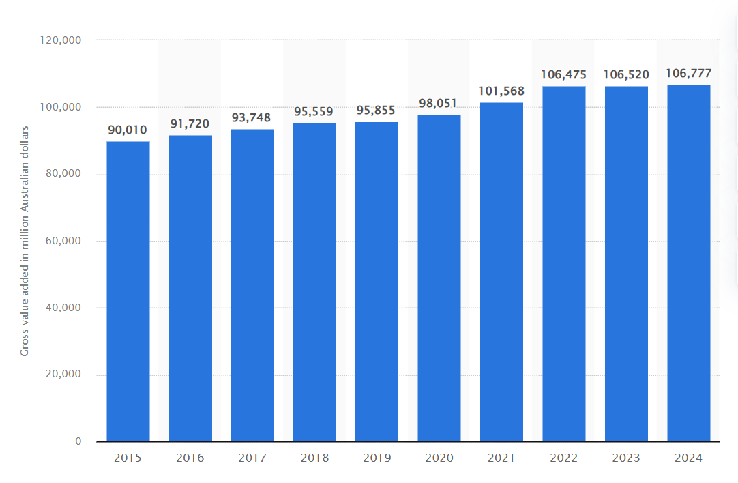
Figure 3: Gross Value Added of Retail Trade Industry in Australia from 2015 to 2024
(Source: Statista GVA, 2025)
Demand Conditions
The demand in the model includes the products or services that can create pressure on companies to innovate and improve. The Australian retail market is characterised by a high consumer spending power and an increasing population that is based in the urban areas. The increased need for online shopping and sustainable products gives Walmart a chance to combine its services that are based on technologies and sustainable sourcing. The acceptance of Australian consumers is open to international brands, portraying a high likelihood of acceptance in the market (Percopo, 2025).
Similar and Supporting Industries
It includes the competitive suppliers and the related industries that contribute to the competitive advantage of. the country. The presence of efficient logistics companies, financial institutions, and digital service firms allows the efficient operation of retailers. The development of local sourcing and partnerships can be used in the agricultural and manufacturing sectors to enable Walmart to adjust to the preferences of Australian consumers.
Strong Strategy, Structure and Competition.
The Australian retail business is highly competitive with the presence of companies such as Woolworths, Coles, and Aldi (McLeod and Barret, 2024). It is a competitive environment that promotes constant improvement and innovation. The operational excellence and pricing strategy enable the company to differentiate itself from its competitors. The launch of the hybrid retail model by integrating large-scale stores with online solutions can allow Walmart to address the market gaps in the value retailing and convenience shopping.
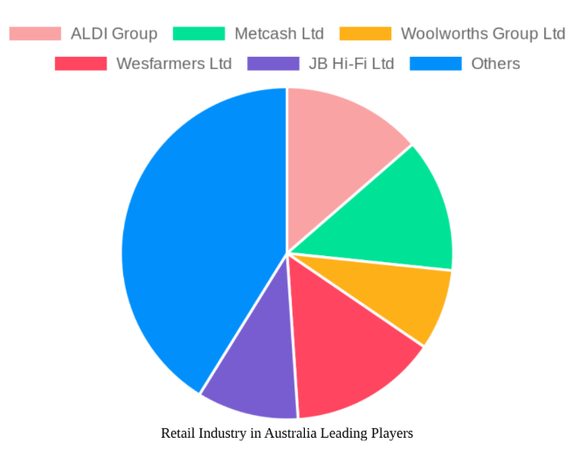
Figure 4: Leading Companies in Retail Industry
(Source: DIM, 2024)

Chance and Government Role
The Australian government is encouraging foreign direct investment and gives clear-cut regulations that facilitate the business activities of other countries (DFAT, 2025). The good relations between Australia and the United States are supported by favourable agreements that focus on imports and the growth of business. The sustainability and digital transformation policies promoted by the government are also compatible with the worldwide efforts of Walmart.
The internal and external analysis shows that the strengths of Walmart and the Australian market characteristics are well aligned. The logistic, technological and cost management capabilities of Walmart are aligned with the highly established infrastructure and consumer demand for affordable prices in Australia. Moreover, the combination of the global practices and the local business environment of Australia allows Walmart to enter and grow in the competitive retail market.
Although, the model assumes national competitiveness guarantees firm success, it lacks accountability for cultural adaptation and customer acceptance challenges Walmart may face.

Task 2: Strategic Analysis of Macro-Environmental and Competitive Landscape
The external macro-environmental factors and the competitive environment need to be analysed to understand the viability of the entry strategy of Walmart into the Australian market. The PESTLE is used to identify the macro-environment factors that can potentially impact Walmart's growth. Whereas the Porter's Five Forces Model is used to assess the level of competitive rivalry.

2.1 PESTLE Analysis
The PESTLE framework analyses the environmental factors that are more widespread by looking at Political, Economic, Social, Technological, Legal, and Environmental factors (Peterdy, 2025). The model is helpful in uncovering the major external drivers and constraints that may influence the market entry and long-term performance of Walmart in Australia.
Political Factors
Australia has a steady political situation, as it promotes foreign direct investment and provides clear governance systems. The framework of the foreign investment review by the Australian government attracts international companies that have the capacity to generate jobs and boost the economy. Additionally, government policies that govern labour rights, wage policies, and competition policies also affect the retail sector in Australia. The Australian Competition and Consumer Commission (ACCC) is an entity that the government closely regulates to avoid monopolistic tendencies and acceptable pricing (ACC, 2025). Walmart has to adhere to these regulations to ensure that it retains its image and succeeds in entering the market smoothly. ‌
Economic Factors
The Australian economy is strong with a stable GDP growth, low inflation and high consumer expenditure power (Comm Bank, 2025). In 2024, Australia’s supermarket sector came under government and ACCC investigation due to concerns over rising grocery prices and limited market competition. Despite household budgets being stretched, leading retailers such as Woolworths and Coles continued to record strong profits, highlighting growing price imbalances. This inquiry reflects increasing consumer demand for affordability and transparency in pricing (Statista, 2025). Therefore, A key challenge for Walmart will be navigating pricing scrutiny and regulatory pressures while maintaining its low-cost strategy in Australia’s competitive market.
Social Factors
The general population of Australia is diverse, urbanised, and digitally savvy and it affects the retail patterns of consumers. Consumers prefer quality, convenience, and sustainability, and they are actively moving towards online and hybrid shopping experiences (Haller, 2022). The omnichannel strategy that has been developed by Walmart fits these preferences. Walmart also needs to create a balance between its effectiveness in the global supply chain and the integration of local products to promote local producers.
Technological Factors
Australia is a developed economy and the usage of the internet and mobile payment systems is high. Automation, data analytics, and artificial intelligence are rapidly changing the retail sector, allowing for a better customer experience. The retail technology of Walmart, such as real-time inventory, AI-powered demand prediction, and digital payment solutions, provides it with an essential advantage (Musani, 2023). Walmart has to invest in localised digital marketing and customer engagement systems to respond to the local consumer behaviour.
Legal Factors
Australia has clear laws on labour, consumer protection and environmental laws that govern the work of businesses. The retailers are obligated to adhere to the laws of minimum wage, product safety, and privacy. The Australian Consumer Law (ACL) guarantees transparency, accountability in product information and price, and safeguards the consumer rights (ACL, 2025). These standards are central to Walmart to retain the trust of the people and long-term brand recognition.
Environmental Factors
Environmental Sustainability of Australia is aimed at carbon minimisation, waste disposal, and sustainable sourcing (Drury, 2024). Customers are increasingly willing to do business with firms that are socially concerned. The global sustainability projects at Walmart, including the minimisation of emissions, the expansion of renewable energy usage, and sustainable agricultural support, align with the environmental preferences of the customers (Walmart Sustainability, 2025).

2.2 Competitive Landscape Through Porter Five Forces
The Five Forces Model developed by Porter assists in determining the intensity of competition in an industry and the appeal of a market. The five forces include competition rivalry, new entrant threat, bargaining power of suppliers, bargaining power of buyers and the threat of substitutes. It gives insight into the level of competition Walmart might have to endure in the Australian retail sector.
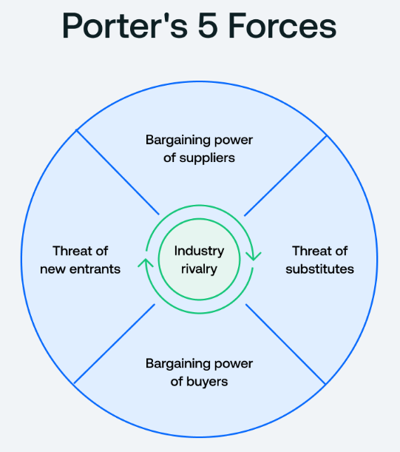
Figure 5: Porter's Five Forces Model
(Source: Quantive, 2025)

Competitive Rivalry
The Australian retailing environment is competitive, with the leading market players such as Woolworths, Coles and Aldi (McLeod and Barret, 2024). Australia’s supermarket sector is highly concentrated, dominated by Coles and Woolworths, creating intense competitive rivalry (ACCC, 2025). For Walmart, entering this mature market will require strong differentiation, innovative pricing, and strategic localisation to effectively compete against these well-established and trusted domestic brands.
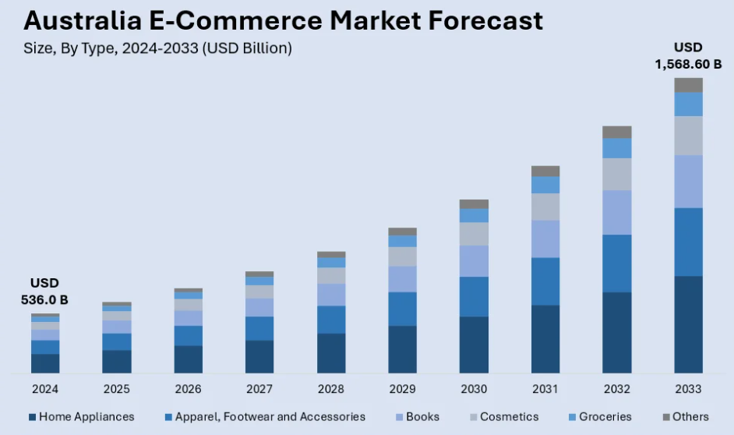
Figure 6: Australian E-commerce Market Forecast
(Source: IMARC, 2024)
Threat of new entrants
The Australian retail market is an environment that requires high capital investment and logistics knowledge, as well as maintaining stringent rules and regulations (KPMG, 2025). The presence of entry barriers is caused by established competitors with well-developed distribution networks. Walmart can overcome these obstacles as it has access to global resources and also has the required experience. Smaller domestic players would not be able to compete with big corporations and the success of Walmart is based on the success of its efficient operations and brand differentiation.
Supplier Power
The balance of supplier power in Australia is neutralised by the existence of the big retailers that buy in large quantities. The global procurement system enables Walmart to secure good terms with the suppliers (Eshkenazi, 2022). However, the company needs to cooperate with local suppliers to ensure compliance and cultural alignment. By creating long-term relationships with the Australian producers, Walmart can overcome the risks of disruption.
Consumer power
Australian customers have multiple choices of retailing, both online and offline and they possess considerable bargaining power. The customers are actively becoming cost-conscious and prefer quality and ethical behaviour (Johnson, 2023). It means that Walmart has to compromise on affordability and focus on sustainability and customer service excellence. Brand loyalty in the retail market is competitive and consumers are willing to explore new retailers that provide a better experience. Buyer switching behaviour can be minimised through competitive pricing activities of Walmart and activities of the company in the community and ethical behaviour.
Possibility of Replacement
The primary competitors within the retail industry are online stores, local stores and discount stores (Sun, 2022). The threat of substitution is increased with the fast development of e-commerce and direct-to-consumer brands. Walmart can resolve this by improving on its omnichannel strategy, incorporating of online and in-store experiences, and providing delivery and pickup services that suit Australian consumers.

2.3 Effectiveness and Limitations of the Models
Effectiveness
PESTLE Analysis assists in identifying the external macro-environmental factors that may affect the entry strategy of Walmart. It allows active response to political, economic and technological trends. Additionally, Porter's Five Forces provides an organisation with a systematic approach to competitiveness in the industry. It helps Walmart to determine its positioning between the competitors and suppliers. These two models present a balanced image of external risks and opportunities that help in strategic decision-making in the case of global expansion (CFI External, 2025).
Limitations
PESTLE is based on the macro-level external factors and lacks consideration of micro-level forces, including cultural preferences and customer behaviour to retail categories (CIPD, 2025). It is non-dynamic and gives a picture of the present situation and lacks consideration of the fast-paced transformations in technology or consumer preferences. Porter's five forces assumes that the industry is relatively stable and might fail to reflect the disruption caused by e-commerce or digital platforms that are changing the face of retail competition. Moreover, the model fails to pay full attention to important factors of strategic alliances, government intervention or innovation-based market transformations (Martin, 2025). Although PESTLE provides a macro overview, it is static in nature and cannot reflect rapid changes in consumer behaviour and digital retail trends.

2.4 Challenges for Walmart in Australia
Walmart face intense competition from Woolworths and Coles, as they collectively hold around 60-70% of the grocery market share (PA, 2024). Regulatory hurdles and zoning laws also limit store setup in desirable locations due to the strict planning and compliance requirements. Consumer preference for online grocery shopping and delivery service is also increasing and it asserts pressure on Walmart to invest heavily in logistics and digital infrastructure.

Task 3: Market Entry Strategy for Competitive Advantage
The decision of Walmart to expand into the Australian market needs an organised development model that determines the best approach for expansion and competitive edge. One of the strategic models offered is the Ansoff Matrix can be used to identify the growth directions based on the products and markets dimensions (CFI Matrix, 2025). These four strategic options are Market Penetration, Product Development, Market Development and Diversification. The most applicable quadrant in the global expansion of Walmart is the Market Development quadrant, as it provides an organisation way to established products or business model in a new geographical location. The Ansoff Matrix analyses the potential of Walmart to enter Australia and maintain its competitive advantage by means of acquisition and strategic alliances.

3.1 BCG Matrix for Walmart’s Global Retail Portfolio
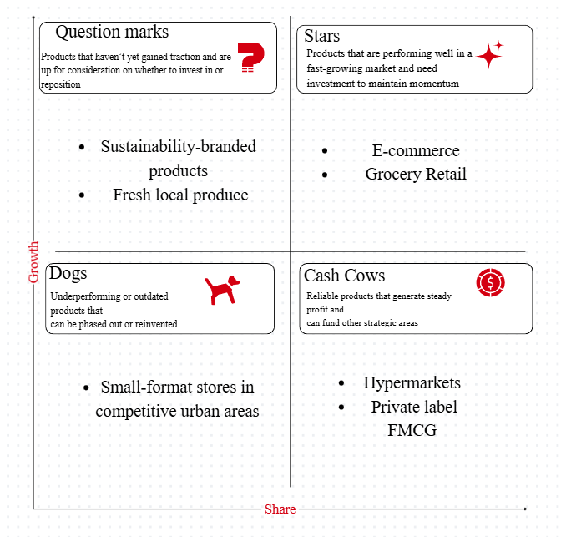
Figure 7: BCG Matrix for Walmart (Source: Author)
The Boston Consulting Group came up with a strategic portfolio tool known as the BCG Matrix which bases its analysis on the growth rate of the business unit and its market share relative to other business units (BCG, 2025). It classifies offerings as Stars, Cash cows, Question Marks and Dogs, which helps organisations to determine where to invest, maintain or pull out. When applied to Walmart, the model can help in choosing the most appropriate formats in which it can enter Australia. The high grocery and hypermarket formats of Walmart are Cash Cows and are yielding consistent returns to finance expansion operations. Its fast-growing online business is a star, which needs constant investment as the market of online retail in Australia has high growth prospects. Some of these new segments, like local products with sustainability implications, could be included in Question Marks and this needs to be reviewed carefully. Concurrently, Dogs are low-demand or low-differentiation formats, which Walmart have to avoid or minimise in an attempt to mitigate operational risk in a mature market.

3.2 Effectiveness of Ansoff Matrix
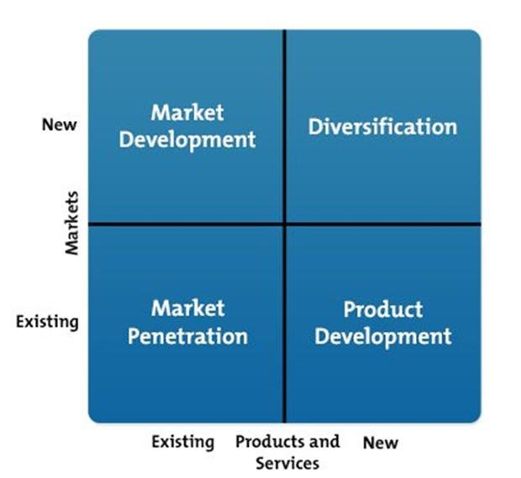
Figure 8: Ansoff matrix
(Source: Peterdy, 2025)
Ansoff Matrix helps managers to coordinate product and market decision with the corporate growth objectives.
Market Penetration: It aims at growing existing markets by penetrating them with the help of current market products at lower prices, promotion, and services.
Product Development: It is the act of coming up with new products in the already existing markets in order to maintain the interest and competitiveness.
Market Development: It is a development that uses the existing products in new geographical or demographics markets.
Diversification: The riskiest option would be diversification and it would need new products and new markets.
For Walmart, the Market Development strategy would offer a rational entry mode into Australia. Walmart low-cost, data-driven retail model can fit in Australia because of its political stability, strong logistics network and actively participating and technologically active population. Implementation of the Market Development strategy enables Walmart to leverage its international expertise in the supply chain efficiency, automation, and e-commerce to enter a new market with less operational risk as compared to diversification. Growing demand of low cost, convenience, and sustainability is reflected in the retail market in the country that has the potential of up to US $396 billion by 2030 (MI, 2025).

3.3 Market Entry through Acquisition
Acquisition is the initial move in the implementation of a Ansoff framework for the market development strategy of Walmart into Australia. Purchasing an existing retailer has various advantages, as it provides instant access to the market, defined infrastructure, and a trained labour force (Patterson, 2024). It also minimises the risks of establishing a new brand in a competitive and controlled retail market. The acquisition made by Walmart might be based on a discount or general merchandise store chain that has a customer base and store network. One of the possible examples would be Big W, a retail company within the same sector that is well-known locally.
However, the integration process must be completed in a gradual manner to maintain the local image and cultural knowledge of the acquired firm (Fantaguzzi and Handscomb, 2024). Local identity and global efficiency can help Walmart to make the transition process smooth and prevent resistance from consumers. This model of entry is based on acquisitions and it promotes the transnational interest of think global, act local. Moreover, it offers Walmart a platform to implement its operational excellence and leverage the familiarity of the acquired company in the local market.

3.4 Market Entry Through Strategic Alliance
As per Ansoff Matrix the alliances can function as cooperative mechanism to integrate the global practises with local experiences. Through acquisition, Walmart has to establish strategic alliances to enhance its operational foundation and reputation in Australia. Strategic alliances provide an entry to local knowledge, technological partnering and regulatory guidelines that are vital to long-term achievement in a new market (Lin, et al., 2025). The strategic alliance in the fields of technology, local supply chain and environmental sustainability can allow Walmart to enhance the effectiveness of the market entry.

3.5 Implementation of the Strategy
The strategies of acquisition and alliance have to be developed in a systematic manner to create a balance between the globalising and localising processes. The implementation process of Walmart should be in four phases that are discussed in the table below.
Table 2: Implementation of the Strategy
Phase 1 (Market Research and Feasibility) | The company has to conducted thorough research to establish possible acquisition and alliance partners depending on compatibility, positioning in the market, and culture. Insights about the consumer have to be obtained to understand the purchasing behaviour, product expectations and the price sensitivity.
Phase 2 (Acquisition and Integration) | After the selection of the target company, Walmart needs to enter into negotiations for the acquisition. The integration process must be based on the introduction of global practices of Walmart, including supply-chain technology, standards of sustainability, and financial controls. However, the company has to ensure that customer service and brand value are relevant for the market entry.
Phase 3 (Development of Strategic Alliance) | The alliances have to be formalised with the local suppliers, logistics firms, and renewable energy sources. These alliances would enhance the company's reputation in the industry and adherence to legal standards.
Phase 4 (Organisational Structure and Governance) | Walmart has to use a dual reporting system where global operations, such as finance and technology, are centrally located. The local branches are in charge of marketing, sourcing and operations, providing strategic coherence.
Periodic evaluation of the strategy through a performance dashboard and KPIs has to be implemented by the company. It ensures that the strategy is on track and in line with the global goals.

3.6 Maintaining Competitive Advantage
The process of innovative learning can help Walmart to maintain its competitive advantage in Australia. The lessons learned during the Australian operations, such as sustainable sourcing and consumer engagement practices, can be used in other market expansion campaigns. Walmart can leverage its technologies of global presence to sustain its cost leadership to build to local partnerships to attain cultural and consumer loyalty. Moreover, the investments in the digital transformation, training of employees and customer service can support the efficiency and differentiation (Widodo, et al., 2024).

Task 4: Performance Evaluation Framework
The expansion of Walmart in Australia needs to have a system that evaluates the effectiveness of attaining strategic goals. The Balanced Scorecard (BSC) proposed by Kaplan and Norton is an appropriate instrument since it connects the vision and strategy of the company with quantifiable results (Madsen, 2025). The BSC is a measure of performance based on four perspectives, including Financial, Customer, internal processes, and Learning and Growth, which make sure that there is efficiency and sustainability in the short-term and long-term.

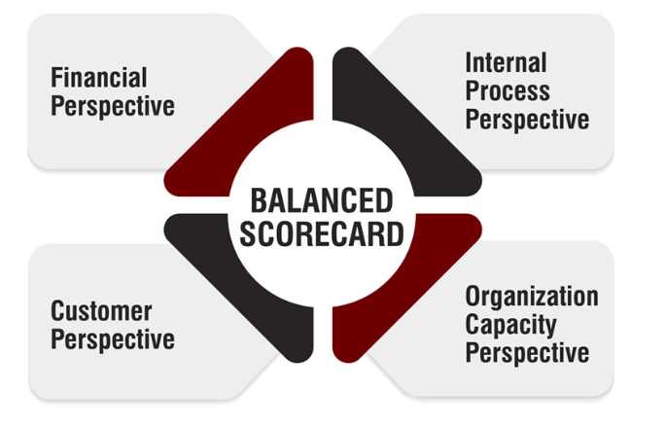
Figure 9: Four Perspectives of a Balanced Scorecard
(Source: Strategy Institute, 2025)

4.1 The Balanced Scorecard
Table 3: Balance Scorecard Table
 |  |  | Sections
Perspective | Explanation | Strategic Objectives | Key Performance Indicators | Target and Implementation
Financial Perspective | The financial perspective considers the capability of Walmart to earn revenues, manage expenses and profitability in Australia and the extent to which the expansion attends to the global financial objectives (CFI BSC, 2025). | Attain balanced profitability.  Ensure cost effectiveness and leadership.  Optimise return on investment (ROI). | • Annual revenue growth: 8–10% per year.  • Net operating margin: 5% by Year 3.  • Supply chain cost reduction: 10–15% by Year 3.  • Inventory turnover efficiency: Improve by 12% annually | At the end of year three, Walmart aims at a 5% net operating margin and growth of annual revenue by 8-10%. The global procurement and the latest logistics will drive cost leadership. Predictive analytics will also optimise stock turnover and minimise storage expenses. The financial performance will be checked quarterly against the projections to check that it is going according to strategy and corrective measures must be taken accordingly.
Customer Perspective | This view evaluates the performance of Walmart in relation to the expectations of the Australian consumers as per price, quality, and service. Customer satisfaction and loyalty are significant to the success in the long run in the competitive retail market (Gupta and Maheshwari, 2020). | Develop brand recognition and credibility.  Provide high quality by being less expensive and giving a wide range.  Grow customer satisfaction and retention. | • Brand recognition: 60% in key cities by Year 2.  • Customer Satisfaction Index (CSI): ≥85%.  • Repeat purchase rate: 70% by Year 3.  • Market share: 10% within five years.  • Net Promoter Score (NPS): ≥75%. | Walmart intends to achieve 60 % brand recognition in the key cities in two years and a CSI of over 85 %. The markets will be promoted with the help of the campaigns in terms of the affordability, convenience, and sustainability. Repeat purchases will be promoted through CRM schemes and online interaction solutions. The retail market share of Walmart is also pegged at 10 % in the next five years and this signifies good market acceptance and brand loyalty.
Internal Process Perspective. | The internal process approach is concerned with operational efficiencies and innovations. The competitiveness of Walmart in Australia will be determined by its management of logistics, supply chain and technology integration (Dubetcky, 2024). | Improve the efficiency and reliability of the supply chains.  Empower omnichannel activities.  Enhance delivery of services and minimize wastage. | • Logistics cost reduction: 15% by Year 3.  • On-time delivery rate: 90% by Year 3.  • Online revenue contribution: 25% of total sales by Year 3.  • Waste reduction in logistics: 20% by Year 3. | Walmart aims at achieving a 15-%age point decrease in logistics expenditures and 90 % on-time delivery in three years. Responsiveness will be improved through automated warehouses and data-driven systems of managing stocks. Integration of omnichannel will connect stores and online platforms with the goal of getting 25 % of the revenue through online channels in Year 3. The monthly reports of the supply chain operation will be compared in the world market to find points of improvement, which will enhance the existing operational excellence and innovation
Perspective of Learning and Growth. | In this view, the capacity of Walmart to grow its workforce, encourage innovativeness, and establish a culture that aligns with the strategic goals and will make it sustainable in the long run is examined (BSC Institute, 2025). | Increase employee potential and retention.  Encourage creativity and flexibility.  Create a culture of constant enhancement and ethical behaviour. | • Employee retention rate: ≥90%.  • Training hours: 30 hours per employee annually.  • Local supplier partnerships: 50+ within two years.  • Innovation adoption rate: ≥3 new initiatives per year.  • Employee engagement score: ≥85%. | Walmart aims to achieve 90 % retention and 30 hours of training per worker or year. The Walmart Academy learning system will be localised to Australia, to educate the employees on leadership, digital tools, and sustainability. The company will also enter into 50+ partnerships with the local suppliers in the course of two years in order to promote local flexibility. Recurring employee engagement surveys will determine the challenges and opportunities, and a motivated workforce will be developed in line with the global culture that Walmart has.

4.2 Framework on Implementation and Monitoring
In order to operationalise the Balanced Scorecard, the following aspects which can be measured, can be observed by a Performance Monitoring Committee constituted by Walmart:
Financial KPI: ROI, revenue growth of 8 -10 % and profit margin of 5% to measure profitability and cost effectiveness.
Customer KPIs: Customer satisfaction index over 85, brand recognition of 60 % and share in the market of 10% to assess customer loyalty and acceptance in the market.
Internal Process KPIs: 90% of on-time delivery, 15 % logistics cost reduction on-line revenue 25 % of how effective and innovative the operation is.
Learning and Growth KPIs: 90 % employee retention, 30 training hours per year to promote development and flexibility.
Real-time results will be displayed on a digital dashboard, and quarterly and annual reviews will be used to ensure that there is accountability and alignment of the strategic goals.

4.3 Balanced Scorecard Effectiveness and Limitations
Effectiveness
- BSC provides Walmart with an integrated system of financial and non-financial criteria.
- It connects the short-term performance with long-term strategic performance.
- Coordinates department activities towards a common vision.
- Encourages evidence-based practice and improvement.
- Enables target localisation in a global uniform approach.
The BSC has helped Walmart to transform its operations in Australia to be strategic, measurable and sustainable.

Limitations
- The BSC has limitations regardless of its strengths:
- Further success relies on proper and time-sensitive data gathering.
- Needs strong managerial dedication and communication.
- May does not consider the unexpected market shocks or changes in regulations.
- There are some qualitative factors, like customer perception or cultural adaptation which are hard to measure.
To address them, Walmart ought to supplement the quantitative KPIs with qualitative evaluation and regular market analysis to provide flexibility.

5. Recommendations and Conclusion

Recommendations
Collaboration with Local Suppliers: The partnership with local Australian suppliers and manufacturers would help Walmart to procure new and sustainable products in the country. This benefits the domestic economy and fulfils the consumer demand for ethical and environmentally friendly procurement. Local collaborations can also assist Walmart to overcome the tough food safety and labelling laws.
Invest in Workforce Capability: The company can invest heavily in employee development and building relationships with the local communities of Australia. Adapting the Walmart Academy as per the requirements of the Australian culture can help the company to develop a strong workforce. It can also help the company to upskill the employees for leadership and sustainability by leveraging digital tools. The strengthening of the workforce can help the company to build a robust operational ecosystem, essential for the long-term success of Walmart.
E-Commerce and Technology: The Australian market includes a fast-growing online retail market (Banerjee, 2022). A business alliance with digital service providers and logistics would benefit the omnichannel retail presence of Walmart. The company will be in a position to provide an enhanced shopping experience through the deployment of local delivery systems and payment platforms.
Sustainability and Energy Partnerships: Walmart can collaborate with renewable energy firms in Australia for efficient and environmentally friendly operations in its stores. It would align with the Australian interest in renewable energy and environmental conservation. Additionally, it can help the company to achieve its global sustainability goals and create a good brand image among environmentally conscious consumers (Zulfikar, 2024).
Improving Operational Efficiency through Digital Integration: The development of advanced digital and automated operational procedures can help the company to strengthen its performance in the Australian Retail Market. The implementation of automated warehouses and data-based stock and inventory management can help Walmart to improve productivity as well as reduce operational costs. Moreover, investment in predictive analysis can help the company to analyse the demands and preferences of the customers. It would also help in reducing waste, making it aligned with the sustainable objective of the company.

Conclusion
It can be concluded that the expansion of Walmart to Australia has a good strategic fit between its international competencies and the stable economic and digital environment of the nation. The Ansoff Matrix's market development facilitated by acquisition and strategic alliances enables a balance between global efficiency and global responsiveness. Walmart is also in a position to achieve a competitive advantage, due to its technological ability, supply chain excellence and its sustainability efforts. The balanced scorecard model provides monitoring of performance, allowing long-term growth and operational efficiency in the Australian retail industry.

References
ACCC (2025). Supermarkets Inquiry Final Report. [online] Available at: https://www.accc.gov.au/system/files/supermarkets-inquiry_1.pdf. [Accessed on: 11th November 2025].
ACCC. (2025) About the ACCC [Online]. Available at: https://www.accc.gov.au/about-us/accc-role-and-structure/about-the-accc [Accessed on: 11th November 2025].
ACL. (2025) About Australian Consumer Law [Online]. Available at: https://consumer.gov.au/about/australian-consumer-law [Accessed on: 11th November 2025].
Afshar, M.Z. and Shah, M.H. (2025) Leveraging Porter's Diamond Model: Public Sector Insights. The Critical Review of Social Sciences Studies, 3(2), pp. 2255-2271.
Amaya, N., Bernal-Torres, C.A., Nicolás-Rojas, Y.W. and Pando-Ezcurra, T.T. (2024) Role of internal resources on the competitive advantage building in a knowledge-intensive organisation in an emerging market. VINE Journal of Information and Knowledge Management Systems, 54(5), pp. 1153-1169.
Banerjee, S. (2022) A Review on Strategic Analysis of Australian Supermarkets. Journal of Production, Operations Management and Economics (JPOME) ISSN 2799-1008, 2(06), pp.36-45.
BCG. (2025) What Is the Growth Share Matrix? [Online]. Available at: https://www.bcg.com/about/overview/our-history/growth-share-matrix [Accessed on: 11th November 2025].
Bose, B. (2025) What Is Global Expansion? A Guide for Businesses Entering New Markets [Online]. Available at: https://www.omnipresent.com/articles/what-is-global-expansion-a-definitive-guide [Accessed on: 11th November 2025].
Brunda, C. and Aithal, P.S. (2025) Strategic Analysis of Walmart Inc. Innovation, Ethical Challenges, and the Future of AI-Driven Services. Poornaprajna International Journal of Management, Education & Social Science (PIJMESS), 2(2), pp. 74-108.
BSC Institute. (2025) Learning and Growth Perspective [Online]. Available at: https://balancedscorecard.org/learning-and-growth-perspective/ [Accessed on: 12th November 2025].
CFI BSC. (2025) Balanced Scorecard: Guide to Strategic Planning & Growth [Online]. Available at: https://corporatefinanceinstitute.com/resources/management/balanced-scorecard/ [Accessed on: 12th November 2025].
CFI External. (2025) External Analysis [Online]. Available at: https://corporatefinanceinstitute.com/resources/management/external-analysis/ [Accessed on: 11th November 2025].
CFI Matrix. (2025) Ansoff Matrix [Online]. Available at: https://corporatefinanceinstitute.com/resources/management/ansoff-matrix/ [Accessed on: 11th November 2025].
CIPD. (2025) PESTLE analysis [Online]. Available at: https://www.cipd.org/en/knowledge/factsheets/pestle-analysis-factsheet/ [Accessed on: 11th November 2025].
Comm Bank. (2025) Australian economy at crossroads heading towards 2026: The CommBank View [Online]. Available at: https://www.commbank.com.au/articles/newsroom/2025/10/australian-economy-crossroads-commbank-view.html [Accessed on: 11th November 2025].
DCunha, S. D. (2022) What’s The Secret Behind Walmart’s Retail Glory? [Online]. Available at: https://cxmtoday.com/martech/whats-the-secret-behind-walmarts-retail-glory/ [Accessed on: 11th November 2025].
DFAT. (2025) About foreign investment [Online]. Available at: https://www.dfat.gov.au/trade/investment/about-foreign-investment [Accessed on: 11th November 2025].
DGCISKOL. (2020) Country profile and trade aspects [Online]. Available at: https://www.dgciskol.gov.in/writereaddata/Downloads/20220624122245Country%20profile%20of%20Australia%2021june%202022.pdf [Accessed on: 11th November 2025].
Drury, L. (2024) Australian government announces sustainable procurement policy to drive greener construction supply chains Online]. Available at: https://oneclicklca.com/en/resources/articles/environmentally-sustainable-procurement-policy-esp [Accessed on: 11th November 2025].
Dubetcky, O. (2024) BSC: Internal Processes Perspective [Online]. Available at: https://oleg-dubetcky.medium.com/bsc-internal-processes-perspective-c71582974610 [Accessed on: 12th November 2025].
Eshkenazi, A. (2022) AI Powers Procurement at Walmart [Online]. Available at: https://www.ascm.org/ascm-insights/scm-now-impact/ai-powers-procurement-at-walmart/ [Accessed on: 11th November 2025].
Fantaguzzi and Handscomb (2024) The importance of cultural integration in M&A: The path to success [Online]. Available at: https://www.mckinsey.com/industries/oil-and-gas/our-insights/the-importance-of-cultural-integration-in-m-and-a-the-path-to-success [Accessed on: 11th November 2025].
Gupta, A.K. and Maheshwari, M. (2020) Customer perspective of balanced scorecard: an empirical view of company’s performance from customer outlook. Pacific Business Review International, 12(10).
Haller, K. (2022) How retailers can meet consumers’ growing demand for sustainability and hybrid shopping experiences [Online]. Available at: https://newsroom.ibm.com/How-retailers-can-meet-consumers-growing-demand-for-sustainability-and-hybrid-shopping-experiences [Accessed on: 11th November 2025].
IMARC. (2024) Australia E-Commerce Market Size, Share, Trends and Forecast by Type, Transaction, and Region, 2025-2033 [Online]. Available at: https://www.imarcgroup.com/australia-e-commerce-market [Accessed on: 11th November 2025].
Ji, Y. (2025). Walmart's International Market Entry Strategies: Benefits and Challenges. Advances in Economics Management and Political Sciences, 165(1), 108–113.
Johnson, C. (2023) The rise of ethical consumption: A new era of consumerism [Online]. Available at: https://etedge-insights.com/featured-insights/the-rise-of-ethical-consumption-a-new-era-of-consumerism/ [Accessed on: 11th November 2025].
KPMG. (2025) Australian Retail Outlook 2025 [Online]. Available at: https://assets.kpmg.com/content/dam/kpmgsites/au/pdf/2025/australian-retail-outlook-2025.pdf [Accessed on: 11th November 2025].
Lin, H., Wen, J., Li, W. and He, Y. (2025) Strategic alliances and corporate ESG performance. International Review of Economics & Finance, 98, p. 103855.
Madsen, D.Ø. (2025) Balanced Scorecard: History, Implementation, and Impact. Encyclopedia, 5(1), p. 39.
Martin, M. (2025) How Porter’s Five Forces Can Help Small Businesses Analyze the Competition [Online]. Available at: https://www.businessnewsdaily.com/5446-porters-five-forces.html [Accessed on: 11th November 2025].
McLeod, C. and Barret, J. (2024) Woolworths says it has more than 40 competitors in Australia – we went looking for them [Online]. Available at: https://www.theguardian.com/business/2024/dec/22/who-are-woolworths-competitors-supermarket-competition-australia [Accessed on: 11th November 2025].
MI. (2025) AUSTRALIA RETAIL INDUSTRY SIZE & SHARE ANALYSIS - GROWTH TRENDS & FORECASTS (2025 - 2030) [Online]. Available at: https://www.mordorintelligence.com/industry-reports/retail-industry-in-australia [Accessed on: 11th November 2025].
Musani, P. Decking the aisles with data: How Walmart's AI-powered inventory system brightens the holidays [Online]. Available at: https://tech.walmart.com/content/walmart-global-tech/en_us/blog/post/walmarts-ai-powered-inventory-system-brightens-the-holidays.html [Accessed on: 11th November 2025].
PA. (2024) SUPERMARKETSHARE2023 - Parliament of Australia [Online]. Available at: https://share.google/0s0lTlkAbxtarvWLU [Accessed on: 11th November 2025].
Patterson, M. (2023) Benefits Of Acquisition [Online]. Available at: https://www.benchmarkintl.com/insights/benefits-of-acquisition/ [Accessed on: 11th November 2025].
Percopo, F. (2025) Why Australia is an Excellent Test Market for CPG Products [Online]. Available at: https://sevendots.com/why-australia-is-an-excellent-test-market-for-cpg-products/ [Accessed on: 11th November 2025].
Peterdy, K. (2025) Ansoff Matrix. [online] Corporate Finance Institute. Available at: https://corporatefinanceinstitute.com/resources/management/ansoff-matrix/. [Accessed on:13/11/2025]
Peterdy, K. (2025) What is a PESTEL Analysis? [Online]. Available at: https://corporatefinanceinstitute.com/resources/management/pestel-analysis/ [Accessed on: 11th November 2025].
Quantive. (2025) How To Use Porter’s 5 Forces: A Strategic Framework to Analyze Markets [Online]. Available at: https://quantive.com/resources/articles/porters-5-forces [Accessed on: 11th November 2025].
SBC. (2021) Australia a top market for e-commerce and online platforms [Online]. Available at: https://smallbusinessconnections.com.au/australia-a-top-market-for-e-commerce-and-online-platforms/ [Accessed on: 11th November 2025].
Statista GDP. (2025) Australia: Gross domestic product (GDP) in current prices from 1987 to 2030 n billion U.S. dollars) [Online]. Available at: https://www.statista.com/statistics/263573/gross-domestic-product-gdp-of-australia/?srsltid=AfmBOoqR8BcbXiLk48b_tHhyRyTSj6jdFBZZdIoJT5O1xbip6AQ1vR3U [Accessed on: 11th November 2025].
Statista GVA. (2025) Gross value added (GVA) by the retail trade industry in Australia from 2015 to 2024 [Online]. Available at: https://www.statista.com/statistics/874963/australia-gross-value-added-retail-trade-industry/?srsltid=AfmBOoqx4PMD8yRD-MNtOmWZZHn6F_pSSDcK8zT-1sGXcOl6RrtYqSBf [Accessed on: 11th November 2025].
Statista. (2025). Topic: Supermarkets and grocery retail in Australia. [online] Available at: https://www.statista.com/topics/6399/supermarkets-and-grocery-retail-in-australia/?srsltid=AfmBOoptR6XAsqvniLfeFhcz8ePMx5OcKdhWw-WFA8-O92kdHYs4MwR5#topicOverview. [Accessed on: 11th November 2025].
Sun, J. (2022) Current situation and future development of Australian retail industry. Modern Economics & Management Forum, 3(2), p. 92.
USA Embassy. (2025) Trade and investment [Online]. Available at: https://usa.embassy.gov.au/trade-and-investment [Accessed on: 11th November 2025].
Walmart History. (2025) From humble beginnings. To redefining retail. [Online]. Available at: https://corporate.walmart.com/about/history [Accessed on: 11th November 2025].
Walmart Report. (2024) Annual Report 2024 [Online]. Available at: https://stock.walmart.com/_assets/_5cab165bd7a5b11210d1ec76fd1e1652/walmart/db/950/9651/annual_report/Walmart_2024-AR-10K_Searchable.pdf [Accessed on: 11th November 2025].
Walmart Sustainability. (2025) Sustainability [Online]. Available at: https://corporate.walmart.com/purpose/sustainability [Accessed on: 11th November 2025].
Widodo, S. D., Rubiyanti, N., Widodo, A., & Silvianita, A. (2024). The role of digital in improving employee performance. Journal of International Conference Proceedings, 7(1), pp. 109-118
Wood, R. (2025) How Walmart's Pricing Strategy Built Retail Dominance [Online]. Available at: https://www.pricinginsight.com/white-papers/walmarts-pricing-strategy [Accessed on: 11th November 2025].
Zulfikar, I. (2024) Sustainable marketing strategy: Building brand image and customer loyalty in the eco-friendly era. Journal Ekonomi, 13(03), pp. 1737-1750.

