Morrison
Submitted by Kulwinder Kaur

STUDENT NAME: KULWINDER KAUR
STUDENT ID NUMBER: 2125861
MODULE: MARKETING MANAGMNET
LECTURER: Tushara Balendran
COURSE: MASTERS OF BUSSINESS ADMINSTRATION (GENERAL)
SUBMISSION DATE: 09TH SEP 2022
PAGES: 18

INDEX

INTRODUCTION 3
MAIN BODY 3
Company background Information 3
Communication 4
Integrated Marketing Communication 5
New Promotion Strategies 6
Brand and brand Equity:- 7
Customer Journey Stages and Diagram and Definition 9
Customer Touch points 10
Customer Journey MAP diagram with the help of example of table 10
Strength and weakness of particular brand customer journey MAP in Detail 11
Total Engagement model 12
CONCLUSION 13
REFERENCES 15
Books and Journals 15

INTRODUCTION
The methods used by the businesses to put marketing tools into practice can be stated as marketing management. Planning and implementation of all the tactics that serve to improve operational activity which can result in attaining the corporate objectives are the part of the marketing management concept (Deepak, and Jeyakumar, 2019). For this report Morrison supermarket organisation has been undertaken into the account. It is one of the largest supermarket chains that are present in the market of the United Kingdom. It was founded in the year 1899 by William Morrison. Its headquarters is present in England and currently they have approximately five hundred supermarkets across England. A discussion of communication and the communication model will be covered in this report. The subject will next turn to integrated marketing communication. Additionally different advertising techniques that businesses might utilise to promote their brands will be examined. Along with that brand and brand equity will be analysed and with that positive and negative aspects of brand equity will also be evaluated. There will also be evaluation of the brand equity theories in light of the company. Following that there will be discussion on the organisations consumer touch points and journey. The total engagement model will be put into practice with the relation to the organisation at the conclusion of the report.

MAIN BODY

Company background Information
Morrison is one of the well-established supermarket chains in the market of the United Kingdom. This organisation was started 123 years ago. William Morrison started this organisation by selling out egg and butter in the market of England. Currently they are serving a variety of products to their customers in their supermarket chain such as food and drink, books clothing etc (Flett, Wilson and Gover, 2020). At first the company was only established in the north of England but at present they have taken over the market. The company had launched its first supermarket 'Victoria' in the district of Bradford in the year of 1961. Morrison’s in the year 1967 became a public limited company and was also listed on the London stock exchange.

Communication
The communication process includes several elements such as information sharing, receiving and giving in order to convey useful thoughts and values. Using technology to convey and receive crucial information between a person and group of people is another way to define it. The sender who sends a message on the other and the receiver who decode the message supplied by the person are both necessary for the communication process to be carried out. In relation to the Morrison’s organisation they connect with their customers through telephone, letter and social media. They use mostly all of these methods in order to connect with their customers in the marketplace.
Communication Model
Decoding
Message
Encoding
Sender
Receiver

Noise

There are different kinds of models that have been present in relation to evaluating the process of communication. The Shannon-Weaver model of communication can be an effective one which was developed by Warren weaver and Claude Shannon in the year 1948. They have effectively stated how the communication process takes place and this model mainly consists of seven components which are mentioned below:
- Sender: The person who has information that needs to be shared with the other person is the initial part of the communication process. Effectively sender chooses the information transfer channel and the message that needs to be conveyed (Ruben and Gigliotti, 2019). A message can be sent in a variety of ways including written words, spoken words and body language.
- Encoder (Transmitter): It is a machine or a person that is involved in the process of turning the message into a helpful signal that is connected to the sender. This model successfully explains how communication takes place via a variety of channels and how a message can be encoded using either spoken or written language.
- Channel: The gadget which is used in the communication process in order to get the information from the sender by the receiver.
- Noise: This part of the model creates interruption when the sender transmits the message to the receiver. It can create issues in understanding the main motive of the message.
- Decoder: A place where a signal is transformed into a usable message that the receiver can understand. It is the opposite idea from encoding and it generally consists of software tools and people who successfully decode the message.
- Receiver: The recipient is the final person who gets the information. After going through the component of noise, the recipient receives information from the sender.
- Feedback: Reviews from the recipient who received the message from the sender come at the end of the communication process.

Integrated Marketing Communication
An organisation's ability to successfully integrate and co-ordinate its numerous communication channels in order to effectively communicate with clients are known as integrated marketing communication. IMC is a fairly broad concept because it compasses all marketing strategies and tactics used by businesses to promote their products and services to consumers in order to increase their sales (Nankali, A and et.al., 2020). One of the IMC's key goals is to make sure that consumers receive the proper information about the company's goods and services. The following marketing approaches are examples of integrated marketing communication tools in relation to the Morrison’s organisation:
Advertising: Advertising is a sort of paid marketing used to advertise goods and services into the marketplace. Newspapers, radio, television, billboards and other media are just a few examples of the many different kinds of advertising techniques that are available.
Sales promotion: This type of marketing communication tool involves direct interaction with the customers that's why it is one of the most successful promotional strategies. In this kind of marketing strategy businesses typically give away free samples, coupons and discounts on their particular goods and services in order to advertise them to the general public. It is one of the best methods for integrated marketing communication because it can help increase sales by bringing in a large number of people to the products. This particular marketing communication tool facilitates the organisation to increase profit level.
Social Media Marketing: This type of marketing communication tool helps the organisation to promote their production services through the medium of social media channels. It is one of the most effective tools because it facilitates the managers of the organisation to connect with the large number of people in the market. In relation to the Morrison’s company they mainly used this integrated marketing communication tool in order to connect with their customers in the marketplace. Social media marketing helps them to effectively analyze the needs of their customers.

New Promotion Strategies
Online promotion
Online promotion in marketing can be referred to as promotion of goods and services over the use of the internet. The main aim of online marketing is to make aware general people about the production services of the brand. Online marketing includes various types of components with it through which organisations carry out the marketing process. It mainly includes social media advertising, email marketing and content marketing (Carranza and et.al., 2020). This helps the organisation to promote their goods and services into the larger section of the market. On the other hand TV, radio, magazines etc. are a kind of indoor advertising or offline that is done by the organisations. These all come under broadcast advertising where organisations promote their production services through these channels.
Sources of promotion
There are various sources of promotion that are undertaken by the organisation. Some of the source formation can be used by Morrison Company in order to attract a large number of customers. These are mentioned below:
Personal selling: - Marketing people of the organisation can directly interact with the customers in order to make them aware about their products and services.
Event marketing: - In relation to Morrison they can also organised an event for the particular new launches so that they can draw the attention of customers.

Offline promotion
Offline marketing is a kind of marketing that is not carried out by the use of the Internet. It is very beneficial for the organisation because it creates an effective image in the eyes of the customer. Some of the tools of offline marketing are mentioned below:
- Television: It is one of the most effective tools for offline promotion. Products and services of the organisation are generally telecasted on television which helps them to reach out to a large number of people.
- Radio: Radio advertising is another part of the offline promotion in which an organisation can connect its products and services to so many listeners. The message that an organisation wants to convey to the consumers can be sent with the proper voice acting, design and sound.
- Magazines: It is another effective part of the offline promotion in which organisations reach to the customers by advertising their products and services on the magazine page. It includes a detailed explanation of the particular products in services of the organisation.
- Newspapers: It is one of the most effective ways of offline promotion in which advertisements can be done to specific democracy areas. It allows organisations to reach effectively to the targeted customers. This type of promotion organisation generally helps in giving ads in the newspaper regarding their products and services.

Difference btw sales promotion and advertising
Basis | Sales promotion | Advertising
Meaning | Advertisement can be referred to as a process of promoting the qualities of products and services into the marketplace. | Sales promotion is another type of marketing in which organisations give free trials coupons and benefits regarding their products and services to the customers.
Time period | Advertisement can be stated as a permanent marketing strategy. | On the other hand sales promotion can be executed for a limited period of time.

Brand and brand Equity:-
Definition of Brand Equity
A brand can be referred to as an intangible marketing or a concept of business that helps people to identify a particular company or its product and services in the marketplace. Brand generally consists of a name, term, symbol or any design that differentiates it from other sellers and it also helps to stand out from the competition (Tasci, 2020). It helps in creating values for the business and brand equity. Brand equity can be stated as a term that is used in the marketing to express the worth of the brand. Values are typically determined by the degree of consumer pleasure and their experiences with the brands goods and services that they offer to them. To put in another way, brand equity may also be thought of as the value that a business derived from a specific product. It claims that customers are more prepared to pay higher rates for a company's goods and services when it has strong brand equity.
Model and diagram
- Identity: Who are you
3. Response: What about you?
2. Meaning: What are you?
4. Relationships: What about You and me
Keller's brand equity model was given by Professor Kevin lane Keller, which was primarily created in building a strong brand. This methodology primarily consists of four steps that aid in creating strong brand equity. This model is mentioned below in relation to Morrison:
Brand Identity: This model's initial level is known as brand identity which describes how a brand defines itself to the consumer it serves in the market. This mainly aims to make the customer aware about the goods and services of the organisation. Morrison company effectively aware the customers about their goods and services by using a variety of marketing techniques.
Brand Meaning: The brand meaning can be referred to as for what purpose a company stands for. It mainly includes components first is imagery (Cruz-Milán, 2021). In relation to the Morrison organisation they effectively analyse the needs and desires of their customers through which they provide their favourable goods and services.
Brand Response: It means the reviews of the customer after using particular products and services. Morrison organisation ensures that they provide quality grocery products to their customers.
Brand Resonance: It is the last part of the model which describes that when customers build physiological connections with the brand. In relation to the Morrison organisation there is high loyalty in their customers because they make repeat purchases. They feel as it is one of the most trusted organisations that is present in the market of grocery.

Advantages and disadvantage of Equity (KELLER’s brand Equity Model)
Advantages
- One of the key benefits of this model is that it aids in creating a strong bread identity that enables businesses to compete as a stronger player in the marketplace.
- Another main benefit of this equity model is that it helps in boosting the company's sales which results in higher profit level.
Disadvantages
- The primary drawback of brand equity models is the high expense to the business of upholding the brand values in the eyes of the customers.
- Another major drawback of the brand equity strategy is that businesses have to keep adequate inventory in hand to satisfy client demands even when the cost of raw material is higher than normal.
Positive and N​egative points about brand equity
Positive Element of Brand equity
- One of the main positive elements of brand equity is that it helps in recognition of a brand. It helps to make customers familiar with the organisation when they come in touch with the logo, tagline and colour. It directly helps in increasing the sale of the organisation.
- Another main positive point of brand equity is that it helps in differentiation from the competition in the market. Because positive brand equity attracts a large number of customers.
Negative Elements of Brand Equity
- One of the main negative points of brand equity is that it is a very complex process for the organisations (Arya, Paul and Sethi, 2022). It requires the high extensive market research and an effective branding strategy which requires a lot of cost and time.
- Another main negative point of brand equity is that it is very hard for the organisation to maintain it in the marketplace. Challenges arise because of the changing preferences of the customers regarding the products and services and in order to handle this organisations have to closely look after the new demands of them.

Customer Journey Stages and Diagram and Definition
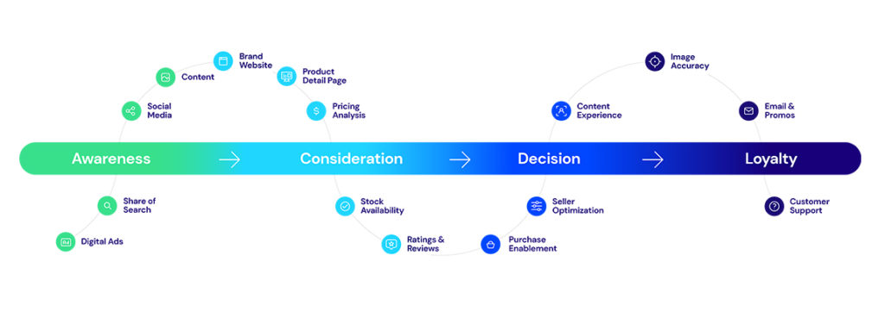
Figure 1Customer Journey stages ( Source:PriceSpider)
Customer journey can be defined as a path of interaction with the brand or the product and services. It includes various phases which complete the journey of the customer. These are mentioned below:
Awareness phase: - It is the first stage of the customer journey in which they find a problem regarding their day to day activities. In order to solve this customers look out for the product and services and on the other hand organisations effectively promote their products and its features.
Consideration phase: - It is the second part of the customer journey in which they compare products of specific organisations with the other (Demmers, Weltevreden and van Dolen, 2020). It can help them to generate more utility. Morrison ensures that they engage their customers by effective marketing techniques.
Purchase decision: - It is the third part of the customer journey in which they make purchases regarding the product or services which they are looking for.
Retention phase: - It is the fourth stage of the customer journey in which organisations focus on engaging particular customers for a long period of time. Morrison always ensures that they analyse the needs and wants of the customers so that they can engage them in the future.
Advocacy phase: It is the beneficial stage for the organisation because customers after using the products and services of the organisation advertise it to their known ones.

Customer Touch points
Customer touch points can be defined as a direct or indirect contact with the customer that has been established by the brand. It can occur at any point of time. Some of the customer touch points are mentioned below in relation to the Morrison Company:
Pre purchase
- Social media: - Marketing department of Morrison organisation effectively uses social media platforms in order to promote their products and services into the market. This process is carried out before the purchase period.
- Online advertisement: Morrison organisation focuses on advertising their new launches in an online way through which they can attract a large number of customers.
- Digital marketing content: - Upper-level department of Morrison organisation hires professional individuals at the workplace who can write good content for their products on their websites. This is done by using digital marketing techniques before the purchase period.
- Company Events: Morrison marketing department organises events when they launch new products in the market place. These events are executed in order to gain a lot of customers towards their business.
- Peer referral: It refers to the formal letter in which one person in the organisation talks about the common traits and characteristics of a product.
Purchase
- Conversation with company Representatives: Marketing department of Organisation effectively connects with the customers regarding the particular products and services for which a customer has a desire to purchase.
- Product catalogues: - They have an effective product catalogue in which each and every grocery product is mentioned (Gao et.al., 2021). This helps the customers to purchase what they want.
- Product reviews: Administration department of Morrison organisation mentions reviews on each and every product so that customers can wisely choose which product they want to purchase.
- Website: Developer team of the organisation have built an effective websites through which customers can make purchases regarding the particular product. It is one of the most effective touch points that customers experience during a purchase.
- Point of sale: Morrison organisation maintain a point of sales system in which they record each and every transaction regarding the sales they have made in a particular period of time. It helps them to maintain the record of past purchases of the customers.
After Purchase
- Thank you Letters: The organisation serves a thank you letter to the customers when they make purchases regarding the particular product.
- Product feedback surveys: After a purchase one of the most important touch points that comes under is the product feedback surveys. This is undertaken by Morrison Organisation in order to take reviews from the customer regarding their product.
- Upselling/cross-selling emails: After a purchase marketing department of Morrison organisation regularly sends email to their customers regarding the new launches.
- Subscription renewals: They also remind their customers regarding their subscription renewals through which they can engage their customers in the long period.

Customer Journey MAP diagram with the help of example of table
A customer journey map can be defined as an idea in which it can see how customers go through the purchase of products or services. Customer journey map for the Morrison organisation is mentioned below:
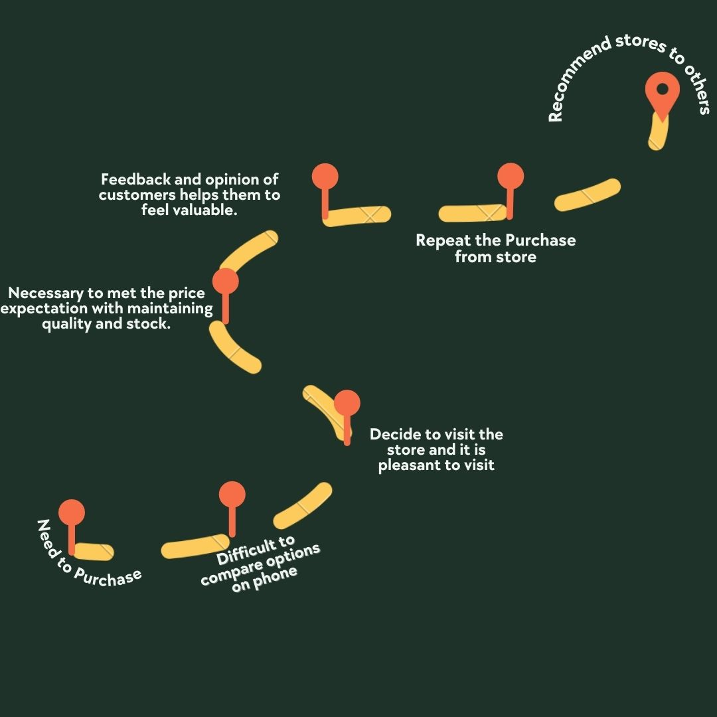
Figure 2 Customer Journey map (Source: Made by learner)
Firstly the customer will arise a need of purchase regarding the grocery product then they will do research from which place they have to get the grocery. In relation to the customers of Morrison they will first go to their store and will pick up all the items they want and make purchases of it and in between the journey of making the purchase they can find that the expectation of their prices are meeting their pocket (Steinhoff and Zondag, 2021). The Morrison organisation operates from their supermarket stores and this helps their customers to check out all the options they have. While customer is making the purchase of the products in their stores they have to face the bad behaviour of the cashier that was receiving payment of their purchasing. After the using of the products and services they can have a positive experience with the particular products which they can recommend to their known ones. Customer journey map is very beneficial for the Morrison organisation because it helps in analysing the experience of their customer by the use of social media, email and many more channels.

Strength and weakness of particular brand customer journey MAP in Detail
From the above customer journey map it can be seen that there are various strengths and weaknesses for the organisation as well as for the customers when they make purchases in the store of the Morrison. Some of these strengths and weaknesses of the organisation are mentioned below in regards to the customer journey map:
Strengths  - One of the main strength of the above customer general map is that Morrison provides supermarket store facilities to their customers so that they can easily search out for the products they want to purchase. It comes out to one of the major strengths of the organisation because they have a supermarket chain across the market of the UK which provides benefits to them as well as to the customers in getting all the grocery products they want.  - Another main strength of the particular customer journey map is that they provide all the grocery products at very reasonable prices. This proves to be beneficial for the organisation because it enhance the experiences of the customers with the Morrison brand. | Weaknesses  - From the above customer journey map, it has been seen that when the customer is making a purchase regarding the products and services they have to faces the bad behaviour of the person who was at the cash counter (Patti, van Dessel and Hartley, 2020). It comes out to be the biggest weaknesses for the Morrison organisation because it can directly affects the engagement and experience of the customers with values of the brand. From the above customer journey map, it can see that affects the image of the company in the eyes of the customers.

Total Engagement model

Figure 3Total Engagement Model (Source: Made by learner)
Total engagement model integrates all the activities of the business effectively and efficiently through which the organisation can increase the engagement of the customers with the products and services in the long run. Total engagement models can be made with the use of several components which helps the organisation to increase the engagement of their customers. In relation to the Morrison organisation they can make an engagement motel that is mentioned below:
Outreach: - It is the first stage of the model in which an organisation must find out the needs and wants of their customers by carrying out effective marketing research and campaigns. This will help the organisation to effectively know the potential customer needs and desires.
Acquisition: This is another part of the model in which organisations must prepare in advance of the questions that their customers will put. Administration department of the Morrison organisation can release content and features of their products on the multimedia channels so that they can attract a large number of customers.
Get in touch: It is the third and most important part of the total engagement model in which organisations must focus on personal interaction with their customers (Shah and Guild, 2022). In relation to Morrison they should effectively perform this part so that they can increase the engagement of their customers regarding their grocery products.
Maintain: It is another part of the model which tells how to maintain a customer relation so that their interest should be kept with the organisation. In relation to Morrison they can hire a manager who can regularly update and give information about new products to their customers.
Grow and Nurture: It is last and effective part of the model in which an organisation must send a postcard, letters and emails through which they can maintain a healthy relationship with their customers.

CONCLUSION
From the above report it has been concluded that the concept of marking management is most effective for the organisations that help in analysing the needs and desires of their customers. It facilitates the managers of the organisation to produce desired products and services so that the value of the organisation can be increased. There has been discussion about the communication model and various integrated marketing communication techniques that are used in order to connect with customers. Along with that new promotional strategies have been evaluated. After that brand equity models have been undertaken into the account. After that there has been discussion about the customer journey stages, touch points and map. These all concepts of the customer journey help to find out the customer experience with the particular product and services of the organisation. At the end total engagement model has been applied. Engagement model helps in increasing the customer engagement with the values of the organisation.

REFERENCES

Books and Journals
Arya, V., Paul, J. and Sethi, D., 2022. Like it or not! Brand communication on social networking sites triggers consumer‐based brand equity. International Journal of Consumer Studies, 46(4), pp.1381-1398. https://onlinelibrary.wiley.com/doi/abs/10.1111/ijcs.12763
Carranza, R and et.al., 2020. PLS–SEM in business promotion strategies. A multigroup analysis of mobile coupon users using MICOM. Industrial Management & Data Systems. https://www.emerald.com/insight/content/doi/10.1108/IMDS-12-2019-0726/full/html
Cruz-Milán, O., 2021. Assessing the role of venturesomeness in a destination consumer-based brand equity model. Journal of Hospitality and Tourism Insights. https://www.emerald.com/insight/content/doi/10.1108/JHTI-09-2021-0264/full/html
Deepak, R.K.A. and Jeyakumar, S., 2019. Marketing management. Educreation Publishing. https://books.google.co.in/books?hl=en&lr=&id=_DmvDwAAQBAJ&oi=fnd&pg=PA1&dq=marketing+management&ots=u46Vmebn_h&sig=gs8Z13LE3FfMYSZ6VIKMK5xHCB4&redir_esc=y#v=onepage&q=marketing%20management&f=false
Demmers, J., Weltevreden, J.W. and van Dolen, W.M., 2020. Consumer engagement with brand posts on social media in consecutive stages of the customer journey. International Journal of Electronic Commerce, 24(1), pp.53-77. https://www.tandfonline.com/doi/abs/10.1080/10864415.2019.1683701
Flett, E., Wilson, J. and Gover, R., 2020. Morrisons off the hook as employers welcome clarity on vicarious liability for data breach: WW Morrison Supermarkets plc v Various Claimants [2020] UKSC 12. Journal of Intellectual Property Law & Practice, 15(7), pp.504-506.
Gao, L.X and et.al., 2021. Exploring the role of service touchpoints on the path to financial, behavioral and relational customer outcomes: insights from a B2B service context. Journal of Business & Industrial Marketing. https://www.emerald.com/insight/content/doi/10.1108/JBIM-02-2021-0100/full/html
https://academic.oup.com/jiplp/article-abstract/15/7/504/5871342
https://www.emerald.com/insight/content/doi/10.1108/IJCHM-03-2020-0186/full/html
Nankali, A and et.al., 2020. Integrated Marketing Communication in B2B2C Area. In Beyond Multi-channel Marketing. Emerald Publishing Limited. https://www.emerald.com/insight/content/doi/10.1108/978-1-83867-685-820201009/full/html
Patti, C.H., van Dessel, M.M. and Hartley, S.W., 2020. Reimagining customer service through journey mapping and measurement. European Journal of Marketing, 54(10), pp.2387-2417. https://www.emerald.com/insight/content/doi/10.1108/EJM-07-2019-0556/full/html
Ruben, B.D. and Gigliotti, R.A., 2019. An Overview of Foundational Perspectives on Communication. Leadership, Communication, and Social Influence, pp.35-54. https://www.emerald.com/insight/content/doi/10.1108/978-1-83867-118-120191006/full/html
Shah, M.U. and Guild, P.D., 2022. Stakeholder engagement strategy of technology firms: A review and applied view of stakeholder theory. Technovation, 114, p.102460. https://www.sciencedirect.com/science/article/abs/pii/S0166497222000074
Steinhoff, L. and Zondag, M.M., 2021. Loyalty programs as travel companions: Complementary service features across customer journey stages. Journal of Business Research, 129, pp.70-82. https://www.sciencedirect.com/science/article/abs/pii/S0148296321000953
Tasci, A.D., 2020. A critical review and reconstruction of perceptual brand equity. International Journal of Contemporary Hospitality Management.

