

Critical analysis of how Covid-19 has effected the (ethnic minority) catering sector in Birmingham city centre .
The Proposal has Been Accumulated for University of Wales Trinity Saint David.
MOHAMMED AMIR HUSSAIN CHAUDHARY 1711710 | 6/6/22 | MBA Dissertation proposal Word count 2000



STUDENT NAME MOHAMMED AMIR HUSSAIN CHAUDHARY STUDENT REGISTRATION NUMBER 1711710 MODULE CODE MBALCMB 7020 GROUP NUMBER QPLR7 LECTURER’S NAME TARILA ZUOFA
MODULE NAME MBA - DISSERTATION

DECLARATION.

As a registered student at UWTSD. I Mohammed Amir Hussain Chaudhary (Student I/D 1711710) declare that this dissertation was submitted for the MBA degree, I am the sole author of this dissertation and I have not been registered at any other institution or University.
No portion of the material in this dissertation has been submitted for any degree or other qualification at any other institution or University by myself, or to the best of my knowledge and belief, by any other person. The dissertation can be defined as the author’s unique work.

ACKNOWLEDGEMENTS.

The research in this dissertation has been accomplished with the guidance of Dr Tarila Zuofa. This dissertation would have been next to impossible without the advice, support and information provided to me throughout the progression of this dissertation. Hence, I have a lot of respect for my supervisor and would like thank him for his guidance and direction during the dissertation, which supported hugely to the research quality and my own improvement. Also I would like to express gratitude to Dr Eric Osei who is module coordinator of the course. furthermore, I want to thank UWTSD for allowing me to pursue my dream in completing my education which I was unable to do in my youth. Also, I want to show my gratitude to UWTSD for their help, supervision, teaching and permitting me to utilise all the resources, for example online library etc.
my special thanks goes to my son and daughter for their support and patient throughout the duration of the dissertation. Lastly, I want to show my appreciation to my beloved wife who has been very understanding, supportive and influential in the whole period of the dissertation.

ABSTRACT.
Coronavirus Pandemic has caused a major business disruption that has had a serious
implication on the Indian, Chinese and Italian restaurants in Birmingham (Nanda et. al. 2021). This research study focuses on critical analysis of how Covid-19 has effected the ethnic minority entrepreneurs and their businesses, operating as Indian restaurants in Birmingham.

Purpose of this research study is to identify some of the challenges faced by Indian restaurants in Birmingham in pre-post pandemic and the significant differences between the restaurant and their management performance to survive during this era, emphasising critical performance changes and strategies that may shape the future of this trade. By assessing all the available secondary data, it is clearly visible and easy to identify the gap for the research questions of this topic and simplify how to exploit and accumulate qualitative resources (social approach) to execute them.

Aim of this research study is to highlight the effect and impact of covid-19 on Indian restaurants in Birmingham and examine how the pandemic has forced diverse challenges like decrease of profit-margin, shortage of employees, supply chain disruption’s and environmental changes effecting restaurants to fail.

Objective of this research study is to bridge the gap that has been identified from secondary data analysis of (ethnic minority) Indian restaurants in Birmingham in Covid-19 era and are still facing in post Covid-19 era.

Research methodology aids to comprehend how covid-19 has impacted and affected the Indian restaurants in Birmingham key literature review relevant to the topic has been utilised for this research study. This embroiled using carefully selected range of online published literature mostly from google scholar (PDF’s, journals and books) and other journal websites at no costs. Also, UWTSD online library and small heath library has been utilised to assess most of the literature that are not available for free on Google Scholar or other journal websites has been used to collect.

Searches for PDF, Journals and books was conducted by using key words related to the topic. Subsequently, distribution of structured questionnaire method has been applied, which has been sent to restaurant entrepreneurs in Birmingham to attain extensive data’s. No expense is involved for this research study, all data collected are free of cost and will require to be thoroughly analysed and all participants are invited to take part in the survey voluntarily, if only they feel contented and confident in doing so.
Limitation of this research study.
There are many limitations to this research study that can be researched about in future by researcher. For example, scrutinising restaurants pricing strategies, pre and post Covid-19 era, as Covid-19 has boosted the inflation rates to an all-time high, this has directly impacted the products and goods that are purchased by the restaurants. The main focus of this research study is on Indian restaurants in Birmingham, there are many other diverse cuisines that can be focused on, there are also other cities in UK which have not been addressed. Secondary data analyses (literature reviewed) suggest that these section have not been addressed, such as impact of Covid-19 on the key stakeholders interest (restaurant customers). Future researches can also scrutinise restaurants pricing strategies, pre and post Covid-19 era, these perspectives can be addressed in future studies, as this will enrichen extensive knowledge and understanding of the topic.

Key findings.
- Shortages of financial resources: liability and debt where increasing.
- Insufficiencies in human resources: crises in finding restaurant workers.
- Barrier developed by changing business environment: innovative technologies.
- Restaurants are unappealing to employees: no promotion, unsecured future.
- Deficiency in training facilities: no training programs for employees.
- Shortage of supply: spices stops arriving from India.

Conclusion.
This research study reveals the significance of Indian restaurants in Birmingham. By conducting this research study, it has enabled to recognised obstacles faced due to covid-19 crises. The literature reviewed in this research study has aided in identifying importance of environmental analysis (using PESTLE) the significance of training employees, prominence of providing appropriate facilities for employees. Also facilitated in understanding models and theories for businesses, if endure in an unpresented time like the pandemic. Although, covid-19 has critically devastated the nation and had a catastrophic impact on the hospitality sector (mainly restaurants). clearly it is recognisable that even if there is a lot of negativity of covid-19, it has also presented businesses with many opportunities. Covid-19 forced businesses to evaluate the current circumstance of the business if they are to have any chance of survival in existing era and developed a pathway for future success of the businesse.

List of Figures.

Figure 1. Qualitative and Quantitative Framework…………………………………………28
Figure 2. Deductive and Inductive theory…………………………………………………...32
Figure. 3. Image of grounded theory…………………………………………………………32
Figure 4. Pie Chart. 1………………………………………………………………………….39
Figure 5. Pie Chart. 2………………………………………………………………………….40
Figure 6. Pie Chart. 3………………………………………………………………………….41
Figure 7. Pie Chart. 4………………………………………………………………………….41
Figure 8. Pie Chart. 5………………………………………………………………………….42
Figure 9. Pie Chart. 6………………………………………………………………………….43
Figure 10 Pie Chart. 7………………………………………………………………………….43
Figure 11 Pie Chart. 8………………………………………………………………………….44
Figure 12 Pie Chart. 9………………………………………………………………………….45
Figure 13 Pie Chart. 10………………………………………………………………………...46
Figure 14: Static for social media platforms………………………………………………….50
Figure 15: Maslow’s Hierarchy of Needs………………………………………………….….52
Figure 16: Image of PESTLE…………………………………………………………………..54
Figure 17: Image of SWOT analysis…………………………………………………………..73
Figure 18: Porters generic competitive strategies……………………………………………74

Table of Content.

Table 1. Literature review table in broader context…………………………………………24
Table 2. Literature review table in broader context…………………………………………25
Table 3. Project schedule chart……………………………………………………………….36
Table 4. Online Questionnaire Guide Transcript……………………………………………37
Table 5. Online Questionnaire Guide Transcript……………………………………………38
Table 6. Email dispatched and retrieved chart……………………………………………...39
Table 7. Maslow’s Hierarchy of Needs……………………………………………………….53

Contents
DECLARATION. 2
ACKNOWLEDGEMENTS. 2
ABSTRACT. 3
List of Figures. 5
Table of Content. 6
CHAPTER ONE. 9
Critical analysis of the hospitality sector pre and post pandemic: 9
An in-depth examination of Indian restaurants in Birmingham. 9
1. Introduction. 9
1.1 Overview. 10
1.2. Problem statement. 11
1.3. Purpose of this research. 11
1.4. Aim of this research. 12
1.5. Objective of the study. 12
1.6. Research methodology. 12
1.7. Data analysis. 13
1.8. Conclusion. 13
CHAPTER TWO. LITERATURE REVIEW. 14
2. Introduction. 14
2.1. Situation analysis of Indian restaurants in Birmingham. 14
2.2. Impact of Covid-19 altering the business environment. 15
2.2.1 Opportunities developed, direct consequence of covid-19. 16
2.3. Disruption within the supply chain, covid-19 stops all movements. 18
2.3.1. distributor directly supplying products. 18
2.4. Employees shortage, direct result of Brexit and pandemic. 19
2.4.1. Utilization of social media platforms. 20
2.4.2. Governments support to revive businesses and deficit of employees. 21
2.5. Leadership crisis, as pandemic forces change. 21
2.5.1. Significance of technological equipment’s in covid-19 era. 22
2.6. Acknowledged a gap within the existing researches. 23
2.7. Literature review table in broader context. 24
2.8 Conclusion. 26
CHAPTER THREE. RESEARCH METHODOLOGY. 27
3. Chapter overview. 27
3.1. Research methodology. 27
3.2. Qualitative vs Quantitative 27
3.3. Research Philosophy. 28
3.4. Philosophy, Ontology and Epistemology. 29
3.4.1 Epistemology. 30
3.5 Mixed method. 30
3.6 Method Selection. 30
3.7 Deductive vs Inductive theory. 31
3.8 Applying grounded theory for qualitative research. 32
Figure 3. Image of grounded theory. 32
(Source: Static how to. 2022). 32
3.8.1. Data collection. 32
3.8.2. Data analysis. 33
3.8.3. Open coding analysis. 33
3.8.4. Axial coding analysis. 34
3.8.5. Selective coding analysis. 34
3.9. Project management. 35
3.9.1. Risk Factors. 35
3.9.2. PROJECT SCHEDULE CHART. 35
3.10. RESEARCH QUESTIONNAIRE FORM. 37
3.10.1. Email dispatched and retrieved chart. 39
3.10.2. Analyzing the questionnaire. 40
3.11. Ethical Considerations. 47
3.12. Conclusion. 47
CHAPTER 4: FINDINGS, ANALYSING AND DISCUSSION 48
4. Introduction. 48
4.1 Presentation of findings. 48
4.2. Analyzing and discussing about the finding. 49
PESTLE analysis. 54
Discussions of the results. 56
CHAPTER 5: CONCLUSIONS AND RECOMMENDATIONS. 57
5. Recommendation. 57
5.1. Research limitation and future recommendations. 58
5.2. Ethical consideration. 59
5.3. Conclusion. 59
6. Reference. 61
7. Appendix 73
Appendix 1. SWOT analysis. 73
Appendix 2. Survival strategy for Indian restaurants. 74

CHAPTER ONE.

Critical analysis of the hospitality sector pre and post pandemic:

An in-depth examination of Indian restaurants in Birmingham.

Introduction.
This chapter aims to discuss the contextual of the topic. How Covid-19 has effected the Indian restaurants and their businesses in Birmingham. Each section of the chapter highlights key data’s like the overview, problem statement (research questions), purpose, aim, objective and research methodology of the study. Chapter one highlights the significance of the research and aids in developing a pathway of how this research study is going to proceed. To provide an enhanced knowledge of the existing circumstances, articles by reputable academics have been presented on the research topic.

Ciotti et. al. (2020) Covid-19 disease (Coronavirus) is a transferrable disease caused by the Sars-Cov-2 virus. Hospitality sector in London, Manchester and Birmingham has been hit hard by Covid-19. and the effect has been devastating, especially on restaurants, hotels, bars and clubs have fared the worst. According to Kim. et. al. (2020), consumer’s expenditure on (hospitality sector) pubs, hotel and restaurants across cities like London and Manchester has gradually started progressing but in Birmingham it still remains less than 71% pre-pandemic level. Likewise, the restaurants revenue is still decreased by 67% in contrast to pre-pandemic levels. Throughout the pandemic on of the key challenges faced by restaurants was obtaining goods and products from suppliers.

According to Islam. et. al. (2020), pandemic has led to disturbances in restaurants supply chain. Also, there was shortage of workers due to Covid-19 infections and lockdown restrictions to stop the spread of the virus. For instance, employee availability was reduced by up to 40% at Summers Poultry (one of the largest distributors of chicken and meat products in UK). They supply 70% of the restaurants in major cities like London, Manchester and Birmingham. Now they are ineffective in meeting the demand of the restaurants, due to this restaurant have been declining post pandemic.

Overview.
The most common ethnic minority cuisine purchased in restaurants in UK is Indian food. Buettner, (2008), claims that Indian restaurants have been a fundamentally part of the British food industry since the early 19th century. Restaurants are utilised for various diverse activities when an individual is dining, such as celebrating special occasions with family, friends or relatives and socialising with colleagues or have business meetings with associates (Pedraja and Yagüe 2001). examination of business figures from the Office for National Statistics has revealed that there is around 98 restaurants in Birmingham (Financial Times, 2020). Independent research conducted by the author suggests a slightly different figure of 104 Indian restaurants, this indicates how popular Indian food is with the local-community in Birmingham and Covid-19 is threatening the very existence of these Indian restaurants.

1.2. Problem statement.
After analysing the literature, researches reveal that there is a gap within the existing researches conducted by academics on the effect and impact of Covid-19 on the hospitality sector. These research questions have been acknowledged that needs addressing.

- Internal and external business environment analysis to evaluate the changes Covid-19 has inforce on restaurants. For example, how the law has been altered like shortening trading hours, how this is effecting the restaurants, this has also been acknowledged by (Hanson. et. al. 2021).

- Evaluation of the supplier’s chain to comprehend the influence the pandemic has had. For example, changes in the supply processes, delivery processes, this is acknowledged by authors like (Islam. et. al. 2020). Also, alternative strategy that can be applied to overcome the current crisis.

- Examining the complication encountered by Indian restaurants to assess the impact covid-19 has had pre and post pandemic, this will aid in developing understanding of why there is shortages of employees, health safety and welfare of employees and why employee trainings is vital. This has likewise been acknowledged by academics like (Zhong et. al. 2021) in their journals.

- Scrutinising the leadership challenges encountered in pre and post pandemic era to evaluate what are the vicissitudes. For example, altering the traditional leadership style and adopting to an appropriate leadership style that enables to safeguard all stakeholders and the business. Academics like (Yang, Liu, and Chen 2020). also acknowledged this in their articles.

1.3. Purpose of this research study.
Purpose for this research is to highlight the effect of Covid-19 and to provide superior knowledge and understanding of how restaurants have previously and are presently confronting challenges. Also, this research study will provide some additional knowledge and understanding and an indication of what future can have in store for these well-known cuisines. Restaurant spending have decreased by 74% in this pandemic and if these doesn’t change then 62% of restaurants will cease trading by 2022 (Dube et al, 2020). There are many researches done on the impact of Covid-19 on restaurants. for example, impact of covid-19 on customer’s services, delivery services, adaptation of innovative technology etc. However, this research study will be completely atypical from previous articles; as it directly scrutinises sections like impact of covid-19 on the changing business environment, effects on supplier’s chain, shortage of employees and leadership challenges. Which have not been analysed by other academics previously.

1.4. Aim of this research.
Aim of this research is to highlight the effect and impact of covid-19 on Indian restaurants in Birmingham and examine how the pandemic has forced diverse challenges like decrease of profit-margin, shortage of employees, supply chain disruption’s and environmental changes effecting restaurants to fail.

1.5. Objective of the study.
Objective is to bridge the gap that has been identified from secondary data analysis of (ethnic minority) Indian restaurants in Birmingham in Covid-19 era and are still facing in post Covid-19 era. To achieve the objectives certain key steps are required such as:

- To examine the available literature and understand the impact of covid-19 on Indian restaurants in Birmingham and how they are coping with their current situation.

- Analysing the leadership challenges encountered by Indian restaurants in pre and post pandemic era.

- Evaluate the external and internal business environment pre and post Covid-19 and compare the difference to comprehend the changes.

- Scrutinising the complications encountered by the supplier’s chain in post pandemic era, to recognise the vicissitudes.

- Examine how Covid-19 has developed diverse challenges for Indian restaurants in Birmingham such as shortage of skilled employees.

1.6. Research methodology.
Research methodology aids to comprehend how covid-19 has impacted and affected the Indian restaurants in Birmingham. Key literature review relevant to the topic has been utilised for this research study. This embroiled using carefully selected range of online published literatures mostly from google scholar (PDF’s, journals and books) and other journal websites at no costs. Also, UWTSD online library and small heath library has been utilised to access most of the literature that are not available for free on Google Scholar or other journal websites has been used to collect.

Searches for PDF, Journals and books was conducted by using key words related to the topic like Impact of Covid-19 altering the business environment or disruption within the supply chain, because of covid-19. According to Panneer selvam (2014), research methodology is the comprehensive procedures applied to recognise, select and collect appropriate data about a topic. Subsequently, distribution of structured questionnaire method has been applied, which has been sent to restaurant entrepreneurs in Birmingham to attain extensive data’s. No expense is involved for this research study, all data collected are free of cost and will require to be thoroughly analysed and all participants are invited to take part in the survey voluntarily, if only they feel contented and confident in doing so.

1.7. Data analysis.
Data analysis will involve probing each structured question transcript prudently read and thematically analysed. According to Terry. et. al. (2017), Thematic analysis is a process for evaluating qualitative data that involves probing across data set to categorise, examine and report frequent patterns. Throughout the preliminary phase of thematic analysis, the utilisation of qualitative coding analyses will be applied to each structured questionnaire. According to Garcia-Cruz et. al. (2006), qualitative coding is the procedure of sorting the collected non-numerical data into groups and conveying the numerical codes to these groups. Numeric coding is collective by all statistical software and among others, it simplifies data conversion and measurement contrasts.

1.8. Conclusion.
Chapter one commenced with the explanation and analysation of contextual knowledge about how covid-19 has effected Indian restaurants in Birmingham. Followed by explaining key facts like purpose, aim, objective, research methodology, data analysis of this study research etc. In the first chapter the outline of this research study have been discussed, the second chapter will be the literature review.

CHAPTER TWO. LITERATURE REVIEW.

Introduction.
Reviewing literatures appropriately is significant, as reputable literature enhances knowledge and understanding of selected topic. According to Knopf (2006), literature review is a summary of earlier research on a subject. Literature review comprises of books, academic articles and further significant sources to a specific area of research. The review enumerates, describe, summarize, accurately evaluate and elucidate this previous research. By reviewing the available literature on restaurants in this pandemic it will facilitate one to understand and view the diverse challenges faced by Indian restaurants in Birmingham pre and post pandemic.

2.1. Situation analysis of Indian restaurants in Birmingham.
According to Mansour and Esseku (2017), situation analysis is basically an efficient way of examining the internal and external aspects that influences the business at any time or any moment. These aspects can comprise of consumers, rivals, the environmental market, and the business's competences. Researches performed by Crick et. al. (2016), found that Indian restaurants are utilised for various diverse activities when an individual is dining, such as celebrating special occasions with family, friends or relatives and socialising with colleagues or have business meetings with associates. Buettner, (2008), claims that Indian restaurants have been a fundamental part of the British food industry since the early 19th century. By examining the literature from the above authors, it can be comprehensible established that Indian restaurants are a crucial part of the British society and Indian restaurants have been around for centuries, so their roots are firmly placed in UK.

According to Sidorova (2021), the death toll in UK was very high and people had direct or indirect experience with it. Death and suffering due to the pandemic induced transformation. Even after lifting strict regulations, people kept fearing to go outside. The trauma affected businesses the most by losing valuable customers. Researches done by Ntounis et. al. (2022), identifies that hospitality sector in London, Manchester and Birmingham has been effected the most by Covid-19 and the effect has been devastating, especially on restaurants, hotels, bars and clubs have fared the worst. In the case of Birmingham, the pandemic affected more than 350,000 people till July, 2022 (Birmingham City Council, 2022).

Chen and Sriphon (2021), has similar views on covid-19 and its impacts as Ntounis et. al. (2022) and further goes on to highlights some of the vital effect Covid-19 has had on Indian restaurants and how covid-19 is forcing changes in social aspects. One of the impact is the lack of physical communication between all stakeholders during Covid-19, it reduced the interactivity between Indian restaurants and their customers. Also, Dube et al, (2020), agrees that the deficiency in communication amongst Indian restaurants and their customers is the cause for the restaurants spending to decreased by 74% in this pandemic and if these doesn’t change then 62% of restaurants will cease trading by 2022.

However, researches by Ramuni (2021), found that there are two additional causes besides the key findings highlighted by Chen and Sriphon (2021), which are liability and debt the two potential threats for businesses while operating in a certain industry. In this area, now restaurant businesses are finding it difficult to operate successfully. Before pandemic, liability and debt were being repaid from earning and profits. During pandemic, debt size kept increasing to pay salary to the workforce as the business was at a standstill. Madeira. et. al. (2020), explains that to overcome this pandemic, it is essential for restaurants businesses to analyse their current situation by performing internal and external business environment analysis and where necessary utilise cost effective methods. For example, amend employee schedules to the need of the business, limit the menu, eliminate all unnecessary products, shorten business hours (eradicate excessive trading hours). This will assist in developing strong resilience in sustaining operation of their business and stop the businesses from further declining in the pandemic.

2.2. Impact of Covid-19 altering the business environment.
According to Duffy (2003) an external analysis examines the conditions and events outside a business environment that influences the business operations. An internal analysis focuses on all the factors within the business such as weaknesses and strengths of the business. By evaluating the Indian restaurant in Birmingham and their business pre and post covid-19, it is assessable to establish how covid-19 has effected these restaurants business environment and the various challenges that the changing business environment has enforced on the Indian restaurants. Studies conducted by Zhong et. al. (2021), explains that these are frightening times and employees are getting infected or are in isolation from Covid-19. This has impacted the Italian, Chinese and Indian restaurants across UK and they are on the verge of shutting down.

Researches by Fetzer (2022), has identified that the key factors why businesses are on the verge of shutting down is casual dining in sector (restaurants) to face massive, well-documented pressures from the government, which have been exacerbated by Covid-19 and the lockdown. Hanson. et. al. (2021), claims that the virus was spreading rapidly, so the government needed to intervene and amend the existing laws and introduce extreme measures on the hospitality sector, which has had an overwhelming impact on the business performances of pubs, restaurants and hotels across the country, this has forced these businesses to alter their existing strategies and adopt to the new vicissitudes which are very costly. This decision implemented by the government has complicated things and prolonged the suffering for restaurants even post covid-19.

Davahli et. al. (2020), argues that the government has made the right decision by introducing new laws to safeguard everyone, by restricting businesses to provide leaflets and guidelines about Covid-19 and health and safety procedures of wearing masks, keeping two-meter distancing and using hand sanitisers constantly throughout, it will reduce the spread of the virus, particularly the restaurants as they are a social get-together place where the virus is more spreadable. Furthermore, they explain that health and safety are a primary concern and money is secondary. Cowie (2020), agrees with the statement made by Davahli et. al. (2020) and comments that it was also a wise decision by the government to constrict the Food Safety Act-1990 and incorporate new instruction to provide containers which are made of food grade materials, proper packaging will sustainable for future products to be safer and healthier.
In a nutshell, it can be said that the governments verdict to alter the law for the hospitality sector (restaurants) can be traumatic in the present scenario, but the consequences of this step will be benefiting for the future of Indian restaurants in Birmingham. By evaluating the researches performed by academics on Indian restaurant in Birmingham and their business pre and post covid-19, it is assessable to establish how covid-19 has effected these restaurants business environment and the various challenges that the changing business environment has enforced on the Indian restaurants.

2.2.1 Opportunities developed, direct consequence of covid-19.
According to Alaneza et. al. (2020), pandemic has immobilised the society from socialising in outdoor venues like restaurants, pubs, hotels and wine bars. This has forced the business environments to transform. At the same time, it has also presented opportunities for Chinese, Indian and Italian restaurants across UK to develop and adopt to innovative business concepts by utilising social media or digital platforms. Obukhova (2022), explains that there was a complete lockdown in UK. The only option was to increase the market awareness and develop brand recognition. 100% customers were relying on social media for communication and internet to know update about Covid-19. However, a research study done by Yost, et. al. (2020) suggests that Covid-19 has developed major challenges for hospitality sector as the changing business environment of Indian, Chinese and Italian restaurants throughout US and UK are struggling to adopt digital platforms, a survey conducted across UK suggests that 79% of restaurant workers are not familiarised in operating digital platforms like Just eat or Uber eats and also are incompetent in accumulating payments through digital card machine, they lack the knowledge and understanding as they are untrained in this field.

Luo and Xu (2021), argues that there are far more benefits to using digital platform within a business then not using digital platforms. They explain although employees within the hospitality sector lack training on how to utilise digital platforms, this obstacle can be achieved through diverse training programs. Siahmazgi and Ramezan, (2021) backs the statement made by Luo and Xu (2021) saying that technology develops the scope to enhance market presence of digital marketing. Though there was no required amount of marketing pre pandemic from Indian restaurant, the scenario started changing promptly. Technology has a positive impact on the business operations. It smoothens operations, improves focus, and increases the target audience by providing a proper presence of product in virtual format.
Yarış and Aykol (2021), disagree to a certain extent with the statements made by Luo and Xu (2021) and Siahmazgi and Ramezan, (2021) highlighting the significance of social media platforms for the hospitality sector in this pandemic (mainly restaurants), but also identifies the impact Covid-19 on businesses and how covid-19 has key role in decreasing business, as a consequence businesses are financially facing a challenging time, training employees are very costly. This method can seriously affect restaurants in many ways such as not being able to pay employees, suppliers, bills on time, causing a backbreaking consequence in the present circumstances.
According to Hao and Chon (2020), the hospitality sector (mainly restaurants) in China faced challenging time as the pandemic brought a halt to the society from socialising in outdoor venues and trading in restaurants, hotels, wine-bars and clubs decreased by 71% in compression to the previous year. Strategy to revive businesses and stabilise the economic, hospitality sector (mainly restaurants) entrepreneur’s where advised by (SAWS) state administration of work and safety (health and safety agency of China) to exploit digital platforms (social media) and after 3 months a survey performed by (SAWS) revealed that the economic recovered by 42%. By reviewing the article, it is noticeable that similar results can be achieved in Birmingham if similar processes where followed.
In short, it is identified that pandemic has had a devastating impact on restaurants in Birmingham physically and financially, to overcome the present crisis it is essential to adapt technological changes within the business structure, this will help develop Indian restaurants for the future challenges. Furthermore, by utilising technology it will potentially increase competitive advantage by dint of technological enhancement scopes over competitors.

2.3. Disruption within the supply chain, covid-19 stops all movements.
According to Barman and De (2021), disruption in the supply can be described in many ways such as disturbance or complications that interrupt the supply from reaching the retailer, process or activity, a supply chain disruption means there is a breakdown in the manufacture flow of products and their delivery to consumers. Restaurants are socialising places where individuals meet for diverse occasions be it family gatherings, parties, friends outing together or business meetings etc. If the management is incapable of suppyling the food ordered by the customers then it will have a negative impact on the business, so it’s vital that the restaurants supply reaches the restaurant on schedule.

Study conducted by Mina. et. al. (2020), identifies that restaurant sector in UK is in crisis as the impact of Covid-19 has taken its toll, prawns and king prawn suppliers in Bangladesh have stopped their supplies, this is due to Covid-19 forcing UK to temporarily postpone all flights from Bangladesh. Similarly, Kaur (2020), comments that the spices that are used in Indian restaurants are imported, the national restrictions on importing from overseas nationally has affected the supply chain. A large portion of ingredients in Indian cuisine depends on the import from India. Indian community is still suffering from the consequence of the pandemic on its operations.

Nordhagen. et. al. (2021), researches identifies that not only restaurants suffered from the result of UK suspending all flights from Bangladesh, this also equally effects other importers like garments and groceries from Bangladesh. Islam. et. al. (2020), differs that if the situation is utilised appropriately then Covid-19 restriction can develop opportunities for pubs, hotels and restaurants to explore other suppliers, this will aid them to develop a platform to be more compatible when purchasing products in future.

2.3.1. distributors directly supplying products.
The pandemic started spreading, substantial care and focuses on the resiliency of food supply chains of Indian restaurants across UK in a time of this catastrophe. Food supply chains was required to modify quickly to demand-side shocks, plus panic buying and vicissitudes in food purchasing patterns, as well as strategy for some supply-side disruptions. As preliminary measure distributors where active in preserving transport and supply systems. (Hobbs 2020).

Chitrakar et. Al. (2021), disagree with Hobbs (2020), claiming that the effect of the pandemic on transport modes show a discrepancy significantly. large shipments haven’t seen any big disruptions, this meant distributors where on schedule with orders. Nevertheless, air freight was severely disturbed. Global air cargo capability in the week of ten to sixteen May was 26% lower than during the same time the previous year, with the biggest decline in capability on routes between Europe and Asia (with declines higher than 80%). Researches conducted by Al Amin et. al. (2021), found that it has undoubtable proven that food supply chains promptly engage in handling the covid-19 and to some extent agrees with Hobbs (2020). Remarking, there have evidently been worries, anxieties and problems, generally, food supply chains which were developed in UK have proven significantly forcefulness and resilience in the face of the pandemic. Reaction by policy makers have facilitated, simplifying the functioning of supply chains and evading the costly errors of the 2007- 2008 food price catastrophe in UK.

2.4. Employees shortage, direct result of Brexit and pandemic.
Employees are the backbone of every business. the significance of enticing and retaining employees in any industry can't be exaggerated. But for the food service industry (especially in restaurants), a loyal team can mean the difference between failure and success of the business. Indian restaurants in Birmingham are social venues, where the public get together for diverse occasions. Interaction and communication is very vital, so restaurants require employees that poses these skills, shortages of employee’s can have a destructive effect on the restaurant business (George 2015).

Zhong et. al. (2021), claims that employees are frightened to work, as they are worried of getting infected from Covid-19. This has impacted Italian, Chinese and Indian restaurants across UK and they are on the verge of shutting down due to the shortage of employees reach an all-time high. Studies conducted by Monras and Vázquez (2018), found that pre-pandemic the hospitality sector in UK (mainly restaurants) where facing a challenging time, there was a shortage of skilled workers, this was a direct consequence of Brexit which stopped the free movements of European Union migrant workers. However, Sumption and Kierans (2019), argues that it was not just Brexit but also other factors like government cumulating the capping on work-permits (for foreign workers) from £16,000.00 to £27, 000.00 Annual, this further complicated matter, to attain skilled workers from Bangladesh or India and pandemic was only the last straw.
Researches carried out by Chang and Chang (2021), found that a survey completed post pandemic by Harris Poll stated that 59% of Italian, Chinese and Mexican restaurant businesses in Canada was struggling to find qualified workers to fill job vacancies, this resulted in businesses opting to local recruiting by utilising social media platforms like LinkedIn, WhatsApp and Facebook, also approaching local job centres, six months along the line the statics was reduced to 31%. Birmingham is in a similar situation with covid-19 this approach can successfully be applied within the Indian restaurants in Birmingham and achieve same results. Meulenbroek and Cherney (2021), agrees with the statement made by Chang and Chang (2021), but also claims that part of the solution has only been identified to fully remerge from this crisis managements of hospitality sector (Indian restaurants) across UK must implement further resources in training and development programs for employee’s and also to entice employee’s. management requires to offer flexible and shorter working hours, sick leaves pays and more paid holidays etc. This will captivate new recruits as well as motivating the current workers.

2.4.1. Utilization of social media platforms.
Razzak et. al. (2021), disagrees with the comments made by Chang and Chang (2021), regarding training and developing employees about social media platforms, stating that their research has identified that prime protocol of training and developing in Indian restaurants is to enhance the communication skills of employee’s (front house), other training programs ought to be introduced to employees accordingly, further explaining that restaurants is a socialising outlets where communication and interaction skills are vital specially in the pandemic.

According to Yang. et. al. (2020), sales of restaurants, pubs and clubs all dropped in UK in the week prior to the government's warning to evade them due to the growing risk of pandemic. As a preventive measure. As a direct effect of this announcement, restaurants experienced the biggest fall in like-for-like sales in the week previous to the pronouncement at 24%, while bar sales decreased by 13%. Micromanaged pubs faired only marginally better with a 11% drop in sales, forcing restaurants, pubs and clubs to face a financial crisis. So the question arises is there enough funds and resources available for Indian restaurants in Birmingham to invest in training and developing programs.

2.4.2. Governments support to revive businesses and deficit of employees.
According to Pope et. al. (2020), after lockdown in March 2020. The government made a wise move to revive businesses that immediately ceased trading like restaurants, public houses, cafes, nightclubs and bars. By announcing various diverse schemes to revive the economic and safeguard the businesses, three examples. Small business grants fund (SBGF) was given in a one off payment of £10,000 for business with low business rates. The Kick-start project lets employers throughout the UK to apply for funding from a £2 billion funding to develop job placements for 24 to 16 year-olds who are claiming Universal Credit and who are at risk of long-term redundancy. Governments coronavirus job retention program (G.C.J.R.P), where the government paid 80% of the wages to employees who were furloughed in the pandemic. However, Baker and Judge (2020), disagrees with Pope et. al. (2020), stating that to obtain government grants was a very difficult and a gruelling process, the application has to tick all the boxes in order to be accepted. Proving the worth and meeting the strict criteria. There are many guidelines, targets and schedules to maintain, which consist of a lot of paperwork and human labour. The purpose of this is the government can trail the use of its funds, and ensure that the businesses are keeping up with their end of the contract.

But, Mayhew and Anand (2020), agrees with statement made by Pope et. al. (2020) claiming
that G.C.J.R.P and other loans and grants was a positive move for businesses that unable to continue with their workforce since their operations have been suffering by the pandemic, businesses can furlough their workforce and apply for a grant to cover a percentage of their normal monthly salary costs where they are recorded as being on the furlough was a salvation for many businesses and employees. It is clear to reconise that the advantages of government grants outweigh the disadvantages. As they can help Indian restaurants in Birmingham make positive strides and pose unique opportunities that wouldn’t be possible or obtainable anywhere else.

2.5. Leadership crisis, as pandemic forces change.
Elkhwesky. et. al. (2022), claim that leadership is a method of managing and inspiring others, through Leadership one is capable of teaching, training and developing attributes of others, such as self-awareness, self-regulation, honesty, unselfishness, integrity and accountability, which are important characteristics of transparent and authentic leader. Leadership plays a vital role in Indian restaurants, as Indian restaurants are small businesses where in majority cases the leader takes the responsibilities especially in the current situations where the pandemic has had a devastating impact on restaurants.

Akpan. et. al. (2021), recognises in their studies that restaurants proprietors are face with chain reactions. Firstly, pandemic has caused a health crisis this turned into social and economical crisis, now the Soviet Union and Kosovo war. This has hammered the businesses and has arisen critical challenges for the management. Kim et. al. (2022), claims that vicissitudes are vital in this pandemic, especially in the hospitality sector. Also, changes have to be manageable and effective, leadership style requires to be supportive, encouraging and motivational for employees, this can be achieved by diverse approaches such as communicating with employees about the changes, setting up website to clarify the significance of the changes and why the changes are critical etc.
Studies conducted by Haas et. al. (2020), identified that the restaurants in India (Bombay) have refurbished and modernised their business premises, also transformed the physical layouts to give it a pleasant, fresh and clean image and developed innovative leadership style (exclusive service styles), changes have worked wonders to achieve post-covid-19 progression successfully. So these methods can be applied in Indian restaurants in Birmingham to attain similar success. Zhong and Moon (2021) share similar opinions, but furthermore adds that refurbishing and restructuring the layout is insufficient, it also requires a strong alliance between managers and the employees to establish an appropriate leadership-style to implement changes and adopt new and innovative technological equipment’s which have been enforced by covid-19 and will aid in overcoming this circumstances.

2.5.1. Significance of technological equipment’s in covid-19 era.
Similarly, Hahang. et. al. (2022), also approves of the statement made by Akpan. et. al. (2021) furthermore, they add that it has already been identified that presently the hospitality sectors in Dubai, Japan and USA, (particularly restaurants) are using innovative technological equipment’s like epos system, IPod tablets connected to epos system, glasswashers, food processing machines and electric tandoori to successfully operate their businesses in this pandemic. By adapting and applying digital devices in the Indian restaurants businesses in Birmingham, this facilitated the overall process food production and customers service to be much faster and more efficient.

Researches performed by Li. et. al. (2021) finds that digital development and utilisation of digital equipment’s, along with a unique customer relationship management (CRM) style will be lifeline for Indian restaurants throughout this catastrophe, as levels of digital commitment among consumers have risen. If trends in China are of any symptom, consumers could remain more digitally betrothed even post pandemic. Starbucks in China. For example, saw a 12-percentage-point growth in the share of digital transactions post crisis—from 15 percent in January to 27 percent in late March (decrease from a height of 80 percent in February). If Starbucks in China can develop business performance and increase revenue through digital development and by exploiting contemporary digital equipment’s, it is clear Indian restaurant in Birmingham can also achieve similar results by using similar methods as research undertaken by Fontanella et. al. (2020), found that experts' judgement from China, South Korea, Italy, the USA, Colombia, and the UK on human behaviour, spending pattern and activity during COVID-19 pandemic are conducted similarly manner in the above stated countries.

Studies conducted by Mueller et al., (2022) illuminates that the pandemic has done more good than bad in term of technological changes. Technology is enhancing businesses. It can be possible to increase competitive advantage by dint of technological enhancement scopes for. However, researches conducted by Shukla et. al. (2022) on the hospitality sector of China reveals that it is not adequate to only embrace new and innovative technological equipment’s, but businesses also require to develop new management strategies (as desperate-times require desperate-measures) at present, business should likewise focus on cost saving methods like waste management, time management, employee schedules management etc. After extensive researches and reviewing the literature from the above authors, it is evidently logical that Indian restaurants in Birmingham can overcome the crisis caused by the pandemic by developing appropriate leadership style by implementing contemporary technological equipment’s within the business, which will benefit the business in many ways such as speed up the process and procedures, make it more effective and efficient towards operating the restaurants.

By scrutinising the available literature and evaluating the data presented by other academic about the leadership crisis, as pandemic forces change, it is undoubtedly recognisable that for Indian restaurants in Birmingham to survive post pandemic era and blossom for the future, it is essential for Indian restaurants to utilisation technological equipment’s within the establishments.

2.6. Acknowledged a gap within the existing researches.
Analysation of various existing literature in regards to the effect of coronavirus on the hospitality sector (restaurants), there is a gap identified from the existing studies. Many articles and studies have been conducted on how covid-19 has effected restaurant, for example, impact of covid-19 on customer’s services, delivery services, sales of restaurants etc. Though, there no or fewer studies conducted on the impact of covid-19on the changing business environment, effects on supplier’s chain, shortages of employees and leadership challenges. Hence, the present research intends to highlight these topics and fill the gap by contributing knowledge that have been acknowledge .

2.7. Literature review table in broader context.
Author | Title | Source | Findings
Sidorova (2021) | Overcoming COVID-19 Impact in the EU: Supranational Financial Aspect. | World Economy and International Relations | Analysing the data available in this article, it is recognisable that covid-19 has had devastating impact on the population of UK as a result, the death toll rises very high and everyone was able to feel its effects directly or indirectly. This raised the suffering due to the induced transformation. After removing all the restrictions. There was still the fear in people’s minds of going out, which reduced individuals from socialising. This trauma effected the Indian restaurants the most, as they lost valuable customers.
Mina, F.B., Billah, M., Rahman, M.S., Das, S., Karmakar, S., Faruk, M. and Hasan, U.K., 2020 | COVID-19: transmission, diagnosis, policy intervention, and potential broader perspective on the rapidly evolving situation in Bangladesh | J Adv Biotechnol Exp Ther. | Examination of this article has facilitated in comprehend the significance of the supplier’s chain and how overwhelming suppliers can be for any businesses. This article highlight how Indian restaurants in UK are in crisis as the impact of Covid-19 has taken its toll, prawns and king prawn suppliers in Bangladesh have stopped their supplies, this is due to Covid-19 forcing UK to temporarily postpone all flights from Bangladesh.
Ramuni (2021) | Coronavirus and its impact on UK hospitality | Office for National Statistics. | Evaluating this article, it is clearly identifiable that before the pandemic businesses where repaying liability and debt from earning and profits of the business. At present the two potential treats and risks for Indian restaurants is liability and debts. As all businesses was at a standstill, due to the pandemic and businesses had no source of income, debt size kept increasing to pay employees salary and all liabilities.
Yang, Y., Liu, H. and Chen, X., 2020 | COVID-19 and restaurant demand: early effects of the pandemic and stay-at-home orders. | International Journal of Contemporary Hospitality Management. | Studying this article has enabled to develop knowledge of how sales of restaurants, pubs and clubs all decreased in UK in the week earlier to government's warning to evade them due to the increasing risk of the pandemic. As a preventive measure. direct effect of this announcement, restaurants experienced the largest decrease in like-for-like sales in the week previous to the announcement at 24%, while bar sales fallen by 13%. Micromanaged pubs faired only marginally better with a 11% decrease in sales, forcing restaurants, pubs and clubs to face a financial crisis.
Kim, H., Im, J. and Shin, Y.H.,2021 | The impact of transformational leadership and commitment to change on restaurant employees’ quality of work life during a crisis | Journal of Hospitality and Tourism Management | By scrutinising this article, it has aided in distinguishing that vicissitudes are vibrant in this pandemic, especially in the hospitality sector. Also, changes have to be manageable and effective, leadership style requires to be supportive, encouraging and motivational for employees, this can be achieved by diverse approaches such as communicating with employees about the changes, setting up website to clarify the significance of the changes and why the changes are critical.
Chang, S. and Chang, S., 2021 | The COVID-19 post-lockdown effect: labour shortages and struggling food retail businesses. | Published on ir. lib. uwo. ca. | Probing the article written by the author, it is understandable that Canada was struggling to find qualified workers to fill job vacancies to eliminate the shortages of employees in this pandemic, businesses in Canada are opting to local recruitments by utilising social media platforms like LinkedIn, WhatsApp and Facebook, also approaching local job centres. Birmingham is in a similar situation with covid-19 this approach can successfully be applied within the Indian restaurants in Birmingham and achieve same results.

2.8 Conclusion.
This chapter has examined crucial literatures available on the chosen topic, analyzing articles by renowned academics aided in attaining rich knowledge of the subject, the key focus of this chapter was to analyze the complication faced by Indian restaurants in Birmingham because of covid-19. diverse articles from diverse academics from different prospective of the same problem have been addressed to develop an enhanced perspective. According to Shah (2012), claims that literature review creates knowledge and understanding of existing research in a specific field before conducting a new study. Performing a literature review enable one to discover what research has previously been done and recognize what is unknown about the topic. In the next chapter the study will discuss the research methodology, data analysis, technique and theories used for the study.

CHAPTER THREE. RESEARCH METHODOLOGY.

Chapter overview.
This chapter highlight the plan and research technique, which examines the impact of covid-19 on Indian restaurants in Birmingham. The research methods which includes procedures for data collection using very carefully selected PDF’s, Journals and books and administering an online questionnaire for the entrepreneurs of Indian restaurants in Birmingham. Purposive sampling method is applied due to its cost-efficiency and time-consuming benefits, how the research is piloted, analysis strategy and approaches to aid the objectives and finally to rap things up a conclusion.

3.1. Research methodology.
Research methodology is conducted by extensively reviewing the available literature on the chosen topic, which includes PDF, Journals, research reports and other documents in the related topic. Also, UWTSD online library and local public library. Additional data were accumulated by administering an online questionnaire. To upsurge the response rate, it was absolute necessary to utilise the professional and personal networking approach, reaching out to Indian restaurant proprietors through diverse social media platforms such as Facebook, WhatsApp and LinkedIn, as well as E-Mails, and requesting them to join in on the online survey. Hundred percent confidentiality was guaranteed to every candidate.

So that a huge number of Indian restaurants in Birmingham can take part in the survey. The online questionnaire was comprised of a total number of 10 questions. Survey involved numerous questions regarding general info about the effect of the pandemic outburst on business, how sales and profit where declining and plea to the government to simplicity the burden. Volunteers who took part in the survey had no financial compensation offered on completion of the survey. Prior to formally launching the survey, the questionnaire items have been pre-tested amid couple chosen Indian restaurant entrepreneurs to assess the clarity and relevance of the questionnaire questions to identify and eradicate any possible problems.

3.2. Qualitative vs Quantitative
Quantitative approach highlight objective that are measurable, statistical, mathematical, or numerical analysis of data often composed through questionnaires and surveys, it is utilized to translate raw data into significant information. It applies mathematical method and data to answer statistical about diverse business and market. It usually is used to find patterns and relationships. The data can be decoded into graphics, charts, and numbers, statistics can be evocative into rich information. According to Plonsey (2007), Quantitative data can be a balance sheet from Tesco’s annual business accounts report, employee’s salary figures from Toyota car company or government annual budget reports etc.

Whereas qualitative analysis is basically information that cannot be measured, it usually involves face to face interviews, written text or spoken words and analysation of detail that have been observed. Basically it can’t be articulated in numbers. According to Gaber (2020), qualitative analysis procedures are subjective and verdict created on "soft" or non-quantifiable data. Qualitative analysis is used for intangible or inexact information that can be problematic to accumulate and measure. One example can be machines find it difficult to conduct qualitative analysis as intangibles can't be well-defined by numeric values.

Qualitative vs Quantitative Table.
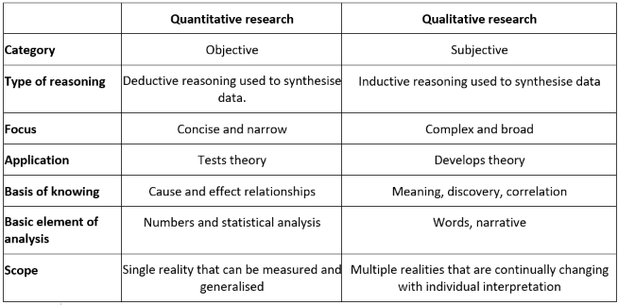
Figure 1. Qualitative and Quantitative Framework.
(Source: learning eupati).

3.3. Research Philosophy.
The research philosophy focuses on explanation and principles, and how accurate knowledge is (what reality is), epistemology (how one distinguish something) and methodology (how one find things out), which form a general view of knowledge (Saunders et. al. 2015)

According to Tombs and Pugsley (2020) how to understand research philosophies and paradigms in how the pandemic effected Indian restaurants across Birmingham. Paradigms reinforce the philosophy of research, such as positivism, post-positivism, acute theorist and constructivist, and drive a well-organized research approach (Baracskai et. al. 2007). Goldman (2009), defines epistemology theory as the nature, derivation, scope and dependability of true knowledge. For now, a research philosophy is what participants of a research community share (Tennis 2008), suggests that the research philosophy purpose is to find models that account for observations within a coherent framework.

3.4. Philosophy, Ontology and Epistemology.
Ontological and epistemological views are vital, particularly in hospitality sector (restaurants), social acknowledgement and understanding is the key to restaurant business success. Ismail (2012), claims that academics who use quantitative techniques exhibit certain extent of epistemological and ontological opinions regarding social reality and how it ought to be analysed. Ontology is about studying how relationship is amongst the academic and the topic being researched on, which also replicates their philosophical situation (Schraw 2013). Many scholars take an idiosyncratic viewing of the social world, trusting reality can be interpreted, and that it is not autonomous to the objects being pragmatic, considered as the constructivist epistemology (Schraw and Olafson 2008; Lazaric 2000).

According to Lazaric (2000), a constructivist’s ontology is founded on relativism and the confidence that realisms are apprehensible in the practise of various, intangible mental constructions, socially and experientially study, precise in nature and reliant on the specific person holding the structures. Diverse academics have faith in in an objective viewpoint of our social world, explaining that reality exists self-sufficiently and externally to the substances that are being viewed. This is explained as positivist philosophy. Other academics accept a realist opinion by fraternisation of both a positivist and constructivist epistemological views and trusting that the world exists independently of one’s perception of it (Abezie 2020; Guba and Lincon 1994). According to Smith, (1983), a post-positivist’s ontology is based on acute realism and the belief that reality is supposed to exist but only indecorously apprehensible because of inconsistent human intellectual mechanisms and the fundamentally stubborn nature of the spectacles.

They mention that reality is subjected to the widest imaginable acute examination to simplify apprehending it as closely as possible. Hascher (1982) disagrees that quantitative and qualitative research methods rest in diverse paradigms in examining the social world and have diverse epistemological viewpoints about formation of knowledge. The positivist embraces the quantitative research method and experimentations, while the constructivist embraces qualitative research methods. For positivists, simulated findings are measured as true reality (Guba & Lincoln, 1994). However, Saunders et al. (2003) and Smith (1983) disagrees that one or both of the ontological viewpoints can be comprised to best suit the researches necessities and neither of the philosophical situations is superior to the other.

3.4.1 Epistemology.
Epistemology research study will aid in examining prudently selected wide range of secondary literature from reputable authors on the effect of the pandemic on Indian restaurants in Birmingham. Epistemology approach is important in aiding to understand the topic, for example how do we distinguish something, in order to critically evaluate the dependability of information developed in the discipline. Hence, epistemology will play a major role in de-coding the structured online questionnaire by clearly supporting to understand human geography. Hofer and Bendixen (2012), terminologically explains that epistemology is the study of knowledge. It is apprehensive with the mind's relative to reality. What is it for this relative to be one of knowledge? When and how do we know things and why we know things?

3.5 Mixed method.
Mix methodology is the merger of qualitative and quantitative research methods. According to Allwood (2012), quantitative research study defined as arithmetical or measurable statistics. In contrast, qualitative research is defined as particular accounts or data’s that clarify in detail how people think or react within society. According to Arora and Stoner (2009), mixed methodology is well-defined as the kind of research in which an academic or team of scholars associates components of qualitative and quantitative research methodologies together (e.g. use of qualitative and quantitative perspectives, data collection, analysis, inference methods etc.) for the broad aims of extensiveness and in-depth understanding and justification.

3.6 Method Selection.
The method selected for this research study is Quantitative research methods. Quantitative research method is preferred over qualitative research methods, as there are vast secondary data available on the research topic, another reason is time and financial restraints, and very significantly, covid-19 is an ongoing concern (still at very large). According to Shahidi (2020), many academics also embraced a similar strategy (Quantitative research methods) and found it useful as well as time-effective and cost-saving.

Quantitative coding analyses will also assist in developing first-order codes. In this process, the emphases will be to understand the experiences of the owners/ managers of the Indian restaurant businesses in Birmingham pre and post pandemic, their response to the crisis, what kind of complications confronted in sustaining their business and what type of methods they practically used to revive their business. This will be performed through a structured questionnaire. A structured coding will be decoded and codes that are irrelevant will be erased. The results of the data analyses can be illustrated through pie-charts or graphs and then transcribing the data into rich text. The reason for not applying Qualitative research methods is arranging face to face interviews is difficult, as the entrepreneurs might not be able to provide the timeslots or not turn-up for the interviews and it is also time consuming and most significantly the covid-19.

3.7 Deductive vs Inductive theory.
The two most common theory development approach are deductive and inductive approach and they are interlinked to quantitative and qualitative research study theories. According to Azungah (2018), deductive theory development approach to research is the one that individuals characteristically associate it with scientific investigation. The academic examines what other scholars have done, reads present philosophies of whatever phenomenon the individual is researching and then examine hypotheses that rise from those theories. Whereas, Inductive theory development approach is when begin with observations and then moving from these specific experiences to a broader set of plans about those experiences. For instance, when academic follow the process from specific to the general.

The inductive reasoning method will be applied as data from PDF’s, journals, books and articles from websites on how covid-19 is impacting the Indian restaurants in Birmingham
is collected to observe and analyse to understand background of the issue and scrutinise for possible patterns. Then relationship and hypothesize and a theory is developed from the social phenomenon and has to be clarified. By applying inductive reasoning, research will use literature from extensively accessible journal and critically evaluate them to find the gaps. Inductive reasoning is a systematic argument between conclusion and the topic inspected to be supported by observation.
Deductive and Inductive theory. 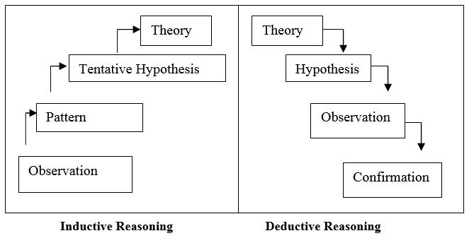
Figure 2. Deductive and Inductive theory (Source: Research Gate. 2021).

3.8 Applying grounded theory for qualitative research.
Academics use grounded theory for qualitative research studies as it helps them to analyze structured data from diverse prospective. Ivey (2017), claims that grounded theory is a renowned approach engaged in numerous research studies. Qualitative and quantitative data generation procedures can be utilized in a grounded theory study. Grounded theory sets out to determine or construct data from theory, systematically attained and analyses applying proportional analysis.

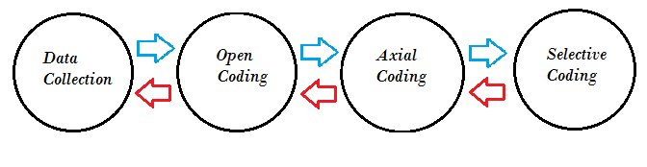

Figure 3. Image of grounded theory.

(Source: Static how to. 2022).

3.8.1. Data collection.
for the research, the data collection method applied was a structured online questionnaire, the questionnaire was manually structured, there was no software involved in forming the questionnaire, the motive for this is specific questions required addressing in order to understand the full impact covid-19 has had on the Indian restaurants in Birmingham. The method utilised to distribute the questionnaire and collect data was mainly via email. Also, other methods that was utilised was social media platforms like WhatsApp and Facebook. The last form of contact was through business websites. This method was applied due to its cost-effectiveness and time-saving benefits. According to Rai and Thapa (2015), close ended structured questionnaire is known as purposive sampling method.

The data was assembled during the period from 25th June, 2022, to 25th July, 2022, through a purposive sampling method. Etikan et. al. (2016), claims that purposive sampling is similarly recognised as critical, selective, or subjective sampling, is a form of probabilistic sampling in which academics be reliant on their own judgment when selecting participants of the public to take part in their surveys. A total of 64 Indian restaurants in Birmingham where requested to join in the survey and give their viewpoint.

3.8.2. Data analysis.
The data was analysed manually, data analysis involved probing each structured questionnaire prudently read and thematically analysing them. Joffe, (1992) claims that structured or closed-ended questionnaires are a quantitative technique of research, it administered as a fixed data sample and is a positivist research process. It includes low level of participation of the academic and high number of candidates (the personals who response the questionnaire). literature was utilised to improve the conceptual understanding for the study. To analyse the complications faced by the supplier’s chain in pre and post Covid-19 era, a structured questionnaire will be sent king prawn suppliers in Bangladesh. According to Ahmed, (2001) Indian restaurants use prawns and king prawns and Bangladesh is the main distributor of this two products. No expense is involved for this dissertation, all data collected are free of cost and will require to be thoroughly analysed and all participants are invited to take part in the survey voluntarily, if only they feel contented and confident in doing so. Below is a sample of the online questionnaire which will be presented to the Indian restaurant owners across Birmingham.

3.8.3. Open coding analysis.
The open coding qualitative analysis will start with get-together all the online questionnaires and developing a chart and categorizing, examine the questions and after that use preliminary labelling to separate each questions appropriately. According to Gygi et. al. (1999), open coding is the procedure performed through which “grounded” academics primarily begin the progression of questioning, replicating upon, and classifying the actions, viewpoints, and words of the actors in their study progression through their raw research information.

3.8.4. Axial coding analysis.
After categorizing all the data collected from the online questionnaire and placing them into appropriate groups, this is where you begin to draw links between the answers ideas for the research. With grounded theory, axial coding is applied to develop conceptual families from the sum-ups and the focus is on converting the raw data from the sum-up families into rich information and develop a theoretical framework. According to Scott and Medaugh (2017), axial coding discloses insight into causal situations, context, strategies, and significances. Causal situations are those that are developed or bring about emergent patterns. Causal situations are comprehensive theoretical concepts. Such concepts may comprise of events, incidents, or actions that eventually lead up to a theme.

3.8.5. Selective coding analysis.
Now that the previous four steps of the grounded theory process of defining data have been accomplished. Selective coding will assist in turning sets of data different families of data’s (formal framework) with a variable that includes all of the collected data. In the initial phase data collection was performed through various different form and methods. For example, secondary data collection method was PDF’s, Journals, UWTSD online library, Newspaper articles and structured online questionnaire. Each step of grounded theory enabled data to be analysed thoroughly, grounded theory aided in understanding the data in a broader context, it is perfect for the type of research conducted in this research study and it can be safely concluded that no alternative method is required for this research study.

3.9. Project management.
Project management is the procedure of establishing a systematic approach to accomplish all project objectives within the specified restraint timeframe (Kerzner 2017). This project highlights the impact of covid-19 on Indian restaurants (ethnic minority cuisine) in Birmingham.

3.9.1. Risk Factors.
Time limit is a risk factor; all processes have to be structured. For example, each task has to be accomplished within its timeframe. Project management is like an iron triangle (waterfall model) all tasks are interconnected to each other if one overlaps then the triangle falls apart (Andrei, 2019)
Retrieving the questionnaire from the owner / managers can be challenging, as they have very busy schedules and sometime they might completely forget about the questionnaire. To mitigate this complication, there has been a five-day free period left should there be any delays.

3.9.2. PROJECT SCHEDULE CHART.

Activity No | Research Activity | Duration | Resource Requirements
1. | Secondary data collection and Data analysis | 7 Days | Some researches are already accomplished, so this should be achievable in the time period allocated.
2. | Obtaining permission for sending online questionnaire. | 2 Days | Contact restaurant managers / owners regarding online questionnaire and explaining its importance.
3. | Writing dissertation | 15 Days | Writing dissertation and structuring it.
4. | Questionnaire data collection | 7 Days | Decode the questionnaire response.
5. | Write dissertation | 15 Days | Continue to complete the dissertation.
6. | Analysing the dissertation. | 2 Days | Structuring / polishing / checking for errors / checking similarities and obtain feedbacks.
7. | Amend any feedbacks | 2 Day | Final check and submit.
Five-days unscheduled for any complications that arises
Total number of days = 50
Table 1. Project Schedule Chart (Source: Author)

3.10. RESEARCH QUESTIONNAIRE FORM.

Kindly read and comprehensive this form cautiously. If you are willing to take part in this research, sign and date the declaration on completion. If something is not comprehendible and would require further information, please ring the number given below the questionnaire.
Name of Researcher: Mohammed Amir Hussain Chaudhary (MBA student form UWTSD)
Title of study: Impact of covid-19 on Indian restaurants in Birmingham.
Aim of this research: to identify the diverse challenges like decrease of profit-margins,
shortages of employees, supply chain disruption’s and environmental changes effecting restaurants.

Please choose one answer to each question about the impact Critically - Moderately - Lightly - Unsure - No Answer
of the pandemic on the restaurant and mark an X.

Q1. Just how affective is the impact of pandemic on the restaurant?
Q2. Exactly how has the pandemic effected the customers?
Q3. What level of impact has the pandemic had on the employees?
Q4. In what way is the supply chain effected by the pandemic?
Q5. How are the environmental changes impacting the restaurant?
Q6 To what extent has the pandemic effected the profit-margin?
Q7. Is training employees about innovative technologies necessary?
Q8. To what degree is utilising social media platforms in the pandemic essential?
Q9. How crucial is the small business grants / fund in the pandemic for restaurants?
Q10. Just how necessary is refurbishing and redecorating in the pandemic?

Business established ………………………………

Candidates job title …………………………………

Candidates signature ……………………………… Date……………………………………

If you have any queries regarding this questionnaire, please contact the
Mohammed on 07542642216 or
Email: mohammedamirhussainchaudhary@gmail.com.

Table 5. Online Questionnaire Guide Transcript (Source: Author).

A total of 115 online questionnaires where emailed to participant of Indian restaurants (owners or managers) all over Birmingham. Below is a list of area’s and the numbers of restaurants the questionnaire was sent to and how many participants responded to the email.

Entrepreneurs discretion. the procedure intended to follow in order to preserve the anonymity and confidentiality of the entrepreneurs of Indian restaurants in Birmingham. Data collection for this questionnaire will be kept secure by the researcher, at no point will any personal details be disclosed or any personal data be accessible to third party. Once the data is coded, it will then be destroyed for protection purposes.

.

3.10.1. Email dispatched and retrieved chart.

Area covered | Email sent | Email received | Area covered | Email sent | Email received
City centre | 7 | 4 | Aston | 6 | 4
Jewellery Quarters | 5 | 3 | Solihull | 8 | 4
Small Heath | 10 | 7 | Northfield | 7 | 5
Kings Heath | 8 | 5 | Rednal | 6 | 4
Sutton Coldfield | 8 | 5 | Shirley | 9 | 4
Weoley Castle | 7 | 5 | Bournville | 5 | 2
Aston | 8 | 6 | Harborne | 7 | 3
Hall Green | 8 | 5 | Edgbaston | 6 | 3
Total. | 61 | 40 | Total. | 54 | 29

Table 6. Email dispatched and retrieved chart (source: author).

3.10.2. Analyzing the questionnaire.
Out of one hundred and fifteen online questionnaire distributed, only sixty-nine online questionnaires were received from the participant, the data from each question will now be analysed and decoded, so it can be illustrated through graphs to clearly demonstrate the results of the questionnaire in an appropriate and understandable manner.

Q1. Just how affective is the impact of pandemic on the restaurant?
Critically - Moderately - Lightly - Unsure - no answer
64 1 0 0 4
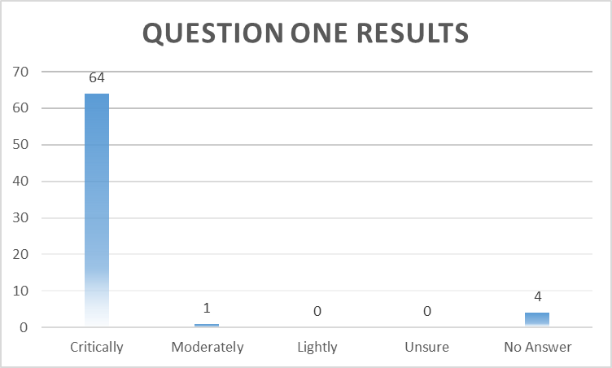
Figure 4. Chart 1. (Source: Author).

By analysing the results, it can be easily reckonable just how affective the impact of pandemic has been on the Indian restaurant, as out of 69 participants who answered the question 98% response to restaurants being critically effected by the pandemic. According to Jain (2020), Covid-19 has critically affected diverse types of businesses including restaurants. In Birmingham, Indian restaurants are suffering from different effects of Covid-19 internally and externally.

Q2. Exactly how has the pandemic effected the customers?

Critically - Moderately - Lightly - Unsure - no answer
19 21 26 1 2

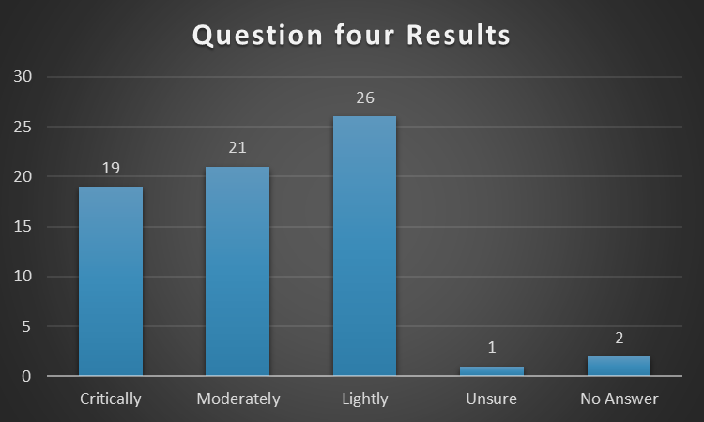
Figure 5. Pie Chart 2. (Source: Author).

Examination of the static reveal that customers have not been effected the way businesses have, reflecting back to the article by Razzak et. al. (2021) where they identify how customers trend have altered, now products or goods are purchased online. In the case of Indian restaurants customers are switching to using digital platforms like Just Eat or Uber Eat to order delivery’s.

Q3. What level of impact has the pandemic had on the employees?

Critically - Moderately - Lightly - Unsure - no answer
49 11 5 0 4

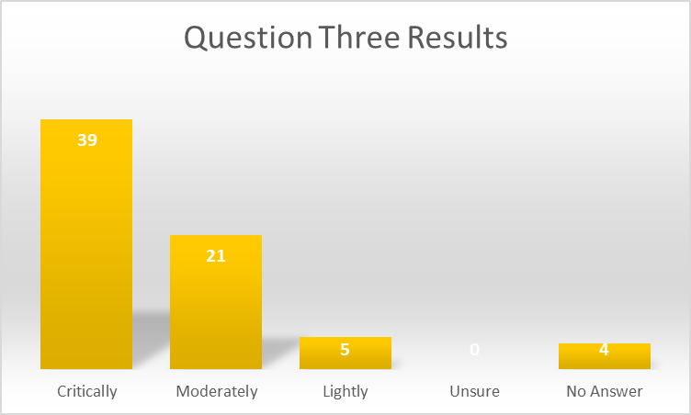
Figure 6. Pie Chart 3. (Source: Author).

By scrutinising the results, it is clearly recognisable that only 32% candidates who responded to the questionnaire was critically effected, the rest were moderately effected. The article by Al Amin et. al. (2021) explains that employees that delivery takeaway food for customers in Indian restaurants are effected the leas, as they are not in direct contact with the customers.

Q4. In what way is the supply chain effected by the pandemic?

Critically - Moderately - Lightly - Unsure - no answer
26 35 3 1 4

Figure 7. Pie Chart 4. (Source: Author).

Evaluation of the static has aided in identifies that restaurants were mostly moderately effected by the supply chain. According to Hobbs (2020), majority of the supplies to Indian restaurants are products from Europe and the transportation of goods from EU manoeuvring accordingly. Perhaps, slow at times, only certain products like king prawns and prawns were distributed from Bangladesh and spices from India, which were the key issues.

Q5. How are the environmental changes impacting the restaurant?

Critically - Moderately - Lightly - Unsure - no answer
28 34 1 2 4

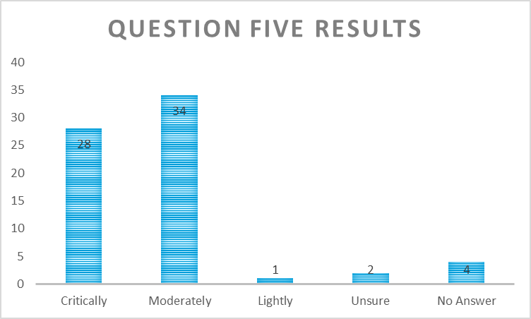
Figure 8. Pie Chart 5. (Source: Author).

By probing the data from the online questionnaire about environmental changes impacting Indian restaurants in Birmingham, it is understandable that the consequence was moderate. According to Alaneza et. al. (2020), pandemic has immobilised the society from socialising in outdoor venues. At the same time, it has also presented opportunities for restaurants across UK to develop and adopt to innovative business concepts by utilising social media and digital platforms.

Q6 To what extent has the pandemic effected the profit-margin?
Critically - Moderately - Lightly - Unsure - no answer
62 4 0 0 3

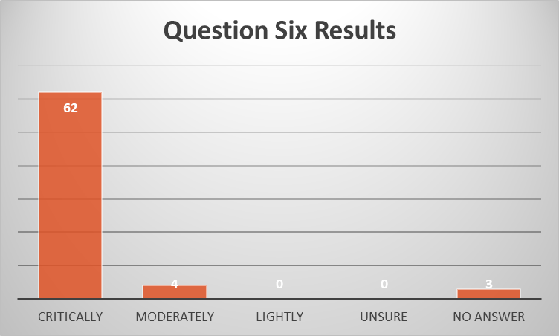
Figure 9. Pie Chart 6. (Source: Author).
The data from the online questionnaire reflects that Indian restaurants are suffering immensely in the pandemic. Now restaurant businesses are finding it difficult to operate successfully. Before pandemic, liability and debt were being repaid from earning and profits. During pandemic, debt size kept increasing to pay bills and salary, as the business was at a standstill (Ramuna 2020; Baker et. al. 2020).
Q7. Is training employees about innovative technologies necessary?

Critically - Moderately - Lightly - Unsure - no answer
43 23 2 0 1
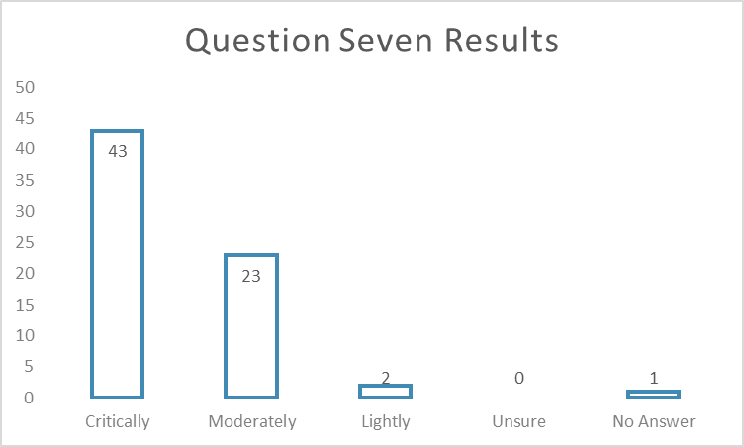
Figure 10. Pie Chart 7. (Source: Author).

Analysing the data from the online questionnaire, it is comprehensible that 62% of the participant release that it is critically important to training employees regarding innovative technologies. Meulenbroek and Cherney (2021), claims that to fully remerge from this crisis managements of hospitality sector (Indian restaurants) across UK must implement further resources in training and development programs about innovative technologies for employee’s, only then, the hospitality sector can successfully re-emerge from this pandemic.

Q8. To what degree is utilising social media platforms in the pandemic essential?

Critically - Moderately - Lightly - Unsure - no answer
58 5 3 0 3

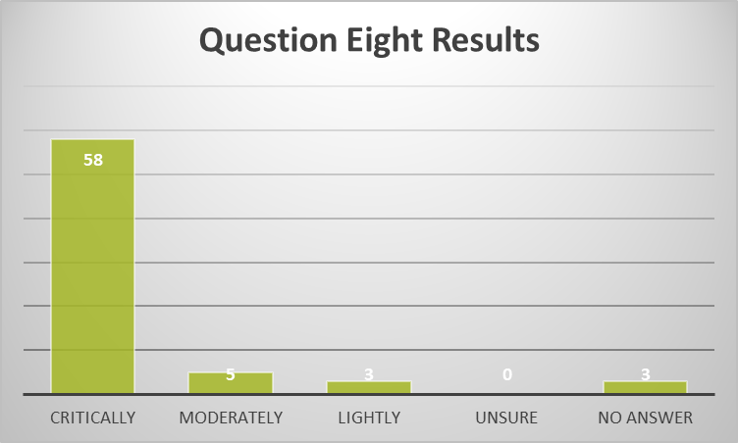
Figure 11. Pie Chart 8. (Source: Author).

Assessing the data collected through the online questionnaire highlights 91% of the participants that took part in the survey finds it necessary to utilising social media platforms to boost business in the pandemic. According to Ahmad and Murad (2020), social media platforms during outbreak of coronavirus is unique method and a new form of communication with customers, which is safe and secure.

Q9. How crucial is the small business grants / fund in the pandemic for restaurants?
Critically - Moderately - Lightly - Unsure - no answer
60 1 0 3 5

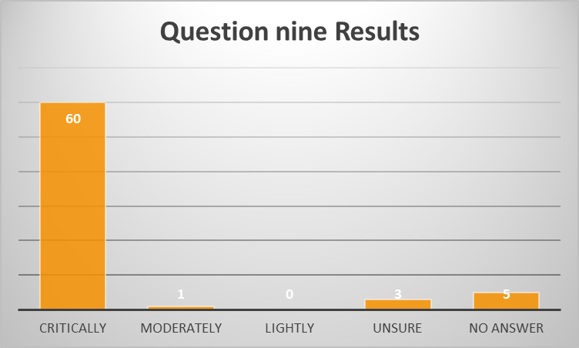
Figure 12. Pie Chart 9. (Source: Author).

The response from the owners / managers of Indian restaurants in Birmingham on how crucial the small business grants, loans and fund in the pandemic is. Analysation of the data suggests 92% of the entrepreneur’s think it is critical to obtain the small business grants, loans and funds. According to Heald and Hodges (2020), UK government has promised seven hundred and fifty million pounds to safeguard VCSE can endure their vibrant work supporting the country during the covid-19 outburst, plus two hundred million pounds for the Coronavirus Community Support Fund, alongside with an extra one hundred and fifty million pounds from building society and dormant bank accounts, to revive the economic and businesses.

Q10. Just how necessary is refurbishing and redecorating in the pandemic?

Critically - Moderately - Lightly - Unsure - no answer
27 30 2 3 4
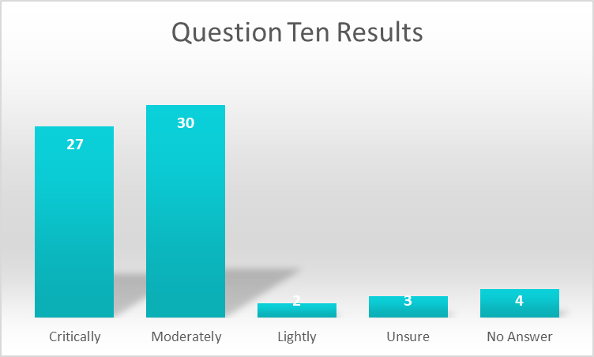
Figure 13. Pie Chart 10. (Source: Author).

Data collected form the online questionnaire finds that 51% of entrepreneurs who participated in the survey have moderate views regarding renovating and decorating the business in the pandemic. According to Battaglia (2022) pandemic developed the perfect opportunity for restaurants to redecorate their premises in the lockdown. A well decorated premises allows to develop an atmosphere where customers feel good. The decoration is part of a corporate culture and brings a sense of belonging.

3.11. Ethical Considerations.
The authors have been acknowledged for all secondary data’s used in this dissertation, no secondary data have been used without the acknowledgement author of the article, books, Journals etc. when collecting any data through online questionnaire voluntarily participation was required, the consent was obtained and upmost respect, understand and confidentiality was provided to the businesses and their entrepreneurs and assured that no-one was treated in any disrespectful way whatsoever. Also, assurance was provided that all data will be stored securely and safely and maintain the interest of the participants was intended when data was gathered.

3.12. Conclusion.
The research plan comprised of collecting data from diverse sources, secondary data was collected from online journals, PDF’s and books. Also, an online structured questionnaires was created to comprehend the effect of the pandemic on Indian restaurants in Birmingham pre and post pandemic era. It specifics all data collection techniques and hypothesises how they are examined and tested to understand the diverse perspectives and this will support to address the research questions emphasised in Chapter One. Explains the plan on how the questions will be evaluated, similarly as the result and influence to knowledge, is included in Chapters One and Three. The data collection and analysis approaches are also utilised in the research philosophy. This research exploits quantitative techniques, exploiting pragmatic perilous and realist ontology to investigate the research topic. Hence, it is alleged that by embracing similar method, the research will accomplish outcomes that are capable of understanding how restaurants traded pre and post pandemic era, the hardship encountered by the entrepreneurs and a possible way forward for the Indian restaurants. Chapter four will focus on the findings, results, analysis and discussions.

CHAPTER 4: FINDINGS, ANALYSING AND DISCUSSION

Introduction.
This chapter examines the findings from the literature review and methodology to provide an acute summary of data extort. Before data is extorted, preliminary stage is to categorise data, followed by analysing the data for findings (which will be linked to the literature review) and results to identify any pattern or themes. The aim of this is to identify the impact of covid-19 on Indian restaurants in Birmingham. By utilising various data’s, the research study will focus on identifying several different findings and scrutinise the results of the findings, their meanings, how it is effecting the Indian restaurants in Birmingham. Analysis of the result will aid in finding scope for the discussions. The purpose of the discussion is to reach the objectives for the research study.

4.1 Presentation of findings.
The strategy used to investigate the subject matter was focused on Indian restaurants of Birmingham. There remains a significant difference between other restaurants and these specific restaurants. The target audience and activities are diverse. When Covid-19 started spreading out, the UK government took the policy of shutting down the hospitality sector (restaurants). Indian restaurants in Birmingham faced diverse types of challenges and these challenges affected their businesses in short term and long term basis, below are just some of the findings that have been identified in literature review.

Key findings.

- Shortages of financial resources: liability and debt where increasing.
- Insufficiencies in human resources: crises in finding restaurant workers.
- Barrier developed by changing business environment: innovative technologies.
- Restaurants are unappealing to employees: no promotion, unsecured future.
- Deficiency in training facilities: no training programs for employees.
- Shortage of supply: spices stops arriving from India.

Analyzing and discussing about the finding.
By analyzing the findings, it will aid in understanding and attaining broader knowledge of the issues from diverse prospective or viewpoints and a pathway can be identified for further discussions.
Shortages of financial resource: after examining the literature from diverse scholars a key finding has been identified as shortages of financial resources which covid-19 has developed. For example, financial resources were not available because of the lack in transaction or sales taken, as the restaurants in Birmingham remained closed for at least couple of months. These are perishable items. Therefore, Indian restaurants had to bear the consequences. The whole aspect of covid-19 is still very much active and this was one of the reason why restaurants are faced with this issues. Referring to the article written by Ramuni (2021), explains how literature highlights about liability and debt being the two potential threats for businesses while operating. Now restaurant businesses are finding it difficult to operate successfully, as there is still the fear in people’s minds of going out, which reduced individuals from socialising. This trauma effected the Indian restaurants the most, as they have lost valuable customers. Researches performed by Crick et. al. (2016), on found that before pandemic, Indian restaurants are utilised for various diverse activities when an individual used restaurants for dining, such as celebrating special occasions with family, friends or relatives and socialising with colleagues or have business meetings with associates and liability and debt of the restaurants were being repaid from earning and profits.

The discussion can be based on how Indian restaurants can improve their business in the pandemic. As a solution, one of the key methods can exploiting social media platforms for digital marketing. In today’s generation, where technology is controlling our lives. Indian restaurants need to able to develop social media platforms such as Facebook, Twitter and Instagram to influence the predicted clients, which will be a beneficial plan as these digital platforms are efficient and cost effective process. By means of social media platforms, all data of the restaurant can be communal, for example the menu or any other offer or promotion available.

The restaurant is able to upload chats and videos’ in regards to the products, services and their availability. Also, social media platforms are suitable for accumulating feedbacks. Research performed by Hays and Buhalis (2013), identified that currently the national tourism industry of Australia is utilising social networking sites to extent out to existing client and future potential clients and results indicate that they are successful in achieving this. Below are some diverse types social media platforms that can indorse restaurants in Birmingham (Matt 2020).


Figure 14: Static for social media platforms.
(source: Ahar 2020).

Another useful method that can be applied by Indian restaurants in Birmingham is search engine optimization (SEO). It is a google search engine, so when an individual is searching for a certain enterprise on google, there are many comparable businesses that appears most of the time customers view the top few and choose from one of them. If your business advertisement is below the top ten, then the chance is very low for consumer to view your restaurant. If the business signs up with SEO then your restaurant will appear above your rivals. According to Grappone and Couzin (2011), the benefits for business who utilises SEO to their business it improved user experience and indorses efficacy and will appear in the top few, this develop a better chance for customers who commute into the area.

Deficiencies in human resource: Another key finding is shortages of employees, this due to employees being frightened of getting infected from covid-19, this is causing employees not to go to work in restaurants. As a result, employee shortage reaches an all-time high and restaurants are on the verge of shutting down (Zhong et. al. 2021). However, Monras and Vázquez (2018), disagrees with Zhong et. al. (2021), claiming that pre-pandemic the hospitality sector in UK (mainly restaurants) where faced with shortage of skilled workers, this was a direct consequence of Brexit which stopped the free movements of European Union migrant workers. However, Sumption and Kierans (2019), argues that it was not just Brexit but also other factors like government cumulating the restrictions on work-permits (for foreign workers) from £16,000.00 to £27, 000.00 yearly, this further complicates matter, to attain skilled workers from Bangladesh or India and pandemic was only the last straw. From the researches conducted, it has been clearly identified that there is a shortage of employees in restaurants and this issue is taking its toll, different academic view this issue from different prospective, but the fact remains that it is vital to find solutions to this complication.

The key discussion point is how this problematic issue can be addressed. Researches carried out by Chang and Chang (2021), identified that Canadian restaurants opted to recruit local employees, so Indian restaurants in Birmingham can follow similar process and opt to local recruit by utilising social media platforms like LinkedIn, WhatsApp and Facebook to attract employees. Furthermore, they can approach local job centres. Meulenbroek and Cherney (2021), claims that part of the solution has only been identified to fully remerge from this crisis managements of hospitality sector (Indian restaurants) across UK must implement further resources in training and development programs for employee’s as this will improve the efficiency of the workforce of the restaurants.

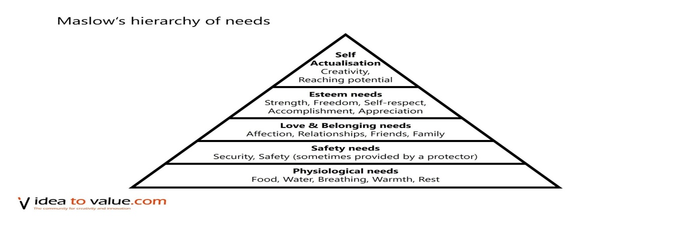 Figure 15. Maslow’s Hierarchy of Needs.
(Source: V idea to value .com 2021).

Restaurants can achieve their objectives; to achieve this it will involve fulfilling employee’s goal from the beginning stages of the pyramid highest stages which emphases on employee gratification (Benson and Dundis, 2003). the utilisation of Abraham Maslow’s philosophy, it will aid in attaining clearer understanding and broader knowledge of what a worker desire from the restaurant. Indian restaurants in Birmingham should reflect on Maslow’s methodology.

Maslow’s Hierarchy of Needs.
Self-actualisation: The Indian restaurants must recognise talented staffs and offer effective teaching and continuous learning resources to aid individuals perform method skilfully.

Self-esteem: once training accomplished, continuously attaining feedback and motivate the employees, so that they will benefit for working in Indian restaurants, as this will assist the employee to understand and develop an affection to their work.

Belonging and love: Indian restaurants should arrange for a digital platform for the workers like WhatsApp group to support employees to communicate with each other’s, only able to gain access to the WhatsApp group after working hours.

Safety need: Indian restaurants should offer various facilities like security for its staffs, authorised leaves, paid holidays and free transportation for employees to commute to the workplace.

Physiological needs: Indian restaurants in Birmingham should provide basic facilities such as free staff toilets, pray facilities, paying worker’s wages on time, free meal for workers when they are at work to attain employee’s faithfulness.

Table 7. Maslow’s Hierarchy of Needs (Source: Author).

Impact of Covid-19 altering the business environment: there many diverse challenges due to covid-19 and also government applied strict rules and regulations on the hospitality sector. Studies conducted by Zhong et. al. (2021), explains that these are frightening times and employees are getting infected or are in isolation from Covid-19. This has impacted the Italian, Chinese and Indian restaurants across UK and they are on the verge of shutting down. Researches by Fetzer (2022), has identified that the key fact why businesses are on the verge of shutting down is casual dining in sector (restaurants) to face massive, well-documented pressures from the government, which have been exacerbated by Covid-19 and the lockdown. Hanson. et. al. (2021), claims that the virus was spreading rapidly, so the government needed to intervene and amend the existing laws and introduce extreme measures on the hospitality sector, which has had an overwhelming impact on the business performances of pubs, restaurants and hotels across the country, this has forcing these businesses to alter their existing strategies and adopt to the new vicissitudes which are very costly.

Key discussion can be developed by analysing the business internal and external environment to find solutions to the issues. According to Worthington and Britton (2009), business environment formed from two factors the external and external business factors. External analysis examines the conditions and events outside a business environment that influences the business operate. An internal analysis focuses on all the factors within the business such as weaknesses and strengths of the business (See Appendix. 1). As covid-19 is an external factor the focus is to identify external challenges developed by covid-19 with the use of PESTEL analysis to be able to find solutions for them.

PESTLE analysis.
According to Matovic (2020), PESTLE analysis is an external factors theory, consisting of six factors that guide an organization. It can be applied in various diverse scenarios, and can guide individual’s professionals and managers in strategic decision-making.

PESTLE ANALYSIS.
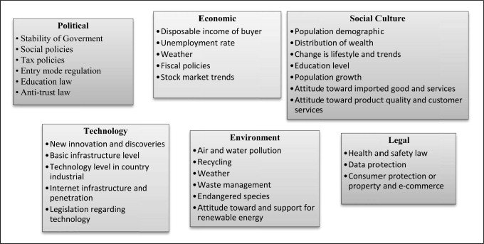
Figure 16. Image of PESTLE
(source: Magora 2021).

Political Factors: Covid-19 effected the geopolitical aspects of Indian Restaurants, the national embargo on importing from overseas nation affected the supply chain. A large portion of ingredients in Indian cuisine depends on the import from India. Indian community is still suffering from the effect of the pandemic on its operations. Political changes due to Covid-19 affected Chinese and Indian catering sector of Birmingham (Kaur, 2020).

Economic Factors: Just before the pandemic the wage rate increased. This affected the cost of production (Ahmed, 2020). When cost of production is high, businesses cannot but raise the price. The price of Indian cuisines increased as a consequence. However, the British economy is at inflationary gap. The progressing stage of inflationary gap is harnessing the pace of development. Economy of the UK is affecting Indian catering sector by reducing its scope in price reduction or setting wage flexibility. Working hour regulation is stricter. Though catering sector in Birmingham sticks with a specific regulatory framework, the strict regulation is affecting these restaurants in term of recovering from the loss during pandemic (Chae and Hanson, 2021).
Social Factors: Coronavirus damaged the cultural diversity. Culture is a key factor in the society. Diversity in culture is highly essential for a dynamic society. Covid-19 restricted people from meeting physically. The lack of physical interaction hinders cultural development (Jones, 2021). People, especially potential customers of Indian restaurants who come from various and diverse cultural backgrounds. Covid-19 increased confusion and miscommunication among them. This remained even after the pandemic started fading out (Fonseca et al., 2020). Indian restaurants rely mostly on customers from respective cultural backgrounds. A significant portion of the target audience are middle aged. The lack of miscommunication arose during the pandemic. This communication gap increased the risk of cultural mutilation (Mayurnikova, Koksharov and Krapiva, 2020). Rather the going out to dine at an Indian cuisine, pandemic has altered their preferences to staying in and having a takeout. Indian restaurants are a victim to this external factor.
Technological Factors: The pandemic introduced a pathway for both businesses and consumers regarding the actual use of technology for selling and buying respectively. People could not get out of their respective households and businesses were unable to operate from physical stores (Obukhova, 2022). The orientation to technology during pandemic had a positive the catering sector. The practice remained as a core practice in restaurant business. It increased the accessibility of technological tools and social media marketing strategies. After the pandemic, the impact is supporting the catering sector to run marketing campaigns and operations (Nakat and Bou-Mitri, 2020). However, there is a cutthroat competition as a result of technology. Many firms have generated online food ordering system. It improves the quantity of sales as well as the quality of food for the scope of large exposure. Kitchens of a few restaurants in Birmingham have the ability to continue such operations. Other than that, majority are falling behind in the competition in relation to technological development. This competitiveness is a result from consistent improvement in technological format for business (Mueller et al., 2022).
Legal Factors: Covid-19 is one of the incidents in the recent periods that impacted largely on legal factors. Coronavirus Act 2020 was passed to handle the pandemic situation. Government of the UK attained power to take emergency measures to protect people from being affected from the highly transmitted disease (Hurley et al., 2021). This legal change is still active and government has to review it once in a while. New waves of pandemic appear with the introduction of new mutation or variation. The government reviews the lethality of the new pandemic and imposes required restrictions and obligations as per the Coronavirus Act-2020 (Gov.uk, 2020). It impacted businesses since the act initiated lockdowns for several periods. Catering sectors could not operate properly because of the restrictions. Food standards act-1999 and Food Safety Act-1990 are two vital legal processes for restaurants (Food Standards Agency, 2020). It is mandatory to follow these legal procedures. Pandemic increased the obligations and regular monitoring. Food Safety Act-1990 has included a new instruction to provide containers which are made of food grade materials (Cowie, 2020). These changes were made in pandemic.
Environmental Factors: In the situation of Covid-19, environment quality improved. Wastage in restaurants was low and it reduced the degradation of environmental qualities. However, the increment of plastic usage increased for doorstep deliveries. Catering sectors had to ensure safe packaging through plastic packaging (Filchenkova, 2022). However, it hampered the air quality. Birmingham Indian catering sectors contributed negatively in this area too after pandemic. The number of visitors reduced, order for doorstep delivery increased, and plastic packaging damaged environmental standard.
To summarise the external factors, Indian restaurants in Birmingham are dealing with drastic transformation. The deficit in raw material, diseconomies of scale, economical and technical changes caused businesses to face less profit and shortages of employees effacing business performance pre and post Covid-19 situation. Also, reflected on some of the disturbance within the supply chain which is effecting the quality of the products. It will require refocusing and restructuring and developing a management riel approach for the business development to get a grasp on the pace of transformation in the external environment.

Discussions of the results.
Effect of Covid-19 is immense and there are overwhelming evidential of impacts on the restaurant businesses. Birmingham has many Indian restaurants. Most of them serve food in dine-in process. Since most of the dishes in Indian cuisines are served after cooking, customers prefer to eat in the restaurant. This is the exact point at which Covid-19 affected Indian restaurants. Customers were unable to visit during lockdown. Again, the delivery process is limited at these restaurants. Businesses started closing when the lockdown was announced for all the entities in the UK. Despite taking any precautionary step, Indian restaurants at Birmingham had to shut their operations down. The lacking in proper operations affected the internal damage. From getting supply to final production, there remained a barrier in the process. This barrier is the reason behind the cause of loss in Indian restaurants. Birmingham could not be maintained as per necessity during the period of lockdown. Presented findings indicated that restaurants were incapable of making profit. Though there have been some infrastructural developments, the suffering and barriers are continuing (Dereń, 2022). Changes will be essential to regain the loss in these restaurant which have been discussed in the findings.

CHAPTER 5: CONCLUSIONS AND RECOMMENDATIONS.

5. Recommendation.
The analysation of all literature in this research study has supported in distinguishing key recommendations to develop a future pathway for Indian restaurants in Birmingham.

- Restaurant need to be more flexible as a business by providing employees with better facilities like free life insurance, more paid holidays, give bonuses etc.

- Indian restaurants require to implement training programs into the business strategy and attain feedback frequently to sustain training standards.

- Indian restaurants require learning from the alterations that where implemented due to the coronavirus disaster, and sustain the theories that have endorsed to work perfectly for the restaurant.

- Indian restaurants need to be more cost efficient, stop unnecessary expenses. For instance, there lots of products on the menu that don’t sell often, discontinue these products and only stock products that sells, allocate funds to areas that have development prospective (See Appendix. 2).

- Indian restaurant should sustain operating business as competently in good times too. This will allow restaurant to generate funds for future investment and buffers for other phases of economical instability.

- Indian restaurant requires to be creative and develop unique product (differentiate themselves) to capture a niche market, this is more significant than ever. Since the mid-market may further decline or even collapse, restaurants need to be well-defined proposition that will connect them to the right segment of the market.

- It is vital for Indian restaurants to keep track of customer trends by using social media and digital platforms and have awareness of customer’s desire, requirements and needs.

- Offer reward card or discount card for regular clienteles like their rivals Chinse & Italian restaurants do.

- Indian restaurants in Birmingham need to have a clear and eye-catching description of products and make sure the discerptions are true to your word, and communicate well (online) to appeal to Millennials that demand unique products.

- It is essential for restaurants to develop a networking relationship with customers, as the pandemic has enticed customers to use digital platforms more, restaurants can connect with customers regarding special offers, promotions or new products.

- Find ways to co-operate with all the suppliers to ensure their longer-term and short-term obligation are upheld to the restaurant. Expect smaller, more just-in-time delivery and more reliable terms so all products are fresh. Provide customers with fresh products and improve business traceability and sustainability.

5.1. Research limitation and future recommendations.
There are some limitations that can be addressed in future researches, as the seven-weeks period for the dissertation is relatively a very short-period to establish facts from all perspectives of this research. To provide guidelines for future researches, it is very critical to identify what this research was ineffective in analysing about the Indian restaurant sector. The main focus of this dissertation is on Indian restaurants in Birmingham, there many other cuisines that can be focused on, there are also other cities in UK which have not been addressed. Secondary data analyses (literature reviewed) suggest that these section have not been addressed, such as impact of Covid-19 on the key stakeholders interest (restaurant customers). Future researches can also scrutinise restaurants pricing strategies, pre and post Covid-19 era, as Covid-19 has boosted the inflation rates to an all-time high, this has directly impacted the products and goods that are purchased by the restaurants. These perspectives can be addressed in future studies, as this will enrichen extensive knowledge and understanding of the topic.

5.2. Ethical consideration.
Consideration of ethic is appropriate vital when it comes to doing any type of research or studies, when conducting a research study if ethical consideration is not taken into account then the structure and design can be harmful or prejudice towards researchers or readers who intend to examine or collect data from your research study, it can also cause offence to certain masses. According to Walker (2007), ethical considerations in research study are morals and principles that guide your research designs and practices. The philosophies include willing participant, avoiding any potential harm to vulnerable personals, self-respect and pride of research participants will be prioritised, anonymity, confidentiality and results communication.
The research study was cautiously accomplished to avoid any misconduct of ethics. Also to evade ethical misapprehension, an ethical consent form was provided by UWTSD which was completed. Extra careful considerations where given to evade any sort of plagiarism whatsoever or anyone claiming this research study. Although the research study utilises PDF, Journal, Books and Newspaper articles and structures online questionnaire (secondary data), it does not disclose confidential information about participants, only what is available in the public domain. All literature used in this research study has provided acknowledgement to authors for using their reference and citations, this can be observed throughout the research study.

5.3. Conclusion.
Final declaration. This research study revealed the significance of Indian restaurants in Birmingham. By conducting this research study, it has enabled to recognised obstacles faced due to covid-19 crises. The literature reviewed in this research study has aided in identifying importance of environmental analysis (using PESTLE) the significance of training employees, prominence of providing appropriate facilities for employees. Also facilitated in understanding models and theories for businesses, if endure in an unpresented time like the pandemic. Although, covid-19 has critically devastated the nation and had a catastrophic impact on the hospitality sector (mainly restaurants). clearly it is recognisable that even if there is a lot of negativity of covid-19, it has also presented businesses with many opportunities. Covid-19 forced businesses to evaluate the current circumstance of the business if they are to have any chance of survival in existing era and developed a pathway for future success of the businesses.

6. Reference.
- Abezie, H., 2020. Assessing a restaurant service quality using the Dineserv model: A quantitative study on Pizza Hut.

- Ahmed, B.A. (2020). Impact of COVID-19 Pandemic on Global Economy. SSRN Electronic Journal. doi:10.2139/ssrn.3719949.

- Ahmad, A.R. and Murad, H.R., 2020. The impact of social media on panic during the COVID-19 pandemic in Iraqi Kurdistan: online questionnaire study. Journal of medical Internet research, 22(5), p.e19556.

- Ahmed, N., 2001. Socio-economic aspects of freshwater prawn culture development in Bangladesh.

- Akpan, I.J., Soopramanien, D. and Kwak, D.H., 2021. Cutting-edge technologies for small business and innovation in the era of COVID-19 global health pandemic. Journal of Small Business & Entrepreneurship, 33(6), pp.607-617.

- Al Amin, M., Arefin, M.S., Alam, M.R., Ahammad, T. and Hoque, M.R., 2021. Using mobile food delivery applications during COVID-19 pandemic: An extended model of planned behavior. Journal of Food Products Marketing, 27(2), pp.105-126.

- Alanezi, F., Aljahdali, A., Alyousef, S.M., Alrashed, H., Mushcab, H., Altham, B., Alghamedy, F., Alotaibi, H., Saadah, A. and Alanzi, T., 2020. A comparative study on the strategies adopted by the United Kingdom, India, China, Italy, and Saudi Arabia to contain the spread of the COVID-19 pandemic. Journal of healthcare leadership, 12, p.117.

- Allwood, C.M., 2012. The distinction between qualitative and quantitative research methods is problematic. Quality & Quantity, 46(5), pp.1417-1429.

- Ali, BJ, & Anwar, G.(2021). Porter’s Generic Competitive Strategies and its influence on the Competitive Advantage. International Journal of Advanced Engineering, Management and Science, 7(6), pp.42-51.

- Andrei, B.A., Casu-Pop, A.C., Gheorghe, S.C. and Boiangiu, C.A., 2019. A study on using waterfall and agile methods in software project management. Journal of Information Systems & Operations Management, pp.125-135.

- Azungah, T., 2018. Qualitative research: deductive and inductive approaches to data analysis. Qualitative research journal.

- Baker, S.R., Bloom, N., Davis, S.J., Kost, K.J., Sammon, M.C. and Viratyosin, T., 2020. The unprecedented stock market impact of COVID-19 (No. w26945). national Bureau of economic research.

- Baker, T.H. and Judge, K., 2020. How to help small businesses survive COVID-19. Columbia Law and Economics Working Paper, (620).

- Baracskai, Z., Dörfler, V. and Velencei, J., 2007. Knowledge Restaurants at the End of the Paradigm. Department of Management Science, University of Strathclyde.

- Barman, A., Das, R. and De, P.K., 2021. Impact of COVID-19 in food supply chain: Disruptions and recovery strategy. Current Research in Behavioral Sciences, 2, p.100017.

- Battaglia, K., 2022. 101 Tips for Surviving in a Pandemic: A Generation Z Guidebook. Loving Healing Press.

- Benson, S.G. and Dundis, S.P., 2003. Understanding and motivating health care employees: integrating Maslow's hierarchy of needs, training and technology. Journal of nursing management, 11(5), pp.315-320.

- Birmingham City Council (2022). Birmingham Weekly COVID-19 Statistics dashboard. [online] Available at: https://www.birmingham.gov.uk/info/50231/coronavirus_covid-19/2305/birmingham_weekly_covid-19_statistics_dashboard/3. Accessed 10 Jul. 2022.

- Blaikie, N., 2003. Analyzing quantitative data: From description to explanation. Sage.

- Buettner, E., 2008. “Going for an Indian”: South Asian restaurants and the limits of multiculturalism in Britain. The Journal of Modern History, 80(4), pp.865-901.

- Buss, A. and Strauss, N., 2009. Online community handbook: Building your business and brand on the Web. New Riders.

- Chang, S. and Chang, S., 2021. The COVID-19 post-lockdown effect: labour shortages and struggling food retail businesses. Published on ir. lib. uwo. ca.

- Chae, A. and Hanson, J. (2021). When the Pandemic Creates Behavioral Changes and Economic Crisis: The COVID-19 Pandemic and the Implications for Policy Making. Journal of Student Research, 10(3). doi:10.47611/jsrhs.v10i3.1673.

- Chen, J.K.C. and Sriphon, T. (2021). Perspective on COVID-19 Pandemic Factors Impacting Organizational Leadership. Sustainability, 13(6), p.3230. doi:10.3390/su13063230.

- Chitrakar, B., Zhang, M. and Bhandari, B., 2021. Improvement strategies of food supply chain through novel food processing technologies during COVID-19 pandemic. Food Control, 125, p.108010.

- Ciotti, M., Ciccozzi, M., Terrinoni, A., Jiang, W.C., Wang, C.B. and Bernardini, S., 2020. The COVID-19 pandemic. Critical reviews in clinical laboratory sciences, 57(6), pp.365-388.

- Cowie, G. (2020). Coronavirus Bill: Amended time limits and post-legislative review. commonslibrary.parliament.uk. [online] Available at: https://commonslibrary.parliament.uk/coronavirus-bill-amended-time-limits-and-post-legislative-review/. Accessed on 10.7.2022.

- Crick, D., Chaudhry, S. and Crick, J.M., 2016. Trading in a competitive environment: South‐Asian restaurants in the UK. Strategic Change, 25(4), pp.371-382.

- Davahli, M.R., Karwowski, W., Sonmez, S. and Apostolopoulos, Y., 2020. The hospitality industry in the face of the COVID-19 pandemic: Current topics and research methods. International Journal of Environmental Research and Public Health, 17(20), p.7366.

- Dereń, A. (2022). The impact of covid-19 and crisis shields on the financing of the catering business. Humanities & Social Sciences Reviews, 10(2), pp.24–30. doi:10.18510/hssr.2022.1024.

- Dube, K., Nhamo, G. and Chikodzi, D., 2021. COVID-19 cripples’ global restaurant and hospitality industry. Current Issues in Tourism, 24(11), pp.1487-1490.

- Duffy, D.L., 2003. Internal and external factors which affect customer loyalty. Journal of consumer marketing.

- Elkhwesky, Z., Salem, I.E., Ramkissoon, H. and Castañeda-García, J.A., 2022. A systematic and critical review of leadership styles in contemporary hospitality: a roadmap and a call for future research. International Journal of Contemporary Hospitality Management.

- Etikan, I., Musa, S.A. and Alkassim, R.S., 2016. Comparison of convenience sampling and purposive sampling. American journal of theoretical and applied statistics, 5(1), pp.1-4.

- Fetzer, T., 2022. Subsidising the spread of COVID-19: Evidence from the UK’s Eat-Out-to-Help-Out Scheme. The Economic Journal, 132(643), pp.1200-1217.

- Financial Times (2020) The Great British Curry Crisis. (online) Available at https://www.ft.com/content/2165279e-b4b2-11e5-8358-9a82b43f6b2f Accessed on 15-6-2022.

- Fontanella, M.M., Saraceno, G., Lei, T., Bederson, J.B., You, N., Rubiano, A.M., Hutchinson, P., Wiemeijer-Timmer, F. and Servadei, F., 2020. Neurosurgical activity during COVID-19 pandemic: an experts' opinion from China, South Korea, Italy, the USA, Colombia, and the UK. Journal of neurosurgical sciences, 64(4), pp.383-388.

- Fonseca, C., Jorge, C., Reis, D. and do Carmo, M. (2020). Pandemic tourism: the new era of catering sector after Covid-19. Anatolia, pp.1–4. doi:10.1080/13032917.2020.1851092.

- Food Standards Agency (2020). Key regulations. [online] Food Standards Agency. Available at: https://www.food.gov.uk/about-us/key-regulations [Accessed 29 Jul. 2022].

- Gaber, J., 2020. Qualitative analysis for planning & policy: Beyond the numbers. Routledge.

- Garcia-Cruz, J. and Sosa, V., 2006. Coding quantitative character data for phylogenetic analysis: a comparison of five methods. Systematic Botany, 31(2), pp.302-309.

- George, C., 2015. Retaining professional workers: what makes them stay. Employee relations.

- Goldman, A.I., 2009. Social epistemology: Theory and applications. Royal Institute of Philosophy Supplements, 64, pp.1-18.

- Gov. UK (2022) skilled worker visa (online) available at: https://www.gov.uk/browse/visas-immigration/work-visas. Accessed on 3-7-2022.

- Grappone, J. and Couzin, G., 2011. Search Engine Optimization (SEO): An Hour a Day. John Wiley & Sons.

- Guba, E. G. & Lincoln, Y. S. (1982). Epistemological and Methodological Bases of
Naturalistic Inquiry. Educational Communication and Technology Journal, 30(4), 233-
252.

- Gygi, S.P., Rist, B., Gerber, S.A., Turecek, F., Gelb, M.H. and Aebersold, R., 1999. Quantitative analysis of complex protein mixtures using isotope-coded affinity tags. Nature biotechnology, 17(10), pp.994-999.

- Hahang, E., Bayraktar, S. and Jiménez, A., 2022. Early evidence of leadership skills and strategies in managing the impact of COVID-19 pandemic in the hospitality industry. Cross Cultural & Strategic Management.

- Hanson, C., Luedtke, S., Spicer, N., Sörensen, J.S., Mayhew, S. and Mounier-Jack, S., 2021. National health governance, science and the media: drivers of COVID-19 responses in Germany, Sweden and the UK in 2020. BMJ global health, 6(12), pe006691.

- Haas, S., Kuehl, E., Moran, J.R. and Venkataraman, K., 2020. How restaurants can thrive in the next normal. McKinsey & Company, May, pp.1-8.

- Hao, F., Xiao, Q. and Chon, K., 2020. COVID-19 and China’s hotel industry: Impacts, a disaster management framework, and post-pandemic agenda. International journal of hospitality management, 90, p.102636.

- Hascher, T., 2008. Quantitative and qualitative research approaches to assess student well-being. International Journal of Educational Research, 47(2), pp.84-96.

- Hays, S., Page, S.J. and Buhalis, D., 2013. Social media as a destination marketing tool: its use by national tourism organisations. Current issues in Tourism, 16(3), pp.211-239.

- Heald, D. and Hodges, R., 2020. The accounting, budgeting and fiscal impact of COVID-19 on the United Kingdom. Journal of Public Budgeting, Accounting & Financial Management.

- Hobbs, J.E., 2020. Food supply chains during the COVID‐19 pandemic. Canadian Journal of Agricultural Economics/Revue canadienne d'agroeconomie, 68(2), pp.171-176.

- Hofer, B.K. and Bendixen, L.D., 2012. Personal epistemology: Theory, research, and future directions.

- Hurley, J., Karmakar, S., Markoska, E., Walczak, E. and Walker, D. (2021). Impacts of the COVID-19 Crisis: Evidence from 2 Million UK SMEs. SSRN Electronic Journal. doi:10.2139/ssrn.3944510.

- Image of grounded theory (2022) static how to (online) available at: https://www.statisticshowto.com/grounded-theory/ Accessed on 10 – 8 2022.

- Jain, Dr.S. (2020). Effect of COVID-19 on Restaurant Industry – How to Cope With Changing Demand. SSRN Electronic Journal. doi:10.2139/ssrn.3577764.

- Jones, C. (2021). The impact of the COVID-19 pandemic on the third sector and carers in the UK. International Journal of Care and Caring, 5(3), pp.529–534. doi:10.1332/239788221x16171137895838.

- Kaur, N. (2020). The Global Impact of Economic, Psychosocial and Geopolitical Changes in the Context of Covid-19: An Analytical Review. Journal of Advanced Research in Dynamical and Control Systems, 12(SP7), pp.1954–1960. doi:10.5373/jardcs/v12sp7/20202310.

- Kerzner, H., 2017. Project management: a systems approach to planning, scheduling, and controlling. John Wiley & Sons.

- Knopf, J.W., 2006. Doing a literature review. PS: Political Science & Politics, 39(1), pp.127-132.

- Kim, H., Im, J. and Shin, Y.H., 2021. The impact of transformational leadership and commitment to change on restaurant employees’ quality of work life during a crisis. Journal of Hospitality and Tourism Management, 48, pp.322-330.

- Kim, O.S., Parker, J.A. and Schoar, A., 2020. Revenue collapses and the consumption of small business owners in the early stages of the COVID-19 pandemic (No. w28151). National Bureau of Economic Research.

- Lazaric, N., 2000. The role of routines, rules and habits in collective learning: some epistemological and ontological considerations. European Journal of Economic and Social Systems, 14(2), pp.157-171.

- Li, B., Zhong, Y., Zhang, T. and Hua, N., 2021. Transcending the COVID-19 crisis: Business resilience and innovation of the restaurant industry in China. Journal of Hospitality and Tourism Management, 49, pp.44-53.

- Islam, M.T., Talukder, A.K., Siddiqui, M.N. and Islam, T., 2020. Tackling the pandemic COVID-19: The Bangladesh perspective.

- Ismail, S., 2012. Customer satisfaction in Malaysian Malay restaurants dining experience. Unpublished PhD thesis, Bournemouth University, Bournemouth.

- Luo, Y. and Xu, X., 2021. Comparative study of deep learning models for analyzing online restaurant reviews in the era of the COVID-19 pandemic. International Journal of Hospitality Management, 94, p.102849.

- Iyengar, K.P., Vaishya, R., Bahl, S. and Vaish, A., 2020. Impact of the coronavirus pandemic on the supply chain in healthcare. British Journal of Healthcare Management, 26(6), pp.1-4.

- Madeira, A., Palrão, T. and Mendes, A.S., 2020. The impact of pandemic crisis on the restaurant business. Sustainability, 13(1), p.40 18.

- Mandviwalla, M. and Flanagan, R., 2021. Small business digital transformation in the context of the pandemic. European Journal of Information Systems, 30(4), pp.359-375.

- Mansour, G. and Esseku, H., 2017. Situation analysis of the urban sanitation sector in Ghana. Urban Sanitation Research Initiative Ghana: Accra, Ghana.

- Matovic, I.M., 2020. PESTEL analysis of external environment as a success factor of startup business. ConScienS, p.96.

- Matt. (2020) Social media statistics in the UK. (online) Available at: https://www.talkwalker.com/blog/social-media-statistics-in-the-uk. Accessed on 4 - 8 -2022.

- Mayurnikova, L., Koksharov, A. and Krapiva, T. (2020). Food safety practices in catering during the coronavirus COVID-19 pandemic. Foods and Raw Materials, pp.197–203. doi:10.21603/2308-4057-2020-2-197-203.

- Mayhew, K. and Anand, P., 2020. COVID-19 and the UK labour market. Oxford Review of Economic Policy, 36(Supplement_1), ppS215-S224.

- Meulenbroek, P. and Cherney, L.R., 2021. Computer-based workplace communication training in persons with traumatic brain injury: The work-related communication program. Journal of Communication Disorders, 91, p.106104.

- Mina, F.B., Billah, M., Rahman, M.S., Das, S., Karmakar, S., Faruk, M. and Hasan, U.K., 2020. COVID-19: transmission, diagnosis, policy intervention, and potential broader perspective on the rapidly evolving situation in Bangladesh. J Adv Biotechnol Exp Ther, 3(4), pp.18-29.

- Monras, J. and Vázquez-Grenno, J., 2018. Understanding the effects of granting work permits to undocumented immigrants.

- Mueller, W., Loh, M., Fletcher, T., Rhodes, S., Pembrey, L., Pearce, N. and van Tongeren, M. (2022). An Ecological Study of COVID-19 Infection Rates within the UK Food and Drink Processing Industry. Annals of Work Exposures and Health. doi:10.1093/annweh/wxac042.

- Mykhailova-Kacimi, D. (2022). Geopolitical competition of global powers during the COVID-19 pandemic. Przegląd Europejski, doi:10.31338/1641-2478pe.1.22.9.

- Nanda, A., Xu, Y. and Zhang, F., 2021. How would the COVID-19 pandemic reshape retail real estate and high streets through acceleration of E-commerce and digitalization? Journal of Urban Management, 10(2), pp.110-124. Xu, Z., Elomri, A.,

- Nordhagen, S., Igbeka, U., Rowlands, H., Shine, R.S., Heneghan, E. and Tench, J., 2021. COVID-19 and small enterprises in the food supply chain: Early impacts and implications for longer-term food system resilience in low-and middle-income countries. World Development, 141, p.105405.

- Ntounis, N., Parker, C., Skinner, H., Steadman, C. and Warnaby, G., 2022. Tourism and Hospitality industry resilience during the Covid-19 pandemic: Evidence from England. Current Issues in Tourism, 25(1), pp.46-59.

- Obukhova, M.R. (2022). ECONOMIC EFFICIENCY OF THE FOOD TECHNOLOGY INDUSTRY IN THE PANDEMIC CONTEXT. Business Strategies, 10(1), pp.13–15. doi:10.17747/2311-7184-2022-1-13-15.

- Pickton, D.W. and Wright, S., 1998. What's swot in strategic analysis?. Strategic change, 7(2), pp.101-109.

- Panneerselvam, R., 2014. Research methodology. PHI Learning Pvt. Ltd.

- Pedraja, M. and Yagüe, J., 2001. What information do customers use when choosing a restaurant? International Journal of Contemporary Hospitality Management.

- PESTLE analysis (2022) Magora (online) available at: https://magora-systems.com/pestel-analysis/ Accessed on 9-8-2022.

- Plonsey, R., Barr, R.C. and Bioelectricity, A., 2007. Quantitative Approach. New York, NY: Springer.

- Pope, T., Dalton, G. and Tetlow, G., 2020. The Coronavirus Job Retention Scheme. Institute for Government, 22.

- Qualitative vs Quantitative table (2021) learning eupati (online) Available at: https://learning.eupati.eu/mod/page/view.php?id=497 Accessed on 7 – 8- 2022.

- Rai, N. and Thapa, B., 2015. A study on purposive sampling method in research. Kathmandu: Kathmandu School of Law, 5.

- Ramuni, L. (2021). Coronavirus and its impact on UK hospitality - Office for National Statistics. [online] Available at: https://www.ons.gov.uk/businessindustryandtrade/business/activitysizeandlocation/articles/coronavirusanditsimpactonukhospitality/january2020tojune2021. Accessed on 20-07-2021.

- Ray, R. and Rojas, F., 2020. Inequality during the coronavirus pandemic. Contexts blog.

- Razzak, B.M., Blackburn, R. and Saridakis, G., 2021. Employees' working life and performance of UK ethnic minority restaurants: a qualitative approach. Benchmarking: An International Journal, 29(1), pp.47-67.

- Sandelowski, M., 1995. Qualitative analysis: What it is and how to begin. Research in nursing & health, 18(4), pp.371-375.

- Scott, C. and Medaugh, M., 2017. Axial coding. The international encyclopedia of communication research methods, 10, p.9781118901731.

- Schraw, G., 2013. Conceptual integration and measurement of epistemological and ontological beliefs in educational research. International Scholarly Research Notices, 2013.

- Schraw, G.J. and Olafson, L.J., 2008. Assessing teachers’ epistemological and ontological worldviews. In Knowing, knowledge and beliefs (pp. 25-44). Springer, Dordrecht.

- Shah, M., 2012. The importance and benefits of teacher collegiality in schools–A literature review. Procedia-Social and Behavioral Sciences, 46, pp.1242-1246.

- Shahidi, S., 2020. Comparing the effectiveness of conventional and Kano model questionnaire for gathering requirement of online bus reservation system. International Journal of Innovative Research and Scientific Studies, 3(1), pp.27-32.

- Shukla, B., Sufi, T., Joshi, M. and Sujatha, R., 2022. Leadership challenges for Indian hospitality industry during COVID-19 pandemic. Journal of Hospitality and Tourism Insights.

- Siahmazgi, M.J. and Ramezan, Y. (2021). The role and importance of food industry and food systems during the COVID-19 and the possibility of cold plasma technology for inactivation: a review. Journal of Food Safety and Hygiene. doi:10.18502/jfsh.v6i3.6942.

- Sidorova, E. (2021). Overcoming COVID-19 Impact in the EU: Supranational Financial Aspect. World Economy and International Relations, 65(1), pp.24–32. doi:10.20542/0131-2227-2021-65-1-24-32.

- Sumption, M. and Kierans, D., 2019. Work visas and migrant workers in the UK. Migration Observatory briefing, COMPAS, University of Oxford, UK.

- Sürücü, L. and Yeşilada, T., 2017. The impact of leadership styles on organizational culture. International Journal of Business and 29.

- Sufi, T. and Ahmed, S., 2021. Surviving COVID-19 crisis by new business models: a case study of the Indian restaurant industry. In Handbook of Research on Entrepreneurship, Innovation, Sustainability, and ICTs in the Post-COVID-19 Era (pp. 301-316). IGI Global.

- Table of Deductive and Inductive theory (2022) Research Gate (online) Available at: https://www.researchgate.net/figure/Deductive-and-Inductive-Reasoning-Trochim-and-Donnelly-2006-Deductive-research-is-a_fig3_318982403 Accessed on 8-8-2022.

- Tennis, J., 2008. Epistemology, theory, and methodology in knowledge organization: Toward a classification, metatheory, and research framework. Knowledge organization, 35(2/3), pp.102-112.

- Terry, G., Hayfield, N., Clarke, V. and Braun, V., 2017. Thematic analysis. The SAGE handbook of qualitative research in psychology, 2, pp.17-37.

- Tombs, M. and Pugsley, L., 2020. How to: understand research philosophies and paradigms in medical education. How to series.

- Worthington, I. and Britton, C., 2009. The business environment. Pearson education.

- Yang, Y., Liu, H. and Chen, X., 2020. COVID-19 and restaurant demand: early effects of the pandemic and stay-at-home orders. International Journal of Contemporary Hospitality Management.

- Yarış, A. and Aykol, Ş., 2021. The impact of social media uses on restaurant choice. Anatolia, pp.1-13.

- Yost, E., Kizildag, M. and Ridderstaat, J., 2021. Financial recovery strategies for restaurants during COVID-19: Evidence from the US restaurant industry. Journal of Hospitality and Tourism Management, 47, pp.408-412.

- Zhong, Y., Li, Y., Ding, J. and Liao, Y., 2021. Risk management: Exploring emerging Human Resource issues during the COVID-19 pandemic. Journal of Risk and Financial Management, 14(5), p.228

- Zhong, Y., Oh, S. and Moon, H.C., 2021. What can drive consumers’ dining-out behavior in China and Korea during the COVID-19 pandemic? Sustainability, 13(4), p.1724.

7. Appendix

Appendix 1. SWOT analysis.
SWOT analysis is an ideal method for analysing the internal business environment it will be very beneficial for Indian restaurants to use SWOT analysis and also recommend to their employees as this will help employees to improve personal performance within the workplace. SWOT analysis is an exceptional strategy to assess self-development at work (Pickton and Wright 1998). This will support Indian restaurants and their staffs to distinguish what are their strengths, what section they require to develop themselves in etc.

SWOT analysis.

Figure 17: Image of SWOT analysis.
(Source: Thrive Global. 2020)

- Strengths: Indian restaurants can identify what their main strengths are, for example. Interacting skills, leadership skills, collaborating skills, will support the business to achieve its objectives within the marketplace.
- Weaknesses: Indian restaurants need to identify their weaknesses as this can support them to design methods that can be applied to improve or overcome the weaknesses.
- Opportunities: Indian restaurants should recognise business opportunities that can support them to improve their business revenue, so in situation like the pandemic they are able to support themselves within the marketplace.
- Threats: might be an obstacle to Indian restaurants that they can development strategies to overcome.

Appendix 2. Survival strategy for Indian restaurants.
Pandemic has placed Indian restaurants in a critical situation by analysing other different cuisines in Birmingham. Before the pandemic majority of the restaurants in Birmingham, be it Chinese, Italian or Indian restaurant used cost leadership strategies (Porters generic competitive strategy) this strategy focuses on cost saving, using the cheaper options of doing thinks as cheap as imaginable, this enables businesses to provide the best prices to their clienteles, the disadvantage of this strategy is the quality of the products are compromised. The pandemic has hiked the inflation rate to an all-time high, restaurant suppliers have also increased their products prices, so Indian restaurants in Birmingham require to be selective in choosing the target market they want to attract, it is essential to have a unique strategy which complements their business methods. By analysing the literature review It is logical that differentiation strategy from Porter generic competitive strategy model is suitable for the Indian restaurants in Birmingham. This strategy is about developing product that stand out, unique in its own way, the product is different from the rival’s products. According to Ali & Anwar (2021), differentiation strategy is a technique that entrepreneurs embrace for their enterprise, when they pursue to increase competitive improvements over their rivals in the market.
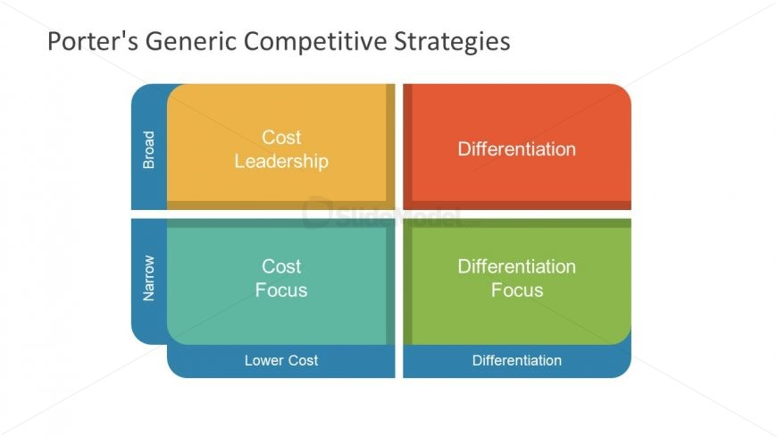
Figure 18: Porters generic competitive strategies.
(Source: Porter 2010)

