GLOBAL BUSINESS ENVIRONMENT

Table of Contents

Introduction 3
PESTLE Analysis in terms of Global Business Environment: 4
Conclusion: 11
Reference: 12
Appendix 13

Introduction

This assignment is a complete guideline for the airline industry in the United Kingdom and will provide the crystal idea of the business environment prevailing in the airline industry in the current scenario. The selected organization for the particular piece of study is British Airways. The British Airways Plc was founded as a British Air Transport company in 1974 in the form of fusion with the British Overseas Airways Corporation.
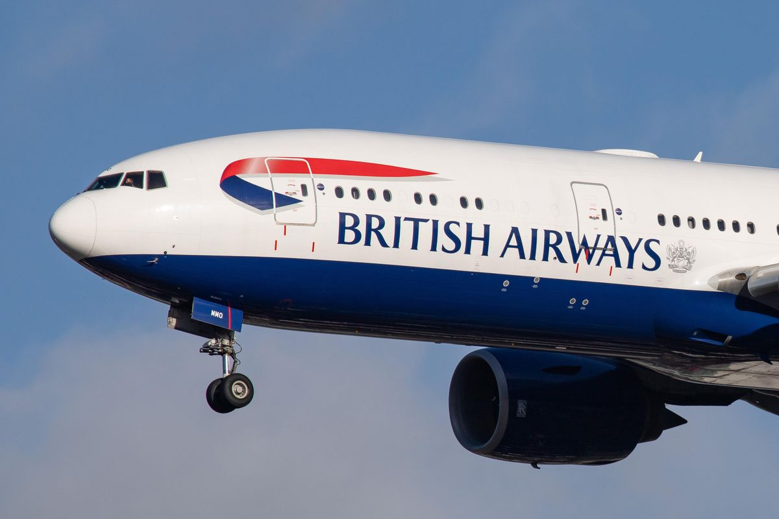
Image1. The British Airways
(Source: https://www.forbes.com/)
This airline industry is having the largest network in the United Kingdom and overall Europe. The organization got privatized in the year 1987. One of the major subsidiaries has BA CityFlyer that is having an operation in connecting between the United Kingdom and continental Europe broadly a connector between Paris and New York City (Airways, 2017). Talking about the popularity, according to the report of 2020, British Airways was the highest in terms of popularity. The report has been attached here below:
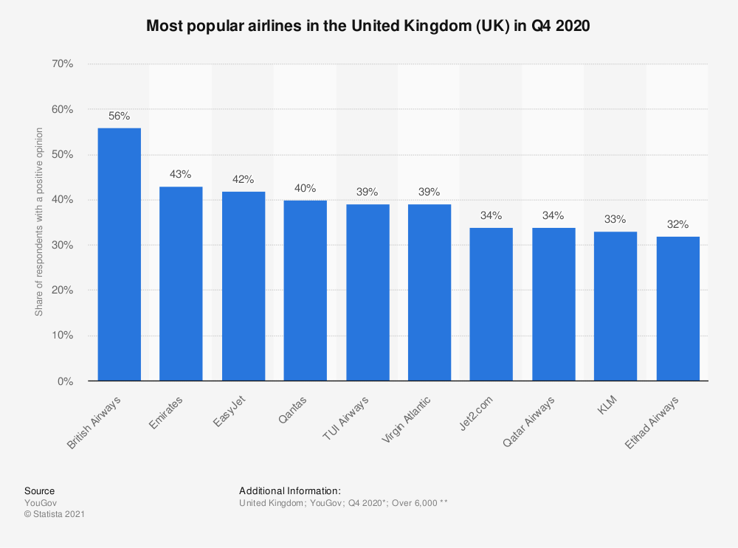
Image 1. Report of 2020 on British Airline Industry
(Source: https://www.statista.com/statistics/951250/most-popular-airlines-uk/)
The global business environment can be determined as the societal and environmental duty for an organization that is mainly influenced by certain global issues regarding business. It depends on the external dynamics mixed with digital imperativeness (Brenner, 2018). These influential factors could be economic, political stabilities, technological factors, and somewhat extend to legal and environmental factors.
The piece of study will be critically analyzed the PESTLE on the airline industry of the United Kingdom.

PESTLE Analysis in terms of Global Business Environment:
PESTLE analysis is one of the main analytical tools in the business field that provides a concrete identity to the organization of the current market scenario. There are many usages for doing PESTLE analysis as it gives a meaningful conclusion to the complete framework. Though it can be classified into two main factors for doing PESTLE framework (Düerkop and Huth, 2017). The two main usages of the analysis are mentioned below:
- To identity the feasibility of entering into a new market segment
- For doing a quick and thorough evaluation of the macro-environmental factors for the business model.
The PESTLE analysis is very useful for giving a suitable answer for the six influential factors as Political, Economic, Social, Technological, Legal, and Environmental. It is because these six factors have a great impact on the business and also it determines the cost selling value and the export and import value structure of the organization. PESTLE analysis is also used for understanding the strengths and opportunities hidden in the new market segment and has better R&D support for establishing a new product line and widening business scope. It is also used to identify the potential business threat factors and turn them into positive factors for the business model (Düerkop and Huth, 2017).
Here the selected organization is British Airways and a thorough PESTLE analysis will be done on the selected business organization:
P- Political Factors: Certain factors influence the operations in the British Airways Industry. It could be a common occurrence in the airline industry because the employees’ strike in the industry disrupts the total operating system and affects the brand image and reputation. According to a recent occurrence in 2017, the BA employees, mainly the 2900 crew members went for strikes for ‘poverty pay’ to the cabin crew members that remained unsolved. As a result, 1400 cabin crew members threatened to go for the strike, leading to a severe disruption in the service. Though the political stability and the strictness of the government rules for the safety of the workers and passengers are quite reasonable that helps British Airways to fly in the open sky between Paris and New York City (Ofori-Parku and Moscato, 2018).
Another reason could be the UK airline industry losing influential control over the European Aviation Safety Agency after the incident post-Brexit, which led them to several legal frameworks and bilateral agreements, which is a time-consuming process and leads to service disruption.
The G20 stands for the Group of 20 major economies that is founded to restart the tourism stopped due coronavirus situation and for the upliftment of the airline industry from the current scenario. Here it provokes governmental support and financial help for the crisis of the industry. This will initiate certain facilities from the government to recover the loss in the existing industrial reports.
E- Economical Factors: The most affected cause prevailing the Airline industry is the economic factors of any nation in the world. Currently, the most relevant problem in the world is facing the issue of Covid-19 and due to the disease every industry got shattered but the most affected industry is the airline industry. The economic slowdown and worldwide lockdown worked as flammable cautions for the industry. Certain factors that cause a severe downfall in business growth are as follows:
- British Airways Plc has planned to have a third runway in Heathrow. Due to that, they have to shift their functional and operational office into some other place, resulting in huge price hiking in the domestic and international flight.
- There is a plus point for the British Airways industry is to slow down the fuel price in the UK which causes a certain increasement in their profitability and share market. It could be a short-term profit for the British airways.
- Another reason could be the post Brexit incident, it will hamper their operational and foundational cost for setting up the agency support and will be reducing the investment costings for the short-term period (Kim and Lee, 2019).
Apart from the above-mentioned factors, the business is affected due to the instability of inflation rates, the economic climate, and increasing currency rates. Another indirect cost can be considered the sudden price drop of, oil which affects the business. It has caused a direct fall in the passenger revenue by 2.8%, equivalent to 288 million US dollars.
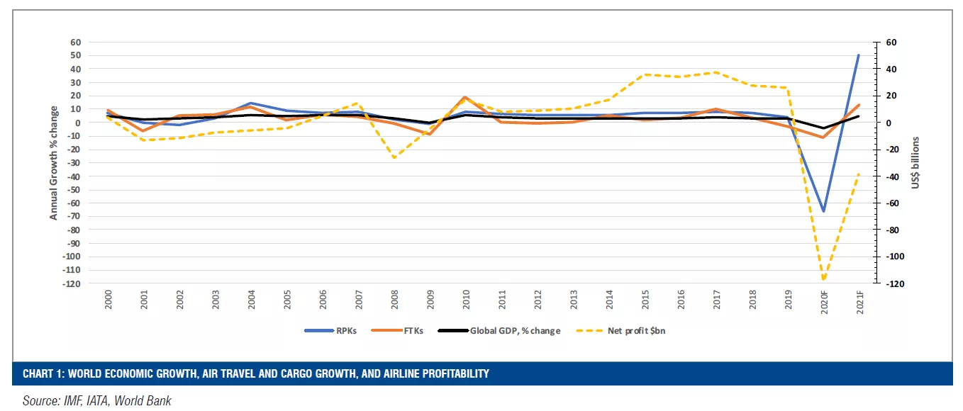
Image 3. IMF Data, World Bank
(Source: https://home.kpmg/ie/en/home/insights/2021/02/aviation-report-2021-surviving-the-crisis.html)

S- Social Factors: It is quite evident that the passengers always want to try the airline that is convenient and trusted above of all that, the price effectiveness. The social factors are the most important factors that are the assets for any type of service industry. Due to this Covid-19 situation, the total social factor has to get devastating effects overall. Social distancing measures and the worldwide lockdown have impacted the service industry of airlines. Certain factors influence the increasement in the market share of British Airways. And the above-mentioned report of 2020 has already shown the derogative popularity of the chosen organization of the airline industry (Barnes, 2017). The factors that influenced the system are as follows:
- From the customer’s perspective, these airlines are providing convenient service at sustainable and affordable rates.
- The quality of the service provided by the organization is comparatively high than the competitors and they are taking into considerations all the preventive guidelines regulated by the government.
The organization has focused on the national cultural factors and migration factors including their system which incentivize their total service quality. They have issued common values, individual normalities, and practices into the flight deck. This helps in creating better communication in the teamwork, take the best exponential measures in the emergency situation due to the consideration of the migration factors. The migration factors have become a significant factor in the airline industry for the sending and the receiving country (Barnes, 2017). As they play a major role in the economic and sociological factors through certain projects, exchanging knowledge base. And here the airline industry works as a vital transportation pillar for the migration purpose.

T- Technological Factors: The technological factors of PESTLE analysis describe the various technical issues and benefits one company has and how they can improve it. For example, if the company has included modern technologies if the company has trained their personnel enough to handle various technological issues, how the company handles customer satisfaction and their queries related to websites or other technical issues and feedback (Baroutaji et al., 2019). These are the part of technological factors. British Airways has different technological factors that affect this company in various time periods. Those factors are-
- Investment in technical research and development of the company (POSITIVE)
- Handling data and analysis to become more improved (POSITIVE)
- Effect of the digital revolution (POSITIVE)
- Safety of the passengers (POSITIVE)
- The Covid-19 pandemic(NEGATIVE)
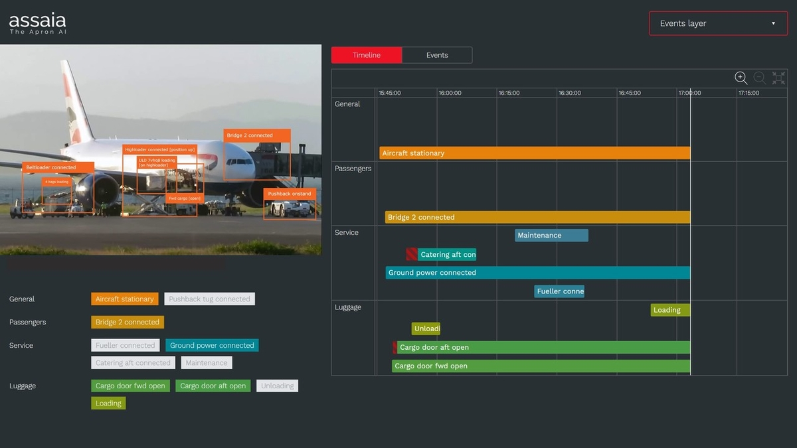
Image 4: British Airways Using Technology to Maintain Punctuality
(Source-https://www.airline-suppliers.com/ba-becomes-first-airline-to-use-next-gen-ai-video-technology-to-improve-its-punctuality/)

Technology is the centre of the airline industry. British Airways is a company that investments a lot of money in the research and development of the company. Digitalized market with the help of the internet helped the growth of British Airways. The company is now using modern and advanced technology to handle the competitive market and ensuring efficiency in the service of the company (Xue and Fu, 2018). They are trying to provide the customers with amazing services and that is why they are monitoring the websites of their company and daily improving and upgrading the data and technology in the website to serve the best to the consumers. Other than the services for the customers British Airways also invested a lot of money in cargo handling, automation of the process and onboarding.
After the terrorist attack on 9/11 British Arline undergoes a lot of trouble and question arose about internet security and safety. A digital revolution took place at that time and the airways invested a huge amount to secure the safety of the passengers (Tian et al., 2020). They ensured uninterrupted connectivity of the websites and no data breaching. All industries faced a huge loss during the time of the pandemic and they need to cut a huge cost-cutting. But British Airways’ investment in R&D helped in achieving super success during the pandemic even as they handled the challenges arising from Brexit and the Covid-19 pandemic.
The ever-changing technology in the aviation industry needs to have detailed, dynamic and modern technology (Xue and Fu, 2018). British Airways ensuring security and quality services by making their technology dynamic, flexible and customer-centric.

L- Legal Factors: The legal factors are mainly connected to the laws international and national and the legal procedure of trading or maintaining customer services. British Airways is facing various legal factors from the beginning. Those factors are-
- Influence of Trade Union or WTO (NEGATIVE)
- Compliances with the labours and consumers (NEGATIVE)
- Crisis of the Cabin Crew (NEGATIVE)
- Pay Settlements and Pilot’s strike (NEGATIVE)
The legal factors are mostly influencing British Airways in a negative manner. The intervention of the trade union caused a recent walkout from the company which went for three days and due to that 1100 flights out of 1950 flights during that period got cancelled and the company faced a massive loss. Also, maintaining compliance with the labourers along with ensuring customer satisfaction needs to be done reliantly by the airways to avoid various settlement problems with the labourers (Lutek, 2018). A cabin crew problem arose due to the strikes and legal process of the trade union recently. All these problems faced by British Airways are very common and usual and most of the problems are from the influence of the trade union as well as from Brexit. The airline still did not come up with a firm solution to these strikes related matters.

E- Environmental Factors: The environmental factors are mainly related to the ecology and the environmental issues and how to overcome them and the positive and negative impact of those factors. The most common environmental factors that affect the aviation business are bad weather conditions, carbon emission and various other environmental remedy issues (Tian et al., 2020). British Airways also faced various issues that negatively affected the airways company. Those issues are-
- Reduced the carbon fuel and energy consumption (POSITIVE)
- Reduce noise in the engine (POSITIVE)
- IAG commitment for environmental remedies (POSITIVE)
- Bad weather condition (NEGATIVE)
By improving the technology British Airways reduced the use of carbon fuel and other energy resources which made a positive impact on the environment. Various technological improvements helped British Airways to reduce their noise pollution by reducing the sound of the engine (Ranasinghe et al., 2019). British Airways has its mother company named IAG who is committed to bring the carbon footprint to zero per cent. Also, they have goals that by 2050 they will reduce carbon emission by 50% and they will improve carbon efficiency by 25% within 2025. Various monetary benefits from the IMF and UN this airway is receiving as they are adopting different technologies to improve the environment as well as working for the environmental remedies. For the environmental factors, British Airways developed several programs to tackle climate change and the emission of carbon in the environment. British Airways faced disruption in their operation in 2016 due to bad weather conditions and many flights got cancelled. This incident made a huge impact on the company as it reduced customer satisfaction as well as due to this company faced a large loss. The company is still working and spending a lot of money in R&D to advance their technology to save the environment. They are focussing on reducing the use of natural resources and reducing their waste material as well (Wong et al., 2017). They are also focussing on recycling the waste material as well as the fuel.
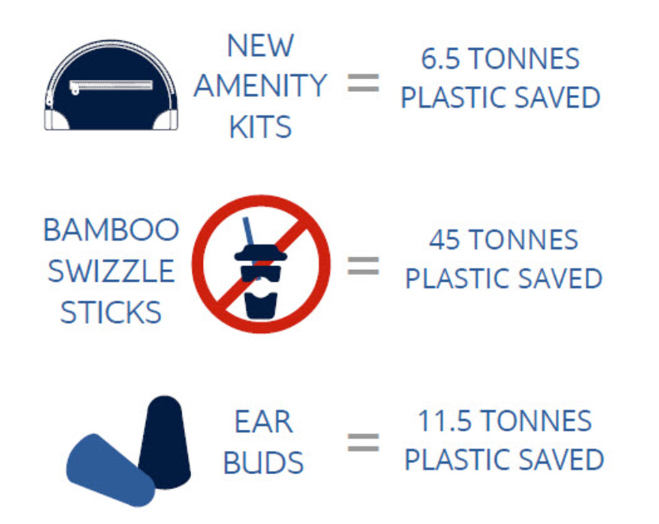
There are several factors that affect the environment. But the companies like British Airways mainly focus on sustainability and for that, they are trying to reduce their environmental damage. Sustainability is the keyword to become successful min this globalisation period. By advancing technology and reducing carbon footprints the company can have the sustainability it desires.

Conclusion
In conclusion, it can be said that after assessing the external environmental factors of British Airways through PESTLE analysis it seems that the airways have various factors in the environment which has a positive and negative impact. It helps in understanding the use of various tools for the development of the product, services and marketing strategies. But the most highlighting areas that this company needs to improve is that-
- The company needs to sort out the various striking problems in the labourers of the company.
- The development and research are not enough they need to monitor the process and trained the employees to handle various advanced technologies.
- The company needs to make sure that it will maintain compliance with the labourers.
- British Airways needs to focus on the WTO and Brexit influence to stop the various crisis, strikes and intervention in the company.
The assignment helped in identifying various environmental factors that are affecting British Airways positively and negatively. Also, it is vital for British Airways to maintain constant performance in the market to ensure sustainability.

Reference list
Journals

Airways, B., 2017. British Airways. Where we fly.[online] Available at: https://www. britishairways. com/travel/where-we-fly/public/en_gb/map [Accessed 13 November 2017].
Barnes, J., 2017. Measuring service quality in the low-cost airline industry.
Baroutaji, A., Wilberforce, T., Ramadan, M. and Olabi, A.G., 2019. A comprehensive investigation on hydrogen and fuel cell technology in the aviation and aerospace sectors. Renewable and sustainable energy reviews, 106, pp.31-40.
Brenner, B., 2018. Transformative sustainable business models in the light of the digital imperative—A global business economics perspective. Sustainability, 10(12), p.4428.
Düerkop, S. and Huth, M., 2017. Transportation under Threat–A PESTLE Analysis for Critical Logistical Infrastructures. ICTA2017, p.14.
Kim, J.H. and Lee, H.C., 2019. Understanding the repurchase intention of premium economy passengers using an extended theory of planned behavior. Sustainability, 11(11), p.3213.
Lutek, M.W., 2018. Legal aspects of safety management in civil aviation. International Journal of Synergy and Research, 7.
Ofori-Parku, S.S. and Moscato, D., 2018. Hashtag Activism as a Form of Political Action: A Qualitative Analysis of the# BringBackOurGirls Campaign in Nigerian, UK, and US Press. International Journal of Communication, 12, p.23.
Ranasinghe, K., Guan, K., Gardi, A. and Sabatini, R., 2019. Review of advanced low-emission technologies for sustainable aviation. Energy, 188, p.115945.
Tian, Y., He, X., Xu, Y., Wan, L. and Ye, B., 2020. 4D Trajectory optimization of commercial flight for green civil aviation. IEEE Access, 8, pp.62815-62829.
Wong, K., Rudd, C., Pickering, S. and Liu, X., 2017. Composites recycling solutions for the aviation industry. Science China Technological Sciences, 60(9), pp.1291-1300.
Xue, Y. and Fu, G., 2018. A modified accident analysis and investigation model for the general aviation industry: Emphasizing on human and organizational factors. Journal of safety research, 67, pp.1-15.

Appendix

Element /Factors | Examples | Effects on the British Airways
Element /Factors | Examples | Positive | Negative
Political | Post-Brexit incidents can be an example of political factors of the UK Airlines Industry. | Political stability and governmental rules and regulations give that leverage to the airline industry. | The employees of the cabin crew go for a strike that could lead to lead to the operation downfall in the prevailing industry.
Economical | Various types of spending in the increasement of airport structure and runways. | It helps in the drop of oil price that helps to grow the passenger’s revenue by 2.8% | Sudden hike in the fuel price increase the cost efficiency in the industry
Social | Influence of national culture agency helps in identifying the prevalent problems. | It helps to create a harmonic situation in teamwork of cabin crew and handling emergency situation. | it creates problem in the midst of Covid-19 crisis and a sudden disruption in providing the quality service.
Technological | Various technological spend on the research and development of the company. | A digital revolution took place at that time and the airways invested a huge amount to secure the safety of the passengers | The industry faced a huge loss during the pandemic and the attack of 9/11 as it breached the data of the customers.
Legal | Influence of Trade Union or WTO leads to various strikes in the company. | It helped the airways company to settle the payments and compliance with the labourers. | Due to various strikes the company faced huge loss as they have to cancel the flights as there was no employees.
Environmental | Reduced the carbon fuel and energy consumption and bad weather condition. | IAG who is committed to bring the carbon footprint to zero per cent and the goals of reducing carbon emission by 50% by 2050 and they will improve carbon efficiency by 25% within 2025. | The company faced various disruption due to the bad weather condition and cancellation of many flights.

