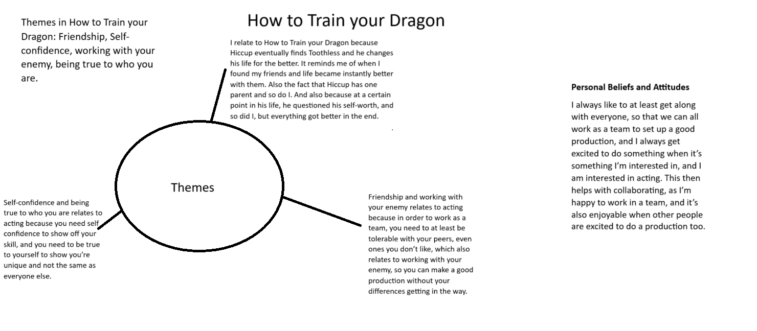

Bibliography

Polygamous Passionista. (2011). Themes and Lessons of How to Train your Dragon. Available at: https://v4violetta.blogspot.com/2011/08/themes-of-how-to-kill-your-dragon-2010.html [Accessed 15 December 2023].

