Blended Learning to Certificate in Higher Education

ACADEMIC AND EMPLOYABILITY SKILLS/ BMSW4001
STEFANIA-CLAUDIA BULETE-2106754
LECTURER NAME: GIRIDhAR KATTI
2021

Aims:
- Pros and cons of blended learning in the university education
- Pros and cons of traditional classroom learning in the HE sectors
- Evaluation of both forms of teaching and learning in the past and present. Support your arguments using evidence and examples.
- Recommendations you would make based on your evaluation.

Table of Contents
Aims: 1
Introduction: 2
1.Pros and cons of blended learning in the university education 2
2.Pros and cons of traditional classroom learning in the HE sectors 3
3.Evaluation of blended and traditional learning 4
4. Recommendations 7
Conclusion: 8
References: 9

`

Introduction:
The integration of transmission technologies in learning environments offers qualitatively totally different learning expertise in higher education, associated this can be thanks to variations in access to resources, improved exchange of information, and new ways in which of collaborating between experts, lecturers, and students. Blended learning describes a basic modification in education by employing a combination of digital learning objects and active learning strategies to help the educational experience and outcomes. Blended learning had 3 main components: Face-to-face active learning activities expedited by an educator, digital learning objects and structured freelance study time guided by the face-to-face teaching experience. Ancient classroom environment, learning begins with the teacher sharing his knowledge, take with discussions between the teacher and therefore the students end with the new data written in notebooks.

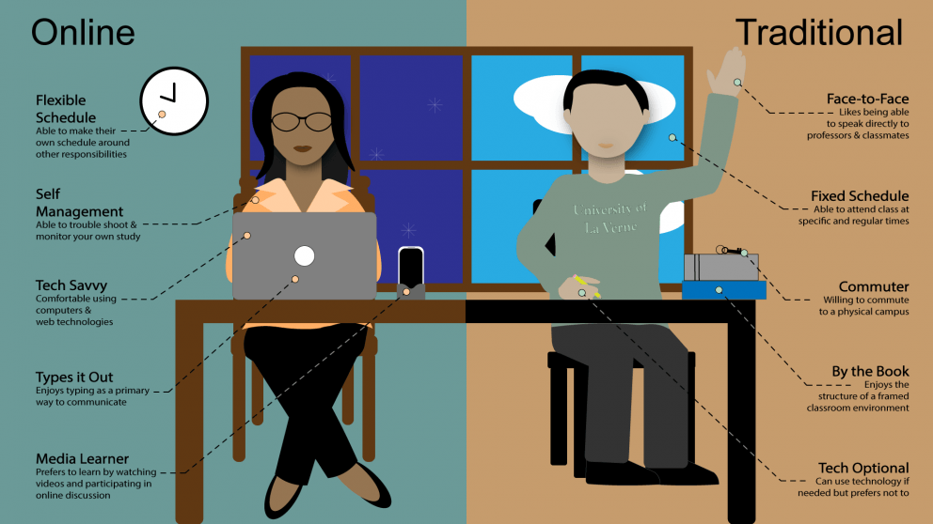

1.Pros and cons of blended learning in the university education
1.1 Saving time- this is often one in every of the vital tools we tend to all have to be compelled to manage well, therefore, amalgamated learning permits America saving longer. Learning from home means that less visits to high school and back, avoiding queues, traffic, or delays, there is more time for practicing, learning, or reviewing a lesson. The saving of your time will facilitate saving more energy, even for teachers, which can invest their time in additional attention-grabbing and charming activities for his or her students.
Increased accessibility- Being a full-time student and having a full-time job as well, could be not easy, blended leaning has been developed over the years as great and usefull method of learning. eLearning provide a huge variety of apps which help on: easy reading material, clearly writing, faster calculator, watching materials how often is necessary for understanding. Misunderstanding? Questions? Content? Focusing? Blended learning optimised everything, allowing the students reviewing the lesson at any time.
“Students appreciated their ability to access the embedded multimedia lessons from outside the classroom, and some attributed their improved learning due to this factor. Four (13%) of the students stated that being able to access the instruction from home was what they liked most about the online instruction. Students wrote, ‘If I didn't get something down, I could watch it at home’ and ‘I can replay a part I don't understand, I can view at home.’ Students also valued the accessibility of the multimedia lessons, which they could use to catch up after an absence: ‘If I was absent, it was like I didn't miss class because I still could learn the lesson.”
1.2. Strong technological dependence- we are heavily dependent on the Internet to be able to use the technological resources and tools, which are the key ingredients of the blended lesson plans. Poor connection to the internet or no internet may cause problems, for example, during an exam your computer just switched off, there may not be another chance to retake the exam in the same day, or, trying to submit an assignment in the last day or hour.
Lack of IT knowledge- It is already known that technology is developing rapidly, and this is not easy to be up to date with everything.
Supervision- In online environment the supervision is poor, is complicated to control how involved the students are during the lesson, the presence, student’s engagement in activities in teamwork or how focused they are on the lesson.

2.Pros and cons of traditional classroom learning in the HE sectors

2.1. Discipline and punctuality: obtaining abreast of time, having an explicit time for everything separated as a schedule, everything sorted and planned not solely college time, however additionally the time before and once school. Having the standard school causes you to have a well-organized routine for your daily activity.
Interaction between the lecturers and students-It helps to extend communication skills, learning to figure in an exceedingly team, getting a distinct purpose of read or asking or responding to the teacher questions.
2.2. Passive learners: If you've got been educated an explicit subject by a selected teacher, the teacher alone becomes your primary supply of data. You become dependent upon the teacher for knowledge and don’t offer abundant effort upon doing analysis on their own. This makes them passive and uninteresting and kills the creativeness of them.
Extent of data: something you learn is restricted to the books and therefore the information your teacher comes up for you. The books are a similar for several years. just some changes are created occasionally. Learning the same thing in and out each currently then isn’t the most effective of information you'll be able to get. it's limited as compared to the likes of on-line learning.



3.Evaluation of blended and traditional learning


3.1. Blended learning- The earlier references to the term “blended learning” are from the late 1990s.
It has a positive impact in students and teacher life, as the following statistics made by Marija Pandurov from Mark in Style show us the way it helps:
“73% of teachers say blended learning increases engagement.
60% of teachers notice blended learning improves academic ability.
59% of students are more motivated when using blended learning models.
82% of students prefer blended teaching to classic teaching environments.
30% to 79% of lessons are delivered online in blended learning models.
48% of students think interactive polls and quizzes are the most useful online tools.
60% of students prefer using separate social media channels for learning and private life.
74% of UK teachers were confident about digital teaching at the beginning of the 2020/2021 school year”

Technology is developing so fast, there are changes everywhere around the world, when the blended learning started being using in schools, for many students was easy to adapt to this kind of study. The lessons are delivered easily and along that, dyslexic students have many methos to learn in their style, which is a win for them and, in the same time a in for teachers. There are many methods for recording lessons from the classroom and rewatching, easy ways for students to upload and work on their assignments, many sources of information, no HomeWorks or exams lost, online library, where is no necessary anymore to read all the books to find whatever you need, only type few keys points and the book is in front of you, directly at your house, online.
Before Covid-19 pandemic started, we were not ready to use blended learning that much, that was a huge opportunity for all of us to develop new skills, trainings provided by schools for teachers and students. When I started my first year of university everything was online, registration, interview, induction, meetings. I was a little crossed by all this technology but at the end all of these were just advantages for me. I gained technological skills.
3.2. Traditional learning: Traditional learning is the first and the oldest form of learning.
One of my high school teachers said: “When I was at university, in your age, our work was handed by teacher, he/she marked it and gave it back to us. There were many libraries for students with limited access to computers, which required appointment or hours of waiting on the queues, being limited time, we had to be prepared for the subject we were looking for. The internet was slow and poor quality, sometimes took 5-10 minutes to upload the page. Our progress on exams was checked on the boards across the school which took quite long to find your name between all the students names. The books were quite bigger, but we always had time to get out with colleagues and share the information.
The main tools of traditional learning were Chalkboards where the teacher delivered the information to us, sponges, when the chalkboard was full, we removed everything using a sponge. Bunches of pens, pads of A4 sheets to write down the information they gave to us.”

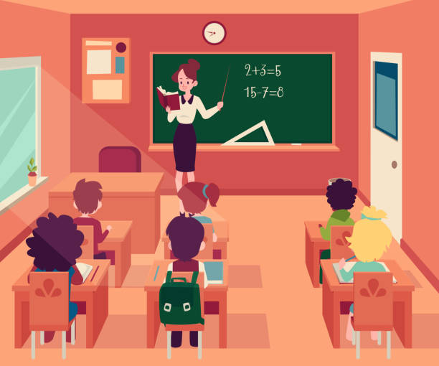

4. Recommendations
This is a right time to start learning to use more, correct, and advantageous the blended learning. Looking at the traditional learning it started to be used less than years ago.
Following the advantages and disadvantages of blended and traditional learning, I would like to recommend for both students and teachers:
-to take as much courses as they need to coupe this new style of learning. Could be hard for all of us to move from the traditional learning to blended learning but taking a basic or advanced course would be usefull and will prevent failing attending the course, submitted the homework or assignments, communicating and sharing the work with teacher or colleagues via online.
-I strongly recommend getting ready with good and spare devices, right and hight internet company and get the Apps Office for a good learning environment.
-Teachers finding more group activities, more interesting and captivating for students, for example, Kahoot is an online interactive game where the teachers insert questions and answers, and the students pick the answer. Also using this app, the teachers have a clear view of the interactivity of their students.
-Taking a traditional course class sometimes, also helps for a better communication development and discovering new ideas and opinions, opportunities and even partners for a new of future project.
-Meeting the teachers face-to-face for a better feedback and extra questions.
-Traditional learning also helps for introvert people to extrovert and get over the introvert illness.
-If there is any crossing situation about the social life, online or IT problems, the schools are always helping you with courses, meetings, or one-to-one sessions, ask for it.

Conclusion:
Blended learning can enhance conceptual understanding and constructivist learning to increase rigor and offer differentiated supports to ensure all students succeed
Learners who expertise blended learning will see the world as they understand it reflected within the programs wherever they learn and can deploy essential thinking skills to participate in an exceedingly society where we have a tendency to create, collaborate, and communicate in digitally mediate networks.
By making a system of support that puts people first, class providers will work responsively to confirm educators are equipped with the knowledge and resources they have to form high-quality, cooperative learning experiences wherever learners develop confidence and competency using technology for learning, for work and in their daily lives.

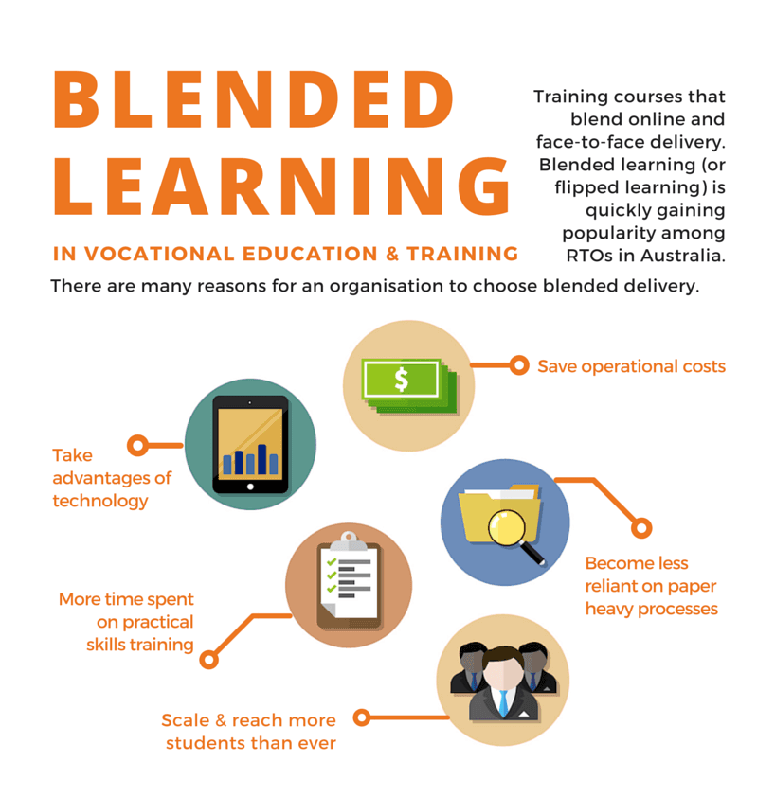

References:
- Allan, B. (2017). Blended learning: tools for teaching and training. London: Facet.
- Burnham, T. (2021). Exploring Blended Curriculum to Enhance Adult High School Learning. International Journal of Social Science and Human Research, pp4(3).
- Davis, Lauren. The Impact of Blended Learning on Student Engagement. Schoology.com, Schoology, 18 June 2020, www.schoology.com/blog/impact-blended-learning-student-engagement#:~:text=Blended%20learning%20has%20a%20negative%20impact%20on%20student.
- Eaton, M. (2020) The perfect blend: a practical guide to designing student-centered learning experiences. Portland, Oregon; International Society for Technology in Education
- Garrison, D. R. (D. R. & Vaughan, N. D. (2008) Blended learning in higher education framework, principles, and guidelines. 1st ed. San Francisco: Jossey-Bass.
- Marija, P. 35 exciting Blended Learning statistics (The 2021 View). Mark in Style, 8 May 2021, 35 Exciting Blended Learning Statistics [The 2021 View] (markinstyle.co.uk)
- RAW-I Studios. Blended learning vs Traditional Learning, YouTube, 17 May 2021 www.youtube.com/watch?v=BSfA_u0z2X8.
- Smith, J. and Suzuki, S. (2015), Embedded blended learning. Journal of Computer Assisted Learning, 31:133-147

