Name: Collette Owen
Student Number: 2517697
Course: Computing (Data & Information) Bsc
Module: L4 - Introduction to Web and Database Concepts - ACCA4023
Date: 27/7/206

Design and Implementation of a Relational Database System

Contents
- Title
- Contents
- Introduction
- Tables
7. Queries
8. Forms.
11. EcoBikes Rentals – Entity relationship Diagram
12. Scenario
13. Challenges
14. Areas for Future Improvement
15. References

Introduction

Modern urban mobility increasingly relies on sustainable transportation solutions, with eco-friendly bike-sharing initiatives like Ecobikes playing a pivotal role in reducing traffic congestion and carbon emissions. Behind every efficient, scalable bike-sharing ecosystem lies a robust relational database designed to seamlessly handle high-volume, real-time operations—ranging from fleet management and user registration to station tracking, ride logs, and payment processing.

This assignment focuses on the structural design, implementation, and evaluation of a tailored database management system for Ecobikes. To establish a logical flow, an Entity-Relationship Diagram (ERD) was constructed to map primary entities, define relationships, and enforce essential data integrity constraints while minimising redundancy.

Following the structural implementation, comprehensive database testing was carried out—including structural verification, data validation, and query performance testing, to evaluate system behaviour under realistic operational scenarios.

This paper presents the full development lifecycle of the Eco Bikes database, detailing the architectural framework established by the ERD, analysing the testing methodology and query performance outcomes, and demonstrating how the final system effectively supports the core demands of a modern green transport network.

Tables
1) Bike Pages
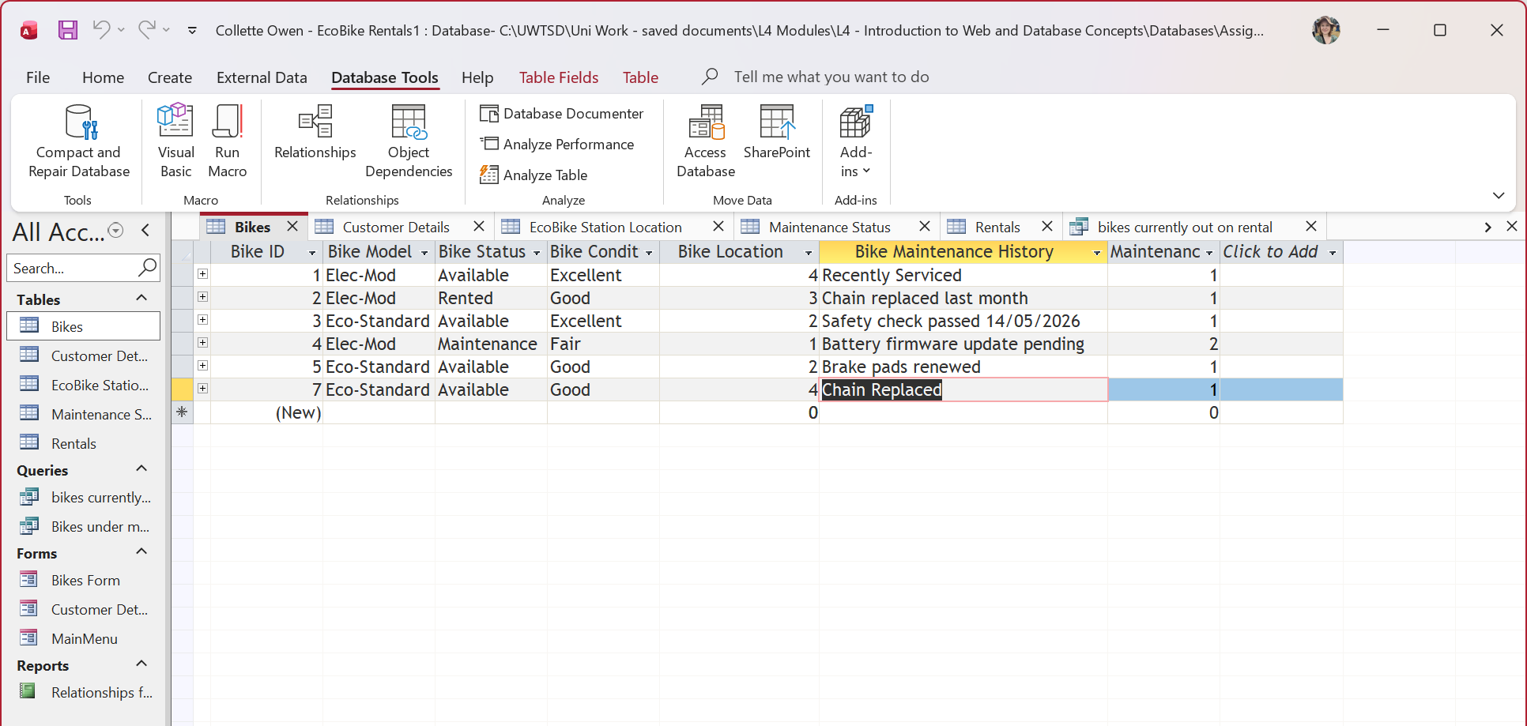

2) Customer Details Page

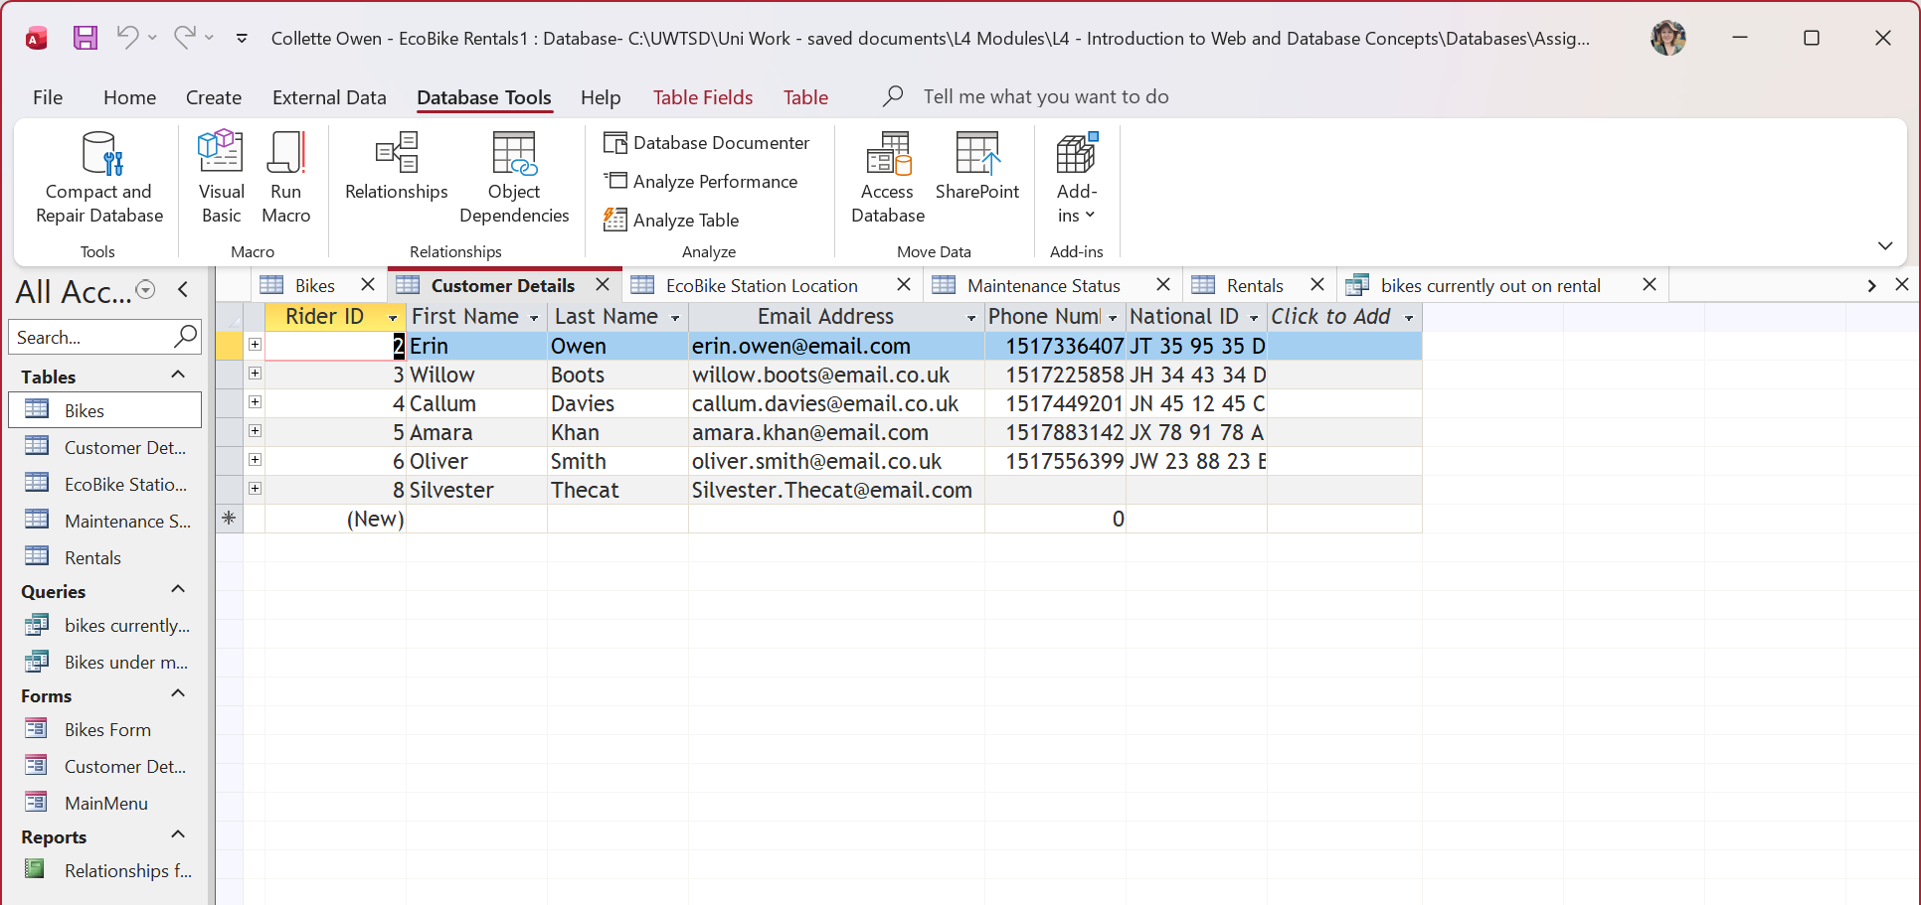

3) EcoBike Station Location page

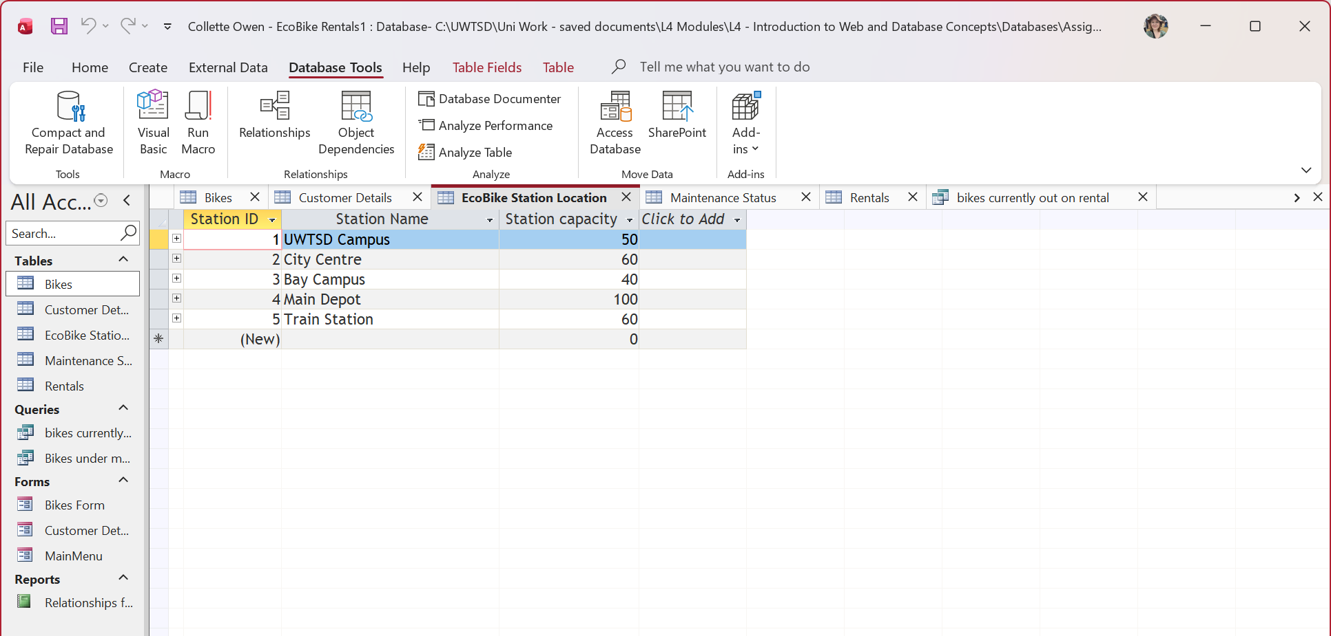

4) Maintenance Status page

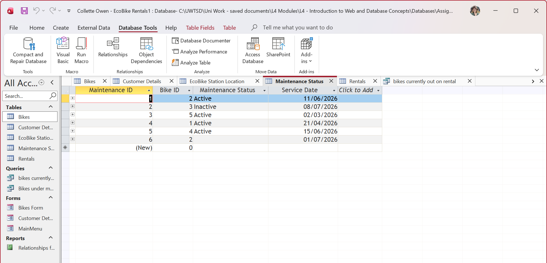

5) Rentals page

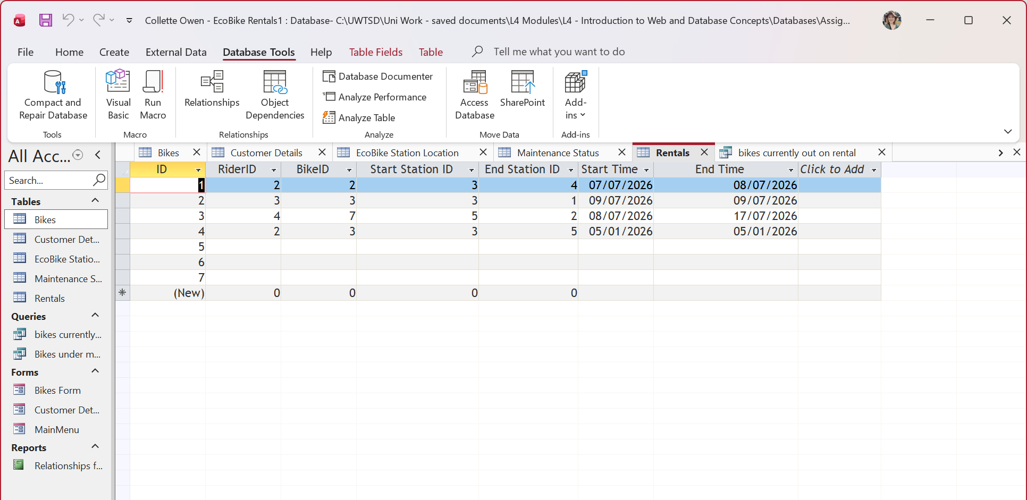

Queries
1) Bikes Currently Out on rental query



2) Bikes under maintenance query


Forms
1) Bikes form
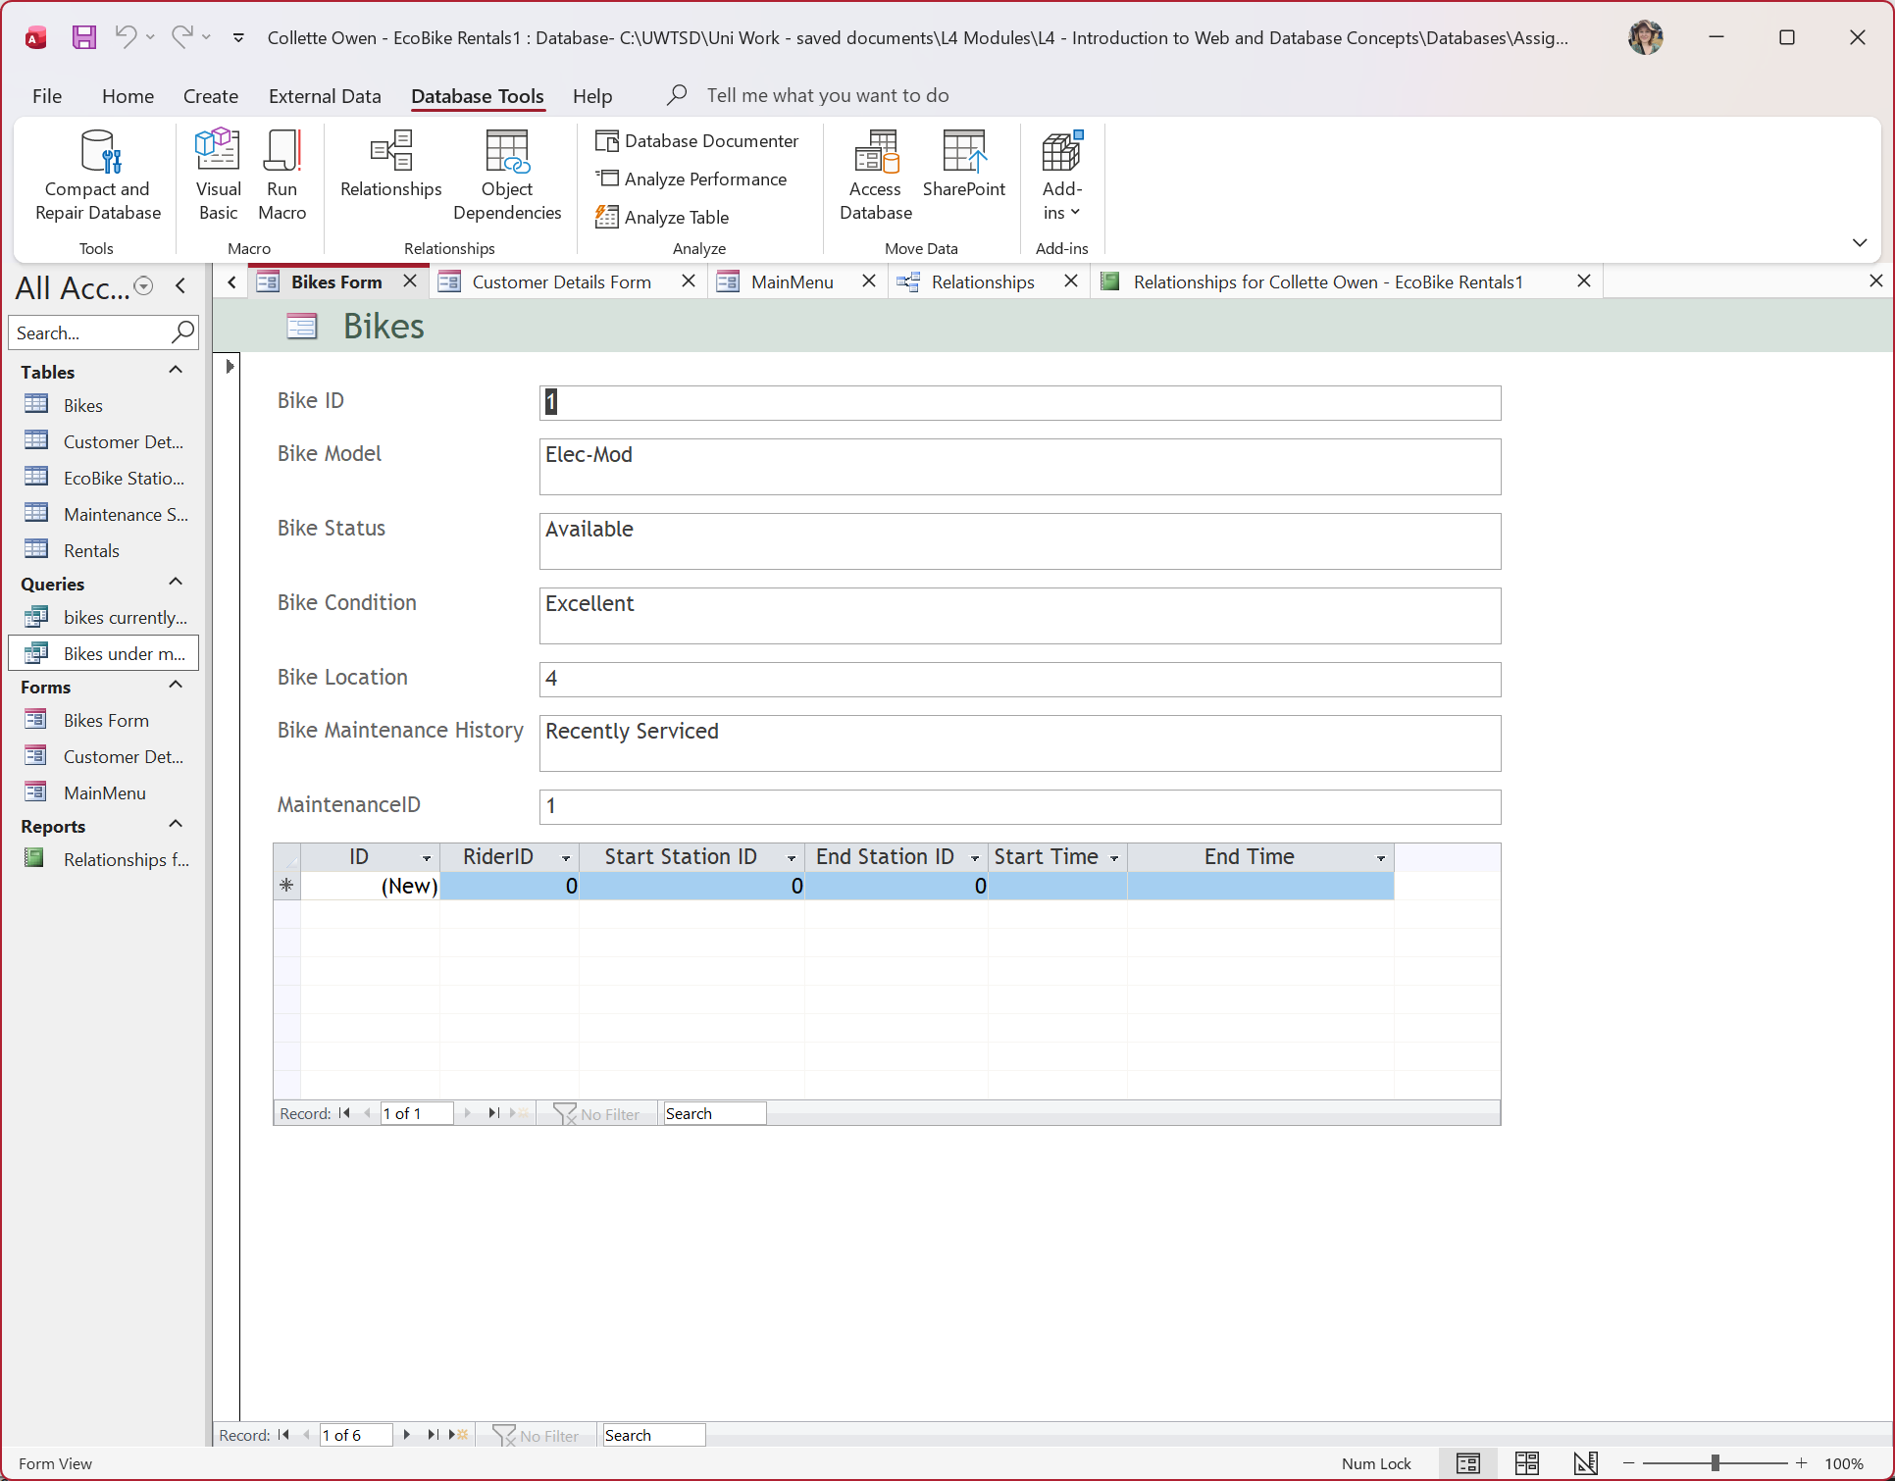

2) Customer Details form
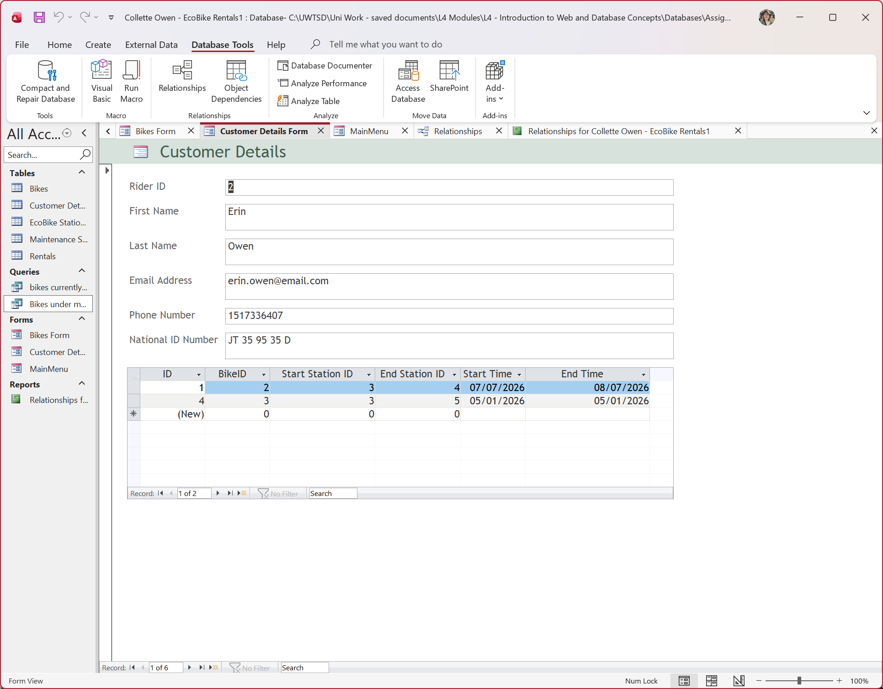

3) Main Menu


EcoBikes Rentals – Entity relationship Diagram
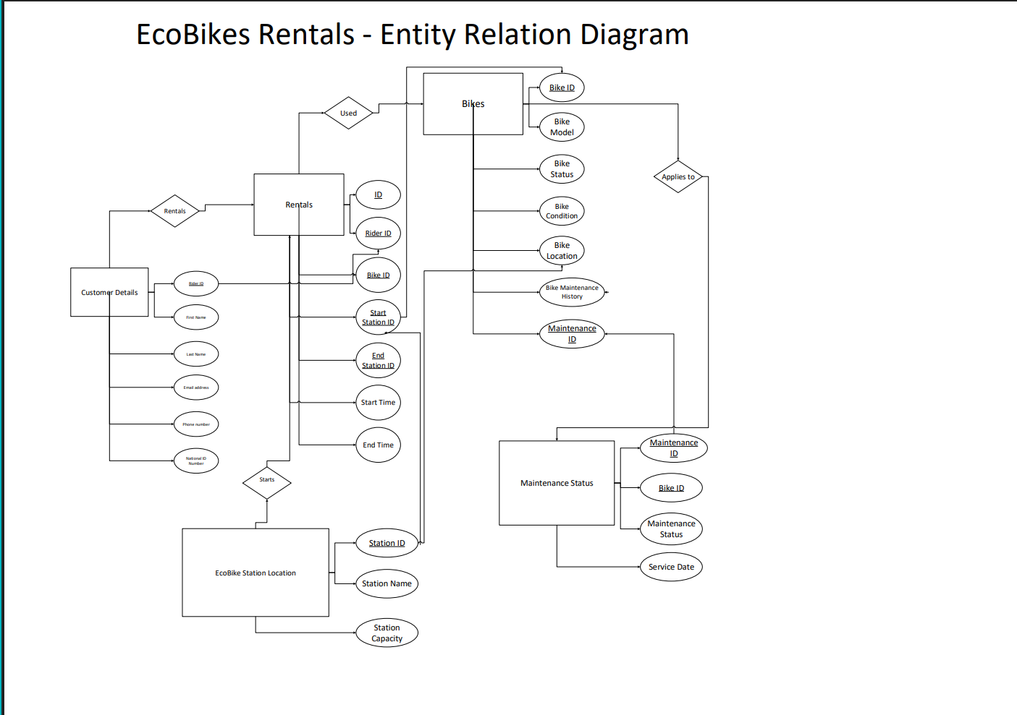

Scenario
System Overview & Purpose
Designed to support a local authority’s green transport initiative, this database provides a centralised management system for an eco-friendly bike rental scheme. The system seamlessly connects key operational entities, including customers, bike fleets, stations, rentals, and maintenance records, into a unified, user-friendly platform.
Design Approach & Learning Objectives
As a beginner in database architecture and Microsoft Access, I intentionally selected a clean, baseline structure. This strategy provided a practical base to build hands-on skills in:
- Relational Design: Systematically identifying and resolving structural design challenges.
- Access Development: Building queries, customising user forms, and configuring tables.
- Testing: Troubleshooting data-entry errors and refining system workflows through active testing.
- Keeping Entity/Attributes clear and meaningful.
“As entity types are identified, assign them names that are meaningful and obvious to the user.” 1. Connolly, T. M., & Begg, C. E. (2015).

Relational Architecture & Normalisation
To guarantee data consistency, primary and foreign key constraints were established to link related tables and enforce referential integrity. The database schema was systematically normalised up to Third Normal Form (3NF), ensuring data redundancy was minimised and storage efficiency was optimised.
Usability & Data Validation
A primary focus of the system design was user experience. Custom forms were created to streamline front end data entry for customers and staff, ensuring inputs remain fast, simple, and accurate. Rigorous backend testing was then conducted across queries, forms, and relationships to verify system reliability for daily use.

Challenges

As a beginner to Microsoft Access, undertaking this project presented a steep learning curve. Navigating the software while simultaneously absorbing core relational database concepts, attributes, and constraints proved significantly more complex than working with standard desktop applications that I am used to.
To bridge this knowledge gap and improve technical proficiency, I completed the Access Basics for Excel Users course on LinkedIn Learning. This additional study provided essential context for transitioning from flat-file spreadsheet thinking to relational data structures.

Course: https://www.linkedin.com/learning/access-basics-for-excel-users-25113993?u=77966930

During construction, implementing appropriate data validation rules presented a primary challenge. Establishing correct data types, input masks, and field formats across tables required a process of testing and refinement to ensure consistent data entry.
Navigating these challenges highlighted the critical importance of a well-structured system. As database expert Michael J. Hernandez notes, “you can appreciate the dangers presented by a poorly designed database now that you’ve learned how to design a database” 2. Connolly, T. M., & Begg, C. E. (2015). Database Systems
Experiencing the practical difficulties of validation and schema configuration firsthand provided deep context for this insight, reinforcing why rigorous design principles are essential for data integrity.

A challenge I also found was ensuring the relevant entities and attributes were situated in the correct places.
In the early stages the Bike ID only resided in the Bikes Table. Throughout the exercise I learned that it would have a place in the Maintenance Status table.

Areas for Future Improvement
ERD Refinement
In terms of structural documentation, the Entity-Relationship Diagram (ERD) could be improved by re-architecting the layout to prevent overlapping relationship lines and improve readability. As a visual learner, developing the ERD was nonetheless an invaluable exercise for conceptualising entity links.
Visualising the layout bridged the gap between raw functional requirements and database implementation, embodying the principle that “it is often easier to visualize a complex system rather than decipher long textual descriptions of a user’s requirements specification” (Connolly & Begg, 2015, p. 351).

Quality Assurance & Testing Framework
To elevate system quality, future work would focus on expanding query capabilities and implementing a broader testing suite. Key testing improvements would include:
- Boundary & Edge-Case Validation: Testing input limits on forms to ensure bad data cannot enter the system.
- Multi-Table Query Stress Testing: Evaluating query execution logic across complex joins (e.g., linking customer, rental, bike, and maintenance data simultaneously).
- End-to-End Integrity Checks: Ensuring referential integrity constraints perform reliably during simultaneous data additions and updates.
Adopting this rigorous evaluation framework would deliver a higher standard of quality assurance for both end-users and database administrators.

In future projects, I would implement more sophisticated field-level validation rules beyond simply designating fields as 'Required' (mandatory). For numeric data, rules such as >= 0 (preventing negative values) and <> 0 (disallowing zero entries) can be applied to maintain baseline numerical accuracy. Furthermore, incorporating temporal constraints, such as <= Date() to prevent the selection of future dates, would effectively eliminate accidental data entry errors in rental logs and maintenance records.

References
1) Pg. 510, Connolly, T. M., & Begg, C. E. (2015). Database Systems : a practical approach to design, implementation, and management (Sixth, global edition.). Pearson.
2) Pg. 455, Hernandez, M. J. (2021). Database design for mere mortals : a hands-on guide to relational database design (Fourth edition.). Addison-Wesley.
3) Pg. 511, Connolly, T. M., & Begg, C. E. (2015). Database Systems : a practical approach to design, implementation, and management (Sixth, global edition.). Pearson.

