


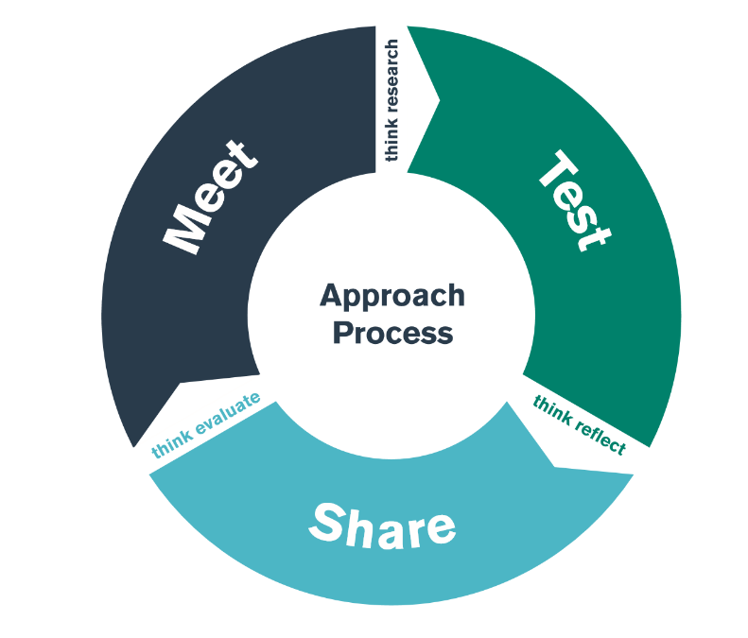

BA2
ECAD5007 – The Learner: who am I teaching?
MEET & SHARE at University
TEST Phase: 19/02/24 – 08/03/24 (School)

Student-Teacher Enquiry Evidence Record (STEER)

What is the purpose of the Bridging activity?

The aim of this Bridging activity is to link theory gained during university lectures with practice regarding supporting the progress of individual learners. By the end of the TEST phase, you should have a better understanding of some of the key interventions used within the school and how these are implemented. You should also have developed your understanding of how these may impact on progression in learning and development.

Make brief notes regarding the school background and context e.g. total number of pupils, learners with ALN, EAL, eFSM, MAT, class and group structures etc.

What do you want to find out during this bridging activity? Note any key questions.

What have you learnt from discussions with staff regarding how and why interventions are implemented within the school? Make some background notes.

During your observations of individual/small group interventions, please complete the following:

INTERVENTION 1

Name of intervention | Number of pupils | Key focus (skills to be developed) | Who is involved?  How many learners? | Where does this take place? | When?  How long for?  How often? | Additional information
Further reflections:

INTERVENTION 2

Name of intervention | Number of pupils | Key focus (skills to be developed) | Who is involved?  How many learners? | Where does this take place? | When?  How long for?  How often? | Additional information
Further reflections:

INTERVENTION 3

Name of intervention | Number of pupils | Key focus (skills to be developed) | Who is involved?  How many learners? | Where does this take place? | When?  How long for?  How often? | Additional information
Further reflections:

What have you learnt regarding how progression in learning is monitored and used to support further development?

Any final reflections on the TEST day. How will this support your planning for the SHARE activity and for your module assessment? Is further information needed? How and where will you get this information?

Standard Title | QTS Descriptor
Pedagogy - Refining Teaching
Managing the learning environment | The teacher understands the importance and demonstrates the  effective establishment and on-going management of the learning  environment, in promoting positive learning habits and behaviours  that meet the four purposes and are understood by learners in that  context.
Assessment | The range of purposes and practices for assessment is understood and articulated.
Differentiation | The teacher demonstrates knowledge, understanding and  experience of high expectations and effective practice in meeting  the needs of all learners, whatever their different needs.
Recording and reporting | The teacher produces appropriate, timely and accurate records and reports and gives feedback to facilitate a deeper understanding of learning and enhance the learning experience.
Involving partners in learning | The importance of positive involvement of parents/carers and other  partners is understood and opportunities are taken to observe and  evaluate processes.
Pedagogy - Advancing Learnings
Four purposes for learners | The teacher demonstrates a knowledge and understanding of the  needs of all learners in planning, preparation and teaching, ensuring  that the four purposes are the drivers for learners’ experiences.
Exploiting subject disciplines in areas of learning | The teacher demonstrates a knowledge and understanding of  relevant pedagogies and disciplines within and across subject  content, areas of learning and cross-curricular themes, and plans  appropriately.
Blended learning experiences | The teacher understands the selection, use and justification of a range  of imaginative teaching approaches for the benefit of each learner.
Real life, authentic contexts | The teacher demonstrates an understanding of the use of real life,  authentic contexts for learning being provided as a natural part of  the learning experience. This extends the learner’s cultural, linguistic,  religious and socio-economic experience and illustrates applications  of concepts and abstracts in practice.
Progression in learning | The teacher demonstrates an understanding of how learning  develops incrementally and tangentially, building on prior experience  and learning, and plans for progress in learning based on this.
Cross-curricular themes | The teacher knows, understands and engages with the principles  of curriculum design and innovation, with development of crosscurricular themes relevant to areas of learning and justifies decisions.
Pedagogy - Influencing Learners
Challenge and expectations | The teacher provides appropriate levels of challenge and  expectations for the range of student abilities and characteristics,  motivating learners to achieve.
Listening to learners | The teacher demonstrates a willingness to seek, listen to and take  account of the views of learners in order to engage and encourage  them as active participants in their own learning.
Learners leading learning | In planning and delivery, the teacher demonstrates an awareness  of the importance of encouraging learners to reflect upon their own  learning.
Sustained effort and resilience in learners | The teacher promotes and secures learners’ self-motivation and  self-direction in their learning.
Reflection on learning | In planning, the teacher demonstrates awareness of the importance  of encouraging learners’ reflection and evaluation around  behaviours and outlooks for learning.
Learning outcomes and well-being | The teacher raises awareness of how high-quality learning  experiences and performance outcomes lead to improved learning  and a heightened sense of well-being.
Collaboration
Seeking advice and support | The teacher actively seeks and engages with support from a range of formal and informal sources. This includes observation and team teaching, whilst demonstrating increasing levels of independence.
Working with in-school colleagues | Organised and constructive work with a range of colleagues to enhance learners' experience is a consistent feature of the teacher's practice. Reflection on developing expertise is structured as a personal or a collaborative process, as appropriate.
Supporting and developing others | The teacher develops high quality relationships with colleagues in order to have a positive impact on learners' experiences within the school.
Enabling improvement | There are examples of improvement in outcomes following the teacher's seeking and adoption of advice.
Professional Learning
Wider reading and research findings | The teacher demonstrates increasingly confident understanding of the theories and research about assessment, pedagogy, child and adolescent development and learning relevant to planning and day-to-day practice.
Professional networks and communities | The teacher has an informed understanding of the contribution of research, including small scale action research, to the development of practice.
Continuing professional learning | The Professional Learning Passport influences the ongoing critical reflection and learning of the teacher and is developmental in prompting further professional growth.
Welsh language skills | There is a commitment to incremental development of personal skills in the use of the Welsh language.
Innovation
Offering expertise | The teachers models an increasing repertoire of teaching techniques, as expertise emerges and flourishes, in order to inform and enhance the development of others.
Developing new techniques | Research on cognitive, social, emotional and physical development has a positive impact on pedagogy. The teacher can demonstrate how professional discernment and critical analysis are brought to bear in shaping developing practice.
Evaluating the impact of changes in practice | The teacher actively seeks support and advice from colleagues in developing innovative approaches within the classroom so that their impact can be evaluated, analysed and shared.
Leadership
Taking responsibility for self | The teacher demonstrates professional attitudes and behaviours, developing positive relationships with learners, parents/carers and coleagues which illustrate a personal commitment to the fundamental principles of equity and of maximising the potential of all learners.
Exercising corporate responsibility | Contractual, pastoral, health and safety, legal and professional responsibilities are known and understood by the teacher.
Leading colleagues, projects and programmes | The teacher's understanding of, and commitment to, leading learning is demonstrated through collaborative experiences in school and other contexts.
Supporting formal leadership roles | The teacher demonstrates an understanding of the nature of responsibilities within and across teams and of the contributions individuals make towards the school's ethos and the successful fulfilment of the school's vision.

EXPERIENCE TEMPLATE

- What did you do and why?
Describe your professional experience. You may wish to refer to your role or involvement, why you had engaged in this experience and the intended outcomes. You can also mention any particular professional standards you had chosen to focus on.

- What have you learned?
You might want to consider some of the following: why is this experience important or relevant? How does it relate to your overall learning, development and/or use of the standards? Did it meet the intended outcomes? Any lessons learned? What are the implications for colleagues and learners? How will you share what you’ve learned?

- What Next?
Is there anything you intend to do as a result of this experience? You might want to consider some of the following questions: Are there any specific actions that you will take? What would you do in similar circumstances in the future? Is there anything you intend to change? Do you have plans for any further learning or development opportunities? If so, who or what can help - using the standards, people, written resources, online materials, workshops etc? How will you share what you’ve learned?

Use your reflections from the ‘Experience Template’ to identify your target and the next steps
in achieving this.

TARGET

What area do you want to develop in your own practice?
TIMESCALE

When do you want to achieve this by?
RESOURCES

What do you need to help you achieve this? Who do you need to talk to/observe? What do you need to research?
SUCCESS CRITERIA/
OUTCOME

How will you judge whether it has been successful or not? What impact do you hope to see in teaching and learning? What reserach/literature is this based on?
MONITORING/
EVALUATION

How will you check that you have successfully achieved your target? Lesson observation? Book scrutiny? Pupil voice?

BA2 ECAD5007 BRIDGING CHECKLIST

 | What to do? | When? | Notes | Done
1. | On your TEST day, observe 3-4 interventions online/in school in your allocated Network school (2 English medium and 1 Welsh medium). | 25 January 2023 | Complete observations in your STEER booklet.
2. | Complete the Experience Template based on your observation to present at the SHARE session within the module at University.  - What did you do and why?  - What have you learned? | 25 January 2023  26 January 2023 SHARE day | Use the “Experience Template” section in your STEER booklet.
3. | Present your Experience Template to your module tutor and peers. Focus on “What you have learned?”. | 26 January SHARE day . | You will be given 10 minutes to share ‘What you have learned?’ during the TEST day.
4. | Following the SHARE session within the module at university, please complete the following section of your Experience Temple:  - What next? |  | Use the “Experience Template” section in your STEER booklet.  N.B. This can be copied and pasted into your PLP.  Observations from the TEST day and the SHARE session may also be used as examples of best practice to support your discussion within the ECAD5007 assignment.

