
Applied Leadership and Management in the Workplace
Module Assignment Submission for A
Student Name: | Nicky-j Paton-Lewis
Student Number: | 2315603
Module No: | BMSK5014
Module Title: | Project Management

Statement of Confirmation of Authenticity
By the act of making this submission, the student declares that this is the work of the student named above. The work has not, in whole or in part, been knowingly presented elsewhere for assessment, or where assessment has been built on a previous assessment, this has been identified. Where materials have been used from other sources it has been properly acknowledged. If this statement is untrue, the student acknowledges that an assessment offence has been committed.
Attention is drawn to the plagiarism and unfair practice policies of both the University and of ILM.

Table of Contents
Introduction 4
Tools and Techniques 4
Initiate 5
Plan 9
Execute 11
Close 13
PDP 14
References 15

Introduction
This assignment focuses on the development and introduction of a mobile work order management app designed for property maintenance teams. It examines how project management approaches and planning tools can be applied to guide the project from initiation through to closure. We will look at setting clear objectives, identifying risks, analysing stakeholders and selecting an appropriate delivery method. It also considers industry standards, costs and benefits and the practical steps needed to ensure the system is effective, user friendly and sustainable in the long term.

Tools and Techniques
All project management methods have been considered for this property maintenance mobile app project. These are the Waterfall model, the V model, the Iterative model method. Each has its own advantages and disadvantages when applied to the planning and delivery of the new system.
According to Kerzner (2022), the Waterfall method follows a clear sequence of stages, beginning with requirements gathering, then moving to design, implementation, testing and finally deployment. For this project, that would mean completing each stage fully before moving on, which helps ensure that documentation is clear and deliverables are well defined. The main strengths of this method are that it is easy to manage, follows a predictable schedule and works well when requirements are unlikely to change. Its main weakness is a lack of flexibility, as late changes can be costly and time consuming.
The V model is closely related to Waterfall but introduces a parallel testing stage for each development stage. In this project, that would mean testing every part of the app as it is designed and built, from early features through to final release, to make sure it meets requirements. Sommerville (2011) explains that this approach provides strong quality control and reduces the risk of defects. However, like Waterfall, it can be rigid and is less suitable if requirements are likely to evolve during the project.
The Iterative model takes a different approach by breaking development into smaller cycles of design, build and test. Each cycle produces a working version of the system that can be refined in the next round. This allows feedback to be gathered earlier and makes it easier to adapt to changes. The benefit is greater flexibility and reduced risk of major flaws being discovered late in the project. The downside is that it can extend timelines if too many revisions are made and requires careful control to prevent the project from drifting. As Sommerville (2011) notes, the iterative process supports ongoing development and accommodates evolving requirements, but requires careful management to avoid project drift.

Model | Description | Pro’s | Con’s
The waterfall. | Linear model moving through requirements, implementation, testing and deployment. | Easy to manage, predictable and clear documentation | Not flexible, late changes are costly.
The V model | Each stage has a testing phase. | Strong quality control, reduces risks and defects, clear link between design and testing. | Rigid, less suited to change.
The iterative model. | Development carried out in cycles of design, build and test. | Flexible and feedback gathered early on and easy to adapt to changes. | Can make timelines longer and there is a risk of loss of focus if not managed well.

For this project, the Iterative model would be the most suitable approach. Both the Waterfall and V model offer clear, structured frameworks that are easy to manage and provide strong documentation. However, their rigidity makes them less effective if requirements change, which is likely in a project like this where stakeholder feedback, maintenance staff, property managers and tenants will play an important role.

Initiate
The initiation phase prepares for the foundation of the mobile work management app project. Axelos (2020) explains that this stage is about confirming the project’s purpose, identifying the key stakeholders and outlining the core requirements. The main goal is to create a shared understanding of the scope and expected benefits before significant resources are invested.
The business case for developing a mobile work order management app is to improve the efficiency and reliability of property maintenance services. The scope of the project is to create an app that allows maintenance staff to receive, update and complete work orders digitally, with features such as real time task assignment, photo uploads and progress tracking. The expected impact is faster response times, reduced paperwork, clearer communication between staff and managers and improved tenant satisfaction. In the long term, the app will support cost savings through streamlined processes and provide better data for decision making.
A risk analysis matrix has been created to highlight the main risks for this project and assess their potential impact and likelihood. This visual tool makes it easier to identify which risks require the most attention, such as technical issues and GDPR compliance and which can be managed with standard monitoring. By mapping risks in this way, the project team can focus resources on the areas that pose the greatest threat to successful delivery. This will be visited and updated right the way through the project.

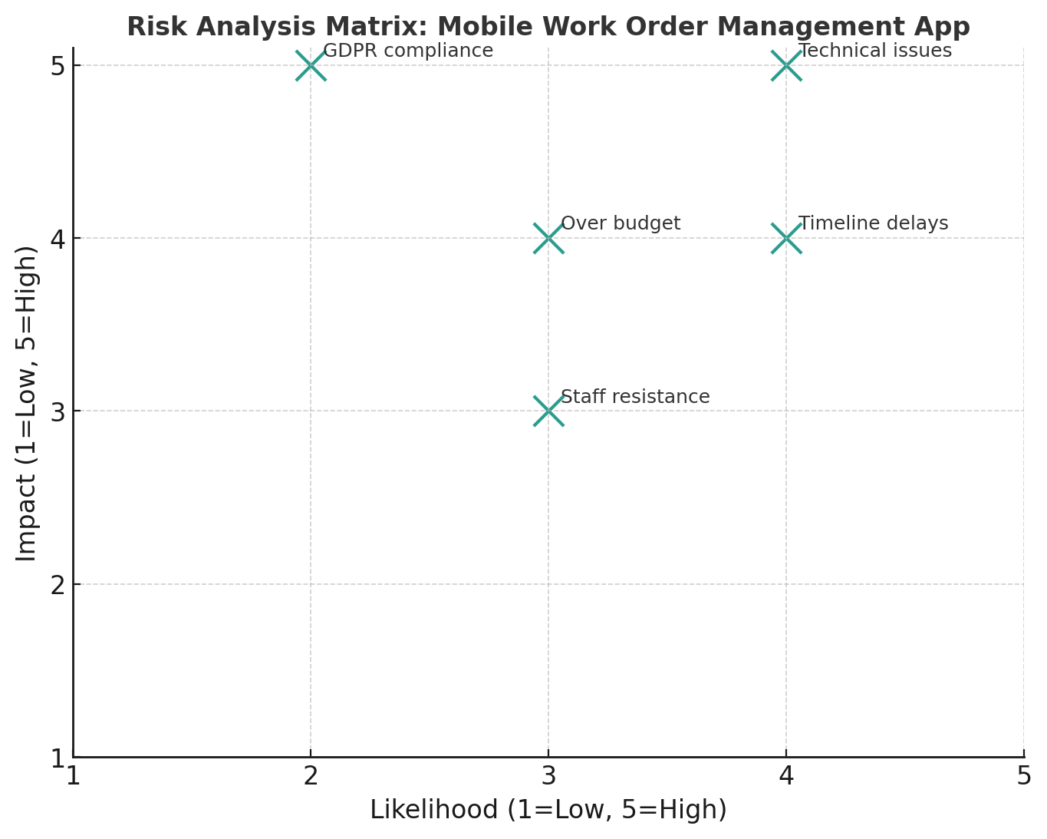

By using SMART goals as a way of setting objectives that are specific, measurable, achievable, relevant and time bound, Doran (1981). For this project, an example would be to deliver a fully functional mobile app for maintenance teams within six months, with at least 90 percent user adoption in the first three months after launch. The main advantage of SMART goals is that they encourage clarity, focus and accountability, while also aligning the team’s efforts with measurable outcomes. A limitation is that SMART goals can sometimes oversimplify objectives, with too much focus on measurable outcomes leading to important qualitative factors, such as user satisfaction, being overlooked.

Specific | Develop and launch a mobile app that enables maintenance staff to receive, update, and complete work orders digitally. | Clearly defines what the project will deliver.
Measurable | Gain at least 90% of active users within 3 months. | Progress can be tracked through system usage reports.
Achieveable | Use an experienced development team and existing IT technology to complete the app within six months. | Resources and timeframe are realistic given the organisation’s capacity.
Relevant | Supports the organisation’s aim to improve efficiency, reduce delays, and enhance tenant satisfaction. | Directly contributes to broader business objectives.
Time | Complete full implementation by October 2025, with initial testing completed by March 2026. | Ensures deadlines are clear and time focused.

A dendron diagram has been used to provide a clear visual overview of how the different parts of this project connect together. It maps the project from the central aim of developing a mobile work management app through the key areas of project management that have been applied, including initiation, planning, execution and closure. Dendron diagrams, provide a structured way to break down complex systems into hierarchical components, making relationships clearer and easier to manage, MindTools,(2020) .This diagram helps to show the logical flow of the work, making it easier to see how each stage comes together.
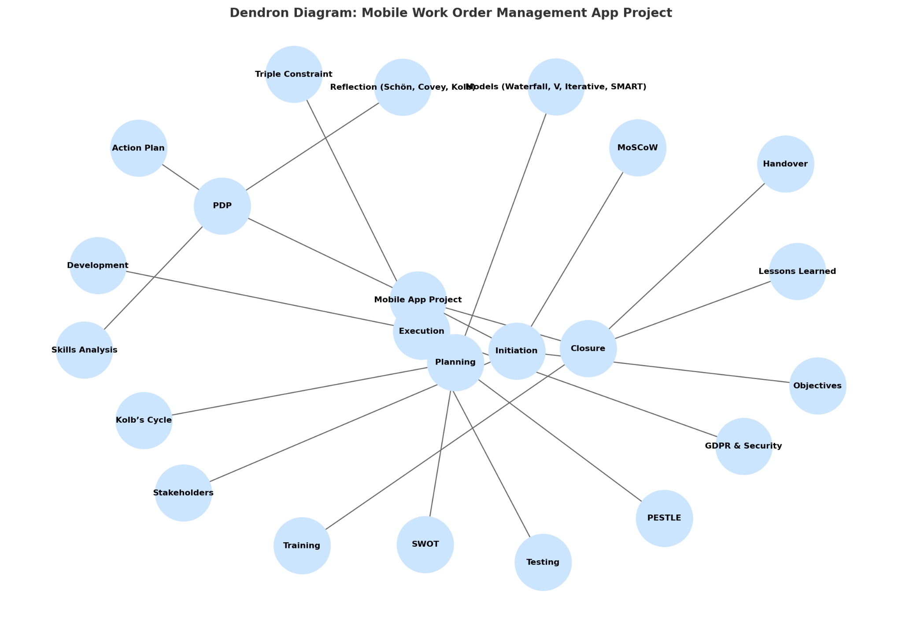

For this project, the primary stakeholders include property managers, maintenance staff, tenants, the IT development team who's creating the app and senior management. A stakeholder interest table will be used to plan how best to engage each group. Property managers and senior management, with their strong influence, will require regular high level updates, while maintenance staff will play a more active role in design feedback and testing.
Completing these steps provides the project with clear direction, agreed priorities and an engagement plan that will help the development process run more smoothly in later stages.

Steakholder | Power | Interest | Engagement Strategy
Property Managers | High | High | Engage in planning meetings and testing sessions.
Maintenance Team | Medium | High | Involve in design feedback and testing.
Tenants | Low | Medium | Provide updates on expected service improvements.
IT Development Team | Medium | High | look closely during design and implementation, daily or weekly check ins.

Another useful tool for this project is the MoSCoW method, which is designed to help teams prioritise requirements. It works by dividing features into four categories, must have, should have, could have and will not have. According to Clegg and Barker (1994), must haves for this project may include real time task allocation, status updates and the ability to attach photos to work orders. Features that fall into the could have category might include integration with an asset management system or predictive maintenance tools, which could be added in later phases once the core system is in place.
Must have | Real time task allocation for maintenance staff.  Ability to update job status on site if completed.  Option to upload photos of the job at hand.  Secure logins for all staff.
Should Have | Notifications for urgent work.  Basic offline mode for areas with no network service.
Could Have | Integration with asset management software.  Predictive maintenance feature.
Wont Have | Full tenant self service portal in the first release (planned for later down the line).

Kanban is a visual method for managing work by moving tasks through stages such as to do, in progress, and done. It reduces overload by limiting the amount of work in progress and makes task status clear to everyone involved. As Oza et al. (2013) explain, Kanban helps teams identify missing tasks and maintain a steady pace, leading to greater productivity. In this project, Kanban will be used to manage the development of the mobile work order app by keeping tasks organised, spotting delays early and ensuring work flows smoothly from start to finish. Compared with the MoSCoW model, which is used to set priorities by categorising requirements as must have, should have, could have or will not have, Kanban focuses on managing the flow of those priorities once they have been agreed. Together, the two methods provide both clarity on what is most important and structure for how the work progresses.

Kanban board for mobile app project
To Do | In Progress | Done
Design how the app will look and feel.  Set up a secure online place to store maintenance records.  Plan how tenants can send and track repair requests. | Build a system that gives jobs to maintenance staff in real time.  Add the feature for uploading photos of completed jobs.  Add the feature that shows updates on repair progress. | Finish the project plan and scope.  Agree how to keep in touch with all stakeholders.  Decide which app features are most important.

Plan

The planning stage is one of the most important parts of any project, as it sets out how the work will be structured and delivered. According to Kerzner (2022), planning is about defining the project’s objectives, identifying the resources required and outlining the steps needed to achieve the desired outcome. For this mobile work management app, careful planning is essential to make sure that the project stays on time, within budget and aligned with the needs of stakeholders. By using recognised planning tools and models, the team can anticipate potential risks, build on strengths and create a clear roadmap that guides the project from start to finish.
Every project carries risks and this mobile app is no exception. The main risks include going over budget, delays in development, resistance to change from staff, technical issues during integration, and challenges around GDPR compliance. While these risks cannot be fully removed, they can be reduced through careful planning, regular progress reviews, staff training and strong data protection measures.
SWOT analysis is a planning tool used to evaluate a project's internal strengths and weaknesses and external opportunities and threats. Gurel and Tat (2017) describe it as a framework for identifying and analyzing the factors that can impact a project’s success. However, it is not without limitations. As Jennings (2008) says, swot can be expensive, time consuming and often mind blowing, when used as a standalone strategic planning model.
Despite these challenges, SWOT remains useful in this project because it offers a balanced overview of what could support or obstruct the development of the mobile work order management app, making it easier to build strategies that use strengths and address risks. Helms and Nixon (2010) says its simplicity allows it to be applied at many levels. This is especially relevant here, as the project spans both operational and technological change. By applying swot, the team can clearly identify what is working, anticipate difficulties and understand how external factors might shape the outcome.
Swot for mobile app project.
Strength  - Real time communication between property managers and maintenance staff.  - Centralised task tracking improves accountability and reduces lost requests.  - Ability to capture photographic evidence for quality assurance. | Weakness  - Initial development costs may be significant.  - Dependence on reliable internet connection for full functionality.  - Staff may require training to adapt to new digital tools.
Opportunity  - Positive tenant feedback can improve organisational reputation.  - Streamlining processes may reduce operational costs over time. | Threat  - Cybersecurity risks associated with storing maintenance data online.  - Resistance to change from staff used to traditional methods.
A PESTLE analysis looks at the Political, Economic, Social, Technological, Legal and Environmental factors that can affect a project. The results show that the project can benefit from political support for digital change and social trends also adding clearer property maintenance services. At the same time, it highlights possible challenges such as higher costs, the need to follow legal rules, and staff who may be slow to accept new ways of working. By tackling these issues early with careful budgeting, regular updates, staff training and strong data protection, the project team can improve the chances of success and make sure the mobile application stays compliant, affordable and useful for years to come.
Political – Government support for digital transformation in housing could help with adoption, while changes in local council policies may shift maintenance priorities.
Economic – Rising labour and material costs may put pressure on the project budget and an economic downturn could make it harder to secure funding for technology.
Social – Tenants increasingly expect faster repairs and clearer updates, which supports the case for a digital system. At the same time, some older staff used to paper based processes may resist the change.
Technological – The growth in smartphone use and cloud solutions makes deployment easier, but rapid changes in technology mean the system could become outdated if it is not regularly updated.
Legal – Compliance with UK GDPR is critical for protecting tenant and maintenance data and building and safety regulations will directly influence app features and reporting requirements.
Environmental – Sustainability goals support preventative maintenance to reduce waste and digital reporting cuts down on paper use, contributing to environmental targets.

To finish the planning stage, I also apply Kolb’s experiential learning cycle. My concrete experience comes from seeing how maintenance requests in property management were often delayed when handled through paper records or phone calls. From this, my reflective observation is that the lack of a digital system created communication gaps and made it hard to track progress. By understanding I can set clear requirements for the new app, such as real time job updates, photo uploads and reporting. Finally, the active experimentation will be applying these requirements in the design and rollout of the app, testing them with staff and refining the system based on feedback. As Kolb (1984) explains, learning is the process where knowledge is created through the transformation of experience. Using this method means my planning is grounded in both practical experience and structured reflection, which helps build a more effective solution for this project.

Execute
The execution phase will cover the design, development, testing and rollout of a mobile work management app created specifically for property maintenance teams. The app will run on both Android and iOS devices and will link directly with the organisation’s existing property management system. Key features will include real time job assignment and status updates, the ability to upload photos of completed work, tracking of materials used, and a reporting dashboard to review past jobs. To support a smooth transition, training will be given to both maintenance staff and property managers, with the app first being piloted in one property portfolio before being introduced across the wider organisation.
This project will be delivered within clear limits to avoid scope creep and unnecessary strain on resources. The budget has been set at £25,000 and the timeline fixed at six months, which means strong project control will be essential. To ensure compliance and reliability, all data will be managed in line with UK GDPR regulations and the app will rely on secure hosting, stable internet access and integration with the existing property management software.
The planning and delivery of the work will follow the principles of the Project Management Triangle, often called the Triple Constraint, Atkinson (1999). This model shows how scope, time and cost are closely linked and how changes in one area will almost always affect the others. For example, if the scope is expanded, the project may need more time or funding, while shortening the timeline could put pressure on quality unless extra resources are added. In this project, the scope covers the agreed features and integrations, the schedule is limited to six months and the budget is capped at £25,000.
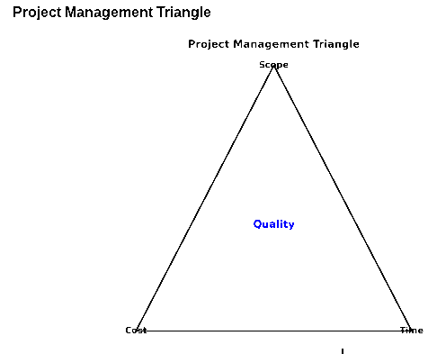
Balancing these three factors is central to achieving a high quality, functional system. This model is a straightforward way to manage priorities, deal with trade offs and make sure the final product meets agreed standards while staying within the set boundaries.

Scope - create a mobile work order app for property maintenance teams. It will include features like real-time job assignment, photo uploads, material tracking and reporting, all linked to the organisation’s existing property management system.
Cost - the project will run on a budget of £25,000, covering development, integration, staff training and the first deployment.
Time - the full project will take six months, from planning and design through to development, testing, and training.
Quality - the aim is to deliver a reliable, user friendly app that meets all agreed requirements, works well with current systems, follows UK GDPR rules and provides accurate real-time data to support better decision-making.
General Data Protection Regulation is a European law introduced in May 2018. It sets out how organisations must handle personal information, giving people more control over their data and requiring companies to protect it securely.

Close
Wysocki (2019) notes that a project is a sequence of unique, complex and connected activities that must be completed by a specific time, within budget, and according to specifications. With this in mind, the Close Phase represents the final stage of the mobile work management app project, ensuring that all commitments have been fulfilled and the outcomes match what was agreed. This involves gaining sign off from stakeholders, handing over the system to support teams and making sure staff have the training and resources needed for long term use. The closure stage is also an opportunity to release resources and document what worked well or could be improved for future projects. By bringing the project to a formal close, the team secures accountability, while also acknowledging the achievement of successful delivery.
A Gantt chart supports this process by clearly laying out final activities such as approval, training, feedback collection and project review, making progress easier to track and adjustments simpler if delays occur.

Task | September | October | November | December | January | February
Requirements | yes
Market analysis | yes
Scope | yes
Plan approval | yes
Review |  | yes
Training |  |  | yes | yes | yes
Feedback |  |  |  | yes | yes | yes, continuous.
Project close |  |  |  |  |  | yes
Using a Gantt chart in this project offered a straightforward way to see the timeline, tasks and how they connect. It made it easier to track progress against key milestones and helped ensure that each stage, from planning through to deployment, stayed on track. For a six month project, this kind of structured view is especially useful as it shows where tasks overlap, how resources are spread and where delays might occur, making the workflow easier to manage and adjust when needed.

PDP

A Personal Development Plan (PDP) is a practical tool for building awareness and ensuring that workloads are managed without becoming overwhelming. It encourages reflection on personal limits, the importance of not taking on too many commitments, and the value of downtime for maintaining structure in both life and work. Building self awareness allows effective leadership. As noted by Carden et al (2022), high self awareness is claimed to lead to better decision making and is linked to team performance and authentic leadership. Adding this insight into a PDP supports long term effectiveness by enhancing decision making and collaborative performance in a balanced and sustainable way.

Area | Current skills | Improvement needed | Action Plan | Timeline
Organisation & Planning | Good at planning and task tracking. | Struggle when tasks take longer than intended. | Break down projects into smaller steps. | 1-3 months.
Communication | Can explain idea’s clearly. | Build confidence in feedback. | Practice actively listening. | 1-3 months.
Problem Solving | Adapt well to changes. | Make better decisions while under pressure. | Build self confidence. | On going.
Time management | Often meet deadlines. | Stress when balancing priorities. | Take regular breaks. | 3 Months.
Wellbeing | Value rest and down time. | Taking too much at one time. | Find a work life balance. | On going.

Schön (1983) says that reflection is an important human activity in which people recapture their experience, think about it, and evaluate it. It is this working experience that is important in learning. Similarly, Covey (1989) highlights the importance of continuous renewal, reminding us that we must never become too busy sewing to take time to sharpen the saw. Together, these perspectives show that by reflecting and balancing into a PDP, learning from experience becomes the foundation for lifelong growth while also ensuring that personal wellbeing and effectiveness are sustained.

References

- Aguilar, F. J. (1967). Scanning the Business Environment. Macmillan.
- Atkinson, R. (1999). Project management: Cost, time and quality, two best guesses and a phenomenon, it’s time to accept other success criteria. International Journal of Project Management. https://www.sciencedirect.com/science/article/abs/pii/S0263786398000696?via%3Dihub (Accessed 15th August 2025)
- Axelos. (2020) Managing successful projects with PRINCE2 (6th ed). London: The Stationary Office.
- Carden, J., Jones, R. J., & Passmore, J. (2022). Defining self-awareness in the context of adult development: A systematic literature review. Journal of Management Education. https://journals.sagepub.com/doi/10.1177/1052562921990065 (Accessed 26th August 2025)
- Chard, K. (2024, August 20). Unlocking efficiency in property management. ARMS Technologies Inc. Retrieved from report on property management inefficiencies and digital transformation
- Clegg, D., & Barker, R. (1994). Case method fast-track: A RAD approach. Addison-Wesley.
- Covey, S. R. (1989). The 7 habits of highly effective people: Powerful lessons in personal change. New York: Free Press.
- Doran, G. T. (1981). There’s a S.M.A.R.T. way to write management’s goals and objectives. Management Review, General Data Protection Regulation (GDPR). (2018). Regulation (EU) 2016/679 of the European Parliament and of the Council. Became enforceable on 25 May 2018.
- Gürel, E., & Tat, M. (2017). SWOT analysis: A theoretical review. The Journal of International Social Research https://www.sosyalarastirmalar.com/articles/stadium-similarities-parallelisms-and-projections.pdf (Accessed 24th August 2025)
- Helms, M. M., & Nixon, J. (2010). Exploring SWOT analysis—Where are we now? A review of academic research from the last decade. Journal of Strategy and Management. https://www.emerald.com/jsma/article-abstract/3/3/215/252714/Exploring-SWOT-analysis-where-are-we-now-A-review?redirectedFrom=fulltext (Accessed 21st August 2025)
- Kerzner, H. (2022). Project management: A systems approach to planning, scheduling, and controlling (13th ed.). Hoboken, NJ: John Wiley & Sons.
- Kolb, D. A. (1984). Experiential learning: Experience as the source of learning and development. Englewood Cliffs, NJ: Prentice-Hall.
- Learned, E. P., Christensen, C. R., Andrews, K. R., & Guth, W. D. (1965). Business policy: Text and cases. Richard D. Irwin.
- Malsam, W. (2024, September 26). 7 steps to project closure (Checklist Included). ProjectManager.com. Retrieved from https://www.projectmanager.com/blog/project-closure (Accessed 20th August 2025)
- MindTools. (2020). Tree diagrams: Breaking down big ideas into manageable parts. Retrieved from https://www.mindtools.com
- Oza, N., Fagerholm, F., & Münch, J. (2013). How does Kanban impact communication and collaboration in software engineering teams? Proceedings of the 2013 International Conference on Software and System Process, https://dl.acm.org/doi/10.1145/2486046.2486063 (Accessed 13th August 2025)
- Schön, D. A. (1983). The reflective practitioner: How professionals think in action. Basic Books.
- Sommerville, I. (2011). Software engineering (9th ed.). Boston, MA: Addison-Wesley.
- Sporsem, T., Hatling, M., & Mikalsen, M. (2021). Invisible data curation practices: A case study from facility management. Facility Management Journal. Retrieved from arXiv.
- Wysocki, R. K. (2019). Effective project management: Traditional, agile, extreme (8th ed.). Hoboken, NJ: Wiley.

