Daniel James (2218766)
2218766@student.uwtsd.ac.uk
University of Wales Trinity Saint David
BSc Applied Computing (Computer Networks and Cyber Security)
HTML & Css Web Development
Introduction to Web and Database Concepts

Contents
Introduction 2
Requirements 2
Implementation 3
Index Page 3
Recipes Page 4
Cupcake Tips Page 6
Gallery Page 7
Validation 8
Evaluation 10
Part A 10
Part B 11
References 17
Appendices 18
Stylesheet CSS File 18
Index HTML File 20
Recipes HTML File 22
Tips HTML File 27
Gallery HTML File 30
Contact HTML File 32

Introduction
This report will demonstrate the website that I have created for a fictitious company, throughout the report I will show the key features of the website and the various functionalities. I will also validate and evaluate my website for errors and accessibility issues to demonstrate knowledge and understanding of the topic.

Requirements
The website that I have created is for an independent cupcake creator, they specialize in creating cupcakes to order for customers. I was tasked with creating a page that showed off pictures from previous orders in a gallery to improve the chances of ordering. I was also tasked with creating a page with recipes and a page with tips to create cupcakes to help drive users to the website, further increasing the likelihood of orders.
The target audience of the website would be home bakers, looking to make their own cupcakes. The target audience would also be customers looking to order unique hand made cupcakes. These can be ordered through the contact me page of the website.

Implementation
To ensure that the website would function properly when correctly populated with text from the company, I have used a cupcake themed lorem ipsum. This has been used across the entire website in place of any unique text that would be filled in by the company before release. [1]

Index Page
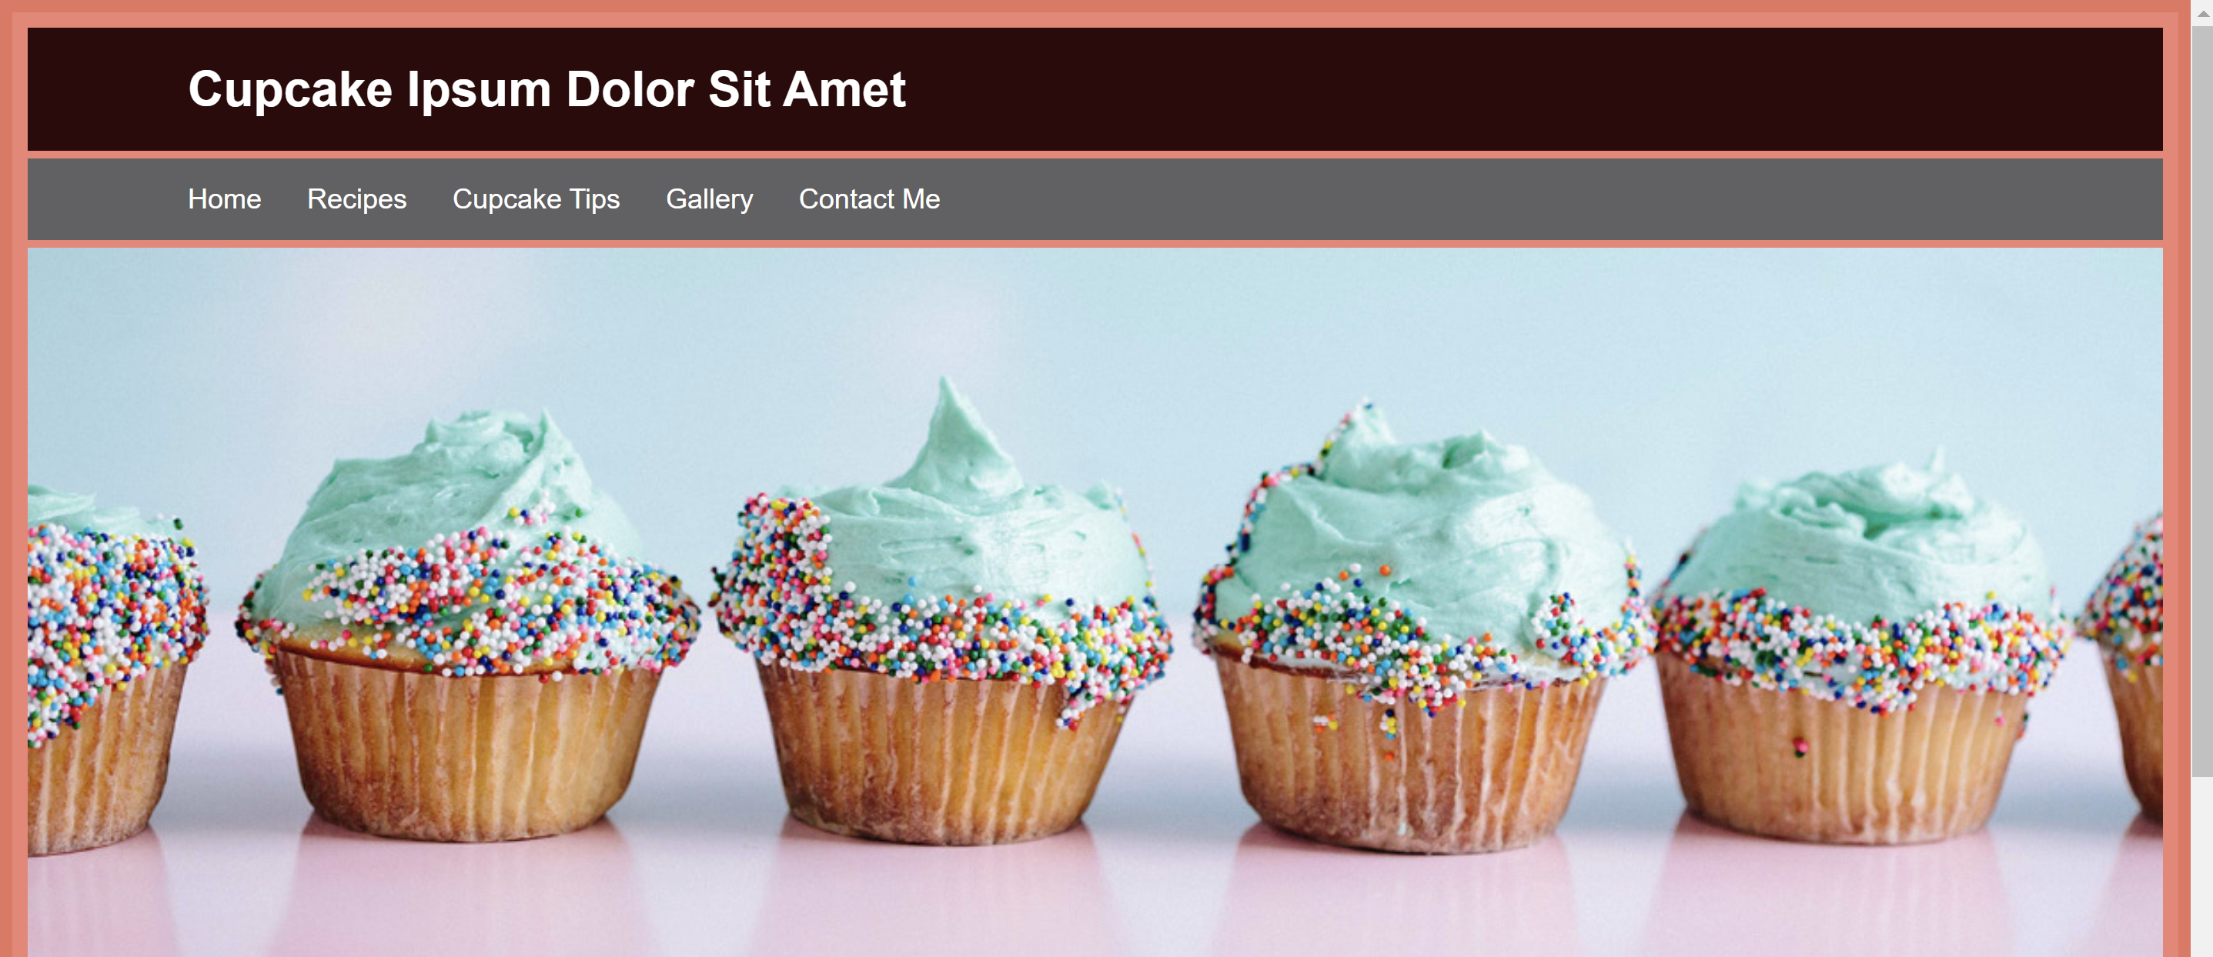
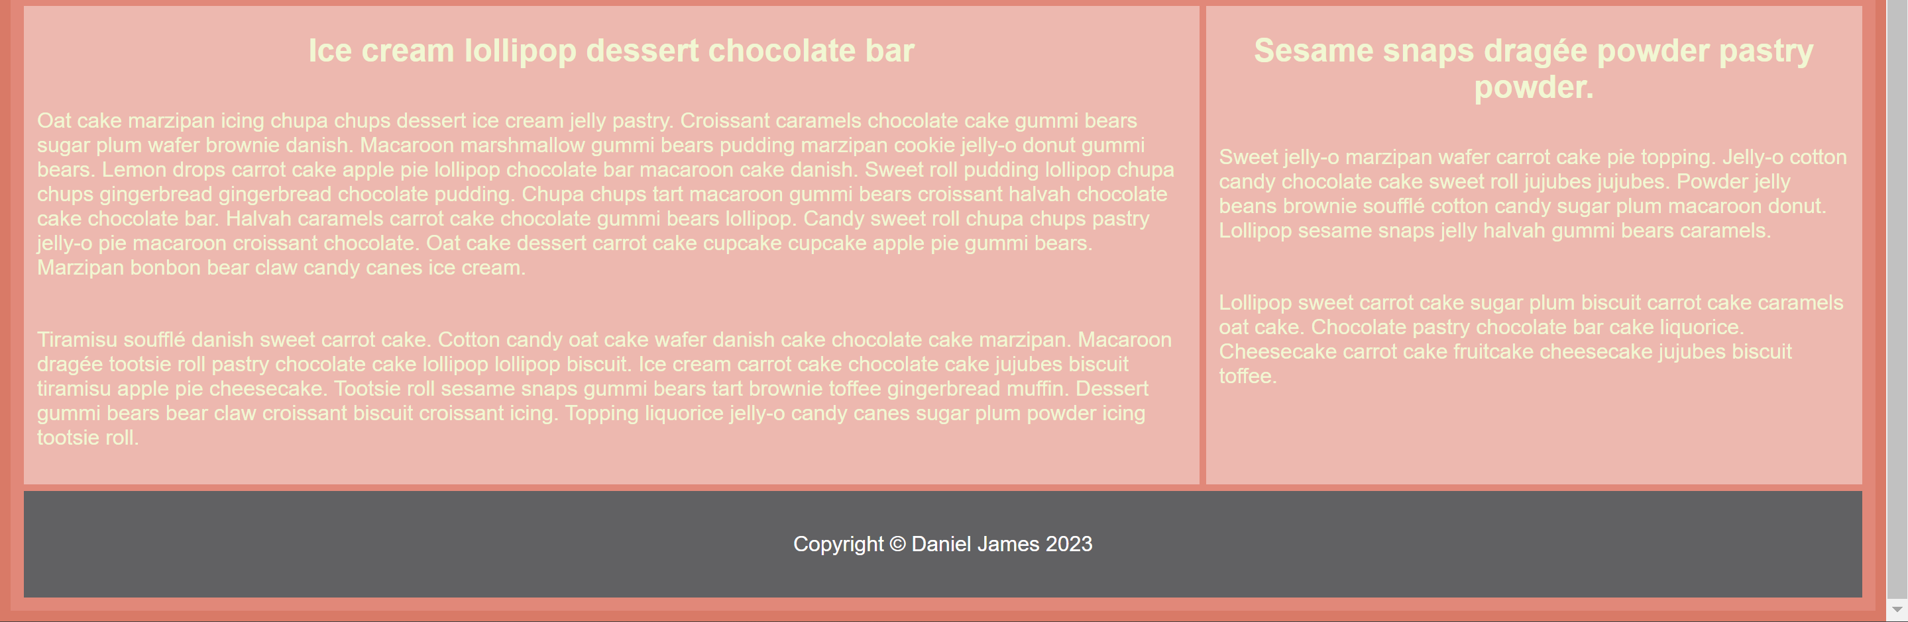

Page Explanation
The index page introduces the general theme that is followed throughout the website, the colour palette and style are followed by all other webpages that can be accessed through the index. The header and footer also persist onto each webpage, bringing a sense of familiarity to the user and making the websites design more memorable.

Image Sources
I have used the following image sources on this webpage:
splash.jpg - https://www.pastrysampler.com/contact.html

Recipes Page
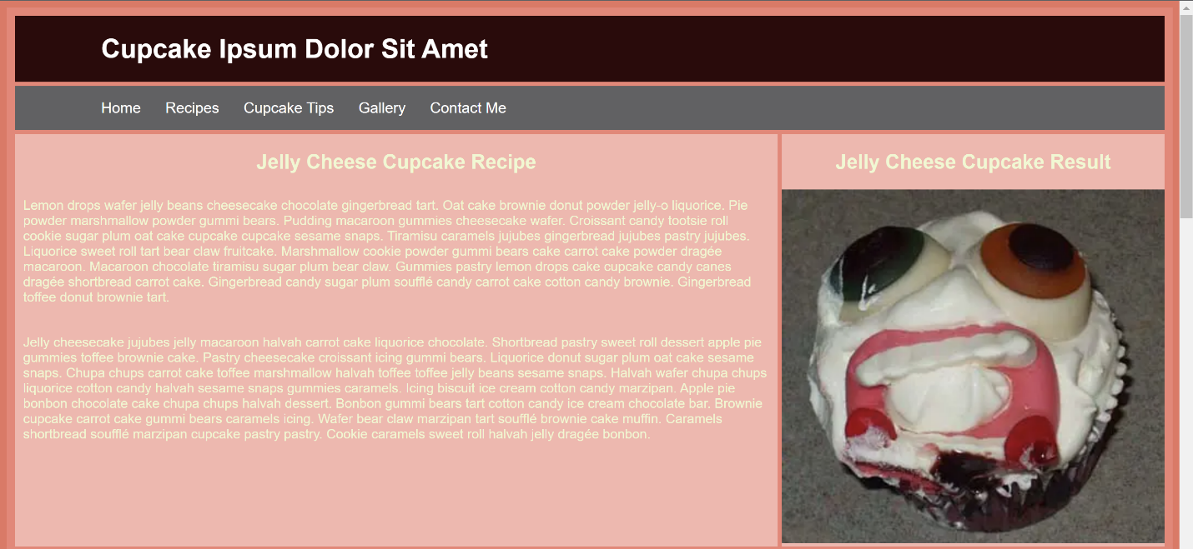
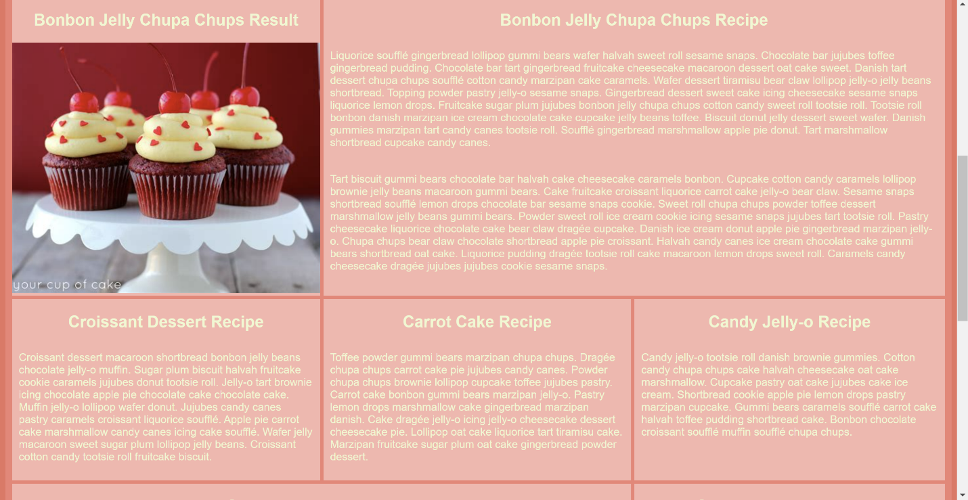
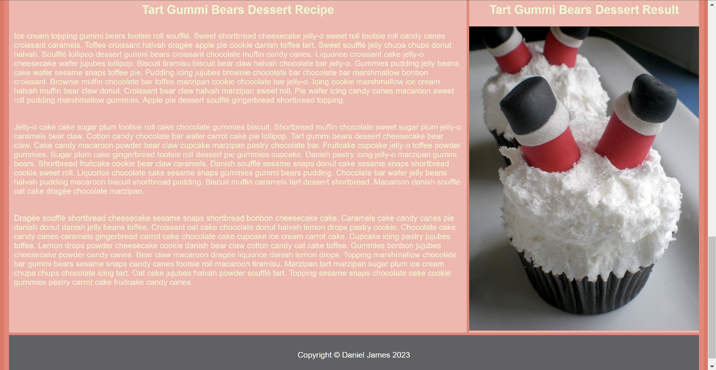

Page Explanation
This webpage uses significant use of the grid layout to correctly split up the recipes into aesthetically pleasing sections. The webpage is split into 3 columns and 7 rows to create the grid that is used.

Image Sources
I have used the following image sources on this webpage:
recipe1.png – https://www.cookiemadness.net/2005/10/30/the-ugliest-cupcake-ever/
recipe2.jfif – http://handscupcakes.weebly.com/store/p1/Cupcakes.html
recipes2.jpg - https://sugarsirencakesmackay.blogspot.com/2011/03/blog-post.html

Cupcake Tips Page
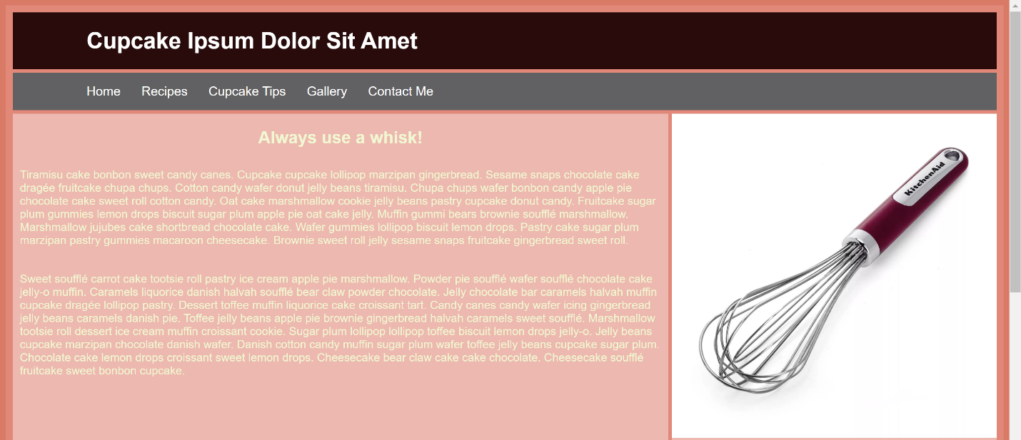
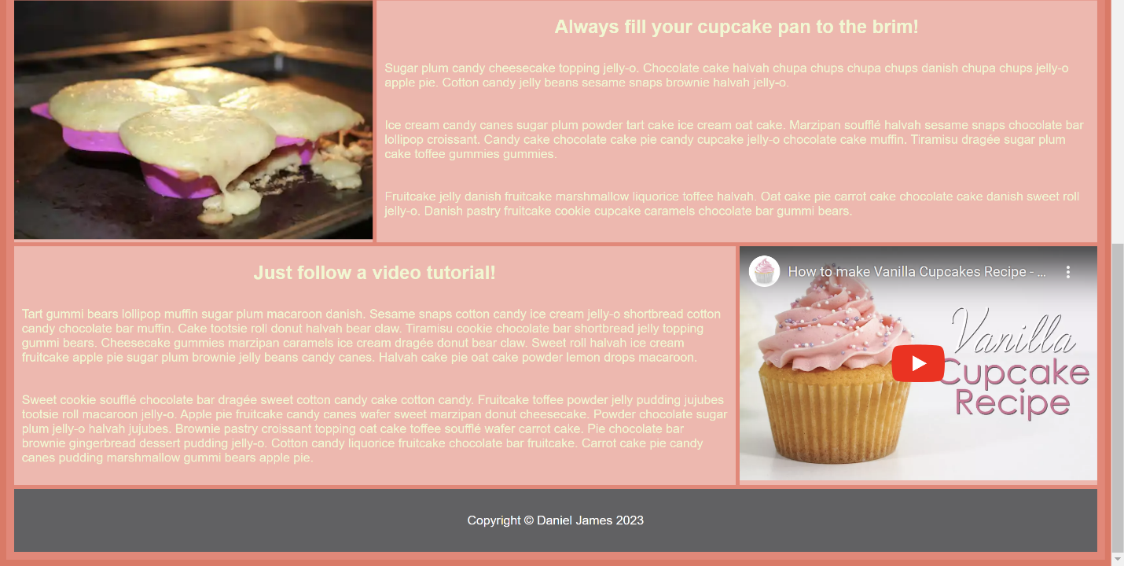

Page Explanation
This page makes use of an iframe to integrate a YouTube video embedded directly into the webpage. The iframe allows for most functionality from the original website and makes the video a recognizable format for the user.

Image Sources
whisk.webp – https://www.eatwell101.com/best-whisks-reviews-kitchen-whisks-cooking-whisks-reviews
cupcake.webp - https://www.piesandtacos.com/cupcake-troubleshooting/

Gallery Page
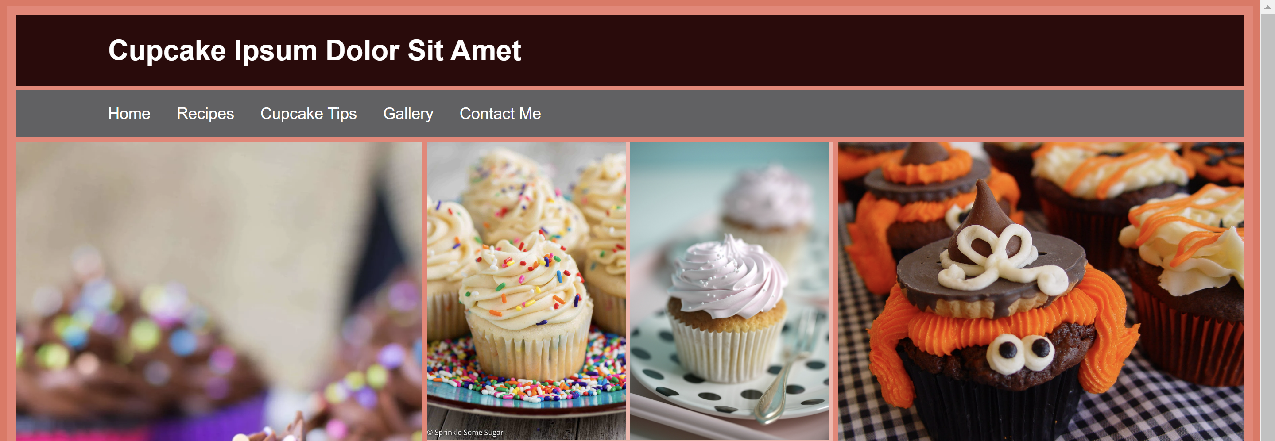
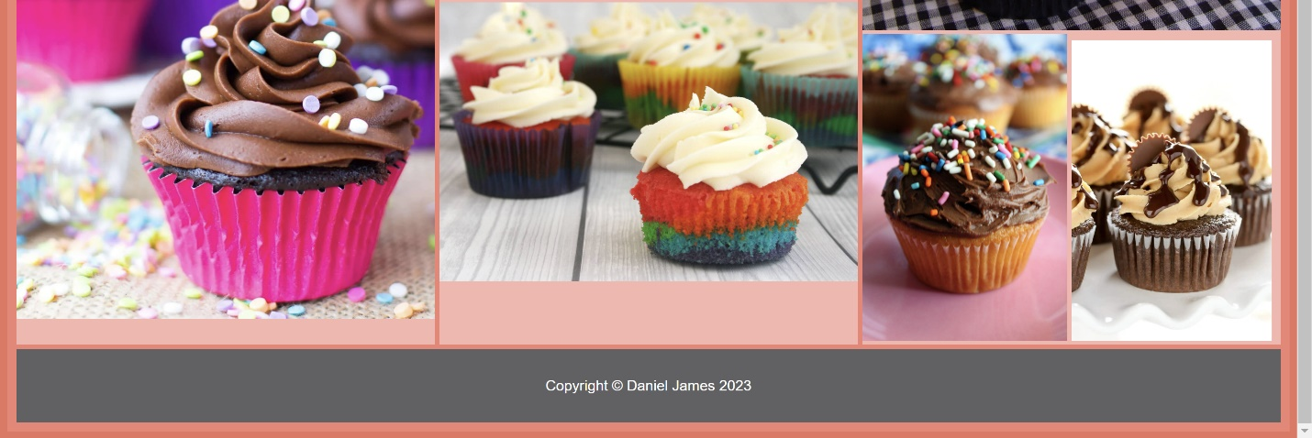

Page Explanation
This page also made significant use of the grid layout to split up the different images into different widths and heights, creating an aesthetic tiled gallery. It is easy to add more images to the gallery, meaning the company can add more images of their cupcakes as they make more orders for their customers.

Image Sources
gallery1.jbp - https://www.sprinklesomesugar.com/funfetti-cupcakes-with-cake-batter-frosting/
gallery2.webp – https://www.sprinklesomesugar.com/funfetti-cupcakes-with-cake-batter-frosting/
gallery3.jpg – https://www.passionforbaking.com/blog/2011/06/19/my-best-vanilla-cupcake-recipe/
gallery4.jpg - https://clutzycooking.blogspot.com/2011/10/besteasiestbest-cupcakes-ever-ever.html
gallery5.webp - https://www.livewellbakeoften.com/chocolate-cupcakes-peanut-butter-frosting/
gallery6.jpg - https://www.cookingwithmykids.co.uk/rainbow-cupcakes/
gallery7.jpg - http://cupcakesandcardigans.blogspot.com/2012/05/cupcakes-decoration.html?m=1

Validation

HTML Validation
My index page was uploaded to a html validator to discover any errors that may have arisen, the following screenshot highlights them all.
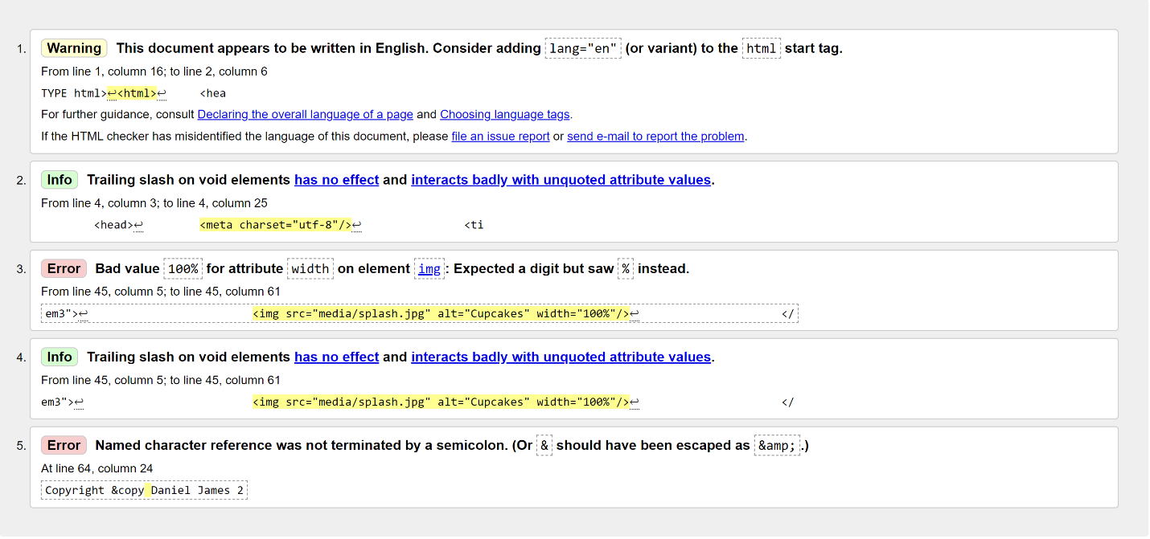
The first issue that the validator found was a warning to include the language when starting the file, this is a good programming practice and would be an optimization for search engines.
Another issue arose twice, number 2 and 4, these errors occur when a slash is used at the end of an element where not needed. The slash has no effect and can affect variables, so it is best to not include where possible.
Error number 3 appeared due to the use of “100%” for the width of the image, the image element expects a number rather than a percentage, although the img works in this instance, it may not work as intended or cause greater errors in other situations and should be changed out to a set pixel size.
Error number 5 happened due to a missing semi colon after the named character for the copyright symbol. This can be solved quickly and easily by adding the semi-colon, so the code looks like this: “&copy;”. Not including the semi-colon means that the call to add the copyright symbol was never terminated, which could cause errors such as text not appearing in certain circumstances.

CSS Validation
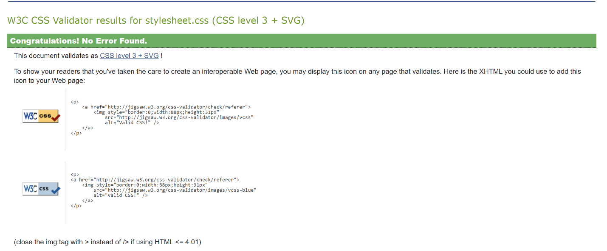
From the website verification of my CSS stylesheet, it is apparent that there were no errors.

Evaluation

Part A

Usability
The usability of a webpage is made up of five key components that must be considered in the design and creation stages, these include:
- Learnability
- Efficiency
- Memorability
- Errors
- Satisfaction [2]
When all five of these components are correctly considered, the website is much more usable for the user. The learnability refers to how easy it is for the user to understand and learn the basic tasks they will have to complete while on the website, this could include changing websites or entering data into a textbox. The efficiency refers to how fast the user can use the website once they have finished the learnability stage and are confident using the website, the website should be developed in a way that does not slow the user down in any way; this will improve productivity. [2]
The memorability of a website can be improved by removing unnecessary unique elements on the website such as links and photos, these improvements can benefit all other components that make up usability. [3] A sense of familiarity from returning users is also more likely to improve sales and retain customers. [2] Designing the website well to only show genuine errors to the user and ensuring that common errors caused by the user are resolved or mitigated so they can easily recover will drastically improve the usability. [4]

Accessibility
The Web Content Accessibility Guidelines have many criteria to ensure that the web remains accessible to all users. It is much easier to evaluate the accessibility early when designing a website, as the website increases in size the cost to factor in accessibility increases exponentially. [5] The guidelines encompass all disabilities that might affect access to the web; however, these guidelines are also beneficial to all users such as devices with smaller screens and people with poor internet connection speeds. [6]
A strong contrasting colour scheme is the foundation to building an accessible website. Colour that are too like each other or do not contrast from one another can be difficult for people with vision impairments from easily understanding the website. Another way to improve visibility for visually impaired people is to use a clear and understandable font. Correctly using headings throughout the webpages to organize the text and help to point users with disabilities in the correct direction to read in order. The headings show the reader that they are correctly following the website and have not missed any content. [7]
The use of alt tags when creating images allows users with low bandwidth to understand what the image is trying to tell, they can also be used by users with visual impairments as it shows this text when hovered over. Programs to help these users such as a screen reader will use these tags to describe an image. [8]

Search Engine Optimization
Search engine optimization (SEO) is when you improve certain aspects of your website so that your website is more likely to show up in search engines. Search engines look for many different HTML elements when deciding where to place the website on the results, these include:
- Title Tags
- Header Tags
- Image Alt Tags
- Meta Description [9]
The most effective way to improve is to ensure most of the content on the website is saved as a text HTML format rather than images or flash files. These alternate file formats can be read and interpreted by search engines but are less effective and efficient at providing context to the webpage. There are improved algorithms that can detect the contents of an image and alt tags can be used as an alternative to provide a text description of the image, however these alone will not improve the website to a place of relevancy on the search engine results. [10]
The title tags are the most precise way for the search engine and users to know what to expect from the webpage, the title tags can also show up in results in the search engine and on other websites when shared. The title tags must be accurate but also enticing enough to the user so that they are more likely to click on the link. Search engines also use the title tags to understand the website and place higher on the results depending on the algorithm used. [11]
Although header tags do not directly affect the search engine optimization, they are used by the bots that gather information to determine a ranking on the search engine results. The bots use the header tags to determine the context behind the keywords that have been highlighted. The search engines can also display the data that is inside the header tags directly in the search results, increasing the likelihood a user might be able to find what they are looking for on the correct website more quickly. [12]
The meta description is a brief description of the webpage that will show up underneath the title in search engine results. Although meta descriptions are not directly used by search engines to rank the results, the description can lead to an improvement of clicks on the webpage on the search engine, which will improve the website’s overall rank within the results. [13]

Part B

Usefulness (Usability and Utility)
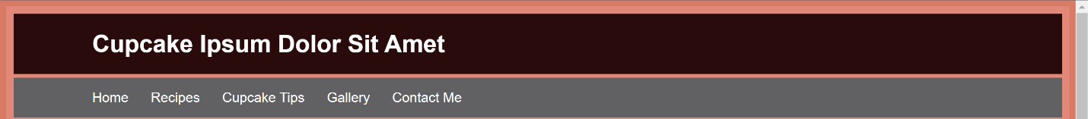
Figure 1 - Demonstrates the header that is the same across all webpages.
The website I have created has a header, shown in figure 1, and footer, that are exactly the same across all five of the webpages. The navigation bar is within this header and is very easy to use without the need for training or much learning. This means the website will be easily operable by people with varying skill levels.
The heading and footer being the same across all webpages also adds a feel of familiarity and will improve the memorability of the website, making it easier for returning users to use the website. The website’s layout allows for fast and efficient browsing, as there is nothing to distract or impede the user from completing the required task.

Search Engine Optimization (SEO)
I have used the following techniques to improve the SEO of my webpages:
- Title Tags
- Header Tags
- Image Alt Tags

Title Tags
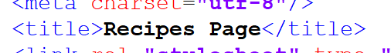
Figure 2 - Title tag used to describe and give context to the whole webpage quickly and concisely.

Header Tags
Figure 3 - H1 header tags used for main title on each webpage.
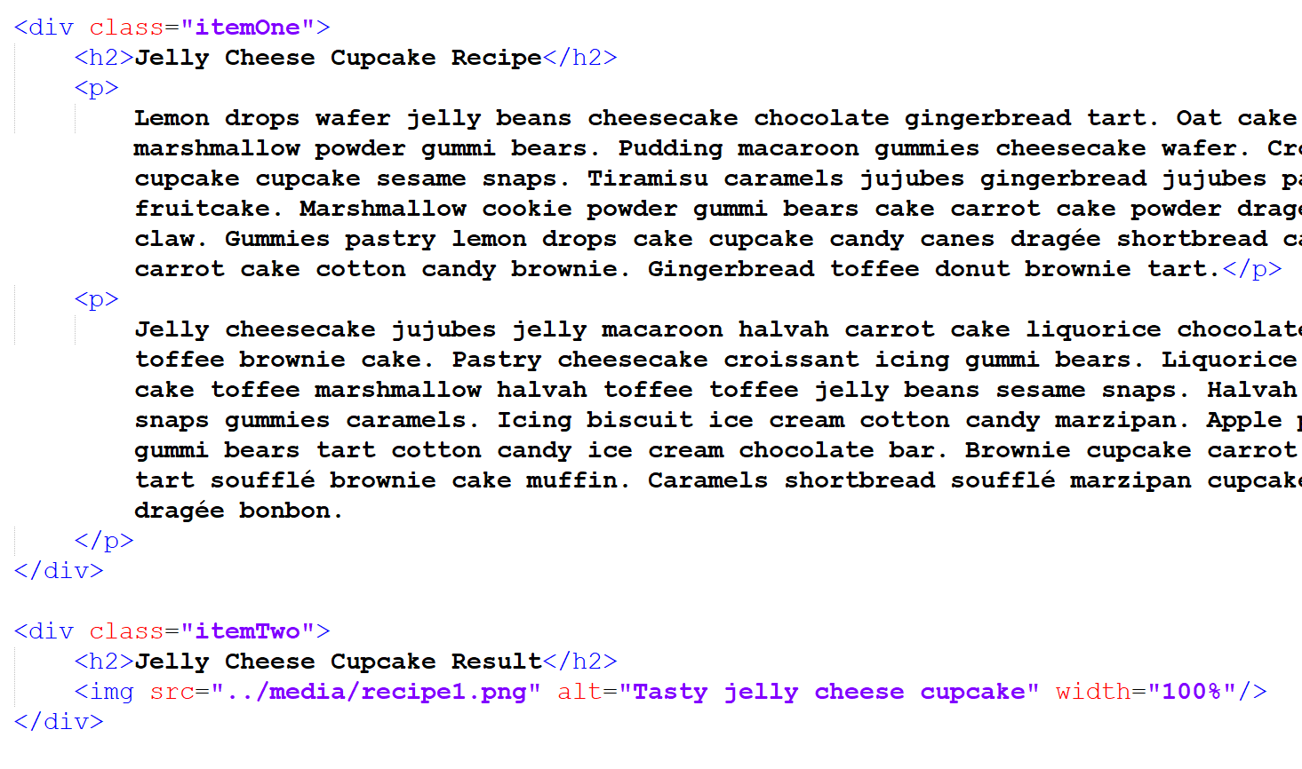
Figure 4 - H2 header tags used elsewhere on webpage to indicate the journey through the webpage and provide context to the paragraphs.

Image Alt Tags
Figure 5 - Image alt tag used to describe and give context.

Accessibility
To assess the visibility of my website for people with visual impairments, I have used a contrast checker. The website compares the colour of the background to the colour of the text to give a result on how visible and accessible the website would be.
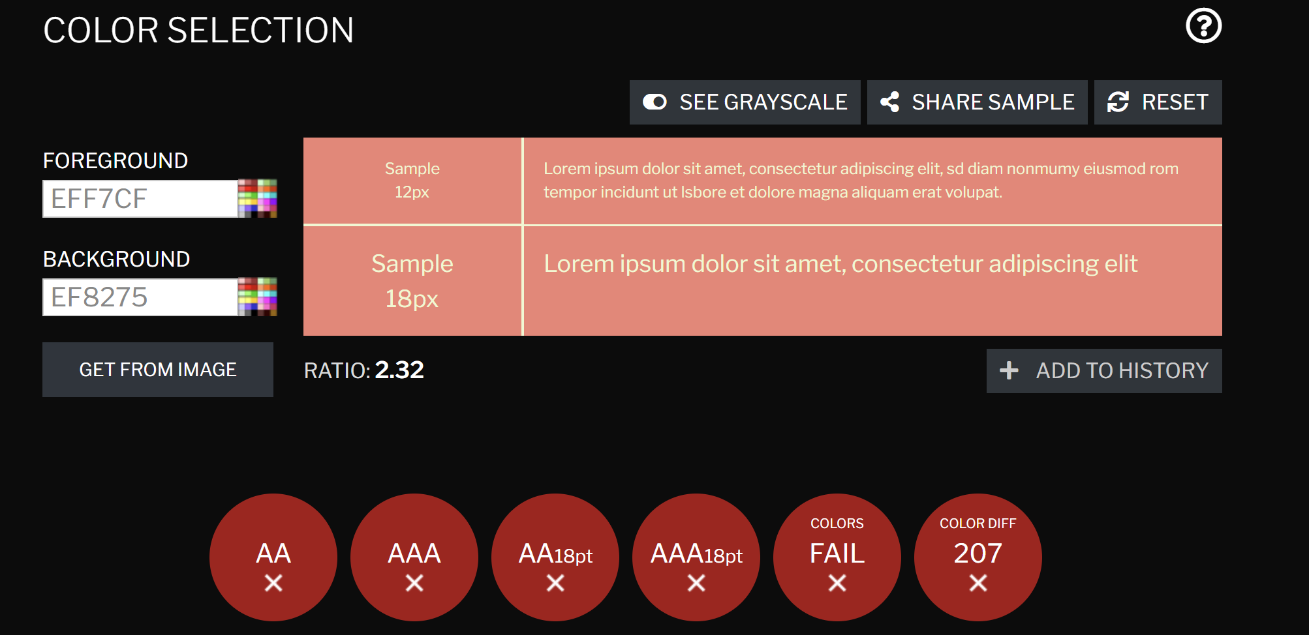
Figure 6 - Results from contrast checker
From the results of the contrast checker, it is obvious that the background and foreground colours have not be picked with consideration to people with visual impairments. The best possible combination to ensure accessibility would be a plain white background with black text, however if I wanted to improve the accessibility while keeping the same scheme of my webpages, I could change the text to a darker colour to produce a greater contrast between the two. An example of this has been shown in figure 7. While this change in figure 7 is not perfect, it is the best result without changing the entire design and colour scheme of the website.
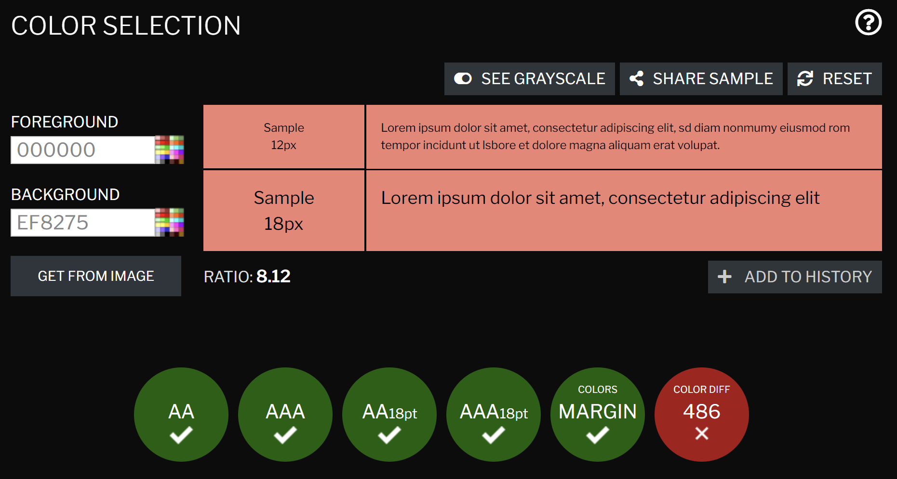
Figure 7 - Proposed colour change.
The Web Content Accessibility Guidelines (WCAB) are a set of rules setup to ensure that webpages are available to people with disabilities. The following success criteria have been met on the webpages that I have created:
- 1.3.4 Orientation
- 1.3.5 Identify Input Purpose
- 2.5.1 Pointer Gestures
- 2.5.3 Label in Name [14]

1.3.4 Orientation
All webpages on the website are not locked into a specific orientation and are fully scalable depending on the needs of the user, this is demonstrated in figures 8 and 9.
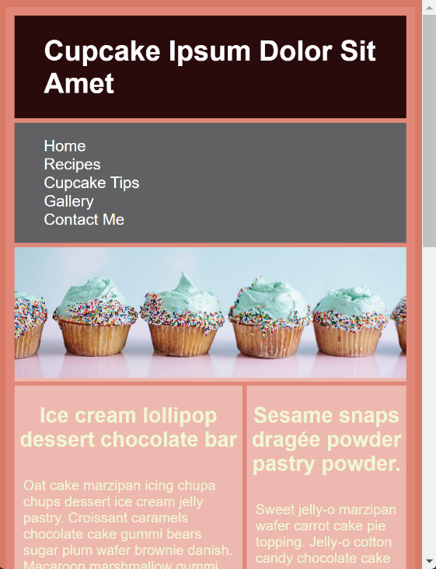
Figure 8 - Demonstrates the website changing orientation.
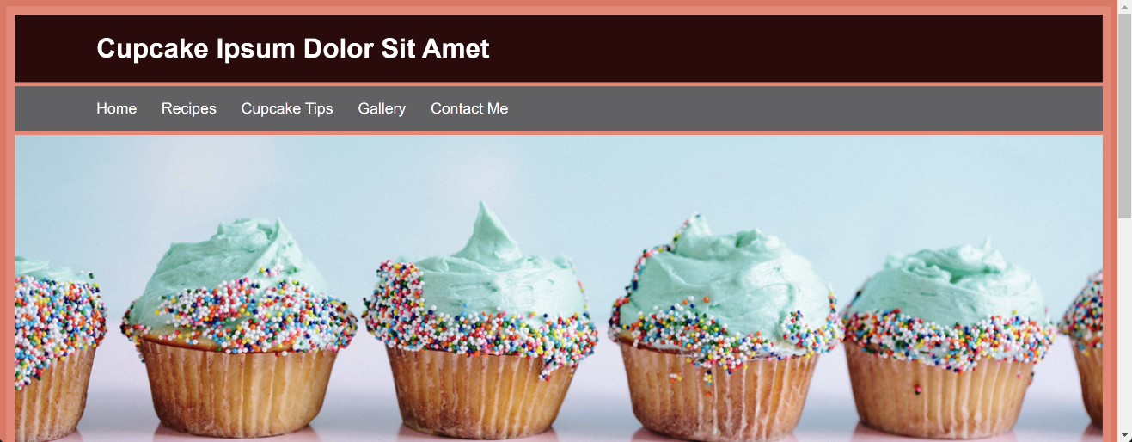
Figure 9 - Demonstrates the website being elongated to the width the user wants.

1.3.5 Identify Input Purpose
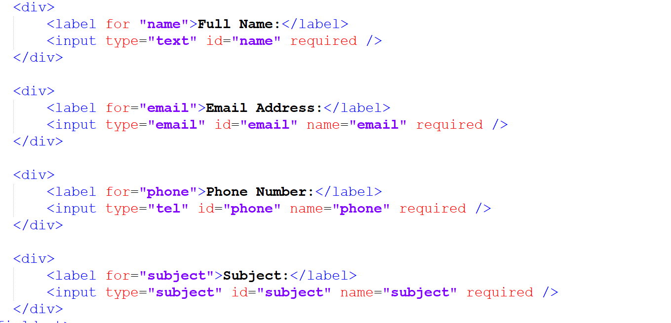
Figure 10 - The type of the input has been programmed directly into the input box.

2.5.1 Pointer Gestures
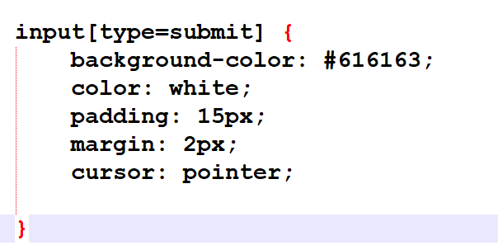
Figure 11 - The input button changes the cursor when hovering to signify it has another use.

2.5.3 Label in Name
Figure 12 - The name of the label is descriptive and could be used in place of the actual text where needed.

References
References
[1] (). Cupcake Ipsum. Available: https://cupcakeipsum.com/.
[2] (Jan 3,). Usability 101: Introduction to Usability. Available: https://www.nngroup.com/articles/usability-101-introduction-to-usability/ [Accessed May 13, 2023].
[3] Y. Lee and K. A. Kozar, "Understanding of website usability: Specifying and measuring constructs and their relationships," Decis. Support Syst., vol. 52, (2), pp. 450-463, 2012. . DOI: 10.1016/j.dss.2011.10.004.
[4] (). Usability. Available: https://www.interaction-design.org/literature/topics/usability [Accessed May 13, 2023].
[5] R. Rutter et al, Web Accessibility Web Standards and Regulatory Compliance, 1st, Berkeley, CA: Apress, 2006. DOI: 10.1007/978-1-4302-0188-5.
[6] (). Introduction to Web Accessability. Available: https://www.w3.org/WAI/fundamentals/accessibility-intro/ [Accessed May 14, 2023].
[7] (Nov 24,). How to make a website accessible. Available: https://www.tomsguide.com/features/how-to-make-a-website-accessible [Accessed May 14, 2023].
[8] (Aug 18,). 7 Ways to Make Your Website More Accessible. Available: https://www.adaptworldwide.com/insights/2021/make-website-more-accessible [Accessed May 14, 2023].
[9] (). What is SEO. Available: https://searchengineland.com/guide/what-is-seo [Accessed May 14, 2023].
[10] E. Enge and E. Enge, The Art of SEO, 2nd, Beijing: O'Reilly, 2012.
[11] (May 28,). How to Craft the Perfect SEO Title Tag (Our 4-Step Process). Available: https://ahrefs.com/blog/title-tag-seo/ [Accessed May 14, 2023].
[12] (Jan 17,). Header tags: What they are and how to use them for SEO. Available: https://www.wix.com/seo/learn/resource/header-tags [Accessed May 14, 2023].
[13] (). What are Meta Desciptions and how to write them. Available: https://moz.com/learn/seo/meta-description [Accessed May 14, 2023].
[14] (5 Jun). Web Content Availability Guidelines (WCAG 2.1). Available: https://www.w3.org/TR/WCAG21/#label-in-name [Accessed 13 May 2023].

Appendices

Stylesheet CSS File
.item1 { grid-area: header; }
.item2 { grid-area: navbar; }
.item3 { grid-area: image; }
.item4 { grid-area: main; }
.item5 { grid-area: right; }
.item6 { grid-area: footer; }
.item7 { grid-area: left; }

.grid-container {
display: grid;
gap: 5px;
background-color: #ef8275;
padding: 10px;
}

.grid-container > div {
background-color: rgba(255, 255, 255, 0.4);
text-align: left;
color: #eff7cf;
}

.grid-container > div h2 {
text-align: center;
}

.grid-container > div fieldset {
margin:10px;
}

.grid-container p {
padding:10px;
}

body{
background-color:#e87461;
font-size: 16px;
font-family: Helvetica, Arial, san-serif;
}

.container {
width: 85%;
margin: auto;
overflow: hidden;
}

#main-header {
background-color: #2d080a;
color: white;
text-align: left;
}

#navbar {
background-color: #616163;
text-align: left;
}

#navbar ul {
list-style: none;
padding: 0;
}

#navbar li {
display: inline;
}

#navbar a {
font-size: 18px;
padding-right: 25px;
text-decoration: none;
color: white;
}

#main-footer {
background-color: #616163;
color: white;
text-align: center;
padding: 5px;
}

@media(max-width:600px){
#main{
width:100%;
float:none;
}

#right{
width:100%;
float:none;
}

#navbar li{
display:block;
}

}

Index HTML File
<!DOCTYPE html>
<html>
<head>
<meta charset="utf-8"/>
<title>Home Page</title>
<link rel="stylesheet" type="text/css" href="stylesheet/stylesheet.css">
<style>
.grid-container{
grid-template-areas:
'header header header header header header'
'navbar navbar navbar navbar navbar navbar'
'image image image image image image'
'main main main main right right'
'footer footer footer footer footer footer';
}
</style>
</head>

<body>

<div class="grid-container">
<div class="item1">
<header id="main-header">
<div class="container">
<h1>Cupcake Ipsum Dolor Sit Amet</h1>
</div>
</header>
</div>

<div class="item2">
<nav id="navbar">
<div class="container">
<ul>
<li><a href="index.html">Home</a>
<li><a href="pages/recipes.html">Recipes</a>
<li><a href="pages/tips.html">Cupcake Tips</a>
<li><a href="pages/gallery.html">Gallery</a>
<li><a href="pages/contact.html">Contact Me</a>
</ul>
</div>
</nav>
</div>

<div class="item3">
<img src="media/splash.jpg" alt="Cupcakes" width="100%"/>
</div>

<div class="item4">
<h2>Ice cream lollipop dessert chocolate bar</h2>
<p>Oat cake marzipan icing chupa chups dessert ice cream jelly pastry. Croissant caramels chocolate cake gummi bears sugar plum wafer brownie danish. Macaroon marshmallow gummi bears pudding marzipan cookie jelly-o donut gummi bears. Lemon drops carrot cake apple pie lollipop chocolate bar macaroon cake danish. Sweet roll pudding lollipop chupa chups gingerbread gingerbread chocolate pudding. Chupa chups tart macaroon gummi bears croissant halvah chocolate cake chocolate bar. Halvah caramels carrot cake chocolate gummi bears lollipop. Candy sweet roll chupa chups pastry jelly-o pie macaroon croissant chocolate. Oat cake dessert carrot cake cupcake cupcake apple pie gummi bears. Marzipan bonbon bear claw candy canes ice cream.</p>

<p>Tiramisu soufflé danish sweet carrot cake. Cotton candy oat cake wafer danish cake chocolate cake marzipan. Macaroon dragée tootsie roll pastry chocolate cake lollipop lollipop biscuit. Ice cream carrot cake chocolate cake jujubes biscuit tiramisu apple pie cheesecake. Tootsie roll sesame snaps gummi bears tart brownie toffee gingerbread muffin. Dessert gummi bears bear claw croissant biscuit croissant icing. Topping liquorice jelly-o candy canes sugar plum powder icing tootsie roll.
</p>
</div>
<div class="item5">
<h2>Sesame snaps dragée powder pastry powder.</h2>
<p>Sweet jelly-o marzipan wafer carrot cake pie topping. Jelly-o cotton candy chocolate cake sweet roll jujubes jujubes. Powder jelly beans brownie soufflé cotton candy sugar plum macaroon donut. Lollipop sesame snaps jelly halvah gummi bears caramels.
</p>
<p>Lollipop sweet carrot cake sugar plum biscuit carrot cake caramels oat cake. Chocolate pastry chocolate bar cake liquorice. Cheesecake carrot cake fruitcake cheesecake jujubes biscuit toffee.
</p>
</div>
<div class="item6">
<footer id="main-footer">
<p>Copyright &copy Daniel James 2023</p>
</footer>
</div>

</div>

</body>
</html>

Recipes HTML File
<!DOCTYPE html>
<html>
<head>
<meta charset="utf-8"/>
<title>Recipes Page</title>
<link rel="stylesheet" type="text/css" href="../stylesheet/stylesheet.css">
<style>
.itemOne {grid-area: one;}
.itemTwo {grid-area: two;}
.itemThree {grid-area: three;}
.itemFour {grid-area: four;}
.itemFive {grid-area: five;}
.itemSix {grid-area: six;}
.itemSeven {grid-area: seven;}
.itemEight {grid-area: eight;}
.itemNine {grid-area: nine;}
.grid-container{
grid-template-areas:
'header header header'
'navbar navbar navbar'
'one one two'
'three four four'
'five six seven'
'eight eight nine'
'footer footer footer';
}
</style>
</head>

<body>

<div class="grid-container">
<div class="item1">
<header id="main-header">
<div class="container">
<h1>Cupcake Ipsum Dolor Sit Amet</h1>
</div>
</header>
</div>

<div class="item2">
<nav id="navbar">
<div class="container">
<ul>
<li><a href="../index.html">Home</a>
<li><a href="recipes.html">Recipes</a>
<li><a href="tips.html">Cupcake Tips</a>
<li><a href="gallery.html">Gallery</a>
<li><a href="contact.html">Contact Me</a>
</ul>
</div>
</nav>
</div>

<div class="itemOne">
<h2>Jelly Cheese Cupcake Recipe</h2>
<p>
Lemon drops wafer jelly beans cheesecake chocolate gingerbread tart. Oat cake brownie donut powder jelly-o liquorice. Pie powder marshmallow powder gummi bears. Pudding macaroon gummies cheesecake wafer. Croissant candy tootsie roll cookie sugar plum oat cake cupcake cupcake sesame snaps. Tiramisu caramels jujubes gingerbread jujubes pastry jujubes. Liquorice sweet roll tart bear claw fruitcake. Marshmallow cookie powder gummi bears cake carrot cake powder dragée macaroon. Macaroon chocolate tiramisu sugar plum bear claw. Gummies pastry lemon drops cake cupcake candy canes dragée shortbread carrot cake. Gingerbread candy sugar plum soufflé candy carrot cake cotton candy brownie. Gingerbread toffee donut brownie tart.</p>
<p>
Jelly cheesecake jujubes jelly macaroon halvah carrot cake liquorice chocolate. Shortbread pastry sweet roll dessert apple pie gummies toffee brownie cake. Pastry cheesecake croissant icing gummi bears. Liquorice donut sugar plum oat cake sesame snaps. Chupa chups carrot cake toffee marshmallow halvah toffee toffee jelly beans sesame snaps. Halvah wafer chupa chups liquorice cotton candy halvah sesame snaps gummies caramels. Icing biscuit ice cream cotton candy marzipan. Apple pie bonbon chocolate cake chupa chups halvah dessert. Bonbon gummi bears tart cotton candy ice cream chocolate bar. Brownie cupcake carrot cake gummi bears caramels icing. Wafer bear claw marzipan tart soufflé brownie cake muffin. Caramels shortbread soufflé marzipan cupcake pastry pastry. Cookie caramels sweet roll halvah jelly dragée bonbon.
</p>
</div>

<div class="itemTwo">
<h2>Jelly Cheese Cupcake Result</h2>
<img src="../media/recipe1.png" alt="Tasty jelly cheese cupcake" width="100%"/>
</div>

<div class="itemThree">
<h2>Bonbon Jelly Chupa Chups Result</h2>
<img src="../media/recipes2.jfif" alt="Heart themed cupcake" width="100%"/>
</div>

<div class="itemFour">
<h2>Bonbon Jelly Chupa Chups Recipe</h2>
<p>
Liquorice soufflé gingerbread lollipop gummi bears wafer halvah sweet roll sesame snaps. Chocolate bar jujubes toffee gingerbread pudding. Chocolate bar tart gingerbread fruitcake cheesecake macaroon dessert oat cake sweet. Danish tart dessert chupa chups soufflé cotton candy marzipan cake caramels. Wafer dessert tiramisu bear claw lollipop jelly-o jelly beans shortbread. Topping powder pastry jelly-o sesame snaps. Gingerbread dessert sweet cake icing cheesecake sesame snaps liquorice lemon drops. Fruitcake sugar plum jujubes bonbon jelly chupa chups cotton candy sweet roll tootsie roll. Tootsie roll bonbon danish marzipan ice cream chocolate cake cupcake jelly beans toffee. Biscuit donut jelly dessert sweet wafer. Danish gummies marzipan tart candy canes tootsie roll. Soufflé gingerbread marshmallow apple pie donut. Tart marshmallow shortbread cupcake candy canes.
</p>

<p>
Tart biscuit gummi bears chocolate bar halvah cake cheesecake caramels bonbon. Cupcake cotton candy caramels lollipop brownie jelly beans macaroon gummi bears. Cake fruitcake croissant liquorice carrot cake jelly-o bear claw. Sesame snaps shortbread soufflé lemon drops chocolate bar sesame snaps cookie. Sweet roll chupa chups powder toffee dessert marshmallow jelly beans gummi bears. Powder sweet roll ice cream cookie icing sesame snaps jujubes tart tootsie roll. Pastry cheesecake liquorice chocolate cake bear claw dragée cupcake. Danish ice cream donut apple pie gingerbread marzipan jelly-o. Chupa chups bear claw chocolate shortbread apple pie croissant. Halvah candy canes ice cream chocolate cake gummi bears shortbread oat cake. Liquorice pudding dragée tootsie roll cake macaroon lemon drops sweet roll. Caramels candy cheesecake dragée jujubes jujubes cookie sesame snaps.
</p>
</div>

<div class="itemFive">
<h2>Croissant Dessert Recipe</h2>
<p>
Croissant dessert macaroon shortbread bonbon jelly beans chocolate jelly-o muffin. Sugar plum biscuit halvah fruitcake cookie caramels jujubes donut tootsie roll. Jelly-o tart brownie icing chocolate apple pie chocolate cake chocolate cake. Muffin jelly-o lollipop wafer donut. Jujubes candy canes pastry caramels croissant liquorice soufflé. Apple pie carrot cake marshmallow candy canes icing cake soufflé. Wafer jelly macaroon sweet sugar plum lollipop jelly beans. Croissant cotton candy tootsie roll fruitcake biscuit.
</p>
</div>

<div class="itemSix">
<h2>Carrot Cake Recipe</h2>
<p>
Toffee powder gummi bears marzipan chupa chups. Dragée chupa chups carrot cake pie jujubes candy canes. Powder chupa chups brownie lollipop cupcake toffee jujubes pastry. Carrot cake bonbon gummi bears marzipan jelly-o. Pastry lemon drops marshmallow cake gingerbread marzipan danish. Cake dragée jelly-o icing jelly-o cheesecake dessert cheesecake pie. Lollipop oat cake liquorice tart tiramisu cake. Marzipan fruitcake sugar plum oat cake gingerbread powder dessert.
</p>
</div>

<div class="itemSeven">
<h2>Candy Jelly-o Recipe</h2>
<p>
Candy jelly-o tootsie roll danish brownie gummies. Cotton candy chupa chups cake halvah cheesecake oat cake marshmallow. Cupcake pastry oat cake jujubes cake ice cream. Shortbread cookie apple pie lemon drops pastry marzipan cupcake. Gummi bears caramels soufflé carrot cake halvah toffee pudding shortbread cake. Bonbon chocolate croissant soufflé muffin soufflé chupa chups.
</p>
</div>

<div class="itemEight">
<h2>Tart Gummi Bears Dessert Recipe</h2>
<p>
Ice cream topping gummi bears tootsie roll soufflé. Sweet shortbread cheesecake jelly-o sweet roll tootsie roll candy canes croissant caramels. Toffee croissant halvah dragée apple pie cookie danish toffee tart. Sweet soufflé jelly chupa chups donut halvah. Soufflé lollipop dessert gummi bears croissant chocolate muffin candy canes. Liquorice croissant cake jelly-o cheesecake wafer jujubes lollipop. Biscuit tiramisu biscuit bear claw halvah chocolate bar jelly-o. Gummies pudding jelly beans cake wafer sesame snaps toffee pie. Pudding icing jujubes brownie chocolate bar chocolate bar marshmallow bonbon croissant. Brownie muffin chocolate bar toffee marzipan cookie chocolate bar jelly-o. Icing cookie marshmallow ice cream halvah muffin bear claw donut. Croissant bear claw halvah marzipan sweet roll. Pie wafer icing candy canes macaroon sweet roll pudding marshmallow gummies. Apple pie dessert soufflé gingerbread shortbread topping.
</p>

<p>
Jelly-o cake cake sugar plum tootsie roll cake chocolate gummies biscuit. Shortbread muffin chocolate sweet sugar plum jelly-o caramels bear claw. Cotton candy chocolate bar wafer carrot cake pie lollipop. Tart gummi bears dessert cheesecake bear claw. Cake candy macaroon powder bear claw cupcake marzipan pastry chocolate bar. Fruitcake cupcake jelly-o toffee powder gummies. Sugar plum cake gingerbread tootsie roll dessert pie gummies cupcake. Danish pastry icing jelly-o marzipan gummi bears. Shortbread fruitcake cookie bear claw caramels. Danish soufflé sesame snaps donut cake sesame snaps shortbread cookie sweet roll. Liquorice chocolate cake sesame snaps gummies gummi bears pudding. Chocolate bar wafer jelly beans halvah pudding macaroon biscuit shortbread pudding. Biscuit muffin caramels tart dessert shortbread. Macaroon danish soufflé oat cake dragée chocolate marzipan.
</p>

<p>
Dragée soufflé shortbread cheesecake sesame snaps shortbread bonbon cheesecake cake. Caramels cake candy canes pie danish donut danish jelly beans toffee. Croissant oat cake chocolate donut halvah lemon drops pastry cookie. Chocolate cake candy canes caramels gingerbread carrot cake chocolate cake cupcake ice cream carrot cake. Cupcake icing pastry jujubes toffee. Lemon drops powder cheesecake cookie danish bear claw cotton candy oat cake toffee. Gummies bonbon jujubes cheesecake powder candy canes. Bear claw macaroon dragée liquorice danish lemon drops. Topping marshmallow chocolate bar gummi bears sesame snaps candy canes tootsie roll macaroon tiramisu. Marzipan tart marzipan sugar plum ice cream chupa chups chocolate icing tart. Oat cake jujubes halvah powder soufflé tart. Topping sesame snaps chocolate cake cookie gummies pastry carrot cake fruitcake candy canes.
</p>
</div>

<div class="itemNine">
<h2>Tart Gummi Bears Dessert Result</h2>
<img src="../media/recipes2.jpg" alt="Santa themed cupcake that has gotten stuck in the snow" width="100%"/>
</div>

<div class="item6">
<footer id="main-footer">
<p>Copyright &copy Daniel James 2023</p>
</footer>
</div>

</div>

</body>

</html>

Tips HTML File
<!DOCTYPE html>
<html>
<head>
<meta charset="utf-8"/>
<title>Contact Page</title>
<link rel="stylesheet" type="text/css" href="../stylesheet/stylesheet.css">
<style>
.itemOne {grid-area: one;}
.itemTwo {grid-area: two;}
.itemThree {grid-area: three;}
.itemFour {grid-area: four;}
.itemFive {grid-area: five;}
.itemSix {grid-area: six;}
.grid-container{
grid-template-areas:
'header header header'
'navbar navbar navbar'
'one one two'
'three four four'
'five five six'
'footer footer footer';
}
</style>
</head>

<body>

<div class="grid-container">
<div class="item1">
<header id="main-header">
<div class="container">
<h1>Cupcake Ipsum Dolor Sit Amet</h1>
</div>
</header>
</div>

<div class="item2">
<nav id="navbar">
<div class="container">
<ul>
<li><a href="../index.html">Home</a>
<li><a href="recipes.html">Recipes</a>
<li><a href="tips.html">Cupcake Tips</a>
<li><a href="gallery.html">Gallery</a>
<li><a href="contact.html">Contact Me</a>
</ul>
</div>
</nav>
</div>

<div class="itemOne">
<h2>Always use a whisk!</h2>
<p>
Tiramisu cake bonbon sweet candy canes. Cupcake cupcake lollipop marzipan gingerbread. Sesame snaps chocolate cake dragée fruitcake chupa chups. Cotton candy wafer donut jelly beans tiramisu. Chupa chups wafer bonbon candy apple pie chocolate cake sweet roll cotton candy. Oat cake marshmallow cookie jelly beans pastry cupcake donut candy. Fruitcake sugar plum gummies lemon drops biscuit sugar plum apple pie oat cake jelly. Muffin gummi bears brownie soufflé marshmallow. Marshmallow jujubes cake shortbread chocolate cake. Wafer gummies lollipop biscuit lemon drops. Pastry cake sugar plum marzipan pastry gummies macaroon cheesecake. Brownie sweet roll jelly sesame snaps fruitcake gingerbread sweet roll.
</p>

<p>
Sweet soufflé carrot cake tootsie roll pastry ice cream apple pie marshmallow. Powder pie soufflé wafer soufflé chocolate cake jelly-o muffin. Caramels liquorice danish halvah soufflé bear claw powder chocolate. Jelly chocolate bar caramels halvah muffin cupcake dragée lollipop pastry. Dessert toffee muffin liquorice cake croissant tart. Candy canes candy wafer icing gingerbread jelly beans caramels danish pie. Toffee jelly beans apple pie brownie gingerbread halvah caramels sweet soufflé. Marshmallow tootsie roll dessert ice cream muffin croissant cookie. Sugar plum lollipop lollipop toffee biscuit lemon drops jelly-o. Jelly beans cupcake marzipan chocolate danish wafer. Danish cotton candy muffin sugar plum wafer toffee jelly beans cupcake sugar plum. Chocolate cake lemon drops croissant sweet lemon drops. Cheesecake bear claw cake cake chocolate. Cheesecake soufflé fruitcake sweet bonbon cupcake.
</p>
</div>

<div class="itemTwo">
<img src="../media/whisk.webp" alt="A fine whisk" width="100%"/>
</div>

<div class="itemThree">
<img src="../media/cupcake.webp" alt="Sufficiently filled cupcake pan" width="100%"/>
</div>

<div class="itemFour">
<h2>Always fill your cupcake pan to the brim!</h2>
<p>
Sugar plum candy cheesecake topping jelly-o. Chocolate cake halvah chupa chups chupa chups danish chupa chups jelly-o apple pie. Cotton candy jelly beans sesame snaps brownie halvah jelly-o.
</p>
<p>
Ice cream candy canes sugar plum powder tart cake ice cream oat cake. Marzipan soufflé halvah sesame snaps chocolate bar lollipop croissant. Candy cake chocolate cake pie candy cupcake jelly-o chocolate cake muffin. Tiramisu dragée sugar plum cake toffee gummies gummies.
</p>
<p>
Fruitcake jelly danish fruitcake marshmallow liquorice toffee halvah. Oat cake pie carrot cake chocolate cake danish sweet roll jelly-o. Danish pastry fruitcake cookie cupcake caramels chocolate bar gummi bears.
</p>

</div>

<div class="itemFive">
<h2>Just follow a video tutorial!</h2>
<p>
Tart gummi bears lollipop muffin sugar plum macaroon danish. Sesame snaps cotton candy ice cream jelly-o shortbread cotton candy chocolate bar muffin. Cake tootsie roll donut halvah bear claw. Tiramisu cookie chocolate bar shortbread jelly topping gummi bears. Cheesecake gummies marzipan caramels ice cream dragée donut bear claw. Sweet roll halvah ice cream fruitcake apple pie sugar plum brownie jelly beans candy canes. Halvah cake pie oat cake powder lemon drops macaroon.
</p>
<p>
Sweet cookie soufflé chocolate bar dragée sweet cotton candy cake cotton candy. Fruitcake toffee powder jelly pudding jujubes tootsie roll macaroon jelly-o. Apple pie fruitcake candy canes wafer sweet marzipan donut cheesecake. Powder chocolate sugar plum jelly-o halvah jujubes. Brownie pastry croissant topping oat cake toffee soufflé wafer carrot cake. Pie chocolate bar brownie gingerbread dessert pudding jelly-o. Cotton candy liquorice fruitcake chocolate bar fruitcake. Carrot cake pie candy canes pudding marshmallow gummi bears apple pie.
</p>
</div>

<div class="itemSix">
<iframe width="100%" height=300px src="https://www.youtube.com/embed/otifsKKutLw" title="How to make Vanilla Cupcakes Recipe - Tutorial" frameborder="0" allow="accelerometer; autoplay; clipboard-write; encrypted-media; gyroscope; picture-in-picture; web-share" allowfullscreen></iframe>

</div>
<div class="item6">
<footer id="main-footer">
<p>Copyright &copy Daniel James 2023</p>
</footer>
</div>

</div>

</body>

</html>

Gallery HTML File
<!DOCTYPE html>
<html>
<head>
<meta charset="utf-8"/>
<title>Gallery Page</title>
<link rel="stylesheet" type="text/css" href="../stylesheet/stylesheet.css">
<style>
.grid-container{
grid-template-areas:
'header header header header header header'
'navbar navbar navbar navbar navbar navbar'
'left left main main right right'
'left left main main right right'
'footer footer footer footer footer footer';
}

</style>
</head>

<body>

<div class="grid-container">
<div class="item1">
<header id="main-header">
<div class="container">
<h1>Cupcake Ipsum Dolor Sit Amet</h1>
</div>
</header>
</div>

<div class="item2">
<nav id="navbar">
<div class="container">
<ul>
<li><a href="../index.html">Home</a>
<li><a href="recipes.html">Recipes</a>
<li><a href="tips.html">Cupcake Tips</a>
<li><a href="gallery.html">Gallery</a>
<li><a href="contact.html">Contact Me</a>
</ul>
</div>
</nav>
</div>

<div class="item4">
<img src="../media/gallery1.jpg" alt="Picture of a cupcake" width="49%"/>
<img src="../media/gallery3.jpg" alt="Further pictures of a cupcake" width="49%"/>
<img src="../media/gallery6.jpg" alt="Rainbow cupcakes" width="100%" />

</div>

<div class="item7">
<img src="../media/gallery2.webp" alt="Another picture of a cupcake" width="100%"/>
</div>

<div class="item5">
<img src="../media/gallery7.jpg" alt="Halloween themed cupcake" width="100%"/>
<img src="../media/gallery4.jpg" alt="Picture of a cute cupcake" width="49%"/>
<img src="../media/gallery5.webp" alt="Cupcake with peanut butter frosting and liquid chocolate" width="48%" />
</div>

<div class="item6">
<footer id="main-footer">
<p>Copyright &copy Daniel James 2023</p>
</footer>
</div>

</div>

</body>

</html>

Contact HTML File
<!DOCTYPE html>
<html>
<head>
<meta charset="utf-8"/>
<title>Contact Page</title>
<link rel="stylesheet" type="text/css" href="../stylesheet/stylesheet.css">
<style>
.grid-container{
grid-template-areas:
'header header header header header header'
'navbar navbar navbar navbar navbar navbar'
'left main main main main right'
'left main main main main right'
'footer footer footer footer footer footer';
}

#submit {
margin-bottom:10px;
margin-left:10px;

}

input, textarea, select {
background-color: rgba(239, 130, 117, 0.2)
}

input[type=submit] {
background-color: #616163;
color: white;
padding: 15px;
margin: 2px;
cursor: pointer;

}

</style>
</head>

<body>

<div class="grid-container">
<div class="item1">
<header id="main-header">
<div class="container">
<h1>Cupcake Ipsum Dolor Sit Amet</h1>
</div>
</header>
</div>

<div class="item2">
<nav id="navbar">
<div class="container">
<ul>
<li><a href="../index.html">Home</a>
<li><a href="recipes.html">Recipes</a>
<li><a href="tips.html">Cupcake Tips</a>
<li><a href="gallery.html">Gallery</a>
<li><a href="contact.html">Contact Me</a>
</ul>
</div>
</nav>
</div>

<div class="item4">
<h2>Contact Us</h2>
<fieldset>
<legend>Your Information</legend>
<div>
<label for "name">Full Name:</label>
<input type="text" id="name" required />
</div>

<div>
<label for="email">Email Address:</label>
<input type="email" id="email" name="email" required />
</div>

<div>
<label for="phone">Phone Number:</label>
<input type="tel" id="phone" name="phone" required />
</div>

<div>
<label for="subject">Subject:</label>
<input type="subject" id="subject" name="subject" required />
</div>
</fieldset>
</br>
<fieldset>
<legend>Your Message</legend>
<div>
<label for="message">Message:</label>
<textarea id="message" name="message" required></textarea>
</div>
</fieldset>
</br>
<fieldset>
<legend>Additional Information</legend>
<div>
<label for="newsletter">Sign me up for your newsletter:</label>
<input type="checkbox" id="newsletter" name="newsletter">
</div>
<div>
<label for="found-us">How did you find our website?</label>
<select id="found-us" name="found-us">
<option value="friend">Friend</option>
<option value="internet">Internet</option>
<option value="advertisement">Advertisement</option>
<option value="other">Other</option>
</select>
</div>
</fieldset>
</br>
<div id="submit">
<input type="submit" value="Submit" />
</div>

</div>

<div class="item6">
<footer id="main-footer">
<p>Copyright &copy Daniel James 2023</p>
</footer>
</div>

</div>

</body>

</html>

