Riverside Health Centre

ENVIRONMENTAL STATEMENT
UPRN PROJECT REFERENCE: 6003
REF: 6003-UWTSD-XX-XX-T-G-0000-EIA
MAIN REPORT APRIL 2024

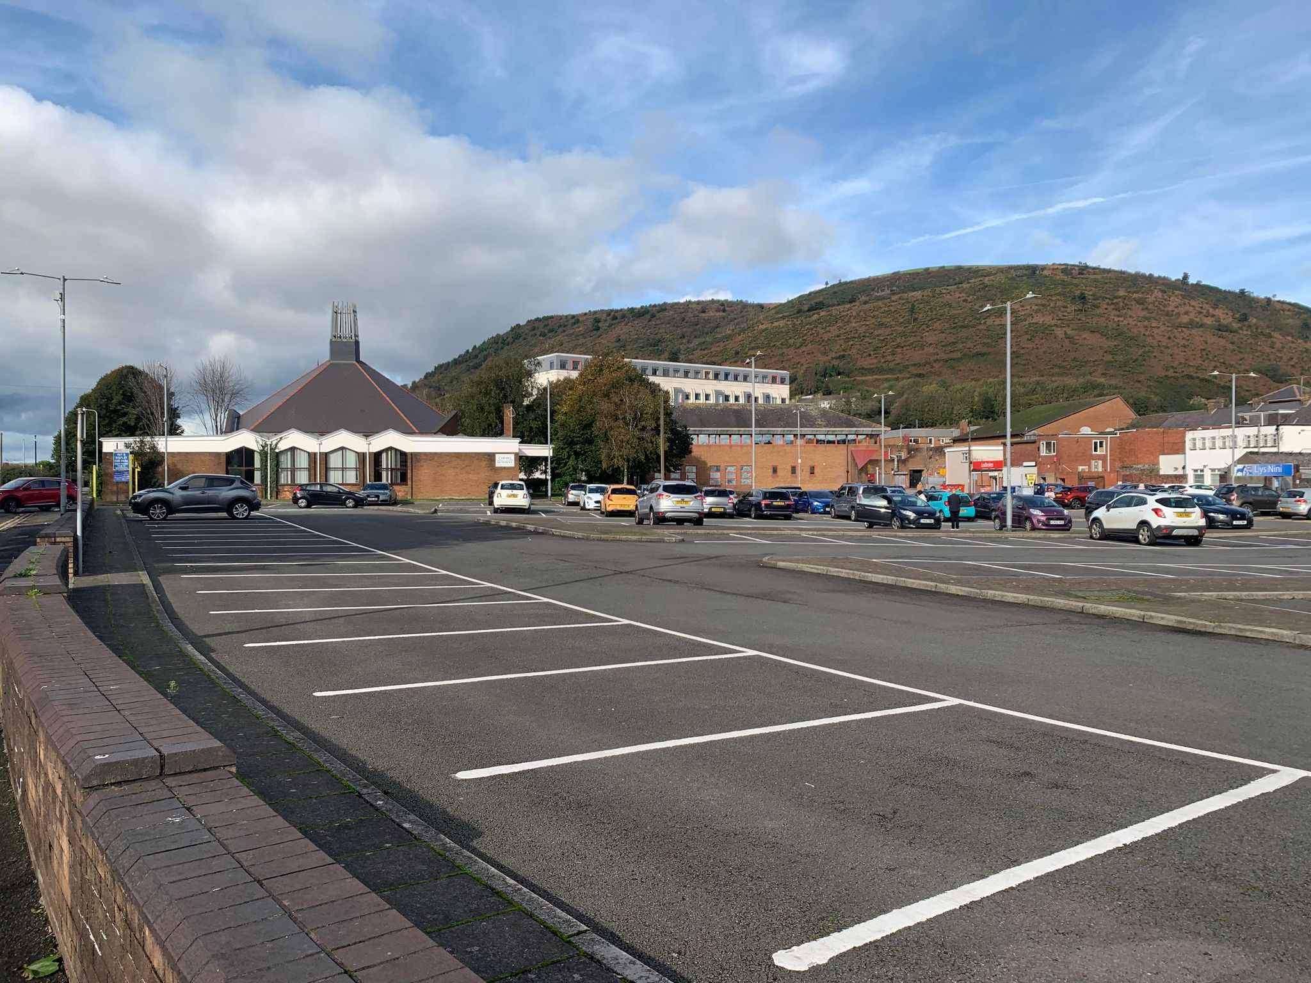

TABLE OF CONTENTS

- INTRODUCTION 4
1.1 The Proposed Development 4
1.2 Site Location 9
1.3 Site History 9
1.4 Application Documents 13
2. ENVIRONMENTAL IMPACT ASSESSMENT 13
2.1 Introduction 13
2.2 Scoping 13
2.3 Consulting 14
2.4 Assessment Method 14
2.5 Assumptions and Limitations 14
3. DEVELOPMENT OVERVIEW 15
3.1 Construction 16
3.2 Site Security 16
3.3 Demolition 16
3.4 Site Remediation 16
3.5 Earth Works 17
3.6 Plant and Machinery 17
3.7 Construction Material 17
3.8 Environmental Management Plan 17
4. NOISE AND VIBRARTION 18
4.1 Introduction 18
4.2 Assessment Summary 18
5. WATER RESOURCES 20
5.1 Introduction 20
5.2 Assessment Summary 20
6. AIR QUALITY 21
6.1 Introduction 21
6.2 Assessment Summary 22
7. TRAFFIC AND TRANSPORT 23
7.1 Introduction 23
7.2 Assessment Summary 23
8. GROUND CONDITIONS 25
8.1 Introduction 25
8.2 Assessment Summary 26
9. ARCHAEOLOGY 28
9.1Introduction 28
9.2 Assessment Summary 28
10. BIODIVERSITY 29
10.1 Introduction 29
10.2 Assessment Summary 29
11. HEALTH AND WELLBEING 30
11.1 Introduction 30
11.2 Assessment Summary 31
12. CLIMATE CHANGE 31
12.1 Introduction 31
12.2 Assessment Summary 32
13. CONCLUSION 33
14. REFERENCE 34
15. BIBLIOGRAPHY 35

- INTRODUCTION
This Environmental Statement (ES) has been prepared to support the outline planning application submitted to Neath Port Talbot Neath Port Talbot County Borough Council for the proposed Port Talbot Riverside Health Centre (PTRHC).

  - THE PROPOSED DEVELOPMENT
ACE Capital Developments Ltd endeavours to establish a facility adjacent to the new Harbour-side Development project, designed to attract diverse demographics to traverse the existing town and its environs. This establishment will serve not only as a gym and spa facility but also as a hub for the Port Talbot public to access educational resources on leading a healthy lifestyle, ranging from fitness literature to culinary classes focused on healthy meal preparation.
The establishment will promote awareness of both physical and mental health, emphasizing the significance of self-care and environmental stewardship. By integrating physical, mental, and environmental health initiatives, the facility will serve as a significant asset to the area, encouraging frequent visits. It will also create approximately 30 job opportunities catering to various demographics, from skilled to unskilled workers, thereby contributing to the appeal of Port Talbot.
In addition to attracting the growing student population, the facility aims to cater to families by offering youth classes and elderly yoga sessions. It will feature a modern design with ample natural light and greenery to enhance the mental well-being of users.
The building will serve as a symbol of Port Talbot's future, showcasing local construction materials and striving to minimize its carbon footprint to align with the area's air pollution policy. Encouraging sustainable travel is paramount, given its location within a master plan area focused on sustainable transportation. To facilitate this, the building will be situated near a cycle path with easily accessible bike racks. Regarding funding, the facility will operate under a match-funded arrangement (60/40) between ACE Capital Projects Ltd and the Welsh Government. Figure 1 shows a complete master plan for the Riverside Health Centre.

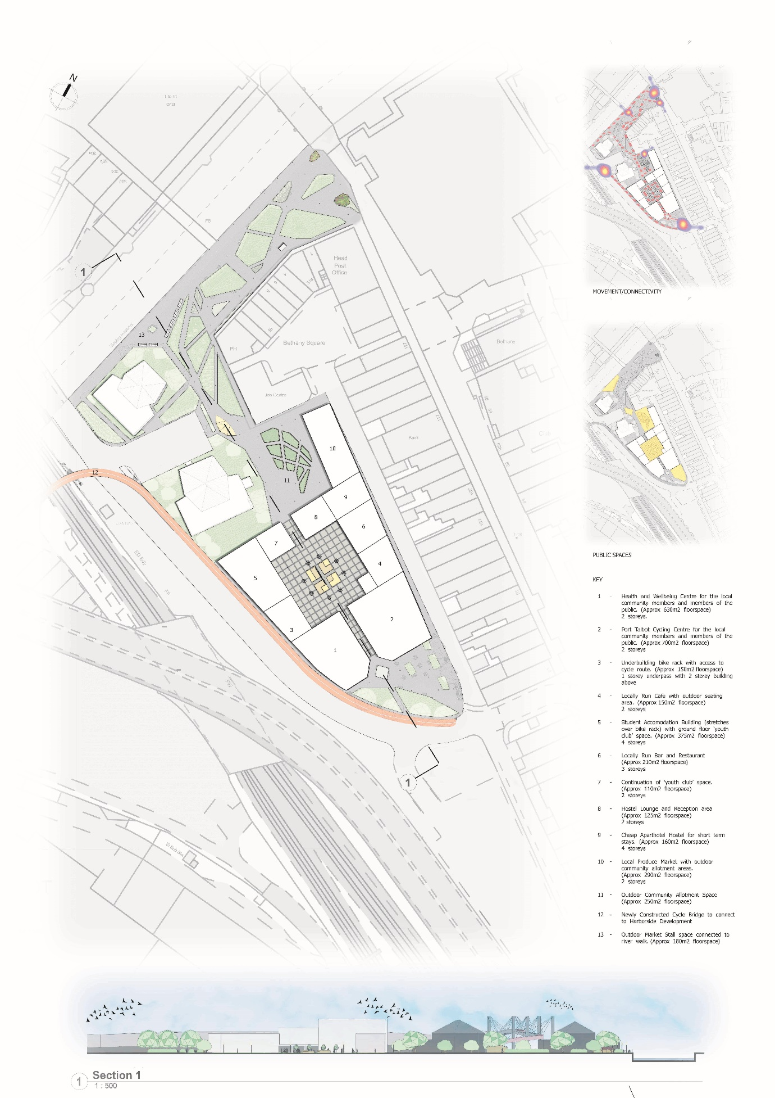

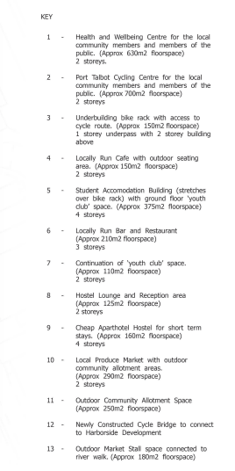
Figure.1 6003-UWTSD-XX-ZZ-M-A-0001-SITE-S5

The proposed (PTRCH) is to include the following:
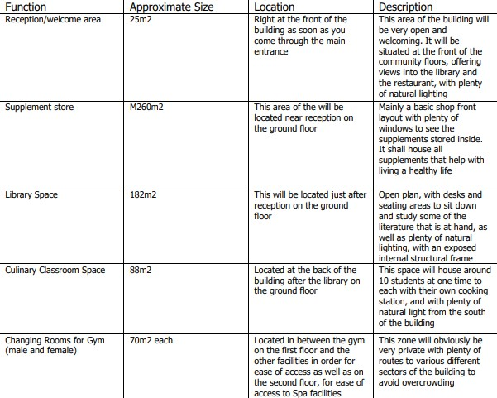
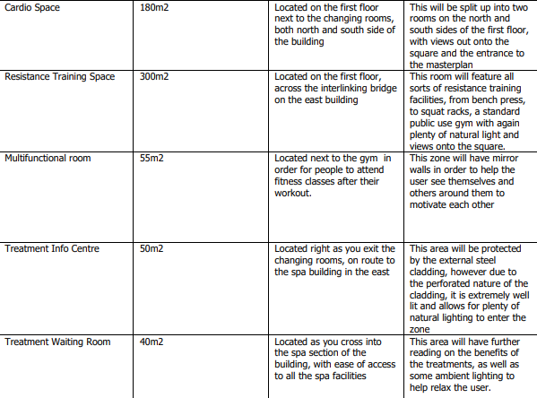
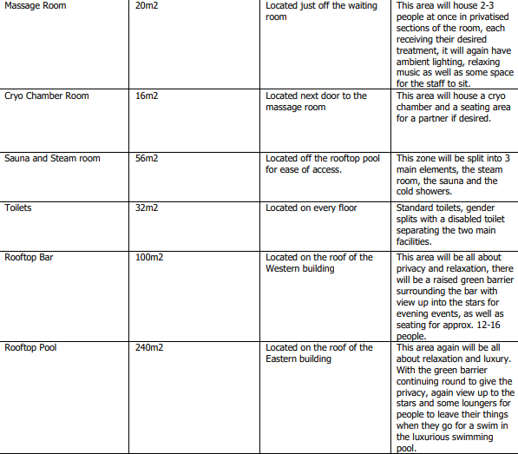
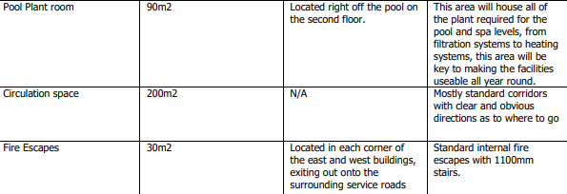

  - SITE LOCATION
The location is situated in Port Talbot, it is 23,327.35 m², and positioned southeast of the River Afan. Presently, it serves as a car park situated on Station Road, situated behind the Port Talbot shopping centre. The site is also located southeast of the river Afan. Adjacent to the site to the north are two churches, with a road encircling the site, featuring a roundabout. Currently, this road is utilized for deliveries to the shopping centre. Given the proximity to numerous shops and residences, the area experiences high foot traffic.
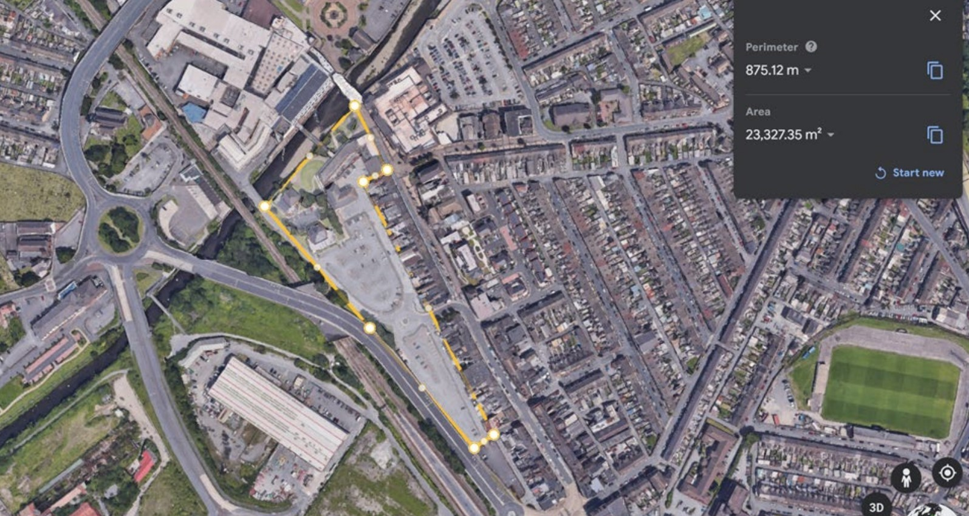
Figure 2. Map showing the proposed site area and location, retrieved by Josh Albrighton, (2023)
1.3 SITE HISTORY
As was previously summarised in the feasibility study this side dating back to the 1870s, the site was previously accommodated at the London Neath Pyle Train Station. During the 1890s, adjacent to the site, both an Iron Foundry and Morgans & Morsel Tin Plate Works were operational. Research suggests that the Iron Foundry operated until the 1880s, while the Tin Plate Works continued until 1910. Subsequently, in the 1930s, the Tin Plate Works, known as Byoss Works, reopened at the same location but was permanently dismantled in the 1940s. In summary, this area has historically been home to various industrial facilities including steel, engine, tin plate, and chemical works. Additionally, infrastructure such as an Iron Foundry, Gasholder, Hydraulic pumps, Quarries, and Rail stations have been present from the 1870s to the present day.
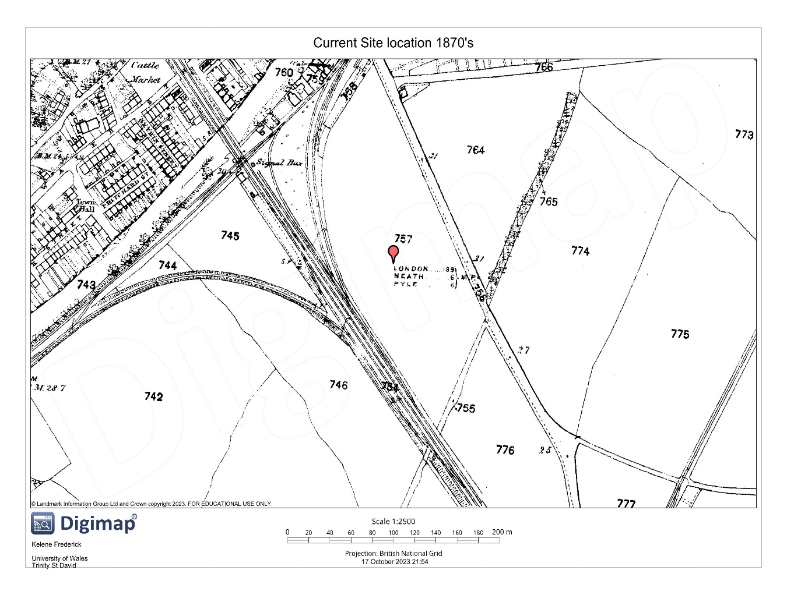
Figure 3. Map showing the historic roam data of the chosen site area taken from Digimap, (1870)
Presently, the site functions as a car park under the ownership of Neath Port Talbot Council, primarily serving visitors to nearby shops and the adjacent churches. Historical records from OS maps indicate that houses were erected on the site during the 1870s, raising concerns regarding potential construction standards and materials utilized during that period. Materials of particular concern from buildings of this era include lead, asbestos, and potential anthrax contamination, as historic plaster was a significant concern before regulations were implemented around the 1900s. Further data from the 1980s, sourced from the OS database, indicates that the houses were demolished around that time and replaced with the current car park infrastructure.
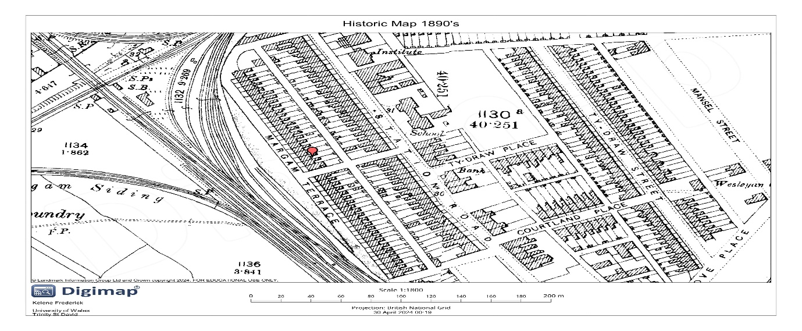Figure 4. Map showing the historic roam data of the chosen site area retrieved by Frederick, K (2024)
The Direct Environmental Impact
Quarries: | Coal, metals, and stone are just a few of the important commodities that can be extracted from the ground through mining and quarrying. While precious stones have long been used for beauty and decoration, these materials are frequently used in the building and industrial industries. According to Waste to Wealth, (2022) environmental damage can be greatly exacerbated by mining and quarrying, by leaving waste dumps and mounds. The extraction procedures may also release Sulphur dioxide and other pollutants into the air and water, endangering local wildlife and populations. These environmental effects can be reduced with more careful resource management, recycling, and restoration efforts following mining and quarrying.
Rail Stations and Engine works: | An important global source of environmental pollution is the petrol emissions from transportation. The type of fuel and transportation used determines these emissions primarily. Diesel exhaust, the abrasion of brakes, wheels and rails, as well as dust from the transportation of minerals and treated railway ties, are potential sources of pollutants linked to railways. Lucas, de Carvalho and Grilo, (2017) state that Carbon dioxide (CO2), methane (CH4), carbon monoxide (CO), nitrogen oxides (NOx), nitrous oxide (N2O), sulphur dioxide (SO2), non-methane volatile organic compounds (NMVOC), particulate matter (PM), and hydrocarbon (HC) are the principal pollutants released by diesel-powered railroads. Some studies found higher than permitted levels of PM10 and PM2.5 close to railroads according to Lucas, de Carvalho and Grilo, (2017).
The tin plate works: | APEAL, (2012) explains that the five standard impact categories associated with the manufacturing of tinplate are global climate change, acidification (AP), eutrophication (EP), and photochemical ozone formation (POCP). Nevertheless, Tinplate production's CO2 emissions (GWP) have lowered by 9% in just two years.
Iron Foundry: | The kind of metal, type of furnace, and moulding process being used directly affect the waste products produced by foundries. Metal Casting, (2022) states that sand mould using foundries is responsible for the majority of sand waste. Due to the presence of lead, zinc, cadmium, and other metals in the waste, non-ferrous and steel foundries may produce hazardous waste. Due to the usage of coke, cupola furnaces produce more air pollution than induction furnaces, and the non-recyclable sand fines used in sand castings produce more solid waste than permanent moulds do. The greatest foundry source in terms of volume is gaseous waste. Additionally, Metal Casting, (2022) says when carbon-containing moulds are heated to elevated temperatures, as occurs during the casting of metals, gases known as hazardous air pollutants (HAPS) are produced. Both chemically bonded and green sand moulds are included. Benzene is the main dangerous air pollutant emitted by poured castings.

Port Talbot has a history of having prominent levels of air pollution, which exceeded danger levels for citizens. According to Chris Odgen, (2019) in 2018, the town of Port Talbot in South Wales was the most mentioned urban region in the UK for the number of days with particulate matter levels over the acceptable threshold. As a result of constant industrial activities from the 1890s to the 2000s causing the air quality to deplete, new laws were implemented to manage and maintain healthy air quality levels. NHS Wales, (2018) reiterates that throughout the past century, the world's towns and cities including Neath Port Talbot have seen a sharp increase in traffic, the burning of fossil fuels, and increased industrial and energy output, all of which have contributed to the inadequate quality of the air.
Neath Port Talbot County Borough Council, (2018) explains that the Council's strategy plan for attaining better air in collaboration with the entire community is outlined in Neath Port Talbot's Local Air Quality Strategy. Additionally, it aligns with the goals and principles of the Council, particularly those concerning sustainability. This includes enhancing the quality of the air and revitalising the region's natural and industrial surroundings. The plan was last reviewed and modified in November 2013, having been created in 2000.
  - APPLICATION DOCUMENTS
The Environmental Statement is being presented to the Neath Port Talbot Borough Council for consideration as an integral component of the outline planning application. Additional documents were submitted to support the application including the Design and Access Statement, Drainage Strategy, Flood Consequences Assessment, and Geotechnical Report. The UK government states that for Schedule 2 developments, a local planning authority must refrain from issuing a Local Development Order unless they have either endorsed a screening opinion or received a screening direction from the Secretary of State. Should the screening process identify potential significant environmental impacts, it necessitates the completion of an Environmental Impact Assessment. The steps for issuing a Local Development Order, for which an Environmental Statement has been compiled, are outlined in Regulation 32.
- ENVIRONMENTAL IMPACT ASSESSMENT
  - INTRODUCTION
A mandatory Environmental Impact Assessment (EIA) is necessary for specific project categories and entails systematically compiling an evaluation of the anticipated significant environmental impacts of a project. This evaluation must be assessed before development consent is issued. The EIA process involves presenting information about the proposed project and its associated environmental impacts in an Environmental Statement. This statement is then considered by the determining authority to determine whether planning permission should be granted.
  - SCOPING
Scoping entails identifying potential significant issues that could emerge in the preliminary stages of a project because of the proposed development. This procedure guarantees that pertinent issues and potential impacts are examined in the Environmental Impact Assessment (EIA) with the necessary level of detail. The council engaged with a roster of stakeholders while crafting its Scoping Opinion. The Environmental Statement (ES) has been crafted using feedback gathered throughout the scoping process. A desktop study along with consultation with the Development Management Office, the Drainage Consent Engineer, the Planning Ecologist, Environmental Health, Highways, REG Planning Consultations, Natural Resources Wales, Network Rail, Welsh Water, and the Coal Authority was conducted to assess the scope of the project. The scope will include the assessment of noise, air quality, ground condition, water conditions, traffic and transport, health and wellbeing, climate change, biodiversity and archaeology.
  - CONSULTING
Public consultation was omitted during the preparation of this Environmental Statement, although formal pre-application consultation was conducted.
  - ASSESSMENT METHOD
- Gathering and organizing existing baseline data of the study area, along with conducting additional surveys to address any data deficiencies or outdated information.
- Engaging in frequent consultations with internal specialists and relevant external stakeholders, spanning various topic areas.
- Analysing the potential impacts of the proposed (PTRHC) on the existing baseline conditions, followed by identifying potential design modifications to mitigate predicted adverse effects and enhance any positive impacts.
- Evaluating the final scheme design and assessing the significance of any remaining and cumulative effects.
- Compiling the necessary Environmental Statement chapters.
- The column associated with Term (S/L/R/I) is defined as short, long, reversible and irreversible. The impacts are scored high, medium or low within (H/M/L) the summary assessment.
  - ASSUMPTIONS AND LIMITATIONS
It is presumed that data supplied by external sources, including publicly accessible information and databases, is accurate at the time of publication. Assumptions and constraints pertinent to environmental considerations are addressed in the corresponding topic assessment sections of this Environmental Statement.
3. DEVELOPMENT OVERVIEW
A planning application has been lodged for the Port Talbot Riverside Health Centre, with all details yet to be determined. Encompassing a total site area of roughly 23,327.35 square meters, the proposed PTRHC comprises several distinct components. The description outlined here serves as the foundation for conducting the Environmental Impact Assessment (EIA).
Riverside Health Centre | The building will incorporate both a gym and spa, serving as an educational hub for the residents of Port Talbot to learn about maintaining a healthy lifestyle. Alongside its aim to attract the growing student demographic, the facility will endeavour to accommodate all age groups, providing a variety of services ranging from youth classes to yoga sessions tailored for seniors and beyond.
Outdoor Leisure | The outdoor leisure area combines the comfort of seating arrangements with the natural beauty of trees, providing a tranquil and inviting space for relaxation and enjoyment.
Landscape | A comprehensive landscape strategy will be devised to integrate high-quality natural landscapes and woodland areas south of the River Afan, where the building is set to be erected. Ample planting will be incorporated around the site to enhance its surroundings and contribute to the overall aesthetic appeal.
Building Specifications | The Health and Wellbeing Centre building will be 2 stories and 630m2, while the Port Talbot Cycling Centre will also be 2 stories and 700m2.
Access | The UK accessibility legislation mandates that public sector entities must adhere to accessibility standards.
Energy | For assessment purposes, it is assumed that bio-fuelled boilers will be utilized for heating the buildings, although the energy strategy has not yet been finalized.
Water supply and Drainage | Surface water management will encompass the entirety of the site, channelling all discharges into the River Avan following filtration with silt barriers. Sustainable Urban Drainage Systems (SuDS) will be integrated into the surface water drainage system for the proposed development, spanning the entire site.
Parking | The specific number of car parking spaces has not been finalized. Nevertheless, the Neath Port Talbot Council has adopted the CSS Wales Parking Standards (2008) as a guideline for determining parking requirements.

3.1 CONSTRUCTION
The construction of the proposed PTRHC will occur in several phases, as outlined by the scheduler of works.
3.2 SITE SECURITY
The construction site will be secured using appropriate temporary hoarding along the boundary of the works area. It will be staffed during working hours and continuously monitored via CCTV around the clock. Secured by Design (SBD) is the official police security initiative aimed at enhancing the security of buildings and their immediate surroundings, creating safe environments for living, working, shopping, and visiting. These regulations will be implemented to ensure the safety of the site before, during, and after construction.
3.3 DEMOLITION
Demolition is not necessary on the site.
3.4 SITE REMEDIATION
The ground conditions Desk Study reveals the presence (and probable presence) of elevated levels of metals, TPHs (Total Petroleum Hydrocarbons), and PAHs (Polycyclic aromatic hydrocarbons) within the made ground materials throughout the site. Additionally, asbestos fibres were identified within the made ground across the site.
3.5 EARTHWORKS
To create a capping layer above the existing contamination, the current ground level of the site will either need to be excavated or raised by approximately 0.5m if the client decides to raise the level the material will need to be imported from local off-site sources.
3.6 PLANT & MACHINERY
During the construction phase, various types of plant and machinery are anticipated to be utilized, such as scrapers, dozers, excavators, loaders, dumpers, trucks, rollers, and compressors. Additionally, lifting equipment like cranes and forklift trucks may be required for building construction. While the specific details of the equipment needed for each phase are currently undetermined, they will be outlined in the Construction Method Statement prepared by the contractor.

3.7 CONSTRUCTION MATERIALS
The construction materials necessary would typically include those commonly used for developments of this kind, such as precast concrete, bricks, windows, roofing materials, ready-mixed concrete, plasterboard, concrete kerbing, and crushed concrete for sub-base.

3.8 ENVIRONMENTAL MANAGEMENT PLAN
The contractor will be responsible for preparing a Construction Environmental Management Plan (CEMP) for the proposed PTRHC.

4. NOISE AND VIBRATION
4.1 INTRODUCTION
This section of the Environmental Statement evaluates the impact of noise and vibration from the proposed development on the surrounding environment and assesses the suitability of the site, taking into account the influence of external noise and vibration sources on the proposed development.
The project could influence surrounding ambient sound and environmental noise levels throughout construction and operation, prompting assessments for both stages. Ground-borne vibration is anticipated during the early construction phase, but once operational, no vibration sources are foreseen to affect buildings or occupants within or beyond the development boundary. Consideration of the land use planning policy for Wales is necessary when drafting development plans.
4.2 ASSESSMENT SUMMARY
Issue/  Impact | Environmental  Impact |  | Negative/Positive Impacts |  |  |  | Mitigation
 | Term S/L/R/I | Extent |  | Score
Construction Development |  |  |  |  |  | H/M/L
Road traffic at construction site | S, R | Local | Expected to result in notable noise impacts. |  |  | H | Construction traffic will be limited to primary roads. Implement road traffic calming measures.
Potential noise impacts on nearby residential areas due to construction activities. | S, R | Local | Construction noise was evaluated as substantial. |  |  | H | A noise reduction plan will be enacted to address construction noise impacts, with the potential provision of noise insulation for affected residential properties.
Potential noise impacts at nearby non-residential receptors due to construction activities. | S, R | Local | Construction noise was evaluated as insignificant. |  |  | H | Measures like closed windows are used to reduce construction noise, maintaining acceptable noise levels.
Development Operations
Potential noise impacts at nearby receptors due to building services electrical and mechanical equipment. | S, R | Local | Building plant noise may be audible if not properly controlled. |  | H |  | Building plant noise will be effectively managed through a planning condition to ensure compliance with noise limits set by the NPT Council.
Potential vibration impacts on nearby buildings due to site preparation and construction activities generating ground-borne vibration. | S, R | Local | Construction vibration will not be affected in the absence of other large-scale concurrent development in the local area. |  | H |  | The contractor is obligated to select appropriate equipment, apply noise reduction measures, and notify residents and office occupants in advance to minimize perceived vibration to acceptable levels.

5. WATER RESOURCES
5.1 INTRODUCTION
This section of the Environmental Statement evaluates how the proposed development could impact water bodies, surface water drainage, flood risk, and drainage infrastructure throughout both the construction and operation phases.
The evaluation has examined the proposed development and its potential significant impacts on surface water, groundwater, and foul water, primarily focusing on:
  - Impacts on the current status of the Water Framework Directive (WFD)
  - Feasibility of implementing WFD mitigation measures for surface water
  - Rise in surface water flood risk within or outside the site
  - The capacity of existing foul infrastructure to accommodate the proposed development.
The assessment has been conducted following the following laws and guidelines:
  - Planning Policy Wales Water Resources Act of 1991
  - The Flood and Water Management Act of 2010
  - Wales Spatial Plan (Updated 2008)
  - Water Framework Directive (WFD) 2000/60/EC
  - Water Environment (England and Wales) Regulations 2003
5.2 ASSESSMENT SUMMARY
Issue/  Impact | Environmental  Impact |  | Negative/Positive Impacts |  |  | Mitigation
 | Term S/L/R/I | Extent |  | Score
Drainage | S, R | Onsite | Poor surface water drainage may cause flooding | H |  | Insert culverts or slipper drains to channel water away from the site. Implement a CEMP (Contractor)
Water Pollution | S, I | Local | Sediments from surface run-off and poor management of foul water drainage may pollute river Afan | H |  | Silt fences, minimising movement of subsoil, settlement ponds. Implement a CEMP (Contractor)
Flooding | S, R | Local | Damage to property and halting works |  | L | Using sandbags as barriers or temporary flood walls. Implement a CEMP (Contractor)

6. AIR QUALITY
6.1 INTRODUCTION
Air quality assessments focus on airborne pollutant levels in the atmosphere. This evaluation delineates pertinent air quality regulations and laws delineates current air quality conditions near the site and delineates the development's nature and associated air quality concerns during construction and operation. Additionally, proposed mitigation measures are outlined to minimize the development's impact on air quality to the extent feasible.
The suggested project may affect the local levels of nitrogen dioxide (NO2) and fine particulate matter (PM10 and PM2.5) originating from emissions of vehicles and machinery throughout both the construction and operational phases. Due to ongoing industrial activities spanning from the 1890s to the 2000s, which have led to a decline in air quality, new regulations have been introduced to regulate and uphold healthy air standards. NHS Wales (2018) emphasizes that over the past century, urban areas worldwide, including Neath Port Talbot, have experienced a significant rise in traffic volume, fossil fuel combustion, and industrial and energy production, all contributing to poor air quality.
The assessment has been conducted following the following laws and guidelines:
  - European Air Quality Management
  - Environment Act 1995
  - Environment (Wales) Act 2016
  - The Well-being of Future Generations (Wales) Act 2015

6.2 ASSESSMENT SUMMARY
Issue/  Impact | Environmental  Impact |  | Negative/Positive Impacts |  | Mitigation
 | Term S/L/R/I | Extent |  | Score
Construction traffic | S, R | Local | Respiratory conditions, heart-related ailments, mortality rates, and lung cancer risks. Diminished lung capacity | H | Before commencing any on-site activities, it is necessary to formulate and submit a comprehensive construction traffic management plan to the local planning authority.
Construction Dust | S, R | Local | Respiratory conditions, heart-related ailments, mortality rates, and lung cancer risks. Diminished lung capacity | H | Formulate and submit a comprehensive construction traffic management plan to the local planning authority. Common measures include dampening dusty areas
Machinery/Operations | S, R | Onsite | Respiratory conditions, heart-related ailments, mortality rates, and lung cancer risks. Diminished lung capacity | H | Avoid burning waste materials. Use hybrid technology instead of diesel-powered machinery. Enhance current equipment by incorporating particulate filters and catalytic converters.

7. TRAFFIC & TRANSPORT
7.1 INTRODUCTION
This section of the Environmental Statement (ES) evaluates the anticipated traffic effects resulting from the development proposals on vulnerable receptors, pedestrians, and the nearby road system. It examines the potential environmental consequences throughout both the construction and operational phases of the project.
As an integral component of the comprehensive transport strategy for the site, the proposed PTRHC project aims to incorporate sustainable transportation methods, including cycling. Situated near a cycle path, the facility will include easily accessible bike racks located beneath the nearby structure. Consequently, the design of the development emphasizes pedestrian and cyclist permeability, facilitated by well-designed access points. Pedestrian pathways throughout the site are depicted on the Site Layout Plan.
7.2 ASSESSMENT SUMMARY
Issue/  Impact | Environmental  Impact |  | Negative/Positive Impacts |  |  |  | Mitigation
 | Term S/L/R/I | Extent |  |  | Score
Vehicular traffic | S, R | Local | Increased traffic congestion within the area, which will cause noise and air pollution |  | H |  | Formulate and submit a comprehensive construction traffic management plan to the local planning authority.
Pedestrians’ safety | S, R | Local | Increased potential for accidents during construction | H |  |  | Ensure that there is appropriate signage to direct civilians through safe paths. Implements a comprehensive traffic management plan.
Material Delivery | S, R | Local | Poorly secure materials on vehicular transport may cause accidents. |  |  | M | Implement a sufficient management plan that includes multiple checks to secure materials before transport and during.
Machinery | S, R | Local | Chemical spills or leaks, which may lead to land and water pollution |  |  | M | Implement a sufficient management plan that includes multiple checks before transport and during.

8. GROUND CONDITIONS
8.1 INTRODUCTION
This section of the Environmental Statement evaluates the potential significant impacts of the proposed development on ground conditions. It encompasses mitigation strategies necessary to mitigate or minimize adverse effects, as well as the anticipated residual impacts following the implementation of these measures. Additionally, it delineates the pertinent regulations and policies governing the assessment of ground conditions at the site Proposed mitigation measures will be executed to alleviate any adverse impacts of the proposed development concerning potential contamination.
The Environmental Protection Act of 1990 and the Environment Act of 1995 establish the essential framework and legal authority for waste management and the regulation of emissions into the environment. Additionally, the EU Water Framework Directive (WFD) 2000/60/EC, as amended in 2008, represents the European Union's commitment to attaining high-quality and sufficient status for all water bodies. The Contaminated Land Regulations of 2006 outline the requirements for identifying and addressing contaminated land.

8.2 ASSESSMENT SUMMARY
Issue/  Impact | Environmental  Impact |  | Negative/Positive Impacts |  |  |  | Mitigation
 | Term S/L/R/I | Extent |  |  |  | Score
Construction workers | S/L/R/I | On-site | Human health and groundwater are at risk of contamination from disturbed soil |  |  | H | Remove contaminated soil, treat contaminated soil, and or cover the contaminated soil of the site raising its level. The contractor is to Implement health and safety measures and a CEMP
Site neighbours/ general public | S/R/I | Local | Human health and groundwater are at risk of contamination from disturbed soil |  |  | H | The contractor is to Implement health and safety measures and a CEMP
Groundwater | L/I | Local | Contaminated groundwater can affect the health of humans and surrounding biodiversity. |  | H |  | The Remediation Verification Plan, Foundation Risk Assessment, and Best Practice guidelines are integral components of the Construction Environmental Management Plan (CEMP).
Chemical and oil spills | S/R | Local | These spills will contaminate the ground | H |  |  | The pollution prevention guidance and the Construction Environmental Management Plan (CEMP) should be put into practice.
UXO’S | L, I | Onsite/ local | Places a harmful threat towards civilians, workers and the development | L |  |  | Conduct detailed ground investigations to identify the presence of UXO
Mining | L, I | On-site/ local | Human health and groundwater are at risk of contamination from disturbed soil | M |  |  | Additional investigation and monitoring will be necessary, along with health and safety protocols and toolbox talks. Remediation or treatment and subsequent verification based on the investigations may also be necessary.

9. ARCHAEOLOGY
9.1 INTRODUCTION
This section outlines the mitigation measures necessary to prevent, minimize, or counteract significant adverse effects concerning archaeological artefacts, as well as the expected residual effects following the implementation of these measures. The desktop study has indicated that this site has no potential archaeological artefacts. The assessment summary will be a guide if artefacts are found.
9.2 ASSESSMENT SUMMARY
Issue/  Impact | Environmental  Impact |  | Negative/Positive Impacts |  | Mitigation
 | Term S/L/R/I | Extent |  | Score
Damaged artefacts | L, I |  | Construction activities will lead to the removal, or loss, of non-designated historic assets within the site covered by the application. | L | Archaeological surveys should be conducted to identify and document the characteristics, extent, and importance of existing and possible buried structural and archaeological features.

10. BIODIVERSITY
10.1 INTRODUCTION
This section of the Environmental Statement evaluates the potential significant impacts of the proposed project on the ecological resources within and around the site. The assessment follows the guidelines outlined in the "Guidelines for Ecological Impact Assessment in the UK and Ireland: Terrestrial, Freshwater, and Coastal" provided by the Chartered Institute of Ecology and Environmental Management. The desktop study indicates that this site has no protected or endangered species. The assessment summary will be a guide if any endangered or protected species are found.
10.2 ASSESSMENT SUMMARY
Issue/  Impact | Environmental  Impact |  | Negative/Positive Impacts |  |  |  | Mitigation
 | Term S/L/R/I | Extent |  |  | Score
Habitat loss/damage | S/L/R/I | Local/On-site | Displacement of species |  | L |  | Comply with the UK and European legislation for ecological impact assessments.
Operational activities | S, R | Local/On-site | Increased noise and air pollution along with potential contamination will affect the surrounding biodiversity. |  |  | H | Comply with the UK and European legislation for ecological impact assessments.
Invasive species | S, R | On-site | Disruption of the natural ecology of the surrounding environment halts the progress of works | L |  |  | Physical control methods such as cutting or trapping, complete removal, and proper disposal. Chemical control methods involving the use of suitable herbicides. Prevention of spread through proper site management and cleaning of maintenance equipment. It is prohibited to spread plants listed under Schedule 9 of the Wildlife and Countryside Act 1981 (as amended) from the site.

11. HEALTH & WELLBEING
11.1 INTRODUCTION
Conducting a health and well-being assessment involves evaluating the potential positive and negative effects of a proposed project on the health and well-being of various populations. This information is then used to inform the project's design to maximize positive impacts and minimize negative ones. Specifically, the assessment aims to identify any adverse or beneficial effects on new residents, facility users (such as labourers, patients, and recreational users), and existing residents near the proposed development during both the construction and operation phases. Additionally, mitigation and enhancement measures are developed to address any negative impacts and improve positive ones after planning consent is obtained. Finally, potential indicators for monitoring and evaluating the actual health impacts during construction and operation are identified. The Wellbeing of Future Generations (Wales) Act, implemented in 2015, mandates that public bodies in Wales, as well as those listed within the Act, are obligated to strive for the advancement of Wales’s economic, social, environmental, and cultural well-being.

11.2 ASSESSMENT SUMMARY
Certain demographic groups, including older individuals, those with low income or socioeconomic status, individuals with disabilities, and those with long-term illnesses or care needs, have been identified as particularly susceptible to health impacts from community and health profiles. Residents living near the development site may face risks associated with air, noise, disrupted transportation and visual pollution during the construction phase, potentially leading to increased crime rates if security measures are inadequate.
The occupants of the Port Talbot Riverside Health Centre are expected to primarily consist of younger and older individuals, who may feel vulnerable to crime, as well as other vulnerable members of the community, such as those with learning disabilities, who may be at higher risk of victimization. However, the fear of crime among PTRHC residents is likely to diminish due to the nature of assisted living provided by the development and enhanced security measures, resulting in a long-term, minor, positive impact.

12. CLIMATE CHANGE
12.1 INTRODUCTION
Within this section of the Environmental Statement, strategies for mitigating the outcomes of the three evaluations conducted within the climate change domain are outlined, specifically addressing:
- Assessment of greenhouse gas (GHG) emissions.
The Climate Change Act of 2008 mandated the UK's initial legally binding target to diminish carbon emissions by a minimum of 80% compared to 1990 levels by the year 2050. Additionally, it stipulated the establishment of five-year carbon budgets to be established and adhered to. Furthermore, the Act introduced the necessity for a climate change risk assessment every five years, alongside the formulation of an adaptation action plan in response to identified risks.
12.2 ASSESSMENT SUMMARY
Issue/  Impact | Environmental  Impact |  | Negative/Positive Impacts |  | Mitigation
 | Term S/L/R/I | Extent |  | Score
Greenhouse gases/emissions from machinery and operation work during and after construction of the development | L, I | Local, Global | Increases the concentration of greenhouse gases within the atmosphere promoting global warming. | H | Promote designs with a low carbon footprint. Utilize materials sourced locally. Utilise equipment powered by renewable energy sources or biofuels Implement recycling of materials from previous projects.  Research and integrate low-carbon materials

13. CONCLUSION
The environmental impact assessment report for the proposed Port Talbot Riverside Health Centre, submitted to the Neath Port Talbot County Borough Council, simplified the importance of carefully considering the site's history, geographical location, and potential environmental implications. Situated southeast of the River Afan in Port Talbot, the 23,327.35 m² site has a history of industrial infrastructure, including an Iron Foundry, Gasholder, Hydraulic pumps, Quarries, and Rail stations, which raises concerns about potential contamination. The ground conditions desk study indicates the presence of elevated levels of metals, TPHs, PAHs, and asbestos fibres within the made ground materials throughout the site. Moreover, neighbouring citizens are likely to be affected by noise and vibrations, while the nearby water body faces contamination risks.
However, mitigation measures such as silt barriers have been proposed to address these concerns. Furthermore, air quality and traffic management measures are deemed necessary to mitigate potential impacts on biodiversity, health, and well-being. Additionally, the report highlights the importance of implementing measures to reduce climate change impacts, thus ensuring the long-term sustainability of the proposed development. Overall, adherence to the recommendations outlined in the environmental impact assessment is crucial to minimizing adverse effects and ensuring the Riverside Health Centre project contributes positively to both the community and the environment in Port Talbot.

14. REFERENCE
- Albrighton, J. (2023b). Site Location.
- Chris Odgen (2019). Port Talbot is the worst in the UK for PM10 pollution. [online] AirQualityNews - The air quality news and information site. Available at: https://airqualitynews.com/health/port-talbot-worst-in-uk-for-pm10-pollution/#:~:text=The%20South%20Wales%20town%20of [Accessed 28 Oct. 2023].
- Digimaps (1870). Historical Roam. [online] wayf.ukfederation.org.uk. Available at: https://digimap.edina.ac.uk/roam/map/historic?unifiedClient=true [Accessed Oct. 2023].
- Digimap (2024). Historic Roam. [online] Edina.ac.uk. Available at: https://digimap.edina.ac.uk/roam/map/historic [Accessed 30 Apr. 2024].
- Lucas, P.S., de Carvalho, R.G. and Grilo, C. (2017). Railway Disturbances on Wildlife: Types, Effects, and Mitigation Measures. Railway Ecology, [online] 1(978-3-319-57495-0), pp.81–99. doi https://doi.org/10.1007/978-3-319-57496-7_6.
- Neath Port Talbot County Borough Council (2018). Neath Port Talbot Council. [online] www.npt.gov.uk. Available at: https://www.npt.gov.uk/1567 [Accessed 28 Oct. 2023].
- NHSWales (2018). Air Quality in Neath Port Talbot. [online] NHSWales. Available at: https://www2.nphs.wales.nhs.uk/environmentalphtdocs.nsf/815f97434d281f8b80257508003d3986/d2a79269418ce40480257705005b22d3/$FILE/Air%20Quality%20Eng%20version.pdf [Accessed 28 Oct. 2023].
- The Metal Casting (2022). Environmental Issues. [online] www.themetalcasting.com. Available at: https://www.themetalcasting.com/enviornmental-issues.html#:~:text=Some%20of%20the%20environmental%20issues [Accessed 24 Oct. 2023].
- Waste to Wealth (2022). Mining and Quarrying Environmental Impacts. [online] www.linkedin.com. Available at: https://www.linkedin.com/pulse/mining-quarrying-environmental-impacts-revati-k#:~:text=Mining%20and%20quarrying%20can%20be.
15. BIBLIOGRAPHY
- GOV.UK (2010). Flood and Water Management Act 2010. [online] Legislation.gov.uk. Available at: https://www.legislation.gov.uk/ukpga/2010/29/contents [Accessed 15 Mar. 2024].
- GOV.UK (2011). The Water Environment (Water Framework Directive) (England and Wales) Regulations 2003. [online] Legislation.gov.uk. Available at: https://www.legislation.gov.uk/uksi/2003/3242/contents/made [Accessed 15 Mar. 2024].
- GOV.UK (2016). Environment (Wales) Act 2016. [online] Legislation.gov.uk. Available at: https://www.legislation.gov.uk/anaw/2016/3/contents/enacted [Accessed 15 Mar. 2024].
- Legislation.gov.uk (1981). Wildlife and Countryside Act 1981. [online] Legislation.gov.uk. Available at: https://www.legislation.gov.uk/ukpga/1981/69 [Accessed 15 Mar. 2024].
- Legislation.gov.uk (2008). Climate Change Act 2008. [online] Legislation.gov.uk. Available at: https://www.legislation.gov.uk/ukpga/2008/27/contents [Accessed 15 Mar. 2024].
- NPT Parking Standards (2016). Parking Standards Supplementary Planning Guidance. [online] Available at: https://www.npt.gov.uk/media/7469/spg_parking_standards_oct16.pdf [Accessed 15 Mar. 2024].
- UK Government (1990). Environmental Protection Act 1990. [online] Legislation.gov.uk. Available at: https://www.legislation.gov.uk/ukpga/1990/43/contents [Accessed 15 Mar. 2024].
- Welsh Government (2015). The Well-being of Future Generations (Wales) Act 2015. [online] Legislation.gov.uk. Available at: https://www.legislation.gov.uk/anaw/2015/2/contents/enacted [Accessed 15 Mar. 2024].

