This Encyclopedia entry will be on the Ahmadiyya movement, and shall primarily focus on its history, how it differs to other forms of Islam, and the persecution of the community. This entry would be suited to a more general encyclopedia, such as Encyclopedia Britannica, or the Encyclopedia of Religion, due to the fact that it was written with a wider readership in mind, the intention being to use it as an introduction to the topic, which could be suited to non-formal education, as well as academic purposes, such as undergraduate level in Religious Studies.

Overview

The Ahmadiyya (also known as the Jama῾at-i Ahmadiyya, simply meaning the Ahmadiyya Community) is a messianic denomination within Islam founded in British-controlled India in 1889 by Mirza Ghulam Ahmad, who is believed to be a Prophet and the Messiah, claiming to fulfill the Islamic prophecy concerning the return of the Messiah in Latter Day times. Due to these beliefs the Community has been associated with controversy and persecution internationally, resulting in its International Headquarters being based in London. The mission of the movement is to revive Islam into a peaceful community of believers, as well as seeking to establish peace amongst all religions by ‘testifying to the truth of the original teachings of various faiths’.While the exact number of Ahmadis worldwide is not known, the Community itself places the number at a vague ‘membership exceeding tens of millions’, although the number is thought to be closer to twenty million.

History
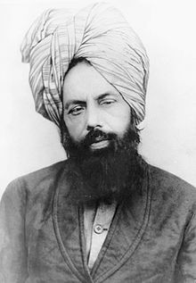
The Ahmadiyya movement formally began in 1889, when its leader Mirza Ghulam Ahmad (1835-1908) took formal oaths of allegiance from a number of his companions in Ludhiana, India. However, the history can be traced back further to Punjab, India, following the early life of Ghulam Ahmed, noting his education and call to prophethood.

It is emphasized by Ahmadi sources that while Ghulam Ahmad did receive formal religious education and training (which was compatible with the standard education of aristocratic children of Punjab at the time), it was largely incomplete and simplistic when compared to the rigorous traditional curriculum undertaken by his contemporary ῾ulamā (Sunni scholars). It is thought that his education was based almost entirely on language acquisition, and the fact that Ghulam Ahmad had no links to a formal program of study with a specialist teacher makes the subject of his study more ambiguous, making the influences on his thought essentially untraceable.
Figure (1) Mirza Ghulam Ahmad of Qadian
As a young adult, Ghulam Ahmad was sent to Sialkot as a reader for the British-Indian ruled court, where he came into contact with a number of Christian missionaries, which allowed him to interact with those who challenged his beliefs, igniting his interest for religious argumentation. It was also during this time that many disillusioned Muslims were converting to Christianity, looking to it as a source of salvation in a society in which the Muslim rule and aristocracy was crumbling at the hands of the Sikhs and the British, further exacerbated by the sheer volume of Christian missionaries, creating a struggle for religious domination in India. There was also a theological dilemma which had become prevalent at the time, but went largely unanswered by the mainstream scholars concerning the role of Jesus in Islam. If Muhammad was indeed the superior prophet, then why was it Jesus’s arrival that the Muslims were awaiting? In order to re-establish Islam as the superior religion, and respond to these issues, Ghulam Ahmad utilized the growing trend amongst scholars of using rational, logical arguments in polemics and wrote his first and most celebrated book Barāhīn-i Ahmadiyya (The Proofs of Islam) in 1880, which was originally planned to consist of fifty instalments, but the fifth and final work was published in 1905. It was in the third instalment of the Barāhīn-i Ahmadiyya in 1882 that included Ghulam Ahmad’s first divine revelation, revealing his divine appointment as mujaddid (religious renewer), and mahdi (the redeemer) using messianic claims associated with this term to imply his status had reached some level of prophethood. The book also gained him a reputation as an expert in anti-Christian and Anti-Hindu polemics.

It was not until six years after this divine revelation that Ghulam Ahmad began making formal arrangements to formalize his spiritual authority over his followers by accepting their bay’at (allegiance) in 1889. It has been suggested that the delay in accepting bay’at is due to the birth of his son, Mirza Bashir Al-Din Mahmud Ahmad, which was prophesied in his earlier years, and that by waiting until his son was born to formally establish the community, the outstanding prophecy would be fulfilled and provide his followers with greater confidence in his abilities.

After Ghulam Ahmad’s death in 1908, he was succeeded in leadership by Maulvi Hakim Nur al-Din (b.1841 CE), one of his first supporters. It was during his leadership that the movement was threatened by differences of opinion on issues pertaining to the relations with non-Ahmadis and the nature of the leadership. After Nur al-Din’s death in 1914, Ghulam Ahmad’s youngest son Bashir Mahmud Ahmad (1889-1965 CE) succeeded him, at which time the differences in the movement created a schism, splitting into two factions, the Qadiyanis, and the Lahoris (who shall be discussed in religious beliefs and practises section). The next Khalifa was Mahmud Ahmad’s son, Mirza Tahir Ahmad (1928-2003), who was stationed at the headquarters in Rabwa, Pakistan, until 1984, when the societal attitudes towards the Ahmadis had reached a new low, with the implementation of the Anti-Ahmadi Laws (see persecution in Pakistan section) and consequently moved to London, which has been the HQ of the movement ever since. As of May 2007, the movement is under the leadership of Masrur Aḥmad (b.1950-), the fifth successor of the founder.

Religious Beliefs and Practises

Religious education can often present Islam as a homogenous, monolithic group, unified in their beliefs and practises. This is simply not the case. Scholar Simon Valentine argues that, Islam is a ‘highly fractured faith, embracing a multitude of differing views and outlooks’, with the Ahmadis representing one sub-group within a multiplicity of subdivisions.

It should be noted here that the Ahmadis doctrinally have a great deal in common with the Sunni branch of Islam, which is widely considered the ‘orthodox’ branch of Islam. The Qur’an read is the same as that of the Sunni and Shia, written and read in Arabic (although the preferred translations and commentaries used differ based on denomination). The Five Pillars (Shahada, Prayer, Fasting, Zakat and Hajj) remain the same, as well as the Six Articles of Faith (Unity of God, His Angels, His Books, His Prophets, The Last Day, and Divine Decree). Like the Sunnis, Ahmadis also accept the first four successors of Muhammad (known collectively as the Rashidun, or the Rightly Guided Caliphs)
Additionally, Ahmadis pray five times a day, as do the Sunnis and Shias. However, while there are subtle gestural differences that can be observed between Sunni and Shia during prayer, these are not found when comparing the prayer of a Sunni and Ahmadi.

It can also be argued that Ahmadi ideology has a number of Sufi influences, as well as Sunni, which can be seen in the exclusivity of Ghulam Ahmad’s early community, as well as the acceptance of bay’at which mirrors that of a medieval Sufi order, as well as the esoteric ambiguity of his claims that were based on spiritual ecstatic experiences. However, these Sufi influences can be considered almost synonymous with the South Asian experiences of Islam, due to South Asia’s history being intimately connected to the wider influence of Sufism.

The Ahmadis beliefs begin to diverge from the mainstream with regards to their beliefs about Prophethood, which was largely inspired by the work of Muslim mystic Muḥyī al-Dīn ibn al-ʿArabī (1165–1240 CE), particularly the concept of legislative and non-legislative prophets. Legislative prophets referred to those who brought some form of scripture or legal code to humankind, while non-legislative prophets served to reinforce the pre-existing scripture. The belief that Ghulam Ahmad is a non-legislative prophet, and that Muhammad was the last legislative one, allows Muhammad to remain the ‘seal of the prophets’, the seal reinterpreted to mean the last ‘legislative’ as opposed to the ‘last’. Whilst he is considered a prophet, it is emphasized that he is subservient follower-prophet to Muhammad, therefore not his equal. However, this belief caused a divide within the Community, resulting in the formulation of the Lahori Ahmadis, who reject the notion of Ghulam Ahmad as Messiah and Prophet, and credit him only as mujaddid (renewer).

Contrary to mainstream Muslim belief, Ahmadis also believe that Jesus did not die on the cross, but died of natural causes after migrating to India in search of the Lost Tribes of Israel, which led him to later die of old age in Kashmir. Ahmadis maintain that the prophecies of the second coming of Christ in the Latter Days is metaphorical for someone coming from God who would reflect the qualities of Jesus, but be born from amongst Muslims to revive Islam, a role they have deemed as fulfilled by Mirza Ghulam Ahmad.

Another defining feature which differentiates the Ahmadiyya Community from other branches is the Khilafah system of leadership that has been in place since the death of its founder Ghulam Ahmad in 1908. Unlike the Caliphate in the times of the Rashidun, the system of leadership is meant to be purely spiritual, not political. The Khalifa’s (meaning successor to a Prophet) main role is to ‘complete the tasks of reformation and moral training that were seeded by the Prophet’ and therefore establish and uphold the authority of Allah on earth. While it may appear as though the Khalifa is elected by a group of pious believers, this is perceived as the work of Allah himself, His Will guiding their decision to select the Khalifa of His choice, and once selected, it is a duty upheld until their death.

Persecution of the Ahmadis in Pakistan

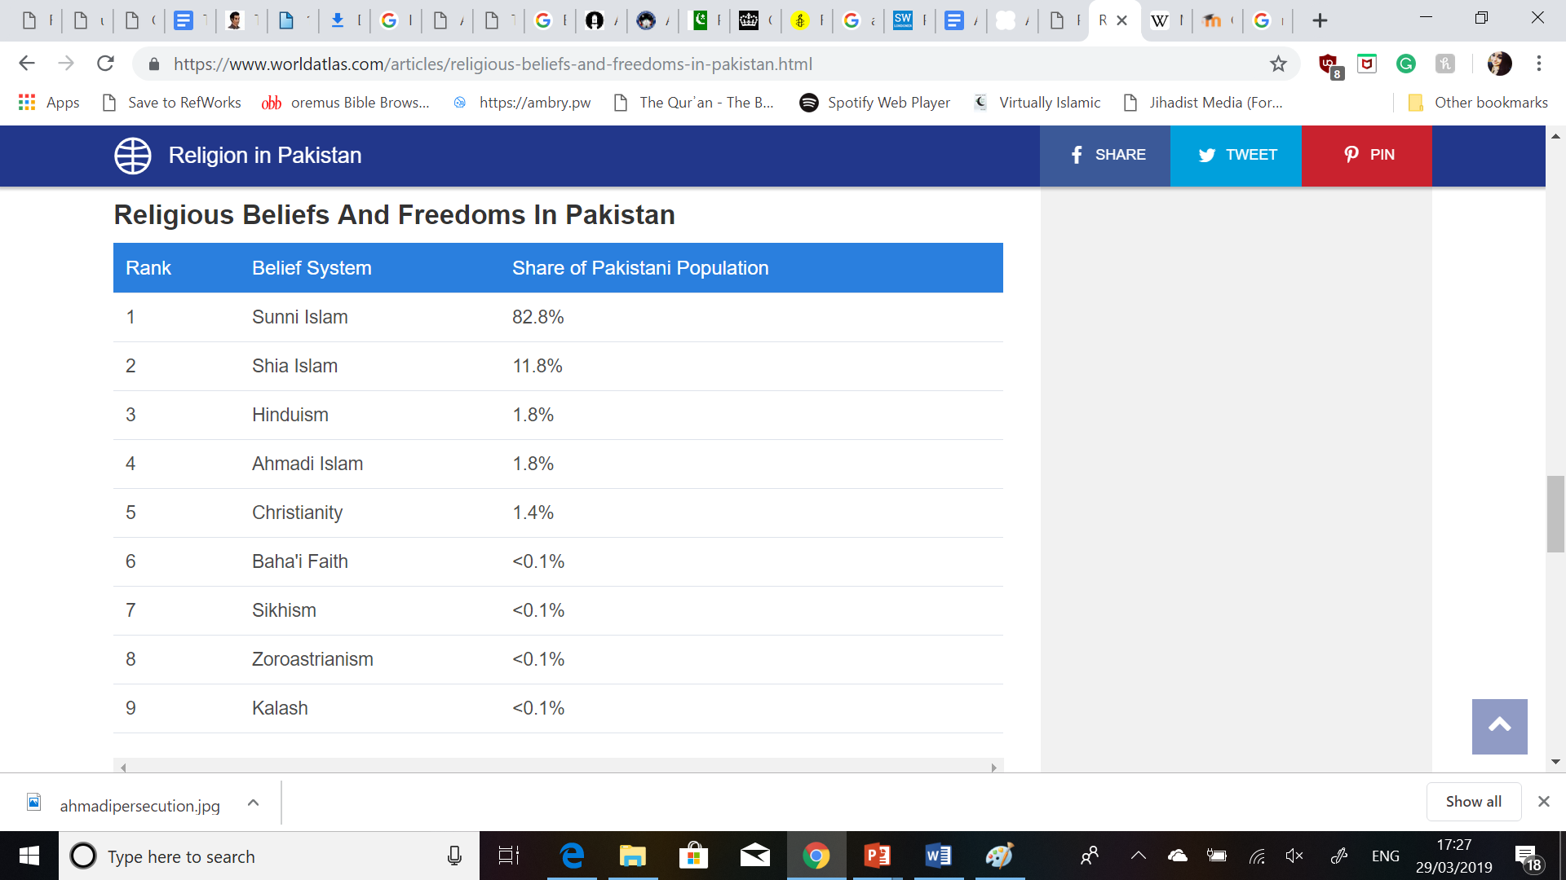
Persecution of the Ahmadis has been prevalent internationally, but Pakistan is of particular importance due to it having the largest Ahmadi Community worldwide, with approximately four million adherents, making 1.8 % of the population Ahmadi, with Sunni Islam being the most prevalent, sharing over 82% of the population.
Ahmadis have faced opposition and persecution since their creation, being challenged, harassed and ostracised for their views, which were deemed heretical by the mainstream Muslims, often referred to derogatively by other Muslims as Mirzai (which is a reference to the founder’s first name) or Qadianis (Qadian being the birthplace of their founder), although the latter can be used as a qualifier to distinguish between the Lahori group.
Figure (2) Religious Beliefs and Freedoms in Pakistan

Following the partition of the subcontinent in 1947, the headquarters of the Community moved to the town Rabwa, which was built to serve as their new center. Despite the animosity towards them, Ahmadis were largely considered part of the Islamic faith up until 1974, when Islamic groups such as Jamāʿat-i Islāmī pressured the government to declare them a non-Muslim minority, which was successful and came into effect the same year. A decade later, the military dictator General Zia-ul-Haq went even further by promulgating Ordinance XX, which revised specific laws against the Ahmadis to the Pakistan Penal Code, known commonly as the ‘Anti-Ahmadi laws’. Under these laws, Ahmadis were forbidden from ‘posing’ as Muslims, and were not allowed to use common Islamic terms (such as the greeting As-Salaam-Alaikum), or preach/propagate their faith, which would result in a three year prison sentence or a fine. As a result of these developments, the fourth Khalifa Mirzā Ṭāhir Aḥmad moved to London, where the headquarters of the movement has remained ever since.However, moving the headquarters to London has not resolved or prevented the persecution of the community. According to a report issued by the Global Institute for Change in 2016, since the promulgation of Ordinance XX, over two-hundred Ahmadis have been killed on the basis on faith alone, with not even 1% of perpetrators receiving proportional punishment. These results show a consistent momentum in attacks against the community that shows no signs of stopping, ultimately demonstrating that the animosity of the Muslim mainstream towards the group has not subsided.

Conclusion
In conclusion, The Ahmadiyya movement is one still surrounded by much controversy and persecution, despite their efforts to emphasis ‘Love for all, hatred for none’, as well as the doctrinal similarities shared with Sunni Islam, the denomination which seems to persecute them most. Due to this pressure, the Ahmadis may at some point find themselves forced to a establish a more distinct religious identity, similar to the position which Christianity occupied with regards to the other sects of Judaism.Ultimately, the hostility toward the Ahmadis in Muslim-majority countries, as well as the West has had direct implications not only for the community itself, but also for the ability to create conditions in which social cohesion amongst Muslims and non-Muslims alike can flourish.

Bibliography

Books

Khan, Adil Hussain From Sufism to Ahmadiyya: A Muslim Minority Movement in South Asia (Indiana University Press, Indiana, USA) 2015

Valentine, Simon Ross Islam and the Ahmadiyya Jama’at: History, Belief, Practise (Hurst Publishers Ltd, London, UK) 1988.

Websites

Ahmadiyya Muslim Community UK
Date Accessed: 27/03/2019
http://www.loveforallhatredfornone.org/

Ahmadiyya Muslim Community: Introduction
Date Accessed: 28/03/2019
https://www.alislam.org/introduction/intro.pdf

Ahmadiyya Muslim Community UK:About Us
Date Accessed: 27/03/2019
http://www.loveforallhatredfornone.org/about-the-ahmadiyya-muslim-community/

Ahmadiyya Muslim Community:About Khilafat
Date Accessed: 29/03/2019
https://www.alislam.org/library/articles/about-khilafat/

The Lahore Ahmadiyya Movement:Islamic Ideology of the Lahore Ahmadiyya Movement
Date Accessed: 27/03/2019
http://www.muslim.org/our-ideo.htm

Articles

Friedmann, Yohanan “The Ahmadiyya” in Oxford Islamic Studies Online
Date Accessed: 28/03/2019
http://www.oxfordislamicstudies.com.ezproxy.uwtsd.ac.uk/article/opr/t236/e0036?_hi=2&_pos=2#match

Reason on Faith The Ahmadiyya: Religious Beliefs and Practises, June 16th, 2016
Date Accessed: 28/03/2019
https://reasononfaith.org/ahmadiyya-beliefs-and-practice/

Reports

Institute for Global Change Persecution of Ahmadis in Pakistan, December 31st 2016
Date Accessed: 28/03/2019
http://www.persecutionofahmadis.org/wp-content/uploads/2017/02/Persecution-of-Ahmadis-in-Pakistan-2016.pdf

Human Rights Watch Breach of Faith: Persecution of the Ahmadiyya Community in Bangladesh, June 2005, Volume 17, No. 6
https://books.google.co.uk/books?id=yi8ONIe1fv4C&pg=PA8&redir_esc=y&hl=en#v=onepage&q&f=false

Misachi, John “Religion in Pakistan” in World Atlas, August 2018
Date Accessed: 29/03/2019
https://www.worldatlas.com/articles/religious-beliefs-and-freedoms-in-pakistan.html

Pakistan Penal Code (Act XLV of 1860) October 6th 1860
Date Accessed: 28/03/2019
http://www.pakistani.org/pakistan/legislation/1860/actXLVof1860.html

Pictures
Figure (1) “Mirza Ghulam Ahmad of Qadian” in Review of Religions: A Message of Peace, 30th May 2013
Date Accessed: 29/03/2019
http://www.reviewofreligions.org/9027/a-message-of-peace/

Figure (2) Misachi, John “Religion in Pakistan” in World Atlas, August 2018
Date Accessed: 29/03/2019
https://www.worldatlas.com/articles/religious-beliefs-and-freedoms-in-pakistan.html

Ahmadiyya Muslim Community: Introduction https://www.alislam.org/introduction/intro.pdf
Ahmadiyya Muslim Community UK:About Us http://www.loveforallhatredfornone.org/about-the-ahmadiyya-muslim-community/
Human Rights Watch Breach of Faith: Persecution of the Ahmadiyya Community in Bangladesh, June 2005, Volume 17, No. 6 C, pg 8 https://books.google.co.uk/books?id=yi8ONIe1fv4C&pg=PA8&redir_esc=y&hl=en#v=onepage&q&f=false
Adil Hussain Khan From Sufism to Ahmadiyya: A Muslim Minority Movement in South Asia (Indiana University Press, 2015) pg 26
A.H. Khan From Sufism to Ahmadiyya (Indiana University Press, 2015) pg 34
A.H. Khan From Sufism to Ahmadiyya (Indiana University Press, 2015)pg 36
A.H. Khan From Sufism to Ahmadiyya (Indiana University Press, 2015)pg 37
Simon Ross Valentine Islam and the Ahmadiyya Jama’at: History, Belief, Practise Valentine, (Hurst Publishers Ltd, 1988) pg. 31
A.H. Khan From Sufism to Ahmadiyya (Indiana University Press, 2015) pg 5
Yohanan Friedmann, “The Ahmadiyya” in Oxford Islamic Studies Online http://www.oxfordislamicstudies.com.ezproxy.uwtsd.ac.uk/article/opr/t236/e0036?_hi=2&_pos=2#match
A.H. Khan From Sufism to Ahmadiyya (Indiana University Press, 2015) pg 57
The Lahore Ahmadiyya Movement:Islamic Ideology of the Lahore Ahmadiyya Movement http://www.muslim.org/our-ideo.htm
Reason on Faith The Ahmadiyya: Religious Beliefs and Practises, June 16th, 2016 https://reasononfaith.org/ahmadiyya-beliefs-and-practice/
Al Islam About Khilafat https://www.alislam.org/library/articles/about-khilafat/
John Misachi, “Religion in Pakistan” in World Atlas, August 2018 https://www.worldatlas.com/articles/religious-beliefs-and-freedoms-in-pakistan.html
Y. Friedmann, “The Ahmadiyya” in Oxford Islamic Studies Online http://www.oxfordislamicstudies.com.ezproxy.uwtsd.ac.uk/article/opr/t236/e0036?_hi=2&_pos=2#match
Pakistan Penal Code (Act XLV of 1860) Article 298b & 298c http://www.pakistani.org/pakistan/legislation/1860/actXLVof1860.html
Institute for Global Change Persecution of Ahmadis in Pakistan 2016, pg 29 http://www.persecutionofahmadis.org/wp-content/uploads/2017/02/Persecution-of-Ahmadis-in-Pakistan-2016.pdf
Ahmadiyya Muslim Community UK: About Us http://www.loveforallhatredfornone.org/about-the-ahmadiyya-muslim-community/

