

Name of Student: Ashish. H. Khubchandani

Student ID: 2220290

Name of Lecturer: Dr. Tushara Balendran

Module Name: Marketing Management

Module Code: LCMB7001

Submission Date: 28th April, 2023

Index
Introduction----------------------------------------------------------------------------------03
Explanation of Communication----------------------------------------------------------04
Types of Communication------------------------------------------------------------------04
The Shannon and Weaver Model--------------------------------------------------------05
Definition of Integrated marketing communication---------------------------------07
New Promotional Strategies for Samsung---------------------------------------------07
Online and Offline new promotional strategies--------------------------------------08
Brand and Branding model----------------------------------------------------------------09
Pre – Purchase--------------------------------------------------------------------------------10
During the purchase-------------------------------------------------------------------------10
Post Purchase---------------------------------------------------------------------------------11
Keller’s Brand Equity Model---------------------------------------------------------------11
Advantages and Disadvantages of Keller’s brand equity model------------------12
Customer Journey Map---------------------------------------------------------------------13
Strength of Samsung------------------------------------------------------------------------14
Weaknesses of Samsung-------------------------------------------------------------------14


Introduction
Samsung is a technology business that has developed into a significant participant in the electronics sector as a result of its effective marketing approach. Samsung's marketing strategy places a major emphasis on building a distinctive brand identity using efficient communication techniques, like applying Shannon and Weaver's methodology. Rundh (2016) claims that Samsung's marketing materials are "designed to resonate with consumers and communicate the brand's value proposition effectively." In order to create and preserve a strong brand image, the company also focuses a significant emphasis on branding during the pre-buy, purchase, and post-purchase stages (Kotler et al., 2017).
Additionally, Samsung used Keller's Brand Equity Model to effectively develop and maintain its brand equity. Samsung's marketing strategy is in line with the model's emphasis on developing a strong brand identity, defining brand meaning, evoking desirable consumer responses, and forging lasting relationships with customers (Keller, 2013). Despite the fierce competition it encounters in the crowded technological sector, Samsung has been able to develop a strong brand that connects with customers and gives it a competitive edge.

Explanation of Communication
The process of transmitting information, concepts, or messages among people or groups using a variety of media is known as communication. It involves the exchange of ideas, sentiments, and meanings between people through either spoken or nonverbal signs. Verbal, nonverbal, written, spoken, in-person, and technological forms of communication are all possible.
Social contact, teamwork, and the growth of relationships all depend on effective communication. Misunderstandings, disputes, and issues in personal and professional relationships can result from poor communication.
Scholars from a variety of fields, including linguistics, psychology, sociology, and communication studies, have intensively studied communication.
- According to Harold Laswell, who created the "five W's" communication model, which emphasizes the who, what, where, when, and why of communication (Lasswell, 1948)
- According to Claude Shannon and Warren Weaver, who developed the mathematical theory of communication that focuses on the transmission of information and the role of noise in the communication process (Shannon & Weaver, 1949).
- According to Marshall McLuhan, who developed the theory of media ecology that focuses on how communication technologies shape human perception and culture

Types of Communication
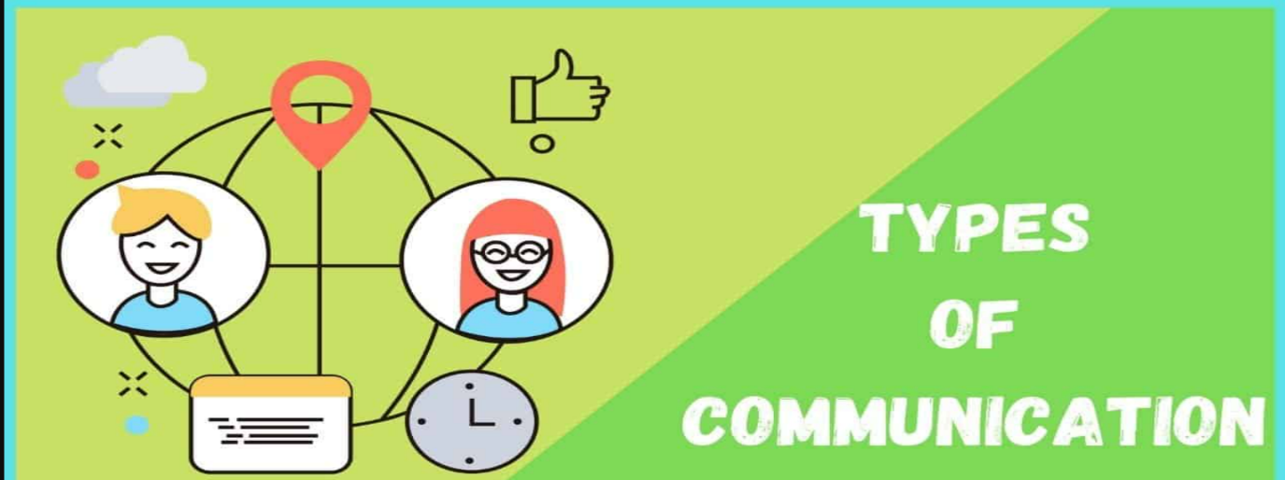
Verbal communication
Verbal communication is the exchange of information, ideas, and sentiments through spoken or written words. It can occur in a variety of contexts, including discussions, speeches, presentations, and interviews. Clear, succinct verbal communication that uses the right tone can help people form enduring bonds and productive partnerships.
Nonverbal communication
Nonverbal communication is the exchange of messages and emotions through body language, facial expressions, gestures, and tone of voice. It is a crucial part of interpersonal communication because it frequently reveals more about someone's emotions or attitudes than words alone. Communication can be enhanced and interpersonal connections can be strengthened by recognising and interpreting nonverbal clues.
Interpersonal Communication
Interpersonal communication is the exchange of information between two or more individuals, typically in person. Personal relationships, professional ties, and social encounters are just a few of the contexts in which interpersonal communication can take place. A solid awareness of social and cultural standards, as well as good listening and speaking abilities, are necessary for effective interpersonal communication.
Group Communication
Information is shared among three or more people in a group when they communicate. To accomplish a common objective, it entails sharing thoughts, opinions, and ideas. Active listening, clear communication, and respect for one another are necessary for effective group communication. It can occur in a variety of locations, including conferences, meetings, and social events.
Mass communication
Mass communication is the process of disseminating information to a sizable and diverse audience via a variety of media, including the internet, radio, television, and newspapers. Its objective is to reach a wide spectrum of individuals, regardless of their location or background, with news, ideas, and opinions.
Intrapersonal communication
The act of speaking to oneself is known as intrapersonal communication. It includes the internal dialogue or self-talk that we have when we digest information, consider our past, and come to conclusions. Intrapersonal communication can support our ability to control our emotions, organise our ideas, and inspire ourselves. It can be expressed through writing, imagining, or speaking aloud or in silence.
Formal communication
The sharing of information through defined channels and protocols inside of a company or institution is referred to as formal communication. It frequently adheres to a predetermined hierarchy and is directed by laws, regulations, and standards. Meetings, official documents, reports, and emails are just a few examples of formal communication in action. It is crucial for communicating crucial information, making choices, and upholding organisational structure.
Informal communication
The exchange of information outside of official channels or established conventions is referred to as informal communication. It frequently occurs in informal situations and involves subjective thoughts, emotions, and experiences. Informal contact can foster collaboration, a sense of community, and the development of new ideas.

The Shannon and Weaver model
The Shannon-Weaver model, created by Claude Shannon and Warren Weaver in 1949 for their book "The Mathematical Theory of Communication," is a well-known mathematical representation of communication. The Transmission Model of Communication or Information Model of Communication are other names for the model.

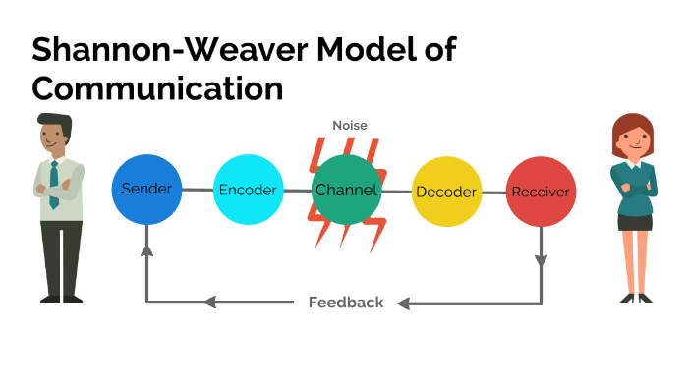
Source - https://prezi.com/p/2li3wpimt_bn/communication-model/

According to Shannon and Weaver model communication includes five key elements:
Sender
The sender, who encodes the information into a format that can be conveyed to the recipient, is the source of the message according to the Shannon and Weaver model of communication. It is the sender's duty to make sure the message is understandable, brief, and suitable for the target audience. The success of the total communication process can be impacted by the sender's efficacy.
Message
The information or material being sent from the sender to the receiver is known as the message. It can be expressed using words, symbols, or any other type of representation. The message must be organised such that it conveys the desired meaning and is simple enough for the recipient to understand. Language, culture, and environment are just a few examples of the many variables that might affect the message.
Channel
The medium used to carry a message from the sender to the recipient is referred to as the channel. It could be a physical or digital media, like the internet, wire, or the air. The quality and efficiency of the communication process might be affected by the channel choice.
Receiver
The person who receives the message and decodes it to determine its meaning is called the receiver. The receiver's responsibility is to actively listen, decipher, and respond to the sender. Context, culture, and experience are just a few examples of the variables that may affect how the message is understood by the recipient.
Noise
Any obstruction or interference that degrades the message's precision and clarity is referred to as noise. It may take the form of something physical, semantic, or psychological. The communication process can be distorted or disrupted by noise, making it challenging for the receiver to correctly decipher the intended information.

Definition of Integrated marketing communication
The goal of integrated marketing communication (IMC), a strategic marketing approach, is to bring a consistent and persuasive message to the target audience by coordinating and integrating different promotional instruments and communication channels. IMC aims to make sure that all components of a company's marketing mix, such as direct marketing, personal selling, sales promotion, public relations, and public relations, collaborate in a coordinated and efficient manner.
According to the IMC strategy, customers are exposed to a variety of messages from many sources, thus it's critical to develop a consistent message that connects with the target audience across all channels of communication. Companies may develop a stronger and more persuading message that engages consumers and motivates them to act by integrating all promotional activities.
By developing a coherent and consistent message, IMC aids businesses in maximising the impact of their marketing initiatives. This in turn promotes brand recognition, brand image enhancement, and brand loyalty.

New Promotional Strategies for Samsung
Innovative promotional techniques are novel and imaginative methods that companies employ to market their goods or services to prospective clients. These tactics could include utilizing social media, content marketing, new technologies, or any other approach that differs from conventional marketing practices.

The primary goals of new promotional tactics are to draw in more customers, raise brand recognition, and eventually boost revenue. Businesses may stand out from their rivals, reach a larger audience, and stay relevant in today's fast-paced and fiercely competitive market by putting new and successful promotional methods into action.

Online Promotional Strategies
Chatbots - On websites and other online platforms, chatbots a type of artificial intelligence can be used to offer customer assistance and support. Chatbots might be used by Samsung to respond to frequently asked queries, make product suggestions, and assist customers with their purchases. Chatbots can aid in boosting customer satisfaction and loyalty by offering speedy and effective customer care.
Personalization - Personalization is the process of adjusting each customer's buying experience using data and artificial intelligence. Based on a customer's prior purchases, search history, and interests, it entails creating customized product recommendations, descriptions, and promotions. By offering a distinctive purchasing experience that caters to each client's specific wants and interests, personalization can help Samsung boost customer happiness and loyalty. By differentiating themselves from their rivals and utilizing personalization as a marketing tactic, Samsung may boost sales and revenue by luring visitors back to their website for a tailored purchasing experience.
Gamification - Gamification is the process of integrating elements of game into the shopping experience to make it more enjoyable and interesting. To encourage customers to make purchases or interact with the business, reward systems, badges, or levels are created. Gamification may boost engagement for Samsung by delivering a more engaging and entertaining purchasing experience. Samsung can entice clients to visit their website again and make further sales by introducing game components into their online marketing campaign. Gamification can also assist Samsung in differentiating itself from its rivals and standing out in the congested online market.

Offline Promotional Strategies
Point of Purchase - Point of Purchase (POP) displays are a potent offline marketing tactic used by Samsung to boost revenue and brand recognition. These displays are advertising items like banners or posters that are positioned near where customers check out. Samsung may design eye-catching screens to emphasize their products' benefits or interactive displays that let users test out the newest smartphone or smart home gadget functions. Samsung can stand out in a congested retail environment, grab customers' attention, and ultimately increase sales by designing interesting and educational displays. POP displays can also aid in increasing brand recognition and setting Samsung apart from the competition.
Sponsorship and event marketing - In order to boost brand awareness and reach a larger audience, Samsung uses sponsorship and event marketing, whereby the company funds or conducts events. To create interest around the launching of new products, Samsung could sponsor sporting or musical events or hold their own events, including product launch parties. This approach can assist Samsung in increasing brand recognition, setting itself apart from rivals, and reaching a larger audience. Samsung may foster favorable associations with their brand and raise interest in their products by partnering with well-known events.
Product sampling - Giving away free samples of a product to prospective buyers is known as product sampling. This increases the possibility that customers will buy the product again by enabling them to test it out before committing to a purchase. Sampling is a good approach to introduce new items or create awareness about current ones. It can be done in-store, by direct mail, or at events.

Branding and Brand Equity

Branding
The process of building a distinctive and memorable identity for a business, good, or service through the use of a name, logo, design, messaging, and general customer experience is known as branding. A firm that has effectively developed a strong brand identity throughout the years is Samsung.
The mission, core principles, and products of Samsung serve as the foundation of its brand identity. The business stresses innovation, quality, and customer pleasure in a clear and consistent messaging strategy. The sleek, contemporary, and instantly identifiable Samsung logo has come to represent the company.
Samsung also makes significant investments in marketing and advertising to promote its goods and raise brand recognition. The business engages clients using a variety of marketing platforms, including social media, television, and print.

Brand Equity
The value that a brand brings to a product or service above and beyond its practical advantages is referred to as brand equity. It is the opinion that consumers hold about a brand based on their interactions, assumptions, and relationships with it. Brand awareness, perceived quality, brand loyalty, and brand associations are just a few ways to gauge brand equity.
Because it can impact a company's overall success and profitability, brand equity is a crucial marketing term. High brand equity enables a company to charge more, build customer loyalty, and expand market share.

Pre – Purchase
Pre-purchase is a crucial stage in the decision-making process for customers, during which they determine their needs and look for information to weigh their options. Through its marketing and promotional initiatives, Samsung, leading electronics brand globally, has a significant presence in this industry.
Companies can affect the pre-purchase stage by educating consumers about their goods and services through advertising, sales promotions, public relations, and personal selling, claim Kotler and Armstrong (2021). To inform potential clients, Samsung employs a mix of these techniques. For instance, to assist customers in making knowledgeable buying selections, Samsung's website offers thorough product specs, reviews, and comparisons. To promote its products and establish its brand, Samsung also performs targeted advertising campaigns on social media, television, and print media.
Additionally, Samsung leverages personal selling through its salespeople in physical stores to give clients individualised information and direction prior to making a purchase. The relationship between the consumer and the sales agent, particularly when purchasing expensive goods like smartphones or televisions, can significantly affect the customer's choice to make a purchase, claim Lee and Kim (2019).
In general, Samsung's marketing and advertising initiatives significantly impact the pre-purchase stage of the consumer decision-making process by giving consumers the knowledge and direction they need to make wise purchases.

During the purchase
Samsung's marketing and advertising initiatives are very important in both the pre-buy and the actual purchase phases of the consumer decision-making process. Samsung delivers information to prospective clients during the pre-purchase phase via its website, targeted advertising efforts, and sales personnel in physical shops. Samsung assists customers in making knowledgeable buying decisions by offering thorough product specs, reviews, and comparisons. Targeted marketing initiatives on print, television, and social media increase brand recognition and product awareness for Samsung. Retail salespeople offer individualised advice and information to customers prior to making a purchase.
When a customer is ready to buy, Samsung makes it simple for them to do so through its website. To encourage sales, Samsung also offers financing options, deals, and free shipping. Samsung also guarantees product accessibility by collaborating with several shops throughout the world. Customer assistance and after-sales services raise client happiness and promote reordering. Campaigns for emotional marketing that highlight innovation, lifestyle, and the beneficial effects that technology may have on people's lives aid in forging emotional ties with customers and promoting purchases.
The goal of Samsung's different marketing strategies and initiatives is to impact consumer decision-making at both the pre-buy and purchase stages, facilitating informed customer decision-making and raising customer satisfaction.

Post - Purchase
After purchasing a product, consumers' post-purchase behaviour describes their attitudes and deeds. Consumers may suffer cognitive dissonance, which is a sensation of discomfort or uncertainty that develops after making a purchasing decision, in accordance with Kotler and Armstrong (2021).
For instance, if a customer buys a Samsung smartphone and then reads unfavourable reviews about its functionality or features, they can feel cognitive dissonance. This might prompt people to ask for comfort from others or take actions that allay their concerns, such looking for more details about the goods or returning it for a refund.
In a study conducted in 2001, Lee, Lee, and Feick discovered that a number of variables, such as expectations, perceived value, and general product satisfaction, have an impact on post-purchase behaviour. Customers who are happy with their Samsung purchase could develop brand loyalty and refer the company to others.

Keller’s Brand Equity Model
A well-known paradigm for creating and managing brand equity is Keller's Brand Equity Model. Brand identity, brand meaning, brand reaction, and brand relationships are the four components of it. The first step in the approach is developing a distinctive brand identity that distinguishes the company from its rivals. The meaning of the brand is then developed through developing brand associations and a brand personality. The third step entails using marketing initiatives to elicit the intended consumer reactions to the brand. The last step is developing long-lasting relationships with customers that lead to advocacy and loyalty. In order to assess and strengthen brand equity, Keller's Brand Equity Model has been widely employed in academic research and marketing practise. (Keller, 2013).
Samsung, a multinational business, has been able to establish a significant brand equity over the years by following Keller's Brand Equity Model (Keller, 2013). Through innovative and cutting-edge goods such as smartphones, tablets, and smartwatches, Samsung has been able to develop a strong brand identity. The company has developed a distinct brand image that distinguishes it from its competitors.

By portraying itself as a technological leader and pioneer, Samsung has also been effective in generating brand meaning. The company's emphasis on research and development has enabled it to routinely introduce new and creative goods. This has aided Samsung in forging a strong link between the brand and innovation in the minds of consumers.
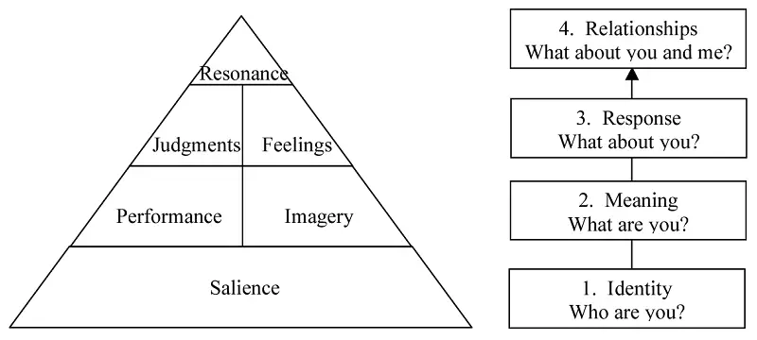
Source - https://www.batheories.com/wp-content/uploads/kellers-brand-equity-model.png

Advantages and Disadvantages of Keller’s brand equity model
Advantages of Keller’s brand equity model
- Customer-focused: The CBBE model places a strong emphasis on the needs of its clients, which is crucial in the current, client-driven industry. The strategy places emphasis on the value of forging close bonds with clients and delivering a satisfying customer experience. (Keller, 2013).
- Holistic strategy: The concept adopts a holistic strategy for establishing brands, taking into account both the practical and sentimental advantages of a brand. This enables marketers to develop a thorough brand strategy that caters to consumers' needs on various levels. (Keller, 2013).
- Flexibility: The concept is adaptable and can be used across a variety of sectors and brand types. Additionally, it can be modified to meet the requirements of various markets and clientele groups. (Keller, 2013).
- Measurable: The CBBE model offers a framework for determining how well brand-building initiatives perform. The model can be used by marketers to monitor changes in consumer attitudes and behaviour over time and to assess the effectiveness of brand initiatives. (Keller, 2013).
Disadvantages of Keller’s brand equity model
- Complex: The CBBE model is a challenging framework for marketers that are new to branding to comprehend and apply. It necessitates a thorough comprehension of consumer behaviour, market trends, and brand strategy. (Keller, 2013).
- Resource-intensive: The CBBE model must be implemented with a lot of employees, funds, and time. For smaller enterprises with fewer resources, it might not be feasible. (Keller, 2013).
- Limited applicability: The model might not work in every circumstance, particularly for well-known brands. Sometimes a straightforward strategy for branding will work better. (Keller, 2013).
- Lack of empirical evidence: Despite the CBBE model's widespread use by marketers, there isn't much data to back up its efficacy. Some detractors contend that the approach is founded on theoretical ideas that might not be applicable to actual results. (Keller, 2013).

Customer Journey
An important tool for comprehending the consumer experience with a brand is customer journey mapping. A customer journey map for Samsung would include all points of contact with customers, from pre-purchase research through post-purchase support.
Samsung's customer journey is characterised by a focus on innovation and design, with an emphasis on producing goods that are both useful and aesthetically beautiful, according to a report by Marketing Week (Marketing Week, 2021). According to the survey, Samsung frequently emphasises the distinctive qualities of its goods, such as the camera technology in its smartphones, and emphasises how these features can improve the lives of customers.
Customers frequently interact with Samsung through its website during the pre-purchase phase. The website offers comprehensive product details, user testimonials, and the option to contrast several versions. Samsung has a robust social media presence and uses sites like Facebook and Instagram to promote its products and interact with customers, which supports this (Marketing Week, 2021).
Samsung offers a variety of post-purchase support solutions after a customer makes a purchase. This covers a customer service phone number, an online help section, and on-site assistance at Samsung locations. Additionally, Samsung provides a variety of add-ons and accessories that can improve the user experience with its products.
A major focus on innovation, design, and customer service can be seen throughout Samsung's customer journey. Samsung is able to develop goods and services that satisfy the demands of its customers and deliver a positive experience at every touchpoint by understanding the customer journey.
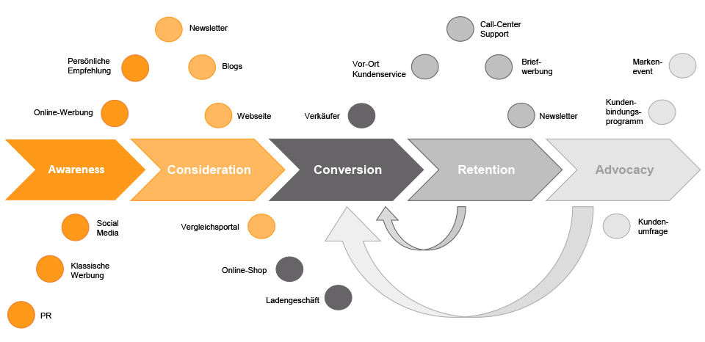

Strengths of Samsung
Samsung is a major player in the technology industry with a number of advantages that have helped it succeed. First off, Samsung has a broad range of electronic items in its product line, including smartphones, tablets, laptops, televisions, and home appliances. Samsung is renowned for emphasising innovation and spending a lot of money on R&D in order to release fresh, cutting-edge products. A competitive edge in the market is provided by the company's strong brand image, global presence in more than 80 countries, and excellent production capabilities, which allow it to produce high-quality products at cheaper costs. Overall, Samsung has developed a solid reputation in the technology sector thanks to its capabilities, which are expected to continue to be the main factors in its success going forward.

Weaknesses of Samsung
Although Samsung has many advantages, it also has a number of drawbacks that could hinder its success in the technology sector. The company has been criticised for lacking product uniqueness in the first place because of how similar its competitor's product line is to its own. This may make it challenging for Samsung to differentiate itself from the competition and keep its competitive edge. Furthermore, Samsung relies significantly on the Android operating system, which might leave it open to changes in consumer tastes or the Android ecosystem. The Galaxy Note 7 battery explosion incident, which harmed the company's reputation, was one of its previous brand image problems. Finally, the industry in which Samsung competes is quite fierce, making it difficult for the business to hold onto its market share and profitability. The areas where Samsung may need to concentrate its efforts to stay competitive and ensure its success in the future are highlighted by these vulnerabilities.

References
Lasswell, H. D. (1948). The structure and function of communication in society. The communication of ideas, 37-51.
Shannon, C. E., & Weaver, W. (1949). The mathematical theory of communication. University of Illinois Press.
McLuhan, M. (1964). Understanding media: The extensions of man. McGraw-Hill.
Shannon, C. E., & Weaver, W. (1948). The mathematical theory of communication. Urbana, IL: University of Illinois Press.
Belch, G. E., & Belch, M. A. (2021). Advertising and promotion: An integrated marketing communications perspective. New York: McGraw-Hill Education.

Duncan, T., & Moriarty, S. E. (2019). Driving brand value: Using integrated marketing to manage profitable stakeholder relationships. New York: McGraw-Hill Education.

Kitchen, P. J., & Burgmann, I. (2015). Integrated marketing communication. In International Encyclopedia of the Social & Behavioral Sciences (2nd ed., Vol. 12, pp. 183-188). Amsterdam: Elsevier.
Kotler, P., & Armstrong, G. (2021). Principles of Marketing (18th ed.). Pearson.

Lee, J. H., & Kim, Y. K. (2019). Effects of customer-to-salesperson interactions on purchase decisions for high and low price products. Journal of Retailing and Consumer Services, 48, 221-231. doi: 10.1016/j.jretconser.2019.02.018
Kotler, P., & Keller, K. L. (2016). Marketing management (15th ed.). Pearson.

Hennig-Thurau, T., Hofacker, C. F., & Bloching, B. (2015). Marketing the pinball way: Understanding how social media change the generation of value for consumers and companies. Journal of Interactive Marketing, 31, 2-4. doi: 10.1016/j.intmar.2015.05.001
Kotler, P., & Armstrong, G. (2021). Principles of marketing. Pearson.

Lee, M., Lee, H., & Feick, L. (2001). The impact of switching costs on the customer satisfaction-loyalty link: mobile phone service in France. Journal of services marketing, 15(1), 35-48.
Keller, K. L. (2013). Strategic brand management: Building, measuring, and managing brand equity. Pearson Education India.

Aaker, D. A. (1991). Managing brand equity: Capitalizing on the value of a brand name. The Free Press.

Keller, K. L. (1993). Conceptualizing, measuring, and managing customer-based brand equity. The Journal of Marketing, 1-22.
Samsung. (2022). Support. Retrieved from https://www.samsung.com/us/support/
Kim, J., Lee, H., & Lee, S. (2015). Understanding customer satisfaction and loyalty: An empirical study of mobile instant messages in Korea. International Journal of Mobile Communications, 13(6), 646-667.
Berthon, P., Pitt, L. F., & Watson, R. T. (1996). The world wide web as an advertising medium: toward an understanding of conversion efficiency. Journal of advertising research, 36(1), 43-54.
Marketing Week. (2021). Inside Samsung’s customer journey: Innovation, design and support. Retrieved from https://www.marketingweek.com/inside-samsungs-customer-journey-innovation-design-and-support/
Kim, H., & Ko, E. (2012). Do social media marketing activities enhance customer equity? An empirical study of luxury fashion brand. Journal of Business Research, 65(10), 1480-1486.

Samsung. (2021). About Us. Retrieved from https://www.samsung.com/us/aboutsamsung/
Lee, J. A., Lee, J., & Feick, L. (2001). The impact of switching costs on the customer satisfaction-loyalty link: Mobile phone service in France. Journal of Services Marketing, 15(1), 35-48.

Liao, C., Liu, Y., & Chen, K. (2018). Crisis communication and brand recovery: The case of Samsung's Galaxy Note 7 recall. Public Relations Review, 44(3), 390-398

Yoo, B., Donthu, N., & Lee, S. (2000). An examination of selected marketing mix elements and brand equity. Journal of the Academy of Marketing Science, 28(2), 195-211.

Ahn, J., Kim, S., & Park, S. (2020). Effects of consumer-based brand equity on smartphone brand loyalty: Focusing on Samsung Electronics. Sustainability, 12(7), 2754.

Park, C. W., Jaworski, B. J., & MacInnis, D. J. (1986). Strategic brand concept-image management. Journal of Marketing, 50(4), 135-145.

