ECIE6001
Moving away from the Traditional Classroom:
Outdoor Education and Learning

Student: Carly Garrett
Student Number: 2110635
Course: BA Inclusive Education

Contents

Element 1 - Essay: Page 3 - 8

Element 1 - References: Page 8 - 9

Element 2: Flyer -

References (Flyer) -

Element 3: Risk-Benefit Analysis -

Element 4: Literature Review -

References (Literature Review) -

Element 1 - Essay

Outdoor education is a powerful way to help children learn and grow. It gives them hands-on experiences that make learning fun and meaningful, while also improving their well-being. Spending time outside helps reduce stress, keeps children active, and builds important life skills like teamwork and problem-solving (Knight, 2013, p.45). Educational theorists like Piaget (1952) and Vygotsky (1978) highlight the importance of hands-on learning, particularly in social settings where children can interact and explore. Kolb’s experiential learning theory (1984) also supports this, emphasising that learning is most effective when it involves active participation and real-world experiences. Additionally, the UN Convention on the Rights of the Child (Article 31) recognises the right of children to engage in play and recreational activities, including outdoor learning, as part of their development. The Forest School approach and the National Curriculum (DfE, 2013) also promote outdoor learning to boost confidence and independence. Outdoor education plays a key role in helping children become happy, capable, and well-rounded individuals.

This discussion looks at how outdoor learning plays a key role in early years Progression step 1 (PS1) and how it changes as children move into a more structured learning environment in progression step (PS2). It compares the benefits and challenges at each stage, exploring how different educational theories and real-life examples show the impact of outdoor learning on children's overall growth and long-term development.

Children in PS1, aged 3 to 5, are at the start of their educational journey, and outdoor learning plays a crucial role in their development. The setting follows a free-flow approach, allowing children to move freely between indoor and outdoor spaces throughout the day, regardless of the weather. To support this, they are provided with waterproof jackets, trousers, and wellies, enabling them to take full advantage of outdoor learning opportunities. The outdoor environment is carefully designed to support continuous provision, offering a wide range of open-ended resources such as a sandpit, water play areas, construction materials, loose parts, a mud kitchen, and bikes and scooters. These resources remain accessible throughout the day, allowing children to revisit activities, deepen their learning, and develop essential skills at their own pace. In PS1 the "Planning in the Moment" approach is used to support child-led learning, allowing educators to respond to children's interests and extend their learning in real time as opportunities arise (Ephgrave, 2017). During outdoor play, practitioners observe children’s interactions, identify learning opportunities, and extend their experiences through meaningful conversations and hands-on activities. For example, if a group of children discovers a worm while digging in the mud, an educator might initiate a discussion about its habitat, introduce new vocabulary like "burrow" and "earthworm," and ask open-ended questions to spark curiosity. Additional resources, such as magnifying glasses or books about minibeasts, can be introduced to support further exploration. This responsive and engaging approach aligns with Vygotsky’s (1978) Sociocultural Theory, particularly his concept of the Zone of Proximal Development, which suggests that children learn best when guided by adults or more knowledgeable peers. By embracing children's natural curiosity and interests, Planning in the Moment makes learning more meaningful, promotes independence, and nurtures a love for exploration and discovery in the outdoor environment (Ephgrave, 2017).

Children in PS2, aged 5 to 8, unfortunately do not spend as much time engaging in outdoor learning as those in PS1 due to the increasing focus on more structured, curriculum-based learning. As children progress, there is a greater emphasis on developing literacy, numeracy, and other academic skills, which often take place indoors. Additionally, the play-based approach that dominates PS1 gradually shifts towards more formal teaching methods in PS2. While outdoor learning is still valued, it tends to be more structured and linked to specific lessons rather than the free-flow exploration seen in PS1. Although children in PS2 do not have as much freedom to explore the outdoors as those in PS1, they still enjoy weekly outdoor learning sessions, held one afternoon each week. These sessions give them the chance to get hands-on with nature through activities like planting and weeding, creating wildlife habitats, looking after the outdoor learning area, building dens, and bird spotting. The children look forward to these sessions as they offer a break from classroom-based learning and allow them to develop practical skills in a fun, natural environment. However, because the school is based in a city, there is limited access to green spaces, which reduces opportunities for outdoor learning beyond the school grounds. Despite this, the sessions make the most of the available space, encouraging children to connect with nature and enjoy outdoor learning in a meaningful way.

Outdoor learning in PS1 provides a wide range of benefits, supporting children's physical, social, emotional, and cognitive development (Early Education, 2024). Engaging in activities like climbing, running, and exploring natural environments enhances motor skills and coordination, aligning with Piaget’s (1952) theory of cognitive development, which emphasises hands-on experiences as crucial for learning. Froebel’s (1887) philosophy of education, which promotes learning through play and exploration, is evident in outdoor environments where children can follow their interests and engage with nature. Additionally, outdoor learning contributes to emotional well-being, reducing stress and anxiety by providing a sense of freedom and connection with the natural world (The Muddy Puddle Teacher, 2024). This aligns with Maslow’s (1943) Hierarchy of Needs, as time spent outdoors can help fulfil children’s basic physiological and emotional needs, creating a foundation for higher-level learning and self-actualisation. By offering a stimulating and open-ended learning environment, outdoor education promotes curiosity, independence, and holistic development in young learners.

However, there are also some challenges of learning outdoors. Some children may find outdoor spaces overwhelming or struggle with risk-taking. Weather, safety concerns, and limited green spaces can also restrict opportunities for outdoor learning, especially in urban areas. Additionally, while outdoor play encourages independence, some children may need extra support to engage and focus. Despite these challenges, with careful planning and flexibility, outdoor education can be a powerful way to help children develop essential life skills and nurture a love for learning through play.

Outdoor learning in PS2 provides valuable hands-on experiences that make lessons more engaging and meaningful. It allows children to apply classroom knowledge to real-world contexts, such as measuring natural objects in maths, writing creatively about nature in literacy, or observing seasonal changes in science. This reflects Piaget’s (1952) theory of constructivism, which highlights the importance of active, experiential learning in children's cognitive development. Outdoor activities also play a key role in social and emotional development, as children collaborate on tasks like building dens, gardening, and problem-solving. Vygotsky’s (1978) Sociocultural theory supports this, emphasising how learning is enhanced through social interaction and guidance from peers and adults. Additionally, Froebel’s (1887) educational philosophy underlines the importance of nature in children’s learning, viewing outdoor play as essential for creativity, exploration, and holistic development. Spending time outdoors is also beneficial for physical health and emotional well-being. Active play helps improve coordination and fitness, while exposure to nature has been shown to reduce stress and boost overall mood. Furthermore, outdoor learning encourages safe risk-taking such as climbing, balancing on logs, or using real tools. This can build confidence, resilience, and independence, aligning with Froebel’s belief in allowing children to develop at their own pace through meaningful, self-directed experiences.

However, there are some challenges. Unlike PS1, where children can move freely between indoor and outdoor spaces, PS2 learners have a more structured day, meaning less time outside. With a big focus on subjects like maths and literacy, teachers may find it hard to fit outdoor learning into the busy school timetable. Schools in cities may also struggle with limited green spaces, making it harder to offer nature-based activities. Not all children enjoy outdoor learning either because some may find the weather uncomfortable, while others prefer the routine of the classroom. To make outdoor learning work for everyone, schools need to find a balance, making sure all children get the chance to enjoy and benefit from learning outside.

In conclusion, outdoor learning plays a vital role in children's development, offering opportunities for hands-on experiences that enhance their learning, well-being, and social skills. In PS1, a free-flow approach allows children to explore and engage with their environment, promoting independence, confidence, and collaboration, aligning with the theories of Froebel, Piaget, and Vygotsky. As children progress to PS2, outdoor learning becomes more structured, integrating with subjects such as mathematics and science to provide meaningful, real-world learning experiences. However, challenges such as time constraints, limited access to green spaces, and curriculum demands can restrict opportunities for outdoor learning. Even though there are some challenges, outdoor learning has so many benefits such as helping children stay active, feel happier, and build important life skills. That is why it is important to make outdoor education part of everyday school life. Schools should try to balance classroom lessons with time outside, so every child gets the chance to enjoy and learn from nature.

Element 1 – Essay References

Department for Education (2013) National Curriculum in England: Framework for Key Stages 1 to 4. Available at: https://www.gov.uk/government/publications/national-curriculum-in-england-framework-for-key-stages-1-to-4 (Accessed: 26 March 2025)

Early Education (2024) Outdoor Learning in the Early Years. Available at: https://early-education.org.uk/outdoor-learning-in-the-early-years/ (Accessed: 2 April 2025)

Ephgrave, A. (2017) Nursery: A Year in Action – Following Children's Interests Through the Year. Abingdon: Routledge.

Froebel Trust (2018) Froebel's Principles and Practice Today. Available at: https://www.froebel.org.uk/uploads/documents/FT-Froebels-principles-and-practice-today.pdf (Accessed: 1 April 2025)

Knight, S. (2013) Forest School and Outdoor Learning in the Early Years. London: SAGE Publications.

Kolb, D. A. (1984) Experiential Learning: Experience as the Source of Learning and Development. Englewood Cliffs, NJ: Prentice Hall.

Maslow, A.H. (1943) A theory of human motivation, Psychological Review, 50(4), pp. 370-396.

Piaget, J. (1952) The Origins of Intelligence in Children. New York: Norton.

The Muddy Puddle Teacher (2024) The Benefits of Outdoor Learning. Available at: https://themuddypuddleteacher.co.uk/the-benefits-of-outdoor-learning/ (Accessed: 31 March 2025)

United Nations (1989) Convention on the Rights of the Child. Available at: https://www.unicef.org/child-rights-convention (Accessed: 26 March 2025)

Vygotsky, L. S. (1978) Mind in Society: The Development of Higher Psychological Processes. Cambridge, MA: Harvard University Press.

Element 2 – Flyer
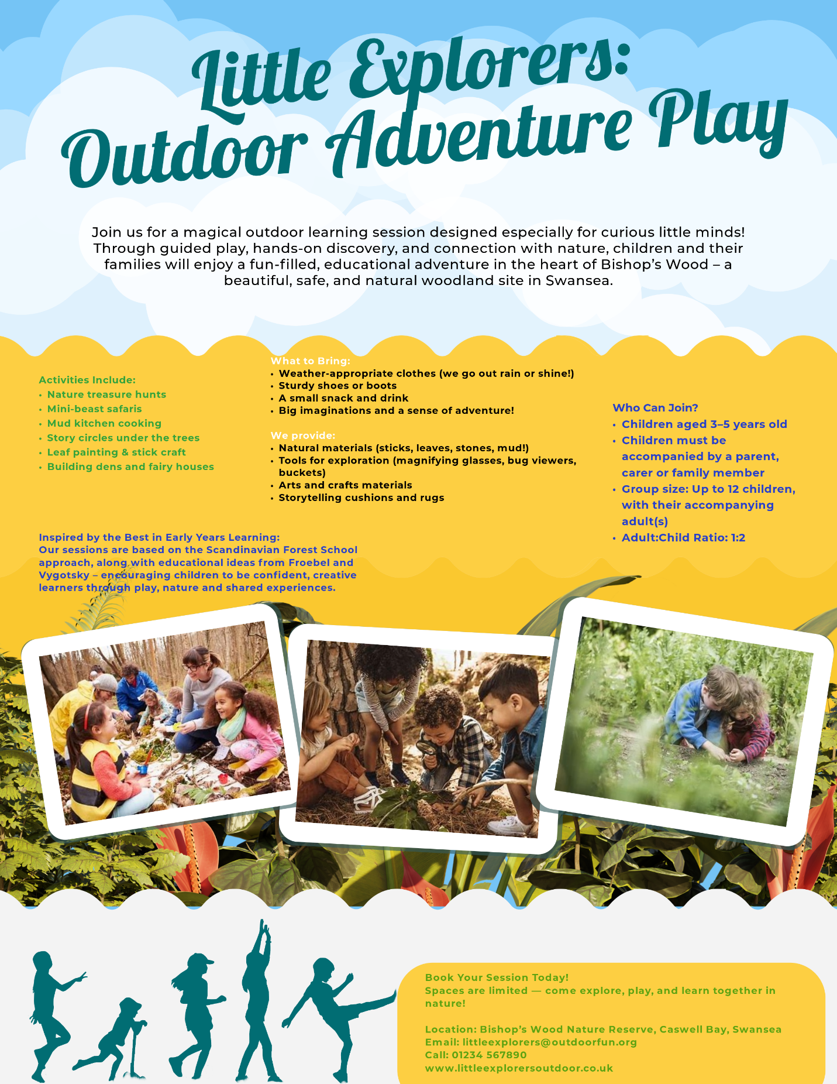
Element 2 – Flyer References

Froebel Trust (n.d) Outdoor Play and Exploration. Available at: https://www.froebel.org.uk/uploads/documents/FT-Outdoor-Play-Pamphlet.pdf (Accessed: 10 April 2025)

Nest in the Woods (2013) Piaget, Vygotsky and Forest Schools. Available at: https://nestinthewoods.co.uk/piaget-vygotsky-forest-school/ (Accessed: 10 April 2025)

Element 3 – Risk Benefit Assessment

RISK BENEFIT ASSESSMENT

Location / Activity: | Brynmelyn Park | Date: | 22/03/2025
Assessor: | Carly Garrett | Review date:

The boxes in the table below will expand as you type into them; pre-entered text is simply for illustration. You should delete irrelevant items and replace with text relevant to your circumstances.
Your overall risk rating – Low, medium or high – is based on your judgement about whether the BENEFITS of the activity or opportunity outweigh the RISKS.

ACTIVITY | How will young people BENEFIT from this activity? | Possible hazards | Who is at risk? | PRECAUTIONS in place to reduce the risk of injury | Overall risk RATING: L/M/H
Local Park  (Playing in the playground) | - Improve strength, balance, coordination, and motor skills.  - Encourage sharing, teamwork, and communication with peers.  - Encourage problem-solving, creativity, and risk assessment.  - Boosts confidence, independence, and reduces stress.  - Connection with nature. | - Trips and falls.  - Collisions.  - Weather conditions.  - Faulty equipment.  - Insect bites and stings.  - Allergies.  - Lost children. | - Pupils.  - Staff.  - Volunteers. | - Remind children about the safe use of equipment and ensure appropriate footwear is worn.  - Supervision.  - Encourage and remind about spatial awareness.  - Apply sunscreen and ensure sun hats are worn for sun protection.  - Check all equipment for broken or loose parts before allowing the children to enter the playground.  - Bring any necessary medication, including EpiPens, a first aid kit and health care plans.  - Remind children about staying with the group and never wandering off or talking to strangers. | Low
Local Park  (Bug Hunt) | - Develop patience and observation skills.  - Spark curiosity about science.  - Teach valuable life skills like problem-solving and caring for small creatures.  - Strong connection with nature. | - Insect bites or stings.  - Allergies.  - Trips and falls.  - Weather conditions.  - Lost children. | - Pupils.  - Staff.  - Volunteers. | - Teach children to look at insects without touching unfamiliar ones.  - Bring any necessary medication, including EpiPens, a first aid kit and health care plans.  - Remind children to walk carefully on uneven surfaces and avoid running.  - Make sure children wear appropriate clothing and footwear.  - Apply sunscreen and ensure sun hats are worn for sun protection.  - Follow staff-to-child ratios and do regular headcounts.  - Remind children about staying with the group and never wandering off or talking to strangers.  - Make sure children wash their hands thoroughly after the activity. | Low

Element 4 – Literature Review

Outdoor learning refers to a diverse range of educational experiences that occur beyond the traditional classroom setting (The Outdoor Teacher, 2025). Friedrich Froebel, the founder of the kindergarten idea, believed that spending time in nature was important for children’s development. He famously said that "play is the highest expression of human development in childhood" (Froebel Trust, 2024), which reflects his strong belief in the importance of nature and play in children's learning. Organisations like Learning Through Landscapes support this idea by helping schools create outdoor spaces for learning. They see outdoor education as a way to help children grow emotionally, socially, and physically. Another well-known approach is Forest School, which began in Scandinavia and is now popular in the UK. It encourages children to learn regularly in nature, take risks, and develop in a well-rounded way (School Uni, 2025). The Welsh Government also supports outdoor education through its new Curriculum for Wales (2022), which encourages hands-on learning that connects children with their environment. All these ideas show how important outdoor learning can be for children's development.

Spending time outdoors is known to improve both physical and mental health. Many studies show that being in nature helps reduce stress, boost mood, and improve overall well-being (Mind, 2021). Children who are regularly exposed to outdoor spaces tend to be calmer and more focused. A study by Natural England (2016) found that children who learn outside enjoy school more and feel more motivated. It also helps them become more emotionally resilient. The Institute for Outdoor Learning (2021) agrees, saying that outdoor activities help children build friendships, stay active, and feel better about themselves. However, some researchers point out that we need more long-term studies to be certain of these benefits. Rickinson et al. (2004), explain that while many results are positive, we still don’t fully understand the long-term impact. Also, not all children have equal access to green spaces, which can create unfair advantages. Still, most experts agree that outdoor education has a strong positive effect on children's overall well-being.

Outdoor learning encourages children to connect with nature, which helps them care about it more. As Children and Nature (n.d.) explains, when children spend time in nature, they form a stronger bond with it and are more likely to protect it. This ties into the Education for Sustainable Development Goals (ESDG), which aims to teach children how to create a better, more sustainable world.

Sustainability is a core part of the new Curriculum for Wales (2022), and it is something that all learners are expected to explore and understand throughout their education and schools are encouraged to use outdoor education to support this. Learning Through Landscapes (2023) describes how learning outdoors can help children understand environmental issues more deeply. However, not everyone agrees that simply being outdoors automatically leads to more sustainable behaviour. Beames et al. (2013) point out that without proper guidance and reflection, children might not fully grasp the bigger environmental issues. This means outdoor learning works best when it’s thoughtfully planned and includes discussions that help children connect what they’re experiencing to real-world challenges.

Outdoor education is great for developing important life skills. These include social skills like working together, thinking skills like solving problems, and practical skills like using tools or reading maps. Dillon et al. (2006) suggest that learning outdoors gives children real situations where they can practice these skills. Activities like group games, exploring nature, or building things give children a chance to take the lead and build confidence. Bandura’s (1977) Social Learning Theory supports this. It shows that children learn a lot by watching others and trying things out for themselves, which often happens in outdoor settings. This is especially helpful for children who do not do as well with traditional classroom learning. However, some challenges remain. Harris (2017) points out that if outdoor activities are not run well, they can leave some children out or make others feel less included. Also, teachers need appropriate training to help children get the most out of these experiences. Nonetheless, outdoor education offers children valuable opportunities to develop practical and social skills in an enjoyable and meaningful context.

The research clearly shows that outdoor education plays a vital role in supporting children’s learning, development, and overall well-being. From Froebel’s early beliefs about the importance of play and nature, to the more structured approaches seen in Forest Schools and the Curriculum for Wales, outdoor learning continues to prove itself as a powerful educational method. One of the most consistent findings in the research is the positive impact outdoor learning has on children’s physical and mental health. Time spent in natural spaces can reduce stress, improve mood, and increase motivation and resilience. Children who regularly engage with the outdoors tend to enjoy school more and are often more focused and cooperative. While there is a need for further long-term research to fully understand these benefits, the existing research strongly supports the idea that nature-based learning contributes significantly to children’s emotional and physical well-being. In addition to health benefits, outdoor education can help develop a deeper connection with nature, which is increasingly important in today’s world. As the climate crisis and other environmental challenges continue to grow, helping children develop a sense of responsibility and care for the planet has never been more important. Outdoor learning provides the ideal setting for this. When children spend time outside, they are more likely to appreciate and want to protect the environment. However, this connection does not happen automatically. Studies show that the most meaningful outcomes occur when outdoor activities are guided and include opportunities for reflection. This aligns with the goals of Education for Sustainable Development (ESD) and the Curriculum for Wales, which both encourage learners to become informed, active citizens who contribute to a more sustainable future. Another key role of outdoor education is in developing children’s life skills. Outdoor settings provide unique opportunities for children to work together, solve real-world problems, take calculated risks, and become more independent. These are not just useful in school, but also in life beyond the classroom. The hands-on nature of outdoor learning allows children to lead their own learning and build confidence in their abilities. The support from theories like Bandura’s Social Learning Theory further shows that children learn effectively by observing and doing this is something that outdoor education naturally promotes. That said, ensuring inclusive practice and proper teacher training is essential to make sure all children benefit from these opportunities. Taken together, these themes show that outdoor education is much more than just an enjoyable break from the classroom. It supports the whole child, physically, emotionally, socially, and cognitively. It can also help children form a relationship with the natural world, learn valuable life skills, and develop a love for learning that often cannot be achieved through traditional classroom teaching alone. Ultimately, the role of outdoor education is to create meaningful, inclusive, and engaging learning experiences that prepare children for a healthy, responsible, and connected life. When done well, it is not an ‘extra’ part of education—it is an essential one.

Element 4 – Literature Review References

Beames, S., Higgins, P. and Nicol, R. (2013) Learning outside the classroom: theory and guidelines for practice. Journal of Adventure Education and Outdoor Learning, 13 (2), pp.175–176. Available at: https://doi.org/10.1080/14729679.2013.800771 (Accessed: 8 April 2025)

Children and Nature (n.d) The benefits of nature. Available at: https://www.childrenandnature.org/the-benefits-of-nature/ (Accessed: 6 April 2025)

Dillon, J., Morris, M., O’Donnell, L., Reid, A., Rickinson, M. and Scott, W. (2006) Engaging and learning with the outdoors: The final report of the outdoor classroom in a rural context action research project. Available at: https://www.nfer.ac.uk/media/qbxf322y/ocr01.pdf (Accessed: 9 April 2025)

Froebel Trust (2024) The Power of Play. Available at: https://www.froebel.org.uk/about-us/the-power-of-play (Accessed: 6 April 2025)

Harris, F. (2017). Outdoor learning spaces: The case of Forest School. Available at: https://www.researchgate.net/publication/318184346_Outdoor_learning_spaces_The_case_of_forest_school (Accessed: 9 April 2025)

Mind (2021) Nature and Mental Health. Available at: https://www.mind.org.uk/information-support/tips-for-everyday-living/nature-and-mental-health/how-nature-benefits-mental-health/ (Accessed: 6 April 2025)

Learning Through Landscapes (2023) How outdoor learning can help you fulfil the four purposes of the new Curriculum for Wales. Available at: https://ltl.org.uk/news/how-outdoor-learning-can-help-you-fulfil-the-four-purposes-of-the-new-curriculum-for-wales/ (Accessed: 8 April 2025)

Natural England (2016). A review of nature-based interventions for mental health care. Natural England Commissioned Reports, Number 204. Available at: https://publications.naturalengland.org.uk/publication/4513819616346112 (Accessed: 6 April 2025)

Rickinson, M. et al. (2006). The value of outdoor learning: Evidence from research in the UK and elsewhere. Available at: https://www.researchgate.net/publication/287621860_The_value_of_outdoor_learning_Evidence_from_research_in_the_UK_and_elsewhere (Accessed: 6 April 2025)

School Uni (2025) What is Forest Schools? Available at: https://www.schooluniguide.com/blog/what-is-forest-schools/ (Accessed: 6 April 2025)

The Institute for Outdoor Learning (2021) About Outdoor Learning. Available at: https://www.outdoor-learning.org/standards/about-outdoor-learning.html (Accessed: 6 April 2025)

The Outdoor Teacher (2025) What is Outdoor Learning? Available at: https://theoutdoorteacher.com/blog/what-is-outdoor-learning/ (Accessed: 6 April 2025)

Welsh Government (2022) Curriculum for Wales: Annual Report 2022. Available at: https://www.gov.wales/sites/default/files/pdf-versions/2023/6/4/1687448152/curriculum-wales-annual-report-2022.pdf (Accessed: 6 April 2025)

