

Title of Report: Brexit – The impact on Talent and Knowledge Management
Name/Number of author: Nishat Choudhury/1704979
Name of Host Organisation: University of Wales Trinity Saint David
Date of Report Publication: 12th July 2019

Executive Summary
Knowledge management within an organisation helps to roll out information and data to transform it into mutual understanding that can be commonly communicated throughout the organisations and its profession. Appropriate use of knowledge has been essential for the survival and achievement of the organisation in the current competitive market to be able to have the ability to solve problems, make faster decisions, increase organisational efficiency and be innovative. The main finding of this report was to establish the impact of knowledge management on two organisations. Knowledge management in Marks and Spencer’s have recently been rolled out over the organisations 600 IT systems where documents are stored in and indexed by SharePoint. They believe this has reduced inbox clutter and has increased communications between different hierarchies. Although this has had a positive outlook on the organisation, employees are reluctant to this change and have to be constantly motivated to share knowledge and expertise.
This report analyses various knowledge management theories, KM value chain and how their context fits in with those of the organisations. Even though the information sharing portal has had a positive outlook on M&S there were some gaps identified within the knowledge management system. As such it is recommended that M&S establish a knowledge marketplace where knowledge can be stored and obtained if employees were to leave. This can be done in terms of research papers and project experience report.

Contents Page
1.0 Terms of Reference 1
2.0 Procedure 2
3.0 Findings 3-11
3.1 Introduction to organisation 3-5
3.1.1 Marks and Spencer 3-4
3.1.2 Lloyds Banking Group 4-5
3.2 Critical evaluation of KM system 6-11
3.2.1 Value Chain .........6-9
3.2.2 Critical Evaluation....................................................................................................9-10
3.2.3 Gaps within the KM system........................................................................................11
4.0 Conclusion 12
5.0 Recommendations............................................................................................................13

1.0 Terms of Reference
The report was requested to be produced on Brexit and how it will be impacting talent and knowledge management within an organisation. The report was produced on the week commencing 19th June 2019. The aim of the report is to research how organisations use knowledge management to collect, store, analyse and develop their strategies to ensure competitive advantage. The report has been accumulated by Nishat Choudhury and will be outlining the knowledge management system of an organisation and how they use it to ensure knowledge is continuously transferred inside the organisation for survival within the market. The date of submission is 12th July 2019.

2.0 Procedure
2.1 Books, websites, internet publications such as journals and reports have been used to prepare the report.

3.0 Findings
Task 1
3.1 Introduction to Organsations
3.1.1 Marks and Spencer
Marks and Spencer were formed in 1884 when Michael Mark a Polish exile opened a market stall in Leeds, with the motto 'don't ask the value, it's a penny'. In 1894 Marks began his partnership with Spencer from where Marks and Spencer started. (M&S, nd).
M&S created its reputation for being a retailer of 'British quality products'. During the 1970s despite everything it sourced the greater part of its items from the UK - not at all like now when they are generally made internationally. (Getty, 2008).
M&S is a main retailer with a solid and interesting legacy of brand esteems, uncommon partners and clients who need to see it succeed once more. (M&S, nd).
Marks & Spencer offers high first-rate fashion, award-winning food and fashionable homeware. Based more than a century in the past and with 1463 shops across 57 nations, M&S are one of the UK’s leading retailers. M&S understand the importance of concept, being in contact, Integrity & Innovation and live via those values in what they do. Through consistent innovation, M&S make their merchandise and tailor the buying experience to pride the customers round the world. (Marks and Spencer, nd).
M&S hire round 85,000 people globally, over ninety percent of which are based in the UK. M&S believes the people convey the organisational values to lifestyles. Their expertise, commitment to the clients and pride in M&S are key to the organisations lengthy-term increase. (M&S, nd).
M&S head offices are based in Stockley Park, Nottingham and Manchester. M&S in store career opportunities begin from Customer Advisor to Hospitality, Visible Merchandising and Management. There are opportunities to work in the distribution centre with a range of jobs available including Engineering, Operations Management, Flow Room, Operatives and Distribution support. As well as opportunities available internationally based in the organisations London head office, M&S additionally recruits in fifty-one other territories. (M&S Careers , nd).
The qualifications needed for these jobs depend on the type of job applied.
- Customer assistant job requires level 2 in customer assistance, communicational skills and team work.
- Jobs in the distribution centre will involve more physical activities and organising which will require level 2 in health and safety.
- Jobs in the head office will require qualifications and experience of leadership, managerial experience, level 6 in management and leadership and level 7 in coaching and mentoring.

Strengths  - Enables employees to connect readily and  have up-to-date data enabling enhanced decision-making  - Increases efficiency and productivity  - Improves communication between employees of all levels. | Weaknesses  - User Acceptance  - Extracting knowledge from individuals  - Complex and difficult to comprehend
Opportunities  - KM can profit M&S by leveraging intellectual capital  - Considering knowledge as a significant currency and the organisational activities as learning possibilities for both employees and learning associates  - Ability to enhance service delivery continually. | Threats  - Knowledge stealing  - Poor quality knowledge been shared  - Maintenance of the knowledge  - Poor knowledge taxonomy
SWOT on M&S KM System

3.1.2 Lloyds Banking Group

Lloyds bank in 1765 started as Taylor & Lloyds in Birmingham. For the first hundred years the bank functioned from simply one office inside the town. However, in the 1860’s Lloyds embarked on a length of fast expansion and development. In 1995 before the merging of TSB the bank had absorbed more than two hundred banks. (Lloyds Banking Group, nd).
Since the establishment of Lloyds bank on 3rd June 1765 the bank has been serving houses, companies and the communities of Great Britain.

Lloyds offer an ample range of financial products and services which includes financial savings, current accounts, loans, credit cards and mortgages as well as financial advice on ways to handle the money. (Lloyds Bank, nd).

The main activities for the group are commercial, corporate and retail banking, wide range of insurances, pensions and investment provision. (Lloyds Banking Group, nd).
Lloyds Bank has a community of over 1100 branches throughout England and Wales with over 10 million customers. Within two years from launch the Bank attained more than 1 million Lloyds club account customers by them receiving above 130 million pounds in credit interest. Approximately 6 million customers are active online and use the digital services such as mobile banking. (Lloyds Banking Group, nd).

Lloyds Banking group has about 75,000 full time employees across their branches in Britain. (Lloyds Banking Group, nd).

Throughout Lloyds Banking Group, there is a genuinely flexible, cooperative and inclusive atmosphere where everyone learns from experiences and other individual perspectives. The bank has been recognised in ‘The Times Top 50 Employers for Women 2017’ and ‘The 2017 Stonewall Top 100 Employers’. (Lloyds Banking Group, nd).

The job roles in Lloyds bank start from retail branch colleagues, retail business banking, customer service centres, graduates and apprentices, personal banking advisor and bank management. (Lloyds Banking Group, nd).
Work experience, communicational skills, being able to take on the knowledge from peers, engaging with customers are the basic requirements to have a career in Lloyds. Level 2 required in customer service and team leading, level 5 in management and leadership and the managerial positions and banking consultants require bachelor’s degree or something equivalent.

Colleagues at Lloyds Bank are encouraged to reside and breathe three distinctive behaviours into the organisation and embody them in every customer communication.
These are:
- Empathy
- Dedication
- Knowledge
(Lloyds Banking Group, nd).

SWOT on Lloyds Bank
Strengths  - Lloyds have fully automated their manual procedures.  - Many information systems being created within the bank.  - Helped managers achieve the desired results as it helps to develop strategic, tactical and functional operations. | Weaknesses  - Due to many information systems within the bank there are now great quantities of data and information  - Overload of data
Opportunities  - Better and more efficient results  - Quick decision making  - If integrated with the organisations information system it works well. | Threats  - Inadequate training of staff  - Information collected is inactive and meaningless if not utilized properly  - Misuse of valuable business data

Task 2
3.2 Critical evaluation of KM system
3.2.1 Value Chain
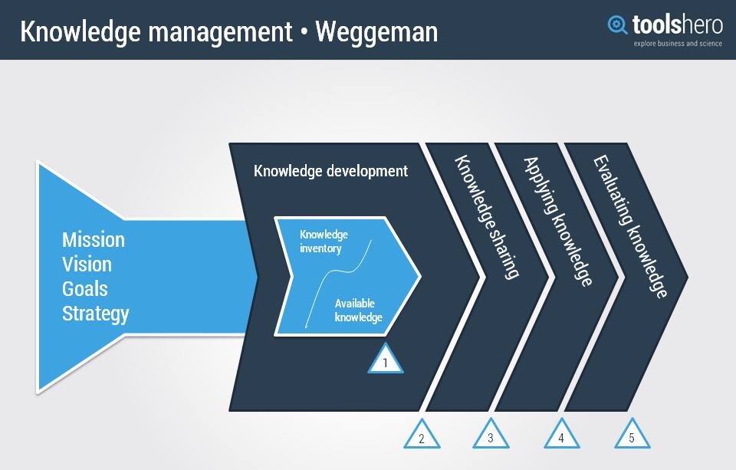
Mission Statement: “To be the standard against which others are measured, to make aspirational quality accessible to all”. (M&S, Nd).
Vision: M&S are committed to their values which are “Inspiration, Innovation, Integrity and In touch” and hope to enhance lives every day by committing to their four core values. (M&S, Nd).
Goal: M&S primary objective is to do business with high values, ethical norms and integrity. (M&S, Nd).
Strategy: M&S want to be socially accountable and lucrative by offering fresh quality clothing, food, household and financial services. According to Chloe Rigby 2018 Marks and spencer sets out strategies to increase the pace of change within their organisation as all the sales are now moving online such as clothing, homeware and food. M&S has stated that rapid change is the only choice combined with increasing discount rivalry in a difficult consumer industry. (Rigby, 2018). According to M&S the ‘Technology Transformation Programme’ as well as the goals towards their Plan A will contribute towards the organisation to accomplish a smooth client experience quicker, easier and more committed. (M&S, 2018).

Knowledge Development
The knowledge gap within the organisation lies within the users. Motivating people to constantly share their knowledge and their expertise and integration of knowledge management into the current information systems where user acceptance is required. Some people are reluctant to change and find the system complicated and difficult to comprehend.
People, Process and Technology forms Knowledge Management and if one fails to perform then the gaps within M&S Knowledge system appear. According to Thomas (2003) Marks and Spencer previously used shared drives and were dependant on people to remember to forward the information and if the information was forwarded it was cluttering up the inbox and was difficult to locate due to which there were gaps in the knowledge management system. (Thomas, 2003).
However, the Knowledge within Marks and Spencer is now developed through their Knowledge Exchange meetings and conferences with their suppliers and also through the Information Sharing Portal where knowledge is recorded and stored for all employees and suppliers to view not just through stores or departments but throughout the whole organisation.
The development of knowledge in M&S is done through tacit knowledge as it involves individuals sharing their knowledge for other people to learn in form of meetings, conferences or through their information sharing portal.
Knowledge Inventory: To be able to engage the Value Chain was the main characteristic of Plan A. M&S has created an online knowledge exchange for the organisations 2500 suppliers so that they are able to benefit from each other as well as from the organisation themselves in applying greater sustainable requirements. 1500 suppliers took part during the first summer that the exchange operated. The Knowledge Exchange for particular issues in M&S happens through working groups where everyone gets to exchange their knowledge. 1000 suppliers attended a one-day meeting which was held in London in February 2011 where they shared knowledge on how to transform Plan A in a cost-effective way. M&S have pursued to actively engage customers in their Plan A with a bid to be able to develop knowledge within the organisation. (Grayson, 2011).
Knowledge Available: In 2003 Marks and Spencer launched an information sharing portal that is used to communicate knowledge and ideas to become more effective. This system assists employees to keep informed with all the data and knowledge that is required to make a faster decision. Members from each department record all the information and data required onto the system which is then available to all to obtain, record and capture knowledge. (Thomas, 2003).

Knowledge Sharing
The information sharing portal has been designed and intended to allow employees to continuously share their knowledge to ‘simply be more efficient’ according to Thomas (2003). This improves organisational agility and helps to develop better strategies. (Thomas, 2003).
According to M&S, partnership has always been at the core of their Plan A. M&S believe some partnerships emphasis on sharing knowledge on specific areas where they lack knowledge. The success of Plan A was achievable due to the interactions and partnership with various organisations. M&S require external knowledge and expertise to recognise what changes are needed and how to accomplish them.
M&S has worked with several charities including Macmillan Cancer support, Breast Cancer Support and Royal British Legion. The main advantage for M&S by working with these charities are the ability to be able to support the causes, share knowledge on areas where they lack knowledge as well as enhance employee engagement. (Marks and Spencer , 2016). Their key principal is to consistently share knowledge in order to prevent past mistakes and establish best practices. (M&S, 2016).

Applying Knowledge
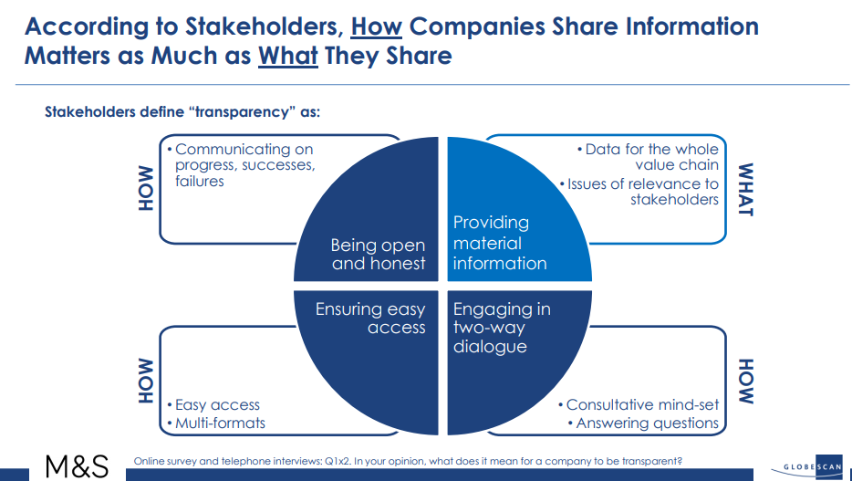
M&S apply knowledge management throughout their organisation which generates value from the organisation’s intellectual capital and knowledge-based assets. The value of knowledge is achieved by discovering what employees, customers and partners understand and also by sharing information with them. M&S believe that by being transparent with the stakeholders will assist them to find best practices. M&S have the ability to articulate knowledge by creating tacit knowledge through shared experiences. This is done through socialisation with the help of their internal social network Yammer which is a tool that is used by M&S to share knowledge, expertise, network and to interact with each other. (Jones, 2016), (GlobeScan, 2015).

The Buddy Network is a community which was established by employees of M&S so that they can communicate their knowledge, skills and promote each other’s wellbeing. Coffee and chat and conference call are the key aspects of this network where knowledge is shared and distributed within the organisation. (King, 2017).
M&S also apply explicit knowledge to tacit knowledge through internalisation with the help of their information sharing portal where everyone within the organisation have access to the information and it can be accessed through the portal through the search tool where information about a product or question on topics are already accessible. (Thomas, 2003).
Knowledge within M&S is also applied through eternalisation when tacit knowledge is transformed into explicit knowledge. This is done through collaborations with other organisations and this process helps to transform the knowledge of people into electronic forms. The partnership with WWF has encourage M&S to source more sustainably and has added knowledge on sustainable fishing and cotton. The belief of M&S is when collaborating with other organisations they get to share knowledge and expertise which helps them to prevent previous mistakes. (M&S, 2016).
Evaluating Knowledge
M&S evaluate knowledge using externalisation within the organisation. This is done through sharing knowledge which can help M&S achieve greatest organisational efficiency by implementing new ideas, procedures, products and facilities. Evaluation of knowledge management in M&S are done by completing surveys and satisfaction ratings. Honest and clear discussion with the employees regarding the organisation and also giving them the opportunity to give their own output and share knowledge via surveys and listening groups. M&S believes communicating with their employees regularly will be beneficial for them where knowledge, ideas and worries can be easily exchanged. The evaluation of knowledge is an ongoing process which commences in the first phase of the value chain. This allows knowledge development and feasible changes. (Marks and Spencer People Principles, nd).

3.2.2 Critical Evaluation
Nonaka and Takuchi believe that knowledge is continually transformed and produced as people practice, communicate, collaborate and discover. According to Nonaka and Takuchi there are four types of knowledge conversion. Marks and Spencer’s internal social networking tool Yammer is a way knowledge is transferred and converted through employees by socialisation as this tool helps facilitate employee engagement and interaction. A domain of communication is constructed through this internal networking tool the buddy network where individuals exchange ideas. During this procedure one persons shared experience and embodied skills are established and evolved into tacit knowledge for the other person. (Nonaka, 2008).
This is also supported by the theory Blackers approach of embodied knowledge where the skills and experience transferred to other people through socialisation does not need to be articulated. (Lee, 2012).
Internalisation and Externalisation is also applied in M&S through their information sharing portal and with the collaborations with the other organisations where tacit knowledge is taken and transformed into explicit knowledge. According to Nonaka and Takuchi externalisation is the method of generating a new product, a concept or developing a new manufacturing method. M&S believe when they collaborate with other organisations knowledge is shared and refined and helps them to avoid previous errors. This is also supported by Davenport and Prusak who differentiate between information and knowledge as functional and claim that individuals are able to convert information into knowledge through contrast, implications, networks, collaborations and discussions. They highlight that knowledge building and transferring occurs between people when they socialise. The information sharing portal of M&S is a way employee socialise and connect to transfer information and data into knowledge which is then distributed and reflects on their performance. (Nonaka, 2008). (Davenport & Prusak, 1998).
According to M&S they provide extensive training and performance coaching programmes to enhance workplace trust and equip the employees with knowledge and skills. This is supported by the Quinn’s Typology where cognitive skills (Know-What) are accomplished through training where knowledge is transferred from one Individual to the other. As well as training, induction is offered to all new employees where cognitive skills are taught and the capacity to know, process and implement understanding, analyse, argue, assess and decide are incorporated. (M&S Careers, nd).
The training provided at Marks and Spencer’s has achieved the ‘Institutes Training Mark Accreditation’ for the organisation’s customer services training programs according to M&S (2012). Achieving ‘Training Mark’ shows a dedication to deliver outstanding customer service through high quality training in all aspects of the organisation as well as equipping the employees with the cognitive knowledge to perform better according to Quinn’s typology. (M&S, 2012). (Lehaney, et.al. 2004).
This is also supported by Karl Wig’s model and is deemed as good practice where knowledge is defined in three forms Public Knowledge, Shared Expertise and Personal Knowledge. M&S in their organisation apply all three forms of knowledge. (Dhar, et.al. 2008).
Public Knowledge is explicit knowledge which is stored in the form of policies such as the code of conduct, ethical and sustainability policy of M&S. This form of knowledge is continuously shared when there are new entries to the organisation.
Shared Knowledge in M&S is applied in the form of informal network such as the buddy network where everyone shares their own experiences and interact with each other to develop the practice of their work. This form of knowledge is also embedded in technology such as recently according to Daniel Himsworth Programme Manager of M&S has stated that the organisation has invested in three companies where digital innovation is being embedded in ways that will help the organisation to think, plan and execute business for the present and for the future. (Himsworth, 2019).
Personal Knowledge is the tacit knowledge which is used by the employees of M&S unconsciously in their everyday work.
Karl Wig’s KM model allows experts to embrace a more comprehensive and improved strategy to knowledge management depending on the form of knowledge whether it is tacit or explicit knowledge. (Dhar, et.al. 2008).

3.2.3 Gaps within the organisation’s Knowledge Management
One of the main gaps and the challenges M&S had to face when the new information network was ruled out was user acceptance according to Gary Colet the knowledge network manager of M&S. People were not able to familiarise themselves with the system and its operations. They were reluctant to the change and were finding it complicated to incorporate this new system in the current process. Gary Colet has stated that people were not motivated to share their knowledge using this system. He also specified that the community knowledge managers were working with staff very closely and informally. To reduce the organisations costs training on the system was provided online which was easy and involved less cost for the organisation. However, for the employees this was complicated and as the training was online it was challenging for them to comprehend. (Thomas, 2003).
This is supported by Van Krogh and Roos in their organisational epistemology KM Model. They have mentioned that if employees are not keen to connect and communicate their thoughts to their peers on the ground of shared trust and values then there will be no creation of cultural, social and collective knowledge within that organisation. (Krogh & Rooh 1995).
Davenport and Prusak have stated that socialisation comprises of shared experiences by observing, imitating and training if employees of M&S are not motivated to share their experiences and knowledge then the knowledge transfer will not be developed and therefore a gap in knowledge management will occur. (Davenport & Prusak, 1998).

4.0 Conclusion
Knowledge management system of Marks and Spencer has been recently rolled out across the organisation 600 IT systems. This information sharing portal is a platform for their employees to share information and expertise reflecting on the organisations strategy to simply be more efficient.
As stated above the gaps within the organisations knowledge management system lies within the employees as they were not willing to accept this new system and were finding it hard to comprehend according to Gary Colet Marks and Spencer’s knowledge network manager.
Areas that require improvements within Marks and Spencer Knowledge Management System:
- Embrace socialising: Motivating employees to interact with others encourages sharing of knowledge as they get to know one another and their strengths and weaknesses. This could be done through their buddy network where there are opportunities to go for coffee and chat as well as informal meetings. This encourages knowledge sharing as interactions occur.
- Encourage open communication: Where employees can interact openly and share their ideas which enables improvisation.
- Soliciting opinions and feedbacks: Asking for their opinions and feedback encourages knowledge sharing.
- Encouraging independence: encouraging employees to be independent will motivate them to share knowledge and their expertise.
Marks and spencer have been facing decline in the current market due to which 100 plus stores are closing down or downsizing by 2022 according to The Guardian (2018). This decline has left their employees to be jobless and to withhold their knowledge and take their ideas when they leave at the cost of the organisation. Establishing a knowledge market is the most efficient way to counter this situation where internal knowledge can be stored in terms of research papers, project experiences which can be accessed anytime and is also an asset to Marks and Spencer. (Butler, 2018).

5.0 Recommendations
Knowledge management in M&S is still restricted to measures such as product information management, accessibility of data and best practices. M&S should adopt a planned approach in the direction of knowledge strategy, execution of knowledge and knowledge measures into the general corporate goals. This provides a broad spectrum and quality control of various projects resulting from the approach.
Having done an analysis above of the knowledge management system in M&S the following recommendations are suggested:
- Establish a corporate knowledge sharing culture amidst M&S and its employees which will encourage people to constantly share and reuse their knowledge. This can be done by creating a knowledge base which may inspire creative thoughts that can bring innovation to a stratified workplace setting.
- To be able to successfully integrate knowledge management into the current process M&S should contemplate transformation of management approaches to establish new knowledge management systems.
- Establishing a knowledge marketplace within the organisation where knowledge can be stored, purchased and sold. This will promote and encourage employees to exchange information while contributing towards the organisational knowledge exchange climate. A market mechanism delivers multiple choices for knowledge pricing that can be used towards rewarding employees. These types of markets can be implemented over corporate intranet portals and by staying connected to human resource management system.

6.0 Appendices
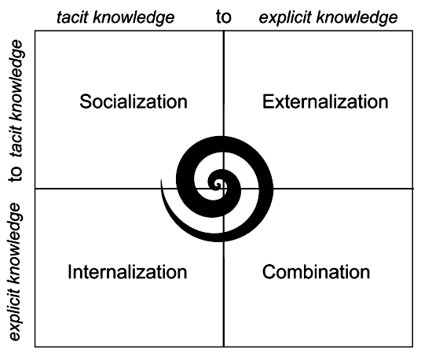

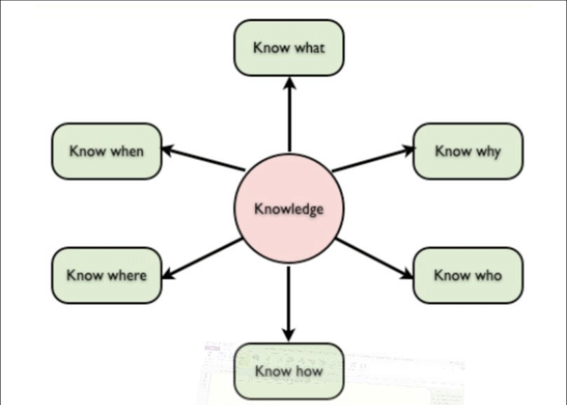

7.0 Reference

References
Butler, S. (2018). The Guardian: M&S store closures full list of shops to shut announced so far. [Online]
Available at: https://www.theguardian.com/business/2018/may/22/ms-store-closures-list-marks-spencer
[Accessed 11 07 2019].
Davenport, T.H. and Prusak, L. (1998). Working Knowledge: How Organizations Manage what They Know. Boston: Harvard Business School Press. [Online]. Available at: https://books.google.co.uk/books?id=-4-7vmCVG5cC&printsec=frontcover&dq=davenport+and+prusak+knowledge+management&hl=en&sa=X&ved=0ahUKEwiOiISJqa3jAhX6QkEAHSouBzcQ6wEIKzAA#v=onepage&q=davenport%20and%20prusak%20knowledge%20management&f=false. [Accessed 11 07 2019].
Dhar, U., Nath, V.V., Nair, S.K., and Yadav, P.K. (2008). New Age Marketing: Emerging Realities. first ed. New Delhi: Excel Books. [Online]. Available at: https://books.google.co.uk/books?id=emgtOx2sIWMC&pg=PA19&dq=karl+wigs+model+of+knowledge+management&hl=en&sa=X&ved=0ahUKEwj9yrP19qrjAhWZEMAKHbt_BZsQ6wEIMDAB#v=onepage&q=karl%20wigs%20model%20of%20knowledge%20management&f=false. [Accessed 10 07 2019].
Getty, (2008). The history of Marks and Spencer. [Online]
Available at: https://www.theguardian.com/business/gallery/2008/jul/09/marksandspencer.history
[Accessed 26 06 2019].
GlobeScan. (2015). THE M&S TRANSPARENCY STUDY: The Research Report, London: GlobeScan

Grayson, D. (2011). Embedding Corporate Responsibility and Sustainability Marks and Spencer. Journal of Management Development, 30(10), pp. 1017-1026.
Himsworth, D. (2019). New wave of tech start ups helping to put digital innovation at the heart of M&S. [Online]
Available at: https://corporate.marksandspencer.com/stories/blog/new-wave-of-tech-start-ups-helping-to-put-digital-innovation-at-the-heart-of-m-and-s
[Accessed 10 07 2019].
Jones, R. (2016). Barrow Monkey and the power of Yammer. [Online]
Available at: https://corporate.marksandspencer.com/stories/blog/barrow-monkey-and-the-power-of-yammer
[Accessed 10 07 2019].

King, S. (2017). Don’t just be a Colleague, be a Buddy. [Online]
Available at: https://corporate.marksandspencer.com/stories/blog/don-t-just-be-a-colleague-be-a-buddy
[Accessed 10 07 2019].

Krogh, V. and Rooh. J. (1995). Organizational Epistemology. London: Mcmillan Press LTD. [Online]. Available at: https://books.google.co.uk/books?id=egy_DAAAQBAJ&printsec=frontcover&dq=von+krogh+and+roos+knowledge+management&hl=en&sa=X&ved=0ahUKEwjqr8Tvp63jAhUUhlwKHd17AQwQ6wEIMDAB#v=onepage&q=von%20krogh%20and%20roos%20knowledge%20management&f=false. [Accessed 10 07 2019].
Lee, W. B. (2012). Systems Approaches to Knowledge Management, Transfer, and Resource Development. Hershey: IGI Global. [Online]. Available at: https://books.google.co.uk/books?id=UayeBQAAQBAJ&pg=PA128&dq=blackers+knowledge+workers+and+organisations&hl=en&sa=X&ved=0ahUKEwjDipLR-6rjAhVHasAKHZYpCRoQ6wEIOTAC#v=onepage&q=blackers%20knowledge%20workers%20and%20organisations&f=false. [Accessed 10 07 2019].
Lehaney, B., Clarke, S., Coake, E., and Jack, G. (2004). Beyond Knowledge Management. London: Idea Group Publishing. p-25. [Online]. Available at: https://books.google.co.uk/books?id=xraSeAz0vUoC&pg=PA25&dq=quinns+typology+knowledge+management&hl=en&sa=X&ved=0ahUKEwi97rumqq3jAhVPilwKHSj_BQAQ6wEIKzAA#v=onepage&q=quinns%20typology%20knowledge%20management&f=false. [Accessed 10 07 2019].
Lloyds Bank, (nd). Who We Are. [Online]
Available at: https://www.lloydsbank.com/banking-with-us/who-we-are.asp
[Accessed 26 06 2019].
Lloyds Banking Group, (nd). Fast Facts About Lloyds Banking Group. [Online]
Available at: https://www.lloydsbankinggroup.com/media/media-kit/faqs/lloyds-banking-group-fast-facts/
[Accessed 26 06 2019].
Lloyds Banking Group, (nd). Fast Facts About Lloyds Banking Group. [Online]
Available at: https://www.lloydsbankinggroup.com/media/media-kit/faqs/lloyds-banking-group-fast-facts/
[Accessed 26 06 2019].
Lloyds Banking Group, (nd). Group Overview: Our Srategy and Structure. [Online]
Available at: https://www.lloydsbankinggroup.com/our-group/group-overview/
[Accessed 26 06 2019].
Lloyds Banking Group, (nd). Lloyds Bank Careers. [Online]
Available at: https://www.lloydsbankinggroup.com/careers/lloydsbank/
[Accessed 26 06 2019].

Lloyds Banking Group, (nd). Lloyds Bank Our Heritage. [Online]
Available at: https://www.lloydsbankinggroup.com/Our-Group/our-heritage/our-history2/lloyds-bank/
[Accessed 26 06 2019].
Lloyds Banking Group, (nd). Lloyds Bnking Group: Banking and Finance. [Online]
Available at: https://www.allaboutschoolleavers.co.uk/employers/profile/lloyds-banking-group#!like-what-you-are-reading
[Accessed 26 06 2019].
Lloyds Banking Group, (nd). WHAT ARE THE Qualities we look for?. [Online]
Available at: https://www.lloydsbankinggroup.com/careers_old/lloydsbank/qualitieswelookfor/
[Accessed 26 06 2019].
M&S Careers, (nd). Why Work For Us?. [Online]
Available at: https://careers.marksandspencer.com/why-work-here-old
[Accessed 10 07 2019].
M&S, (2012). MARKS & SPENCER’S CUSTOMER SERVICE TRAINING ACHIEVES LANDMARK ACCREDITATION STANDARD. [Online]
Available at: https://corporate.marksandspencer.com/media/press-releases/2012/customer_service_training_achieves_landmark_accreditation_standard
[Accessed 10 07 2019].
Marks and Spencer People Principles, (nd). M&S People Principles. [Online]
Available at: https://corporate.marksandspencer.com/documents/plan-a.../mns-people-principles.pdf
[Accessed 09 07 2019].
M&S Careers , (nd). Explore M&S career opportunities. [Online]
Available at: https://careers.marksandspencer.com/careers-at-m-and-s
[Accessed 26 06 2019].
M&S, (2016). Building Partnerships. [Online]
Available at: https://corporate.marksandspencer.com/sustainability/delivering-plan-a/leading-with-others-to-accelerate-change/building-partnerships
[Accessed 27 06 2019].

M&S, (nd). A Short History of Marks and Spencer. [Online]
Available at: https://marksintime.marksandspencer.com/download?id=996
[Accessed 26 06 2019].
M&S, (nd). About Us. [Online]
Available at: https://corporate.marksandspencer.com/aboutus
[Accessed 26 06 2019].
M&S. (nd). Code of Ethics and Behaviour. [Online]
Available at: https://corporate.marksandspencer.com/documents/policy.../code-of-ethics.pdf
[Accessed 27 06 2019].

M&S, (nd). People. [Online]
Available at: https://corporate.marksandspencer.com/sustainability/people
[Accessed 26 06 2019].
M&S. (2018). MARKS & SPENCER ANNOUNCES TECHNOLOGY TRANSFORMATION PROGRAMME. [Online]
Available at: https://corporate.marksandspencer.com/media/press-releases/2018/marks-and-spencer-announces-technology-transformation-programme
[Accessed 26 06 2019].
Marks and Spencer, (nd). About M&S. [Online]
Available at: https://global.marksandspencer.com/about-ms/
[Accessed 26 06 2019].
Nonaka, I. (2008). Harvard Business Reviews Classic: The Knowledge Creating Company. Unites States of America: Harvard Business School Publishing Corporation. [Online]. Available at: https://books.google.co.uk/books?id=LmF3CgAAQBAJ&printsec=frontcover&dq=nonaka+and+takeuchi+model+of+knowledge+management&hl=en&sa=X&ved=0ahUKEwjTyo6L-qrjAhXMgVwKHfY8B2wQ6wEINjAC#v=onepage&q&f=false. [Accessed 10 07 2019].
Rigby, C. (2018). Marks & Spencer: ‘accelerated change is the only option’. [Online]
Available at: https://internetretailing.net/strategy-and-innovation/strategy-and-innovation/marks--spencer-accelerated-change-is-the-only-option-17772
[Accessed 27 06 2019].
Sarsby, A. (2016). SWOT Analysis: A guide to SWOT for Business Studies Students. England: Leadership Library.
Thomas, D. (2003). M&S rolls out knowledge management network. [Online]
Available at: https://www.computerweekly.com/news/2240052101/MS-rolls-out-knowledge-management-network
[Accessed 10 07 2019].

