Troubleshooting Challenge - Document the network
Addressing table
Device name | Interface | Device type | IP Address | Subnet Mask | Default Gateway
PC1 | NIC | Host | 192.168.1.153 | 255.255.255.0 | 192.168.1.1
PC2 | NIC | Host | 192.168.3.50 | 255.255.255.0 | 192.168.3.1
PC3 | NIC | Host | 192.168.4.115 | 255.255.255.0 | 192.168.4.1
PC4 | NIC | Host | 192.168.5.83 | 255.255.255.128 | 192.168.5.1
PC5 | NIC | Host | 192.168.5.227 | 255.255.255.128 | 192.168.5.129
PC6 | NIC | Host | 192.168.2.48 | 255.255.255.224 | 192.168.2.33
PC7 | NIC | Host | 192.168.2.67 | 255.255.255.224 | 192.168.2.65
Hub | G0/0/0 | router | 192.0.2.1 | 255.255.255.252 | N/A
Hub | S0/1/0 | router | 192.168.0.1 | 255.255.255.252 | N/A
Hub | S0/1/1 | router | 192.168.0.5 | 255.255.255.252 | N/A
Hub | S0/2/0 | router | 192.168.0.9 | 255.255.255.252 | N/A
Hub | S0/2/1 | router | 192.168.0.13 | 255.255.255.252 | N/A
Branch-1 | G0/0/0 | router | 192.168.1.1 | 255.255.255.0 | N/A
Branch-1 | S0/1/0 | router | 192.168.0.2 | 255.255.255.252 | N/A
Branch-2 | G0/0/0 | router | 192.168.2.33 | 255.255.255.224 | N/A
Branch-2 | S0/1/0 | router | 192.168.0.6 | 255.255.255.252 | N/A
Factory | G0/0/0 | router | 192.168.3.1 | 255.255.255.0 | N/A
Factory | G0/0/1 | router | 192.168.4.1 | 255.255.255.0 | N/A
Factory | S0/1/0 | router | 192.168.0.14 | 255.255.255.252 | N/A
HQ | G0/0/0.1 | router | 192.168.6.1 | 255.255.255.0 | N/A
HQ | G0/0/0.5 | router | 192.168.5.1 | 255.255.255.128 | N/A
HQ | G0/0/0.10 | router | 192.168.5.128 | 255.255.255.128 | N/A
HQ | S0/1/0 | router | 192.168.0.10 | 255.255.255.252 | N/A
SW-B1 | VLAN 1 | switch | 192.168.1.252 | 255.255.255.0 | 192.168.1.1
SW-B2 | VLAN 1 | switch | 192.168.2.62 | 255.255.255.0 | 192.168.2.1
SW-F1 | VLAN 1 | switch | 192.168.3.252 | 255.255.255.0 | 192.168.3.1
SW-F2 | VLAN 1 | switch | 192.168.4.252 | 255.255.255.0 | 192.168.4.1
SW-HQ1 | VLAN 1 | switch | 192.168.6.252 | 255.255.255.0 | 192.168.6.1
SW-HQ2 | VLAN 1 | switch | 192.168.6.253 | 255.255.255.0 | 192.168.6.1
SW-HQ3 | VLAN 1 | switch | 192.168.6.254 | 255.255.255.0 | 192.168.6.1

Network topology
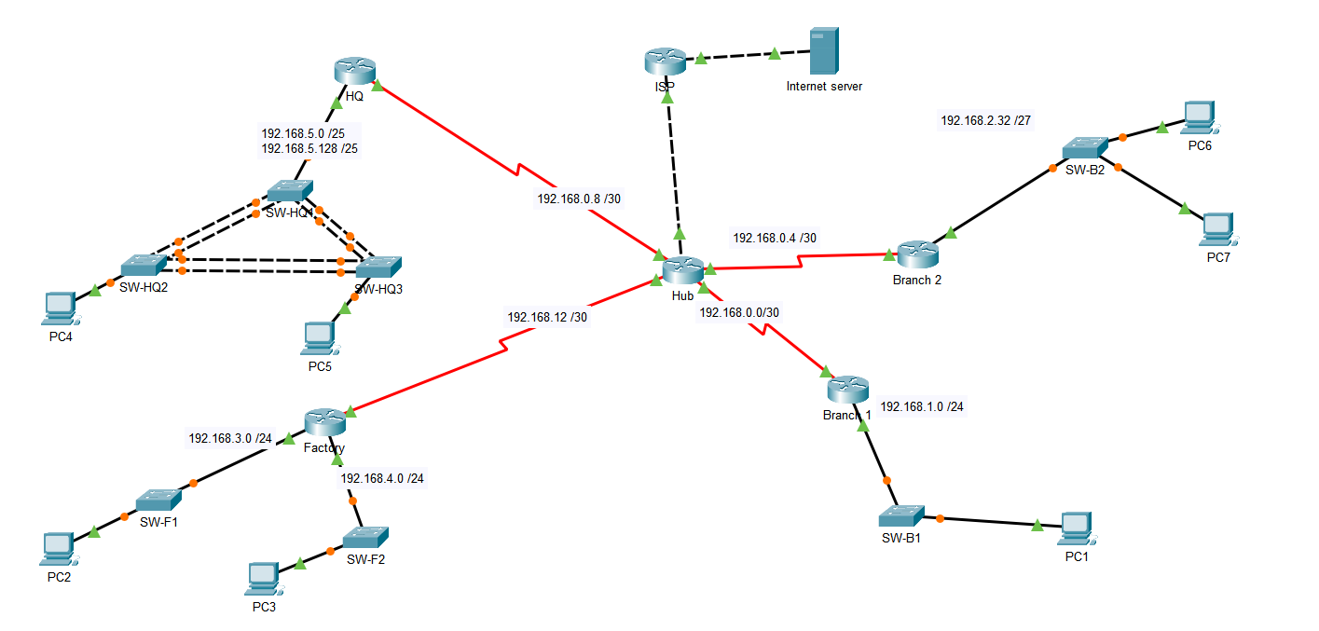

Recommendations
- All switches use the default SVI and management VLAN which should be changed.
- Switchports in VLAN 1 should be moved to appropriate VLANs instead of the default
- Native VLAN 1 should be changed from trunk links.
- Unused switchports are in VLAN 1 which should be moved to different VLANs.
- Port security is not in use.
- SSH is not in use.

