The impact on the events sector from socioeconomic, environmental and biological events.

By Sam Goodfield – 2000621

Table of Contents
The impact on the events sector from socioeconomic, environmental and biological events. 1
Introduction 3
Impact of Covid-19 3
Economic Crisis 4
Climate Change and War 6
Conclusion 7
Reference list 8

Introduction
The events and Hospitality sector, from hereon Industry have faced increased challenges because of global change in recent years. In this report we will discover the challenges faced by Grass Root Venues, and how the industry is combatting it to remain commercially sustainable.

The author believes that Industry has been affected by factors including but not limited to, Global Conflict, Cost of Living, EU Exit and Global Pandemic. The author will use a mixture of research and experience working within the industry.

The Music Venue Trust, an organisation setup to support Grass Root Venues, suggests that 125 Independent music venues closed in 2023, as a direct result of Inflation (Trendell, 2023). The Department of Culture suggest that Grass Root Venues are the birthplace of many artists who later go on to perform in larger venues, and a crucial part of the hospitality economy (Digital, Culture, Media and Sport Committee, 2019).

Impact of Covid-19
Industry was grievously affected by Covid-19, research conducted by the Office for National Statistics, shows that the hospitality sector was a booming industry in February 2020, and overnight consumer expenditure crashed to around 2% of pre lockdown levels. Following the first lockdown, Hospitality started making a slow increase, at the time of the Eat out to Help Out campaign, to around 85% of pre-pandemic expenditure. Both the Autumn and early 2021 restrictions saw a significant decrease in expenditure, to around 15% pre-pandemic levels. After April 2021, a swift recover happened to around 60% pre-pandemic levels (Ramuni, 2021).

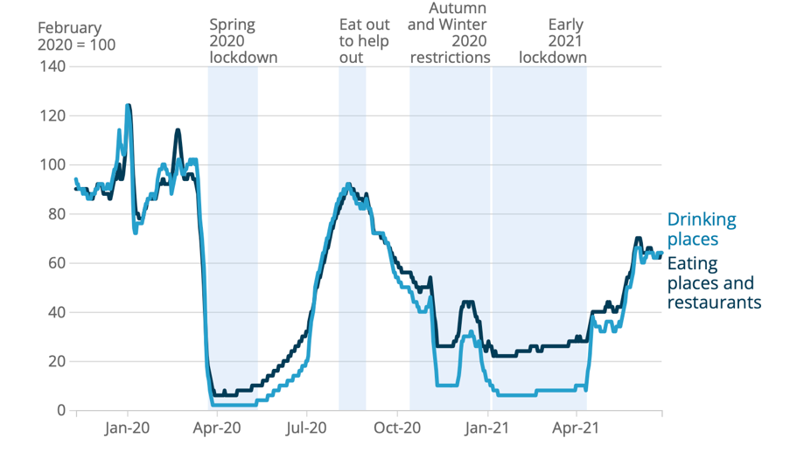
(Ramuni, 2021)

In contract, Digital Platforms, such as Zoom, which hosted many online events during lockdown saw a large increase in demand. Zoom’s profits increased from $21M to $671m in 2020 and to $1060m in 2021. Zoom’s profitability has remained high, post pandemic (Iqbal, 2024).

GMV’s had to make fast, systematic change to ensure business continuity and survival. Deltic Group (Now Rekom UK), moved to online club nights, utilizing online platforms such as Facebook to stream nightclub DJ Sets. Some GMV’s also moved to online platforms for bands to perform in a social distanced way (Tappenden, 2020). The author believes this was both a strategic decision to ensure income from online subscribers and to ensure continued promotion of their brand, to entice customers to re-enter venues once restrictions are lifted.

Its suggested that many GMV’s and Artists continued to promote through other campaigns, such as supporting the Black Lives Matter and Metoo Campaigns. Promoting the causes through the consumption of music (Raine, Taylor and Hamilton, 2021).

Limited funding was made available to Grass Root Venues, through the Welsh government, funding that was vital to ensure survival for many venues. One venue manager, owner of Le Pub, suggests that they had to cancel over 50 Gigs as a direct result of Covid-19 (Welsh Government, 2022). In contracts, the Night Time Industries Association suggests that the funding provided is not enough for survival, and that venues don’t want to rely on public funding. Creating the Let Us Dance campaign, the NTIA wanted a safe reopening of venues without social distancing measures in place (Kill, 2022). The author can recall, one Swansea based venue, Sin City had to become innovative to ensure survival, and sold there dancefloor to raise money.

The Music Venue Trust conducted some research after the first month of venues re-opening, and the results suggest that 82.1% had attended or planned to attend an GMV event with around 91.3% saying that they were happy for additional safety measures to be implemented. A high number of venues stated that advance ticket sales were lower that pre-covid and that scanned tickets were down (Music Venues Trust, 2021).

Bangor University suggest that Mental Health was a big problem because of lockdown, with many stuck with anxieties about going out. They suggested that those who had a high compliance of lockdown regulations had a worse mental health than those who were less compliant (Willegers, n.d.). The author believes, that because of lockdown, many students continued to socialise, but in domestic settings, rather than venues. Furthermore, the author believed, venues would’ve been a more controlled setting over a domestic property. The guardian suggests, in England there was a large rise in House Parties in domestic settings during the lockdown, with compliance with regulations diminishing over each lockdown (Murray and Mistlin, 2021).

The Office for National Statistics, shows that many workers within hospitality were placed on Furlough, with the HMRC showing that in April 2020, over 1.5 Million were on furlough (Ramuni, 2021b).

Economic Crisis
With out of Doubt, the Economic Crisis is affecting everyone, with Rekom, the UK’s largest provider of night-time entertainment citing it the reason for closing 7 Companies within its organisation and 17 venues with immediate affect (Rekom Group, 2024). Lapavitsas suggests that, Covid19 was a huge shock to the world’s economy, stating that it will be a source of serious difficult times for a long time. A supply issue of Aggregate, because of Climate Change caused a market wide price increase and the war in Ukraine, and the UK’s reliance on fuels from abroad have contributed to an increase in energy prices (Lapavitsas, Meadway and Nicholls, 2023). The Music Venues Trust, states that the increase in energy costs, have added an overall additional cost to GMV’s of £90m. A call has been made for a sustainable pricing structure for venues to ensure energy prices remain affordable (Music Venue Trust B, 2022). Sky News, say only a third of Hospitality Firms are optimistic about their future, as energy prices rise by 81% (Sky news, 2023).

Research shows, that people are spending less on a night out, with people aged between 25-34 spending significantly less, citing a concern on affording Rent payments (MixMag, n.d.). Rekom Research shows that most of us will only go out once a week, spending on average £20 on drink within a venue and the majority going out at around 23:00, heading back at around 03:00 (Rekom UK, 2022).

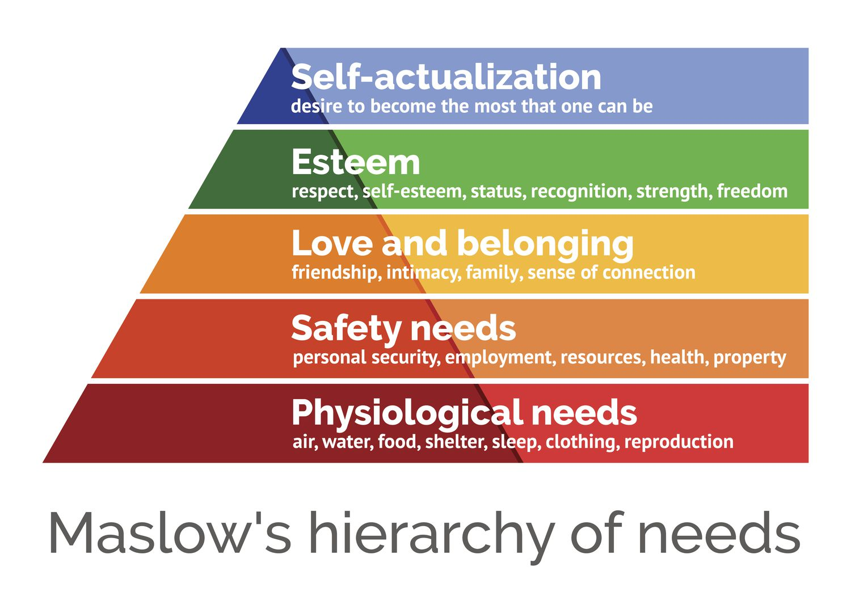
(Hopper, 2020)

Looking at Maslow’s Hierarchy of Needs, this seems to correlate with the situation in the GMV and Hospitality sector. People are prioritising Physiological Needs, over Self-Actualization.

The increase of Minimum wage has been a subject of controversy within the hospitality sector. Some organisations such as Rekom have stated it being a cause of business failure, and other supporting it (Rekom Group, 2024). Avon Data, have suggested that the increase in National Living Wage, may cause issues for smaller companies within hospitality, including but not limited to GMV’s (Rezcontrol, 2023).

Marketing is important to ensure the continuity of venues, making admission prices viable, alongside promoting events in an enticing way. Research Suggests, having an enticing brand identity, that correlates across the organisation’s promotions material can help customers decide. Posters that suit the target market, such as creating a bright colourful poster for a rave or a dark image with a strong font for Rock (Smith and Zook, 2019).

Sustainable procurement is vital to the running of any business, ensuring deliveries are on time and the correct stock is ordered. The role of Procurement links well with Climate Change as well as the cost of living. Research suggests that many of the large beverage providers have increased prices, alongside food service provider, to factor in the additional costs due to increased costs with production and transport (Quando Drinks, 2023). It’s evident, that venues are having to increase the price of Food and Beverage activities to ensure sustainability.

Climate Change and War
According to Kitchen, it’s evident that our climate is changing, Storms, Floods, Heatwaves are all factors that are evidence to a changing climate (Kitchen, 2016). Mathez suggests, that it may be a natural cycle in the earth’s lifecycle (Mathez and Smerdon, 2009). Whatever your views are on the climate, and if it’s a natural cycle or caused by human activities, one this is evident, and that’s the impact it has on business. GMV’s are less suspected to climate change when compared to outdoor events, research suggests, that weather has an impact on outdoor event attendance and spend. Forbes suggests that adverse weather is the leading cause for event cancellations, delays and reschedules (Foerster, n.d.). Board masters was cancelled in 2019 due to high winds, Cheltenham festival was cancelled in 2008 due to high winds and Dog Fest was cancelled due to heavy snow (Insure our Event, 2020). The British Psychological Society suggests that warm sunny weather makes us happier, and more prone to spending money, Whereas, poor weather makes us more prone to staying at home and spending less (Harley, 2018).

The War in Ukraine as research suggests caused significant harm to the cost of running a business, alongside an increase in, Products, Energy and Consumables. A Blog on the Caterer suggests that 60% of sunflower oil is produces in Ukraine, and that due to supply and demand, this has caused a knock-on increase of other oil products used in hospitality (Price, 2022). GMV’s rely on beverage to ensure sustainability, Brew and Hub, suggest that Ukraine is a major supplier for the key ingredient in the making of beer, alongside higher than average temperatures have caused a poor grain yield. Prices for many of the core ingredients have almost doubled, because of Climate Change and War (REDACCIÓN, 2022). Evidence provided by Ukrainian MP’s also suggests that supply of the core ingredients for making beer, is strained due to the war, and it’s likely that the price of beer in the UK will increase (Glaze and Isgin, 2022). The author believes that the increase in costs, alongside with the cost of living crisis, will make it harder for GMV’s and hospitality industry’s to survive.

From the new financial year, in Wales businesses will have to comply with new workplace recycling regulations. The Welsh government suggest that this will enforce business in Wales to sort recyclable materials, such as Food, Paper, Glass, Metal and plastics away from general waste (Welsh Government, n.d.). The author believes, that many businesses within hospitality, especially GMV’s have a high reliance on disposable packaging to serve customers, and is reliant on customers making changes to their disposal habits while in a venues. Paul Jackson, Director at NRC suggests that the changes to law in Wales, will have significant cost increases for venues, more storage requirements for bins and Staff Training will be required to ensure compliance. Paul further suggests that hospitality businesses will experience a 5% increase in waste collection costs (Sinclair, 2023). The Music Venues Trust, suggests venues only make a 0.2% profit (Music Venues Trust, 2022). The author believes, that the additional costs faced by GMV’s and Hospitality as a whole will further impact GMV’s and more will become commercially un-viable. Furthermore, the UK Government have implemented a ban on single use plastics, to more expensive sustainable options, a move that has caused an increase in costs for many businesses (restaurantonline.co.uk, 2023).

It suggested that Significant Energy cost Increases have affected everyone, especially businesses and GMV’s. Energy Prices increased significantly in 2021, with a larger spike in December 2021. The energy price per Kilowatt hour, still hasn’t recovered to the pre 2021 levels (Office for National Statistics, 2022). An article posted by Resolve Energy, suggests that the increase in energy prices has left widespread business closures in the hospitality sector, with over 1000 businesses closing in the last quarter of 2022 alone. In 2022, its suggested that businesses will expect a 101% increase in energy prices, when compared to the previous year (Resolve Energy, 2023). The Office for National Research suggests that businesses within the hospitality sector are likely to cut trading, in response to energy costs. Further suggesting that many businesses will cut 2 trading days per week, to ensure commercial viability. The ONS also states, that hospitality business are 19% more likely to make changes to trading hours to counteract the cost of energy than other businesses (ONS, 2022).

Conclusion
The past few years have presented many struggles to organisations within the hospitality sector, from increased operational prices to reduction in trade due to the cost of living and government policy. VAT, Rates, Rent, Utilities and increased cost of procurement have all had a large-scale impact on the viability of organisations within hospitality. A large proportion of GMV’s are Not for Profit, investing profits into the venue to bring bigger and better acts for their supporters. 2023, was suggested to be the worst year for GMV’s and Hospitality (Clarke, 2024). Its suggested that around 3.5Million people work in the hospitality sector (UK Hospitality, n.d.), the ONS suggests that the majority of people working in hospitality are under 25 (Office for National Statistics, n.d.). Gen-Z are more worried about there future and Job Security. Many are also suffering symptoms of burnout and suggesting they don’t earn enough to have a good quality of life (Carnegie, 2023). Evidence suggests that Gen-Z are going out later and drinking before going into venues, further reducing the spend in hospitality venues (First post, 2024).

The economic situation in the UK is not only having a personal impact, changing people’s social habits, but also having a knock-on effect with venues. Reducing spend and Box Fees, but having increased costs for procurement, rates and energy.

Government policy, such as the protections implemented by Covid policies, increase in rates and policy implemented in both the UK and Wales to reduce the environmental impact of Business have had a negative impact on the hospitality sector. Many organisations within hospitality are still recovering from the downfall in business because of the restrictions put in place by the COVID restrictions.

Gen-Z, one of the main target markets for hospitality and GMV’s are going out less, with only around 25% expressing interest in going out. This is suggested to be a result of the pandemic, with people changing attitudes to socialising and the cost of living (Wild, 2024).

Procurement has become harder for Hospitality, with increased costs of consumables, energy and rates, because of War and the cost of living. The cost of the raw products used in many beverages have increased, causing a knock-on effect of prices being increased to the consumer. Alongside, the cost of living, people are prioritising spend on needs, rather than Esteem and Self Actualisation.

Weather also has an impact on venues, increased consistent changes in the weather, which research suggests could be a result of Climate Change is a decision factor for many attending Hospitality Settings and GMV’s (US EPA, 2016). Its suggested, that poor weather has an impact on attendance at indoor hospitality settings and has a direct impact on peoples spend.

The impacts on GMV’s will have a longer term impact on the overall events industry, with larger events feeling the strain of less acts working up through the various platforms to stadia events. Many famous artists, including but not limited to Ed Sheeran and Adele started their careers in GMV’s and at open mic nights (Gruet, 2023).

Overall, the Hospitality Industry is in a dire situation, and without urgent support will likely see more businesses close, and platforms for socialisation and performance dry up.

Reference list
Carnegie, M. (2023). Are Gen Z the most stressed generation in the workplace? [online] www.bbc.com. Available at: https://www.bbc.com/worklife/article/20230215-are-gen-z-the-most-stressed-generation-in-the-workplace.
Clarke, N. (2024). Grassroots music venues had ‘worst year’ for closures in a decade, report says. [online] Evening Standard. Available at: https://www.standard.co.uk/business/business-news/grassroots-music-venues-had-worst-year-for-closures-in-a-decade-report-says-b1134387.html.
Digital, Culture, Media and Sport Committee (2019). Live music Ninth Report of Session 2017-19 Report, together with formal minutes relating to the report. [online] Available at: http://musicvenuetrust.com/wp-content/uploads/2019/03/Digital-Culture-Media-and-Sport-Comittee-Live-Music-Ninth-Report-of-Session-2017-2019.pdf.
First post (2024). Say No to Partying: Why Gen Z in the UK is ditching nightclubs. [online] Firstpost. Available at: https://www.firstpost.com/explainers/why-gen-z-in-the-uk-is-ditching-nightclubs-13736422.html.
Foerster, J. (n.d.). Are Weather Risks Equal For Outdoor Events? [online] Forbes. Available at: https://www.forbes.com/sites/jimfoerster/2023/06/07/are-weather-risks-equal-for-outdoor-events/.
Glaze, B. and Isgin, K. (2022). Fears price of lager could rise due to war in Ukraine. [online] Manchester Evening News. Available at: https://www.manchestereveningnews.co.uk/news/uk-news/fears-price-lager-could-rise-24357549 [Accessed 23 Mar. 2024].
Gruet, S. (2023). Cost of living crisis increases fears for small gig venues. BBC News. [online] 24 Mar. Available at: https://www.bbc.co.uk/news/newsbeat-65014849.
Harley, T. (2018). Weather and behaviour - The British Psychological Society. [online] www.bps.org.uk. Available at: https://www.bps.org.uk/psychologist/weather-and-behaviour.
Hopper, E. (2020). Maslow’s Hierarchy of Needs Explained. [online] Thought Co. Available at: https://www.thoughtco.com/maslows-hierarchy-of-needs-4582571.
Insure our Event (2020). 10 Major Events That Were Cancelled Because Of Bad Weather | IOE. [online] Insure Our Event. Available at: https://insureourevent.co.uk/events-cancelled-bad-weather/.
Iqbal, M. (2024). Zoom Revenue and Usage Statistics (2020). [online] Business of Apps. Available at: https://www.businessofapps.com/data/zoom-statistics/.
Kill, M. (2022). #LetUsDance Campaigns for including Electronic Music with CRF Grants - NTIA. [online] Available at: https://ntia.co.uk/letusdance-campaigns-for-including-electronic-music-with-crf-grants/ [Accessed 21 Mar. 2024].
Kitchen, D. (2016) Global Climate Change. 1st edn. Taylor and Francis. Available at: https://www.perlego.com/book/2192851/global-climate-change-turning-knowledge-into-action-pdf (Accessed: 22 March 2024).
Lapavitsas, C., Meadway, J. and Nicholls, D. (2023) The Cost of Living Crisis. [edition unavailable]. Verso. Available at: https://www.perlego.com/book/3848560/the-cost-of-living-crisis-and-how-to-get-out-of-it-pdf (Accessed: 21 March 2024).
Mathez, E. and Smerdon, J. (2009) Climate Change. [edition unavailable]. Columbia University Press. Available at: https://www.perlego.com/book/775242/climate-change-the-science-of-global-warming-and-our-energy-future-pdf (Accessed: 22 March 2024).
MixMag (n.d.). One in three young people are ‘cutting down’ on nights out due to Cost of Living Crisis. [online] Mixmag. Available at: https://mixmag.net/read/one-in-three-young-people-are-cutting-down-on-going-out-due-to-the-cost-of-living-crisis-news.
Murray, J. and Mistlin, S. (2021). Police report rise in large Covid lockdown parties in England. The Guardian. [online] 19 Feb. Available at: https://www.theguardian.com/uk-news/2021/feb/19/police-report-rise-in-large-covid-lockdown-parties-in-england.
Music Venue Trust B (2022). Music Venue Trust Energy Costs Policy Statement. [online] Music Venue Trust. Available at: https://www.musicvenuetrust.com/2022/09/music-venue-trust-energy-costs-policy-statement/ [Accessed 21 Mar. 2024].
Music Venues Trust (2021). The State of The (Live) Nation. [online] Music Venue Trust. Available at: https://www.musicvenuetrust.com/2021/08/the-state-of-the-live-nation/.
Music Venues Trust (2022). Protecting, securing & improving Grassroots Music Venues across the UK Leading the national & international movement for sustainability of the sector. [online] Available at: https://www.musicvenuetrust.com/wp-content/uploads/2023/01/MVT_Annual-Report_FINAL_web-enabled_Single-Page-version.pdf.
Office for National Statistics (2022). Energy prices and their effect on households. [online] www.ons.gov.uk. Available at: https://www.ons.gov.uk/economy/inflationandpriceindices/articles/energypricesandtheireffectonhouseholds/2022-02-01.
Office for National Statistics (n.d.). The occupations most dependent on older and younger workers - Office for National Statistics. [online] www.ons.gov.uk. Available at: https://www.ons.gov.uk/employmentandlabourmarket/peopleinwork/employmentandemployeetypes/articles/theoccupationsmostdependentonolderandyoungerworkers/2023-05-31#:~:text=Young%20people%20more%20dependent%20on.
ONS (2022). Food and drink service firms are most likely to cut trading to tackle energy costs - Office for National Statistics. [online] www.ons.gov.uk. Available at: https://www.ons.gov.uk/businessindustryandtrade/business/businessservices/articles/foodanddrinkservicefirmsaremostlikelytocuttradingtotackleenergycosts/2022-11-14.
Price, K. (2022). Ukraine crisis ‘a long-term threat to food... [online] The Caterer. Available at: https://www.thecaterer.com/news/ukraine-crisis-long-term-threat-food-prices-lynx.
Quando Drinks (2023). 2024 Brewery Price Increases. [online] Quando Drinks. Available at: https://www.quandodrinks.co.uk/2024-brewery-price-increases/ [Accessed 22 Mar. 2024].
Raine, S., Taylor, I.A. and Hamilton, C. (2021). Crisis as a Catalyst for Change: COVID-19, Spatiality and the UK Live Music Industry. IASPM Journal, 11(1), pp.6–21. doi:https://doi.org/10.5429/2079-3871(2021)v11i1.3en.
Ramuni, L. (2021a). Coronavirus and its impact on UK hospitality - Office for National Statistics. [online] Ons. Available at: https://www.ons.gov.uk/businessindustryandtrade/business/activitysizeandlocation/articles/coronavirusanditsimpactonukhospitality/january2020tojune2021.
Ramuni, L. (2021b). Coronavirus and its impact on UK hospitality - Office for National Statistics. [online] Ons. Available at: https://www.ons.gov.uk/businessindustryandtrade/business/activitysizeandlocation/articles/coronavirusanditsimpactonukhospitality/january2020tojune2021.
REDACCIÓN, P. (2022). How the war in Ukraine is affecting the beer sector. [online] Brew&Hub. Available at: https://brewandhub.es/en/how-the-war-in-ukraine-is-affecting-the-beer-sector/.
Rekom Group (2024). Commercial in Confidence. [online] Available at: https://backend.rekomgroup.com/media/hnhndp3q/rekom-uk-administrators-press-release-2-feb-2024_2.pdf [Accessed 21 Mar. 2024].
Rekom UK (2022). REKOM UK NIGHT INDEX. [online] Available at: https://hudsonsandler.com/wp-content/uploads/2022/11/REKOM-Night-Index-Report-October_FINAL.pdf.
Resolve Energy (2023). How the energy crisis has affected hospitality.... [online] Resolve Energy. Available at: https://www.resolveenergy.co.uk/blog/article/how-the-energy-crisis-has-affected-hospitality#:~:text=The%20higher%20energy%20price%20has [Accessed 25 Mar. 2024].
restaurantonline.co.uk (2023). Hospitality warns of further price rises as Government confirms single-use plastics ban. [online] restaurantonline.co.uk. Available at: https://www.restaurantonline.co.uk/Article/2023/01/16/Single-use-plastics-to-be-banned-from-October-leading-to-hospitality-concerns-over-implementation.
Rezcontrol (2023). UK Minimum Wage: How it affects the hospitality industry – Avon Data Systems. [online] Rezcontrol. Available at: https://rezcontrol.com/uk-minimum-wage-how-it-affects-the-hospitality-industry/.
Sinclair, T. (2023). New Welsh recycling regulations could cost businesses thousands. [online] The Pembrokeshire Herald. Available at: https://pembrokeshire-herald.com/86552/new-welsh-recycling-regulations-could-cost-businesses-thousands/ [Accessed 25 Mar. 2024].
Sky news (2023). Only a third of hospitality firms optimistic about their future - as average energy prices rise by 81%. [online] Sky News. Available at: https://news.sky.com/story/only-a-third-of-hospitality-firms-optimistic-about-their-future-as-average-energy-prices-rise-by-81-12892834#:~:text=Pubs%2C%20bars%20and%20restaurants%20say [Accessed 21 Mar. 2024].
Smith, P. and Zook, Z. (2019) Marketing Communications. 7th edn. Kogan Page. Available at: https://www.perlego.com/book/1589959/marketing-communications-integrating-online-and-offline-customer-engagement-and-digital-technologies-pdf (Accessed: 20 February 2024).
Tappenden, R. (2020). The DJs getting clubbers moving from their kitchens. BBC News. [online] 25 Apr. Available at: https://www.bbc.co.uk/news/uk-england-52351790.
Trendell, A. (2023). 2023 was ‘worst year for venue closures’ while ‘no one in music industry seems to care’, say MVT. [online] NME. Available at: https://www.nme.com/news/music/2023-was-worst-year-for-venue-closures-while-no-one-in-music-industry-seems-to-care-say-mvt-3562266.
UK Hospitality (n.d.). Facts and stats. [online] UKHospitality. Available at: https://www.ukhospitality.org.uk/media-centre/facts-and-stats/.
US EPA (2016). Climate Change Indicators: Weather and Climate. [online] US EPA. Available at: https://www.epa.gov/climate-indicators/weather-climate#:~:text=Rising%20global%20average%20temperature%20is.
Welsh Government (2022). Support for grassroots music venues in Wales. [online] GOV.WALES. Available at: https://www.gov.wales/support-grassroots-music-venues-wales.
Welsh Government (n.d.). Workplace recycling | GOV.WALES. [online] www.gov.wales. Available at: https://www.gov.wales/workplace-recycling#:~:text=From%206%20April%202024%2C%20it [Accessed 25 Mar. 2024].
Wild, A. (2024). From rowdy behaviour to clean-living kids: why Gen Z gave up on clubbing. The Telegraph. [online] 17 Feb. Available at: https://www.telegraph.co.uk/health-fitness/diet/alcohol/gen-z-clubbing-going-sober-clean-living/#:~:text=According%20to%20a%20July%202022.
Willegers, D.M. (n.d.). Mental health costs of lockdown compliance still being felt, research shows. [online] Bangor University. Available at: https://www.bangor.ac.uk/news/2023-11-21-mental-health-costs-of-lockdown-compliance-still-being-felt-research-shows.

