University of Wales Trinity Saint David
Wales Institute of Science & Art



Application of Computer Aided Engineering Processes
Structural Design & Fluid Analysis ACHA6010

Parry Hill
2004858
11/12/2023
Table of Contents
Table of Figures 2
Table of Tables 2
1. Introduction to CAE in Engineering. 3
2. Literature Review. 4
3. Validation of CAE. 6
3.1. Bimetallic Strip. 6
3.2 Cantilever Beam. 8
4. Material Choice. 10
5. Kinematic Simulation and Analysis. 11
6. Thermal Influence on Structural Analysis 12
7. Structural Performance Analysis. 13
8. Modified Piston Analysis 15
9. Analysis of the Fully Linked System 17
9.1. Forces on the piston 17
9.2. Temperature 18
9.3. Maximum deformation 18
9.4. Von Mises (Equivalent) Stress 19
10. Limitations and Challenges of CAE. 21
11. Conclusion. 22
12. References. 23

Table of Figures
Figure 1 - Assembly 3
Figure 2 - Bimetallic Strip Deformation 7
Figure 3 - MATLAB Calculations for Bimetallic strip 7
Figure 4 - Cantilever Beam Deformation 8
Figure 5 - MATLAB Calculations for Cantilever Beam 9
Figure 6 - Rigid Dynamics Output 11
Figure 7 - Steady State Thermal Results 12
Figure 8 - Imported Motion Loads 13
Figure 9 - Von Mises Stress 14
Figure 10 - Total Deformation 14
Figure 11 - Modified Piston 15
Figure 12 - Modified Piston Motion Loads 15
Figure 13 - Modified Piston Temperature 16
Figure 14 - Modified Piston Deformation 16
Figure 15 - Modified Piston Von Mises Stress 16
Figure 16 - Location of the Maximum Von Mises Stress - Original 19
Figure 17 - Location of the Maximum Von Mises Stress - Modified 20

Table of Tables
Table 1 - Bimetallic Strip variables 6
Table 2 - Bimetallic Strip Mesh Sizing Variation 7
Table 3 - Cantilever Beam Variables 8
Table 4 - Cantilever Beam Mesh sizing 9
Table 5 - Aluminium 6061 T6 Properties 10
Table 6 - Thermal Boundary Conditions 12
Table 7 - Rigid Dynamics Forces 17
Table 8 - Temperature across Different Areas of Both Pistons 18
Table 9 - Von Mises Stress 19

- Introduction to CAE in Engineering.
For this report an assembly of a piston, gudgeon pin, conrod and crankshaft as shown in figure 1 below will be used for analysis.
Ansys Workbench will then be used to conduct several studies of which are:
- Rigid Dynamics
This involves analysing motion of rigid bodies under the influence of forces and torques. It assumes that the bodies do not deform under stress, simplifying the analysis of their movement and interactions.
- Steady State Thermal
This analysis determines the temperature distribution and heat flow in a system at equilibrium. It assumes that the temperature fields do not change over time, focusing on the consistent state of heat transfer.
- Static structural
This refers to the examination of structures under loads that are constant or slowly changing. It evaluates stress, strain, and deformation to ensure structural integrity and stability without considering dynamic effects like vibrations or time-dependent forces.

The focus of these studies will be centred on the piston with the full assembly only being used for the ridged dynamic study to simulate the piston during an engine cycle, following this the piston will then be subject to modification to optimise the design by reducing mass.
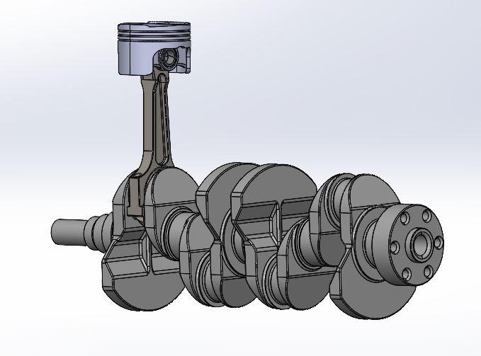
Figure 1 - Assembly

Literature Review.
Computer-aided engineering software (CAE) is a broad term describing the use of computer software for performing engineering-based analysis of components. One of the main components of CAE is Finite Element Analysis (FEA), which is extensively used. For example, ANSYS Workbench, a CAE tool, facilitates FEA of models to analyse stresses and strains in different materials when applied to a geometry such as a piston.

A piston is constantly subjected to a combination of high mechanical and thermal stresses. The significant temperature differences between the piston crown and the cooling galleries result in these substantial thermal stresses.
Additionally, factors such as gas pressure, piston acceleration, and the forces exerted on the piston contribute to a complex cycle of mechanical stresses, the use of FEA allows a model to be built combining all forces felt by the piston and assessed for areas such as fatigue life from cyclic loading (Singh, et al. 2015).
Furthermore, FEA can also be used for the following as well as many more:
- Predicting failure points and improving safety factors
FEA can be used to predict component failure in pistons by analysing the stress and temperature distribution under different operating conditions through cyclic loading enabling the identification of critical areas prone to fatigue failure (Zhang, Zuo and Liu, 2013)

- Design Optimization
FEA can be used to optimise the design of components such as pistons by finding where excess mass can be removed without compromising the components integrity by still conforming to other constraints such as maximum Von Mises stress and safety factors through static structural analysis, because of this, component mass can often be decreased significantly (Rajam, Murthy and Krishna, 2013).

- Material Selection
When conducting FEA simulation different materials with varying properties can easily be assigned to components and studied for suitability to determine the best fit for specific design requirements. By varying parameters such as density, elasticity, thermal conductivity, and yield strength, the simulation can predict how different materials will behave under various loads and environmental conditions (Vinswath, et al. 2021).

One Important consideration when conducting FEA is mesh sizing the size of the elements in the mesh significantly influences the accuracy of the results, a finer mesh with smaller elements provides higher accuracy by better capturing more detailed data about the geometry to be calculated however, this often can cause an increase in computational resources and time, Alternatively, a coarser mesh with larger elements reduces computational demands but may lead to less accurate results (More and Bindu, 2015).

Validation of CAE.
To validate the effectiveness of Ansys Workbench for CAE testing, simple test cases like a bimetallic strip and a cantilever beam were used. The bimetallic strip test examined the strip's deflection under a temperature change, comparing results from Ansys with mathematical calculations.
Similarly, the cantilever beam test involved analysing beam deflection under a uniform load, again comparing Ansys results with calculated results.
These cases provided a practical assessment of Ansys Workbench's accuracy and reliability for simulation validation.

Bimetallic Strip.
Table 1 displays the variables used for the validation example of a bimetallic strip made from Copper and Invar including metal properties, boundary conditions and geometry of each strip during a static structural test for thermal loading.
Table 1 - Bimetallic Strip variables
 | Invar | Copper
Modulus of Elasticity  (MPa) | 137000 | 130000
Poisson's Ratio | 0.280 | 0.354
Coefficient of Thermal Expansion  (C°⁻¹) | 1.200x10⁻⁶ | 2.000x10⁻⁵
Thermal Load (°C) | 100
Geometry (mm) Width x Thickness x Length | 5.00 x 1.00 x 100.00

Figure 2 displays the result of deformation when the bimetallic strip is subjected to a temperature increase of 100°c and affixed at one end, for this analysis a mesh size of 0.25mm was used. From this a total deformation of 7.1213 mm was observed, when compared to the results of the MATLAB calculations shown in figure 2 (7.049mm) there is a 1.020% difference in the results, this could be due to the mesh size causing inaccuracies during each iteration of the simulation however producing a result with a less than 1% difference highlights the accuracy of the CAE software.
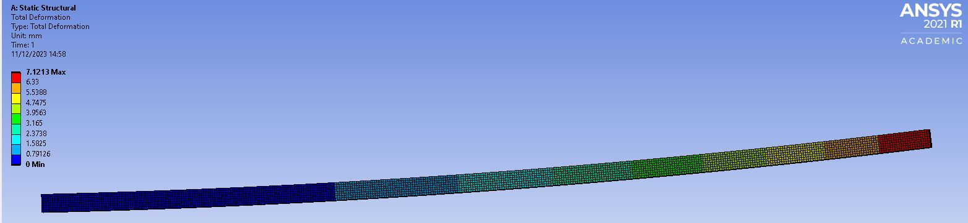
Figure 2 - Bimetallic Strip Deformation

Table 2 displays results for when different mesh sizes were used to display the accuracy of calculations changing when a finer or courser mesh is used, as the table shows a finer mesh will achieve a higher level of accuracy however when refining mesh size, the runtime of each simulation increases.

Table 2 - Bimetallic Strip Mesh Sizing Variation
Mesh Size (mm) | Deflection
0.25 | 7.1213
0.5 | 7.123
1 | 7.1233
0.1 | 7.1203

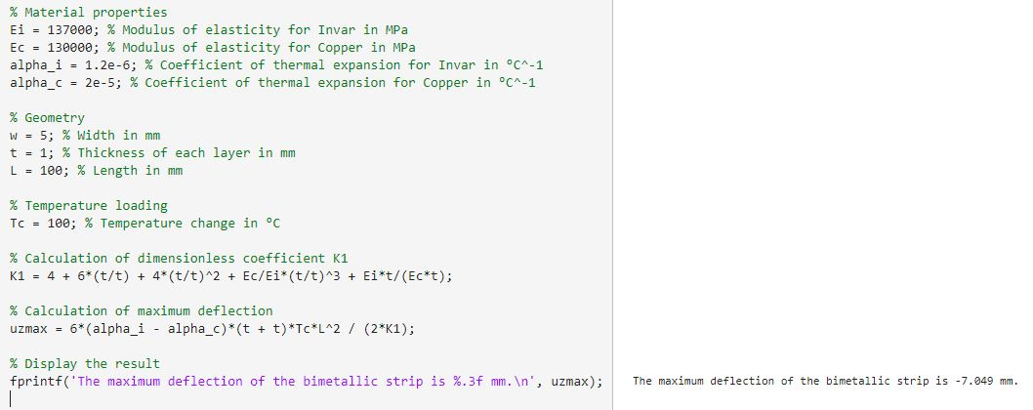
Figure 3 - MATLAB Calculations for Bimetallic strip

3.2 Cantilever Beam.
Table 3 displays the variables used for the cantilever beam deflection case with a uniform load applied to the surface with it being affixed at one end.

Table 3 - Cantilever Beam Variables
 | Elastic - Plastic
Modulus of Elasticity  (MPa) | 210000
Poisson's Ratio | 0.000
Shear Modulus (MPa) | 105000
Load Applied to Surface (Pa) | 2750
Geometry (mm) Width x Thickness x Length | 1000 x 50 x 5

The results of this study are shown in figure 4 below, with a load of 2750Pa applied to the top surface of the geometry a maximum overall deflection of 157.15mm was observed using a 2.5mm mesh size, as shown in table 4 changing the mesh size both courser and finer did not affect the results however this could be due to the simplicity of the model.

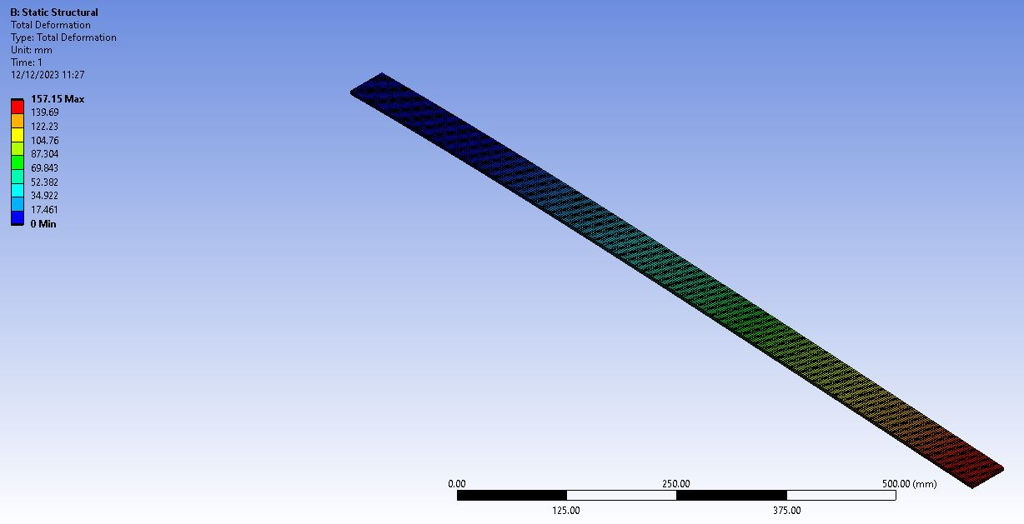
Figure 4 - Cantilever Beam Deformation

When the deflection was calculated using MATLAB for verification a maximum deflection of 157.43mm was observed and when compared to the results from Ansys, this gives a 0.004% error once again showing the accuracy for simulation models within the software.

Table 4 - Cantilever Beam Mesh sizing
Mesh Size (mm) | Deflection
2.5 | 157.15
1 | 157.15
5 | 157.15
20 | 157.15

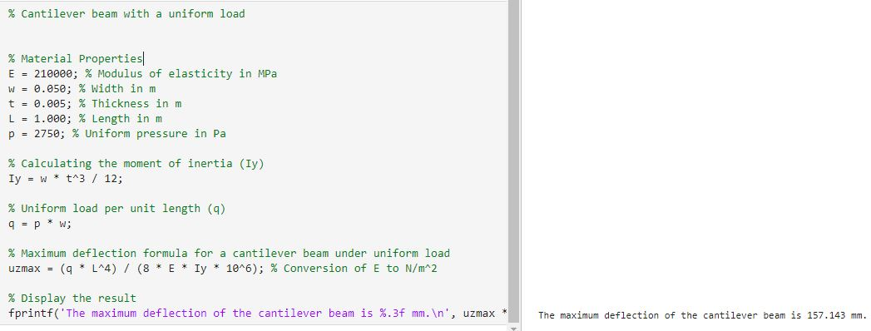
Figure 5 - MATLAB Calculations for Cantilever Beam

Material Choice.
The material used for the piston in this analysis will be Aluminium 6061T6 due to its combination of properties. One of the key advantages of using Aluminium 6061T6 for pistons is its high strength and low density. This property is crucial for components like pistons that undergo rapid and repeated stress changes, as it allows for reduced inertia and improved engine efficiency. Additionally, Aluminium 6061 T6 exhibits good fatigue strength and is resistant to corrosion, which enhances the durability and longevity of the pistons. Its ability to withstand high temperatures and pressures, while maintaining structural integrity, makes it an ideal material for high-performance applications (Azadi, et al. 2020).
Table 5 below was created using data from Ansys (CES) Granta EduPack (2022) to display some of the specific properties of AL 6061 T6.

Table 5 - Aluminium 6061 T6 Properties
Property | Value/Description
Density | 2712.9 Kg/m³
Melting Point | 580-650°C
Thermal Conductivity | 152 - 169 W/m-K at 25°C
Thermal Expansion | 22.7 – 23.9 µm/m-K
Young's Modulus | 66.6 – 70 GPa
Tensile Strength | 310 MPa
Yield Strength | 276 MPa
Hardness, Brinell | 95
Fatigue Strength | 96.5 MPa (14,000 psi)
Machinability | Good
Corrosion Resistance | Good

Kinematic Simulation.
For the kinematic simulation a rigid dynamics study was conducted, first revolute joints were created for all surfaces in contact, a body to ground revolute joint was used for the crankshaft body to allow for fixed rotation and a general joint with translation in the Z axis was applied to the piston to allow for the correct degrees of freedom simulating it moving up and down in a cylinder.
For the analysis, a step end time of 0.05s and a time step of 0.0001s and a joint load using the ground to crankshaft joint was used, it was then given a rotational velocity of 4000RPM. Once these parameters were set the force loading between to the piston from the gudgeon pin were selected for analysis.
Once the kinematic simulation had been run an output showing the forces over the completed cycle was produced as shown below in figure 6, the maximum force was then selected and added to the joint probe solution and exported to a text file for use within the static structural study.
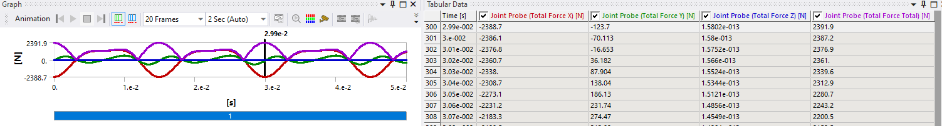
Figure 6 - Rigid Dynamics Output

Thermal Influence on Structural Analysis
To conduct the steady state thermal analysis, all bodies other than the piston were suppressed and the stiffness behaviour of the piston changed from rigid to flexible, following this a 4mm mesh was applied to the piston to accurately discretise the geometry. Thermal boundary conditions were then added to different sections of the piston as displayed in table 6 below and the simulation run to produce the results as shown in figure 7, highlighting the differing temperature conditions of different areas on the piston.

Table 6 - Thermal Boundary Conditions
Location | Heat Transfer Coefficient W/m².°C | Boundary Temperature (°C)
Crown | 497.5 | 928.5
Sides of the Crown | 447.5 | 425
Ring Grooves | 437.5 | 190
Oil Ring | 338.75 | 163.75
skirt | 462.5 | 107.5
underside | 675 | 91.25

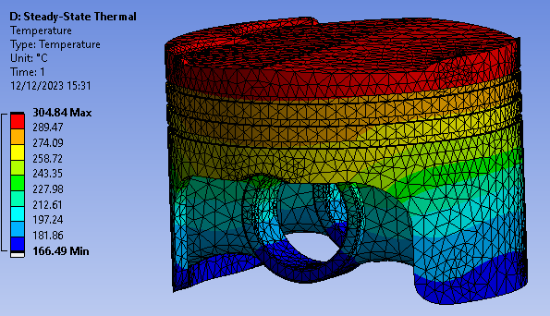
Figure 7 - Steady State Thermal Results

Structural Performance Analysis.
The static structural analysis focuses on just the piston, therefore all other bodies within the assembly were supressed, the pistons stiffness behaviour was then changed from rigid to flexible in order map deformation with the load being applied.
The motion loads from the rigid dynamic study were imported as shown in figure 8 with a pressure of 10.5MPa applied to the crown to simulate gas pressure.
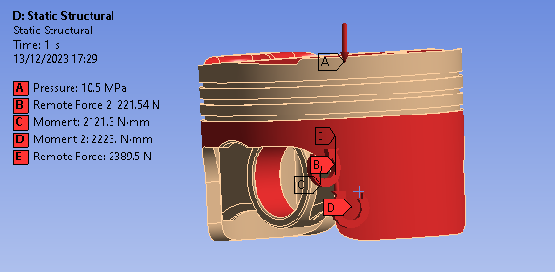
Figure 8 - Imported Motion Loads
A 4mm mesh was then created for the entire piston with a sizing control of 2mm for the crown enabling higher accuracy within the results.
For this simulation to run, weak springs had to be used to add a constraint to the piston without interfering with the results.
The final simulation was run with total deformation and Von-mises (Equivalent) stress being calculated as shown in figures 9 and 10.

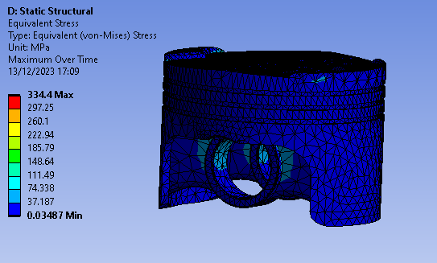
Figure 9 - Von Mises Stress

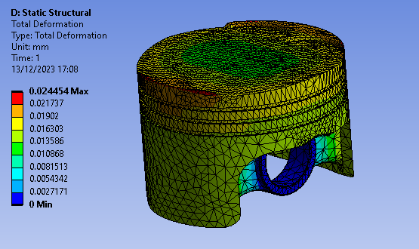
Figure 10 - Total Deformation

Modified Piston Analysis
To build a comparative study, material was taken away from the underside of the piston with the aim of decreasing the overall mass of the piston, using Aluminium 6061 T6’s density of 2712.9 Kg/m³ a mass of 254.14gwas calculated using the SolidWorks part file, compared with the original weighing 257.00g, giving a total mass reduction of 2.86g.
The modified geometry is shown in figure 11 below.
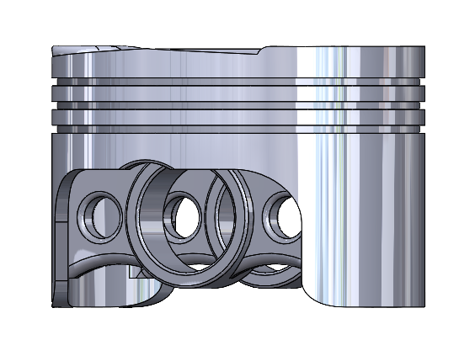
Figure 11 - Modified Piston
The Study was then re undertaken with the new modified geometry, being given the same initial constraints and variables to make the studies as similar as possible, the results of the different stages can be seen in figures 12 to 15 below.

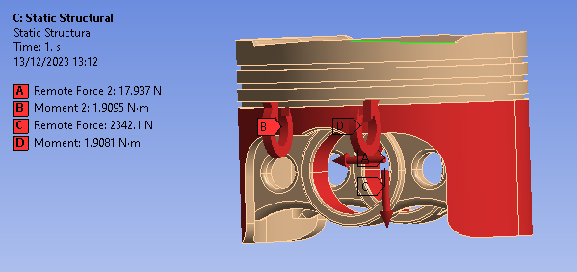
Figure 12 - Modified Piston Motion Loads
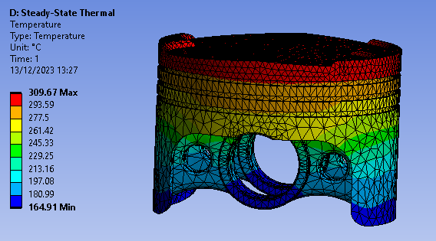
Figure 13 - Modified Piston Temperature
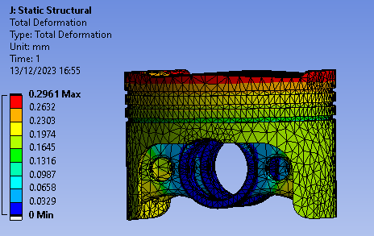
Figure 14 - Modified Piston Deformation
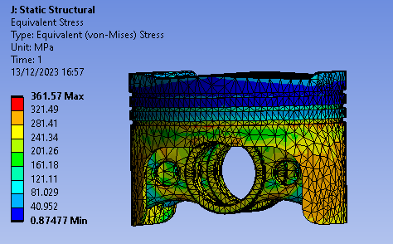
Figure 15 - Modified Piston Von Mises Stress

Analysis of the Fully Linked System
Below are the results of both simulations using the original and modified piston for comparison, revealing differences in motion loads, temperatures, maximum deformation, and von Mises stress. The modified design demonstrated lowered capability in dissipating thermal stress in certain areas of the geometry however in others it exceeded the original, when comparing the maximum deformation and von Mises stress values, the modified piston indicated having less structural integrity. Comparing this data is essential for assessing the design changes' effectiveness and provide a basis for further improvements to optimize piston performance and durability.

Forces on the piston
Table 7 displays the different motion loads generated from the original and modified pistons rigid dynamics studies, as can be seen from the results the modified piston with a reduced mass had slightly lower motion loads.

Table 7 - Rigid Dynamics Forces
Point ( About Axis) | Original | Modified
A - Pressure | 10.5 MPa (Gas Pressure) | 10.5MPa (Gas Pressure)
B – Remote Force (x) | 2389.5 N | 2354.9 N
C – Moment (y) | 2389.3 Nmm | 2342.1 Nmm
D – Remote Force 2 (y) | 221.54 N | 87.738 N
E – Moment 2 (piston skirt) | 2223 Nmm | 1102.9 Nmm

Temperature
Table 8, which shows temperature data from the steady state thermal analysis, indicates some notable differences between the original and modified pistons. The crown of the modified piston is slightly hotter, while the sides of the crown are cooler compared to the original. There's a marginal increase in temperature in the ring grooves and oil ring areas of the modified piston. The skirt temperature shows a notable decrease in the modified piston, suggesting improved thermal management. Additionally, the underside of the modified piston has a lower minimum temperature, indicating potentially better cooling efficiency.

Table 8 - Temperature across Different Areas of Both Pistons
Location | Original (°C) |  | Modified (°C)
Crown | 300.13 |  | 302
Sides of the Crown | 297.43 |  | 294.68
Ring Grooves | 280.31 |  | 281.9
Oil Ring | 263.42 |  | 266.23
skirt | 264.49 max | 174.75 min | 249.1 max | 172.92 min
underside | 273.65 max | 167.56 min | 272.53 max | 162.37 min

Maximum deformation
For the modified piston, a maximum deformation of 0.2961mm was observed at the edge of the crown, whereas the original piston exhibited a maximum deformation of 0.02445mm in the same area. This indicates that the modified design experiences considerably more deformation under similar conditions, suggesting a potential problem with its structural integrity.

Von Mises (Equivalent) Stress
Table 9 below displays point data for different areas of each piston and the Von Mises stress seen at that area, for the original the highest stress occurred where the Gudgeon hole meets the main body of the piston at a value of 334.4 MPa, comparatively the highest stress on the modified piston was seen at the edge of the oil ring groove at a value of 361.57 MPa as shown in figure 16 (original) and figure 17 (modified).
Other notable stress differences include a lower stress at the side of the crown and Gudgeon hole in the modified piston. However, the skirt of the modified piston shows a significant increase in stress compared to the original, indicating a shift in stress distribution in the modified design.
Table 9 - Von Mises Stress
Location | Original (MPa) | Modified (MPa)
Maximum | 334.4 (Gudgeon Pin Support) | 361.57 (Oil Ring Groove)
Side of the Crown | 74.748 | 71.89
Gudgeon Hole | 237.09 | 189.03
skirt | 0.54837 | 267.18

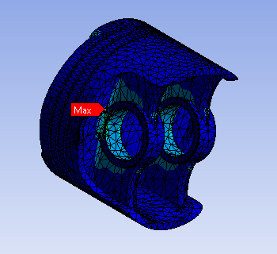
Figure 16 - Location of the Maximum Von Mises Stress - Original
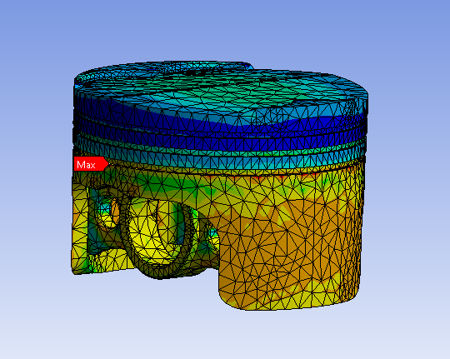
Figure 17 - Location of the Maximum Von Mises Stress - Modified

Limitations and Challenges of CAE.
During this study, a key limitation of CAE was its inconsistency in simulation results. Running multiple iterations of the same geometry with identical boundary conditions in studies like steady state thermal analysis occasionally yielded different outcomes.
Additionally, the process for modifying geometries proved challenging at times. Alterations made to the geometry required creating a new study rather than updating the existing one, leading to a time-consuming process for even minor changes. Furthermore, multiple simulations were often necessary after a geometry change, as the system sometimes failed to calculate results on the first attempt.
These limitations found whilst conducting this study highlight an element of unpredictability in simulation outcomes which can necessitate multiple itterations, reducing efficiency. Moreover, the inability to easily modify geometries in existing studies adds to the time and complexity of this process.

Conclusion.

To conclude, the analysis of the fully linked system for the original and modified pistons reveals key differences in forces, temperatures, deformation and von Mises stress. The modified piston shows altered thermal distribution with slightly higher temperatures at the crown and lower temperatures at the skirt and underside, suggesting improved heat distribution. Maximum deformation was significantly higher in the modified piston, raising concerns about its structural integrety, in addition to this the highest von Mises stress in the modified piston shifts to the oil ring groove, indicating a redistribution of stress compared to the original design.
However, it is important to note the modified geometry was created through a trial-and-error process of creating a working model to compare with the original, if this study was to be repeated then an in-depth topology study to find where material can be taken away with the aim of keeping the forces and stresses felt by the piston consistent with the original or lowering them.

References.
- Ansys (CES) Granta EduPack R2 (2022) [Computer program]
- Ansys (CES) Workbench 2021 R1 (2021) [Computer program]
- Azadi, Bahmanabadi, Gruen and Winter (2020) ‘Evaluation of tensile and low-cycle fatigue properties at elevated temperatures in piston aluminium-silicon alloys with and without nano-clay-particles and heat treatment’ Materials Science and Engineering: A. Volume 788, Page(s) 2-15
- More and Bindu (2015) ‘Effect of Mesh Size on Finite Element Analysis
- of Plate Structure’ International Journal of Engineering Science and Innovative Technology (IJESIT). Volume 4, Issue 3, Page(s) 181-185
- Rajam, Murthy and Krishna (2013) ‘Linear Static Structural Analysis of Optimized Piston for Biofuel Using Ansys’ International Journal of Mechanical and Production Engineering Research and Development (IJMPERD). Volume 3, Issue 2, Page(s) 11- 20.
- Singh, Rawat, Hasan and Kumar (2015) ‘Finite Element Analysis of Piston in Ansys’ International Journal of Modern Trends in Engineering and Research. Page(s): 619-626
- Viswanath, Ajay, Bharathraja, Deepika and Ramnath (2021) ‘Design and Analysis of Piston on Different Materials using CAE Tools’ International Journal of Engineering Research & Technology (IJERT) ETEDM – 2021, Vol.9, Issue 10. Page(s) 37-43
- Zhang, Zuo and Liu (2013) ‘Stepped-isothermal fatigue analysis of engine piston’ FFEMS Fatigue & Fracture of Engineering Materials and Structures. Volume 37, issue 4 page(s) 349 - 461.

