

Management Economics

Assessment component 2 / Report
Module Lecturer: Dr David Jenkins
Name: Dorin Barban
Student ID: 2114965
Module code: LCBB5003
Program and level: Business Management, Year 2 L5

Executive Summary

The United Kingdom was made on the first date of the 19th century. The country’s present population is around 68,816,589. The most of citizens of the country are white British. Moreover, most of the citizens are following Christianity in the country. The manufacturing and production profile along with imports and exports, and major trading partners of the UK have been evaluated in the report. The report indicated that the pandemic, Brexit and Ukraine-Russia war have affected the import, exports as well as other trades in a major way. The UK has experienced fluctuation in the inflation rate along with unemployment issues and the insatiable GDP. It can incorporate Keynesian economics theory for improving the economic sustainability and management in the country.

Table of Contents
Introduction 4
Overview of the country in respect of its population, type of government, ethnicity, and religion 4
Evaluation of manufacturing and production profile along with imports and exports, and major trading partners of the UK 7
Manufacturing and production profile of the UK 7
Imports and exports, and major trading partners of the UK 9
Analysis of the macroeconomic indicators 10
Conclusion 14
References 15

Introduction
The country's population as well as its working service industries plays a major role in the growth and development of the nation along with its economic factors. The report has been developed to understand how different service factors and business operations in the UK contribute to the economic growth of the nation. Overview of the country in respect of its population, type of government, ethnicity, and religion will be provided in the report for understanding the basic factors of the UK. In addition, an evaluation of the manufacturing and production profile along with imports and exports, and major trading partners of the UK will be done as well for comprehending how the use of these aspects economically benefits the nation. Furthermore, the macroeconomic indicators of the nation will be analysed in the report as well.
Graphs and statistical information regarding the information provided will be demonstrated in the report as well.

Overview of the country in respect of its population, type of government, ethnicity, and religion
The “United Kingdom of Great Britain” and “Northern Ireland” is usually called the United Kingdom (Government of Netherlands, 2023). It is a country situated in Europe. The United Kingdom was made on the first date of the 19th century, on 1st January 1801 by joining Great Britain and Ireland. As per the opinion of the research by Wendling (2021), the United Kingdom was formed under the “Act of Union 1800”. The act was passed by both parliament of Ireland and Greta Britain. After the merger, the separate parliaments of Ireland and Greta Britain has been abolished and created a new parliament known as the “Parliament of the United Kingdom”. The United Kingdom defeated the French army and emerged as a superpower across Europe. The country made an industrial revolution in the 19th century and enhanced its trade policies to do business with the neighbouring countries. The United Kingdom has less power and population as compared to the French government at that time. However, with the help of mobilising the country’s financial and industrial resources, the United Kingdom made a strong force and defeated French dominance in Europe. They have captured some portion of the United State and enhanced their presence in the Asian contingency.
Besides this, the Whigs party of the United Kingdom focused on social reforms in their region and took effective measures to abolish slavery in the country. According to Manjapra (2019), the government incorporated the “Slavery Abolition Act, of 1833” and purchased all the slaves in the country for approximately £20,000,000. Then they freed all the slaves and promote a sustainable society in the country.


Figure 1: Flag of the United Kingdom
(Source: Briggs et al., 2023)
The national flag of the United Kingdom is known as the “Union Jack” (Briggs et al., 2023). It was first inaugurated by King James in 1606.
The current population of the United Kingdom is around 68,816,589 (Worldometer, 2023). This vast population have contributed to the development of the country and helped the economic expansion of the country. They have made the nation strong in every aspect and increased the country’s capacity to become a superpower in the global scenario. The country has a constitutional monarchy. The king has occupied the highest position in the state but does not make any decisions to run the country. All the crucial decisions have been made by the British parliament which has been nominated by the citizens of the country (Parliament, UK, 2023).
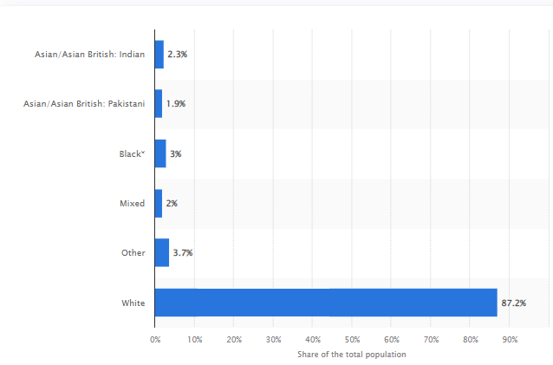
Figure 2: Ethnicity in the United Kingdom
(Source: O’Neill, 2022)
The most of citizens of the country are white British. They have occupied around 87% of the total population. Additionally, 2.3% of citizens are Asian and 3% of citizens are Black population.
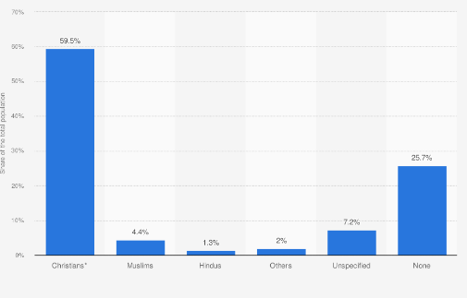
Figure 3: Religions of the United Kingdom
(Source: Statista, 2022)
From the above figure, it has been observed that 59.5% of the total population has been identified as Christians and 25.7% of the total population has not identified themselves under any religious boundaries. Moreover, there are around 4.4% of Muslims and 1.3% of the Hindu population in the country.

Evaluation of manufacturing and production profile along with imports and exports, and major trading partners of the UK

Manufacturing and production profile of the UK
In the UK, the major sectors that manufacture and produce products for the nation as well as for exporting products are food, drink, tobacco, paper, printing, publishing and textiles (Themanufacturer, 2023). The major business firms in the UK that contribute to the manufacturing and production profile of the UK are Diageo, Unilever, Cadbury, Tate & Lyle, British American Tobacco, Imperial Tobacco, HarperCollins and Reed Elsevier. The biggest manufacturing industry of the UK is the food manufacturing industry which makes up 20 % of the total sales. The manufacturing and sales of wood and furniture come next (Tradingeconomics, 2023).
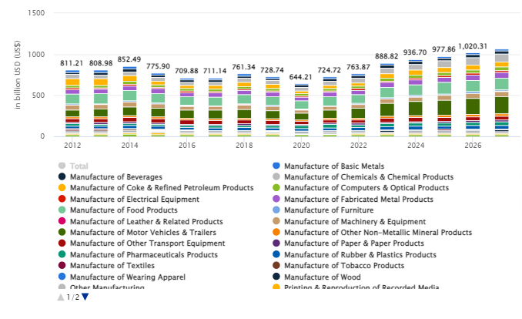
Figure 4: Revenue from the manufacturing industry of the UK in the last few years
(Source: Statista, 2023)
The graph indicated that the revenues that are projected in the manufacturing industry will amount to over 888.90 billion US Dollars in 2023. The annual growth rate of the manufacturing industry is expected to be 4.65% CAGR for the financial years 2023 to 2027.
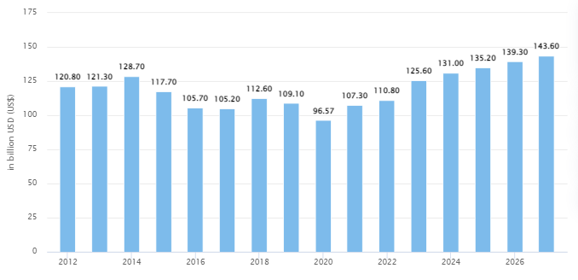
Figure 5: The revenue generation by the food manufacturing industry in the UK
(Source: Statista, 2023)
The above graph indicates that the revenue in the food manufacturing industry is expected to grow to 125.60 Billion US Dollars in the year 2023. The annual growth rate of the industry is expected to grow at 3.40 % CAGR for the financial year 2023 to 2027 (Gov, 2023). The total number of firms in this industry is over 8500.
However, it has been observed that the overall manufacturing and production of products in the UK will decrease by over 5 % in 2022. By the end of 2022, the downfall of manufacturing and production in the UK has been observed due to the post-pandemic situation, the Brexit situation as well as Ukraine-Russia war (Gov, 2023). The pandemic situation in the financial year 2019 has especially impacted the manufacturing industry in a negative way.
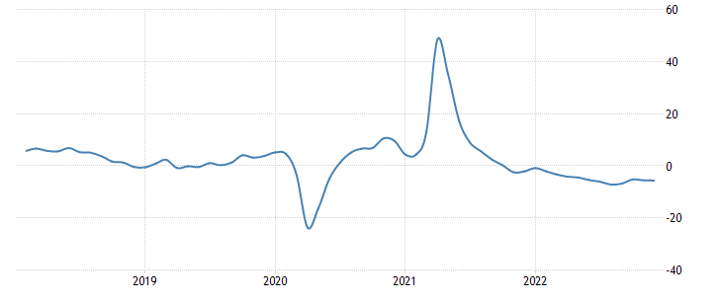
Figure 6: Manufacturing and production in the UK in the last 5 years
(Source: Trading economics, 2023)
The graphs have indicated that the manufacturing and production business in the UK makes the most of economic puppets in the nation. The most significant sectors in the UK are the food, Tobacco and drinks industries along with the production of transport equipment, basic metals as well as other manufacturing and repairing equipment (Statista, 2023). In addition, pharmaceutical product manufacturing along with rubber and plastic products are also included in the manufacturing and production industry.

Imports and exports, and major trading partners of the UK
Destinations in which the UK exported the most till the end of 2022 are the United States with 5.38B Pounds, China with 4.34B Pounds, Switzerland with 3.61B Pounds, Netherlands with 3.49B Pounds and Germany with 2.93B Pounds (OEC, 2023). The nation imported mostly from China for 6.86B Pounds, the United States for 6.82B Pounds, Germany for 6.11B Pounds, the Netherlands for 5.08B Pounds and France for 3.08B Pounds. The major import partners of the UK are Germany, Ireland, Netherlands and France as per the reports from the World Bank. In the analysis of the reports from November 2022, the UK exported over 42.1 Billion Pounds and imported over 59.1 Billion Pounds (Statista, 2023). This has resulted in the nation's negative trade balance of 17 Billion Pounds. Between November 2021 to November 2022, the exports of the UK improved by 12 Billion Pounds (that is 40.7 %) from 29.9 Billion Pounds to over 42 Billion Pounds. On the other hand, the imports in the UK have increased as well with an increase from 47.8 Billion Pounds to over 59 Billion Pounds, which is an increase of 11.3 Billion Pounds (23.7 %).
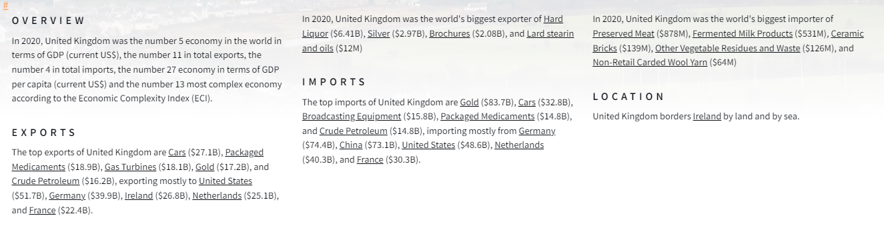
Figure 7: Imports and exports of the UK in 2020
(Source: OEC, 2023)
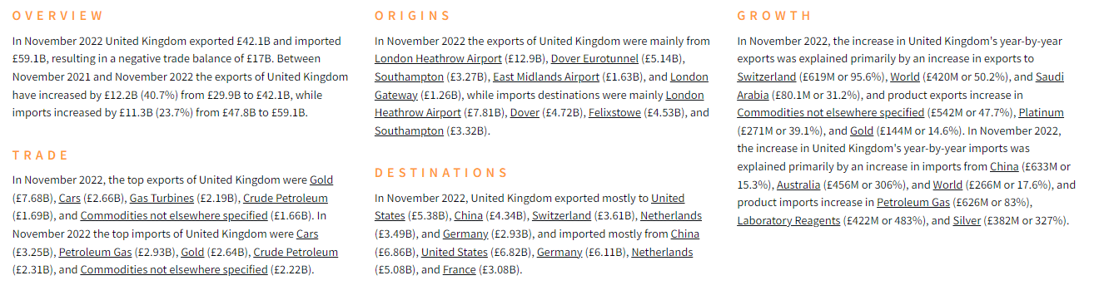
Figure 8: Imports and exports of the UK in 2022
(Source: OEC, 2023)
It has been observed that from the last few years, the total amount of imports and exports in the nation has increased in the financial year 2022 (OEC, 2023). However, due to the Ukraine-Russia war, the imports in the UK have been reduced, that is the imports of gas and refined petroleum have reduced.

Analysis of the macroeconomic indicators
The indicators of the economy can help to assess the economic activity of both the nation and international horizon. Countries generally produce products and consumed them in the domestic market (Merga and Haji, 2019). On the other hand, these products are also transacted through an international trading system. These factors can help to determine the economic condition of a country with respect of its current market position in the global market. In this context, it can be stated that these aspects help to determine the economic status of a country. Therefore, it can be stated that economic indicators play an important role to foster change in the case of size, market opportunity and contractions of the economy.
Macroeconomic aspects deal with the GDP rate of a country along with the expenditure and consumption of the products, and the budget of the country. The supply of money across the country is the major aspect that can help to determine the country's economic status and sustainability in the economy as well (Zafar et al., 2022). Therefore, these factors can be considered macroeconomic indicators for a country.
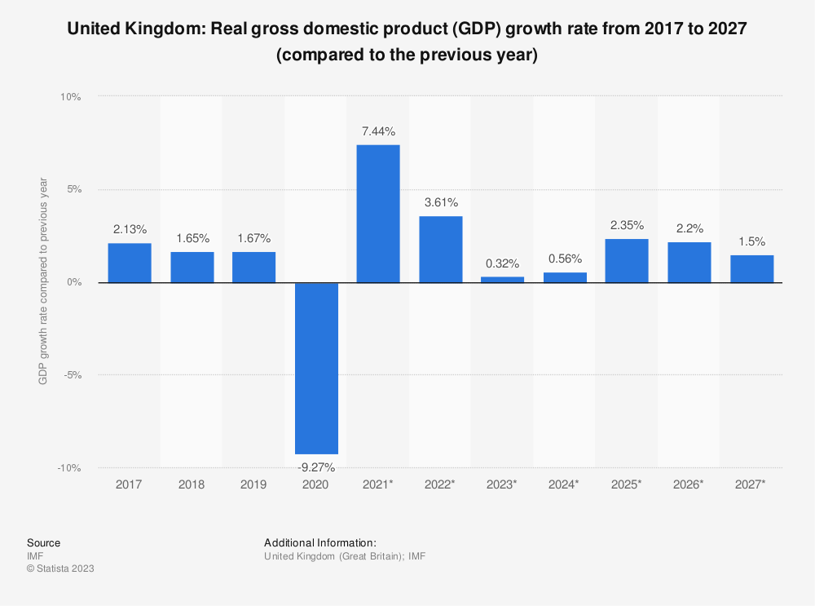
Figure 9: GDP fluctuation 2017 - 2027
(Source: Statista, 2023)
From the above figure, the facts can be determined that the GDP rate of the UK was moderate before 2020. It was struggling to increase and stabilise as well. However, due to the pandemic in 2020, the GDP rate of the UK dropped by -9.27% (Statista, 2023). It again recovered from 2021, as the selling rate of the goods along with the consumption rate gets increased post-pandemic. Therefore, it can be stated that in recent 5 years, the GDP rate of the UK was fluctuating it has not been stable for long. However, the big bang policy of the UK government helps to counter the unstable status of the economy.
Unemployment is a significant issue in most countries due to insatiable infrastructure. According to Pratap et al. (2021), most developing countries suffer from the issue of a high unemployment rate within the region due to a lack of opportunities and infrastructure for employment as well. On the other hand, being a developed country, it is least expected from the UK and its structure of being suffered from the unemployment issue. However, it can be seen that the UK also experienced a higher rate of unemployment.
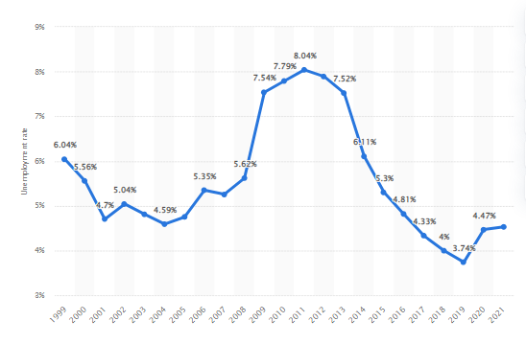
Figure 10: The Unemployment ratio of the UK
(Source: Statista, 2023)
From the above statistics, it can be stated that the issue of unemployment was rooted in the UK for a very long around 1999 or even before that (Statista, 2023). The rate of unemployment was moderate in the country. However, it was drastically getting high from 2009 to 2019, in these 10 years of duration; the country was suffering from huge unemployment issues. Unemployment is one of the most influential challenges for a country in the case of stabilising its economy within the global market (Indrawati and Kuncoro, 2021). On the other hand, it also can be observed that post the pandemic state, 2019 the rate is gradually lower for further improvement in the economy.
Inflation is a state in which the power of the consumers gets lower than the available price of the commodities in the competitive market. Moreover, the original monetary value gets reduced during this period, as most of the residents can be capable of purchasing the products with their available money. In other words, it also can be stated that the monetary flow of a country gets disrupted due to the increasing rate of money and lower transactions. The UK has been experienced the inflation condition a few times.

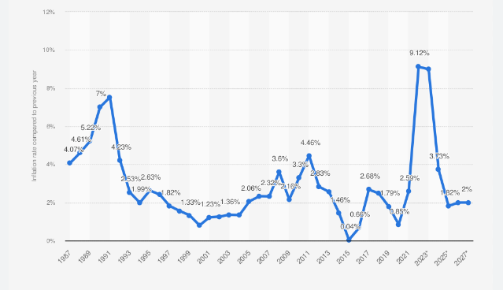
Figure 11: Inflation rate of the UK
(Source: Statista, 2022)
The above figure helps to understand that the UK has experienced inflation several times. It affects the development and the money flow within the country. The UK has been going through the issue of inflation from 2015 to 2020, and the state getting better from 2021 after the accessibility and opportunity of different businesses (Statista, 2022). The Keynesian economics theory can help to analyse the financial instability of the UK over the last 5 years even more briefly.
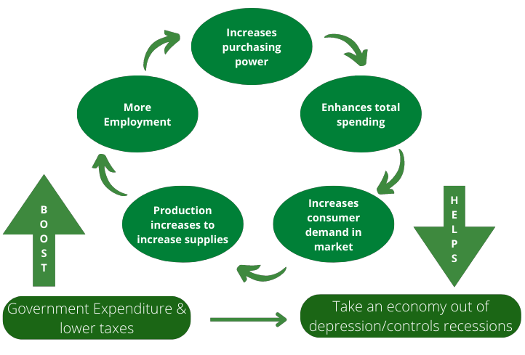
Figure 12: Framework of Keynesian economics theory
(Source: Lavoie, 2019)
This theory helps to determine economic growth in respect of the expenditure within the economy. It also helps to understand the importance of monetary policy for managing and controlling the money flow within an economy. Economic stabilisation greatly depends on the governmental policies and expenditures within the businesses (Chugunov et al., 2021). The expenditure of the government and non-government finances can help to enhance the production capability of most companies, which increases the production rate of goods and commodities across the country. The increased rate of production helps to boost the consumption rate nationally and internationally.

Foreign Exchange

Ipek Ozkardeskaya of Swissquote Bank stated in 2016 that the pound had dropped to its lowest level against the US dollar in 31 years after the UK voted to leave the European Union. However, in 2017, it started to recover after the Bank of England increased its interest rates (BBC News, 2017).
The uncertainty surrounding the UK's exit from the European Union continued to affect the value of the pound in 2019. In 2020, the pandemic of COVID-19 caused the pound to lose value against the US dollar. However, the implementation of the UK's trade deal with the EU and the availability of vaccines helped boost the currency's value by the end of that years. (BBC News, 2020b).

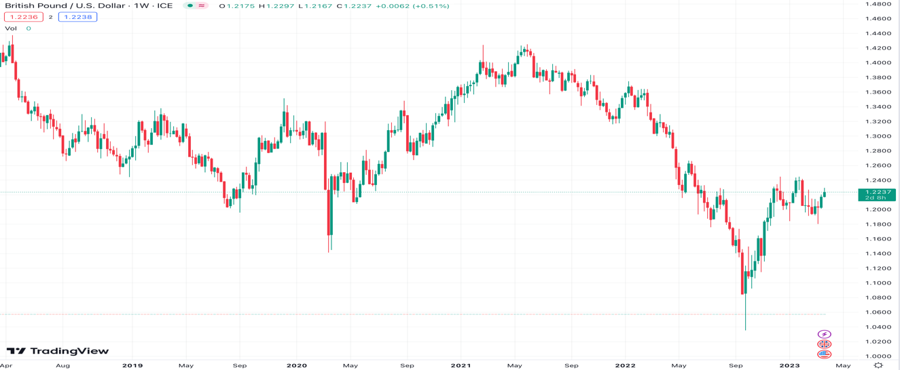
Figure 13 British Pound/ U.S.Dollar
(Source tradingview.com)

Balance of Payments

A country's current account deficit is a vital part of its economic performance. It shows the flow of services and goods between the nation and the rest of world. In the United Kingdom, the deficit has increased to 3.9% of its GDP in 2019 (Office for National Statistics, 2020).
The deficit can also be caused by various factors, such as an increase in imports and a decline in export revenues. According to Mundell-Fleming, an imbalance in the current account can be caused by an overvaluation of the exchange rate, as well as domestic demand. For instance, the UK's investment income declined due to the fall in the value of the pound.

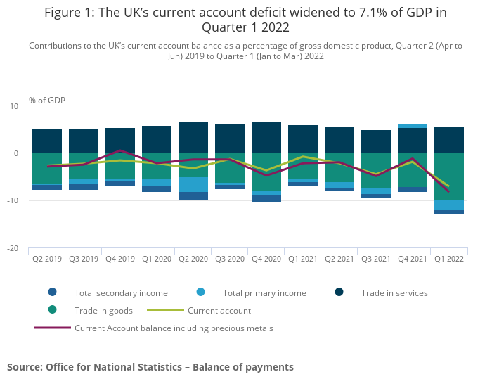

Figure 13: Balance of Payments
Source: Office for National Statistics (2020)
Budget Balance

The UK's budget deficit has been a recurring issue for several years now (Office for National Statistics, 2020). It can be attributed to various factors, such as the country's high public spending and the lack of tax revenues.
The theory of Keynesian economics states that a budget deficit can stimulate economic growth by increasing aggregate demand. Unfortunately, this can also lead to higher interest rates and inflation as the government must borrow money to fund its spending.

Interest Rates

Central banks use interest rates as a tool to manage economic growth and inflation. In the UK, for instance, the Bank of England keeps its key rate at a record low of 0.1% to stimulate the country's economy and prevent deflation (Bank of England, 2020).
The concept of the Taylor rule states that interest rates should be based on the country's inflation and the output gap (Taylor, 1993). However, in response to the UK's economic growth concerns, the Bank of England decided to deviate from this rule.

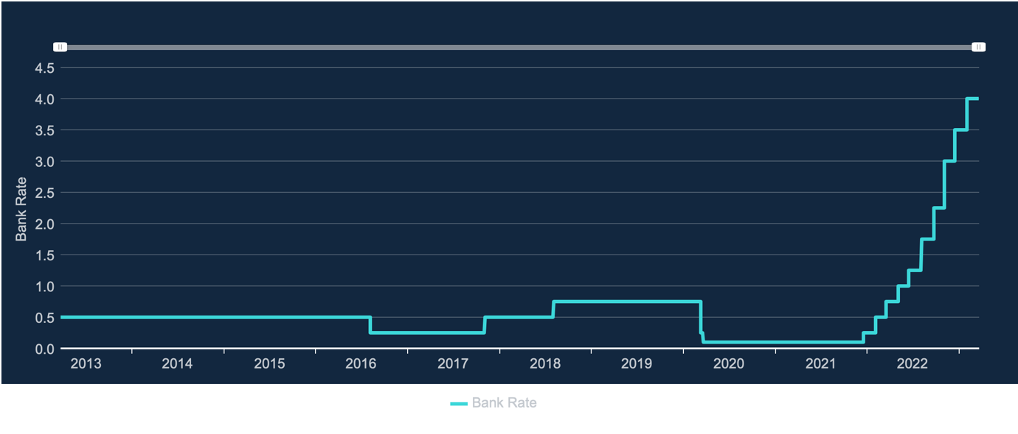
Figure 14: Interest Rates
Source: Bank of England (2020)

Conclusion
From the above discussion, it can be concluded that the nation's trade, imports and exports as well as the domestic production of the nation are successful considering certain factors. In the pandemic and post-pandemic situation along with the effect of Brexit and the Ukraine-Russia war, trade and imports as well as exports have been impacted in a negative way. However, domestic manufacturing and production in the UK are positively enhanced as demonstrated through the statistics and facts. The report indicated how the macroeconomic factors in the contemporary business aspect have affected the national economy and business activities in the UK. In addition, the economic aspects that have been impacted due to macroeconomic factors have been demonstrated through graphs and tables.

References

Bank of England. (2020). Interest Rates. Retrieved from https://www.bankofengland.co.uk/boeapps/database/fromshowcolumns.asp?Travel=NIxIRxSUx&FromSeries=1&ToSeries=50&DAT=RNG&FD=1&FM=Jan&FY=1963&TD=31&TM=Dec&TY=2023&FNY=&CSVF=TT&C=IIN&Filter=N
BBC News. (2017). Pound surges after interest rate hike. Retrieved from https://www.bbc.com/news/business-41846330

BBC News. (2020a). Pound falls to lowest level in over 30 years. Retrieved from https://www.bbc.com/news/business-51953917

BBC News. (2020b). Pound reaches highest level against dollar since May 2018. Retrieved from https://www.bbc.com/news/business-55212020
Briggs, A., Smith, L., Atkins, R., 2023. United Kingdom. [Online], Available at:<https://www.britannica.com/place/United-Kingdom>, Accessed on 14 February 2023.
Chugunov, I., Pasichnyi, M., Koroviy, V., Kaneva, T. and Nikitishin, A., 2021. Fiscal and monetary policy of economic development. European Journal of Sustainable Development, 10(1), pp.42-42.
Gov, 2023. Manufacturing and production industry. Available from: https://www.ons.gov.uk/businessindustryandtrade/manufacturingandproductionindustry#:~:text=The%20manufacture%20of%20food%20remains,largest%20proportional%20increases%20in%20sales [Available on 14 February 2023]
Gov, 2023. UK trade: June 2022. Available from:
Government of Netherlands, 2023. Which countries make up the United Kingdom.[Online], Available at:<https://www.government.nl/topics/brexit/question-and-answer/which-countries-make-up-the-united-kingdom#:~:text=The%20United%20Kingdom%20(UK)%20is,Scotland%2C%20Wales%20and%20Northern%20Ireland.&text=Was%20this%20information%20useful%20for%20you%3F>, Accessed on 14 February 2023.
https://www.ons.gov.uk/economy/nationalaccounts/balanceofpayments/bulletins/uktrade/june2022 [Available on 14 February 2023]
Indrawati, S.M. and Kuncoro, A., 2021. Improving competitiveness through vocational and higher education: Indonesia’s vision for human capital development in 2019–2024. Bulletin of Indonesian Economic Studies, 57(1), pp.29-59.

Krugman, P. R., Obstfeld, M., & Melitz, M. J. (2012). International economics: theory and policy (Vol. 9). Pearson.
Lavoie, M., 2019. Modern monetary theory and post-Keynesian economics. Real-world economics review, 89(3), pp.97-108.
Manjapra, K., 2019. The Scandal of the British Slavery Abolition Act Loan. Social and Economic Studies, 68(3/4), pp.165-184.
Mankiw, N. G. (2014). Principles of macroeconomics. Cengage Learning.
Merga, B. and Haji, J., 2019. Economic importance of chickpea: Production, value, and world trade. Cogent Food & Agriculture, 5(1), p.1615718.
O’Neill, A, 2022. United Kingdom-ethnicity.[Online], Available at:<https://www.statista.com/statistics/270386/ethnicity-in-the-united-kingdom/>, Accessed on 14 February 2023.
OEC, 2023. The UK. Available from: https://oec.world/en/profile/country/gbr#:~:text=Destinations%20In%20November%202022%2C%20United,France%20(%C2%A33.08B). [Available on 14 February 2023]
OEC, 2023. The UK. Available from: https://oec.world/en/profile/country/gbr#:~:text=Overview%20In%20November%202022%20United,B%20to%20%C2%A359.1B. [Available on 14 February 2023]
Office for National Statistics. (2020). Balance of Payments. Retrieved from https://www.ons.gov.uk/economy/nationalaccounts/balanceofpayments/timeseries/ikbj/pnbp
Ozkardeskaya, I. (2016). Pound hits lowest level since 1985. Swissquote Bank.

Parliament, UK, 2023. Parliament and the Government.[Online], Available at:<https://www.parliament.uk/about/how/role/relations-with-other-institutions/parliament-government/>, Accessed on 14 February 2023.
Pratap, P., Dickson, A., Love, M., Zanoni, J., Donato, C., Flynn, M.A. and Schulte, P.A., 2021. Public health impacts of underemployment and unemployment in the United States: Exploring perceptions, gaps and opportunities. International journal of environmental research and public health, 18(19), p.10021.
Statista, 2022. Inflation rate in the United Kingdom. Available at: <https://www.statista.com/statistics/270384/inflation-rate-in-the-united-kingdom/> [Accessed on 14 February 2023].
Statista, 2022. Religions of the United Kingdom.[Online], Available at:<https://www.statista.com/statistics/270385/religions-in-the-united-kingdom/>, Accessed on 14 February 2023.
Statista, 2023. Manufacture of Food Products - United Kingdom. Available from: https://www.statista.com/outlook/io/manufacturing/manufacture-of-food-products/united-kingdom#revenue [Available on 14 February 2023]
Statista, 2023. Manufacturing - United Kingdom. Available from: https://www.statista.com/outlook/io/manufacturing/united-kingdom#revenue [Available on 14 February 2023]
Statista, 2023.Gross domestic product (GDP) growth rate in the United Kingdom. Available at: <https://www.statista.com/statistics/263613/gross-domestic-product-gdp-growth-rate-in-the-united-kingdom/> [Accessed on 14 February 2023].
Statista, 2023.The unemployment rate in the United Kingdom. Available at: <https://www.statista.com/statistics/263709/unemployment-rate-in-the-united-kingdom/> [Accessed on 14 February 2023].

Taylor, J. B. (1993). Discretion versus policy rules in practice. Carnegie-Rochester Conference Series on Public Policy, 39, 195-214.

Themanufacturer, 2023. UK Manufacturing Statistics. Available from: https://www.themanufacturer.com/uk-manufacturing-statistics/ [Available on 14 February 2023]
Tradingeconomics, 2023. United Kingdom Manufacturing Production. Available from: https://tradingeconomics.com/united-kingdom/manufacturing-production#:~:text=Manufacturing%20Production%20in%20the%20United%20Kingdom%20averaged%201.38%20percent%20from,percent%20in%20April%20of%202020. [Available on 14 February 2023]
Wendling, K.B., 2021. “The priests do their best to inflame the people.” Religious actors in Ireland, 1800–1845: Instigators of violence or peacemakers?. Violence: An international journal, 2(1), pp.106-130.
Worldometer, 2023. United Kingdom Population.[Online], Available at:<https://www.worldometers.info/world-population/uk-population/#:~:text=The%20current%20population%20of%20the,year%20according%20to%20UN%20data.>, Accessed on 14 February 2023.
Zafar, M.W., Saleem, M.M., Destek, M.A. and Caglar, A.E., 2022. The dynamic linkage between remittances, export diversification, education, renewable energy consumption, economic growth, and CO2 emissions in top remittance‐receiving countries. Sustainable Development, 30(1), pp.165-175.

