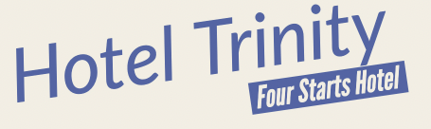
CHRISTMAS DAY MENU

STARTERS

Traditional Scotch Broth £8.90
This will be served with a crusty bread roll and butter

Tomato and Pesto Soup £11.00
This will be served with a crusty bread roll and butter

Pearls of Melon £5.90
Topped with a sorbet of blood orange

MAIN COURSES
Royal Deeside Turkey £18.50
Trimmed with chipolata bacon roll, skirlie and finished with a rich gravy

Sirloin Steak £21.00
Topped with chasseur sauce

Pan Fried Salmon £19.59
Topped with a smoked cheese and chive sauce

Note: all main courses will be served with roast potatoes, boiled potatoes, and vegetables.

DRINKS

BEER
Bud Light, Budweiser, Miller Light, Coors, Stella Artois, Guinness, Blue Moon

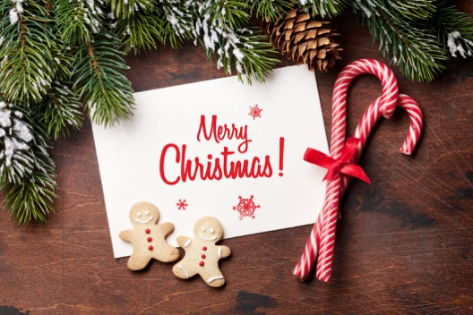
WINE
Syrah, Merlot, Pinot Noir, Sauvignon Blanc, Riesling, Zinfandel, Muscat

SPIRITS
Grey Goose Vodka, Balleys, Patron, Jim Beam, Crown, Captain Morgan

NON-ALCOHOLIC
A selection of soft drinks, juices, water, teas, and coffee are also available.



HotelTrinity_

@HotelTrinity
EXTRAS FOR THE NIGHT
Christmas Carol Concert- Live Band
Arranged play area for children

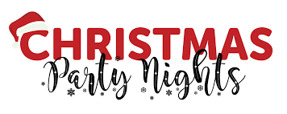

BOOKING DETAILS:
You can book your table by accessing our website:
www.hoteltrinity.co.uk

