Globally Responsible Business (BMSP6001)
Dr Alex Bell
Investigation
Joaquim Anthony Fernandes (1805865)

Executive Summary

This summary is to show my critical understanding and knowledge of how to systemically evaluate approaches to responsibility in business and demonstrate how to research, critically analyse, and propose solutions to ethical challenges for my chosen organisation.

Introduction

The purpose of this assignment is to reflect how the principles of the circular economy can emphasise a responsible business and this will be done by discussing what the linear economy is and what the circular economy is and then compare the two and once they have been compared with each other and then can see where they differ from each other. This will consist of what issues does the linear economy have and how can the circular economy resolve these issues. After that what will be discussed then would be a little description about the share economy and how the share economy is part of the circular economy and how it alters the way we change from product ownership to service acquisition and then see how it fits within the circular economy and how it can benefit the circular economy. Another purpose for this assignment is to choose a company as a case study and do some research in how the chosen business already displays the principles of the circular economy, what tasks the chosen company is still facing and how those tasks can be accomplished as a set of short, medium and long term goals.

The linear economy is an old style of model based on the steps of take, make, consume, and waste. Which basically means that raw materials are transformed into a product and then the product is then utilised all the way to the end of its lifecycle and then it gets thrown away and sent to landfill (Entrepreneurship Campus, 2019). Whereas the circular economy is transforming all the steps of take, make and waste as it is a model based on the principles of designing out waste and pollution which is changing our viewpoint that waste is a design flaw and utilizing new materials and technologies in the correct way can then guarantee that waste and pollution are not created in the first place , keeping products and materials in use instead of just wasting resources, as some products can be reused, repaired and remanufactured, and regenerating natural systems will cause less harm as we as human being will be aiming to do good. By restoring valuable nutrients to the soil and other ecosystems, which will then let us improve our natural resources (ELLEN MACARTHUR FOUNDATION, 2017).

The issues that come with the linear economy is not only can it come with ecological and environmental issues, but it can also come with economical issues. The ecological issues consists of unnecessary pressure on the planets ecosystems which then risks the provision of vital ecosystem services such as water, air, and soil cleaning. Using the three steps of the linear economy take, make and waste can also affect the planets ecosystem as the collection of all the raw materials leads to high energy and water consumption, emissions of toxic substances and the disruption of natural capital such as forests and lakes. Another issue caused by the steps of the take, make and waste is that a lot of plastics are being used in a short period of time. As a result of this, three hundred million tonnes of new plastics are being produced globally each year, and from that three hundred million, five million tonnes either end up in the ocean, dumped on land or can end up in the sewer systems. The economic issues of the linear economy can consist of risk towards the supply of materials, the change of pricing towards raw materials, scarce materials, geopolitical dependence on different material and the increase of demand for materials (NaturKilma, 2021). The circular economy resolves the issues of the linear economy as it based on minimising the extraction of raw materials, using renewable energy will stop the unnecessary pressures of the vital ecosystem services, reduced emissions will stop the issue of toxic substances being emitted and by following the principles of the circular economy will help reduce the plastics getting dumped into the ocean, sewer systems and dumped onto land. Circular economy will also solve linear economy issues by reducing dependence on importance of raw materials which solve the issue of geopolitical dependence on different materials, avoidance of environmental damage caused by resource extraction will help solve the issue of disruption of the natural capital and the circular economy will also be the creation of new green industries and jobs (WASTE WISE PRODICTIONS, 2017).

The share economy also known as peer to peer based sharing is basically an economic system founded on platforms that allow the sharing of an asset or resource among peers (MARKET BUSINESS NEWS, 2020). Share economy is transforming the way we change from product ownership to service acquisition by renting out products instead of buying thigs new all the time or could even share with friends or family, which will generate income for the owners and sharing platforms would also be squeezing more value out of products and financially benefiting users on both sides of a rental transaction. The share economy fits in with circular economy as using the renting process could solve the planets e-waste issue by enticing us to lend and borrow equipment and peer to peer marketplaces could persuade us into thinking to see our purchases as long term investments and the share economy fits into circular economy as it is encouraging us to buy less often when people go out to make purchases, as people would have been enticed to invest in quality, durable and repairable products with a long life span (Dallas, 2020). The benefits of the share economy is that it offers flexibility and efficiency to consumers, where goods and services are accessed for only as long as they are needed, increase quality of service through rating systems and it forces traditional businesses to change which could mean an expansion in entrepreneurship and innovation (AnyGood?, 2018).

Dell Technologies Circular Economy

The business I have chosen as a case study that participates in circular economy is Dell Technologies which is an American multinational technology company based in Texas and it is an information technology company that provides consumers on a worldwide basis with cutting edge technology solutions, services and support from hardware to software and cloud computing (Dell Technologies, 2021). It all started off with the founder Michael Dell who commenced his business in his dormitory room whilst studying at the University of Texas at the same time in 1984. He started his business with only $1000 loan from his parents so he could start off his business and kick it off to begin with he would start by selling computer to his school mates, then he dropped out of school so that his business would be his main focus because he believed that he could provide customers with more powerful technology at a better value by buying computer parts from different companies and then he would assemble them and selling them directly to the consumers. In 1985 Dell built his first computer system called the Turbo PC with a 10MB hard drive, and an intel 8088 processor running T 8MHz meaning it executed 8 million cycles per second.

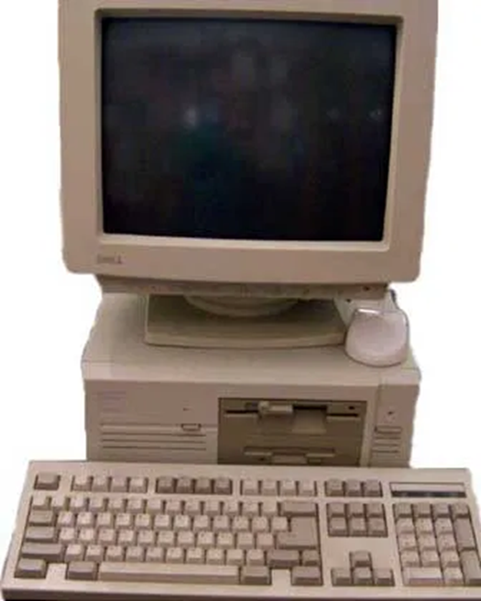

In the upcoming years of 1991 – 2000 with the dawn of the dot com boom Dell continued to expand its operations into North and South America, Asia, and Europe. In 2006 Dell became the first in the technology sector to offer free product recycling for customers worldwide and they were listed in Greenpeace’s Guide to greener electronics (Zibannay, 2016). Now in present times, Dell technologies now consists of two technology companies with one shared vision and that is to drive human progress, through greater access to better technology, for people with big ideas around the world (Dell Technologies, 2021). Dell technologies not only sell computers, laptops, servers, computer software, computer and network security and information security, they are providing services such as consulting services, deployment services, support services, education services, residency services, managed services and Virtustream cloud services (Dell Technologies, 2021).

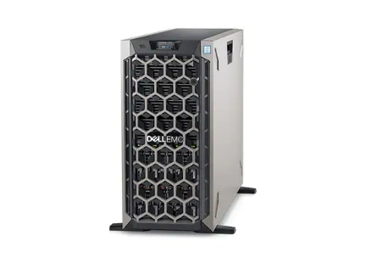
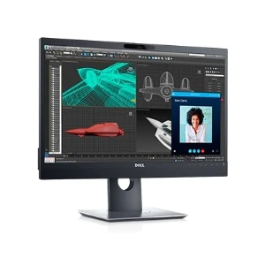
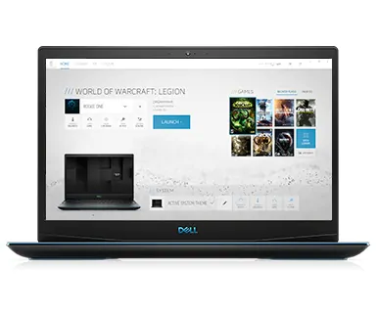

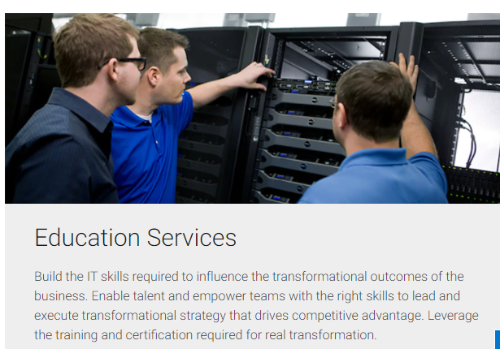
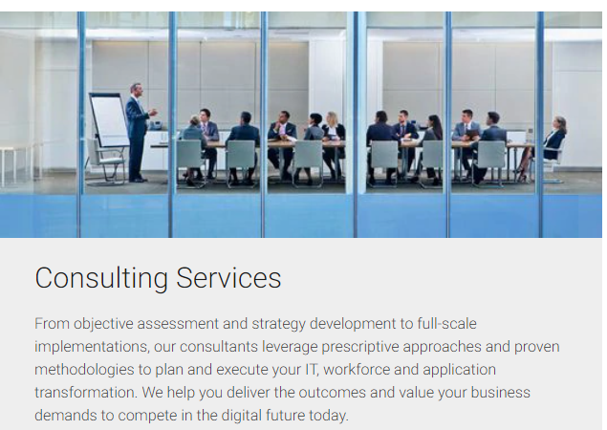
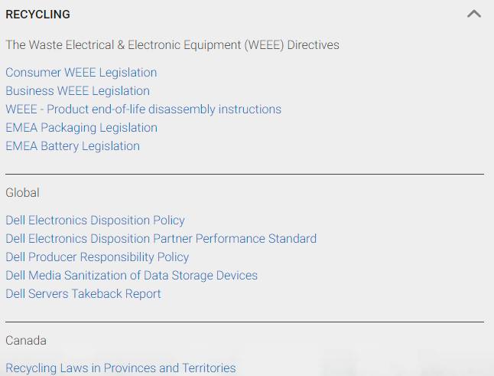
Dell Technologies has been committed to the environment and its sustainability of their products since the company was founded. The company has always looked at the design of the product and has always looked at how to make sure the products is recyclable in the past Dell and the circular economy | Dell Iceland . For example, in 2006 Dell was the first in the technology sector to offer free product recycling for customers worldwide and they were listed in Greenpeace’s Guide to greener electronics (Zibannay, 2016). Whereas now none of that has changed the only thing that has changed is the increase in of the sense of feeling, responsibility, and ability to be more creative and more focused and this is being done by Dell Technologies to look at their product design, look at the material usage, look through the supply chain to see what they are doing and once all those processes have been looked at then Dell would then look at the products end of life cycle and study it to see how the company can recycle and reuse it over and over again Dell and the circular economy | Dell Iceland . To do all this recycling they have put policies in place so that the company can fully support their team members and ensure their workplace is safe. Also, Dell’s policies administer over the materials that are used in their products and how their suppliers that support their operations are held to the highest ethical and environmental standards. The policies include things such as The Waste Electrical & Electronic Equipment (WEEE) Directives, which consist of Product end of life disassembly instructions, packaging legislation and battery legislation and they have other recycling policies for different countries as well such as recycling laws in provinces and territories in Canada, Recycling Program in USA which goes by state by state that the company needs to be abide by. Also, Dell has environmental policies which look at the environmental impact of our products throughout their lifecycle – from how they were built to how they are recycled (Dell Technologies, 2021).
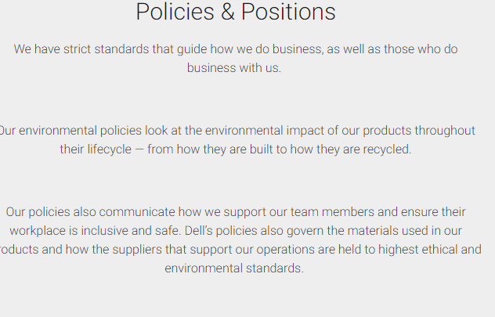

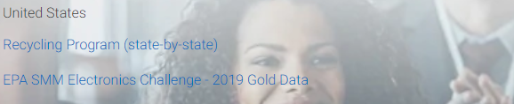
Dell Technologies is not only following policies to show how they are inputting towards the circular economy, but they have also recently been using the closed loop plastics system. The closed loop circular system is a backbone of the circular economy that lets the introduction of plastic materials in the recycling cycle by engaging in a circular way where materials are being recycled and reused rather than being used once and then getting turned into waste (Cornall, 2020). Dell has been using closed loop recycling since 2014, Dell have taken the plastics from old computers recovered from their recycling programs and turned that back into new plastic parts, which gives the plastic parts an extended life and a smaller carbon footprint and it even reduces costs. They are also using the closed loop process for recycling gold from e waste back into new motherboards. This process causes 99 percent less environmental damage than mining virgin gold (Dell, 2021). However, Dell could do more towards sustainable materials when making new products. For example, Apple have been making their products from 100 percent recycled or renewable materials since 2017 (Phipps, 2019).

Challenges

Due to Dell technologies being part of two companies in one the challenges that they are facing is that it will take on more than $45 billion in additional debt which means that dell will be overly exposed to interest rates over a long term period. EMC has over $5 billion in long term debt and $2 billion in short term commercial paper outstanding. Another long term challenge that these two companies are facing while trying to merge together is keeping up with the change of demand as both companies are used to using different operating systems which could take years to solve, and Dell could use this to Buff up their offerings and generate cash flow in the meantime (Lipton, 2015). Dell is also facing long term challenges such as a continuous price war in a highly competitive PC market as technology is always progressing with time and there is a real challenge for Dell’s old strategy in today’s computer market now because most of the PC makers are efficient in decreasing inventory and getting new products into the market (Ignatiuk, 2008). A medium term challenge Dell is facing is e marketing due to global reach and effective communication, e commerce and e marketing becoming more popular (UK Essays, 2017).

Dell’s SWOT Analysis

Strengths  - Strong Branding  - Strong positioning strategy  - Keeps up to date with the technologies.  - Low prices  - Direct marketing  - Product customisation  - Product diversification  - Reliable support  - Excellent customer service and efficient utilization of e commerce. | Weaknesses  - Strategy  - Suppliers  - Lacking in the student community area  - Loss in education market  - No proprietary technology unlike its competitors  - Technology used by Dell is shared by its customers.
Opportunities  - Dell is able to reach any niche market in any part of the world.  - Sell their products directly to the customer.  - Product diversification  - Continuously extending their products. | Threats  - Competitors  - Competitive pricing  - Bargaining power of suppliers and buyers is high.  - Technology advances too quickly  - Branding and low cost strategy should be intensified to sustain.  - E marketing  - Collaboration when making mergers with other companies.

To make the weaknesses into strengths they could make a better policy to improve their strategy making skills, to gain an improvement in the student community area so there is no loss in the education market they could have an outreach team go to schools and colleges to teach them things about technology maybe even organise educational trips to their warehouses where they make their products so that they can see how they are made. To keep up to date with their threats of e marketing the company can ensure that their products and offers are really convincing to the user as through e marketing as they cannot do it in person. Make better policies so that the branding and low cost strategy can be intensified to sustain, and they should make sure they have better collaboration with their partners or who they want to make mergers with so in the future they can see if they operate on similar strategies and systems.

Conclusion

I have met the purposes of this assignment as it reflects how the principles of the circular economy can emphasise a responsible business by comparing the linear and circular economy and saw how they differed and saw how the circular economy can resolve the issues that the linear economy has made. Also, I have discussed how the share economy participates within the circular economy. Another purpose that has been met is that I chose a business and the business I chose was Dell Technologies and I discussed a little bit about the companies history and what they do, and I also discussed how Dell Technologies have participated within the circular economy and saw what tasks the company is still facing and gave them options in how they could resolve the tasks the company is still facing.

References
AnyGood? (2018, December 21). The benefits of the sharing economy. Retrieved from https://anygood.com/: https://anygood.com/benefits-sharing-economy/#:~:text=%20The%20benefits%20of%20the%20sharing%20economy%20,sharing%20economy%20will%20lead%20to%20less...%20More
Cornall, J. (2020). Closed loop: Ailpast system for reuse of plastic packaging. Retrieved from https://www.dairyreporter.com/: https://www.dairyreporter.com/Article/2020/09/08/Closed-loop-Aliplast-system-for-reuse-of-plastic-packaging#:~:text=A%20%E2%80%98closed-loop%E2%80%99%20circular%20system%20that%20allows%20for%20the,flexible%20PE%20films,%20PET%20sheets%20and%20regenerated
Dallas, R. (2020). HOW SHARING PLATFORMS ARE BRINGING ABOUT A CIRCULAR ECONOMY. Retrieved from https://www.consciousconnectionmagazine.com/: https://www.consciousconnectionmagazine.com/2018/01/sharing-platforms-bringing-circular-economy/
Dell. (2021). Dell and the Circular Economy. Retrieved from https://www.dell.com: https://www.dell.com/learn/is/en/iscorp1/corp-comm/circular-economy#:~:text=The%20circular%20economy%20is%20about%20more%20than%20just,their%20customers%20without%20tying%20it%20to%20new%20hardware.
Dell Technologies. (2021). Policies. Retrieved from https://corporate.delltechnologies.com/: https://corporate.delltechnologies.com/en-gb/social-impact/reporting/policies-and-positions.htm#scroll=off&tab0=1
Dell Technologies. (2021). Products. Retrieved from https://corporate.delltechnologies.com/: https://corporate.delltechnologies.com/en-gb/about-us/who-we-are.htm
ELLEN MACARTHUR FOUNDATION. (2017). What is the circular economy. Retrieved from https://www.ellenmacarthurfoundation.org/: https://www.ellenmacarthurfoundation.org/circular-economy/what-is-the-circular-economy
Entrepreneurship Campus. (2019, August 16). The Difference Between Linear and Circular Economy. Retrieved from https://www.entrepreneurship-campus.org: https://www.entrepreneurship-campus.org/the-difference-between-linear-circular-economy/
Ignatiuk, A. (2008). Analysis of Dell’s Business Strategy. Retrieved from https://www.grin.com/: https://www.grin.com/document/124459
Lipton, J. (2015). Four challenges for the Dell-EMC deal. Retrieved from https://www.cnbc.com/: https://www.cnbc.com/2015/10/12/four-challenges-for-the-dell-emc-deal.html
MARKET BUSINESS NEWS. (2020). What is the sharing economy? Definition and meaning. Retrieved from https://marketbusinessnews.com/: https://marketbusinessnews.com/financial-glossary/sharing-economy/
NaturKilma. (2021). Disadvantages of the linear economy. Retrieved from https://naturklima.eus/: https://naturklima.eus/hec-disadvantages-of-the-linear-economy.htm
Phipps, L. (2019, April 18). Apple dials up its circular materials aspirations. Retrieved from https://www.greenbiz.com/: https://www.greenbiz.com/article/apple-dials-its-circular-materials-aspirations
UK Essays. (2017). Dell SWOT Analysis and Dell Porter's Five Forces Analysis. Retrieved from https://www.ukessays.com/: https://www.ukessays.com/essays/marketing/challenges-faced-by-dell-and-its-e-marketing-strategies-marketing-essay.php
WASTE WISE PRODICTIONS. (2017, November 30). 4 Benefits of a Circular Economy. Retrieved from https://www.wastewiseproductsinc.com/: https://www.wastewiseproductsinc.com/blog/sustainability/4-benefits-of-a-circular-economy/
Zibannay. (2016, May 11). Dell History. Retrieved from https://accatech.com/: https://accatech.com/dell-history/

