

Student Name: Edwige Taty - Bitemo
Student Number:

Module Code: LCHS4008
Module Title: Introduction to Public Health

Lecturer’s name: Gillian Weaver (Module Lead)
Assignment title: Assessment 2 - Report on a Health Issue

TABLE OF CONTENTS
Introduction 3
The different approaches used to measure and monitor these diseases 3
Explanation of how this disease is controlled 4
The consequences of this illness on people in the community 5
Health and Social Care Support Services for Individuals with Lung Cancer in the Community 6
Conclusion 7
Reference List 8

Report on a Health Issue

Introduction
Lung Cancer is a malignant respiratory disorder that involves abnormal cell growth in the lungs, leading to the formation of tumours that affect breathing and metastasise to other parts of the body, such as the brain, liver, and bones (Sembiring et al., 2023). In 2022, approximately 2,480,675 people across the world were suffering from this disorder.
The manifestations of Lung Cancer include a persistent cough with expectoration for more than three weeks, coughing up blood, pain when breathing, difficulty breathing, and unexplained weight loss (Block, 2025). For instance, most people diagnosed with Lung Cancer in the United Kingdom present with recurrent chest infections before the onset of the disorder.
In the world, approximately 2,480,675 people suffered from Lung Cancer, with a large number from China (1,060,584) and the United States (226,033). About 48,904 people were suffering from the disorder in the United Kingdom, and 33,513 deaths were recorded in 2021 (World Cancer Research Fund, 2024).
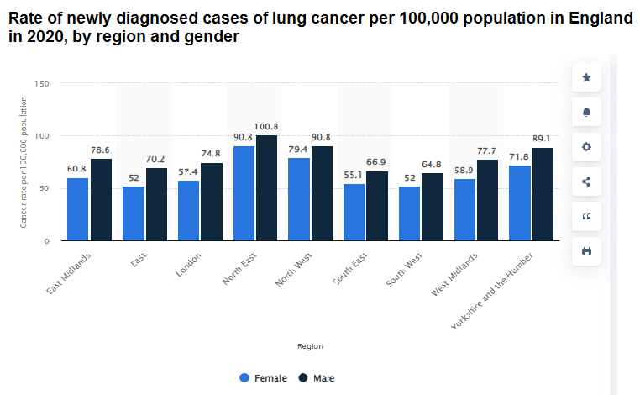
Figure 1: Statistics of Lung cancer
(Source: Statista, 2020)

The different approaches used to measure and monitor these diseases
Epidemiological Surveillance and Cancer Registries
Epidemiological surveillance is used to monitor the trend of lung cancer in terms of national cancer registries, which documentally capture the diagnosis, death, treatment consequences, and demographic characteristics. The United Kingdom records the national registries of lung cancer, showing about 48,000 cases every year (Navani et al., 2022). Such databases enable researchers to determine high-risk areas like industrial areas that expose the air to a considerable amount of pollution. The biggest asset is long-term population surveillance, but limitations are long, whereas reporting would be delayed, and clinical data would be incomplete.
Screening Programmes and Early Detection Methods
Diagnostic technologies detect lung cancer at an early stage when it is not severe through a screening programme. Low-dose CT scans of the lung are done for long-term smokers between the ages of 55 and 74 to provide a specific scan that allows identifying the lung diseases in the United Kingdom (Lancaster et al., 2022). Minimal tumours, as small as 4 millimetres, can be detected now. An example is pilot screening studies in Manchester, where in the past two years, over 250 low-stage lung cancers have been detected. Screening has strength in its ability to enhance survival as well as facilitate early treatment. Disadvantages are high financial burdens and false-positive results.
Health Data Collection through Surveys and Medical Records
The medical records and health surveys give elaborate behavioural and clinical information regarding lung cancer risk factors. The national health surveys gather data on thousands of participants on their smoking, occupational exposure to asbestos and air pollution exposure (Li et al., 2024). Across the UK, the survey of health looked at data from more than 8,000 people to determine the pattern of smoking-related lung disease. Hospital electronic medical records also record the treatment plans, diagnosis and outcomes of patients. Such advantages are extensive patient histories and big data, but associated challenges are privacy issues and variable data capture.

Explanation of how this disease is controlled
Tobacco Control and Smoking Prevention Policies
The major approach to decreasing the incidence of lung cancer is the tobacco control policies. The United Kingdom enacted new laws, including the nationwide Smoke-Free Law Act, which was initiated in 2007, that prohibited smoking in enclosed spaces, protecting millions of workers and other people who visit the country on a daily basis (Khan, 2022). There are also graphic health warnings on the packaging of cigarettes, and an increase in the taxation of tobacco items to make their purchase expensive. Prevention at population levels is also a strong aspect of these policies, but the drawbacks are the presence of illegal markets of tobacco and ongoing smoking among the poor population.

Early Detection and Diagnostic Screening
Early diagnosis of patients has a high chance of improving lung cancer outcomes because of diagnostic screening and clinical investigation. The UK Targeted Lung Health Check programme provides low-dose CT to at-risk groups of persons with long smoking histories aged between 55-74 years (Murray et al., 2022). Scanning of more than 6,500 residents in pilot projects in Liverpool and Manchester has found the cases of over 200 early-stage lung cancer cases that could be treated through surgery. Chest X-rays, bronchoscopy, and biopsy tests are also used as diagnostic tools (Philip et al., 2023). The advantages of screening include the ability to identify tumours in their early stages prior to spreading, but, disadvantages, such as high expenditure, false positives, and low participation rates.
Medical Treatment and Public Health Interventions
Lung cancer is medically treated through multidisciplinary clinical therapy, which includes surgery, chemotherapy, radiotherapy, targeted therapy and immunotherapy. Thousands of lung cancer patients in major cancer centres in the UK, like the Royal Marldene Hospital in London, have advanced treatments every year (Colman et al., 2025). Early tumours can be removed by means of surgery, and the cancerous cells can be attacked by drugs like immunotherapy. Smoking-quit clinics and air pollution projects also fall under the classification of public health interventions.

The consequences of this illness on people in the community
Physical Health and Quality of Life Impacts
Lung cancer has a bad impact on physical health and normal functioning. Patients may have continuous breathlessness, chest pains, habitual coughs and excessive fatigue, which restrict mobility and autonomy. Over 48,000 are diagnosed in the United Kingdom each year, and many of them need a long-term hospital environment and oxygen equipment (Igwe et al., 2025). Speaking of which, one can use the example of patients who have chemotherapy and undergo over 6 treatment sessions in a few months. Modern treatment is also powerful in controlling symptoms and increasing longevity; although there are some weaknesses related to excessive side effects, the decrease in lung capacity.
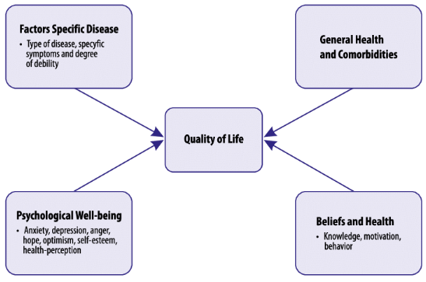
Figure 2: Quality of life
(Source: Mokaya et al., 2025)
Psychological and Emotional Effects
The diagnosis of cancer in the lung often causes immense mental disturbances to the patients and their families. Anxiety, the feeling of death, emotional trauma, and depression are common among many people who have been diagnosed and put under intensive treatment (Mokaya et al., 2025). Thousands of cancer patients with lung cancer in the UK in major cancer centres should receive mental or psychological counselling every year. In particular, cancer patients who are involved in chemotherapy can experience ambiguity regarding treatment and survival. Despite these, its drawbacks are that the wait list of people seeking psychological help is long.
Social and Economic Consequences
Lung cancer is another issue that poses significant social and economic problems to persons and societies. The high number of patients is compelled to cease labour in the treatment process, thereby lowering the earnings of these households and increasing dependence on the social support networks (Vanleeuw et al., 2022). In the United Kingdom, the healthcare system incurs billions of pounds every year in treating lung cancer in terms of hospitalisation, surgery, radiotherapy, and medication. Financial assistance is the strength of social welfare programmes, but has certain limitations, such as complicated systems of benefits and slow access to financial aid.

Health and Social Care Support Services for Individuals with Lung Cancer in the Community
Community Health and Palliative Care Services
Community health and palliative care services help patients live with their condition outside the hospital environment. Community nurses are tasked with the responsibility of monitoring patients' symptoms, administering medication, and assisting patients in need of oxygen and pain relief at their homes (Sun et al., 2023). In the United Kingdom, thousands of patients with lung cancer are helped in their end-of-life care by hospice care services like Marie Curie and Macmillan Cancer Support. The advantage of community care is that patients are comfortable and dignified, but the challenge is that there is a lack of staff and an increased need for home care services.
Psychological, Social, and Financial Support Services
Psychological, social, and financial support services deal with the impact of lung cancer. Counselling enables the patient to cope with anxiety, depression, and pressure from the treatment. Social workers enable patients to access disability benefits and home care. Organisations, for instance, Macmillan Cancer Support, provide financial advice and have assisted over 200,000 people annually by offering welfare benefits (Aveline-Dubach, 2022). This includes patients who cannot work and require financial grants and protection. The strength of the system lies in its holistic nature, but the weakness of the system is the lack of funding and accessibility.

Conclusion
One of the most important health issues, both on an international level and within the UK, is the presence of Lung Cancer. This condition causes a significant impact, as measured by its high occurrence, mortality, and complex care needs. Monitoring the condition by using epidemiological surveillance, cancer registries, screening programs, and various systems of health data plays a significant role. Similarly, the control of the condition by using tobacco control, early diagnostic screening, and various medical treatments also helps reduce the impact of the disease. However, the condition causes significant physical, psychological, social, and financial consequences. Therefore, the provision of various health and social care services, such as community care and financial assistance, becomes important for the condition.

Reference List
Aveline-Dubach, N. (2022) ‘Financializing nursing homes? The uneven development of Health Care REITs in France, the United Kingdom and Japan’, Environment and Planning A: Economy and Space, pp. 50-68. Available at: https://doi.org/10.1177/0308518x211072865.
Block, M. (2025) ‘Clinical Manifestations and Presentations of Lung Cancer’, Lung Cancer Navigation and Care, pp. 135-147. Available at: https://doi.org/10.1007/978-3-032-02200-4_11.
Colman, J.M., Williams, W.G., Silversides, C.K., Harris, L., Benson, L., Heggie, J., Alonso-Gonzalez, R. and Oechslin, E. (2025) ‘Toronto ACHD program: A 65 year legacy’, International Journal of Cardiology Congenital Heart Disease, 19, pp. 86-110. Available at: https://doi.org/10.1016/j.ijcchd.2024.100563.
Igwe, M.C., Alum, E.U. and Alphonsus Ogbonna Ogbuabor (2025) ‘Medical gases and long-term oxygen therapy: reducing the chronic obstructive pulmonary disease burden in aging populations in Sub-Saharan Africa’, Medical Gas Research, 16(1), pp. 63-70. Available at: https://doi.org/10.4103/mgr.MEDGASRES-D-25-00024.
Khan, J. (2022) The Khan Review Making Smoking Obsolete Independent Review into Smokefree 2030 Policies. pp. 110-120. Available at: https://www.bda.org/media/p23fe2ai/khan-review-making-smoking-obsolete.pdf.
Lancaster, H.L., Heuvelmans, M.A. and Oudkerk, M. (2022) ‘Low‐dose computed tomography lung cancer screening: Clinical evidence and implementation research’, Journal of Internal Medicine, 292(1), pp. 68-80. Available at: https://doi.org/10.1111/joim.13480.
Li, X., Su, X., Wei, L., Zhang, J., Shi, D. and Wang, Z. (2024) ‘Assessing trends and burden of occupational exposure to asbestos in the United States: a comprehensive analysis from 1990 to 2019’, BMC public health, 24(1). pp. 86-80 Available at: https://doi.org/10.1186/s12889-024-18919-7.
Mokaya, P.O., Ntinyari, N., Limungi, G., Kasmai, E.K. and Gabriella, H.-F. (2025) ‘Assessing the impact of the coronavirus pandemic on the mental health status of intensive care unit nurses: a systematic review’, BMC Nursing, 24(1). pp. 113-130. Available at: https://doi.org/10.1186/s12912-025-03117-6.
Murray, R., Davies, N. and Cheeseman, H. (2022) The role of smoking cessation services within the Targeted Lung Health Checks programme. pp. 20-22. Available at: https://ash.org.uk/uploads/Smoking-cessation-and-targeted-lung-health-checks.pdf.
Navani, N., Baldwin, D.R., Edwards, J.G., Evison, M., McDonald, F., Nicholson, A.G., Fenemore, J., Sage, E.K. and Popat, S. (2022) ‘Lung Cancer in the United Kingdom’, Journal of Thoracic Oncology, 17(2), pp. 186-193. Available at: https://doi.org/10.1016/j.jtho.2021.11.002.
Philip, B., Jain, A., Wojtowicz, M., Khan, I., Voller, C., Patel, R.S.K., Elmahdi, D. and Harky, A. (2023) ‘Current investigative modalities for detecting and staging lung cancers: a comprehensive summary’, Indian Journal of Thoracic and Cardiovascular Surgery, 39(1), pp. 42-52. Available at: https://doi.org/10.1007/s12055-022-01430-2.
Sembiring, Y., Dillon, J., Soebroto, H., Jiwangga, D., Winarno, S., Puruhito, P., Gusti, I., Made, A., Putra, A., Nego, A., Sebayang, O., Pramesthi, S. and Bowo, W. (2023) ‘Lung Cancer: A Literature Review’, 09(03). pp. 90-115. Available at: https://doi.org/10.20473/jr.v9-I.1.2023.246-251.
Statista (2020) Lung cancer rate by region & gender 2020| Statista, Statista. Available at: https://www.statista.com/statistics/312896/lung-cancer-cases-rate-england-region-gender/?srsltid=AfmBOorJL0v2sAPTLwuQ5e4wx3yy5SIwEksIy5xT7J-8FE2qjKCxbNlp (Accessed: 16 March 2026).
Sun, D., Sun, P. and Wang, Z. (2023) ‘Assessment and therapeutic management of acute asthma: The approaches of nursing staff in patient care’, Advances in Clinical and Experimental Medicine, 32(10). pp. 110-150. Available at: https://doi.org/10.17219/acem/161156.
Vanleeuw, L., Zembe-Mkabile, W. and Atkins, S. (2022) ‘Falling through the cracks: Increased vulnerability and limited social assistance for TB patients and their households during COVID-19 in Cape Town, South Africa’, PLOS Global Public Health. Edited by M.O. Afolabi, 2(7), p. e0000708. pp. 50-56. Available at: https://doi.org/10.1371/journal.pgph.0000708.
World Cancer Research Fund (2024) Lung cancer statistics | World Cancer Research Fund, World Cancer Research Fund. Available at: https://www.wcrf.org/preventing-cancer/cancer-statistics/lung-cancer-statistics/.

