Changemakers: Creativity and value creation

By

Halema Begum 1816637

Changemakers: Creativity and Value Creation

BMHP5014_BIRM

Azura Hurd
table of Contents
Introduction 2
Unit 1 topic 2 who am I? my sense of self 2
Unit 1 topic 2.1 the idea of self 2
Unit 1 topic 2.2 Social influence 2
Unit 1 topic 2.3 creative confidence 3
Unit 2 topic 2.1 storytelling – stories and why we tell them 4
Unit 2 topic 2.2 spotting competencies in a story 4
Unit 2 topic 2.3 creating your own competency story 5
Unit 3 mobilising support topic 1 establishing a supportive network 5
Unit 3 topic 2.2 stakeholder analysis 5
Unit 3 topic 2.3 creating a stakeholder map 6
Unit 4 closing the loop 6
REFERENCES 8

Introduction
This assignment will look at the topics that were covered in this module changemakers, creativity and value. There were many areas covered, and I shall look at the areas that appealed to me more in depth.

Unit 1 topic 2 who am I? my sense of self
Within this unit and the following units there are sub sections that make up the entire unit and this is what makes this unit so invigorating.

Unit 1 topic 2.1 the idea of self
This unit was majorly about passions that drive you and what you are passionate about. It also explores how being passionate about something can create new ways of thinking and produce new ideas. The framework included the philosopher Descartes and how problems can be solved if we searched within ourselves basically saying we have the answer to our own barriers. A lot of our passion stems from different feelings or what you are feeling in that moment but how you choose to utilize these feelings is the key factor.

Unit 1 topic 2.2 Social influence
This unit focuses on how others impact your thought process or how you are feeling or even how you act in any given situation as peers or people you associate yourself with do have input into your overall existence whether someone likes it or not. This unit also focuses on how you see yourself and how others perceive you. The Milgram experiment was used as an example to carry weight of what was being said that social influences can have an impact on what you do if the person is was close by or of a higher authority figure. The words that are being said to a person in a highly tense situation also plays a key role. This topic actually makes you delve deep and explore if you have been in a social situation that has influenced your decision-making skills. To explore who has control of your life and what you do about it or how someone can contradict what you want to do. The looking glass self-theory by Charles Horton Cooley looks at how a person portrays themselves and how they think others conceive them. Quizzes and blogs form interactions with others but this one is aimed at the looking glass theory.
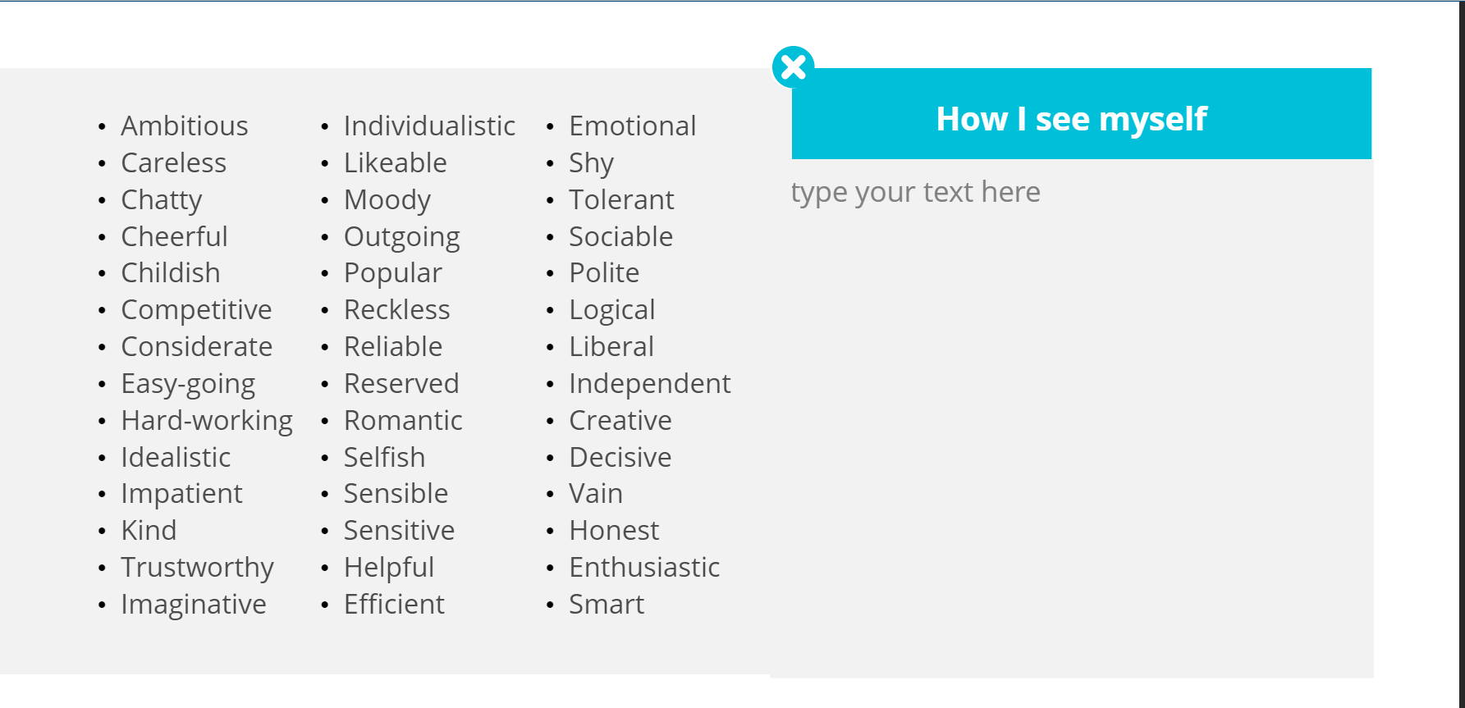
The above quiz does throw you slightly, how often do you evaluate how you are as a person? Having said that it is good for ones self to actually evaluate yourself as a person. The human race are bound to evaluations and questionnaires about what they may like and dislike could this possibly be a way to highlight your strengths and weaknesses and perhaps work on them to better ones self.

Unit 1 topic 2.3 creative confidence
The main objective for this unit was to look at creative confidence and how to recognize it and use it for the success in the topic area of your choice. This could be by expanding on the creative confidence in yourself and others. Being creative can be very open ended it could be a natural talent or it can be a skill that is learnt then through practice or training can be enhanced. Creativity is so important because it is innovation that means are the world develops around you so do you and you are not cast aside for something more current. Developing your skill or creativity will have major downfalls but for anyone that wants to be best at what they are doing they must allow and accept failure as nothing will be perfect, but it is how you monitor and improve that will lead to the optimal success.

Unit 2 topic 2.1 storytelling – stories and why we tell them
Storytelling is a fact of life we all do it whether it is to get a point across to add emphasis on a situation or to highlight your own competencies to others without being obnoxious. So how does storytelling incorporate itself in this unit? As humans we usually observe others and create a story that translates what we are observing.

Unit 2 topic 2.2 spotting competencies in a story
A story without substance is just words, this unit looks into the lives of semi famous induvial and looks into the history of where a person grew up what kind of education was had but also what led them to excel at what they are currently doing, this could be based on the entrecomp framework.
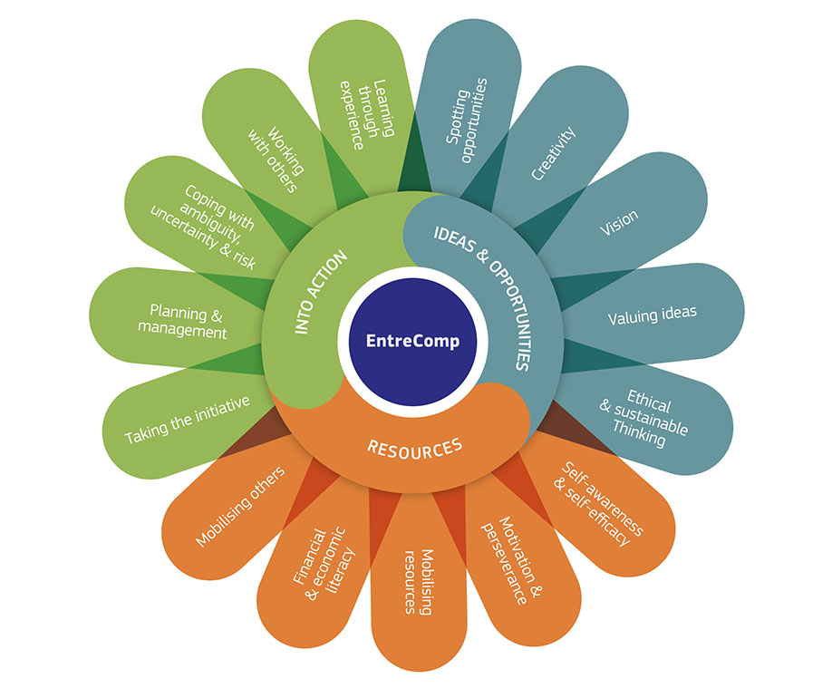
(UWTSD, 2022)
The framework ideas that you may possess, the means to get the idea off the ground and put it into action. But it also allows for mistakes to be made and opportunities made through blunders due to self-perseverance. The unit also gave food for thought that if you are not happy you basically put in all your efforts to make yourself happy. If you are doing something, you enjoy your mental health and every part of your being will also reflect that you are content.

Unit 2 topic 2.3 creating your own competency story
This unit helped focus on what competencies you as an individual have. If you don’t know your worth, then no one else will want to so this unit draws on that using the entrecomp framework. Allows you to look at past experiences and future goals but also what you are doing at present to reach future goals.

Unit 3 mobilising support topic 1 establishing a supportive network
No one gets through life alone you need help, and this could be in your personal life and also your professional life as stated in Vaux and Harrison journal, but who do you enlist with such responsibilities. Research was carried out by Wallace and Vaux the stated if you have a strong support network you will thrive but those that did not had a lot of trust issues and did not have strong relationships or bonds. This unit talks a lot about recruitment and hiring through contacts of current employees as this saves the company a lot of money by not having to advertise to an outside company and also the person recommending will know what that person is like ethically. Exploring your own network quality and what makes a good network is key if you want to move forward in any situation. Seeking out assistance through a mentor may be crucial to building a strong network

Unit 3 topic 2.2 stakeholder analysis
A stakeholder is anyone that has input and is impacted by the triumphs of a company. A study by Stephens states There are 10 different forms of stakeholders. Also, some stakeholders have a genuine interest in what you are trying to build but others are more keen on gaining power by becoming a stakeholder. this is where a stakeholder analysis should be incorporated, this consists of a graph that shows people that have been identified that have an interest in growth and others may be identified as a threat or a barrier that may need to be closely monitored (Shirey, 2012).

Unit 3 topic 2.3 creating a stakeholder map
A stakeholder map is of whoever is affected by your work (Newcombe, 2003). A list should be compiled of names and then it would be vital to use the power/ interest matrix to get a clearer visual of who may be an obstacle or a supporter.

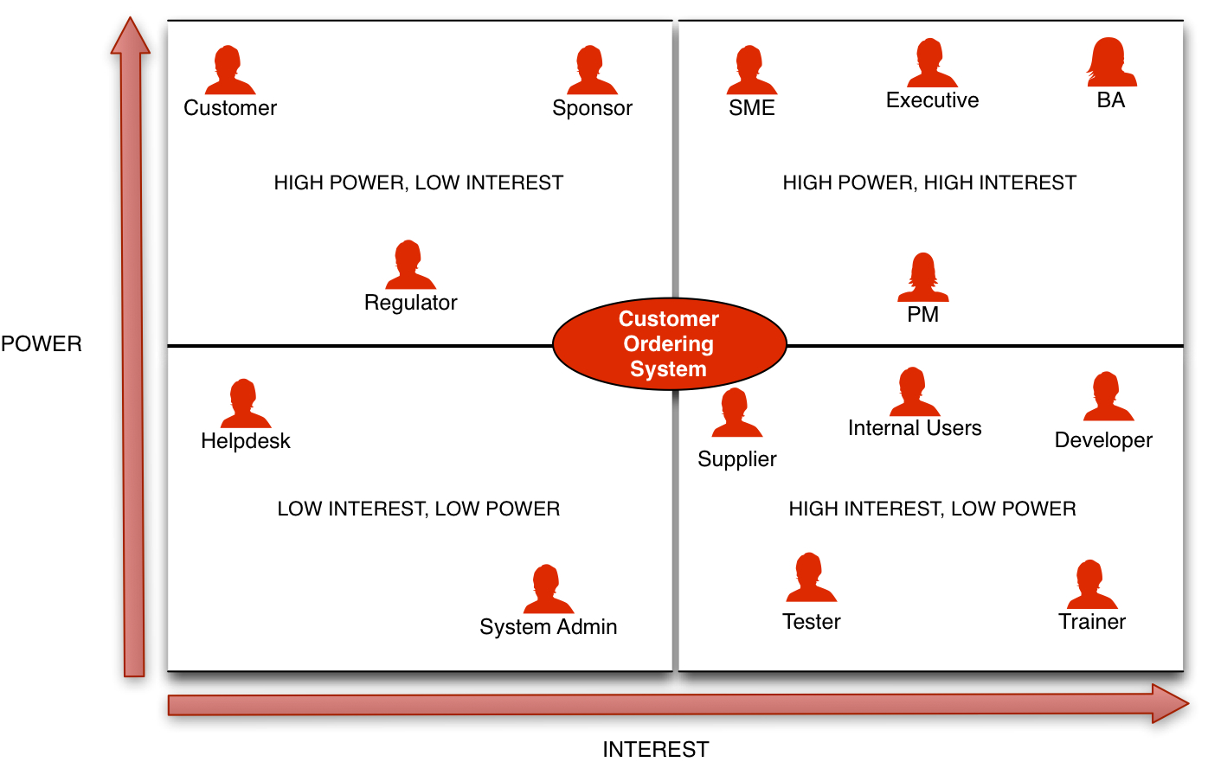
(Stakeholder Matrix: A Practical Guide — Business Analyst Learnings, 2022)

The above chart shows how a map would be devised. After the map is devised, it would be advised to recognize what drives the stakeholders especially if you need there backing.

Unit 4 topic 4.1 skills and attributes
In this unit the focus is the learner and what knowledge they have gained. Through experience they have accomplished great things but also a reflection on what might have been done better. This is an evaluation of you, where you are, where you aspire to be and how you can get there but also what you did to get where you are. As much as this is a great skill it is also humbling to look at past failure to appreciate great successes. In a study by Cigdem it is stated that skills can be used lifelong but knowledge or gaining knowledge through learning will equate to growth.

Unit 4 topic 4.2 learning outcome
No one gets success with anything straight away unless it’s a fluke trialing different things and ultimately failing will then help evaluate a project to counteract the previous failure to make it a success as stated by DRASGOW, 1958,

Conclusion

Everyone retains information in many different ways, some through verbal discussions others through reading. A lot of detail was put into this course but for me personally I felt I missed the actual depth of this course as I learn through discussion and more face to face. If I am sat in front of a screen I tend to get distracted as I’m home, chores and other factors may disturb my learning and I do believe this is the case as my all was not put into this course as I do learn better face to face rather then sat in front of a screen trying to digest all this new information that is very daunting and also mind numbingly boring. I do believe I could have learnt so much from this actual subject but due to factors beyond the control of the university this was not safe or possible to do so due to covid 19 restrictions,
I enjoy the areas that focused on reflection, what you have done, what you want to do and how will you get there, people are so quick to put themselves down but do not appreciate the actual effort that has been made to reach the destination or job that they are in now. Although it may not be exactly how you planned it is a lot better than what it could have been. I feel this topic in particular echoes the mind set of the cup being half full rather then half empty which does fill one with hope especially in this day and age where everyone seems to have an opinion and even through social media these opinions that may not encourage you actually seem to matter for some unbeknown reason. But the summary of my personal learning is if you learn some thing new you have more knowledge then you did yesterday and if you strive to learn something everyday you will always have more knowledge then the present day you are on.

REFERENCES

Business Analyst Learnings. 2022. Stakeholder Matrix: A Practical Guide — Business Analyst Learnings. [online] Available at: <https://www.businessanalystlearnings.com/ba-techniques/2013/1/23/how-to-draw-a-stakeholder-matrix>

Cigdem, K., 2014. Lifelong learning perceptions of pre-school pre-service teachers. Educational Research and Reviews, 9(19), pp.780-785.

DRASGOW, J., 1958. SUCCESS THROUGH FAILURE IN COUNSELING. The Personnel and Guidance Journal, 36(9), pp.637-638.

Newcombe, R., 2003. From client to project stakeholders: a stakeholder mapping approach. Construction Management and Economics, 21(8), pp.841-848.

Shirey, M., 2012. Stakeholder Analysis and Mapping as Targeted Communication Strategy. JONA: The Journal of Nursing Administration, 42(9), pp.399-403.

Stephens, K., 2005. Communicating with stakeholders During a Crisis: Evaluating Message Strategies. Journal of Business Communication, 42(4), pp.390-419.

UWTSD, W., 2022. EntreComp | UWTSD. [online] Uwtsd.ac.uk. Available at: <https://www.uwtsd.ac.uk/iiced/entrecomp/>

Vaux, A. and Harrison, D., 1985. Support network characteristics associated with support satisfaction and perceived support. American Journal of Community Psychology, 13(3), pp.245-265.

Wallace, J. and Vaux, A., 1993. Social Support Network Orientation: The Role of Adult Attachment Style. Journal of Social and Clinical Psychology, 12(3), pp.354-365.

