
Programme: Master of Business Administration

Module Name: Strategic Management
Module Code: LCMB7003

Assessment Title: Individual Report

Assitnment Title: Strategic Management Practices of Tesla Inc.

Student Name: MD Faysal Rahman
Student ID: 2436576

Lecturer’s Name: Hoang Nguyen

Word count: 5480

AI Use Acknowledgement
I would like to declare that I did not use AI in any format such as content creation, compose, paraphrase or editing to prepare my report and whetever I discussied in the report is my own research. In my whole, I have properly cited my research and the sources have been attached in the reference list.

Table of Contents
Introduction 4
Section 1 4
1. Organisational Context and Overview 4
2. External and Internal Environment Analysis 6
2.1 External Environment: PESTEL Analysis 6
2.2 Strategic Challenges and Critical Success Factors 8
2.3 Internal Environment: Resources, Capabilities, and Core Competencies 9
2.4 VRIO Analysis of Strategic Capabilities 9
2.5 Internal Strengths and Competitive Advantage 10
3. CSR and Sustainability Objectives 11
4. Comprehensive and Holistic View 12
5. Strategic Choices and Implementation 14
6. Strategic Evaluation and Recommendations 17
6.1 SWOT Analysis 17
6.2 Ansoff's Matrix Application 18
6.3 Strategic Recommendations and Their Justification 19
SECTION 2: REFLECTIVE ACCOUNT 20
Applying Gibbs' Reflective Cycle to the Research and Analytical Process 20
Conclusion 24
References 25

Introduction
Tesla, Inc. is an American electric vehicle and clean energy company that have been in existence since 2003 and whose operations of making electric vehicles in Europe are located in the Gigafactory Berlin-Brandenburg and therefore Germany is strategically a critical market (Teece, 2018). Tesla is rapidly developing into a niche manufacturer of EVs and a world-recognized technology and energy brand, and now has to worry about strategic issues in Germany such as the accelerating number of domestic and Chinese competitors, cracks in its image, and the loss of federal EV subsidies (Best-Selling-Cars, 2025c). In this report, the strategic management practices at Tesla Germany have been critically evaluated. It reviews both the external and the internal environment based on the PESTEL and VRIO, reviews CSR and sustainability compatibility, reviews organisational performance based on the Balanced Scorecard, evaluates strategic decisions at both business and corporate levels and ends up with evidence-based suggestions that will ensure Tesla maintains its competitive edge in the German market.

Section 1

1. Organisational Context and Overview
Company Background
In the year 2003, Tesla, Inc. was established by Martin Eberhard and Marc Tarpenning and Elon Musk became the chairman and the principal investor in the year 2004. The company has also transformed itself into one of the most valuable automotive and clean energy companies in the world, and it has developed as a niche electric sports cars manufacturer (Teece, 2018).
Mission, Vision, and Business Model
The mission of Tesla is to hasten the conversion of the world to sustainable power ( Tesla, 2024a). The vertically integrated business model based on strong pricing control and brand consistency is through bypassing traditional dealerships through its direct-to-consumer business model. Its core products consist of the Model S, Model 3, Model X and Model Y, and energy products like Powerwall and Megapack. The global revenues are reported to be touching 97.69 billion dollars in 2024 (MacroTrends, 2025).
Industry and German Operations
Tesla is in the fast-changing international EV and clean energy industry. It has a presence in Germany anchored by the Gigafactory Berlin-Brandenburg that opened in 2022, which has a capacity of over 375,000 vehicles annually, mostly serving the European markets (Tesla, 2025). The total BEV market of Germany was down to 380,609 registrations in 2024 after the abrupt cancellation of the federal EV subsidies (Best-Selling-Cars, 2025b).
Key Competitors and Market Position
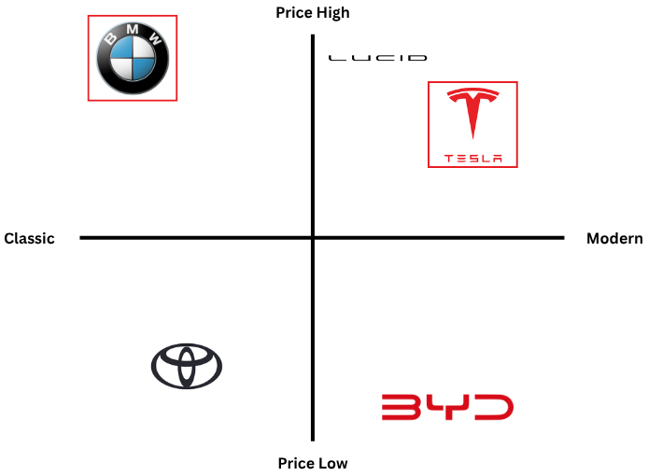
Figure: Perceptual map for Tesla
Source: (EVBoosters, 2025)
With a premium-price, contemporary position in the competitive EV market in Germany, Tesla stands in contrast to BMW flowing on a premium-price classical heritage and BYD on a modern low-price car handle. The local producers Volkswagen, BMW, and Mercedes-Benz in Germany have strong consumer loyalty based on years of engineering reputation (Teece, 2018). In Germany, Tesla registrations dropped by 62 percent in 2025 compared to 2024 (Best-Selling-Cars, 2025c), partially due to the reputational harm of Elon Musk and his political connections in Germany. In the meantime, BYD and MG had tripled their sales in Germany in early 2025 (EVBoosters, 2025), which raised the stress of the low-cost modern quadrant. Despite this, the Model Y remained Germany's best-selling individual BEV model throughout 2024, confirming Tesla's product competitiveness even as its market share erodes.

2. External and Internal Environment Analysis

2.1 External Environment: PESTEL Analysis
The PESTEL model as emerged in the strategic management literature offers an organised perspective on macro-environmental forces that impact organisational strategy (Johnson et al., 2020). Applied to Tesla's operations in Germany, PESTEL reveals both significant opportunities and complex challenges.
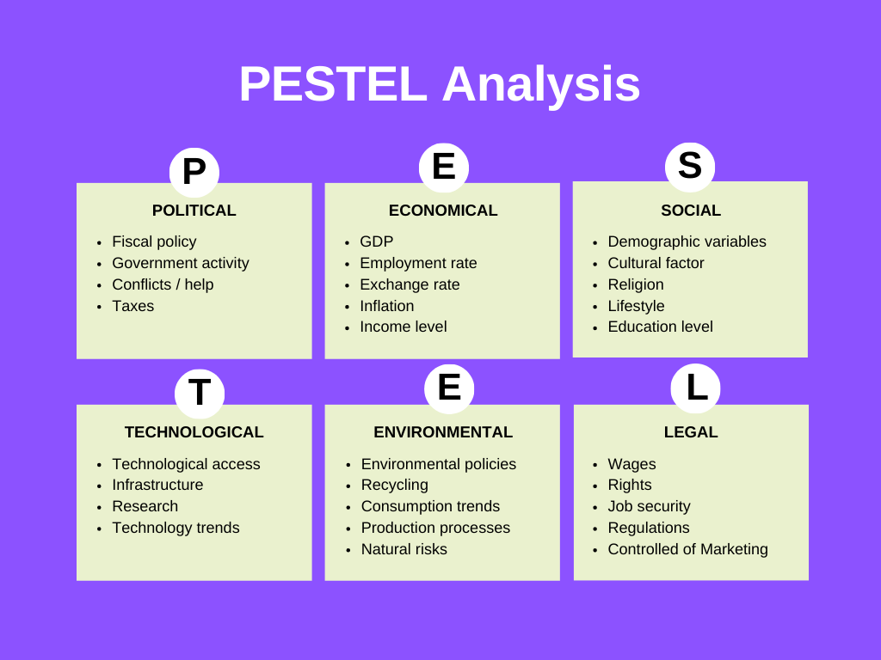
Figure 2:PESTLE Analysis
Source: (Qadri and Tariq, 2025)
Political Factors
The political climate in Germany has had significant impact on the strategic direction of Tesla. The sudden cancellation of federal EV subsidies in December 2023, an effect of the German government shifting climate funds due to a constitutional court decision, was effectively a withdrawal of financial incentives that had earlier spurred EV demand (Clean Energy Wire, 2025). In Germany, the number of battery-electric vehicles sold decreased by 27.4% to 380,609 units in 2024, a drop in market share compared to 18.4% the previous year (Best-Selling-Cars, 2025b). Furthermore, the vocal endorsement of the AfD party by Elon Musk in the 2025 German federal election campaign produced significant reputational harm, as the Tesla sales in Germany were down 62% in the first quarter of 2025 than in the first quarter of 2024 (Best-Selling-Cars, 2025c).
Economic Factors
The economic environment in Germany is a mixed up scenario to Tesla. Although Germany is the largest economy in Europe, with a GDP of about €4.1 trillion, the nation was subjected to slow growth, inflation, and high energy prices during 20232024, suppressing consumer expenditure on luxury high-value goods such as premium EVs (Statista, 2025). The drop in EV subsidies has a specific implication on the pricing strategy of Tesla Model Y, which, despite being competitive, depends on government subsidies to reduce the effective purchase price. German subsidiary Tesla boasts 2024 revenues of 7.68 billion euros, operating profit of 156.8 million and net income after taxes of 55.6 million (Teslarati, 2026), which displays the magnitude of the German operation.
Social Factors
Consumer attitude towards electric vehicles in Germany has also become more subtle. Although society is widely agreed on the subject of environmental sustainability, a section of consumers is still sceptical of the charging infrastructure, range anxiety, and overall cost of ownership (Bohnsack et al., 2014). Also, reputational contagion of the political commentary by Musk is especially notable in Germany, which is historically and culturally sensitive to far-right political movements (Best-Selling-Cars, 2025c). This social fact has been directly converted into commercial loss making brand image management a pressing strategic issue.
Technological Factors
The most sustainable source of competitive differentiation of Tesla is technological capability. The company was the first to launch over-the-air (OTA) software updating in the automotive sector making vehicles constantly evolving digital platforms (Teece, 2018). The biggest autonomous driving data in the industry is Tesla Full Self-Driving (FSD), which had more than three billion miles recorded by 2024 (Tesla, 2024b). The launch of 4680 battery cell production and structural battery packs at Giga Berlin is a step-change in production efficiency. In late 2024, Tesla reached the 100-millionth mark of cells in all plants (TechAU, 2025).
Environmental Factors
The German regulatory commitment to a phase-out of internal combustion engines by 2035, which is in line with EU policy, is structurally favorable to the Tesla core product offering. Customers of Tesla worldwide prevented the emittance of about 32 million metric tons of CO2e in 2024 (Tesla, 2024a). Tesla reduced its Scope 2 emissions by 41% between 2020 and 2024 to 1.06 million MTCO 2e at the corporate level (Sustainable Innovation, 2026). German market, which is highly environmentally aware, should theoretically fit into the Tesla sustainability story, but the lack of Science Based Targets initiative (SBTi) commitments and the lack of collective bargaining agreement makes this placement a little bit difficult.
Legal Factors
Tesla works in the framework of the strong legislation of Germany, including EU Corporate Sustainability Reporting Directive (CSRD), GDPR data protection requirements, and strong employment law the Works Constitution Act. There were environmental permitting complexities in the building of Giga Berlin, with various environmental groups challenging the operations of the company with lawsuits. Its continuous growth strategies, such as a request to increase capacity to one million vehicles per year, are still under environmental impact reviews (Euronews, 2023).

2.2 Strategic Challenges and Critical Success Factors
Critical Success Factors
Critical success factors are the limited areas in which satisfactory results ensure competitive performance (Johnson et al., 2020). Battery technology is one of the key theme CSF in the EV market of Germany since the energy density and cost-per-kWh directly dictate the vehicle range and financial reach, where Tesla currently enjoys an industry edge (TechAU, 2025). The infrastructure charging is also important because range anxiety is a significant consumer adoption issue. Meeting EU emission targets through regulatory compliance is not a bargaining point and robust brand positions are a necessity in a market where engineering heritage is an unwavering passion (Teece, 2018).
Strategic Challenges
External pressures that cause threats to sustained performance in competitive activities are known as strategic challenges (Teece, 2018). Volkswagen and BMW pose direct competitive threats, combining established brand loyalty with rapidly expanding EV portfolios. The production costs are volatile due to shortage of raw materials especially lithium (MacroTrends, 2025). Moreover, labour conflicts at Giga Berlin and continuing environmental approval challenges limit Tesla operational ability in Germany.

2.3 Internal Environment: Resources, Capabilities, and Core Competencies
Internal environment is defined as those organizational forces like resources, capabilities as well as the competencies which affect the strategic performance.
Key Resources
Tesla has tangible and intangible resources. One of its most tangible assets is its Gigafactory in Berlin, which increases the efficiency of production and lowers the logistics expenses (Tesla, 2024b). Its brand equity which comes with innovation and sustainability is an important intangible resource. This brand positioning enhances customer loyalty and justifies high prices.
Key Capabilities
The ability to integrate technology has enabled Tesla to integrate hardware and software together, particularly in autonomous drives. The other capability is its direct to consumer sales model that removes intermediaries and enhances customer experience. These features allow Tesla to react swiftly to changes in the market (Tesla, 2024a).
Core Competencies
The innovation of batteries and energy management systems are the main core competency of Tesla. Its proprietary battery technology offers longer range and cost benefit (TechAU, 2025). Another core competency is its software ecosystem, including over the air updates, which differentiates Tesla from traditional automakers.
Importantly, these internal factors are interrelated. The capabilities are supported by resources and they result in competencies. This combined system empowers Tesla competitive positioning in the EV market in Germany.

2.4 VRIO Analysis of Strategic Capabilities
Strategic capabilities refer to the unique combination of resources and competencies which allow an organisation to acquire and sustain a competitive advantage (Foss and Eriksen, 2023). The VRIO assessment analyses Tesla as a company based on Value, Rarity, Imitability and Organisation.
1. Battery Technology
By increasing energy density and lowering cost-per-kWh, battery technology provides a high value that is directly behind the performance competitiveness of Tesla and its pricing efficiency (Tesla, 2024b). This is rare, as few competitors have reached a similar manufacturing scale with proprietary cell design like the 4680 at Tesla. The level of imitability is very high as it demands considerable investment in R&D and proprietary chemistry and years of process innovation ( TechAU, 2025). The benefit Tesla gains organisationally with regard to vertical integration and ongoing investment in next-generation batteries is long-term competitive advantage.
2. Software Ecosystem
The Tesla feature of delivering high value is the ability to update vehicles over-the-air to constantly enhance their performance and safety without adding hardware (Tesla, 2024a). It is rare since traditional automakers are mechanical-based and do not have integrated software-defined platforms. Custom chips, gigantic driving datasets, and a decade of AI development are required (TechAU, 2025). The organisational structure of Tesla offers direct-to-consumer model an opportunity to gain long-term competitive advantage through complete control of the deployment process.
3. Brand Equity
The providing of high value by Tesla brand equity facilitates premium pricing and forms a high level of customer loyalty without the use of traditional advertising funding (Teslarati, 2026). This is rare due to its combination of technology, sustainability and aspirational identity. Its construction took more than fifteen years of the regular innovation, which cannot be easily copied. On the organisational level, it is utilised via viral marketing and reinforcing product ecosystem (Tesla, 2024a), which maintain a long-term competitive edge.

2.5 Internal Strengths and Competitive Advantage
Internal strengths are the unique resources and capabilities of an organisation that leads to performance and competency improvement. In the case of Tesla in the German electric vehicle market, a culture of innovation facilitates sustained product development based on the increased requirement of sustainable mobility (TechAU, 2025). It has high-technology battery that lowers production costs, and enhances the performance of the vehicle, and this allows both the cost leadership and differentiation.
Also, Tesla has an excellent software engagement that boosts customer experience with capabilities like autonomous driving and over the air updates which make switching costs high and customers stuck. The resource based view states that having such rare and imitable capabilities forms the basis of lasting competitive advantage (Teslarati, 2026).
However, reliance on technological superiority exposes Tesla to competitive disruption, while regulatory and labour challenges in Germany may limit operational efficiency. In spite of these restrictions, the strengths of Tesla match well with the external opportunities in the green energy transition enabling Tesla to stay competitive in the long term due to constant adaption (Sustainable Innovation, 2026).

3. CSR and Sustainability Objectives
Corporate Social Responsibility (CSR) strategy is defined as the planned incorporation of social, environmental and ethical issues into the core activities and relationships of an organisation whereas sustainability involves long term value creation without jeopardizing the environmental and societal welfare (Carroll, 1991). Nowadays, CSR is intertwined with competitive advantage, especially in sensitive to the environment sectors like electric cars.
In the case of Tesla, CSR is integrated into the main mission of speeding up the process of going green. The products of Tesla are sustainability solutions not peripheral, as it is the case with traditional firms. According to the 2024 Impact Report of the company, its customers saved about 32 million metric tons of CO2e emissions, which proves that the environmental impact is significant (Tesla, 2024a). Furthermore, Tesla aims to achieve net zero emissions across its product lifecycle and has committed to matching its Supercharger network electricity consumption with renewable energy. Its circular economy efforts are also remarkable, and 92 percent of battery materials like nickel, copper and cobalt can be reused, which contributes to the resource efficiency (Tesla, 2024b). Its sustainable business model is further supported by the rapid growth of the deployment of energy storage (Sustainable Innovation, 2026).
The main business goals of Tesla are to be a technological leader, to enter the global market, and to be cost-effective due to the innovation. These targets closely coincide with its environmental CSR strategy, especially in Germany, where environmental regulations and consumer preferences are strict in favour of sustainable mobility. This consistency boosts brand position and regulatory compliance of Tesla, which is a competitive advantage (Teslarati, 2026).
Nevertheless, a critical analysis shows significant weaknesses in social and governance aspects. Tesla is not implementing Science Based Targets Initiative, has no formal collective bargaining agreements, and does not publish a commitment to the living wage (Sustainable Innovation, 2026). These omissions pose institutional tension and reputational risks in the co determination system in Germany.
Thus, although Tesla has good alignment between business goals and environmental CSR, the lack of full integration of the social responsibility prevents the full efficiency of the CSR strategy.

4. Comprehensive and Holistic View
The Balanced Scorecard (BSC) is a performance measurement methodology, proposed by Kaplan and Norton (1992) to supplement financial metrics in organisational performance measurement by adding the customer, internal business processes, and learning and growth lenses. It allows the management to focus on operational activities in line with strategic goals, which gives a multi-dimensional perspective of organisational health.
Financial Perspective
Objective: Return profitability levels and increase revenue in the German market.
KPIs: revenue growth of German subsidiary; operating margin; contribution of revenue of the carbon credit; revenue contribution of the carbon credit.
Targets: Return German revenue to pre-2024 growth trajectory; achieve operating margin of at least 10% at Giga Berlin.
Initiatives: In 2024, the Tesla operations in Germany earned the company a revenue of 7.68 billion Euros and operating profit of 156.8 million Euros (Teslarati, 2026). FY2024 total revenue was 97.69 billion globally, but GAAP operating income decreased by 20% to 7.08 billion and net income decreased by 52.7% to 7.09 billion. In 2024, carbon credit revenues amounted to $2.76 billion, which is about 30% of Q4 net income (Sustainable Innovation, 2026), a vulnerability because such credits will decline as European competitors electrify their fleets.
Customer Perspective
Objective: Recapture the market share and regain brand trust in Germany.
KPIs: Customer satisfaction rating; Tesla market share in Germany BEVs; repeat purchase; Net Promoter Score.
Targets: Regain market share of 4.4% (Q1 2025) to more than 10% by 2026; customer satisfaction scores close to those of BMW in Germany (Teslarati, 2025).
Initiatives: Launch updated Model Y locally with enhanced range and features; invest in localised marketing to address reputational damage; expand Supercharger network across Germany; introduce customer loyalty and referral programmes. In Germany, Tesla Model Y was the best-selling BEV model during 2024 (Best-Selling-Cars, 2025b), which means that there is still some product demand that could be exploited through strategic communication.
Internal Business Processes Perspective
Objective: Optimise the production efficiency of Giga Berlin and simplify the supply chain resiliency.
KPIs: Weekly output of vehicles; Giga Berlin capacity utilisation rate; frequency of supply chain disruption; rate of quality defects.
Targets: Produce 375,000+ vehicles in a year at Giga Berlin; produce continuously without Red Sea-type challenges as seen in January 2024 (Tesla, 2024b).
Initiatives: Retooling of new Model Y; diversify supply chain to minimize geopolitical exposure to logistics; further integrate 4680 cell production on-site; develop battery second-life and recycling on-site. In March 2025, the plant made the 500,000th Model Y, which took it 1,105 days to achieve this milestone (Teslarati, 2025).
Learning and Growth Perspective
Objective: Build human resources and digital strengths to enable long-term innovation.
KPIs: Training hours of employees; attrition rate; increase in the number of AI and software development; diversity and inclusion indicators.
Targets: decrease reported high absenteeism and retention rates at Giga Berlin, invest in German apprenticeship and graduate recruitment systems, increase autonomous driving R&D partnership with European universities (Teslarati, 2025).
Initiatives: Introduce structured co-determination engagement, reflecting German legal norms; invest in upskilling existing workforce for new vehicle lines including Cybercab; partner with technical universities like Technische Universität Berlin, TU Dresden on battery and autonomy research. The 11,000-person Giga Berlin Tesla workforce (TechAU, 2025) represents a considerable organisational learning resource that, when properly handled, can sustain the innovation of processes.

5. Strategic Choices and Implementation
Strategic decisions on the business level include the way a firm is competing in a particular market where cost leadership or differentiation is normally used. Corporate level strategy in contrast is concerned with the general range and orientation of the organisation such as whether to diversify or move into international markets (Seifzadeh and Rowe, 2019).
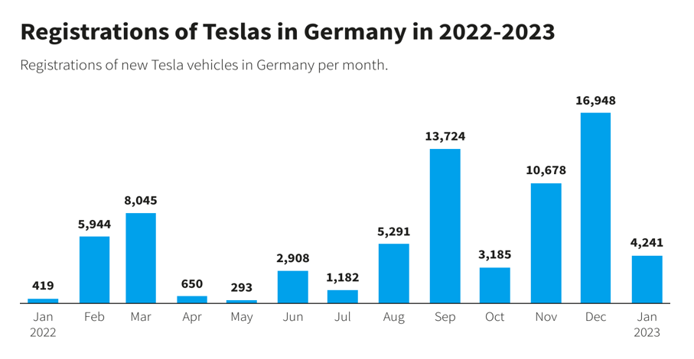
Figure 2: Registrations of Tesla in Germany
Source: Statista (2025)
Business-Level Strategic Choices
Tesla has a differentiation strategy that has provided sustained competitive advantage throughout its growth phase based on proprietary battery technology, OTA software updates, autonomous driving features, and direct sales (Teece, 2018). Nevertheless, the rise of competitive pressure among Volkswagen Group (20.1% EV market share in Europe, May 2024), BMW (10.3%), and Chinese car manufacturers, such as BYD, all with competitively specified electric vehicles at lower prices, has diluted Tesla differentiation premium (European Alternative Fuels Observatory, 2024). In Germany, in particular, where consumers have a high level of concern with engineering pedigree and value-for-money, Tesla has a risk of becoming neither the cost leader nor the differentiator that no one can challenge.
The business level strategic repositioning to a hybrid differentiation-focus strategy can be justified (Jukka, 2023). This would include premium positioning in the high-margin software-as-a-service (SaaS) model by FSD subscription, energy storage and fleet autonomy, and competitive pricing of Model Y by manufacturing efficiency achieved at Giga Berlin. Tesla should make sure that its differentiation story is persuasive because EV technology is converging among manufacturers.
Corporate-Level Strategic Choices
On the corporate level, Tesla has been aggressive in its international expansion with its network of Gigafactories. The Giga Berlin plant is the foundation of its European plan, serving 38 markets (Teslarati, 2025). Associated diversification in energy generation (Solar Roof, Powerwall, Megapack) and services (insurance, charging) expands the base of Tesla revenues beyond the vehicles. The expansion of robotics (Optimus) as well as autonomous ride-hailing (Cybercab) are both exploratory diversification, and have the potential to be transformative.
The suggested corporate policy is further, continued international deepening in particular, consolidation and deepening of the European market presence by Giga Berlin as opposed to further geographic expansion (Furrer, 2016). At the same time, energy storage business acceleration in Germany, where the global deployment increased 114% in 2024 (Sustainable Innovation, 2026), is another high value diversification opportunity, in line with the German Energiewende policy.

Change Management and Strategic Implementation
In order to determine the effectiveness with which Tesla has dealt with change, the Unfreeze Change Refreeze framework by Lewin is used.
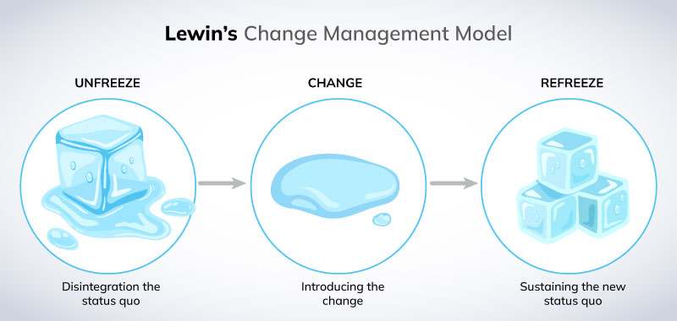
Figure 4: Change Management Model
Source: (Harrison et al., 2021)
Unfreeze Stage: Tesla has been quite capable of disrupting conventional automotive practices through encouraging electric mobility and direct sales. In Germany, however, labour unions and regulatory bodies opposition reflect pre-emptive lack of stakeholder congruency at this phase (Teslarati, 2025).
Change Stage: Tesla has effectively implemented large scale changes, such as establishing Giga Berlin and integrating new production technologies (TechAU, 2025). The firm responds promptly to technological changes, which depicts robust dynamic capabilities. Nevertheless, there are operational blips and supply chain pressures that imply that change implementation is not always planned.
Refreeze Stage: This stage seems to be rather weak. Tesla has had difficulties in institutionalising change in the socio legal environment of Germany, especially in labour relations and governance systems (EVBoosters, 2025). The high rate of absenteeism and criticism by stake holders shows that new practices are yet to be stabilised.
Tesla excels at change initiation and execution but is less effective at embedding and maintaining. Such an imbalance poses a problem in implementing the strategies, particularly in a highly controlled market such as Germany. Consequently, although innovation driven strategies are undertaken quickly, their effectiveness in the long run is limited by organisational and institutional misalignment (Harrison et al., 2021).
The direction of Tesla strategy is good, but change management, especially change refreeze should be improved to make the strategy implementation sustainable and effective.

6. Strategic Evaluation and Recommendations

6.1 SWOT Analysis
The strategic evaluation models like SWOT offer a combined overview of the strategic stance of an organisation and the compilation of internal capabilities and weaknesses alongside the external opportunities and threats (Johnson et al., 2020).
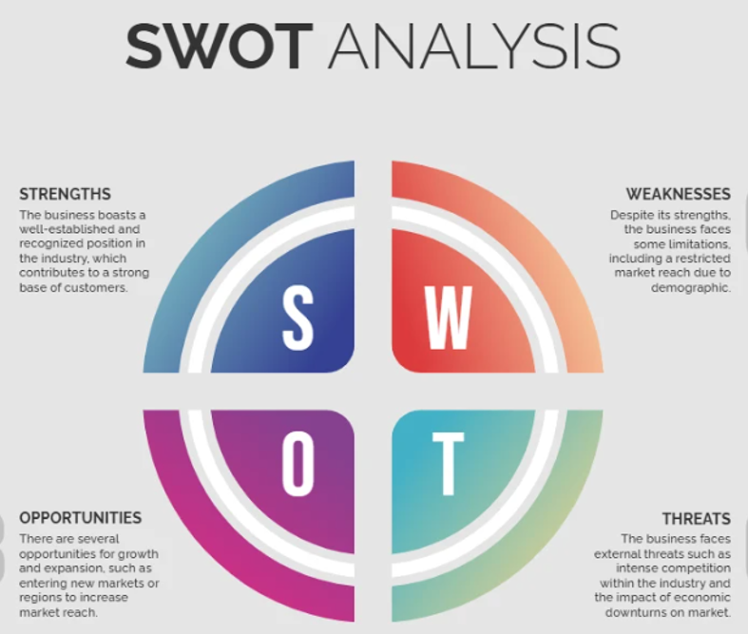
Figure 5: SWOT Analysis
Source: (Qadri and Tariq, 2025)
Strengths: Technological leadership in EVs, software, and autonomous driving; integrated manufacturing capability of Giga Berlin; global brand; dominance of Supercharger network in Europe; strong cash position; 36.5 billion at the end of 2024 (Medium, 2025).
Weaknesses: Loss of market share in Germany; reputational damage associated with CEO; excessive reliance on carbon credit income; lack of formalised labour relations system in Germany; cannot meet a production target of 250,000 units a year at Giga Berlin by mid-2025 (TechAU, 2025).
Opportunities: The rising market of BEV in Germany; 545,142 units in 2025 versus 380,609 in 2024 (Best-Selling-Cars, 2026); EU 2035 ban on ICE will create structural long-term demand; Energiewende legislation favoring energy storage products; developing autonomous vehicle regulation; expansion
Threats: VW Group dominance (21.1% BEV in Germany, H1 2025); Chinese EV manufacturers (BYD and MG tripling in Germany, 2025) (EVBoosters, 2025); loss of EV subsidies; reputational risk on the part of the CEO; required disclosure of CSRD reporting, exposing governance voids; further supply chain

6.2 Ansoff's Matrix Application
Growth Matrix by Ansoff points out four strategic options, which are market penetration, market development, product development, and diversification (Ansoff, 1957).
.
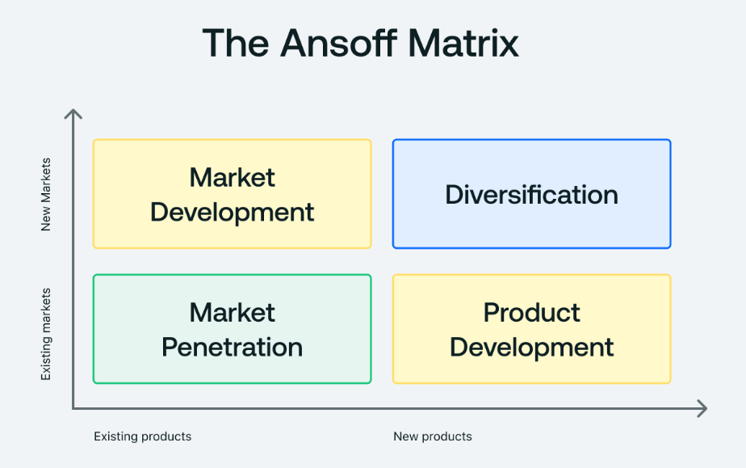
Figure 6: Ansoff's Matrix
Source: (Ansoff, 1957)
Market Penetration: In the case of Tesla in Germany, the market penetration is the most applicable and immediate strategy. This involves regaining lost EV market share through pricing adjustments, improved vehicle specifications, and rebuilding brand trust in the German market (TechAU, 2025).
Market Development: Market development includes the expansion of underserved German markets, including rural regions and commercial fleets, by enhancing charging infrastructure and offering customized products and services to expand in the current market instead of geographic expansion(Tesla, 2024a).
Product Development: Product development is a medium term strategy whereby a new model like the Cybercab can supplement Tesla product portfolio and be able to capture new segments of the market. This corresponds to the innovative driven positioning of Tesla.
Diversification: Diversification, especially to energy storage solutions such as Megapack, is a related and low risk growth opportunity. It builds upon the battery and energy solutions already available at Tesla and fits the renewable energy shift in Germany (Sustainable Innovation, 2026).
As a whole, Tesla growth strategy must focus on the first stage penetration that could be supported by product innovation and subsequent diversification (Ansoff, 1957).

6.3 Strategic Recommendations and Their Justification
Recommendation 1: Decouple Brand from CEO Persona
Tesla needs to structurally and communicatively decouple its German brand presence and the personal political actions of Elon Musk. The Tesla market share in the German electric car market fell to 4.4% in Q1 2025, down a full 16.1% in Q1 2024, and market observers cite the overt support of far-right parties by Musk at the German Federal elections as the principal cause (EVBoosters, 2025). It is a strategic decision to appoint a special European CEO, investing in locally relevant marketing. Empirical studies in strategic management show that brand equity has a direct impact on pricing power and customer acquisition costs.

Recommendation 2: Accelerate Works Council Engagement
Tesla must actively seek to engage the works councils in Germany to gain organisational legitimacy. The institutionally complex markets have a sustainable competitive positioning that is based on the legitimacy. This is especially relevant to Germany where co-determination is legally binding under the work constitution act (Tesla, 2024b).
Recommendation 3: Expand Megapack Deployment in Germany
Tesla should make Germany the flagship market in Europe with its Megapack energy storage offerings and use the German energy transition policy framework. In 2020, Tesla introduced the Megapack utility-scale energy storage system, enabling low-cost, low-emission renewable energy to be consumed during peak hours, instead of costly, high-emission energy generated by fossil fuel generators. This strategic move would diversify revenue, enhance stakeholder relationships with German energy utilities and solidify the sustainability credentials of Tesla (EVBoosters, 2025).
Recommendation 4: Pursue Aggressive Model Y Refresh Positioning
The new Model Y, which is being ramped at Giga Berlin, should be packaged as a technology and value retelling. Giga Berlin is now seeking to resume its ideal production capacity that was stifled as the plant transitioned to the new Model Y (TechAU, 2025). Dealer-proximate service centre expansion and competitive pricing policies are expected to help Tesla get back to its competitiveness with VW and BMW.

SECTION 2: REFLECTIVE ACCOUNT

Applying Gibbs' Reflective Cycle to the Research and Analytical Process
Reflective Cycle is a systematic model of the experience-based learning process which is especially suitable within the context of postgraduate academic reflection and as it promotes critical self-awareness and analytical rigour (Gibbs, 1988). The reflective account below uses Gibbs cycle to the research, analysis and writing of this strategic management report on Tesla in Germany.
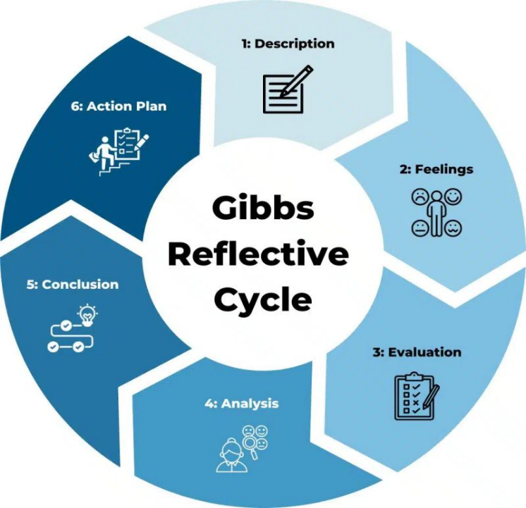
Figure 7: Gibbs' Reflective Cycle
Source: (Sobreira, 2022)
Description
This assignment involved writing 5,000 words of a single strategic management report on an organisation of choice, using a collection of theories, such as PESTEL, VRIO, the Balanced Scorecard, Ansoffs Matrix, SWOT, and CSR theory. I chose Tesla in Germany, because of its strategic importance as a case study of technological disruption, geopolitical complexity, reputational management problems, and manufacturing innovation. The study was carried out based on the use of academic journal articles, corporate filings, statistical databases, and reputable news sources, and focused on information published in 2020-25 to guarantee currency and relevance.
Feelings
Initially, the intellectual challenge of the strategic situation of Tesla in Germany caught my attention. The firm provided an exceptional paradox: a technologically dominant company that is facing a steep market fall, caused by non-technological reasons, the first one being the reputational loss of the CEOs and the loss of subsidies. This paradox posed the challenge of analysis as both thought provoking and to an extent, discomforting as it did not allow a direct use of the classical strategic models. I was confused, at times, whether the frameworks that had been created in rather stable competitive settings could entirely reflect the dynamics of a fast-paced EV market that was influenced by political upheavals. Some apprehension was also felt in the balancing of the critical academic register needed at Level 7 with the complexity of the empirical data, especially the sometimes-conflicting market statistics.
Evaluation
The writing process and several aspects of the research were effective. The PESTEL analysis was of great value, as it enabled an orderly disaggregation of the highly complicated macro-environment of Germany into discrete yet interdependent forces. It seemed analytically significant and provided critical depth to descriptive analysis the acknowledgment of CEO reputational risk as a PESTEL political factor, and not just a PR problem. The VRIO framework also allowed drawing a significant difference between the really sustained competitive advantage sources of Tesla such as software and data capabilities, Supercharger network and more contestable ones like brand, market share.
I however found the Balanced Scorecard part difficult. The framework proposed by Kaplan and Norton (1992) works best when the internal metrics and data on KPI of an organisation is readily available. At Giga Berlin, internal operations KPIs in the case of Tesla are not completely transparent, but only partially disclosed. I needed to utilize publicly reported production achievements, capacity levels, and financial overviews to fill in the scorecard lenses, which demanded interpretive judgement.
Analysis
Analytically, I can say that the most challenging part of the process was to connect the various frameworks into a strategic story and not to apply each separately. Johnson et al. (2020) warn that strategic analysis may turn into a checklist exercise when the deployment of different frameworks is not supported by a critical synthesis. I tried to overcome this by making sure that results of PESTEL and VRIO were directly inputted in the Balanced Scorecard and strategic recommendations so that a logical flow of reasoning was created as opposed to unrelated sections of analysis.
One of the dimensions of Tesla German situation that the literature on strategic management currently available did not provide much direct advice was the reputational damage dimension. The majority of frameworks presuppose that competitive dynamics are mainly product, price and capability-based. The Tesla example in Germany shows that the behaviour of CEOs can be a strategic variable of similar scale to the market price or product differentiation, especially in politically charged consumer markets. This aligns with the new literature on stakeholder capitalism and corporate governance strategic role (Carroll, 1991), and made me consider more critically the limits of the traditional strategic analysis.
Conclusion
I find that the research and writing of this report enhanced my skill to simultaneously use various strategic frameworks, to integrate quantitative market information with theoretical models, and to adopt a critical but not descriptive analytical register. Another insight that I have gained as a result of this exercise is that corporate governance, reputational management, and competitive strategy are interdependent and I can now appreciate this more. As the case of Tesla demonstrates, perhaps more clearly than most, strategic management in the twenty-first century cannot be divested of issues of leadership ethics, stakeholder confidence and institutional credibility.
Action Plan
Area of Development | Current Reflection | Action Steps | Expected Outcome
Stakeholder Theory & Corporate Governance | Recognised as underweighted in traditional strategic management understanding | Study advanced literature on stakeholder theory and governance frameworks | Improved ability to integrate governance into strategic analysis
Strategy & Sustainability (ESG) | Limited depth in linking ESG with competitive positioning, especially in European markets | Read academic and industry sources on ESG and sustainability strategy | Stronger strategic evaluation aligned with sustainability trends
Use of Operational Data | Strong use of financial data but weaker use of operational level metrics | Identify and utilise sources such as annual reports, investor updates, and sustainability disclosures early | More balanced and data driven analysis
Research Planning | Data source identification was not done early enough | Plan research structure and data sources at the beginning of projects | Increased efficiency and depth in analysis
Reflective Practice | Reflection was more descriptive than critical | Apply Gibbs’ Reflective Cycle more rigorously to question assumptions and limitations | More critical, analytical, and insightful reflection skills

Conclusion
This report has critically examined the strategic position of Tesla Germany on external, internal, and performance levels. Effective implementation through the use of sustainability-based policies and energy shift creates structural opportunities, but subsidy withdrawal, reputational loss, and more intense competition with European and Chinese manufactures are also found to be rather a challenge. Internally, Tesla's battery technology, software ecosystem, and brand equity constitute sustained competitive advantage. Nonetheless, weaknesses in governance and misalignment on operations in Germany are essential areas of weakness. The ability of Tesla to strike a balance between technological leadership and proper stakeholder management, localisation, and sustainable institutionalisation of strategic change in the German market will be critical to long-term success.

References
Ansoff, H.I. (1957) 'Strategies for diversification', Harvard Business Review, 35(5), pp. 113–124.
Best-Selling-Cars (2025a) 2025 (Full Year) Germany: Best-Selling Electric Cars by Brand and Model. Available at: https://www.best-selling-cars.com/germany/2025-full-year-germany-best-selling-electric-cars-by-brand-and-model/
Best-Selling-Cars (2025b) 2024 (Full Year) Germany: Best-Selling Electric Cars by Brand and Model. Available at: https://www.best-selling-cars.com/germany/2024-full-year-germany-best-selling-electric-cars-by-brand-and-model/
Best-Selling-Cars (2025c) 2025 (Q1) Germany: Best-Selling Electric Car Brands and Models. Available at: https://www.best-selling-cars.com/germany/2025-q1-germany-best-selling-electric-car-brands-and-models/
Bohnsack, R., Pinkse, J. and Kolk, A. (2014) 'Business models for sustainable technologies: Exploring business model evolution in the case of electric vehicles', Research Policy, 43(2), pp. 284–300.
Carroll, A.B. (1991) 'The pyramid of corporate social responsibility: Toward the moral management of organizational stakeholders', Business Horizons, 34(4), pp. 39–48.
Clean Energy Wire (2025) Tesla registrations plummet 41 percent Germany 2024. Available at: https://www.cleanenergywire.org/news/tesla-registrations-plummet-41-percent-germany-2024-company-slides-ev-ranking
Euronews (2023) Tesla aims to double production capacity in German Gigafactory, targeting 1 million EVs annually. Available at: https://www.euronews.com/next/2023/07/21/tesla-aims-to-double-production-capacity-in-german-gigafactory-targeting-1-million-evs-ann
European Alternative Fuels Observatory (2024) Europe's EV Market Update for May 2024. Available at: https://alternative-fuels-observatory.ec.europa.eu/general-information/news/europes-ev-market-update-may-2024
EVBoosters (2025) Germany's EV market surges 43% in early 2025 to 158,000 units; Tesla slumps 60% as BYD and MG triple sales. Available at: https://evboosters.com/ev-charging-news/germanys-ev-market-surges-43-in-early-2025-to-158000-units-tesla-slumps-60-as-byd-and-mg-triple-sales/
Furrer, O., (2016). Corporate level strategy: Theory and applications. Routledge.
Gibbs, G. (1988) Learning by Doing: A Guide to Teaching and Learning Methods. Oxford: Further Education Unit.
Harrison, R., Fischer, S., Walpola, R.L., Chauhan, A., Babalola, T., Mears, S. and Le-Dao, H., (2021). Where do models for change management, improvement and implementation meet? A systematic review of the applications of change management models in healthcare. Journal of healthcare leadership, pp.85-108.
Johnson, G., Whittington, R. and Scholes, K. (2020) Exploring Strategy: Text and Cases. 12th edn. Harlow: Pearson.
Jukka, T., (2023). Does business strategy and management control system fit determine performance?. International Journal of Productivity and Performance Management, 72(3), pp.659-678.
Lynch, R. (2021). Strategic management. Sage.
Kaplan, R.S. and Norton, D.P. (1992) 'The balanced scorecard: Measures that drive performance', Harvard Business Review, 70(1), pp. 71–79.
MacroTrends (2025) Tesla Revenue 2012–2025. Available at: https://www.macrotrends.net/stocks/charts/TSLA/tesla/revenue
Qadri, A.U. and Tariq, M., (2025). SWOT and PESTLE Analyses in Strategic Business Planning. International Journal of Modern Research in Management, 2(01), pp.34-44.
Seifzadeh, P. and Rowe, W.G., (2019). The role of corporate controls and business-level strategy in business unit performance. Journal of Strategy and Management, 12(3), pp.364-381.
Sobreira, I.C., (2022). Building a Sucessful Team: Strategic Management and Group Dynamics (Master's thesis, Universidade NOVA de Lisboa (Portugal)
Statista (2025) Electric vehicle market share in Germany 2024. Available at: https://www.statista.com/statistics/1166826/electric-vehicles-market-share-germany/
Sustainable Innovation (2026) Tesla Sustainability 2025: Circular Energy and Net Zero Goals. Available at: https://thesustainableinnovation.com/tesla-sustainability/
TechAU (2025) Tesla's Gigafactory Berlin produces 500,000 vehicles in 1,105 days. Available at: https://x.com/techAU/status/1906647290447855747
Teece, D.J. (2018) 'Tesla and the reshaping of the auto industry', Management and Organization Review, 14(3), pp. 501–512.
Tesla (2024a) Impact Report 2024. Available at: https://www.tesla.com/impact/environment
Tesla (2024b) Q3 2024 Financial Summary Update. Available at: https://ir.tesla.com/_flysystem/s3/sec/000162828024043432/tsla-20241023-gen.pdf
Tesla (2025) Q4 and FY2024 Update Letter. Available at: https://ir.tesla.com
Teslarati (2025) Tesla Giga Berlin hits new milestone by producing 500,000th Model Y. Available at: https://www.teslarati.com/tesla-giga-berlin-produces-500k-model-y/
Teslarati (2026) Tesla Giga Berlin head calls out Handelsblatt's claimed 2025 production figures. Available at: https://www.teslarati.com/tesla-giga-berlin-head-handelsblatt-false-production-figures/

