
Airbnb Marketing Strategy
Module: BMMB7026 Managing Marketing Change
Organisation: Airbnb
Student Details: Mohd Ravish- 2523743


Executive Summary
The aim of this report is to analyse the marketing strategy of Airbnb in a competitive and regulated travel market. It identifies the largest benefits to Airbnb as being its global brand, large network of hosts, digital platform and customer data that can be used for personalisation with the help of AI. Regulation, inflation, shifting traveller expectations, high buyer power and fierce competition are transforming its marketing focus, as revealed by PESTEL and Porter's Five Forces analysis. Airbnb has as a result transitioned from positioning based on the experience to trust, value, quality, flexibility and transparent pricing. It has differentiated targeting which effectively reaches value conscious travelers, families, remote workers, experience seekers and responsible tourists digitally. But there are issues related to inconsistent host quality, reputation and overdependence on search marketing. The report calls for "better host quality assurance, responsible destination marketing, and trust and community-impact performance metrics.

Table of Contents
1. Introduction 4
2. Task 1: Concept and Importance of Marketing 4
2.1 Marketing Resources 5
2.2 Macro Marketing Environment (PESTEL) 7
2.3 Micro Marketing Environment 9
2.4 Target Market 10
2.5 Segmentation, Targeting and Positioning (STP) 11
2.6 Marketing Mix 12
2.7 Media Selection and Communication Channels 13
3. Task 2: Conclusion 14
4. Task 3: Recommendations 15
4.1 Strengthen Host Quality Standards and Trust 15
4.2 Investment in Responsible Destination Marketing 16
4.3 Trust and Reputation Performance Metrics 16
5. References 18

Introduction
Organisations are now operating in a very competitive and dynamic environment, where marketing has become one of the most crucial functions in the business. Today's marketing is not just about selling products or services (Albrecht, et al., 2023). Rather, it concentrates on developing customer value, establishing long-term relationships and adapting to the changing demands of customers and market conditions at a rapid pace. Ignoring the evolving consumer's desires could cost companies market share to those offering better customer experiences. Airbnb is one of the biggest online platforms for travel experiences and short-term rentals offering listings from hosts in over 220 countries and regions (Airbnb, 2024). Unlike a hotel, both the guest and the host are involved in the creation of the value for the Airbnb business. Obviously, if you want to attract travellers you'll need to attract hosts and retain them.
In the last couple of years, Airbnb marketing has changed drastically. Choices of accommodation have been impacted by the high cost of living, greater sensitivity to price, the growing competition from hotels and online travel agency websites and a more challenging regulatory environment and greater public awareness of overtourism. This means travellers are more inclined to make booking decisions based on trust, safety and price transparency and flexibility, rather than just unique local experiences. Airbnb has thus moved to a marketing approach that focuses on customer confidence and value for money, and verified quality, rather than emotional experiences (Kwok, et al., 2020).
This report critically consider Airbnb's current marketing activities and then assess whether these are suitable to meet the evolving market conditions. The analysis in the report is based on the use of academic theories and business models relevant to the company's marketing resources, external and internal marketing environment, target markets, segmentation strategy, positioning, communication channels and performance measures. Lastly, the report outlines the weaknesses of Airbnb's current marketing strategy and recommends a set of feasible recommendations that would be capable of being put in place within the next year.

Task 1: Concept and Importance of Marketing
Marketing is defined as the process by which organisations provide value to customers and establish profitable long-term relationships with them. The purpose of marketing is not to sell products, it is to identify customer needs and create appropriate products and experiences that stimulate repeat purchases and customers' loyalty (Bilgihan and Ricci, 2024). Marketing has a larger strategic function for digital platform businesses, like Airbnb, where success relies on how well you can manage two customer groups: guests and hosts. Unlike the traditional hotel that owns the property in which you stay, Airbnb is completely dependent on people who are independent with their own homes. This means that marketing should effectively both draw in travellers and motivate homeowners to post their homes on the site (Parment, et al., 2022).
Marketing also supports Airbnb's competitive advantage. The Resource Based View (RBV) suggests that firms can acquire a sustainable competitive advantage by acquiring resources that are valuable, rare, difficult to imitate and organised (VRIO) (Kero and Bogale, 2023). Airbnb's biggest assets for marketing are its worldwide brand, large network of hosts, innovative digital interface, customer information, artificial intelligence (AI) features, and reputation system which is supported by customer reviews and ratings (Airbnb, 2018).
These resources are especially critical as trust is one of the most valuable assets in the sharing economy. However, unlike hotels people tend to book private property that they have never met. Trust is an important factor in the customer's buying process in peer-to-peer (P2P) marketplaces, marketing communications and reputation management play a critical role in alleviating the uncertainties of the customers (Ye et al., 2019). Airbnb shows their knowledge of marketing by putting a significant effort into brand development, customer experience, and digital innovation. The company's AI, personalised search, identity verification and customer support features were also all in play in 2025, adding additional pieces to build trust on the platform, such as Guest Favourites, and streamlined total price displays (Airbnb, 2025). The investments reveal that Airbnb recognizes marketing isn't simply about adverts, it's about a function.

Marketing Resources
To keep its global competitive position, Airbnb invests significant financial, technological and human resources in its marketing activities. These are not only investments in advertising, but also in the creation of digital platforms, artificial intelligence (AI), customer relationship management, product innovation and efforts to gain customer trust (Islam, 2026). Airbnb's technology platform is one of its biggest assets. The company continually works to enhance its website and mobile application to deliver tailored suggestions, quicker search and booking experiences (Meleo, Romolini and De Marco, 2016). AI's ability to analyse consumer behaviour, suggest appropriate accommodation and enhance customer service is becoming increasingly prevalent across Airbnb (2025b). The features enable Airbnb to offer much personalised experiences, something that many hotel companies cannot reproduce (Osth et al., 2025).
Another key marketing resource is data. All of the search, booking, review and saved-destination data that every customer records is useful to Airbnb in understanding how customer tastes and habits evolve. This enables the company to personalise marketing messages, improve recommendation algorithms and increase conversion rates. Organisations that can make the best use of customer data can better enhance customer satisfaction and build long-term customer loyalty (Prentice and Pawlicz, 2024).
The Human Resources are also making good contributions to Airbnb's marketing performance. The company has a team of digital marketing experts, customer experience experts, AI experts, and product development and data analytics experts. Concurrently, Airbnb puts a large amount of effort into educating and supporting hosts due to the direct impact host performance has on customer satisfaction and brand reputation.
But the fact that AirBnB's success depends on the independent hosts is a drawback for the marketing of AirBnB. Airbnb does not have control over the quality of service the host has provided for their accommodation, as a hotel chain has over the quality of service it provides. Best of luck with your advertising if your customers' experiences are poor as a result of poor hosting. This is a sign of the lack of integrity between Airbnb's marketing and the service it offers, thus losing trust. The VRIO framework states that a company can gain a sustainable competitive advantage if it has Valuable, Rare, Inimitable, and Organised resources to create value (Amaya et al., 2024). There are a number of marketing resources that are important to Airbnb and that can be assessed with this framework. The below is the VRIO analysis of Airbnb.
Marketing Resource | Valuable | Rare | Difficult to Imitate | Organised to Capture Value | Competitive Implication
Global Airbnb brand | ✓ | ✓ | ✓ | ✓ | Sustainable competitive advantage
Large global host network | ✓ | ✓ | ✓ | ✓ | Sustainable competitive advantage
Customer reviews and trust system | ✓ | Moderate | Moderate | ✓ | Temporary competitive advantage
AI and customer data | ✓ | Moderate | Moderate | ✓ | Competitive advantage
Digital platform and mobile app | ✓ | No | No | ✓ | Competitive parity
Marketing and data analytics team | ✓ | Moderate | Moderate | ✓ | Temporary competitive advantage
Table 1: VRIO Analysis

Macro Marketing Environment (PESTEL)
PESTEL analysis is a framework for external environment analysis. It also serve as a scanning tool which allow organisations to map external changes systematically and anticipate strategic threats (Ulubeyli et al., 2019). The PESTEL analysis for Airbnb is explained in Table 2.
PESTEL Factor | Explanation
Political | - Short-term rental websites are facing more regulation from governments to ease housing shortages, overtourism and high rental prices (Bei and Celata, 2023).  - A number of cities have enacted licensing and limits on how many days you can rent the property, as well as zoning and limits on how many Airbnb listings are permitted (Airbnb, 2023).  - The political landscape around sustainable tourism and its local interests also affect Airbnb's capacity to run and promote accommodation in other nations.
Economic | - With the global inflation, rising interest rates and cost of living, consumers have less money at their disposal to spend, which makes them more price sensitive when traveling.  - Consumers are becoming more price-sensitive and compare prices on multiple platforms as well as require clear pricing and flexibility in cancellation terms.  - Other factors that influence international tourism patterns and Airbnb marketing include exchange rate fluctuations and shifting tourism demand (Tung and Thang, 2022).
Social | - The changing preferences of the consumers are towards the real local experience, flexible travel, and a longer stay because remote working and digital nomadism is increasing. Concurrently, customers give greater weight to trust, safety, cleanliness and quality reviews and value for money (Zhou et al., 2024).  - The issue of overtourism, affordability and the social impact of short-term rentals on the public have also been affecting Airbnb's reputation and marketing messages (Airbnb Newsroom, 2025).
Technological | - The advent of artificial intelligence (AI), machine learning, big data analytics, mobile apps and cloud computing has revolutionised how customers search, compare and book accommodation (Biswas and Gofur, 2025).  - Customers are now looking for personalised recommendations, seamless online booking, secure online transactions and prompt customer service.
Environmental | - There has been a growing consciousness on climate change and sustainable tourism that has led to the rising demand for sustainable travel (Slocum, 2022).  - With increased awareness of climate change and sustainable tourism, there is a rising demand for sustainable travel. Eco-friendly accommodation, extended stays to decrease travel, and destinations that do not overrun are becoming more attractive to travelers (Mishra and Kumar, 2024).
Legal | - The legal challenges Airbnb faces are multifaceted, including consumer protection, taxation, licensing, health and safety, privacy, and data protection (such as GDPR).  - Different countries have different laws, resulting in higher compliance costs and an influence on how Airbnb offers their services.  - Fines, restrictions on listings and reputational damage may be imposed for failure to comply with regulations.
Table 2: PESTEL analysis

Micro Marketing Environment
The Porter's Five Forces analysis (Figure 1) indicates that the competitive rivalry, buyer power and threat from substitutes are very high in the Airbnb industry. There is a high level of competition as Airbnb faces competition from online travel agencies, like Booking.com, Expedia and Vrbo, as well as from traditional hotels. These players spend a fortune on social media marketing, technology and customer loyalty programmes, so it is hard for Airbnb to keep up the price. As such, Airbnb has adopted a differentiation strategy by offering the accommodation that is different, local experience and flexibility, a strategy recommended by Porter.
The buyer power is also strong as customers can easily compare the prices, reviews and accommodation options on several booking platforms. With the help of this, Airbnb has been able to improve price transparency, develop Guest Favourites and use personalised recommendations to drive trust and conversions. But these campaigns add to marketing expenses and decrease pricing flexibility.
Supplier power is also medium as hosts supply Airbnb's inventory and list properties on other platforms. This means that Airbnb is constantly investing in the way that they engage hosts and enforce quality standards, in order to keep customers happy. The threat from new entrants is moderate as Airbnb has good brand loyalty and network effects, while the technological barriers are relatively low. Last but not least, alternative accommodation like hotels and serviced apartments are still in abundance. Overall, Airbnb's marketing approach is right, but the services need to be of a good standard and this needs to be continued in order to keep their differentiation.
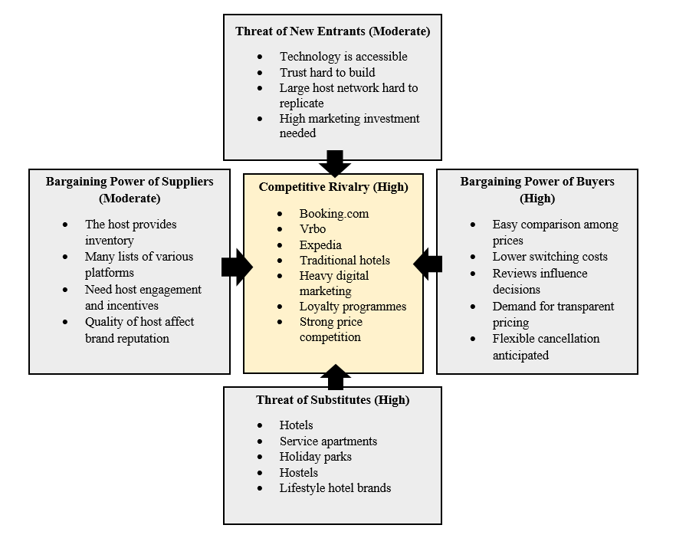
Figure 1: Porter five force analysis

Target Market
While Airbnb caters to a wide customer base around the world, its marketing targets those who are more likely to appreciate flexibility and one-of-a-kind lodging and local adventures. It is not just a hotel for Airbnb, but for travellers who are not being addressed by hotels. A target market helps the organisations to develop marketing strategies that are more responsive to the needs of their customers and improve the organisations' competitive advantage (Aghdaie and Alimardani, 2015). The key users of Airbnb are young professionals, Millennial and Generation Z travellers who are familiar with digital technologies and looking for genuine travel experiences. Apart from that it also serves as a hotel for families and groups requiring more room than a hotel can provide, for remote workers or digital nomads who need to stay longer than a hotel would allow, but still want the feel of a hotel, and for people who want more room than a hotel, but value the hotel overall. But, in more recent years, Airbnb has proven to be an attractive option for environment-conscious and responsible travelers.

Segmentation, Targeting and Positioning (STP)
STP is an acronym for Segmentation, Targeting and Positioning. A marketer could not satisfy every person in the market and so the concept came, where marketers divide the market into various segments and positions (Santoso, et al., 2024). STP is a strategic marketing techniques for the market where this helps to understand how much efficiently the business is planning various marketing activities to compete in that market and how they are linking to the overall market (Kalam and Kalam, 2020). Airbnb segmentation is not primarily demographic-based, it is a mix of behavioural, psychographic and occasion-based segmentation. This is in line with the marketing practice of these days which is that, the behaviour and lifestyle of the customer can be a better indicator of their buying decisions rather than the age or income alone. The major customer segments are highlighted in the table 3.
Market Segment | Characteristics
Value-conscious travellers | Compare total accommodation costs with hotels and competitors.
Experience seekers | Prefer unique homes, local culture and Airbnb Experiences.
Remote workers and digital nomads | Book longer stays with workspace and home facilities.
Families and groups | Need larger accommodation, multiple bedrooms and shared living space.
Responsible travellers | Prefer sustainable destinations and lower-impact tourism.
Table 3: Major customer segments
Airbnb uses differentiated targeting, creating separate marketing messages for the various segments. For example, experiences are recommended for younger travellers who are looking for adventure. Remote workers are addressed by long-stay filters and flexibility in bookings. Long-stay filters and flexibility in bookings are geared towards remote workers (Lutz and Newlands, 2018). Whole home accommodation for families and larger groups is encouraged. Sustainable destinations are marked and marked-up for travellers who are sensitive to the environment. In doing so, Airbnb can tailor marketing messages to the individual and make them more relevant to customers. Differentiated targeting can also be resource-intensive, complex and expensive, as it requires creating multiple campaigns, digital content, and personalised recommendations for various audiences (Nashiroh, et al., 2024).
Positioning is the process of how the customer sees a customer brand compared to the others in the market (Saqib, 2021). Over the past few years, Airbnb has made a conscious effort to re-brand itself. The first messages that Airbnb used were more emotional, like “Belong Anywhere” and “Live like a Local.” Today, it is placed to highlight trust, value and quality and comes with a number of features such as guest favourites, identity verification, verified listings, flexible cancellation policies and price transparency.
This shift in positioning is a result of evolving consumer behaviour. The research results indicate that trust has emerged as one of the most significant factors influencing bookings in the sharing economy. Now that Airbnb is in a more modern position, it is better suited to meet the modern customer's expectations than in the past when it was more experience focused (Mody Suess and Lehto, 2017).

Marketing Mix
The marketing mix is a powerful concept as it appears to make marketing a simple process, allows for the separation of the marketing mix into different components and is applicable across all industries. The marketing mix is able to affect the competitive position of a company. The 7Ps of marketing mix has been frequently and extensively used by marketing firms, branding agencies, and even web design firms all across the world. The table below explains the 7ps of marketing mix for Airbnb.
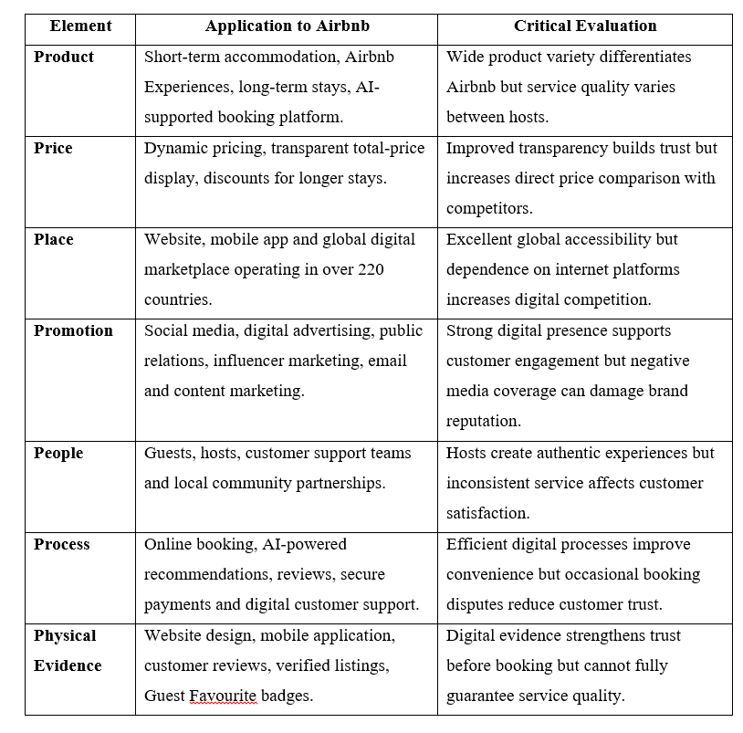
Table 4: 7ps of marketing mix

Media Selection and Communication Channels
The communication strategy of Airbnb is mostly digital, both due to their business model and the behaviour of their customers. The company's primary marketing channels are social media (YouTube, Instagram and TikTok), search engine optimisation (SEO), paid search advertising, email marketing, mobile marketing, content marketing and public relations. Social media is a great way to do this because accommodation is a very visual product. Airbnb has a strategy of inspirational travel content, features of unique properties and destination stories to motivate customer engagement and sharing (Laradi et al., 2023). Social media is the most preferred marketing channel used by Airbnb. It allow guests to share and create quality content of their experiences and opinions from their previous stays with Airbnb (Kim and Liu, 2023).
One of Airbnb's most significant acquisition channels is search engines as many users who begin their accommodation search first with Google and not directly on Airbnb's website. As such, Airbnb invests heavily in SEO and pay-per-click (PPC) advertising to enable individuals to discover them on-line (Medium, 2026). The company also utilises customer information to tailor e-mail marketing and app notifications, suggesting spots on the basis of past searches and bookings. Using AI for personalisation can help businesses improve customer engagement and encourage repeat bookings (Kapai, 2019).
However, Airbnb's communication strategy has certain drawbacks. When customers rely heavily on search engines, they are more likely to compare prices with their competitors, which makes it harder to differentiate. Furthermore, the negative media attention which has been written about housing shortages and overtourism is far more publicized than Airbnb's marketing efforts. This undermines the brand image even as they invest further in communication through digital channels (Responsible Travel, 2024).
In general, Airbnb has chosen the right communication channels with its digitally connected customer base. However, the firm still needs to work on its public relations and community outreach initiatives to gain the trust of the public and ensure a good long-term image.

Task 2: Conclusion
This report critically evaluated Airbnb Marketing activities and determined to what degree Airbnb has been responding to consumer media consumption behaviours in the context of STA in the global market. The results suggest that Airbnb has implemented a comprehensive and customer-centric marketing strategy that has helped it stay competitive in the face of the growing competition and regulatory hurdles.
The assessment highlighted that Airbnb understands the need for strategy and investing in technology, AI, CRM, and building customer trust and relationships. As per the VRIO analysis, Airbnb has the most favorable marketing resources as they have a well-known brand and an extensive network of hosts that provide a sustainable benefit. Moreover the study on PESTEL and Porter's Five Forces analysis revealed that economic factors, changing customer requirements, increasing regulation and strong competition have played a great role in the marketing strategy of Airbnb. Correspondingly, the company has shifted its emphasis from a unique experience to trust and value creation, to flexibility and transparency of cost.
The report also revealed that Airbnb has been able to successfully implement behavioural and psychographic segmentation, providing a variety of customer groups including families, remote workers, experience seekers and those looking for value. The company's digital marketing efforts, combined with its presence on social media, its activities on search engines, its use of artificial intelligence and its personalized approach to communication, have improved its customer engagement strategy and helped its business to develop.
There are a couple of downsides, however. Firstly, Airbnb's brand promise is quite dependent on the independent hosts and as such the quality of the service may be variable and may undermine customer confidence. Second, the further the company goes into search engine marketing, the more it will be compared with other companies making it more difficult to sustain difference. Finally, Airbnb's measure is mostly corporate and income and booking oriented, and trust and brand acceptance, as well as community acceptance are to a minimum. Understanding these shortcomings is critical for Airbnb to bolster its competitive position over time and continue to grow in a highly regulated and competitive market.

Task 3: Recommendations
The results of this study yield three practical and feasible recommendations to enhance Airbnb's marketing strategy. The recommendations specifically target the identified weaknesses in the evaluation and are achievable with Airbnb's available resources and capabilities.

Strengthen Host Quality Standards and Trust
Airbnb needs to roll out a ‘Host Quality Assurance Programme' for all existing hosts in the next year. Points of the programme, including mandatory online training, property quality checks once a year, better customer service and regular performance checks (Xue, et al., 2022). Airbnb has implemented a few features that are preferred by the customer such as guest favorites and verified listings, however, the satisfaction of the customer is still largely based on the individual host. Overall, the marketers' promises on Airbnb could be improved and better aligned with what their guests experience, leading to higher customer satisfaction and trust in the brand. This is a very achievable idea as Airbnb already has a mechanism to collect customers' reviews and to measure and validate hosts. The objective is to raise by 15% the percentage of Superhosts and highly rated listings within 12 months and also to lower by 20% the customer complaints about the quality of the accommodation in the next 12 months.

Investment in Responsible Destination Marketing
Airbnb should increase its efforts in promoting responsible tourism in places undergoing regulatory pressure by collaborating with local governments, tourism organisations, and community organisations (Bąk, Jaremen and Nawrocka, 2026). Marketing activities to encourage sustainable travel, off-peak tourism, tourism to the countryside and longer visits should not focus on over concentrating demand in the city centres. The PESTEL analysis highlights the political, legal and social issues that are likely to arise in the future, which this recommendation aims to address. Communicating proactively with the local community would help Airbnb's reputation as well as the company's ability to show a positive impact on local economies rather than issues with housing. The SMART objective is to promote responsible tourism campaigns in the 20 markets with the strictest regulations in 12 months and boost the number of bookings in alternative destinations by 10% over the next year.

Trust and Reputation Performance Metrics
Airbnb should measure its success with other metrics including publicly available Trust and Community Impact Metrics, as well as commercial metrics like Gross Booking Value and Nights Booked. Recommended indicators are customer trust scores, average host quality ratings, complaint resolution time, community satisfaction surveys and regulatory compliance rates (Fleischer and Ert and Bar-Nahum, 2022). These metrics would give a more comprehensive picture of the success of marketing efforts by helping to determine if Airbnb is truly fulfilling its strategic goal of building trust or just driving bookings. The objective is to create and launch a Trust and Community Performance Dashboard within 12 months, and present at least five trust-related Key Performance Indicators (KPIs) in Airbnb's annual sustainability or shareholder report, every three months to senior management.

References
Aghdaie, M. H., and Alimardani, M. (2015). Target market selection based on market segment evaluation: a multiple attribute decision making approach. International Journal of Operational Research, 24(3), 262-278.
Airbnb Newsroom. (2025). Overtourism in the EU What data tells us about the overwhelming impact of hotels on overtourism in the EU. https://news.airbnb.com/wp-content/uploads/sites/4/2025/06/overtourism-report_20240611.pdf
Airbnb. (2018, March 23). Sharing More About the Technology That Powers Airbnb. Airbnb Newsroom; Airbnb. https://news.airbnb.com/sharing-more-about-the-technology-that-powers-airbnb/
Airbnb. (2023, June 26). Airbnb short-term rental regulation toolkit for policymakers. Airbnb Newsroom. https://news.airbnb.com/policy-toolkit-short-term-rental-regulations/
Airbnb. (2024). Vacation Rentals, Homes, Experiences & Places - Airbnb. Airbnb; Airbnb. https://www.airbnb.com
Albrecht, M. G., Green, M., and Hoffman, L. (2023). Principles of marketing. OpenStax.
Amaya, N., Bernal-Torres, C. A., Nicolás-Rojas, Y. W., & Pando-Ezcurra, T. T. (2024). Role of internal resources on the competitive advantage building in a knowledge-intensive organisation in an emerging market. VINE Journal of Information and Knowledge Management Systems, 54(5), pp. 1153-1169.
Bąk, A., Jaremen, D., & Nawrocka, E. (2026). Attitudes of tourists using Airbnb and Couchsurfing in the light of the United Nations World Tourism Organisation’s Tips for Responsible Travellers. Economics and Environment, 96(1), pp. 896-896.
Bei, G., and Celata, F. (2023). Challenges and effects of short-term rentals regulation: A counterfactual assessment of European cities. Annals of Tourism Research, 101, p. 103605.
Bilgihan, A., and Ricci, P. (2024). The new era of hotel marketing: integrating cutting-edge technologies with core marketing principles. Journal of Hospitality and Tourism Technology, 15(1), pp. 123-137.
Biswas, M. S., and Gofur, A. R. (2025). Smart tourism: the role of AI and data analytics in shaping traveler behavior and preferences. Canadian Journal of Business and Information Studies, 7(6), pp. 505-520.
Fleischer, A., Ert, E., and Bar-Nahum, Z. (2022). The role of trust indicators in a digital platform: A differentiated goods approach in an Airbnb market. Journal of Travel Research, 61(5), pp. 1173-1186.
Islam, J. U. (2026). The rise of customer engagement in the digital business age. In Customer Engagement and Digital Business (pp. 7-23). Routledge.
Kalam, K. K., and Kalam, K. K. (2020). Market segmentation, targeting and positioning strategy adaptation for the global business of Vodafone Telecommunication Company. International Journal of Research and Innovation in Social Science, 4(6), pp. 427-430.
Kapai, S. (2019). Evaluating the Web-Site & Digital Environment of Airbnb. International Journal of Online Marketing (IJOM), 9(3), pp. 49-69.
Kero, C. A., and Bogale, A. T. (2023). A Systematic Review of Resource-Based View and Dynamic Capabilities of Firms and Future Research Avenues. International Journal of Sustainable Development & Planning, 18(10).
Kim, J., and Liu, W. E. (2023). Airbnb purchase intentions: How familiarity and social media impacts millennials. Journal of Global Hospitality and Tourism, 2(2), pp. 183-202.
Kwok, L., Tang, Y., and Yu, B. (2020). The 7 Ps marketing mix of home-sharing services: Mining travelers’ online reviews on Airbnb. International Journal of Hospitality Management, 90, p. 102616.
Laradi, S., Berber, N., Rehman, H. M., Hossain, M. B., Hiew, L. C., and Illés, C. B. (2023). Unlocking the power of social media marketing: Investigating the role of posting, interaction, and monitoring capabilities in building brand equity. Cogent business & management, 10(3), pp. 2273601.
Lutz, C., and Newlands, G. (2018). Consumer segmentation within the sharing economy: The case of Airbnb. Journal of Business Research, 88, pp. 187-196.
Medium . (2026, May 7). Airbnb Pays Almost Nothing for Their Best Customers on Google. Here’s the Trick. Medium. https://anandinikapur.medium.com/airbnb-pays-almost-nothing-for-their-best-customers-on-google-heres-the-trick-89b28efc56a7
Meleo, L., Romolini, A., and De Marco, M. (2016, May). The sharing economy revolution and peer-to-peer online platforms. The case of Airbnb. In International Conference on Exploring Services Science (pp. 561-570). Cham: Springer International Publishing.
Mishra, L. K., and Kumar, N. (2024). Sustainable travel and the rise of eco-tourism: trends, challenges, and opportunities. Journal of Tourism & Hospitality, 13(2), pp. 56-66.
Mody, M. A., Suess, C., and Lehto, X. (2017). The accommodation experiencescape: a comparative assessment of hotels and Airbnb. International Journal of Contemporary Hospitality Management, 29(9), pp. 2377-2404.
Östh, J., Türk, U., Kourtit, K., and Nijkamp, P. (2025). Hedonic price models, social media data and AI–An application to the AIRBNB sector in us cities. Computers, Environment and Urban Systems, 120, p. 102303.
Parment, A., Kotler, P., and Armstrong, G. (2021). Principles of marketing: Scandinavian edition. Pearson Higher Ed.
Prentice, C., and Pawlicz, A. (2024). Addressing data quality in Airbnb research. International Journal of Contemporary Hospitality Management, 36(3), pp. 812-832.
Responsible Travel. (2024). How Airbnb went wrong ? And how to fix it | Responsible Travel [Review of How Airbnb went wrong ? And how to fix it | Responsible Travel]. Responsible Travel. https://www.responsibletravel.com/copy/how-airbnb-went-wrong
Santoso, R. P., Ningsih, L. S. R., and Irawati, W. (2024). Implementation of segmenting targeting and positioning strategies in improving marketing performance. BIMA: Journal of Business and Innovation Management, 6(2), pp. 280-292.
Saqib, N. (2021). Positioning–a literature review. PSU Research Review, 5(2), pp. 141-169.
Slocum, S. L. (2022). Airbnb host’s perspectives on climate change: Wildfire threats to rural tourism. Sustainability, 14(23), p. 15874.
Tung, L. T., and Thang, P. N. (2022). Impact of exchange rate on foreign tourist demand: Evidence from developing countries. GeoJournal of Tourism and Geosites, 45(4), pp. 1579-1585.
Ulubeyli, S., Kazancı, O., Kazaz, A. and Arslan, V., 2019. Strategic factors affecting green building industry: A macro-environmental analysis using PESTEL framework. Sakarya University Journal of Science, 23(6), pp.1042-1055.
Xue, L., Leung, X. Y., and Ma, S. D. (2022). What makes a good “guest”: Evidence from Airbnb hosts' reviews. Annals of Tourism Research, 95, p. 103426.
Ye, S., Ying, T., Zhou, L., and Wang, T. (2019). Enhancing customer trust in peer-to-peer accommodation: A “soft” strategy via social presence. International Journal of Hospitality Management, 79, pp. 1-10.
Zhou, L., Buhalis, D., Fan, D. X., Ladkin, A., and Lian, X. (2024). Attracting digital nomads: Smart destination strategies, innovation and competitiveness. Journal of Destination Marketing & Management, 31, p. 100850.

