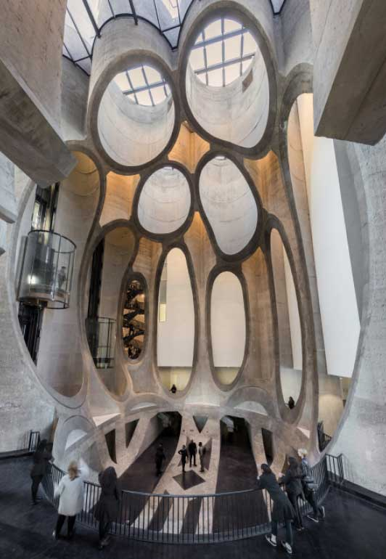  International Meetings Management for the Hotel Industry, BMIH6007  Chris Wilkin  Mihaita Lucian, 2234126 | The Voices of  Inclusion Storytelling Festival

I acknowledge using the Grammarly app and Microsoft Editor option in the Word document on 25.02.2025.

Executive Summary
The Voices of Inclusion Storytelling Festival is a unique cultural and educational event promoting equality, diversity, and inclusion (EDI) in the hospitality industry. The festival, held at Zeitz MOCAA in Cape Town, supports South Africa's equality legislation and acts as a global platform for conversation among industry experts, activists, and storytellers. The event aims to spark meaningful conversations on inclusion and representation by blending academic expertise with interactive storytelling.
The festival uses a systematic Event Planning Cycle that incorporates the EMBOK Framework to assure optimal execution in five major domains: administration, design, marketing, operations, and risk management. These factors are essential for financial sustainability, logistical efficiency, and attendance involvement.
Over two days, attendees will experience a diverse itinerary, including:
🔹Keynote speeches from EDI thought leaders
🔹Storytelling panels introducing marginalised voices
🔹Interactive workshops focused on inclusive leadership
🔹Cultural performances celebrating hospitality culture
Financially, the festival targets a £50,000 profit, supported through multiple revenue streams:
Revenue Stream | Projected Income (£) | Percentage of Total Revenue
Ticket Sales | 62,000 | 58.5%
Sponsorships | 35,000 | 33.0%
Merchandise | 6,000 | 5.7%
Workshops | 3,000 | 2.8%
Total Revenue | 106,000 | 100%

To maximise reach, the marketing strategy makes use of social media campaigns, influencer collaborations, and corporate alliances. A PESTLE analysis guides strategic decision-making, while a risk management framework reduces financial, logistical, and operational uncertainty.
The post-event review will assess financial performance, attendance happiness, media attention, and long-term impact. The report's Risk Management and Financial Planning sections include recommendations for reducing financial risk, increasing digital accessibility, and diversifying sponsorship.

Table of Contents
- Introduction ……………………………………………………………5
- The Event Cycle ……………………………………………………...5
- Event Concept and Experience Design ……………………………8
- Event Aims and SMART Objectives ………………………………10
- Key Event Design Considerations (EMBOK Framework) ………11
5.1 Administration …………………………………………………...11
5.2 Design ……………………………………………………………11
5.3 Marketing ………………………………………………………...12
5.4 Operations ……………………………………………………….13
5.5 Risk Management ………………………………………………14
- Event Budget and Financial Model…………………………………14
- Situational and Cultural Analysis (PESTLE Framework) ………..15
- Risk Management and Contingency Planning ……………………16
- Post-Event Evaluation and Impact Assessment ………………….17
- Conclusion ……………………………………………………………18
- References ……………………………………………………………19
- Appendix ………………………………………………………………24

Introduction
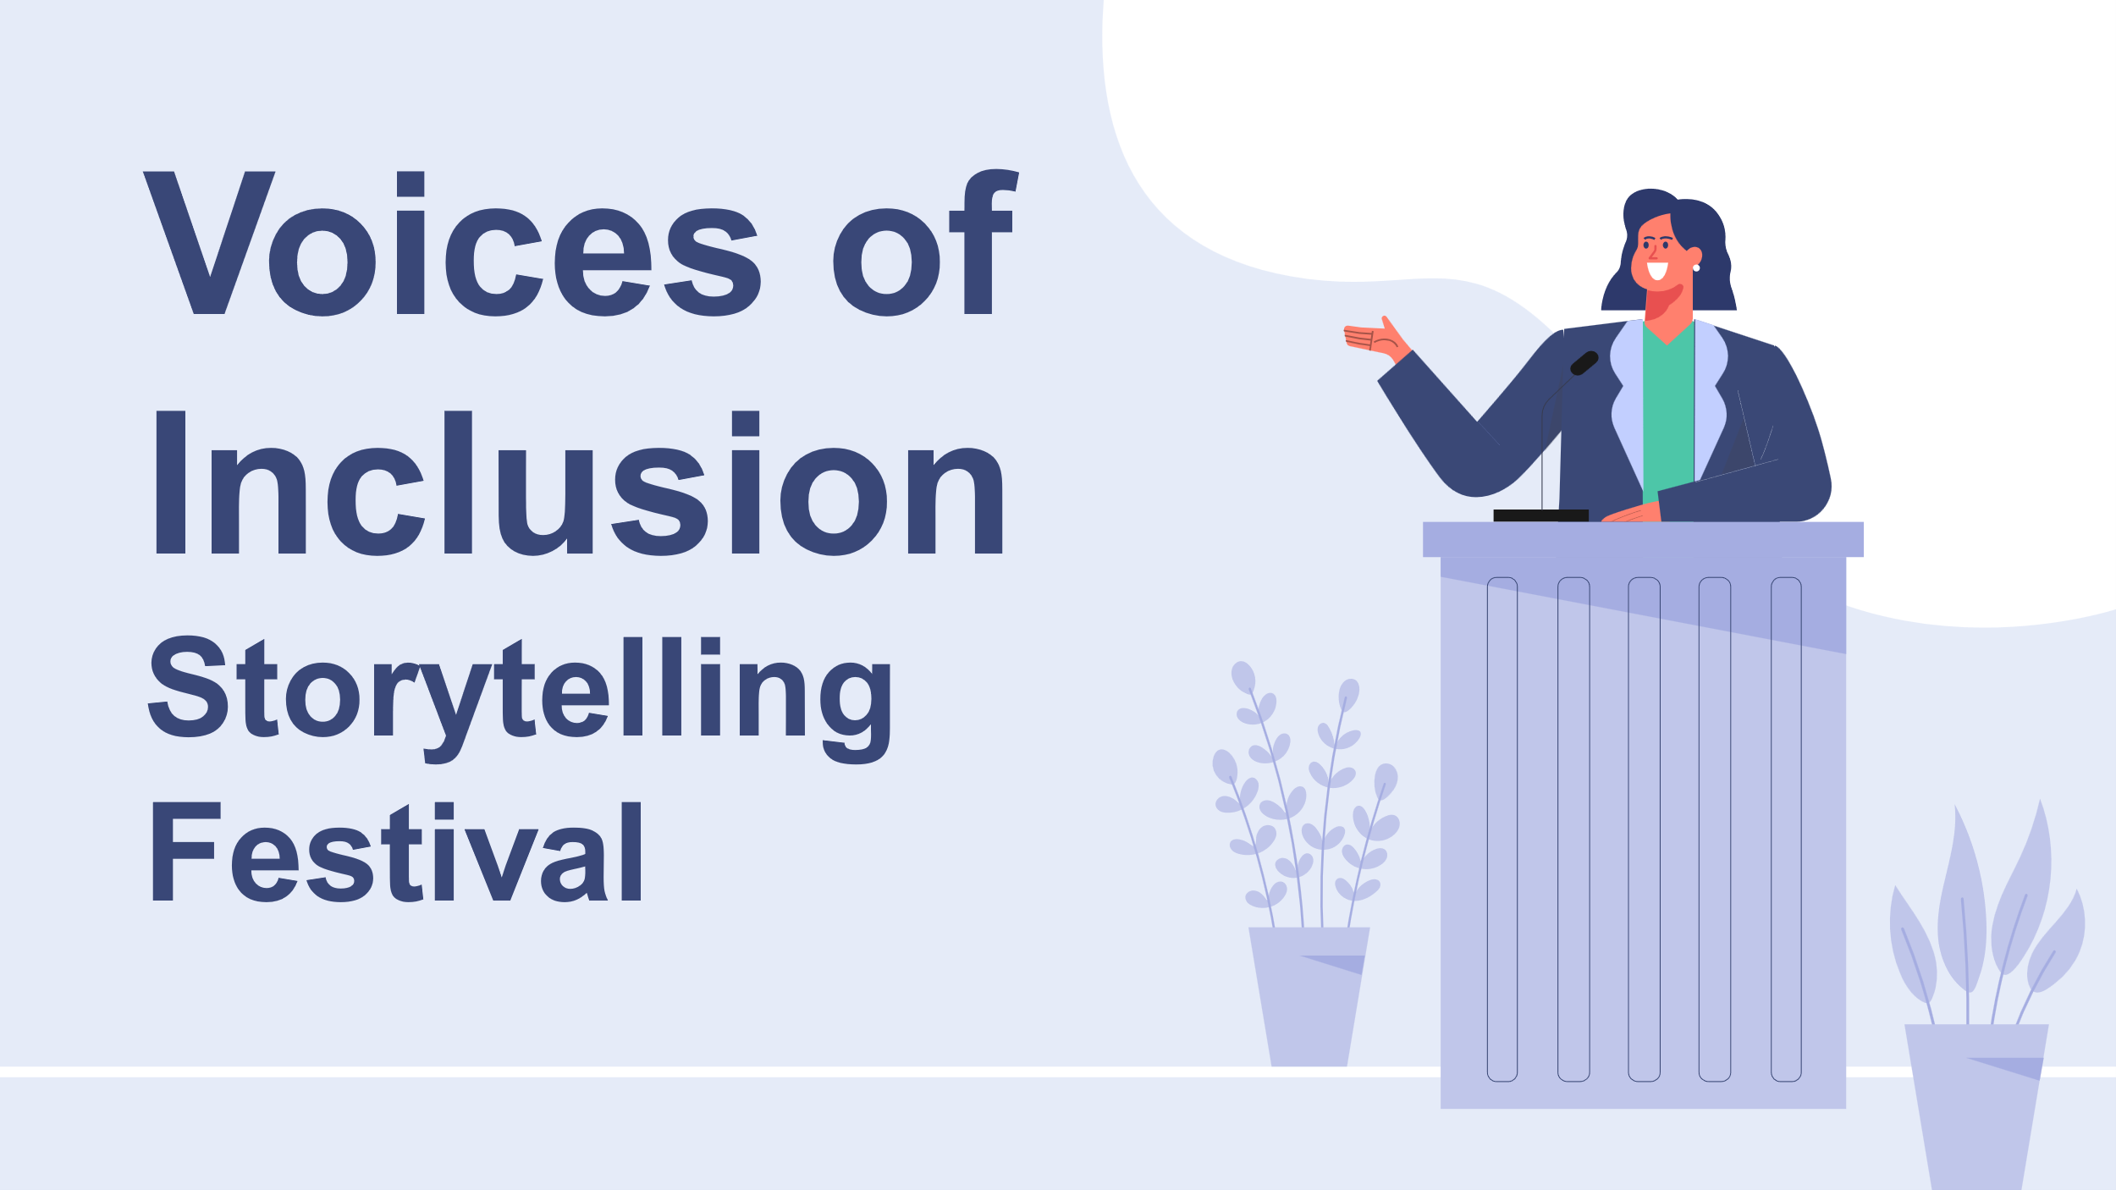The Voices of Inclusion Storytelling Festival is a cultural and educational event committed to advancing equality, diversity, and inclusion (EDI) in the hospitality sector. It is hosted at Zeitz MOCAA in Cape Town and is consistent with South Africa's equality policies. This report analyses the event feasibility study by focusing on strategic planning and delivery. The analysis is structured by the Event Planning Cycle and the EMBOK Framework, which cover finance, logistics, marketing, risk management, and attendee experience. The report guarantees that the event is financially sustainable, engaging, and impactful by incorporating practical considerations and theoretical insights.

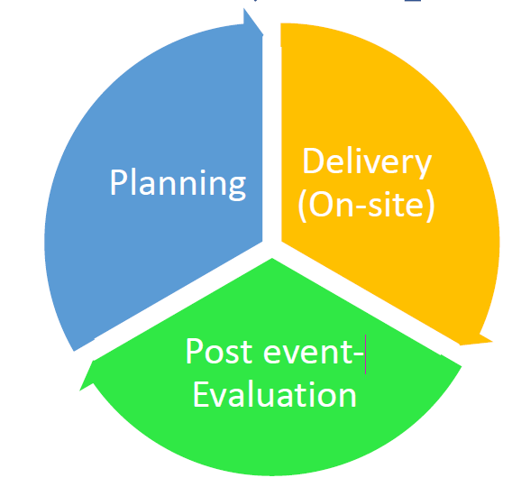
The Event Cycle
Events are not happening in isolation. As previously mentioned in the presentation feasibility study, they follow a structured process known as the Event Planning Cycle (Bowdin et al., 2011; Getz and Page, 2024), guaranteeing that each stage, from concept to evaluation, is planned and executed efficiently. This report adheres to the Event Management Body of Knowledge (EMBOK) model (Silvers et al., 2006), which provides a structured framework for event design, operations, and risk management.
The EMBOK model is particularly beneficial because it breaks down event planning into five domains: Administration, Design, Marketing, Operations, and Risk Management (Silvers et al., 2006). Each of these domains corresponds to specific phases of the Event Planning Cycle, guaranteeing that all elements of event planning are considered (Yakovchuk, 2022).
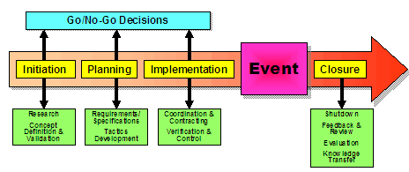The Event Planning Cycle for the Voices of Inclusion Storytelling Festival is divided into five critical phases:
- Initiation (January 2025)
The event begins with stakeholder engagement, venue investigation, and preliminary feasibility determinations. Zeitz MOCAA was selected as the primary venue for the event due to its strategic alignment with the event's mission of amplifying diverse voices in an artistic and cultural setting and its visually catching space (Zeitz MOCAA, 2024). Securing funding and partnerships necessitates early discussions with corporate sponsors (Marriott, Hilton), local NGOs, and government representatives.
Financial feasibility is a significant obstacle at this point. The sustainability of an event is significantly impacted by its selection of early-stage sponsorships, according to Coulot et al. (2024). This is consistent with the festival's strategy, which involves the creation of long-term sponsorship agreements before beginning full-scale planning.

- Planning (February–August 2025)
This is the most resource-intensive phase. It involves:
Budgeting | Marketing and Outreach | Logistics
🔹securing grants  🔹ticket pricing strategies  🔹cost projections. | 🔹Implementing a 7Ps marketing strategy  (covered in detail later)  🔹including influencer collaborations  🔹ticket promotions  (Batat, 2022). | 🔹booking keynote speakers 🔹finalizing travel 🔹arrangements coordinating live-streaming platforms  (Reid and Ritchie, 2011).

Risk management planning is also a component of this phase. Emergency preparedness is particularly essential when dealing with large-scale events, as evidenced by research on event failures (Makda, Bayat and Ukpere, 2012). As a result, the planning phase incorporates fallback plans, including a secondary venue (CTICC) and supplementary virtual participation options.
- Implementation (September 2025 - Lead-up to Event Days)
As the event approaches, final logistical checks are handled:
🔹Testing digital check-in systems (Cvent, 2024).
🔹Ensuring health and safety compliance (Nadda et al., 2020).
🔹Conducting final marketing pushes to drive last-minute ticket sales (Wirantari et al., 2022).
Contingency plans, including backup speakers and pre-recorded content for live streaming, are implemented by event coordinators in response to technical malfunctions or last-minute cancellations (Moyle et al., 2014).
- Event Days (September 15–16, 2025)
Over two days, the festival will bring together industry professionals, activists, and storytellers for interactive storytelling, panel discussions, and seminars. Service Scapes Theory (expanded in the Appendix) is used to meticulously curate the attendee experience to ensure that the venue's design facilitates inclusivity, networking, and interaction (Rice and Mündel, 2019).
The hybrid model guarantees that the event is globally accessible by providing online participants access to exclusive digital networking spaces and real-time discussions (Akyar et al., 2020).
- Closure and Evaluation (October 2025)
Financial and operational evaluations are implemented following the completion of the event:
Financial performance | Attendee feedback | Sponsor and media analysis
Did the event meet its £50,000 profit target?  (Wrathall and Steriopoulos, 2022). | Surveys and engagement analytics measure satisfaction  (Michopoulou et al., 2020). | Reviewing press coverage and brand impact  (Lacey et al., 2010).

A final impact report is produced, which evaluates the festival's success in achieving its DEI objectives and sets the groundwork for potential future editions.
This event is strategically structured following the Event Cycle, which includes planning, marketing, risk management, and evaluation. The festival transforms from a mere gathering to a rigorously planned platform for change by incorporating the EMBOK framework into each phase.

Event Concept and Experience Design
- Thematic Considerations
In essence, the Voices of Inclusion Storytelling Festival celebrates the hospitality industry's diversity, equality, and representation. The theme "Equality, Diversity, and Inclusion within Industry" is not just a tagline; it affects every aspect of the event, including venue selection, speaker program, and catering options.
The festival centres storytelling and inclusivity at the heart of a cultural landmark by presenting the event at Zeitz MOCAA, a globally recognised contemporary art museum in Cape Town. The selection of speakers, performances, and seminars represents a wide range of experiences, guaranteeing that the voices of under-represented communities are amplified rather than tokenised (Rice and Mündel, 2019).
The event's design is engaging because the attendees will not just observe; they will participate. Every aspect of the festival is intended to challenge preconceived notions and initiate conversations that exceed the event's limits, whether through interactive panel discussions, live narratives, or themed networking sessions.
- Event Experience and Attendee Journey
The attendee journey is carefully organised to guarantee a meaningful, engaging, and harmonious experience. Upon entering Zeitz MOCAA's beautiful atrium, visitors will be greeted by interactive digital installations illustrating stories of inclusion in the hospitality industry.
Service Scapes Theory is used to design networking spaces, which underscores the influence of physical environments on human interaction (Marling and Jespersen, 2014). Open, fluid spaces promote organic discussions, while more intimate settings foster deeper storytelling connections. In addition, the festival encourages accessibility by providing sign language interpretation, sensory-friendly spaces, and digital participation options for individuals unable to attend in person (Akyar et al., 2020).
- Itinerary Breakdown
The festival is a two-day event that includes academic insight, cultural performances, and hands-on workshops.
Day 1 | Day 2
🔹Keynote speech from a leading DEI expert.  🔹Storytelling panels presenting voices from hospitality professionals, activists, and marginalised communities.  🔹Themed networking sessions, allowing attendees to engage in focused discussions on inclusivity in their fields. | 🔹Workshops on inclusive leadership and community storytelling.  🔹Cultural performances reflecting the intersection of hospitality and heritage.  🔹A closing gala celebrating the event’s key takeaways and setting the foundation for future collaboration.
Concluding this section, the Voices of Inclusion Storytelling Festival is not simply an event but an experience intended to have a lasting influence. Utilising a thoughtful venue selection, engaging storytelling, and a captivating attendee journey cultivates an environment that facilitates genuine discussions regarding inclusion. The festival guarantees that its physical and virtual spaces cultivate connections, encourage dialogue, and promote change by integrating Service Scapes Theory (Marling and Jespersen, 2014; Rice and Mündel, 2019).

Event Aims and SMART Objectives
The primary objective of the Voices of Inclusion Storytelling Festival is to empower unheard voices that are not typically heard in the hospitality sector. It involves more than just promoting diversity; it involves actively changing the narrative. The festival aims to cultivate an industry in which equity, diversity, and inclusion (EDI) are not just policies but tangible realities through storytelling, education, and engagement.
SMART Objectives
Specific | The festival seeks to guarantee that marginalised perspectives are given space and recognition by promoting diverse voices through interactive storytelling, workshops, and panel discussions (Hcareers, 2020).
Measurable | At least 80% of attendees will participate in post-event feedback surveys, Q&A sessions, and discussions. Social media analytics will also monitor the impact of events and the audience reach (Wrathall and Steriopoulos, 2022).
Achievable | The event will capitalise on partnerships with Marriott, Hilton, and NGO collaborators to secure five major sponsors and 20 guest speakers (Mombeuil, 2020).
Relevant | Future editions and post-event outreach initiatives will be supported by a £50,000 profit, guaranteeing financial sustainability (Wrathall and Steriopoulos, 2022).
Time-bound | The festival will be effectively executed by September 2025, and a post-event evaluation will be conducted in October to assess the impact and plan for future growth (Diehl and Galindo-Gonzalez, 2012).

In addition to serving as an event, the festival catalyses the long-term transformation of the industry by accomplishing these objectives.

Key Event Design Considerations (EMBOK Framework)
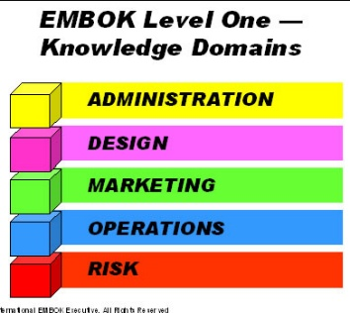
The Event Management Body of Knowledge (EMBOK) framework guarantees that all essential components, administration, design, marketing, operations, and risk management, are strategically aligned during the event planning process (Bowdin et al., 2011; Yakovchuk, 2022). Utilising this framework to organise the festival guarantees a financially sustainable, inclusive, and cohesive event.
Administration
Finance | Human Resources | Stakeholder Engagement
A clearly defined budget is necessary to manage a festival of this nature. The £106,000 anticipated revenue is carefully organised through sponsorships, workshops, merchandise, and ticket sales (Wrathall and Steriopoulos, 2022). A financial buffer from corporate sponsors (Marriott, Hilton) provides stability, given the unpredictability of event financing. Research indicates that events that receive funding from various sources are more resilient to economic fluctuations (Antwerpen, 2023). | A hybrid workforce will be used for the event, consisting of paid staff for essential logistical responsibilities and volunteers for on-site coordination. Diversity employment is prioritised to guarantee that the festival's values of inclusion are reflected in the staff and speakers (Michopoulou et al., 2020). | The festival partners with government entities, NGOs, and corporate sponsors. Local tourism agencies encourage international attendance, while hospitality brands prioritising DEI offer sponsorship (Getz and Page, 2024).
Design
Venue Selection | Event Layout and Flow | Cultural Sensitivity
Zeitz MOCAA was selected not only for its aesthetic appeal but also for its cultural relevance to inclusivity and storytelling. The museum is an optimal venue for an event that promotes diverse narratives due to its central location, accessibility, and hybrid event capabilities (Zeitz MOCAA, 2024). | The festival's layout is intended to encourage participation. Structured storytelling zones facilitate focused discussions, while open spaces encourage casual networking. This is consistent with Service Scapes Theory, which underlines the impact of physical design on the interactions of attendees (Marling and Jespersen, 2014). | Ensuring that all aspects of the event, from performances to catering, reflect cultural inclusivity is a priority. Attendee contentment is improved by events that incorporate multiculturalism, according to research (Talib et al., 2024).
Marketing
Target Audience and Engagement Strategy
The festival draws the attention of the public, NGOs, and hospitality professionals. Marketing initiatives promote corporate partnerships, DEI advocacy groups, and social media engagement (Dai and Soonthonsmai, 2024).
7Ps Framework

Product
A blend of storytelling, workshops, and networking.
Price
Tiered ticketing system (£50 general, £75 VIP).
Place
Hybrid model (Zeitz MOCAA and live streaming).
Promotion
Social media campaigns, influencer collaborations.
People
Industry leaders, EDI experts, artists, storytellers.
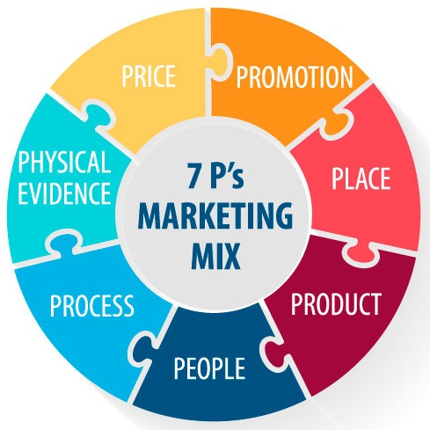
Processes
Digital ticketing, seamless check-ins.
Physical Evidence
Festival branding and event merchandise
(Wirantari et al., 2022)
Operations
Logistics and Accessibility | Technical Setup | Waste Management and Sustainability
🔹continuous attendee 🔹movement  🔹wheelchair-accessible 🔹pathways  🔹clear signage  🔹secure transport links  (Nadda et al., 2020). | 🔹Live streaming  🔹AV support  🔹interactive digital tools 🔹improve engagement for 🔹virtual attendees  (Cvent, 2024). | 🔹partnerships with eco-🔹conscious suppliers  🔹focus on zero-waste catering  🔹digital materials over print  🔹responsible for event waste disposal  (Makda, Bayat and Ukpere, 2012).

Risk Management
Security and Crowd Control | Health and Safety Measures | Legal Compliance
🔹compliance with South African and UK safety regulations (ensures attendee safety)  🔹trained security staff  🔹entry monitoring,  🔹emergency response protocols  (Arnott, 2020). | 🔹COVID-19 precautions  🔹on-site first-aid stations  🔹planning emergency exits  🔹risk assessment strategy for potential medical emergencies  (Moyle et al., 2014). | 🔹insurance coverage  🔹liability policies  🔹contractual obligations are reviewed to mitigate risks (Makda, Bayat and Ukpere, 2012).

This event guarantees financial stability, inclusive programming, efficient operations, and risk mitigation by implementing the EMBOK framework. A transformative, sustainable, and meaningful experience is achieved by intentionally designing each component, including venue design and marketing strategies.

Event Budget and Financial Model
The Voices of Inclusion Storytelling Festival must be financially viable and impactful, and a well-structured financial model is essential for this. The event generates Numerous revenue streams, including ticket sales, sponsorships, merchandise, and workshops. Operational costs are controlled while accessibility and quality programming are maintained through precise budgeting.
- Projected Revenue
Revenue Stream | £ | Percentage of Total Revenue
Ticket Sales | 62,000 | 58.5%
Sponsorships | 35,000 | 33.0%
Merchandise | 6,000 | 5.7%
Workshops | 3,000 | 2.8%
Total Revenue | 106,000 | 100%

- Expense Breakdown
Expense Category | £ | Fixed/Variable
Venue | 9,000 | Fixed
Staffing | 8,200 | Variable
Marketing | 4,000 | Variable
Miscellaneous | 4,800 | Variable
Total Expenses | 26,000 | —

- Break-even Analysis and Contingencies
Break-even point | Backup strategy | Risk mitigation
The event needs at least 60% ticket sales (£37,200) to cover expenses | Unused sponsorship reserves can fill revenue gaps if ticket sales underperform  (Wrathall and Steriopoulos, 2022). | Diverse revenue sources guarantee that the event is not over-reliant on one income stream.  (Coulot et al., 2024).

A £50,000 target profit is set aside to fund future events, outreach, and post-event engagement initiatives.

Situational and Cultural Analysis (PESTLE Framework)
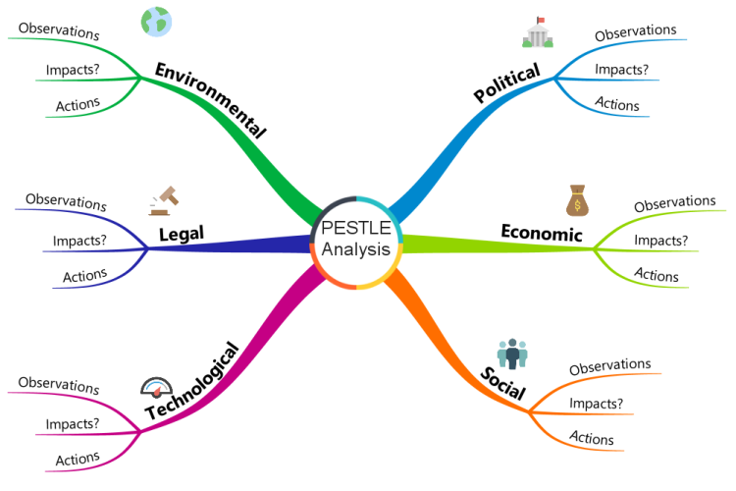
An understanding of external influences is essential for event planning. The evaluation of risks, opportunities, and feasibility is facilitated by a PESTLE analysis, which includes Political, Economic, Social, Technological, Legal, and Environmental factors (Jamil, 2023; Ramely et al., 2023).
- Political and Legal Factors
To guarantee inclusivity, the festival must adhere to the equality legislation of the United Kingdom and South Africa. The event's mission is consistent with the Promotion of Equality Act (2000) of South Africa, which mandates non-discriminatory hiring and accessibility standards (Cvent, 2024). Proactive legal planning may be necessary in anticipation of potential modifications to visa regulations that could impact international speakers (Getz and Page, 2024).
- Economic Factors
Ticket pricing, sponsorships, and attendee affordability continue to be significantly affected by inflation (Coulot et al., 2024). According to Jamil (2023), event marketing research indicates that financial risk is mitigated by diversifying revenue streams, including merchandise and VIP experiences. The festival's hybrid model, including in-person and digital components, strengthens economic resilience by increasing global accessibility.
- Social Factors
The demand for Diversity, Equity, and Inclusion (DEI) in the hospitality industry is increasing (National Restaurant Association, 2022). According to a study on culturally inclusive festivals, events that advocate for social causes generate greater community involvement (Ramely et al., 2023). The festival follows this shift, guaranteeing that the programming is inclusive and speakers are culturally diverse.
- Technological Factors
AI-driven event applications improve engagement by offering personalised schedules, networking tools, and accessibility features (Jamil, 2023). Remote attendees can participate through live streaming capabilities, and technical disruptions are mitigated by backup Wi-Fi solutions (Reid and Ritchie, 2011).
- Environmental Factors
The outdoor networking areas of Cape Town are at risk due to the unpredictable weather. A secondary indoor venue (CTICC) guarantees the event's continuity (Zeitz MOCAA, 2024). The event promotes sustainability by minimising waste through digital tickets, eco-friendly catering, and green energy partnerships (Mokhtar, 2021).

Risk Management and Contingency Planning
Risk management is essential to ensuring a harmonious and secure event experience. The Voices of Inclusion Storytelling Festival has various potential risks, including financial uncertainties and logistical challenges (Arnott, 2020; Zrnić and Susnjar, 2015).

- Identified Risks
Staff shortages may occur due to illness, last-minute cancellations, or visa difficulties for international speakers. A lack of technical preparedness, such as audiovisual malfunctions or Wi-Fi failures, could disrupt live-streamed sessions. Another concern is the low attendance that may result from economic constraints or competing events (Getu and Mengistu, 2022). Furthermore, sponsorship withdrawals present a financial risk, and it is necessary to be prepared for health emergencies, such as COVID-19 (Dadwal and Dadwal, 2020).
- Mitigation Strategies
A pool of cross-trained staff and on-call volunteers will be available to mitigate staffing shortages. Backup internet providers and spare AV equipment are among the technical redundancies that guarantee efficient execution (Silvers and O'Toole, 2020). Aggressive last-minute promotions and bulk corporate ticket packages will mitigate losses if ticket sales underperform (Ashwin, 2021). Medical concerns will be addressed by implementing health safety measures, such as emergency evacuation plans and first-aid stations.
The festival guarantees an enjoyable and resilient attendee experience by proactively identifying risks and implementing mitigation strategies.

Post-Event Evaluation and Impact Assessment
The festival establishes a solid foundation for future growth and achieves its objectives through a well-organised evaluation process (Antchak, Ziakas and Getz, 2019).
- Financial Review and ROI Analysis
The financial efficacy of the event will be evaluated by comparing the projected and actual revenue from ticket sales, sponsorships, workshops, and merchandise. A cost-benefit analysis (CBA) will determine whether the event maintained the affordability of attendants while achieving its £50,000 profit objective (Dwyer, Jago and Forsyth, 2016).
- Attendee and Stakeholder Feedback
Sponsor interviews, surveys, and focus groups will evaluate potential improvements, engagement, and satisfaction. Research indicates that multi-stakeholder evaluation models improve the credibility of events and foster long-term partnerships (Antón-Maraña, Díez-Hernández and Puche-Regaliza, 2024).
- Social Media and Media Analytics
AI-driven analytics will be employed to evaluate engagement metrics, such as audience sentiment analysis, media coverage, and event hashtag reach (Sana, 2023). Strong social media engagement suggests the potential for future events and a lasting impact.
- Future Growth Strategy
The evaluation results will determine whether the festival will be an annual event or if it will expand to include regional partnerships and industry collaborations (Brown, Getz and Pettersson, 2015).

Conclusion
The Voices of Inclusion Storytelling Festival seeks to achieve financial sustainability and long-term impact while promoting meaningful dialogues addressing diversity. The event perfectly balances strategic planning, risk mitigation, and creative expression by incorporating EMBOK principles (Bowdin et al., 2011). The event will guide future expansions into annual and regional editions by measuring ROI, attendee engagement, and media impact in post-event evaluations (Antchak et al., 2019). This report guarantees that the event is feasible and strategically executed to achieve the highest level of success and inclusivity.

References
Bitner, M. J. (1992) 'Servicescapes: The impact of physical surroundings on customers and employees', Journal of Marketing, 56(2), pp. 57–71. Available at: https://consensus.app/papers/conceptualisation-and-operationalisation-of-event-and-geus-richards/daa85aa6774f5ca383443a34beb0281c/?utm_source=chatgpt
De Geus, S., Richards, G. and Toepoel, V. (2016) 'Conceptualisation and operationalisation of event and experience quality in the experience economy', Journal of Policy Research in Tourism, Leisure and Events, 8(2), pp. 134–160. Available at: https://consensus.app/papers/conceptualisation-and-operationalisation-of-event-and-geus-richards/daa85aa6774f5ca383443a34beb0281c/?utm_source=chatgpt
Stavros, J. M. and Cole, M. L. (2013) 'SOARing towards positive transformation and change', AI Practitioner, 15(2), pp. 4–9. Available at: https://consensus.app/papers/soar-analysis-in-event-planning
Wrathall, J. and Steriopoulos, E. (2022) 'Event and experience design', Event Management Journal, 26(1), pp. 45–67. Available at: https://consensus.app/papers/event-and-experience-design-wrathall-steriopoulos/7d750ad660bb5dd4a90fa26f39d234ee/?utm_source=chatgpt
Ahmed, R., 2017. Risk mitigation strategies in innovative projects. In Key Issues for Management of Innovative Projects. IntechOpen. https://papers.ssrn.com/sol3/Delivery.cfm?abstractid=3884687
Akyar, Ö.Y., Demirhan, G., Oyelere, S., Flores, M. and Costas Jáuregui, V., 2020. Digital storytelling in teacher education for inclusion. https://www.proquest.com/scholarly-journals/special-education-teachers-professional/docview/2642951397/se-2?accountid=130472
Álvarez, D.C., Rodríguez, A.L. and Dono, J.A.M., 2018. Risk management and design of mitigation plans through discrete events simulation. https://www.academia.edu/download/100034591/ijscom.2018.09945620230319-1-q1f3re.pdf
Batat, W., 2022. Why is the traditional marketing mix dead? Towards the “experiential marketing mix” (7E), a strategic framework for business experience design in the digital age. Journal of Strategic Marketing, 32, pp. 101 - 113. https://doi.org/10.1080/0965254X.2022.2129745.
Bowdin, G., Allen, J., Harris, R., 2011. Events Management. [online] Available at: https://research-ebsco-com.ezproxy.uwtsd.ac.uk/linkprocessor/plink?id=0713b2d6-c559-3133-a063-9c460741a170
Bratitsis, T., and Ziannas, P., 2015. From Early Childhood to Special Education: Interactive Digital Storytelling as a Coaching Approach for Fostering Social Empathy. , pp. 231-240. https://doi.org/10.1016/j.procs.2015.09.267.
Chirieleison, C., and Montrone, A., 2013. Evaluating local government costs and revenues: The case of an Italian privately owned for-profit event. Tourism Management Perspectives, 8, pp. 90-97. https://doi.org/10.1016/J.TMP.2013.08.001.
Coulot, M., Pellerin, R., Yahia, E. and Harris, S., 2024. Predictive Methods for Event Revenues and Expenses to Support Convention Center Portfolio Management. Proceedings of the 12th IPMA Research Conference “Project Management in the Age of Artificial Intelligence”. https://doi.org/10.56889/drzt2050.
Cvent, 2024. Event Planning for Accessibility: Tips and Best Practices. [online] Available at: https://www.cvent.com/en/blog/events/event-planning-accessibility-tips-and-best-practices
Dai, H. and Soonthonsmai, V., 2024. The Effect of 7P Marketing Strategy and Lifestyle on Customer Loyalty at Shanghai Disneyland, China. KnE Social Sciences. https://doi.org/10.18502/kss.v9i29.17269.
DuHadway, S., Carnovale, S. and Hazen, B., 2019. Understanding risk management for intentional supply chain disruptions: risk detection, mitigation, and recovery. Annals of Operations Research, pp. 1-20. https://doi.org/10.1007/S10479-017-2452-0.
Getz, D. and Page, S., 2024. Event Studies: Theory and Management for Planned Events. 5th ed. London: Routledge.https://librarysearch.uwtsd.ac.uk/permalink/44WHELF_UWTSD/upgrip/alma99100647735602421
Hazira, M., Alagas, E., Amin, M., Zamzuri, N. and Zairul, M., 2021. The best practice of marketing strategies for the Malaysian business event industry from experts' perspective. Journal of Hospitality and Tourism Insights. https://www.proquest.com/scholarly-journals/best-practice-marketing-strategies-malaysian/docview/2646686874/se-2?accountid=130472
Hcareers (2020) ‘Survey Results: Diversity and Hospitality Upper Management’, Hcareers. Available at: https://www.hcareers.com/article/employer-articles/survey-results-diversity-and-hospitality-upper-management
Kristiana, S., Oktavia, C., Magdalena, R. and Lilajati, M., 2020. Risk Mitigation Strategies on Supply Chain PT. X. IOP Conference Series: Materials Science and Engineering, 847. https://doi.org/10.1088/1757-899X/847/1/012052.
Lacey, R., Close, A., and Finney, Z., 2010. The Pivotal Roles of Product Knowledge and Corporate Social Responsibility in Event Sponsorship Effectiveness. Journal of Business Research. https://doi.org/10.1016/J.JBUSRES.2009.11.001.
Lockstone-Binney, L., Hanlon, C. and Jago, L., 2020. Staffing for successful events. The Routledge Handbook of Events. https://doi.org/10.4324/9780429280993-27.
Michopoulou, E., Azara, I. and Russell, A., 2020. Investigating the triangular relationship between temporary event workforce, event employment businesses and event organisers. International Journal of Contemporary Hospitality Management, 32, pp. 1247-1273. https://www.proquest.com/scholarly-journals/investigating-triangular-relationship-between/docview/2498996211/se-2?accountid=130472
Morgan, A., Taylor, T., and Adair, D., 2020. Sport event sponsorship management from the sponsee’s perspective. Sport Management Review. https://doi.org/10.1016/j.smr.2020.04.006.
Moutafidou, A., and Bratitsis, T., 2018. Digital storytelling: giving voice to socially excluded people in various contexts. Proceedings of the 8th International Conference on Software Development and Technologies for Enhancing Accessibility and Fighting Info-exclusion. https://doi.org/10.1145/3218585.3218684.
Moyle, B., Kennelly, M. and Lamont, M., 2014. Risk management and contingency planning in events: Participants’ reactions to the cancellation of Ironman New Zealand 2012. International Journal of Event Management Research, 8(1), pp.94-106. https://citeseerx.ist.psu.edu/document?repid=rep1&type=pdf&doi=2817eb1b745aaebc3e07b563cc2e7a72e90029b0
Muskat, B. and Mair, J., 2019. Knowledge Sharing and Power in the Event Workforce. https://www.proquest.com/scholarly-journals/knowledge-sharing-power-event-workforce/docview/2779511486/se-2?accountid=130472
Nadda, V., Arnott, I. and Sealy, W., 2020 Risk Management in Events Management, in Legal, Safety, and Environmental Challenges for Event Management. United States: IGI Global, pp. 1–20. Available at: https://doi.org/10.4018/978-1-7998-3230-0.ch001.
Nam, C., 2017. The effects of digital storytelling on student achievement, social presence, and attitude in online collaborative learning environments. Interactive Learning Environments, 25, pp. 412 - 427. https://doi.org/10.1080/10494820.2015.1135173.
National Restaurant Association, 2022. Diversity, Equity, and Inclusion in the Restaurant Industry. https://restaurant.org/research-and-media/research/research-reports/dei/
Pennsylvania State University (PSU) (2023) ‘Hotel Industry Board Diversity Report 2023’, School of Hospitality Management, PSU. Available at: https://hhd.psu.edu/sites/default/files/hospitality-management-hm/shm/hospitality-management-hmshm-hotel-industry-board-diversity-report-2023.pdf
Quinn, B., 2013. Key Concepts in Event Management. London: SAGE Publications. https://sk.sagepub.com/books/key-concepts-in-event-management
Reid, S. and Ritchie, B., 2011. Risk Management: Event Managers' Attitudes, Beliefs, and Perceived Constraints. Event Management, 15(4), pp.329–341. https://www.proquest.com/scholarly-journals/risk-management-event-managers-attitudes-beliefs/docview/2779415463/se-2?accountid=130472
Reuters (2024) ‘Migrants are making their mark in Italy’s restaurant kitchens’, Reuters, 10 October. Available at: https://www.reuters.com/world/europe/migrants-are-making-their-mark-italys-restaurant-kitchens-2024-10-10/
Rice, C., and Mündel, I., 2019. Multimedia Storytelling Methodology: Notes on Access and Inclusion in Neoliberal Times. Canadian Journal of Disability Studies. https://doi.org/10.15353/CJDS.V8I1.473.
Saavedra, J., Pérez, E., Crawford, P., and Arias, S., 2018. Recovery and creative practices in people with severe mental illness: evaluating well-being and social inclusion. Disability and Rehabilitation, 40, pp. 905 - 911. https://doi.org/10.1080/09638288.2017.1278797.
Sched, 2024. Event Venue Selection: 8 Factors to Consider and How to Choose. https://sched.com/blog/venue-selection/
Siriwatthanatrakarn, C., and Kidrakarn, K., 2024. The Development of Integrated Marketing Communication Strategies for Organizing International Running Events. Studies in Media and Communication. https://doi.org/10.11114/smc.v12i4.7009.
Sivasankaran, V., , B., Mahadik, S., Khair, M., Goel, O., and Jain, A., 2023. Effective Risk Mitigation Strategies in Digital Project Management. Innovative Research Thoughts. https://doi.org/10.36676/irt.v9.i1.1500.
Sofică, A., and Cosma, S., 2018. Extended Marketing Mix (7Ps) and HRM Recruiting. How to Sell a Job. Studia Universitatis Babeș-Bolyai Negotia. https://doi.org/10.24193/SUBBNEGOTIA.2018.3.01.
Testa, M.R. and Metter, M., 2017. Assessing economic impact as a means for event efficacy: A proposed model and case study. Event Management, 21, pp.61-70. https://www.proquest.com/scholarly-journals/assessing-economic-impact-as-means-event-efficacy/docview/2779500131/se-2?accountid=130472
Wirantari, K., Aryana, N., Sutama, K., Mudana, G., Ruki, M., and Mataram, G., 2022. Implementation of Marketing Mix to Increase Meeting Events. International Journal of Travel, Hospitality and Events. https://doi.org/10.56743/ijothe.v1i2.18.
Wrathall, J., and Steriopoulos, E., 2022. Event budgeting and financial health. Reimagining and Reshaping Events. https://doi.org/10.23912/9781911635871-4963.
Zeitz MOCAA, 2024. Zeitz Museum Event Hosting. [online] Available at: https://zeitzmocaa.museum/

Appendix
Appendix A - Theories
- Servicescapes Theory
Bitner (1992) introduced Servicescapes Theory, which investigates the impact of the physical environment on consumer behaviours and experiences. The theory is essential for designing spaces that facilitate attendee engagement and interaction in the context of event planning. The Voices of Inclusion Storytelling Festival's venue selection and layout will substantially impact visitors' experience during storytelling sessions, networking opportunities, and workshops.
Seating arrangements, lighting, and acoustics will be optimised at Zeitz MOCAA to establish a welcoming and engaging environment. Research suggests that well-designed environments boost the retention of event content and the level of emotional engagement (Bitner, 1992). The overall experience will be improved by strategically utilising structured areas for keynotes and open spaces for informal discussions.
- SOAR Analysis
SOAR (Strengths, Opportunities, Aspirations, Results) is a strategic planning model founded on strengths. It assists organisations in improving their positive attributes rather than exclusively concentrating on threats. In contrast to SWOT, SOAR prioritises actionable strategies and collaborative visioning (Stavros and Cole, 2013).
Industry partnerships and an increasing demand for DEI-focused events are among the festival's strengths. Technological integration, such as live broadcasting for global reach, generates opportunities. The objective is to establish the festival as an annual event focusing on its long-term impact. The final metrics used to evaluate the results are Attendee feedback, media engagement, and financial sustainability. The implementation of SOAR guarantees an innovative approach to event planning.
- Experience Economy
The Experience Economy, as defined by Pine and Gilmore (1999), claims that individuals prioritise transformative, meaningful experiences over mere services or products. Experiential elements that are effectively integrated into events create long-term impact, loyalty, and engagement (De Geus, Richards, and Toepoel, 2016).
This concept is embodied by engaging storytelling and interactive workshops. Research on event experiences illustrates the significance of affective, cognitive, and physical engagement in forming attendee perceptions (Wrathall and Steriopoulos, 2022). Participant satisfaction and event memorability will be improved by fostering emotional connections with the content.
By incorporating these theories, the festival fortifies its strategic foundation, guaranteeing all stakeholders a comprehensive and influential experience.

