Sustainable Hospitality and
Tourism Management
(M5X01925_BIRM)



Student: Andreea Sandru
Student number: 1815220
Lecturer: Abdi Rahman

Contents

Introduction………………………………………………………………………………………………………2
Principles of Sustainability and Theories……………………………………………………….….2
Constance Hotels and Resorts……………………………………………………………………….…3
Compare the Constance with Cancun………………………………………………………….….6
Conclusion ………………………………………………………………………………………………….….7
References ……………………………………………………………………………………………….……8

Introduction

The purpose of this assignment is to evaluate the principles of sustainable tourism in an objective way, whilst enumerating the principles of sustainable development and to conclude if these principles are compatible.
According to the United Nations Brundtland Commission (1987), Sustainable Tourism “meets the needs of present tourists and host regions while protecting and enhancing opportunity for the future”. To put it in a simple manner, when a tourist chooses a destination and ends up visiting it, they must remain aware of their role in the environment, society, and economy they are indirectly affecting. Any definition of durable tourism underlines the environment, social, and economic elements of the tourism structure. (Swarbrooke, 1999). This theory is essential as the number of people that are travelling is increasing year by year and it ends up having an everlasting impact on life worldwide. If humanity doesn't protect its own planet, the resources will finally end, and survival is at risk for everyone. Lasting tourism is applauded in the concept of Sustainable Development that was defined by Stappen in 2008, as “ development that meets the basic needs of all human beings and which conserve, protect and restore the health and integrity of the Earth’s ecosystem, without compromising the ability of future generations to satisfy their own basic requirements and without going over the limits of long term capacity of the earth’s ecosystem. “

Principles of Sustainable Tourism and Theories

Sustainability is based on 3 essential factors such as environmental sustainability, economic sustainability, and social sustainability (Huang, 2011). The regulations of Renewable Tourism are economic growth, resident well-being, enrolment condition, Social fairness, tourist satisfaction and well-being, natural virtue, Biological diversification, and the cleanliness of the environment. At the same time, the basis of long-lasting development is represented by existing within Environmental limits, attaining a viable economy, advocating for great Governance, applying sound Responsibly and establishing a society which in is great physical health and displays an ethical attitude. All these principles of tourism and development have the same objective: keeping nature safe, recycling and improving the quality of life on this planet. Promoting feasible tourism is an endless process and it demands constant research, strategy and intervention. Some of the theories involved in this type of tourism are very weak, weak, strong and very strong sustainability.
Based on these definitions, principles, and theories, we will analyse how hotels and resorts of any kind are helping the planet whilst promoting tourism.

Constance Hotels and Resorts

These hotels and resorts are placed in the Indian Ocean: Mauritius, Maldives, Seychelles and Madagascar. They make sure to deliver amazing and original experiences to all their guests, whilst pouring their heart and soul to make them happy. They also insist on everyone respecting the Indian Ocean islands where their properties are based, as protecting nature and conserving it is their primary goal, especially when bringing in tourists from all over the world.

The Constance empire got enrolled in an environmental sustainability performance program in 2013. Their strategy was to consolidate their engagement to the people and riches of their different locations by enforcing new eco projects and endorsing viable doctrines & green initiatives. That is how Constance became a brand of eco-luxury hotels and resorts. For numerous times, Constance hotels & resorts were certified as Green Globe, now finally being a Green Globe Gold Member.

Constance Hotels and Resort wishes to assure the persistence of their procedures, through immense improvements to natural conservation, community development and cultural legacy preservation. This performance can be achieved by focusing on four keys areas such as Environmental, Socio-Cultural, Quality, Health & Safety and all their subcategories. Basically, these resorts are empowering all the principles of touristy while applying ingenious strategies which aim to conserve natural and cultural factors. The managers are devoted at balancing their economic prerogatives with their responsibility to protect the environment by reducing, reusing and constantly recycling. For example, in 2011 they introduced a daily monitoring to analyse and reduce their energy utilization. Between 2017 and 2018, the reduction of GHC emissions was -10,6%, while the cutback of energy was -15,1%. They focused on reusing foods and materials by gifting them to local organisations. Also, what can be recycled is closely kept under surveillance. As a result, the resorts managed to reduce the organic waste at a shocking 3,6% and the hazardous at an amazing 34,3%.
The Constance brand does not only focus on what goes in an out but also on what’s around them. They are planting trees, keeping the beach clean, preserving the mangrove, advocating for turtle and coral recovery. They support and promote pro-poor tourism, giving a lot of poor people a place to earn their bread from. When hiring extremely poor people, they offer them extra support to help them survive. Pro-poor tourism (PPT) was defined by Spence lay in 2003, “as tourism that generates net benefits for the poor, which may be economic, social or environmental”. There are a lot of factors that have been crucial in identifying if the poor are able to receive great benefits regarding tourism favourable circumstances. ((Renard, Darcheville and Krishnarayan, 2001-pag 7).
It is said that success depends on your location, your personality, what you own, and your general knowledge and skills. Pro-poor tourism is able to offer poor people a second chance. The principles that determine the rate of success of the Pro Poor Tourism theory are cooperation, integrated sustenance, dispersion, resilience, financial viability and learning. Starting with the cooperation of the poor people within the industry to concluding with learning from the experience gathered along the way, all these principles are essential for an efficient Pro-Poor Tourism. Their future objectives are to cover a stronger environmental-friendly approach. Constance resorts plan to do so by entrusting a special team, which shall be represented by a nominated Environment champion in each property which shall apply the corporate viability practices. Connecting humans with nature is in their DNA, so to speak. As a game plan for Pro Poor Tourism, they desire to resolve local poverty through tourism, and to have fruitful partnerships with the local government in order to make changes at a larger scale.
The Constance resorts are nurturing the natural and cultural values of the local areas, they encourage locals to try local foods which they serve in their restaurants. When tourists are checking in, they offer them souvenirs that are crafted by locals. One of the most important things is that they make sure that wastewater is not ejected in the ocean, which we know is a major issue affecting all the oceans in the world. The resorts use only organic fertilisers, and make sure to not abuse the water plant so as to not waste water. In concordance with the sustainable development principles, we can declare that the Constance resorts are extremely careful with the health and safety of their surrounding areas and community. By constantly training their employees and investing in their eco-friendly education, recycling everything and reusing most of wastes, providing high quality services without sacrificing nature, they truly ensure that both tourists and nature are well taken care of.
The feasible development is permanently developed, so that the guests are invited to explore the natural environment and even receive free guides about wildlife and sustainable development. The best theory that applies to this resort is very strong sustainability. The model of long-lasting development that suits this brand is THE TRIPLE BOTTOM LINE MODEL, that “assumes that all three sub spheres are equally important, and that their equal interaction produces sustainable development.”

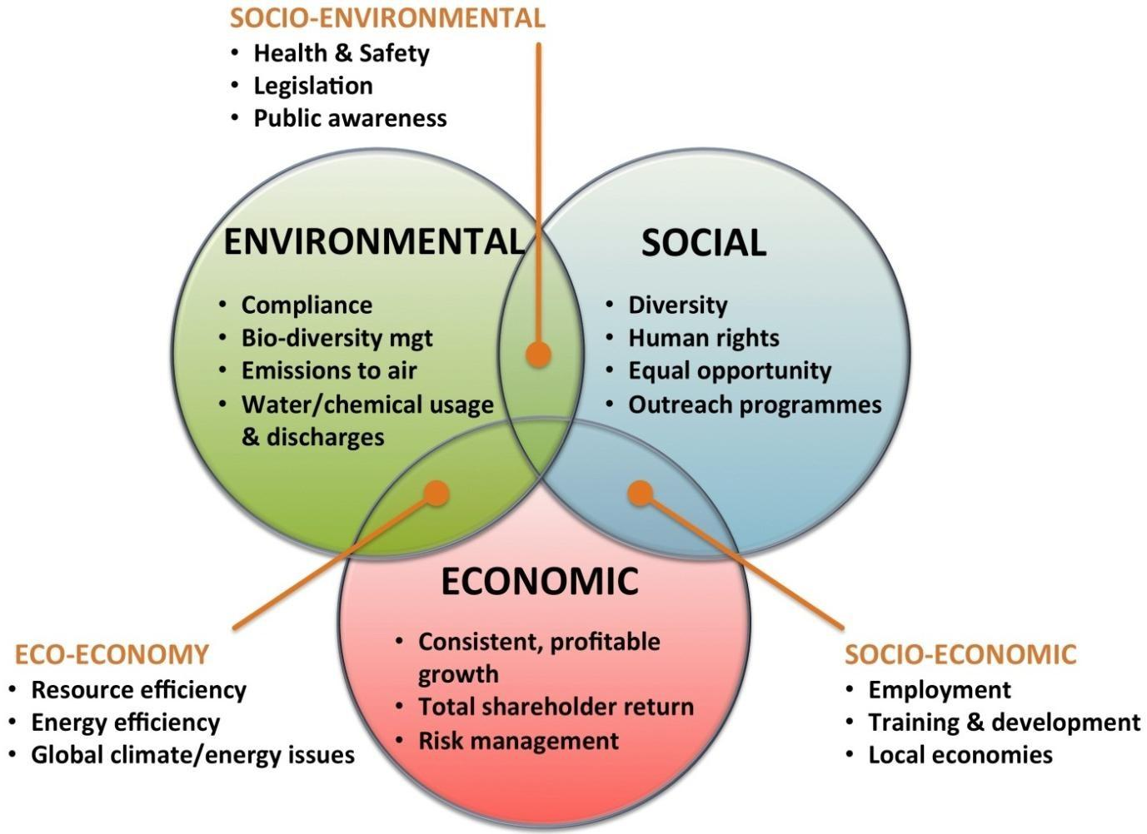
All of these are good practices, especially since they are nurturing the environment and appreciate the good coming from Mother Earth. Constance resorts are aware of the growing number of tourists that visit every year and of the huge impact that could have on the splendid nature in which they reside.

Compare The Constance with Cancun

The situation in Cancun is the exact opposite, as they represent a perfect example of non-sustainable tourism. Due to the fact that the economy is desperately dependent on tourists coming in, the once beautiful seas are now contaminated. Sadly, that had a negative impact on the wildlife present there. The irony is that Cancun mostly relies on their tourism industry now, as the other major economic sectors were seriously affected, therefore fishing and agriculture are not that reliable anymore. As another side effect, the locals are pushed to abandon their farm or renounce fishing so they could find other jobs, so they won’t starve. To top this already grim scenario, some of the locals are frustrated with the tourists, as they claim that tourists do not show any respect towards them or their local flora or fauna. Even so, the profits brought in by the tourists end up in the accounts of a foreign company, which has no interest in investing in the local community and nature. In conclusion, there are no astounding benefits that could excuse the lack of interest in a sustainable approach.
Instead, the tourism industry should focus on preserving the culture and the environment and on providing the locals from Cancun with a fair share of the profits. This particular industry highly relies on natural resources and has overwhelming environmental, cultural, social and economic impacts, mostly in an adverse manner (Mowforth & Munt, 2003 pag 282). Waste water still remains one of the biggest issues that cripples the environment. Please note that the hotel industry spewed approximately 95% of total sewage water, which is a disastrous percent, considering that this filthy and untreated water is dumped into the sea. Besides waste water, we can talk about another culprit: solid waste. Due to the high number of tourists, the soil and underground water is affected by this huge amount of untreated waste. What else do tourists bring to the table when there is no sustainable development in place? Pollution. An enormous number of tourists equals a tremendous number of cars on the streets, as a lot of them prefer to call a cab rather than using the already packed public transportation.
Eventually, Cancun showed a visible interest to ameliorate the recurring environmental issues. They started by limiting major building projects, banning deforestation in periclitated areas and by emitting restrictive laws that affect constructions in conservation zones. The model that Cancun should use is Strong sustainability as the environment reinforces all other life forms and embodies the Social and Economic area. Without nature, humans and their economy will cease to exist. The Environment is the foundation of it all, whilst Society and Economy are just pillars. Also, the theory that applies is very weak sustainability.
Therefore, Cancun should renounce its bad practices and focus on cleaning and regenerating its surrounding environment, starting with reducing waste in its waters and finishing with air pollution. It will be an excruciatingly long and painful process, but everything must be done in order to ensure the health of your environment and community.

Conclusion

Based on the examined case studies, it can be concluded that the principles of sustainable tourism and sustainable development are synonyms, as with sustainable tourism you meet the needs of the tourists and with sustainable development you meet the needs of tourists and protect the planet, and all the resources. By maintaining nature’s well-being, and by resetting tourism to respect and nurture our planet, humanity can still hope for many merry years on this earth. After analysing the strategy and efforts of the Constance Resorts, it can be confirmed that they are applying an excellent strategy and their will to improve an already successful plan, should be the perfect example for sustainable development study cases. On the other end of the spectrum, the dire situation in Cancun in which the number of tourists is immense and no kind of sustainability is applied, shows the importance of having some balance between making a profit, giving people jobs and still having a place to call home at the end of the day. Our planet is not immortal, but each of our efforts can contribute to a possible scenario in which our resources will last indefinitely.

References

- Edgerton, D., 2006. Managing Sustainable Tourism. New York: Haworth hospitality Press.
- Hardy, A. and Beeton, R., 2001. Sustainable Tourism or Maintainable Tourism: Managing Resources for More Than Average Outcomes. Journal of Sustainable Tourism, 9(3), pp.168-192.
- Honey, M., 2008. Ecotourism And Sustainable Development. Washington, D.C.: Island Press.
- Kostić, Marija & Tončev, Melita. (2014). Importance of sustainable tourism. 722-725. 10.15308/sinteza-2014-722-725.
- Mowforth, M., and Munt, I., (2003), In Tourism and sustainability: New tourism in the third world, ed. 2nd, New York: Routledge.
- Renard, Y., Darcheville, A., and Krishnarayan, V. (2001) ‘Practical strategies for pro-poor tourism:
A case study of the St. Lucia Heritage Tourism Programme’, PPT Working Paper7,

- Stappen, R.K. (2008). A Sustainable World is Possible. [Retrieved 2015-11-03]. Available at: http://www.faape.org/wise-consensus-4-2008.pdf.
- Swarbrooke, J.1999. Sustainable Tourism Management. UK: CAB International.
- Spenceley, Anna & Seif, Jennifer. (2003). Strategies, Impacts and Costs of Pro-Poor Tourism Approaches in South Africa. Pag 7.

