Effective Team Working
And Communication

Christopher Mafuva

Edis Yumerov
1907377

Contents

Introduction
In this report I will be talking about communication and team working and how they link together. I will be mentioning and talking about the main communication theories such as Shannon and Weaver, Schramm and Berlo.. Also in this report I will be talking about a personal experience at my workplace where there was bad communication between me and another worker or my boss and analyse how it could have been improved.

What is communication?
Communication is the process of passing information from both verbal and non-verbal communication and understanding from one person to another. In simple words, it’s transmitting or sharing visions, ideas, opinions, facts etc. with another person.

Why is communication important?
Communication is important so you can get your point across and make sure people what understand what you mean. Communication is also important in many areas of your life such as: education, work and also just from day to day talking to people. By being to successfully communicate, more gates are opened for you in life for example at work. If you have good communication skills you’re most likely to get picked in the I interview over others who lack those communication skills. Also communication is important in leading a business. It’s important as you’d have to manage a team, make sure they know what they’re aware of their individual tasks and also you’d have to ensure that no false information is passed down as the outcome can be bad.

Different types of communication
There are many types of communication such as verbal, non-verbal, written and visual. All of them are good in their own ways and I will explain each one of them below and why but I’d say that the most important one is verbal.

Verbal communication
Firs I’m going to start with the definition of verbal communication. Verbal communication is the use of sounds and words to express your feelings or to pass down information. Verbal communication is very important as almost every job required workers to use verbal communication skills and that’s why verbal skills are valued by many employers The stronger your communication skills are, the more likely you are to get hired regardless of the job or position that you’re applying for.

Non-verbal communication
Non-verbal communication is communication without the use of spoken language. It includes gestures, facial expressions and body language. No verbal communication is used to show emotions such as anger, happiness, sadness, embarrassment etc. And people show these unconsciously most of the time. As Peter F. Drunker said “The most important thing in communication is hearing what isn’t said.” Nonverbal communication helps in workplace efficiency and makes work better.
-Effects of non-verbal communication
There are 5 effects of non-verbal communication

Repetition
A person can reinforce something that has already been said

Contradiction
A person can contradict the message and make them seem unfaithful. Sometimes nonverbal signs can be contradictory to what has been said which can lead to confusion. For example if a person is crying but is saying that they’re fine, it’s clear that they are not and a person can clearly see that by reading their nonverbal signs.

Substitution
Gestures or actions can take the place of words. Sometimes depending on the situation, silence can convey a message better than words.

Complementing
A person can compliment the verbal message or what’s being said, for example they can pat a person on the back or give them a handshake depending on the situation. Also another meaning to this is that non verbal communication mostly works complimentary to verbal. For example if a person is happy and they say that they are happy where as their gestures and expressions can convey the same message. Gestures add and accompany words that have a similar meaning.

Accenting
They can underline something that has been said. An example of this is if you’re talking about or describing something that you’re not happy about you can make a fist and hit the table showing your frustration of the situation

Personal communication issue at my workplace:
I work at the Co-Op super market as a sales assistant on the shop floor. On my first day of work my boss took me to the office and gave me my uniform. Shortly after he just told me to start without explaining what to do or what my job was or even how to do it. Obviously I was super confused as it was my first day and he didn’t explain what I had to do, but he seemed very disappointed in me for some reason even though he was the one at fault. In this case I believe it was an issue in Source(information source) being my boss. I believe that that was the issue as he did not pass down any information to me about my tasks, therefore creating unnecessary confusion. There is a simple solution to this. The solution to this issue is if the boss takes you up to the office and explains to me or another worker exactly what we had to do and also tell us how to do it as some tasks are more technical and are hard for new workers to do. By doing this they avoid confusion and create a better work environment.

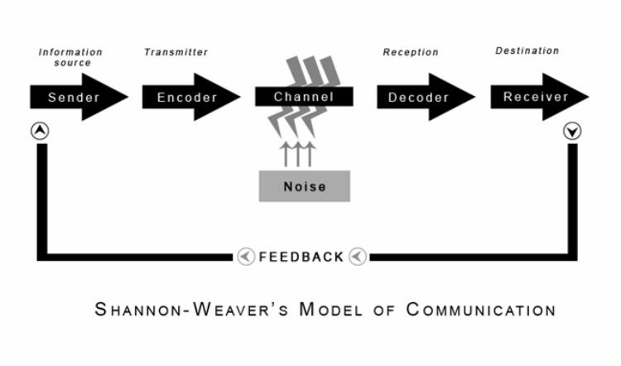
This is the Shannon Weaver model. The Shannon and Weaver argues that communication can be broken down into6 key concepts, which are: sender, encoder, channel, noise, decoder, receiver. Later on there was a 7th concept added by Warren Weaver which was the feedback and therefore changing the model from a linear to a cyclical model. Now I will briefly go over each concept and explain what it is.The sender is another person or object or anything who has the information to begin with. The sender starts the proceeds by deciding a message to send, who and where to send it to and this may be done in many different way, some being orally, writing etc. The encoder is a person or a machine that converts the idea into signals. The channel is the infrastructure that gets the I formation from the sender all the way to the receiver. Noise interrupts the information that is being sent from the sender to the receiver . Decoder is the exact opposite of encoder, it’s pretty self explanatory. Finally the receiver is the person that finally gets the message, or what’s left of it after accounting for noise. Lastly the feedback is when the receiver of the message responds to the sender of the I formation or message in order to close the communication loop.
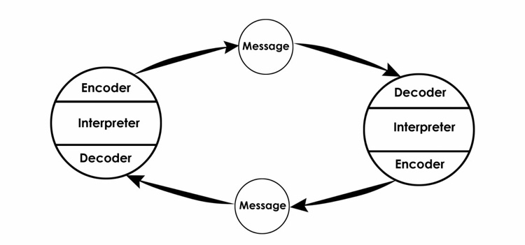

This is the Schramm communication model. The Schramm model is built on the concept that communication is a two way process, with a sender and a receiver. Egerton Osgood believes that communication was circular rather than linear meaning it took two participants taking turns in sending receiving messages. Schramm has 4 components and those are:
-Sender, the person that converts and sends the message
-Message, this is the information that is being shared between the parties.
-Receiver, this is the person that decides the message
-Semantic barriers. The beliefs of how the sender conveys a message and how the receiver interprets it.

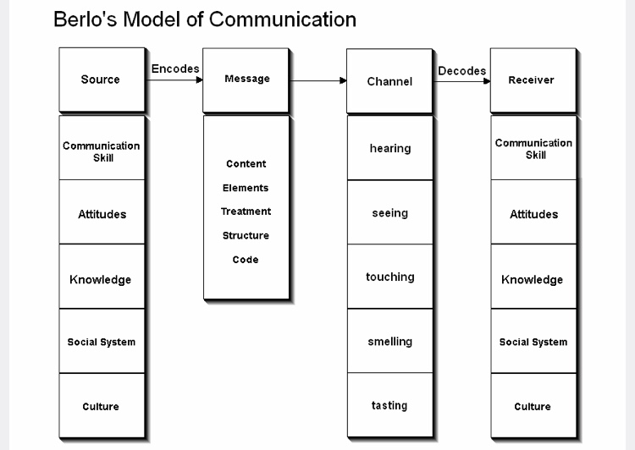
This is a Berlo’s communication model. The model focuses on encoding and decoding before the sender sends the message and before the receiver receives the message. This model mainly has 4 components which are: sender, message, channel and receiver.
-Sender: Communication Skills of a person can effect the communication process, depending whether they have good communication skills or not
Attitude of the sender and the receiver creates effect in the message
Knowledge: Familiarity of the subject makes the communicates message have its effect more.
Social systems: beliefs, values and religion affect the sender’s way if communicating the message.
Culture: Differences in culture make the message different.

-Message
Content is the thing that is the message.
Elements are the non verbal things that go along with the content such as gestures.
Treatment is the way that the message is conveyed to the receiver.
Structure is the way the message has been structured which can effect the effect of the message.
Code is the form that the message is sent

The other two are similar, if not the same as last two so I will not be including them.

Conclusion
In conclusion it is very important to have good communication skills as they’re an essential skill. Also we’ve learnt that lol 3 communication models have a lot in common, but that is because all of them take inspiration from each other, but mainly from Schannon and Weaver.

