Fergus G.M. Russell
1810348@student.uwtsd.ac.uk
Abstract
[Draw your reader in with an engaging abstract. It is typically a short summary of the document.
When you’re ready to add your content, just click here and start typing.]
ACDA5012 Research Methods
Reverse Engineering and testing of 3D printed armour plates

Contents
1.0-Introduction & Literature Review 1
1.1-Introduction 1
1.2-Three-Dimensional Scanning 1
1.2-Additive Manufacturing 1
1.3-Armour Plate Materials 2
1.4-Armour Plate Testing Standards 2
1.5-Ballistic Computer Modelling 2
2.0-Project Design 2
2.1-Project Purpose 2
2.2-Project Outcomes 2
3.0-Data Collection, Analysis and Evaluation 3
3.1-Data Collection 3
3.2-Analysis 3
3.3-Evaluation 3
5.0-Legality, Ethics, Risks and Limitations 3
5.1-Legality 3
5.2-Ethics 4
5.3-Risks 4
5.4-Limitations 4
6.0-Research Resources 4
7.0-Project Timeline 5

1.0-Introduction & Literature Review

1.1-Introduction
Within the Ordnance, Munitions and Explosives (OME) environment, a number of explosive and ballistic trials are performed to assess the performance of armoured plates to qualify them for use in theatre. From a tactical standpoint, modern reverse engineering and manufacturing techniques such as three-dimensional scanning and additive manufacturing could present a significant advantage in the battlefield allowing the rapid development of armour plating in theatre and custom fit repairs to damaged vehicles, this capability presents an advantage if the threat environment is constantly changing and would allow armour plate design to be adapted quickly to match the threat.
This research proposal will perform a literature review investigating the relevant technologies to be utilised in the research, the relevant armour material chosen and its uses in in-service equipment and any relevant industry standards relating to testing and qualification of such armour materials. The proposal will then go on to propose a project design and aims for the project as well as any relevant data collection and analysis techniques that will be utilised in the project. Aspects of the project’s legality, ethics and limitations will be discussed along with what resources would be required to carry out the project and an appropriate project timeline will be proposed.

1.2-Three-Dimensional Scanning
Three-dimensional scanning is a much-needed tool in modern product development. It allows designers to obtain geometric data of components in a convenient and rapid manner and then allows manipulation of that geometric data in the Computer Aided Design environment [1]. Such technology has been gaining more utilisation in product development programmes and can be used to generate components for vehicles and household appliances and also manufacturing tooling and jigs [1]. Such technology can be used for applications where either obtaining spares is difficult (in the case of historic and classic motor vehicles) or if a bespoke component is required to improve performance. Within the military domain such technology would allow components or hard point geometry to be scanned into a computer aided design environment and then manipulated to design the required component. Such a technology also has a good pairing with additive manufacturing which allows the product development process to be reduced in terms of time and cost [2]

1.2-Additive Manufacturing
Additive manufacturing is a technology where material is added layer upon layer into the desired geometry of the designed component. Additive manufacturing is a desirable manufacturing solution as it presents a number of advantages, particularly on internal structure of materials where a structure such as a honeycomb structure can be added in situ [3]. This is an interesting property as it can allow components to maintain a high degree of structural strength yet reduce weight.
Another aspect of consideration within additive manufacturing is the material choice. Polymers are materials which have been capable of being applied to additive manufacturing yet from the point of view of ballistic protection offer little advantage unless bonded with composites and aramid fibres. Metals are more likely to be employed in military vehicles such as aluminium in the case of the British Army Warrior tank [4]. Metal additive manufacturing is capable of using a number of powdered metal feedstocks to construct the desired component. Materials such as titanium, stainless steel, miraging steel and aluminium alloys can all be utilised in metal additive manufacturing [5].

1.3-Armour Plate Materials
As previously discussed in section 1.2, Aluminium is an appropriate armour plate material to be utilised for additive manufacturing and has been proven to be effective in theatre, but there are other materials which could be utilised for these applications. Ceramic and composite armours have been used more of late in advanced armour designs and have proven to be highly effective against a variety of threats [6]. These materials however are expensive and difficult to manufacture and do not lend themselves currently manufacturable through means of additive manufacture. Maraging steel has been known to be used for additive manufacturing applications and has also been utilised in armour applications therefore in the scope of this project could be a suitable candidate for trial and test however will be dependent on the chosen use case of the project.

1.4-Armour Plate Testing Standards
Within the defence industry there are a number of standards which are used to qualify materials and systems for use in the UK military. These standards dictate a number of material properties the material must meet and also the testing procedures and requirements the material must pass to qualify for use. In the UK these standards are collectively known as a “DEFSTAN” and is short for Defence Standard. In the scope of this project Defence Standard 95-022 will be used. This relates to the specifications, testing and qualification of Aluminium Alloy Armour Plate (Heat Treatable 6-120mm) [7]. These standards are applied directly to the qualification of solid materials however these standards could provide a basis for hollow and honeycomb style materials for further work.

1.5-Ballistic Computer Modelling
Computer modelling of ballistic problems is a field which has been developed over a number of years. As computing power has increased the capability of such modelling has been opened up to more users. Using such capability allows for iterative design optimisation to occur without the need for expensive material manufacture and weapons ranges. Using computer modelling can allow the development of a final design before committal to manufacture and trial. Software packages such as LS DYNA and ABAQUS can be utilised for such analysis [8]. Ballistic computer modelling packages can also read computer aided design data from CAD packages such as Inventor or SolidWorks readily with little file or model conversion to work properly.

2.0-Project Design

2.1-Project Purpose
The purpose of this project is to test the feasibility and application of reverse engineering, computer modelling and additive manufacturing to the design, development and qualification of armour plating for armoured vehicles.

2.2-Project Outcomes
As part of this project the predicted outcomes of the project are: -
- An in-depth literature review of current advances within the identified fields of 3D scanning, additive manufacturing, computer modelling, armour materials and designs and suitable qualification test standards to be utilised.
- Identification of a suitable vehicle hardpoint to 3d scan
- An optimised design armour plate for the vehicle using ballistic computer modelling to develop an optimised design and using relevant DEFSTAN standards to provide results for the designs performance.
- Verification and comparison of the computer modelled design using relevant DEFSTAN testing standards.
- Any further recommendations of research and changes which could be made to improve future work.
- All information is to be written up into an academic report documenting the method and results.

3.0-Data Collection, Analysis and Evaluation

3.1-Data Collection
As part of this project a number of data fields will need to be collected and managed. The first data points that will need to be collected will be the 3D scan data from the chosen vehicle hardpoint. This data can then be manipulated into Computer Aided Design data where information such as geometry and internal structures can be added and modified, this digital data will need to be kept for each iteration of the design. The next digital data set that will need to be managed will be the results from any ballistic modelling, such data would be projectile velocity, penetration depth and penetration diameter. Once the digital design process has been complete G code data will need to be generated to manufacture the prototype armour plate on a metal additive manufacturing machine. Once manufactured the final data set that will need to be collected will be the results from any real ballistic testing, this will be in the form of physical witness plates, photographs, penetration depth and diameter results and any high-speed imagery of the projectile to measure projectile velocities pre and where applicable post impact.

3.2-Analysis
The data that will need to be analysed to obtain the desired need to know results will be obtained from the computer modelling and the live fire trial. Likely data to be obtained from both the modelling and the life fire trial will be penetration depth, penetration diameter, photographic data from the live fire trial compared with deformation data from the ballistic modelling and any projectile velocity data pre and post impact obtained from the ballistic modelling and live fire high speed imagery. Such data can be analysed side by side and will require presentation of data in graphs, tables or raw imagery in the final report.

3.3-Evaluation
The evaluation of any analysed data will be conducted in comparison to the requirements set out in any relevant DEFSTAN, for example DEFSTAN 95-022. This evaluation will allow the prototype design to be evaluated and qualified for use on UK military armoured vehicles.

5.0-Legality, Ethics, Risks and Limitations

5.1-Legality
Legality considerations are minimal for this project however there will be a number of areas of legal considerations for the live fire trial. As ammunition and firearms will be utilised a facility that is compliant to current firearms legislation and section 5 authorisation will need to be used for the live fire element of the project [9]. Another piece of legislation that will need to be adhered to will be the Explosive Regulations (2014) [10]. As well as any national laws and regulations that need to be followed there will need to be local rules and regulations for the facility to be followed such as Safe Systems of Work, work instructions and range standing orders.

5.2-Ethics
Ethical considerations for this project are minimal, if anything they are positive ethical matters. The work carried out by the project will not be using human subjects or performing experimentation on live animals or humans. The only ethical matter is that the technology could in the future be utilised in the preservation of life in theatre, which is a positive ethical area to perform the work.

5.3-Risks
Risks to the project are mostly related to the high hazard work related to firearms and explosives. Both areas are highly legislated and as such have a high degree of control and risk assessment associated to them. Another risk area will be in the 3d scanning process where equipment will be used in close proximity to heave vehicles which have geometric features which could cause injury to those performing the scanning. The final risk area is in the manufacture of the prototype plate, this is because the additive manufacturing machines utilise powdered metals which can be dangerous if inhaled and laser sintering and furnaces to finish the component which present laser hazards and temperature hazards. Due to these hazards being present these various parts of the project will be suitably risk assessed by competent persons prior to work commencing.

5.4-Limitations
At present no limitations are expected for the project. Facilities and equipment are available within the energetics community across the United Kingdom and all of the technology being utilised in the project from initial concept through to manufacture, test and evaluation is commercially available and will not require any new technology to be developed or any modifications of existing technology.

6.0-Research Resources
The project will require a significant number of resources to be completed effectively and to obtain all the desired results such resources include: -
- 3D scanning equipment with suitable 3d scan manipulation software
- Suitable Computer Aided Design Software such as Autodesk Inventor or Dassault Systems SolidWorks
- Suitable military vehicle to 3D scan (for example Warrior/Challenger/Bulldog/Ajax/Boxer)
- Suitable ballistic modelling software such as ANSYS LS-DYNA or Dassault Systems ABAQUS and suitable computational power through high end desktop PC or supercomputer access.
- A suitable metal 3D printer for example the Mark Forged Metal X 3D printing system.
- A suitable weapons range with instrumentation and firearms capable of meeting the requirements as set out by DEFSTAN 95-022 or similar. Such facilities exist at Cranfield University Ordnance Test and Evaluation Centre (COTEC) or at Dstl Porton Down
- Suitable cameras to document various stages of the projects including high quality SLR still image cameras and high-speed videography cameras.
- Suitable result analysis software that allows interpretation of results such as Microsoft Excel and a suitable word processing software such as Microsoft Word
- Human resources throughout the project will include trials and instrumentation engineers and technicians to assemble the trials environment and operate various pieces of equipment such as gas guns and high-speed videography as well as manufacturing technicians to manufacture the prototype armour plates.
Other resources may be required over time that are not mentioned here and have at present potentially been overlooked.

7.0-Project Timeline
Successful projects need to be successfully managed in terms of when deliverables are to be delivered. Such project management should reduce the risk of a project being delayed and helps to control financial spend over the project lifecycle. A variety of project management techniques can be used to do this such as Critical Path Method (CPM) and Program Evaluation and Review Techniques (PERT). On a smaller scale tools such as a Gantt chart are much better at showing a timeline of a project and showing which tasks rely on others being completed or can be run independently of one another or concurrently. A Gantt chart also allows for expectations and delays in deliverable to be managed by showing pessimistic, on-time and optimistic deliverable dates. Software such as Microsoft Project can be used to manage the project however this is a complex piece of software and is a dark art known only to project managers, for the scope of this project and its relatively small size Microsoft Excel or Microsoft PowerPoint can be used to develop a basic project timeline.
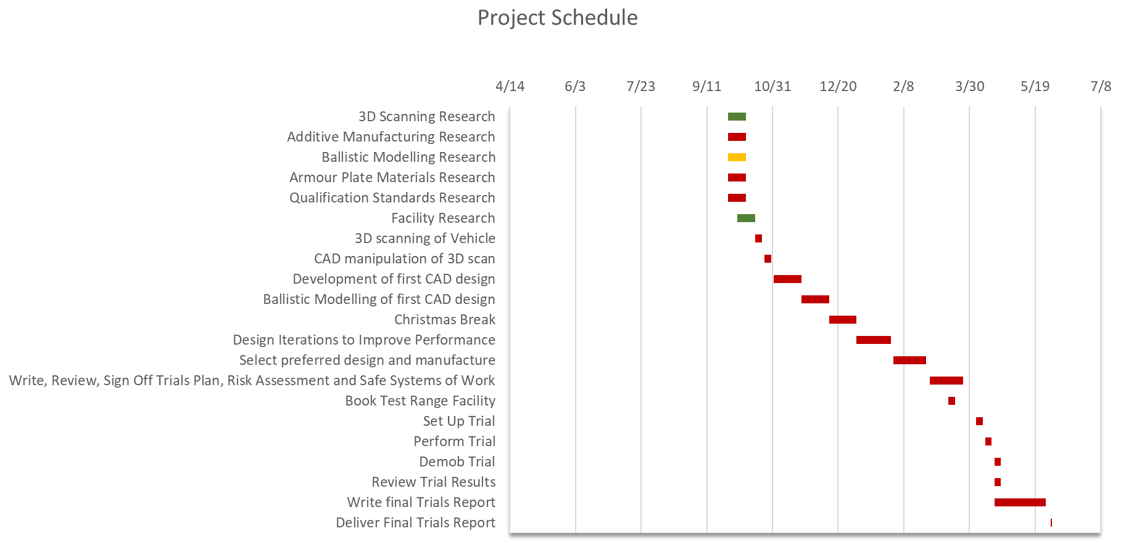
For this proposal a basic Gantt chart has been provided. It should be noted that a more in-depth Gantt chart should be created at the beginning of the project and should be regularly maintained and updated throughout the project lifecycle.

8.0-References

[1] | M. Sokovic and . J. Kopac, “RE (reverse engineering) as necessary phase by rapid product development,” Journal of Materials ProcessignTechnology, pp. 398-403, 2006.
[2] | M. Paulic, T. Irgolic, J. Balic, F. Cus, A. Cupar, T. Brajlih and I. Drstvensek, “Reverse Engineering of Parts with Optical Scanning and Additve Manufacturing,” Procedia Engineering, vol. 69, pp. 795-803, 2014.
[3] | S. Hou, T. Li, Z. Jia and L. Wang, “Mechanical Properties of sandwich composites with 3d-printed auxetic and non-auxetic lattice cores under low velocity impact,” Materials and Design, vol. 160, pp. 1305-1321, 2018.
[4] | Army Technology, “Warrior Tracked Armour Vehicles,” Army Technology, 2021. [Online]. Available: https://www.army-technology.com/projects/warrior/. [Accessed 29 4 2021].
[5] | 3D Systems, “Metal Materials,” 3D Systems, 2021. [Online]. Available: https://uk.3dsystems.com/materials/metal. [Accessed 29 4 2021].
[6] | L. Bracamonte, R. Loutfy, I. K. Yilmazcoban and S. D. Rajan, “Design, manufacture, and analysis of ceramic composite armour,” in Lightweight Ballistic Composites, Woodhead Publishing, 2016, pp. 349-367.
[7] | Ministry of Defence, “Defence Standard 95-022: Aluminium Alloy Armour Plate (Heat Treatable 6-120mm),” United Kingdom Ministry of Defence, Glasgow, 2019.
[8] | J. F. Abrosini, “Simulation of ballisitc impacts in steel plates,” Universite de Mons, Mons, 2015.
[9] | UK Government, “Guidance: Firearms Licencing,” UK Government, 2021. [Online]. Available: https://www.gov.uk/guidance/firearms-licensing-police-guidance. [Accessed 29 4 2021].
[10] | Health & Safety Executive, Explosive Regulations (2014), City of London: Health & Safety Executive, 2014.

