Childrens Play: Theory and Practice.
There are many types of play such as sensory play, solitary play, object play and creative play. It is important to have a variety of play types and resources to carry out these activities. These can be handmade or shop bought, they don’t have to be expensive. According to Play Scotland.org, It is important to be able to recognise the different types of play in order to, recognise the advantages and the abilities of different types of play. It also helps to asses types of play already happening and to ensure to extend and support different types of play so that the children have a wider-range, high-quality experience as all the different types of play are necessary for the child’s healthy development.(Play Scotland, NoDate)
“There is no better activity for learning and development than play”. (Doherty and Hughes, 2014:176)
Self-directed play is a really important type of play because, according to Hollis Montessori School.org,
- It builds self-confidence,
When they explore on their own, children understand there is a lot more they can do for themselves. They are able to make their own rules and make their own games. They then feel successful in their outcome when they and their friends enjoy the games.
- It encourages independence,
This is not our goal for children as they may be able to get along without us just fine. Self-directed play allows us to experience solitary play from a young age, all while they are in a safe and prepared environment.

- It stimulates imagination,
Children are unable to help but be creative during self-directed play. By giving these children chances, we are letting them use their muscles. They will then also see opportunities nobody else have imagined, and they will create their own story lines as they play.

- It teaches problem-solving,
Being able to come up with their own rules creates problem solving skills. Children will have to decide how to figure something out themselves the way they want to (Play Sense, Nodate).
- It allows children to learn at their own pace,
When self-directed playing, there is no timeline or time limit to meet. Children have opportunities to create and build on their own understanding, day after day, in ways that the children understand.
- It cultivates internal motivation,
Without adults recognising the success of a child’s activity. They will be obliged to find the natural joy in their play. They will usually naturally challenge themselves to try innovating, new ideas and will find it personally invigorating doing so.
(Hollis Montessori School, Feb 2018)
The two types of play i will be focusing on are imaginative play and physical play.
Imaginative play is a type of play that encourages the child to use their imagination. It is also known as pretend play, fantasy play and make believe. This type of play involves role-playing story lines that the child has experienced, seen or would like to experience. This play type can be done with or without costumes, toys or props. Imaginative play also helps children discover choices, learn along the way and show their feelings. The importance of this type of play includes practising language, social skills and communication in a safe environment where the child is in control (Montessori,1949). They may also use elements of symbolic play, where they pretend that some objects are other things such as, using a twig as a magic wand or using a stack of boxes as a castle.(Twinkl, NoDate) Imaginative play helps a child develop the bond between a child and parent and creates a safe and nurturing relationship. It also helps to improve academic skills and improve focus and concentration. There are so many benefits of imaginative play, it is very important as a parent to make time to allow your child to develop these skills independently in their own space.
Physical play is any sort of tasks or activities that include movement. This involves things like jumping, running or dancing. This type of play helps children develop fine motor and gross skills, uses their energy, socializing and learning new things. Physical play also benefits the child’s health by making them physically fit, helps burn calories and keeping them healthier. This type of play also helps them to move from bigger movements like jumping and running to smaller movements such as tying a knot and simply just picking up a pencil. According to Maketime2play physical activity has been shown to help brain development and also function and attention to academic subjects. They also say that “studies show that the earlier you get children active the more active they will choose to be when they are older”. (Maketime2play) Some of the physical benefits of play are fitness, strength, balance, social skills, good behaviour and confidence. According to the child development institute, “75 percent of brain development occurs after birth”.(HelloMotherhood, June 2017)
Both imaginative and physical play support children’s development by helping them make decisions and developing their self-confidence. They also learn how to deal with anxiety, difficult emotions and fears. As O. Fred Donaldson wisely said, “Children learn as they play. Most importantly, in play, children learn how to learn” (RedMonkeyPlay NoDate)

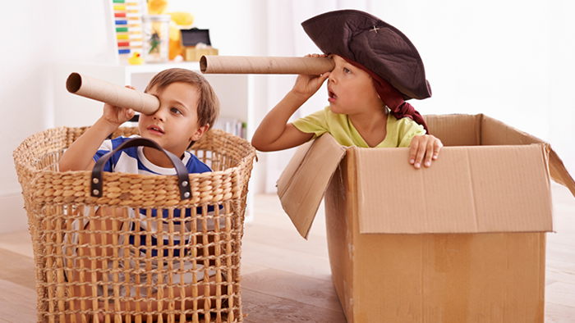

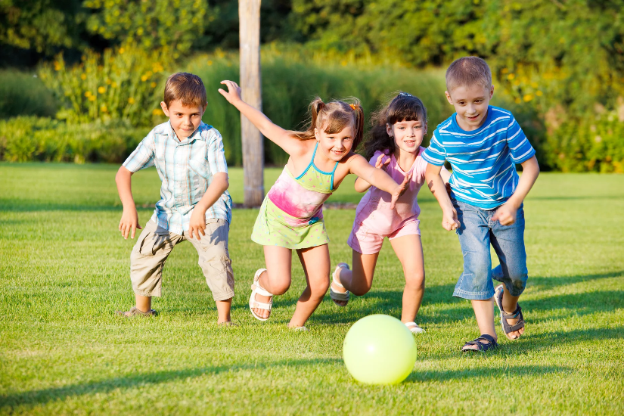
(Reading Eggs, 2014)

(Physical play image, NoDate)

Self-directed play.
Self-directed play is a very important type of play. This allows children to play independently and engage in open-ended play without any interference. Self-directed play is beneficial to children because it helps with improving self-confidence, encourages their independence, stimulates imagination, helps them learn how to problem solve, allows the children to learn at their own pace and helps cultivate internal motivation.(TheMotessoriSchool, Feb 2018)
In self-directed play, children use simple materials like balls, cardboard tubes, sticks, scarves, and playdough to create their own games and explore their creativity. Unlike toys with predefined purposes (such as dolls or toy trains), self-directed play allows for endless possibilities. Children set their own rules and discover outcomes independently, building self-confidence, stimulating imagination, and developing problem-solving skills. It’s a magical process where children learn at their own pace within safe boundaries. (Michigan State University, Dec 2015)
Adults can support self-directed play by:-
Planning for play-
Adults have all of the control over a child’s environment. They are needed to ensure that the environment that their children play in is an appropriate and fun one. They are able to help them grow and the children plan their play by paying attention to the structure and environment (if it is indoors or outdoors). This can be done by taking into consideration the child’s needs, strengths and abilities. (GL Education, NoDate) You are able to increase their usual play and help them be independent and successful. As adults they should also build and extend on the child’s current understanding or knowledge by using materials and opportunities. Providing choices. Being able to give the children the opportunity to create their own choices, helps them to learn different experiences depending on their abilities and interests.
Supporting play-
In order to help the child to learn, adults will need to know and learn about the child. You can do this by supporting the child by communicating with them. Adults or practitioners are able to support and extend the children’s play by simply just engaging with them during play. By being involved, the children will learn that adults are interested and will respect their play choices. Being able to add to children’s play and participate when invited will help the children extend on their current knowledge and help them make new connections. (Michigan State University, Dec 2015) This type of communication can be done by modelling interactions or positive behaviours. When an adult is actively involved in the children’s play process, they are in a good position to get involved if an issue occurs or when the child may need help, whether it is a safety concern or an interpersonal conflict. It is also very important that we take on board that children need that opportunity to problem solve and sort out situations individually unless the adult is needed to intervene. Being able to build the child up by engaging and joining in with activities is important to.
Reviewing Play-
Reviewing the children’s play can help to accumulate information about the child when they are learning or doing activities. They can renew the children by listening, observation and talking to them. As an adult you can learn a lot from observing the children such as effectiveness, enjoyment or the purpose of the child’s play experience. Having this information can help you think about future activities and being able to keep their play meaningful and engaging (GL Assessment, NoDate). Being able to have the space for the children to play is important. By thinking how the space may affect the child’s play, you are able to think about how you can make it even better. Through the experiences of observing and interacting the child’s play, you can critically think about the children’s interactions, preferences, interests and relationships to look back on and check their progress and help success future successes. Making plans is also important when reviewing play. This can be done by collecting all of the information while planning and putting it into play. Adults can plan any issues that occurred to prevent them happening again in the future. Help build on the children’s needs and requirements to enhance the children’s play experience. (Michigan State University, Dec 2015)

Schedule of growing skills (SOGS)
What is SGS?
Schedule of Growing Skills (SGS) is an extremely useful tool for adults or practitioners who need to set up the levels of the children’s development. Children from birth to 5 years of age can have these assessment done at any time, which allows the professionals to assess the children as and when is convenient and appropriate.(GL Assessment, NoDate)
There are nine key areas that will be assessed in this type of assessment.
- Passive Posture- This area assesses a child’s stable body position when at rest and the ability to maintain a relaxed body.
- Active Posture- This assessment figures out how well the child can maintain stability and balance during play and movement.
- Locomotor Skills- The Locomotor skill includes movements such as running, walking, jumping and hopping. This examines how qualified the children’s fundamental skills are.
- Manipulative Skills- This type of assessment is to do with fine motor skills, including tasks such as using utensils, grasping objects and using building blocks.
- Visual Play- This assessment consists of assessing the child’s visual ability such as focusing attention, tracking objects and recognising shapes.
- Hearing and Language Skills- This assessment explores a child’s language development and auditory perception. It includes speech sounds, listening comprehension and voluntary (NHS, NoDate).
- Speech and Language- The SOGS assesses expressive language skills including communication articulation and grammar.
- Interaction Social Skills- Being able to social interact in play is a crucial role to the child’s development. This assessment interacts with the child to assess the ability to engage with others, take turns, share and follow social cues.
- Self-care Skills- Self-care includes tasks such as toileting, feeding or dressing. SOGS assesses the independent tasks in the child’s daily routines.(GL Education, NoDate)(NHS, NoDate)

By using engaging and colourful toys such as dolls, building blocks, pegs and shapes, this will allow the assessments to feel like an activity or playtime to the children, which allows the professionals to assess and observe reactions as the child is playing. They usually asses regularly and more than once. This will help indicate the progress over time.

Why use SOGS?
Pros?
SOGS has a clear visual of a child’s development level. This would be an ideal basis for discussion with professionals or parents. SOGS is an easy and quick observation type to use, it has clear interpreting and scoring results. It also has clear instructions and is able to provide feedback within 30 minutes. Using SOGS ensures than children are assessed the same and in a consistent way as it is an universal screening measure.(GL Assessment, NoDate)
Cons?

Key feature of schedule of growing skills:
- Clear instructions- The assessment has clear instructions for guided activities.
- Scoring system- Allows scoring the child multiple times which helps track any progress overtime.
- Feedback report- Provides results for developmental and strengths where a child may need a referral or extra support.
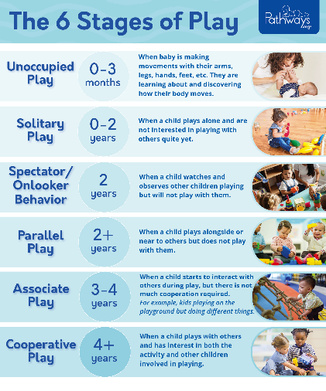
- Training package- Training courses are available to make sure that the interpretation and administration of the tests are accurate.

(Pathways.org, 2019)
In order to see full potential, you will have to see them in play. In Howarth and McInnes (2012) they demonstrate that when children perceive an activity as play, they would show more signs of emotional well-being than when they perceive the same activity as not play. Well-being can be explained in many different ways but it is usually explained as social, physical and emotional health (Statham and Chase, 2010). The child’s well-being is considered to be very important. Good well-being can protect the children’s future against lots of problems such as behaviour and emotional problems, crime, violence and teenage pregnancy (National Institute for Health and Clinical Excellence, 2008). According to (Fattore et al. 2007) children report that being able to pay contributes to their happiness and wellbeing.
Observing is a practice in understanding children’s development and learning. This involves carefully recording and watching what children say, do and how they interact with their peers and environment (early years careers, 2016). Assessment is checking those observations to see into the children’s abilities, progress and needs. This helps the assessors figure out what support is needed and help meet their individual requirements (NAEYC, 2018) It is important to observe and assess because when we observe with an open mind, we can observe the richness of children’s play and interactions. Play is a powerful source for learning, social development and creativity. Through observations, we see what children know and can do. This information guides us in interactions that align with their needs and abilities, and in providing appropriate activities (early years careers, 2016).
Despite Making practical and effective use of the same materials, Children in the current study shows behaviours related with growing emotional well-being with activities recognising as ‘like play’ instead of being ‘not like play’ as measured by the leuvers involvement scale (laevers et al. 1994). Behavioural examination also shows that the children in the ‘like play’ classes were a lot more focused on the task or activity, move freely and smiled more (Fattore et al. 2007; Layard & Dunn 2009).
It has been suggested that when children recognise an activity as play leads to a higher developmental effect as children are able to try out multiple behaviours with less risk of failure. When attending an activity as play, children control their outcomes and directions of their actions and this increases self-esteem and confidence (Brown 2003; Howard 2010a).

Observation Types-
There are many different types of observation. This activity helps the practitioner assess what levels each child is on for example:
- Running Record- Running record is one of many observation methods. A running record includes descriptive account of a certain activity, giving the facts which include exactly what a child is saying or doing. Running records are usually used for assessing a child’s reading skills (bright wheel blog, 2023).
- Time Tracker- To time observe, the practitioners have to make observations of a child frequently, over a set time frame which is usually about an hour. They would observe the child every five minutes which can be difficult when working in a free-flow industry, but the observing will only take one minute per observation (bright wheel blog, 2023). This type of observation the child’s level of interests in play and their character. An example of this would be that a child could spend hours playing in the nursery but only spent the time in construction activities. Another example is when a child never engages in writing activities but is always playing in areas that include writing opportunities (teach early years, NoDate).
There are many other types of observation such as interaction tracker, love letter and SOGS, and they will chose the observation type by the time they have and the reason why the children are being observed. Different practitioners will use their own observation method from their past experiences, recording different parts of the child’s development. An example of this is that if you they are trained in children’s physical development, they will more likely be observing the motor skills. Whilst if the other practitioner is trained in musical development, they are more likely to observe the musical pitch (teach early years, NoDate).

Reference List:
Bright wheel blog (February, 2023) Running Record Observations in Early Childhood Education. Available at: https://mybrightwheel.com/blog/running-record-observation (Accessed: 2nd of March 2024).
Brown, F. (2003) Playwork: Theory and Practice. Open University Press, Buckingham, UK.
Class For Kids, (NoDate) Available at: https://blog.classforkids.co.uk/hs-fs/hubfs/shutterstock_59018779.jpg?width=1875&name=shutterstock_59018779.jpg (Accessed on 29th of Feb, 2024).
Early years careers, (Jan, 2016) observing children’s play. Available at: Observing Children's Play - Early Years Careers (Accessed on 26th of Feb, 2024)
Fattore, T., Mason, J. & Watson, E. (2007) Children’s conceptualisation(s) of their well-being. Social Indicators Research, 80, 5-29.
GL Assessment, (NoDate) Schedule of growing skills. Available at: Schedule of Growing Skills - GL Assessment (gl-assessment.co.uk) (Accessed on 28th of Feb, 2024)
GL Education, (NoDate) Schedule of growing skills GSG. Available at: Schedule of Growing Skills (SGS) - GL Education (gl-education.com) (Accessed on 28th of Feb, 2024)
HelloMotherhood, (June, 2017) The Importance of Physical Play in Child Development. Available at: https://www.hellomotherhood.com/article/86563-importance-physical-play-child-development/ (Accessed on 18th of Feb, 2024)
Hollis Montessori School, (Feb,2018) Why encourage self-directed play? Available at: Why Encourage Self-Directed Play? | Hollis Montessori School, NH (Accessed on 12th of Feb, 2024)
Howard, J. (2010a) Making the most of play in early years. In: Play and Learning in the Early Years (eds P. Broadhead, J. Howard & E. Wood), pp. 145-160. Sage publishing, London, UK.
Howard, J. and McInnes K. (2012) ‘the impact of children’s perception of an activity as play rather than not play on emotional well-being’, child: care, health and development, 39(5), pp. 737-42. Available at: https://doi.org/10.1111/j.1365-2214.2012.01405.x
Laevers,F., Vandenbussche, E., Kog, M. & Depondt, L. (1994) A process-oriented child monitoring system for young children. Centre for experimental Education, Leuven, Belgium.
Lanyard, R. & Dunn, J. (2009) A Good Childhood. Penguin Books, London, UK.
Maketime2play, (NoDate) Physical. Available at: https://www.maketime2play.co.uk/why-play/physical/ (Accessed on 12th of Feb, 2024)
Michigan State University, (Dec, 2015) The power of play – Part 5: Adult roles in child’s play. Available at: https://www.canr.msu.edu/news/the_power_of_play_part_5_adult_roles_in_childs_play (Accessed on 29th of Feb 2024)
Montessori, M. (1949) The absorbent mind. Oxford: Clio Press.
NAEYC, (March, 2018) Observing, Planning, Guiding: How an Intentional Teacher Meets Standards through Play. Available at: Observing, Planning, Guiding: How an Intentional Teacher Meets Standards through Play | NAEYC (Accessed on 29th of Feb, 2024)
National Institute for Health and Clinical Excellence (2008) promoting children’s social and emotional wellbeing in primary education. Journal. Available at: http://www.nice.org.uk/PH012 (last accessed on 2 March 2024)
NHS, (NoDate) Schedule of growing skills. Available at: Schedule of Growing Skills (datadictionary.nhs.uk) (Accessed on 29th of Feb, 2024)
Pathways,org, (No Date) How Kids Learn to Play: 6 Stages of Play Development. Available at: The 6 Stages of How Kids Learn to Play | Play Development (pathways.org) (Accessed on 12th of Feb, 2024)
Pathways.org, (2019) Available at: 6-stages-of-play.jpg (2083×2500) (pathways.org) (Accessed on 24th of Feb, 2024).
Play Like Mum, (May, 2022) What is imaginative play? Available at: https://www.playlikemum.com/imaginative-play/ (Accessed on 12th of Feb, 2024)
Play Scotland, (No Date) Play Types. Available at: Play Types - Play Scotland (Accessed on 12th of Feb, 2024)
Play Sense, (NoDate)- How Playing Helps Develop Emotional Regulation in Children. Available at: How Playing Helps Develop Emotional Regulation in Children | Play Sense Micro Playschools (Accessed on: 24th of Feb, 2024).
Reading Eggs, (2014) Available at: https://readingeggs.com.au/images/articles/encourage-imaginative-play-201410.jpg (Accessed on 29th of Feb, 2024).
Red Monkey Play, (No Date) Why Is Creative Play Important For Children’s Development? Available at: https://redmonkeyplay.co.uk/why-is-creative-play-important-for-childrens-development/ (Accessed on 18th of Feb, 2024)
Sheridan, M.D (1980) From birth to five years, children’s development progress. Windsor: NFER-Nelson Publishing Company.
Stathan, J. & Chase, E. (2010) Childhood wellbeing: A brief overview. Childhood wellbeing research centre, London, UK.
Teach early years (NoDate) Observations in early years – Different types, why they are important and examples. Available at: https://www.teachearlyyears.com/nursery-management/view/making-observations (Accessed on: 3rd of March 2024)
The Montessori School, (April,2020) Why encourage self-directed play? Available at: https://www.berkshiremontessori.org/msb-blog/self-directed-play (Accessed on 18th of Feb, 2024)
Twinkl, (NoDate) What is the importance of imaginative play? Available at: https://www.twinkl.co.uk/teaching-wiki/importance-of-imaginative-play#cont-1 (Accessed on 12th of Feb, 2024)

