Syed Moksudul Islam (1709371)

Leading and Implementing Workplace Change
The REPORT is COMPILED FOR the uNIVERSITY OF WALES TRINITY SAINT DAVID 2021

Module: Leading and implementing workplace change
Module code BMSW610
Lecturer: Syed Jaffery
Student/ID: Syed Moksudul Islam (1709371)
Submission Deadline: 30th March 2021
Word Count: 5500 Academic Report

Executive Summary.
The aims and objective of this study are to compile a change management report for the purpose of strategic implementation and recommendation. The report will explore the company’s new vision, current operational strategy and leadership style. Levines Furniture will be critically appraised using theoretical tools like PESTLE, SWOT and Porter’s Five Forces. The report will also take the reader through the process of change, using tools like Kotter’s Eight Step Change. The report will also consider the Barriers of Change, Organisational Culture, Risk Management, Stakeholders, Transition Curve, Management Software, Organisational structure, Managing Resistance, Effective Communication, Coaching and Training. Using the information that was collected, the report will compile a systematic approach to implementing the chosen strategy. The report was compiled using secondary data sourced from websites, books and online journals. No primary data was collected, or interviews were performed.

Table of Contents
1 Introduction. 5
Impact of Covid-19 on the Organisation. 5
Macro and Micro-Environment. 6
2 APPRAISING AND EXAMINING THE MACRO/MICRO- ENVIRONMENT OF LEVINS FURNITURE SHOP. 7
The PESTLE Framework. 7
Examining and Evaluating Macro-Environmental using PESTLE. 7
The SWOT Model. 9
Critically Evaluating the Findings from the SWOT Analysis. 10
Porters Five Forces. 10
Benchmarking Levines Furniture against Competitor Cousins Furniture store. 11
Areas in Need of Improvement. 12
3 KOTTER’S 8-STEP CHANGE MODEL FOR LEVINES. 12
Kotter’s 8-Step Change Management Model. 13
Step 1. Establishing a Sense of Urgency. 13
Step 2. Creating the Guiding Coalition. 14
Step 3. Developing Vision and Strategy. 14
Step 4. Communicating the Change Vision. 15
Step 5. Empowering Employees for Broad-Based Action. 15
Step 6. Generating Short Term Wins. 16
Step 7. Consolidating Gains and Producing More Change. 16
Step 8. Anchoring New Approaches in the Culture. 16
4 MANAGING CULTURAL CHANGE. 17
Levines Cultural Change. 17
To Help Individuals Adapt to The New Culture. 17
Examining the Impact of Levines Cultural Change. 18
Models of Employee Engagement. 18
New Leadership Style. 19
New Organisational Structure for Levines. 20
New Reward and Control System. 20
Managing Emotions with Daniel Goleman's framework of Emotional Intelligence. 21
5 LEVINES CHANGE MANAGEMENT PROGRAMME. 22
Introduction 22
The Project Sponsor. 22
Purpose and Objectives for Levines. 22
Rationale and Drivers for the Change. 23
Communication Strategy. 23
Managing Stakeholders with Freeman’s Stakeholders Theory. 24
Levines Furniture Stakeholder Power Interest Grid. 25
The Kubler-Ross Model Transition Curve. 26
Employees Reaction to Change (please refer to appendix 2). 26
Change Management Plan for the Future Template. 26
Coaching and Training. 27
Risks and Barriers to the Change Strategy. 27
Managing Resistance. 28
Monitoring and Reviewing the Change. 28
6 Conclusion and Recommendation. 28
7 Reference. 30
8 Appendices. 34
Appendix1. Examining the Competition and Rivalry using Porters Five Forces. 34
Appendix 2. Employees Reaction to Change Template. 36

List of Figures
Figure 1: Macro and Micro-Environment, Source (Solutia, 2019). 6
Figure 2: PESTLE Adapted From (Mullins, 2010). 7
Figure 3: SWOT Adapted From (Sammut-Bonnici and Galea, 2015). 9
Figure 4: Porter’s Five Forces Adapted From (Grundy, 2006). 11
Figure 5: Kotter’s 8-Step, Source (Periyasami, 2020). 13
Figure 6: Models of Employee Engagement, Source (Bedarkar and Pandita, 2014). 19
Figure 7 Own Construct. 20
Figure 8: Daniel Goleman's framework of Emotional Intelligence Adapted rom (Shamian-Ellen and Leatt, 2002p.38). 21
Figure 9: The Project Sponsor, Own Construct. 22
Figure 10: Levines Stakeholders Adapted from (Smith, 2019). 24
Figure 11: Stakeholder Power Interest Grid Aapted from (Schuurman, 2019). 25
Figure 12: Transition Curve, Source (Cameron and Green, p37, 2012). 26

List of Tables
Table 1. Examining Micro/Macro-Environment using SWOT. 9
Table 2. Services and Product Comparison. 11

Introduction.
Levines is a furniture company initially founded in 1951 has four stores situated across West Midland, Redditch, Brierly Hill, Bearwood and the largest one in Tyseley, and it currently employs 50 people across all its stores (Levines Furniture, 2020), with current asset valued at £1.5 million and a cash balance of £313 thousand according to (Company Check, 2021). According to Levines Furniture 2020a), the company’s operations include logistics, IT, finance and retailing through the stores; the company also has a dedicated website for an online shopping experience. A well-established company with a terrific reputation for customers service, sales and a well-known brand with a loyal following. However, Levines current business strategy has been hindered by Covid-19 epidemic, and Brexit has affected profitability and has changed the way Levines has been operating previously. However, the current administration has supported businesses in the UK through furloughs and business grants. Levines board of directors now seek to bring strategic and operational changes to the company to safeguard the organisation's future. The directors have instructed managers to create a report, lead and implement a new strategic plan. The task is to manage change efficiently to become more cost-effective, customer satisfaction, and long-term sustainable business stability. With a brief overview of Levines, the report will take the reader through a systematic approach to change management.
PART 1 of the report will analyse the strategy, macro/microenvironment, rivalry and competition utilising various tools to appraise the organisation. The aim is to get a holistic view of the business environment that Levines Furniture operates in. The purpose is to make an effective decision using the information compiled.

Impact of Covid-19 on the Organisation.
Since the lockdown was introduced in March of 2020, the Levines business has suffered tremendously and left the business in disarray. The current government’s failure to control the Covid-19, THE economy at a standstill, new rules imposed, shoppers have to abide by social distancing and self-isolating. With many of Levines staffs are on the furlough scheme, Leavines is on the brink of collapse. The shop stores are closed due to the dangers of transmitting and are no longer able to sell through the stores, while some sales are made by Levines internet site and telephone the sales are not enough to cover the cost. Though Levines managed to transfer some of its work to remote workers, it is still not enough. The morale of employees is down, and the social change has impacted the workforce, leaving some of them asking the question about their future; with staff unable to meet or socialise, staff fear the worst of the pandemic.
Directors are very concerned with the macro-environments (see figure 1 below), the various forces affecting the business. They also concerned about the long-term recovery of the economy and the withdrawal of grants and furlough scheme anytime soon. Rishi Sunak, the chancellor, has also announced corporation tax rising to 25% and other changes that will affect business and employees (Binns, 2021).

Macro and Micro-Environment.
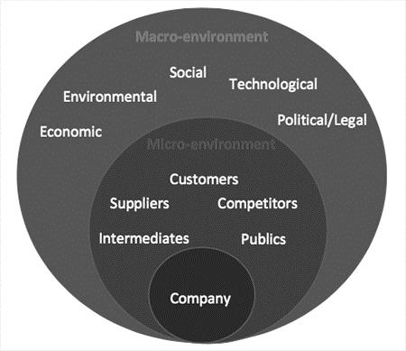
Figure 1: Macro and Micro-Environment, Source (Solutia, 2019).
The Directors Key Concerns.
- Despite the progress of new vaccines, many still wonder what recovery could be, as it has impacted the global economy (Brown and Palumbo, 2020).
- With no guarantee of the virus entirely eradicated by the vaccines, Levines future is a significant concern for the directors.
- Furloughs and grants have kept the economy from crumbling, but soon that is expected to come to an end, which can negatively influence the economy.
- Levines have minimal time, and it must act soon and make changes to save its business and losing its customers to the competitors.

APPRAISING AND EXAMINING THE MACRO/MICRO- ENVIRONMENT OF LEVINS FURNITURE SHOP.

The PESTLE Framework.
Harvard Business School professor by the name of Francis J. Aguilar first founded PESTLE, and it is an acronym for Politics, Economics, Social, Technology, legal and Economics (Frue, 2017).
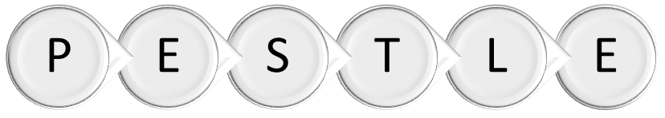
Figure 2: PESTLE Adapted From (Mullins, 2010).

Examining and Evaluating Macro-Environmental using PESTLE.
POLITICS: A weak government after the disastrous Covid-19 epidemic has led to an economic slowdown (Kibasi, 2020). With Brexit now fully completed and the Chancellor Rishi Sunak announces the rise in taxes in the budget, recovery seems very unlikely anytime soon.
- The morale is down, the economy in the brink of collapse uncertain future can impede economic recovery; all future investment must be made with caution (Studdert, 2020).
ECONOMICS: The economy has been slow since 2008, and no real recovery since then (Cribb and Johnson, 2018). Taxes are expected to rise due to the heavy spending and quantitative easing by the government. This will lead to a rise in inflation, European import tax due to Brexit and food price is expected to go up (King, 2020).
- Government furloughs and business grants will cause a rise in tax, inflation and high employments are expected too, as revealed in the budget.
- Brexit will cause significant disruption and a rise in the price of goods.
- A weak economy means that consumers have less money to spend on luxury furniture (Giles, 2020).
SOCIAL: Currently, large groups of the population are working from home, and this has had an impact on furniture stores sales. Furthermore, the way consumers buy products has changed due to lockdown and social distancing. Many gave switched to online shopping and preferred to have it delivered.
- Remote working is the new norm, and the pandemic has shown it is possible to adapt and work from home effectively. Additionally, the pandemic has revealed an opportunity to save money on operating cost.
- Cost savings, like staff parking smaller working space leading to lower rent and rates well as heating cost.
- Staffs benefit too, being close to family, no travel cost and savings on day-care centres.
- There is another opportunity now to sell office furniture to remote workers who wish to set up an office at home.
- The cost of setting up the internet and laptops is an extra burden on the company: however, in the long run, it will be beneficial.
- There will be a cultural change towards the organisation that will need to be addressed.
- Social distancing and the lockdown have changed the way people do their daily activities, and it has affected public and mental wellbeing that may longer for people to recover.
TECHNOLOGY: More consumers are adapting to technology, and more shoppers are growing online with the help of the lockdown. The concerns of expanding online business also mean protecting customer data and abiding by GDPR rules, and the cost of expanding can be costly to set up, but the benefits are high.
- The expansion of IT and the internet has allowed a new way of operating business; this is an opportunity to expand online shopping and delivery (Richter, 2019a). Technologies and management software will allow the company to be more efficient and have cost leadership. Integrating sales, harvesting customer data for repeat sales.
LEGAL: Levines need to be aware of employment laws changing for remote workers; protecting customer and employee data is a crucial concern. Even more, concerns are due to Brexit, VAT policy, and import duty will directly impact the furniture business.
- Employment laws will need to be revised for all remote workers. GPDR laws demand that organisations respect and handle customer data with care, and employees will need to be trained and managed for e-commerce business. Another concern that will arise is the new import duty as many products are sourced from Europe due to Brexit.
ENVIRONMENTAL: Customers demand greener and sustainably sourced furniture has become a selling point in today’s environment. It has become a constant challenge for Levines Furniture to stay the head of the competition like IKEA, a leader in ethical, sustainably sourced furniture. Likewise, the constant challenge to recycle waste and lower carbon footprint to keep local council and consumers happy have a financial burden on Levines operating cost.
- IKEA is a leader in sustainably sourced furniture; many industries are shifting towards a more sustainable and eco-friendly approach to doing business. To maintain business growth, it will be an ideal time to shift Levines strategy to a more ethical style of business (Milne, 2019).
The weakness of the PESTLE model, it does not perform any internal examination, so the report will examine opportunity and weakness using SWOT below.

The SWOT Model.
The SWOT framework originally coined by Albert Humphrey; SWOT will aid researchers that PESTLE may have skipped, opportunity and weakness is the key emphasis in this part of the report (Friesner, 2011).
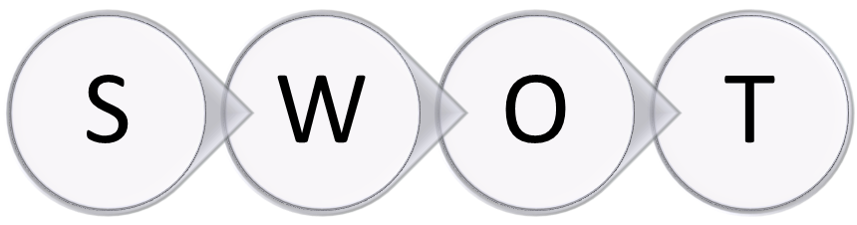
Figure 3: SWOT Adapted From (Sammut-Bonnici and Galea, 2015).
Table 1. Examining Micro/Macro-Environment using SWOT.
STRENGHT (INTERNAL)  - N/A | WEAKNESS (INTERNAL)  - Unable to buy a cheaper product due to safety and standard.  - Competitors have adapted their business model more effectively on the internet.  - Competitors have a better selection of furniture.
OPPORTUNITY (EXTERNAL)  - The Covid-19 may be an opportunity to expand online and close the shop stores.  - 5G and fibre optic has helped business have a vibrant online shop.  - Online shopping is ever more popular due to Covid-19 and lockdown. | THREATS (EXTERNAL)  - N/A

Critically Evaluating the Findings from the SWOT Analysis.
- WEAKNESS: Levines must recognise its weakness that competitors like Cousins Furniture, Cotswolds and IKEA have better demographical and geographical exposer to customers due to their brand, internet, marketing and business strategy. Cousins have also adapted to the internet more effectively, using the latest marketing and 3D/360 virtual tours. This has led Levines is losing crucial revenues. Levines must pursue better marketing of brand strategy and more exposure with a better online presence to mitigate its losses.
- OPPORTUNITY: The above weakness can be classed as a strategic opportunity to migrate to online business and shut down more costly stores. With Covid-19 and an explosion in internet technology like 5G and E-Commerce business growing yearly it is a perfect time to migrate to online business (Bhatti et al., 2020).

Porters Five Forces.
Porter's Five Forces, developed by Michael E Porter, a simple framework for evaluating the competitive strength and situation of a business environment (Porter, 1979); see appendix 1 for the complete analysis.
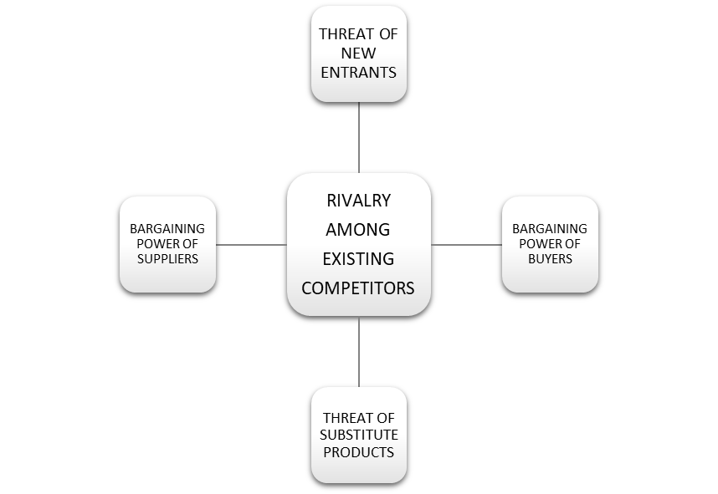
Figure 4: Porter’s Five Forces Adapted From (Grundy, 2006).

Benchmarking Levines Furniture against Competitor Cousins Furniture store.
The aim of benchmarking Levines against the nearest competitor with a similar business model provides an overall picture of the provided quality and services. It helps to identify areas that can be improved for performance (Erdil and Erbıyık, 2019). The information used was collected from the Levines furniture’s website.
Table 2. Services and Product Comparison.
Services and products | Levines Furniture | Cousins Furniture
Google reviews | 3.8/5 | 4.0/5
International delivery | No | Yes
Collection from store | Yes | Yes
Mon-Saturday delivery | Yes | Yes
Returns | 7-day money-back guarantee | 14 -day money-back guarantee
Interest-free credit | No | Yes

Areas in Need of Improvement.
There are gaps in Levines service and products that can be improved, while Cousins furniture has a wide range of catalogues online, giving customers a wider choice and credit facility to bring strong sales. Levines suffers in terms of communication, and it utilises social media. Cousins is ahead of service, and communicating with its customers, dealing with criticisms effortlessly. The list below should be considered as a part of the strategy.
- The benchmarking results have revealed some gaps between the organisations in areas where Levines needs to improve.
- Need to improve better communication between the firm and consumers, latest technology like text message and tracking numbers.
- Levines offering credit facility will posh more sales since many new generations of consumers are looking to buy products on monthly instalment.
- Cousins has a better brand, reviews, and social media following; Levines should invest in promoting their brand; more exposure to online social media will help facilitate the organisation's awareness (Levines Furniture, 2020b; Cousins Furniture, 2021).
The Drivers for Change.
While both directors and managers both have identified the need for change based on the external factors and the information gathered, their best strategy is going online and bringing immediate change to mitigate the threat. Directors are now considering a strategic shift to resolve the current issues as a long-term solution and utilising the above information, creating feasible options, making the critical decision based on the findings (Adair, 2007). Levines will act in the organisation's best interest, and the managers are proposing a new business direction for Levines to adapt to the current condition.
PART 2 of the report will develop a change management process, utilising Kotter’s 8 Step model, using the necessary information gathered in Part 1.

KOTTER’S 8-STEP CHANGE MODEL FOR LEVINES.
John Kotter’s 8 step process is a structured approach that aids businesses in leading change in an organisation. Levines will adopt Kotter’s Model to help initiate the strategy and change.

Kotter’s 8-Step Change Management Model.

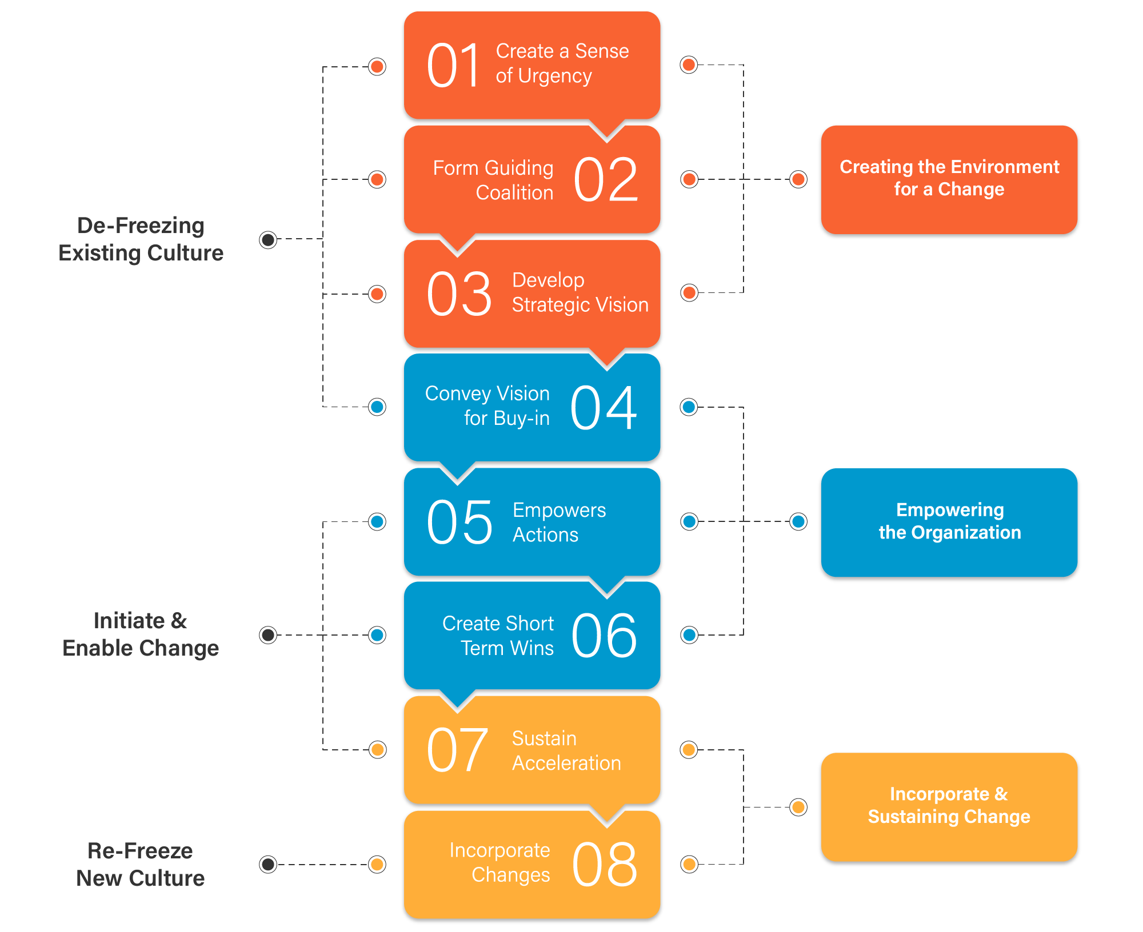
Figure 5: Kotter’s 8-Step, Source (Periyasami, 2020).

Step 1. Establishing a Sense of Urgency.
The importance of urgency is to create the motivation to bring the change. Since the information required for change has been acquired from part 1, it would wise to start delivering the findings to the employees. Show the effects of Covid-19 and Brexit have hindered trade, and it is impossible to say what the future holds for the organisation. Internet businesses are the current winners in this pandemic and the threat to physical stores. As time passes, the organisation existence will get harsher; however, there is hope as the organisation has a plan to mitigate the issue. The company wants to reassure that its main motive is the wellbeing of the employees and the company's future. Taking an empathetic approach will help managers, directors engage with employees, taking their feeling and shocks into context, tell them it can be done. The store managers are the key to change, and the majority must convince them that the new strategy is better than the status quo.
The Key Takeaways from Above:
- Make it clear about the status quo, how severely Covid-19 and Brexit are affecting the business.
- Use the data collected as validation of proof and the reason behind the proposed change.
- Tell them the benefits of the planned change to create a sense of security and motivation.
- Driving employees out of their comfort zones can be difficult; they can become an obstacle, and monitoring will be crucial to avoid future barriers.

Step 2. Creating the Guiding Coalition.
McKinsey & Company (2017) believed that assembling a coalition team is vital to a successful outcome of the change. The change agent should be formed from experts within the company managers, an influential employee with good leading capability, group leaders, the position of power and knowledgeable employees. It would be wise to convince the rebellious employees to avoid barriers to change; interviewing will be necessary to compile the guiding coalition.
Another issue is employee engagement; Bedarkar and Pandita (2014) stressed the importance of recognising employee engagement. This is the key to a successful project or change; keeping employees in the dark can have ramification, or some may even develop remorse against the organisational. Furthermore, employees and lower-level managers can contribute to the project's success and develop the change that will lead to job satisfaction and personal fulfilment.
The Key Takeaways from Above:
- Barriers to change can from any employees, convincing rebellious leaders early stage of the project to avoid delays in plans.
- Employee engagement is also beneficial in the organisations in development, can help overcome obstacles.
- The guiding coalition should be created from experts and leaders with skill and knowledge; lack of skills and knowledge can become an obstacle.

Step 3. Developing Vision and Strategy.
The vision will be articulated briefly without over complicating the plan. Describing the vision will not be enough, but to have a short business plan will be essential. For example, Levines existing situation needs to be addressed about Covid-19 hindering trade, how it intends to do future business and how it will be achieved. Describe the projects intended vision, budget, timeline, and explaining the sales method and IT technology required to make the transactions. Furthermore, Levines will ensure the training and coaching given to the staffs who require it. It is essential, the above change is documented and agreed upon, and the team agent should be appointed to amended and recommend in the early part of a project with a start date and an end date.

Step 4. Communicating the Change Vision.
The Levines strategy for effective communication, Levines intends to deliver it very simple using jargon-free language to avoid any confusions and assist in understanding the scope of the problem. Emails and leaflets will be sent to all employees, which will ignite the discussion between the employees and management. There will need to be two-way communication; ask for feedback, it is the only way to know what the employees are thinking. Managers will need to have an empathetic ear being aware of employees feelings, anger, shock and fear of losing their position. Additionally, using other successful business models online to give an example and giving a presentation will aid a visual road map to success will assure employees confidence (Harvard Business School, 2020).
The Key Takeaways from Above:
- Essential, the vision of the business is portrait realistic as possible without over-complicating it. It ought to be short enough to deliver in about five minutes.
- Feedback will be essential in understanding the thoughts of and well-being of the stakeholders.
- Take into consideration that employees will be disappointed; feelings and fear can turn into backlash or strikes.

Step 5. Empowering Employees for Broad-Based Action.
Levines will make changes to the existing structure as it will be necessary due to the new strategy. The new updated operating software will be required as an old system is outdated, new laptops for remote working, phones, apps, Customer Relationship Management Software and real-time packaging tracking software. New warehouses will be acquired to store the furniture, replacing the old showrooms in an industrial area. Sales representatives and customer service working from home will require laptops, internet and phones; all staffs will require training and supervision. New procedures and systems will be crucial for the change. Since most goods are going to be delivered, vehicles purchased meeting government standards emissions will be required. Likely to be resistance by managers and employees due to the procedure changes, it is advised that Levines ought to deal with these threats efficiently in the early stage of the change. Empowering employees will accelerate the plan through effective communication, competence, and rewarding individuals to quickly and successfully transition.
The Key Takeaways from Above:
- Necessary training and coaching will empower the existing workforce and equip them with new knowledge to smooth transformation.
- Effective communication and connecting different department will also be necessary to have an efficient workforce.
- New privacy policy and data protection training will be necessary, especially for a remote worker.

Step 6. Generating Short Term Wins.
In this part of the project, the new proposal should be up and running. If the plan is successful, there should be some short-term wins; sales should have improved while expense reduced. Any good news should be celebrated with enthusiasm, and this will reinforce any momentum. Some rewards pat on the shoulder will be necessary to those individuals who helped to achieve these milestones.
The Key Takeaways from Above:
- Any resistance will be eradicated with the news of short-term wins.
- With success, the cloudy vision becomes more transparent at this stage, and the stakeholders become more confident about the change.

Step 7. Consolidating Gains and Producing More Change.
Merging success and keeping the momentum becomes crucial at the point. The change management should be creating new wins and proposition to continue the success. Reviewing the previous plans, methods, procedures, making changes, removing products and unnecessary features is crucial now. At this stage, evaluating the workforces performance, reviewing, tracking sales and helping individuals to the new culture and practices.
The Key Takeaways from Above:
- Many weakness and constraints may surface at this moment, and managers need to eliminate any obstruction.
- Management must continue the organisation's vision towards the new reality. However, success must be taken with caution, and short-term wins may not emerge to become a long-term win.

Step 8. Anchoring New Approaches in the Culture.
With all corporate transition and change management comes cultural change. It is essential to remember with the change, and the previous culture can become useless in some instant or even an obstacle to change management (Kotter, 1996).

MANAGING CULTURAL CHANGE.
PART3 of the report will evaluate how change management can impact organisational culture and create a plan to mitigate any potential issue. The report will also develop a change management programme to implement the new strategy based on part 1 and 2 of the report.

Levines Cultural Change.
The change management process will institutionalize the new organisations beliefs, behaviour and shared values as the previous one will become invalid. The new practices, new stories, and work policies that make up the new culture will now be embedded. These philosophies will further develop as individuals contribute to the organisation's culture and aid in the indoctrination of the company’s culture (Cacciattolo,2014).

To Help Individuals Adapt to The New Culture.
- A new up-to-date mission vision statement has been created for the website to help guide employees to adapt to the new strategy, vision, values, beliefs, and culture to facilitate the change.
- An online chat box will be created to help sales agents to communicate effectively with the customers.
- For staff/employees, an online community will be created to help staff socialise and adapt to the new environment using Zoom and Micro-Soft Teams.
- The directors propose to issue bonuses top-performing employees, departments, and teams who exceed quarterly sales target.
- The company’s previous design was very authentic, and a new modern logo will be created for delivery vans and staffs who interact directly with the buyers.
The corporate culture is the heart of any business that stems from the founders; however, the employees help nurture that culture. The new mission vision statements will help reinforce the new value, beliefs and culture. This will aid employees to foster organisational goals, assist new objectives and reshape the culture (Jones, Jimmieson and Griffiths, 2005).
New Mission: A family-run furniture business, always looking to deliver outstanding customer service and the very best online shopping experience!
New Vision: To be the leader on affordable shopping experience for all.

Examining the Impact of Levines Cultural Change.
With all changes and restructuring, there will be an impact on the organisation's culture. These may include external or internal; a list of effects below the organisation is likely to face during the transition.
- With social distancing and remote working, many will find the new approach to work challenging as the workforce prefer to socialise. However, some employees benefit from working at home, saving on travel cost and being with the family.
- The workforce may not have the right skills to work in groups or teams, affecting organisational performance.
- Some employees may not adapt to the new procedures and culture, efficiency and services can be affected.
- External factors like the weak economy, end of furlough, Covid-19, high tax and inflation can impede the new strategy (Jones, Palumbo and Brown, 2020).
- Online business relies on cybersecurity and reliable infrastructure; if any of this structure were to be compromised, it would be affected.

Models of Employee Engagement.
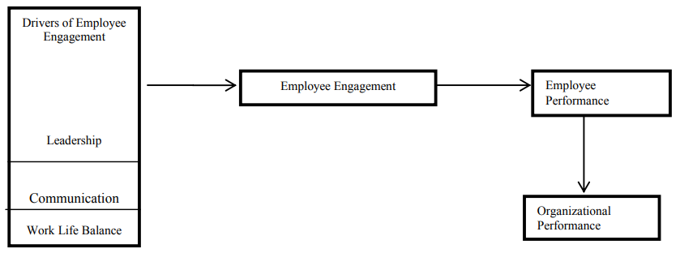
Figure 6: Models of Employee Engagement, Source (Bedarkar and Pandita, 2014).
The above figure represents the importance of employee engagement in organisational change. This can be achieved by maintaining outstanding leadership, effective communication and work-life balance. The work-life balance is likely to improve through Levines planned remote working facility. The large workforce will enjoy the comfort of their home, family and children; however, there those who prefer their office environment due to lack of space at home.
Benefits of Employee Engagement.
- Employee engagement generates more yield, and happier staffs will help employee commit to organisational change.
- Employee engagement aids goals and strategy to be achieved more effortlessly.

New Leadership Style.
The management wants to propose is a flexible, informal and democratic style of leadership. Levines now believe that the old way has worked; however, it is time to change to meet the current condition. The directors now want to adopt and encourage more transformational leadership style. To help with creativity, encourage, motivate individuals, influence and lead them toward organisational goals, and be agile in times of change. Leaders will be asked to interact more with employees to accelerate the new style of leadership and culture.
- Transformational leadership will encourage creativity in the organisation to produce a new proposition, new strategy, goals and alignment with a new culture (Anthony and Schwartz, 2017).
- Democratic leadership will allow employees to work more independently and have the flexibility to allow better culture growth.

New Organisational Structure for Levines.
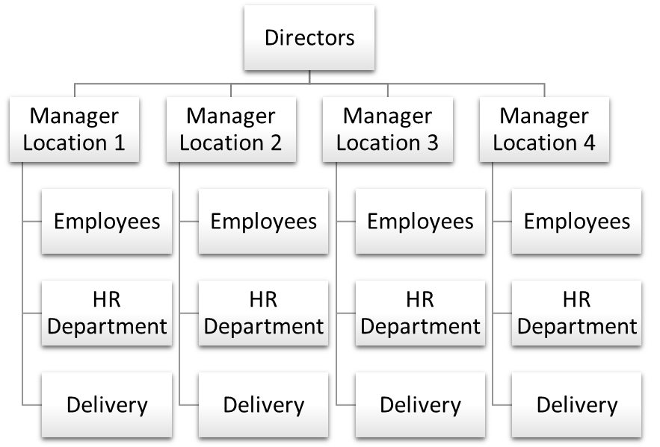
Figure 7 Own Construct.
A new organisational hierarchy is created to help employees understand the command chain. It will help employees and departments to understand their specific job role better.

New Reward and Control System.
The directors will monitor each location quarterly sales and expenses; simultaneously, Levines will reward employees and managers who perform above targets. However, if stores are underperforming, the managers must compile reports for the directors to make a strategic decision. Any employees not performing their jobs will give written warnings by the store managers and lose bonuses. Boundaries are set, and most employees know when not to cross the line.
The directors believe in excellent service and quality that brings repeat business. They also believe in the organisation's reputation is vital for long term trade; the directors reward method keeps its employees aligned with the organisation’s tradition. Their belief stems back to the founders, and the vision mission statement reflects that on the website that has so far worked for Levines; however, a new mission vision is proposed to aid current change management designed for the online business.

Managing Emotions with Daniel Goleman's framework of Emotional Intelligence.
Levines will train managers on using Goleman’s Emotional Intelligence (EI); this will be a critical role for the organisation in communicating the vision. Managers need to be socially aware and have rapport building skills. The purpose is to manage emotions effectively and convey the message effectively (Shamian-Ellen and Leatt).

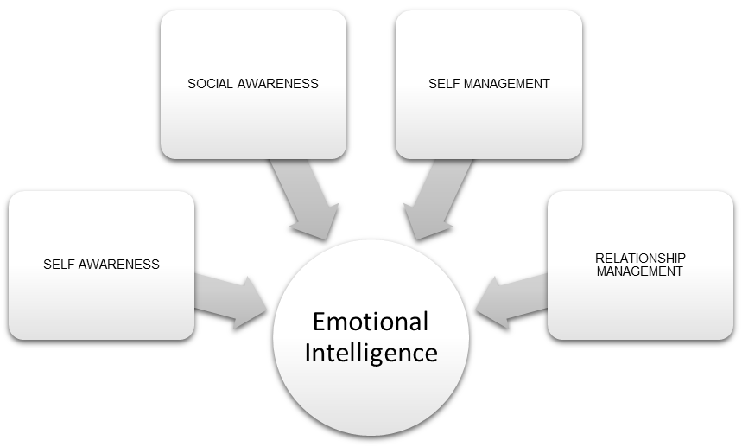
Figure 8: Daniel Goleman's framework of Emotional Intelligence Adapted from (Shamian-Ellen and Leatt, 2002p.38).

- Managers will need to be Self-Aware of their own self emotions and accurately assess their competence. Vital for help in dealing and understanding with emotional of employees.
- Self-Management, recognising and having self-control of own feelings will be essential in controlling the conversation. Management adapting to the new transformation will help others follow.
- Social-Awareness is another skill need in understanding the negative feelings of colleagues when impacted by the changing news. Empathy should be used in dealing with negative emotion likely to arise in the organisation.
- Relationship-Management is another skill leader needs in building rapport, managing conflict, developing others to help overcome the catalyst.

LEVINES CHANGE MANAGEMENT PROGRAMME.

Introduction
After extensive research above, the managers have now asked for a change request, and the directors have now committed to moving Levines operation online and stopping operating the physical stores due to the pandemic.

Levines objective is to target new millennial with more modern brands like IKEA. The change will save on running cost, efficiency, adapt to the pandemic, cost leadership and improve profitability. Levines directors believe the strategy will help organisations long term sustainability and winning back the customers, which is essential to business survival.

The Project Sponsor.
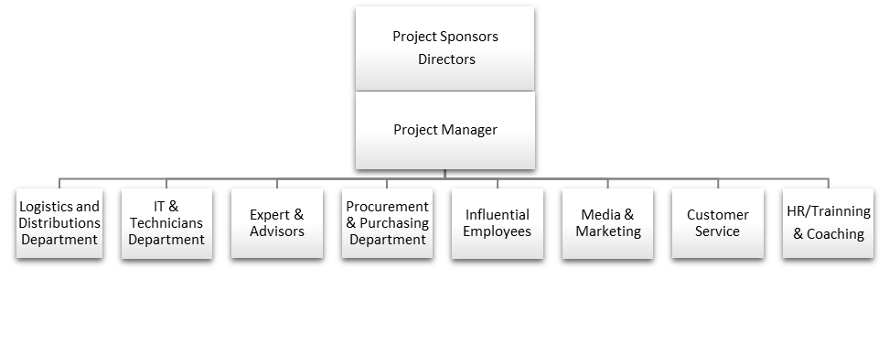
Figure 9: The Project Sponsor, Own Construct.
The above hierarchy is the project sponsor and steering group chosen from the organisation for their competence, aptitude who will be responsible for the project outcome. The group will take responsibility for proposed deliverables as listed below.

Purpose and Objectives for Levines.
Strategy-1 | Close physical store to become fully operational online furniture shop with home delivery, click & collect facility offered on warehouse location.
Strategy-2 | To create an interest-based loan facility based on the customer’s credit score through party loan companies.
Strategy-3 | Levines desires to be a more ethical business, sourcing more eco-friendly recyclable, sustainable products.
Strategy-4 | A more modern and broader product range will be created to meet the demand for the new generation.

Rationale and Drivers for the Change.
- To adapt the business to the external changes of Covid-19.
- To be greater efficient and reduce cost against the competitors.
- Use modern technology selling furniture on online shops, social media, eBay and to be competitive.

Communication Strategy.
- Creating a clearly documented plan and strategy for stakeholders using Power Interest Grid above, starting with directors, managers and employees.
- A communication template is agreed upon for critical messages to be delivered for the employees, emails, meeting and presentation every two weeks.
- The change agents should repeat the strategy so it does not fade or lose momentum. Use Goleman’s Theory for Managing Emotions that may arise.
Draw Backs.
- Drawbacks to communication strategy can be time-consuming for an organisation to keep every individual informed.
The Message Template Example.

THE MESSAGE.  Agree on the message to be delivered, makes sure its consistency. What is the organisation's plan, and what is the strategy to deal with the external threats? | THE FUTURE.  Describe the desired outcome of the plan.  Close physical store to become an online retailer. | COMMUNICATION CHANNEL.  Leaflets, email, and presentations.
FREQUENCY OF THE MESSAGE.  Leaflets and emails – weekly.  Presentation – every two weeks. | KEY MILESTONES.  Key milestones and goals achieved by the change agents. | STAKEHOLDER.  Make a list of stakeholders and prioritised who should be informed.

Managing Stakeholders with Freeman’s Stakeholders Theory.
Dr F Edward Freeman Stakeholders Theory was a concept designed to identify and manage those affected by the change in the business strategy, using stakeholders theory to facilitate a smooth transition for change management (Parmar et al., 2010).

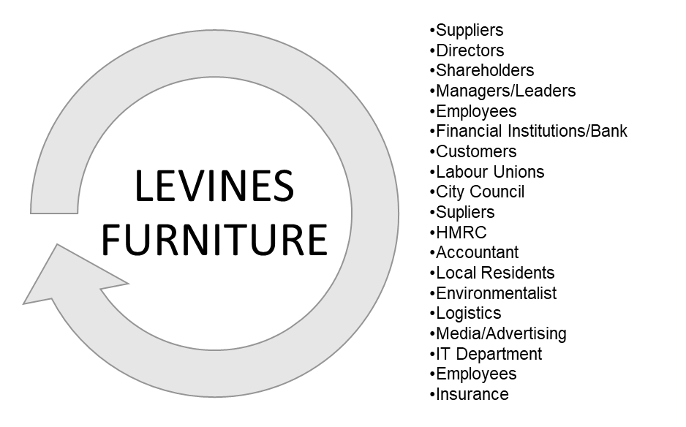
Figure 10: Levines Stakeholders Adapted from (Smith, 2019).
The above is the list of Levines stakeholders that are likely to be affected by the proposed change. To bring smooth change management, each of them will need to be managed carefully to achieve the goal. For instance, any expansion works by an organisation; the city council will need to approve it; however, residents may disapprove and halt the project.

Levines Furniture Stakeholder Power Interest Grid.
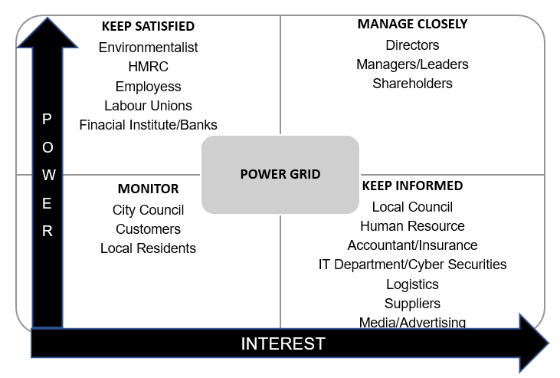
Figure 11: Stakeholder Power Interest Grid Adapted from (Schuurman, 2019).
The above is Levines Power Interest Grid designed to help the organisation understand how stakeholders are connected to the current project and how they should be prioritised based on how they are categorised. According to the proposed plan, these are the individuals/organisations who are likely to be affected or have a claim on the business. For example, the customers may face changes in the way they shop, and the company will need to assess the transition to reduce loss. Banks/Financial Institutes may need to be notified as they have invested in the business through loans; a meeting with bank managers may be needed with a business plan. Having an organised insight into a power interest grid will assist with an effortless transition (Ackermann and Eden, 2011).

The Kubler-Ross Model Transition Curve.
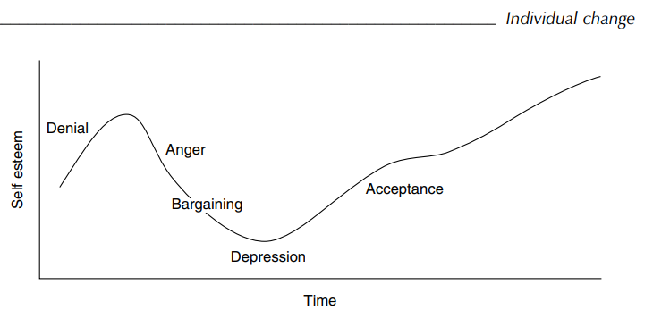
Figure 12: Transition Curve, Source (Cameron and Green, p37, 2012).
Using the Kubler-Ross Model, some strategies have been created to deal with employees emotional reaction to the Levines change process, as listed below.

Employees Reaction to Change (please refer to appendix 2).

Change Management Plan for the Future Template.
Activity Description | Department/Party Responsible | Start Date | End Date
Create Gantt chart for communication and progress of the project | Project manager | 18/04/2021 | 01/08/2021
Design and construction of the new website. | IT Department and web developer. | 18/04/2021 | 18/07/2021
Create a new online catalogue. | IT Department, purchasing department and web developer. | 18/04/2021 | 18/07/2021
Create a new loan facility. | Finance department and loan underwriter. | 01/05/2021 | 01/07/2021
Purchase or rent new warehouses. | Managers. | 18/04/2021 | 01/07/2021
Purchase delivery vans, broad band, laptops, computers and telephone. | IT department and purchasing department. | 01/05/2021 | 11/07/2021
Training and coaching staffs on new software. | HR department and senior employees | 11/07/2021 | 11/08/2021
Marketing | Levines marketing department. | 18/07/2021 | 01/09/2021
Testing and launching the website. | Project manager, marketing department, store managers. | N/A | 05/09/2021

Coaching and Training.
The company intends to offer training to those employees who will require additional support to perform their task effectively (Tompkins, 2018).
- Communication skills to deal with telephone and online sales and customer service, warranty and returns.
- Training staffs on computer skills, navigating through the new online software and website.
- Training staffs on online security, data protection, loans and payment system.
- Senior employees will aid in coaching and mentoring.

Risks and Barriers to the Change Strategy.
With all change comes obstacle and barriers that must be mitigated for a change to be successful, some issues likely to rise in the future.
- Driving employees out of their comfort zone can be difficult; they may resist.
- Influential employees can obstruct plans and the change management process. (Voehl and Harrington, 2016).
- The threat of a new pay per mile tax by the government that can affect the profitability of Levines in the near future is seen as a threat (Sillars, 2020).

Managing Resistance.
Managing resistance becomes very critical at this part of the project as individuals can still resist organisational change. To resolve issues communication template has been assembled to manage emotional issues. Coaching, mentoring and training will be offered to those who will require additional support. The new leadership style and a new culture will help in facilitating change. The organisation will support all those who require further support through the change.

Monitoring and Reviewing the Change.
Monitoring the performance of the new strategy will be paramount in identifying the success of the change. This can be achieved using several data collection methods to create a performance chart, as listed below. Eliminate and review the strategy and make changes to the model if necessary.
- Use previous historical sales data and compare it with the current data.
- Use previous expense to assess the savings made from the online project against the previous strategy.
- Benchmark feedback collected from customers to assess customer satisfaction of service and product quality (Westover, 2010).
- Create a new report and data for redistribution to inform the stakeholders of current progress.

Conclusion and Recommendation.
The report aims to create a change management process to mitigate the current Macro Environment change due to the Covid-19 and Brexit. The study discusses various external, internal threat and possible opportunity that has surfaced. The study used various theoretical models and tools to evaluates Levines Furniture Shop to understand further the holistic business environment that the store operates in.
Theoretical Models and Tools used to Compile the Report.
- PESTLE/ SWOT framework was used to collect data on the macro/micro-environment to evaluate the potential threat or opportunity from Covid-19 and Brexit to the organisation.
- Porter’s Five Forces was performed to analyse the industry and examine the business organisations competition.
- Benchmarking was done to make product and services comparison to evaluate any weakness in the company’s features.
- Kotter’s 8-Step Model was used to compile the structured approach to change.
- A new organisational hierarchy structure is proposed and is created for the new proposal.
- A new change management programme and strategy was created from the research performed above.
- Stakeholder mapping and power interest grid are developed to address those who can be affected by the change.
- A new flexible democratic leadership is proposed to help with creativity and the development of proposition.
Some Risks Associated with Change Implementation.
- The possibility of management resistance and risk to the project was discussed; these issues can still be a continuing threat.
- The economy may take longer to recover due to the governments quantitative easing, which could lead to hyperinflation.
- A new variant of Covid-19 is on the rise, which could be more of a threat as vaccines may not work.
- It is too early to declare the battle against Covid-19 is won, and the future is very uncertain, which may affect trade longer than anticipated.
The report recommends that Levines implement the chosen strategies immediately for the long-term sustainability of organisational well-being and prosperity.

Reference.

- Ackermann, F. and Eden, C. (2011). Strategic Management of Stakeholders: Theory and Practice. Long Range Planning, [online] 44(3), pp.179–196. Available at: http://hadjarian.com/esterategic/tarjomeh/2-90/khamesi.pdf [Accessed 7 Mar. 2021].
- Adair, J. (2007). Decision Making & Problem-Solving Strategies. Editorial: London; Philadelphia: Kogan Page.
- Anthony, S.D. and Schwartz, E.I. (2017). What the Best Transformational Leaders Do. [online] Harvard Business Review. Available at: https://hbr.org/2017/05/what-the-best-transformational-leaders-do [Accessed 7 Mar. 2021].
- BBC News (2017). Ikea sees annual UK sales top £1.8bn. BBC News. [online] 14 Nov. Available at: https://www.bbc.co.uk/news/business-41969928 [Accessed 17 Feb. 2021].
- Bedarkar, M. and Pandita, D. (2014). A Study on the Drivers of Employee Engagement Impacting Employee Performance. Procedia - Social and Behavioral Sciences, [online] 133, pp.106–115. Available at: https://www.sciencedirect.com/science/article/pii/S1877042814030845.
- Bhatti, A., Akram, H., Basit, H., Khan, A., Naqvi, S. and Bilal, M. (2020). E-commerce Trends during COVID-19 Pandemic. International Journal of Future Generation Communication and Networking, [online] 13(2), pp.1449–1452. Available at: https://www.researchgate.net/publication/342736799 [Accessed 16 Feb. 2021].
- Binns, K. (2021). Budget 2021: The Results. The Times. [online] Available at: https://www.thetimes.co.uk/money-mentor/article/budget-at-a-glance/ [Accessed 5 Mar. 2021].
- Brown, L.J., David and Palumbo, D. (2020). Eight Charts on How Coronavirus Has Hit the Global Economy. BBC News. [online] 6 Mar. Available at: https://www.bbc.co.uk/news/business-51706225 [Accessed 7 Mar. 2021].
- Cameron, E. and Green, M. (2012). Making Sense of Change Management. 3rd ed. London: Kogan Page.
- Company Check (2021). Levine Brothers (Home Furnishings) Limited. [online] Company Check. Available at: https://companycheck.co.uk/company/01473176/LEVINE-BROTHERS-HOME-FURNISHINGS-LIMITED/financials [Accessed 17 Feb. 2021].
- Cousins Furniture (2021). Finance FAQs | Cousins Furniture. [online] cousinsfurniture.co.uk. Available at: https://cousinsfurniture.co.uk/knowledge-base/finance/ [Accessed 18 Feb. 2021].
- Cribb, J. and Johnson, P. (2018). 10 Years on - Have We Recovered from the Financial crisis? [online] Ifs.org.uk. Available at: https://www.ifs.org.uk/publications/13302 [Accessed 15 Feb. 2021].
- Erdil, A. and Erbıyık, H. (2019). The Importance of Benchmarking for the Management of the Firm: Evaluating the Relation between Total Quality Management and Benchmarking. Procedia Computer Science, [online] 158, pp.705–714. Available at: https://www.sciencedirect.com/science/article/pii/S1877050919312761 [Accessed 18 Feb. 2021].
- Friesner, T. (2011). History of Swot Analysis. [online] Available at: https://www.researchgate.net/publication/288958760_History_of_swot_analysis [Accessed 16 Feb. 2021].
- Frue, K. (2017). Who Invented PEST Analysis and Why It Matters. [online] PESTLE Analysis. Available at: https://pestleanalysis.com/who-invented-pest-analysis/ [Accessed 14 Feb. 2021].
- Giles, C. (2020). UK’s Poor GDP Performance Rooted in Weak Household Spending. [online] www.ft.com. Available at: https://www.ft.com/content/c5d72dea-50bc-4f1f-98d3-bc758aafa905 [Accessed 16 Feb. 2021].
- Grundy, T. (2006). Rethinking and Reinventing Michael Porter’s Five Forces Model. Strategic Change, [online] 15(5), pp.213–229. Available at: https://onlinelibrary.wiley.com/ [Accessed 1 Mar. 2021].
- Harvard Business School. (2020). How to Communicate Organizational Change: 4 Steps | HBS Online. [online] Available at: https://online.hbs.edu/blog/post/how-to-communicate-organizational-change [Accessed 24 Feb. 2021].
- Johnson, G., Whittington, R. and Scholes, K. (2011). Exploring corporate strategy: [text and cases]. Harlow: Financial Times Prentice Hall.
- Jones, L., Palumbo, D. and Brown, D. (2020). Eight Charts on How Coronavirus Has Hit the Global Economy. BBC News. [online] 6 Mar. Available at: https://www.bbc.co.uk/news/business-51706225.
- Jones, R.A., Jimmieson, N.L. and Griffiths, A. (2005). The Impact of Organizational Culture and Reshaping Capabilities on Change Implementation Success: The Mediating Role of Readiness for Change. Journal of Management Studies, 42(2), pp.361–386.
- Khorana, S. (2021). India: UK Is on a Charm Offensive to Win a Free-Trade Deal – Will It work? [online] The Conversation. Available at: https://theconversation.com/india-uk-is-on-a-charm-offensive-to-win-a-free-trade-deal-will-it-work-154745 [Accessed 7 Mar. 2021].
- Kibasi, T. (2020). At Long Last We Have a Brexit Deal – and it’s as Bad as You Thought | Tom Kibasi. [online] the Guardian. Available at: https://www.theguardian.com/commentisfree/2020/dec/24/at-long-last-we-have-a-brexit-deal-and-its-as-bad-as-you-thought [Accessed 15 Feb. 2021].
- King, B. (2020). Could Brexit Make My Food More expensive? [online] 14 Dec. Available at: https://www.bbc.co.uk/news/business-55222125 [Accessed 15 Feb. 2021].
- Kotter, J.P. (1996). Leading Change. Boston, Mass.: Harvard Business School Press.
- Levine's Furniture (2020a). About us. [online] Levine’s Furniture. Available at: https://levinesfurniture.co.uk/pages/about [Accessed 17 Feb. 2021].
- Levines Furniture (2020b). Terms and Conditions. [online] Levines Furniture. Available at: https://levinesfurniture.co.uk/pages/terms-and-conditions [Accessed 18 Feb. 2021].
- McKinsey & Company. (2017). The Change Agent Challenge. [online] Available at: https://www.mckinsey.com/business-functions/operations/our-insights/the-change-agent-challenge [Accessed 23 Feb. 2021].
- Milne, R. (2019). Ikea Says It’s Easier Being Green If You Are Private. [online] Financial Times. Available at: https://www.ft.com/content/18c93c7a-0562-11ea-a984-fbbacad9e7dd [Accessed 16 Feb. 2021].
- Mullins, L.J. (2010). Management and Organisational Behaviour. 9th ed. Harlow: Financial Times Prentice Hall.
- Parmar, B.L., Freeman, R.E., Harrison, J.S., Wicks, A.C., Purnell, L. and de Colle, S. (2010). Stakeholder Theory: The State of the Art. The Academy of Management Annals, 4(1), pp.403–445.
- Periyasami, R. (2020). Kotter’s 8 - Step Model - a Beginners Guide to Change Management. Apty. [image] Available at: https://www.apty.io/blog/kotters-8-step-model [Accessed 1 Mar. 2021].
- Porter, M. (1979). How Competitive Forces Shape Strategy. [online] Harvard Business Review. Available at: https://hbr.org/1979/03/how-competitive-forces-shape-strategy [Accessed 16 Feb. 2021].
- Richter, F. (2019a). Online Furniture Sales Are Booming. [online] Statista Infographics. Available at: https://www.statista.com/chart/14771/e-commerce-sales-of-furniture/ [Accessed 17 Feb. 2021].
- Richter, F. (2019b). Online Furniture Sales Are Booming. [online] Statista. Available at: https://www.statista.com/chart/14771/e-commerce-sales-of-furniture/ [Accessed 7 Mar. 2021].
- Sammut-Bonnici, T. and Galea, D. (2015). SWOT Analysis. Wiley Encyclopedia of Management, [online] 12, pp.1–8. Available at: http://onlinelibrary.wiley.com/doi/10.1002/9781118785317.weom120103/abstract [Accessed 7 Mar. 2021].
- Schuurman, R. (2019). Creating a Stakeholder Analysis: How Do You Do that? [online] Medium. Available at: https://medium.com/the-value-maximizers/creating-a-stakeholder-analysis-how-do-you-do-that-b2b8198ca6c [Accessed 1 Mar. 2021].
- Shamian-Ellen, M. and Leatt, P. (2002). ‘Emotional Intelligence - How Well Do We Know Ourselves and How We Relate to Others?’. Healthcare Quarterly, 6(1), pp.36-41.
- Sillars, J. (2020). Rishi Sunak Eyes “pay-by-the-mile” Road Pricing Scheme Ahead of £40bn Tax Threat from Electric Vehicle Drive - Report. [online] Sky News. Available at: https://news.sky.com/story/road-pricing-sunak-eyes-40bn-tax-threat-from-electric-vehicle-drive-12133772 [Accessed 28 Feb. 2021].
- Smith, L.W. (2019). Stakeholder analysis, a Pivotal Practice of Successful Projects. [online] Project Management Institute. Available at: https://www.pmi.org/learning/library/stakeholder-analysis-pivotal-practice-projects-8905 [Accessed 1 Mar. 2021].
- Solutia. (2019). What Are Micro and Macro Environment Consideration in marketing? – Solutia. [image] Available at: http://solutia.ir/2019/05/what-are-micro-and-macro-environment-consideration-in-marketing/ [Accessed 7 Mar. 2021].
- Studdert, J. (2020). The UK Government Has Failed to Handle Covid, but Local Councils Give a Ray of Hope | Jessica Studdert. [online] The Guardian. Available at: https://www.theguardian.com/society/2020/dec/17/the-uk-government-has-failed-to-handle-covid-but-local-councils-give-a-ray-of-hope [Accessed 16 Feb. 2021].
- Tompkins, M.W. (2018). Coaching in the Workplace. Journal of Practical Consulting, [online] 6(1), pp.115–122. Available at: [Accessed 8 Mar. 2021].
- Voehl, F. and Harrington, H.J. (2016). Change Management: Manage the Change or It Will Manage You. New York: Productivity Press.
- Westover, J.H. (2010). Managing Organizational Change: Change Agent Strategies and Techniques to Successfully Managing the Dynamics of Stability and Change in Organizations. International Journal of Management and Innovation, 2(1), pp.45–50.

Appendices.

Appendix1. Examining the Competition and Rivalry using Porters Five Forces.
Rivalry Between Existing Companies is Low.
- Levines aims to sell products to middle-income family; by taking this approach, it does not directly compete with Cousins Furniture store and Habitat.
- IKEA dominates the furniture market, sales topping 1.8b (BBC News, 2017). However, the stores are located too far from the residential area; shoppers find it inconvenient sometimes.
- Due to competition in the same sector, Levines is competitively priced against rivals with a good furniture range.
- Several smaller local players do not directly compete with Levines as they are selling cheaper low-grade product.
Bargaining Power of Suppliers is Low.
- Many industry suppliers sell similar products who are looking to sell their product through the high street and online retailers.
- After Brexit Levines will have access to cheaper suppliers from emerging markets like Malaysia, Indonesia and India, which means cheaper products (Khorana, 2021).
- Suppliers must price their goods fairly to get their products on the shelves due to the large supplies.
Bargaining Power of Buyers is Medium.
- Due to online shops and physical stores competing for similar trade, bargaining power is medium.
- Consumers do have lots of online choices and stores, so products need to be priced moderately.
- Levines price, service and quality are hard to copy; limited companies are offering the same proposition.
The threat of Substitute Product is Medium.
- The products that Levines sell are minimal, and only a few retailers have access to those products.
- The switching cost can be relatively high for consumers looking for the same quality and products.
- The threat is from some well-established online furniture retailers offering similar quality and service.
The Threat of New Entrants is Low.
- The initial high-cost investment in a large furniture store will deter most investors, so barriers to entry are high.
- New entrants will require extensive knowledge and experience to set up a large chain of stores, accessing distribution and logistics.
- To create a new brand, the timeline can be long, extensive marketing and capital needed.
- Established stores have cost advantages as an established business can buy large bulks at a lower price.
Critically Evaluating the Findings from the Porter’s Five Forces Analysis.

- The rivalry between existing companies is low: While there is lots of rivalry between furniture stores, Levines differentiate itself with an entirely distinct product line from its competitors. By taking this approach, it avoids direct competition and attains its buyers.
- Bargaining power of suppliers is low: A substantial number of suppliers in the market wishing to sell their products to retailers. The help of the Asian Emerging Market has allowed more product choices in recent years, which has allowed the retailer to price competitively.
- Bargaining power to the buyer’s medium: Since the advent of online shops and the vast choices buyers have, the physical shops are being outpriced and are having to lower their price. This offers more bargaining power to the buyers medium and less profit to high street brands. Levines may need to follow this new trend and tread with caution.
- The threat of substitute product is medium: According to (Richter, 2019), online business is booming; this can be observed in several companies now. Online businesses are leading in terms of better price leadership due to lower rent/rates, cheap storage, saving costly space, fewer employees and access to nationwide consumers who wish to purchase online. There are cost advantages of setting up an online shop, with very little working space are needed, or expensive refurbishment, no demand for car parks and very low building maintenances. Creating an online substitute for a physical shop is effortless due to the advance of IT. However, online business lacks the human touch, viewing products that appeal to the older generation who cannot access or IT technology.
- The threat of new entrants is low: Creating brands, raising funds, supply chain, and logistics requires extensive knowledge and time. Nevertheless, a new threat is rising due to the expansion of information technology, and the ease of setting up an internet shop reminiscent of a physical shop is a growing threat (Johnson, Whittington and Scholes, 2011).

Appendix 2. Employees Reaction to Change Template.
Employees Emotional Response to the Change | Employees Emotional Reaction to the Change | Recommended Approach for Emotional Response.
Denial | Shock and disbelief, employees may deny the changing news. | Should stick to the plan and provide the plan change.
Anger | Employees might try and obstruct the intendant change. | Managers need to differentiate between feelings and bad behaviour. Keep promoting and motivating the actual change.
Bargaining | After being exhausted, the employees start to accept the change because there is no alternative. | Employees begin to except inevitable; these individuals are ready to accept the change.
Rejection | Employees believe the problem is a temporary issue, and it will pass. | Allow time for the change to absorb, reassure the benefits of change.
Depression | Individuals may find it hard to perform the daily task due to their feelings. | Provide enough information about the progress, assure them their jobs are secured. This stage is the last stage before accepting the change.
Acceptance/Approval | Employees embrace change and concentrate on the future. | Employees can participate in the change and help and coach others.
(Cameron and Green, 2012).

