
Project Planning formConstruction
Programs



Jonathan Triggs
1807834

Contents
Introduction 3
Work Breakdown Structure 3
Method Statements 4
Pour Concrete Piers 4
Site Clearance 5
Kerb Laying 6
Critical Path 7
Report 8
Conclusion 9
References 10

Introduction
This document is a report covering the planning of building a link bridge in the Quays industrial estate to start on the 6th of May. The information consists of every task that need to be completed and how this can be done in an efficient manner using a Gantt chart with a critical path. This document also has cost evaluations for the project as well as method statements for major tasks.

Work Breakdown Structure
A work breakdown structure clearly indicates in a structured manner all tasked that need to be completed as part of a construction project. Creating a work break down structure allows construction projects to be planned considering time and cost. This is done so that construction projects can be efficiently managed throughout. A work breakdown structure can be set out in different ways, but they all have the same purpose in that that they all how what tasks need to be completed in correlation with each other. As well as the time a task takes a work breakdown structure can include all the costs involved in the tasks. For example, how much labor and equipment will be needed to complete the task. (Cohen, 2018)
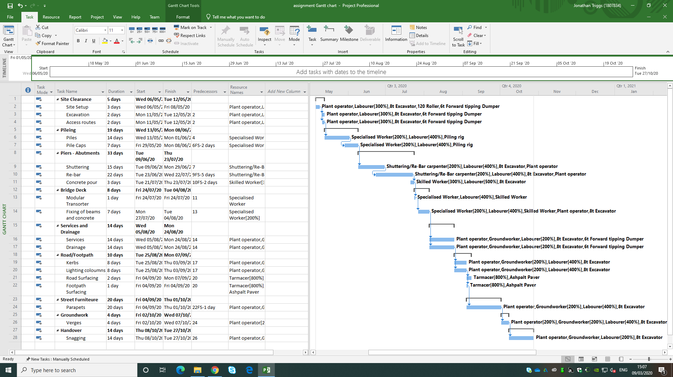
This diagram shows the work break down structure for the construction of the link bridge for the Quays industrial estate. It clearly indicates every task that needs to be completed with times as well as the labor and plant weightings required to be completed. Once the construction project has started management an refer to the work break down structure to ensure that they not spending too much time or overspending on plant and labor.

Method Statements

Pour Concrete Piers
What needs to be carried out before the start of the Activity:
- Works are must be visually checked to ensure safe environment.
- Before work starts all operatives that will be working on site must be briefed before any work can commence.
- Ensure that every operative has the correct PPE for the task.

Mandatory PPE requirements:
- Hard hat.
- Safety footwear.
- High visibility clothing. (incl. trousers and long sleeves)
- Safety Glasses.
- Gloves.

Concrete Pour Procedure:
- Engineer to set out foundation will be agreed with the structural engineer.
- Shuttering must be set up accurately and securely by trained shuttering carpenters.
- Re-bar must be securely in place to the specification of the drawings and to be checked by trained professional.
- The concrete will be placed in a controlled manner from the concrete pump
- The pour shall proceed in this manner until complete.
- Mini mix concrete delivery vehicles will be reversed into the site, under the control of a dedicated banksman / vehicle marshal onto the concrete pump.
- The work area shall be kept clean and clear of any trip hazards.
- Operatives must always keep PPE on to avoid dermatitis.
- There must be an operative controlling the end of the pump as well as a banksman supervising the whole operation.
- Operatives are not to enter the shuttering at any time as the pump and poker should be able to spread it evenly.
- Operatives may use a rake at a distance to spread concrete from outside of the shuttering once the concrete pump has finished.

Main Equipment:

- Concrete Pump
- Small tools
- Shuttering
- Re bar/ tying wire

Site Clearance

What needs to be carried out before the start of the Activity:
- Works are must be visually checked to ensure safe environment.
- Before work starts all operatives that will be working on site must be briefed before any work can commence.
- Ensure that every operative has the correct PPE for the task.

Mandatory PPE requirements:
- Hard hat.
- Safety footwear.
- High visibility clothing. (incl. trousers and long sleeves)
- Safety Glasses.
- Gloves.

Pile Procedure:
- The works area is to be clearly set out and marked up before works can begin.
- Vehicular access must be identified to site so that routes can be made if necessary
- Once routes are set out adequate traffic management must be set up to ensure safe distance from pedestrians and live traffic.
- Work areas to be fenced off and debris netting fixed to fencing to prevent debris leaving the work site.
- Any Existing street furniture blocking access is to be removed mechanically and under supervision to ensure appropriate clearance.
- Using excavator clear spoil to create an even surface for ease of mobility around site as well as room for a site compound.
- Hand dug trial holes will be required in congested / sensitive areas to positively located & identify existing services.
- Banks man to be at hand always when mechanical excavations are ongoing.

Main Equipment:

- Small tools
- Excavator
- Pedestrian Barriers

Kerb Laying

What needs to be carried out before the start of the Activity:
- Works are must be visually checked to ensure safe environment.
- Before work starts all operatives that will be working on site must be briefed before any work can commence.
- Ensure that every operative has the correct PPE for the task.
- Ensure that all kerb packs are even delivery along kerb run to ensure minimal handling.
- Using a mechanical kerb lifter attached to a excavator all kerbs must be run out next to where they will be laid.

Mandatory PPE requirements:
- Hard hat.
- Safety footwear.
- High visibility clothing. (incl. trousers and long sleeves)
- Safety Glasses.
- Gloves.

Kerb Procedure:
- Engineer to set out kerb line with levels to ensure that kerb line is built to specification.
- Concrete must be delivered by ready mix and be laid along kerb run by supervision of a dedicated banksman.
- Once concrete is in place operatives must use mechanical kerb lifer to drop kerb into place by a dedicated banksman to avoid manual handling.
- Dedicated Kerb layer must have another operative to help if the kerbs require minor adjustments.
- Kerb layer must then hammer kerbs to correct level and placement in accordance to the engineers setting out and must be checked by a supervisor.
- Once kerbs are in place an operative must back all of the kerbs using residue concrete from the trench that they were laid in.
- The backing must then be compacted to ensure that the kerbs are stable and don’t move.

Main Equipment:
- Mechanical kerb lifter
- Excavator
- Ready mix concrete wagon
- Small tools

Critical Path

A critical path of a program of works is the longest sequence of events possible that need to be competed as part of the project. This meaning that if any of the tasks within the critical path are altered, delayed or require more time, the finish date of the project will need be to be extended. This can also work vice versa where if a task within the critical path is completed early the finish time of the project can be reduced. Identifying a critical path as part of a construction project is essential if the project is to be competed under any time restraints. An example of this would be that if the client has given a finish date for a project cost implication can be brought in if the project runs over leading to loss of earnings. (Ray, 2019)

This Diagram shows the critical path of the construction project to build a link bridge in the Quays industrial estate. The critical path is highlighted in red and shows the tasked that needs to be completed on time to ensure that the project is completed efficiently. This construction project starts on the 6th of May and with the use of the critical path it highlights that the projected can be completed on the 27 of October is the program is followed efficiently.
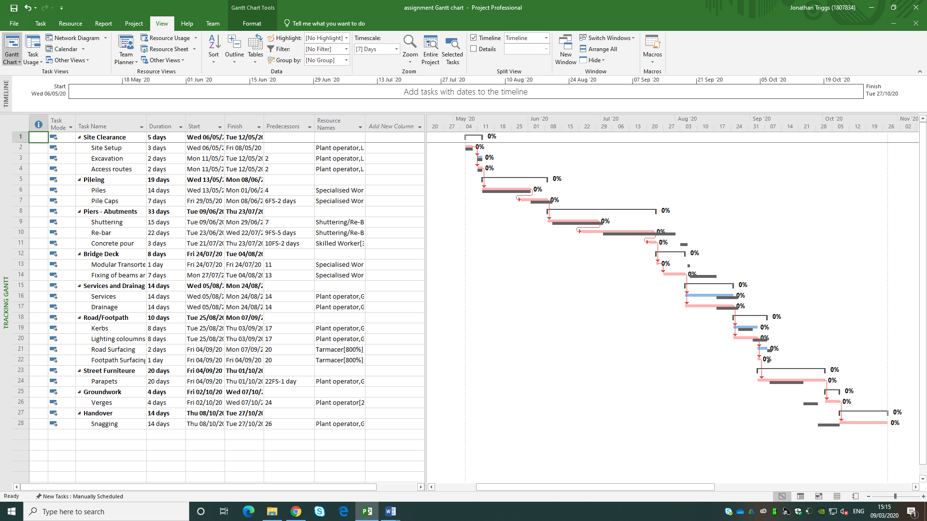Figure 1 Screenshot of Project Gantt chart

Report
To create an overall predicted report for the entire project comparing time to the cost of labor and plant can be calculated. This figure is a bassline figure for a construction project as there are always different variations when completing the job.


This first diagram shows the task cost overview which illustrates how much the labor and plant will cost for each task within the construction project:
These diagrams illustrate the cost variance for each major task and the resource cost variance:

This table shows the breakdown of all the resource, plant and labor costs through out the project. All the cost forecasts are made off this table as each item is done on a pound per hour basis. This means that depending on how many and how long each item is required for the tasks cost forecasts can be made.

Conclusion
To conclude this construction project the construction process is programmed to last from the 6th of May to the 27th of October making it 25 weeks. It is essential that the link bridge is to be constructed off site and put in place via module transporter due to overhead power lines being cautious of live train route running under the bridge. Variations may occur on site and must be dealt with by on-site team working with the client’s permission to ensure that the bridge is built in accordance to design. Any cost variations must be dealt with by on-site quantity surveyors liaising between contractor and client.

References
Cohen, E., 2018. What is WBS (Work Breakdown Structure) in Project Management?. [Online]
Available at: https://www.workamajig.com/blog/guide-to-work-breakdown-structures-wbs
[Accessed 25 April 2020].
Ray, S., 2019. Understanding Critical Path in Project Management. [Online]
Available at: https://www.projectmanager.com/blog/understanding-critical-path-project-management
[Accessed 25 April 2020].

