Uploading your Presentation and Notes to Moodle

The university now requires all work to be submitted electronically to Turnitin via Moodle. This means that you will need to submit both your presentation slides and your speaker’s notes to Moodle.

Tutors will provide your mark and feedback via Moodle, so a required element of your submission is to upload your work before you present.

Once you click on the Turnitin link, you will see that there are now two separate tabs. One should be used to upload your power point slides. The other should be used to upload your speaker’s notes.

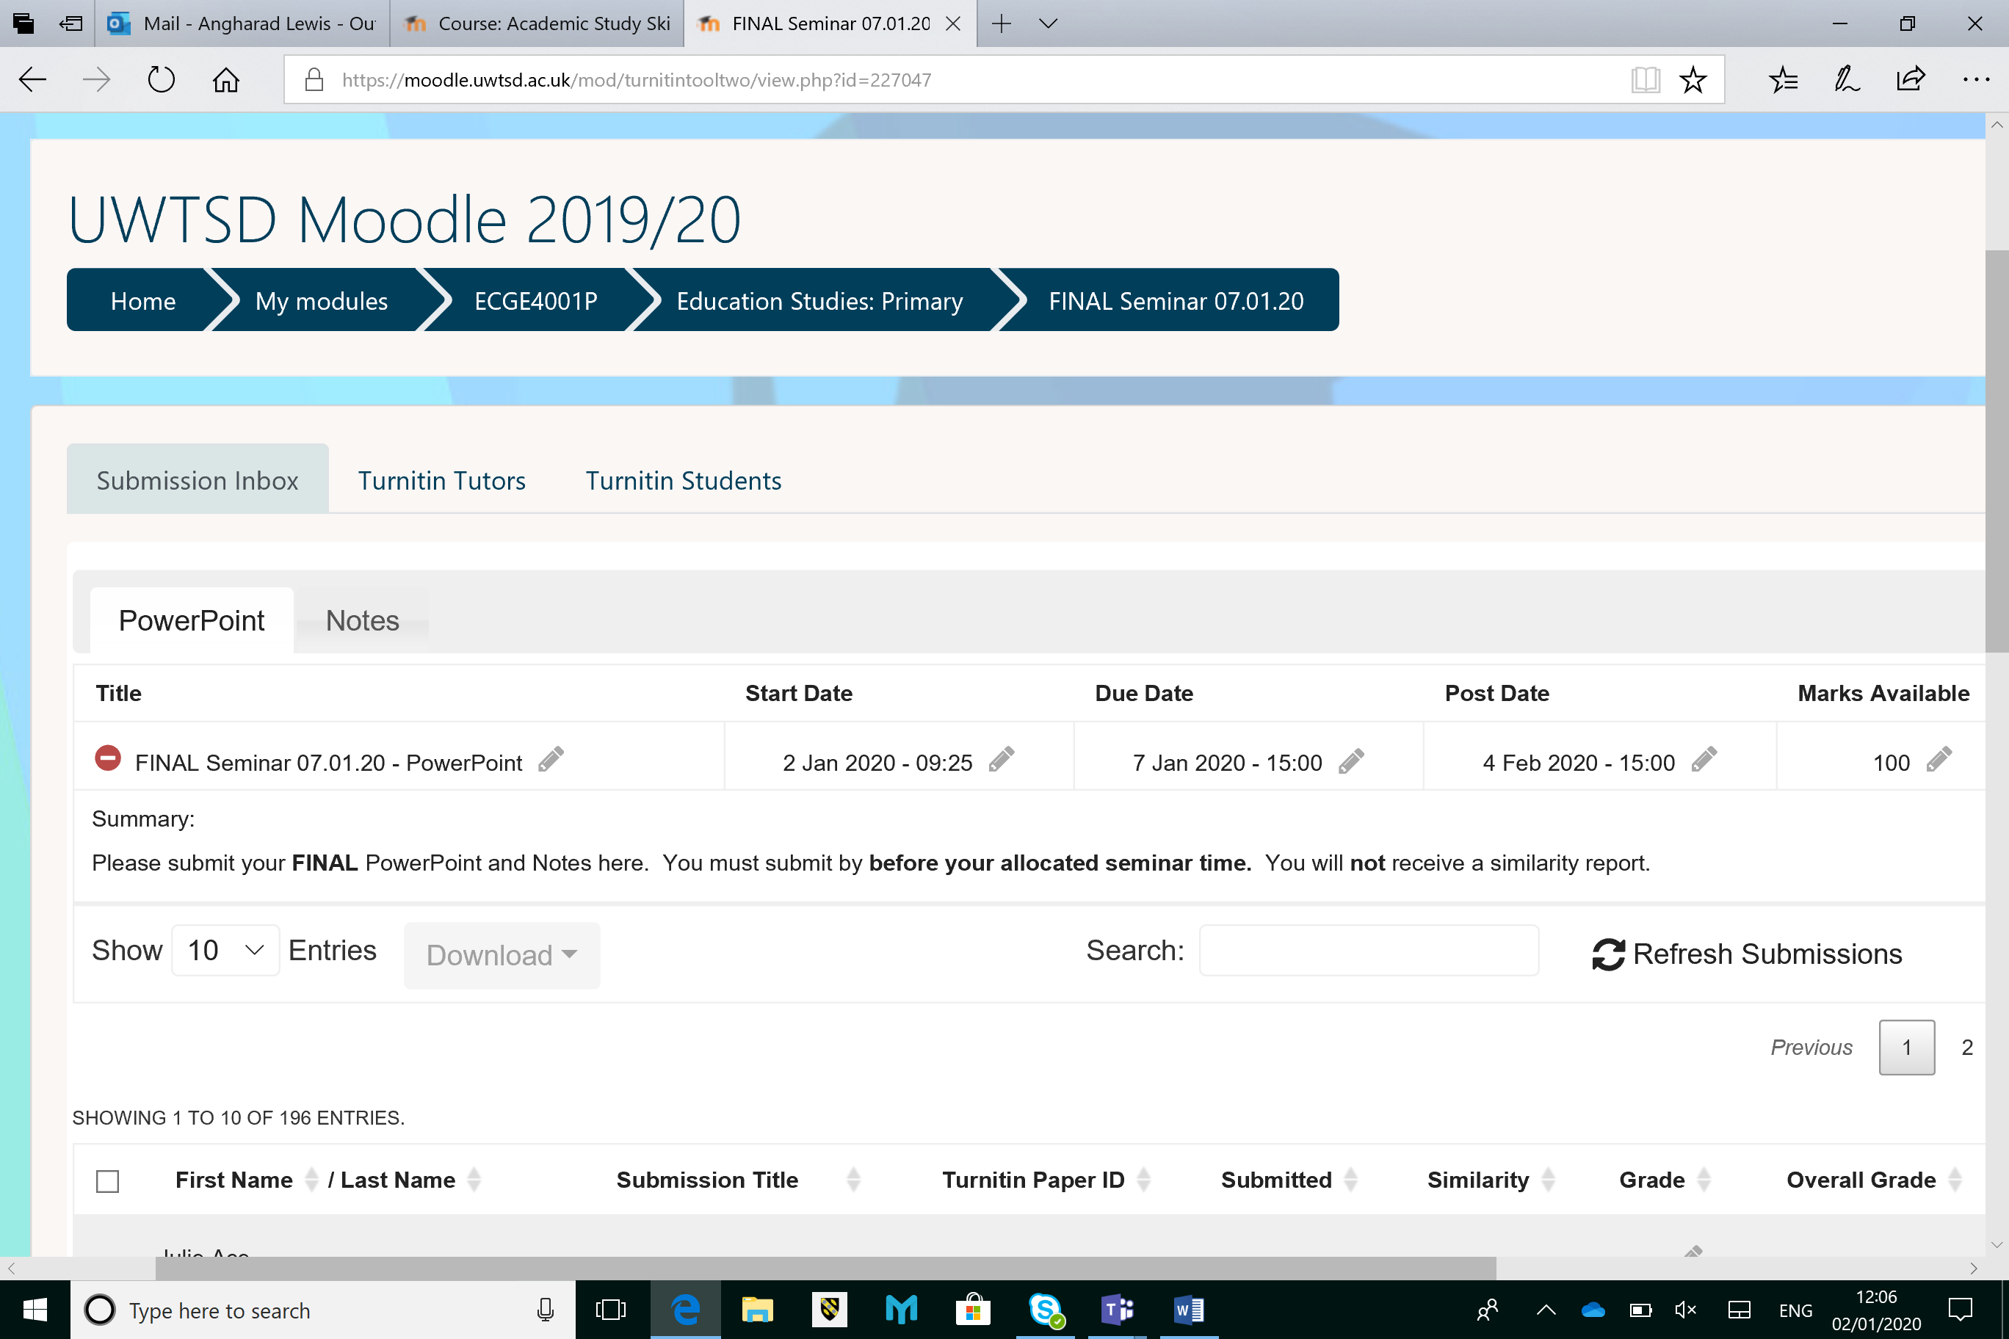

- Uploading Your Power Point Presentation
Click on the ‘PowerPoint’ tab. Upload your PowerPoint (as you would any other kind of document).

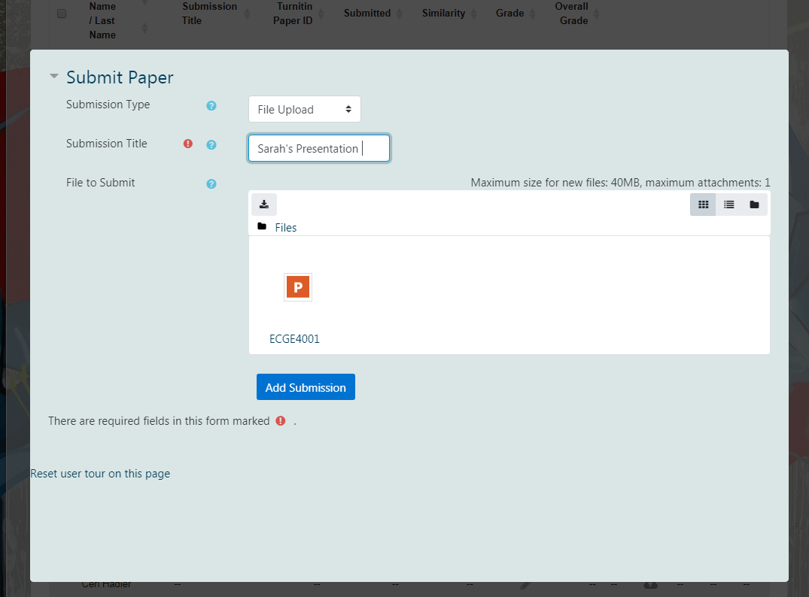

- Uploading your Speaker’s Notes

You will need to use the second tab to upload your speaker’s notes.
For uploading your notes, you can either:
- write your notes in a word document, indicating clearly which slide the notes correspond to, or
- you can type your notes into the ‘notes’ section of your power point. If it is this second option that you choose, you will need to save your powerpoint as a PDF document which shows your notes.

Save as a PDF and Enable Notes (see diagrams on nect page)

Step 1:
Firstly, go to ‘Save as type’. Click on this and choose ‘PDF’ from the drop-down menu.

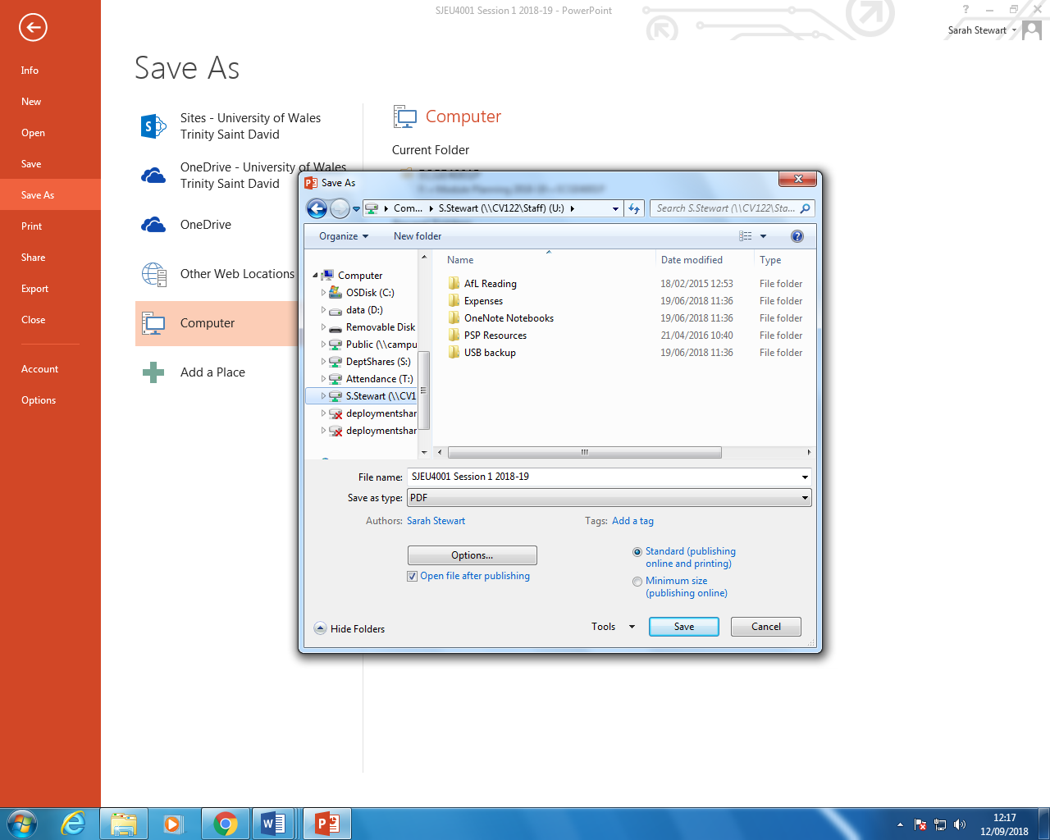
Secondly, select ‘options’

Step 2:
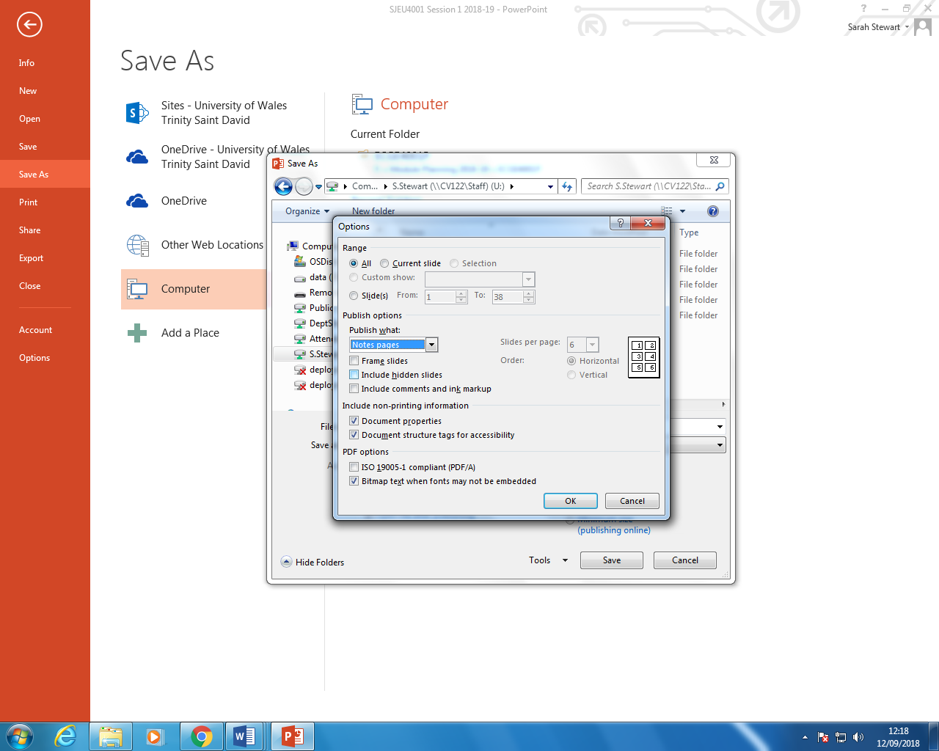
Under ‘Publish what:’ select ‘Notes pages’. Next, click OK and Save as usual.

