Component 1- Coursework: Portfolio

Tony Ly 2535528
UWTSD Quay Place Campus
Software Solutions for Business
Osman Elgawi
CertHE Computing Skills for Workplace
ACCA4026
17.07.2026

Table of Contents
Component 1- Coursework: Portfolio 0
Task 1: E-Commerce Web Builder 2
Shopify & WooCommerce 2
Task 2A: Mind Mapping Description 3
Task 2b: Mind Mapping Creation 3
Task 3 A: Office Applications 4
MS WORD 4
MS POWERPOINT 6
MS EXCEL 7
MS ACCESS 8
Task 3 B: Practical Testing 9
IF Function 9
Pivot Table 10
Task 4 A: Communication and Collaboration 10
Task 4 B: Feature Testing 12
References 14

Task 1: E-Commerce Web Builder

E-commerce platforms enable businesses to establish online storefronts, manage products, process payments, and reach global customers without extensive technical expertise. Two widely adopted solutions are Shopify and WooCommerce, each differing in structure, useability and flexibility, suited to distinct business needs.

Shopify & WooCommerce
Shopify is a fully hosted, all-in-one platform launched in 2006 designed specifically for online selling. It handles all technical infrastructure, including hosting, security, updates and compliance, meaning users do not manage servers or software maintenance. It offers over 100 professional, mobile-responsive templates, drag-and-drop customization and built-in tools for inventory management, shipping, tax calculation and multi-channel sales (social media, marketplaces, and physical stores). Its key strength is scalability: plans start at affordable entry levels and extend to enterprise-grade solutions, supported by an ecosystem of over 8,000 apps to add features such as subscriptions, international selling or advanced analytics. According to research, it is the most popular dedicated e-commerce builder, valued for reliability and ease of set-up, ideal for small-to-medium businesses and those prioritizing speed and low technical overhead [1]. Pricing is subscription-based, from approximately £25 to £250 per month, including hosting and core features.

WooCommerce, by contract, is an open-source e-commerce plugin built for WordPress, launched in 2011, Unlike Shopify, it is self-hosted: users require their own domain, hosting and WordPress installations, giving full ownership and control over every aspect of the store. The core plugin is free to download, making it highly cost-effective initially, though costs arise from hosting, premium themes, extensions and development work. It inherits WordPress’s flexibility, supporting unlimited products, categories, content and integrates seamlessly with thousands of extensions for payment and customization. It excels businesses that need deep customization, content integration (blogs, resources), or unique functionality not available in standard platforms [2].

However, it demands basic technical knowledge or developer support for setup, security and maintenance, and performance depends on hosting quality. It powers around 40% of all online stores globally, favored by users already familiar with WordPress or requiring bespoke solutions [3].

In summary, Shopify is the best for ease of use, reliability and fast growth, while WooCommerce offers maximum control, flexibility and cost efficiency for those with technical capability or custom requirements. Both remain leading choices, selected based on budget, skill level and long-term business goals.

Task 2A: Mind Mapping Description
Some people find mind mapping very useful not only for recording information, but also for recalling it. Mind maps are an idea created by Tony Buzan as a way of visually representing material. Buzan (1995) argued that drawing maps of ideas and concepts rather than lineal lists is much more in tune with the way we think.
Mind maps can be particularly useful in making connections between ideas and forming a visual concept map of a reading, a lecture, or even the whole course. By using drawings, colours and visual cues, mind maps can also be powerful memory devices. You can use mind mapping during a lecture/reading or you might find it useful to create a mind map after the lecture/reading as a summary of your notes, making a mind map of the whole course can be a useful exercise during when revising or studying for an exam. [4]
Mind mapping breaks down complex workflows, strategies and projects into manageable visual components, reducing cognitive load and speeding comprehension. [5] Confirms that it improves conceptual organizing and decision-making by making relationships, priorities, and bottlenecks immediately visible. This clarity streamlines planning, resource allocation and task tracking and raising operational efficiency.
Shared visual maps create a common framework for teams, aligning members across all departments. [6] Note that mind maps support real-time idea exchange, reduce misinterpretations and improve knowledge sharing, critical for cross-functional projects and requirements gathering, foster inclusive brainstorming and faster consensus. This results in better problem solving and innovation, by encouraging divergent thinking and revealing hidden connections. Mind maps help identify root causes and generate creative solutions; they support holistic analysis, enabling businesses to adapt quickly to changes and optimize processes.

Task 2b: Mind Mapping Creation

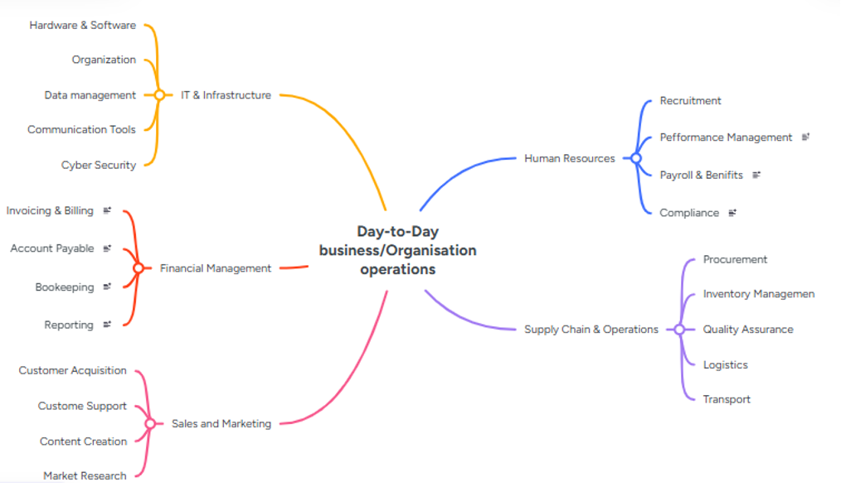

Task 3 A: Office Applications

MS WORD

The benefits of using MS Word. Ready-made templates, consistent styling and layout tools let users create high-quality reports, proposals, and letters quickly. Automated formatting ensures uniformity across all business and technical documents

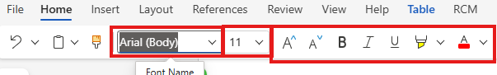

Built-in spelling/grammar check, Editor and AI powered suggestions improve clarity and reduce error. Advanced find/replace and formatting tools speed revisions, critical for documentation. Bullet points, numbering, and text alignment are also available. Along with Font names and sizing, with Bold, underline and italic controls help change the layout of the document with optional choices available.


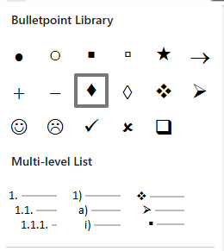

Real-time co-editing, Track changes, comments and version history simplify teamwork. Cloud saving via OneDrive enables secure access and sharing across devices eliminating version conflict-ideal for UK-based remote and hybrid teams. Creating new documents, whilst opening old ones. With easy access to print and export to moving files and renaming them.

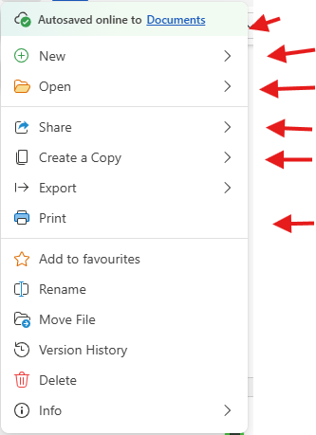

Auto-save, macros, mail merge and automatic tables of content, footnotes and bibliographies save significant time, especially for long or respective documents. Accessibility Checker ensures compliance with UK equality standards; password protection and encryption safeguard sensitive business data. [7]

( Auto-save)

MS POWERPOINT

Microsoft PowerPoint is a widely used presentation program developed by Microsoft, part of the Microsoft Office suite. First launched in 1987, it empowers uses to create polished, slide-based presentations for education business and personal use. Its core features is a slide deck framework, where users add and arrange content across individual slides, It supports interesting text, images, charts, tables, audios, video and shapes, plus built-in templates, themes and design tools to ensure visual consistency and save time. Advanced functions include animations, slide transitions, speaker notes and tied rehearsals to enhance delivery. PowerPoint integrates seamlessly with other Office apps like Excel and Word and files can be shared, presented live online or exported as PDFs or videos. Accessibility features such as alt text and screen-reader support ensure inclusive use. Available on Windows, macOS, mobile devices and the web, it remains the global standard for clear, engaging visual communication.

This article presents a summary of some of the research that has been done using PowerPoint with individuals who have disabilities to promote computer access, reading decoding, and social communication skills. Several examples of PowerPoint presentations that can be created for use in teaching students with disabilities are described with visual examples provided. Brief directions for using several features of PowerPoint to create instructional presentations are given. [8]

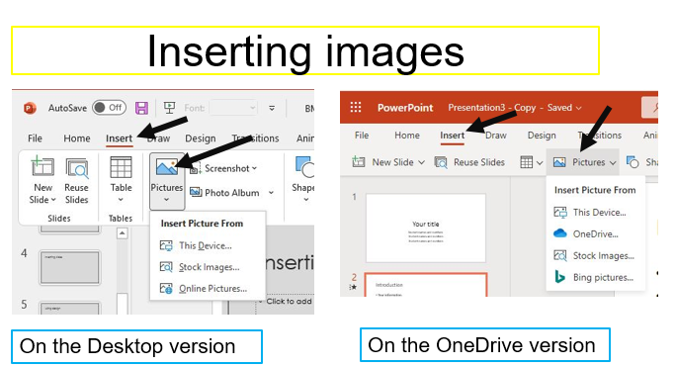
Using power point isn’t difficult, you can insert pictures, tables, drawing and designs with a click of a button. Adding new slides and designing new slides at ease. With live internet connection to add pictures and insert them to the slides. Theres also options to insert SmartArt, with bright colours and shapes available will make your slide show standout from others.

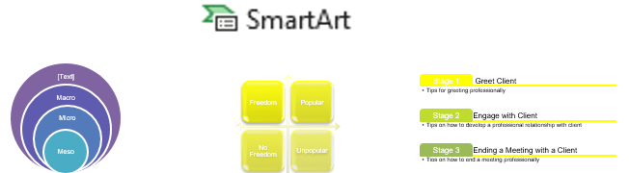

MS EXCEL

Microsoft Excel serves various educational and analytical purposes across disciplines, particularly in teaching and data analysis. It is used as a tool for teaching basic statistics by leveraging its charting capabilities and the Analysis ToolPak, which extends Excel’s functionality to include data analysis tools typically found in specialized statistical software. This integration allows instructors to guide students through statistical procedures within a familiar spreadsheet environment, offering an alternative to packages like SPSS or SAS/STAT. [9]

MS Excel is a spreadsheet program used to organize, calculate, analyze, and visualize data. Ideal for personal, work, and business use. You can create workbooks, worksheets with individual tabs/sheets inside a workbook, with cells intersections of columns (A, B, C...) and row (1,2, 3...) Where you enter data. It lists a range of groups of connected cells (e.g., A1:C10).

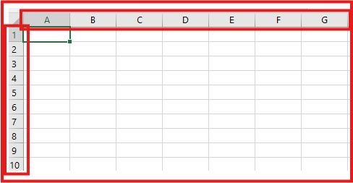

adjusted fonts, colors, borders, and alignment. You can use calculations such as formulas (=A1+A2) and built-in functions such as SUM, AVERAGE, VLOOKUP AND IF. Organizing & sorting, using filter, sort, remove duplicates and freeze panes. Analyzing, using tables, conditional formatting, PivotTables and What –If Analysis. Visualize data turned into charts/graphs (bar, line, pie, etc.). We can share and collaborate by saving cloud (OneDrive/SharePoint) co-editing in real time. Basic users can enter and format data with text, numbers, dates, currency;

MS ACCESS

Microsoft Access offers several benefits in managing and delivering data across various applications. One key advantage is its ability to centralize data management and maintenance, which streamlines administration and allows for customized content delivery. This is particularly useful in environments with multiple simultaneous users, as it improves response times compared to static HTML sites. The use of relational tables within Access supports efficient database organization, facilitating dynamic content delivery and management. [10]

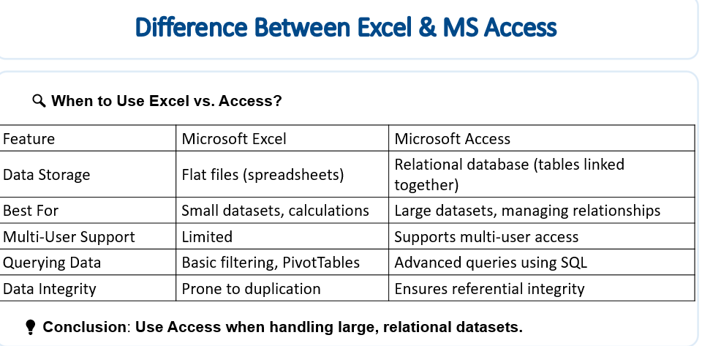
In educational and business intelligence contexts, Microsoft Access supports the construction of realistic data warehouses by handling large fact tables, which can be iteratively developed and imported. This enables meaningful queries and cross-tab analyses, such as pivot tables, without requiring advanced SQL knowledge. Access’s Query by Example feature simplifies query creation, making it accessible for users with varying programming skills. Additionally, it allows experimentation with indexing techniques, which can enhance database performance [11]

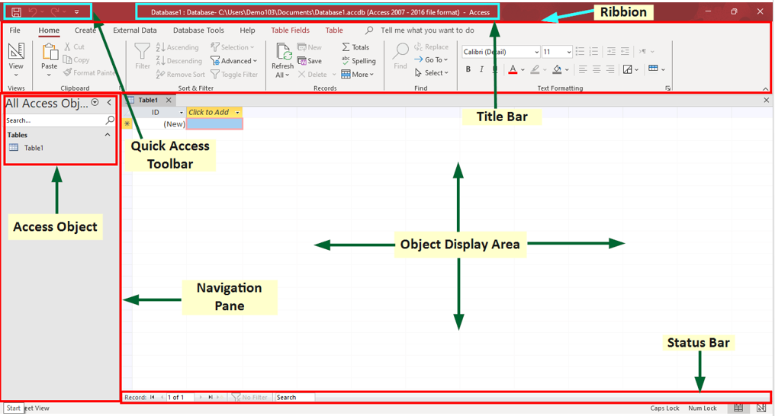

- The navigation pane lists database objects such as tables, queries, forms, and reports.
- Ribbon contains commands for managing and editing database objects.
- Tables are where we store all raw data.
- Forms are used for easier data entry.
- Reports summarize and present data professionally.
- Queries retrieve and manipulate data.

Task 3 B: Practical Testing

IF Function

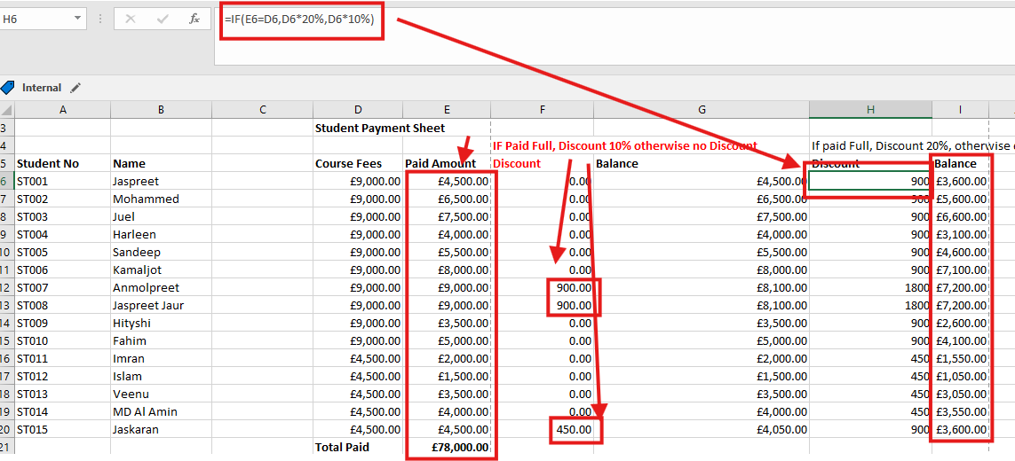
The picture above demonstrates the IF formula that works out 20% discount if the course is paid in full. Also, it calculates the paid amounts. A perfect example of how we can make the most of Excel using formula to help our everyday lives at a click of a button.

Pivot Table

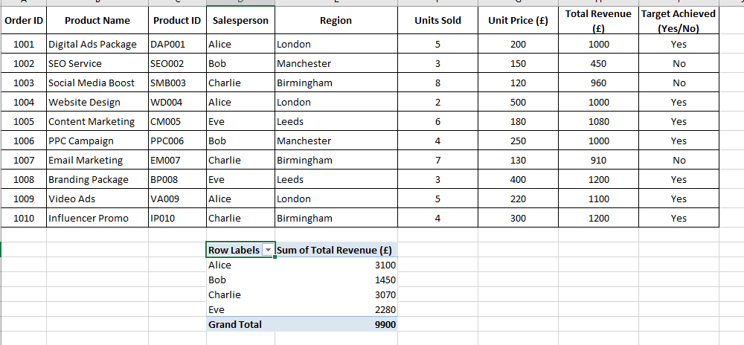

The above shows how we can use a Pivot table to automatically summarize groups and analyse large datasets without writing formulars. It instantly extracts totals, averages, or counts from raw data and allows you to “slice and dice” metrics by simply dragging and dropping different categories.

Task 4 A: Communication and Collaboration

Microsoft 365 Copilot integrated within Outlook offers functionalities specifically designed to assist with email summarization. It can generate summaries of emails and email threads, which is particularly useful for lengthy conversations involving multiple recipients and numerous back-and-forth messages. This feature helps users quickly grasp the main points without needing to read the entire thread. Additionally, Copilot can assist in managing escalations and provide coaching on the tone and content of emails after they have been drafted, enhancing communication effectiveness within Outlook. [12]

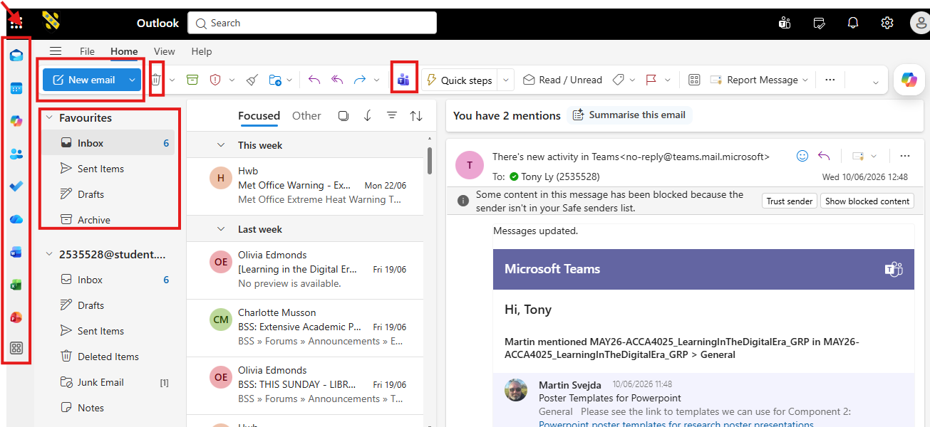
The Outlook tool has many features, such as adding files from other Microsoft tools and sharing them, you could add a file from Excel or PowerPoint with ease. You can insert a link into your email or an attachment. This makes online communication easy and simple to use. There are options to make a favourites listing, where you can list your Inbox, Sent, Deleted and Drafts together. You can also link to Teams at a click of a button. Making new emails have now been made easier for anyone to use.

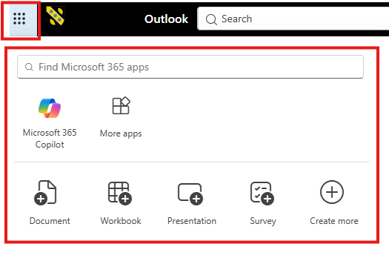Microsoft SharePoint offers several benefits that support organizational efficiency and collaboration. It functions as a content management system that facilitates the provision and management of information to users, enabling companies to reduce costs and increase operational efficiency through automated workflows. These workflows are logical, step-by-step processes that help streamline document handling and related tasks, thereby saving time and resources [13]

Task 4 B: Feature Testing

Testing this feature below, shows how we can add people to an email by clicking the To option> By selecting Bcc, you can attach other people to the email who are not visible to other. By selecting Cc, this will make it visible to others. This is a great feature for privacy.

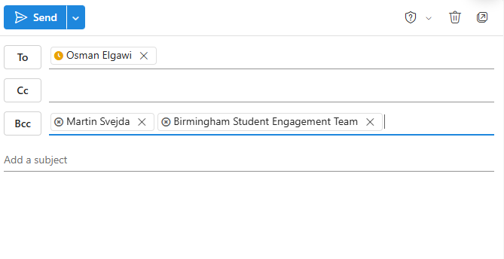
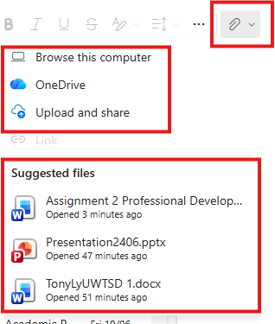

There are further options available where you can add a signature to the email. This identifies us in a professional manner. We can also add attachments from OneDrive or Upload and share documents from our computer. A suggested file option will also pop up and show the previous files we could send.

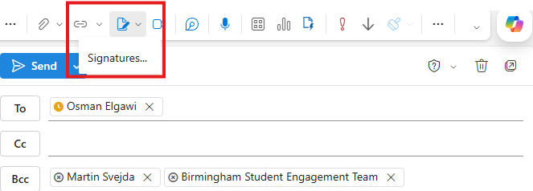
One practical approach to attaching files in Outlook is demonstrated in instructional materials for Outlook 2016, which show how to attach or embed files directly into an email. This includes selecting files from the file explorer or other storage locations and adding them to the message before sending. [14]

References

- Style Factory, “Best Ecommerce Platforms (2026) - Top Online Store Builders Compared,” Style Factory, Mar. 3, 2026 [online]. Available: https://www.stylefactoryproductions.com/blog/best-ecommerce-platforms-compared. [ Accessed: May 16, 2026].
- Futuremerce, “Top 5 Ecommerce Platforms Compared (with Pros, Cons & Use Cases),” Futuremerce, Sep. 19, 2025. [online]. Available: https://www.futuremerce.com/guides/shopify-vs-other-platforms/best-ecommerce-platform-comparison/. [Accessed: May 16, 2026].
- Wix, “10 best eCommerce website builders to get your online business up and running,” Wix, July, 2025. [Online]. Available: https://www.wix.com/blog/best-ecommerce-website-builders. [Accessed: May 16, 2026].
- Buzan, Tony and Barry Buzan, The Mindmap Book. (London:BBC Books 1995. http://www.edu.au/students/academic-skills/study-skills/note-taking. (Accessed: June 06, 2026).
- J. Chen, “The using of mind map in concept design”. 2008 9th international conference on Computing-Aided industrial Design and Conceptual Design, pp, 1-4, 2008 doi:10.1109/CAIDCD.2008.4730739.
- M.Abdeen, et al. “ Direct automatic generation of mind maps from text with M2Gen,” 2009 Toronto International Conference Science and Technology for Humanity (TIC-STH) 2009, pp. 346-351, doi:1109/Tic-STH.2009.5444360.
- A. Smith and R. Davies, “Optimising Business Document Workflows Using Microsoft Word 365” 2022 8th International Conference on Cloud Computing and Internet of Things (CCIO) IEEE UK and Ireland Section, pp. 47-52, 2022 doi:10.1109/CCIOT56789.2022.9876543.
- Coleman, M. B. “PowerPoint” Is Not Just for Business Presentations and College Lectures: Using “PowerPoint” to Enhance Instruction for Students with Disabilities. Teaching Exceptional Children Plus, 6(1), 2009.
- Warner, C. B., & Meehan, A. M. Microsoft ExcelTM as a Tool for Teaching Basic Statistics. Teaching of Psychology, 28(4), 295–298, 2001. https://doi.org/10.1207/S15328023TOP2804_11
- Davidson, B. H. Database driven, dynamic content delivery: providing and managing access to online resources using Microsoft Access and Active Server Pages. OCLC Systems & Services, 17(1), 34–42, 2001. https://doi.org/10.1108/10650750110383596
- Davidson, B. H. Database driven, dynamic content delivery: providing and managing access to online resources using Microsoft Access and Active Server Pages. OCLC Systems & Services, 17(1), 34–42, 2001. https://doi.org/10.1108/10650750110383596
- Sanford, J., Van Laan, S., Matfess, J., & Flock, T.. Microsoft Outlook. In Microsoft 365 Copilot At Work ‐ Using AI to Get the Most from Your Business Data and Favorite Apps (pp. 119–131), John Wiley & Sons, Inc, 2025. https://doi.org/10.1002/9781394319756.ch7
- Căruţasu, G., & Pîrnău, M. ROLE AND EFFECTIVENESS OF WORKFLOWS IN SHAREPOINT. Journal of Information Systems & Operations Management, 9–19, 2018.
- Outlook 2016 for dummies course. Sending files and photos in Outlook 2016. [Video recording]. John Wiley & Sons, 2015.

