Networks and Cyber Security Essentials

  - Synthesize a solution to a potential real-life scenario.


Software Engineering

Kayleigh Davies
Student Number: 2316137
Contents
Synthesize a solution to a potential real-life scenario 3
1. Introduction 3
2. Identification of Cyber Threats and Trends 3
3. Security Policies and Procedures 4
4. Mitigation Measures 4
5. Monitoring and Responses 5
7. Conclusion 6
8. References 7
9. Appendices 7

Synthesize a solution to a potential real-life scenario
Kayleigh Davies
Student University of Wales Trinity St David, Swansea, Wales
2316137@student.uwtsd.ac.uk

Abstract: This report focuses on identifying the cyber threats and trends affecting FinSecure Ltd (FSL) and recommends a refined approach for improving cybersecurity for this organization. It focuses on creating and implementing appropriate security policies, mitigation techniques, and monitoring methods that lower the risks triggered by phishing attacks, unauthorized access, and internal vulnerabilities. Recommendations for FSL’s cybersecurity strategies include adopting international standards and frameworks, including the General Data Protection Regulations (GDPR), the NIST Cybersecurity Framework, and ISO 27001. Analysing internal and external threats, the report recognizes key weaknesses in current access controls, training programs, and incident response procedures. A revised set of security policies and employee awareness programs are recommended to enhance resilience and reduce the company’s exposure to potential risks. Mitigation strategies such as better software management, access controls, phishing simulations, and routine monitoring are outlined. The report suggests that regular threat analysis and frequent training sessions is essential for FSL to maintain an effective cybersecurity framework.
Keywords – Cyber Threats and Trends, Phishing Attacks, Unauthorized Access, Confidentiality, Integrity, Accessibility Triad (CIA), General Data Protection Regulations (GDPR), National Institute of Standards and Technology (NIST)

1. Introduction
The purpose of this report is to discuss the development of security policies for FinSecure Ltd (FSL) with the aim of mitigating the risk of security incidents from both internal and external threats while improving awareness and resilience throughout the organisation.
As FSL have experienced security incidents including unauthorized access and phishing attacks they are aware of the challenges that arise from protecting the data and assets of an organisation [1].
Applying effective and reliable security measures is a critical objective for any organisation to ensure the confidentiality, integrity and availability of their data is protected and the number of security incidents are minimal [3]. Achieving this will avoid the risks of data loss, data breaches and reputational damage for FinSecure Ltd [1].
Using the information that’s available from international standards and frameworks such as ISO 27001, NIST Cybersecurity Framework, CIS Controls and GDPR will support FinSecure Ltd in creating stronger security policies allowing them to protect their data and employees from further cyberattacks.
Considering the existing access control policies, verification measures and access permissions will identify areas of vulnerabilities that will need to be addressed during this exercise along with reviewing the current training materials for the topics of phishing and social engineering attacks.

2. Identification of Cyber Threats and Trends
When relying on digital technology for managing, storing and processing sensitive data it’s important that cyber threats are identified at the earliest opportunity to ensure the correct mitigation measures, policies and procedures are in place to enhance resilience, effectively respond to cyber threats and minimise the negative impact they can have on the operations and reputation of a business.
There are several cyber threats that can affect an organisation including phishing, social engineering, ransomware, software attacks, human errors and unauthorized access. These examples can be categorized into two parts which are internal threats and external threats as shown in the diagram below [1-4].
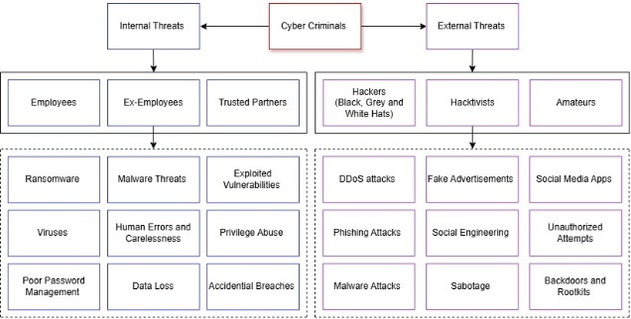
Figure 1. Internal and External Threats
Internal threats can be described as “a cybersecurity risk which stems from inside an organization to exploit systems and cause damage” [2]. Examples of the internal threats include human error and carelessness while handling data. This could be due to privilege abuse, storing information in the incorrect locations or accidentally deleting data [2].
Another common example of internal threats is employees clicking on malicious links or media displayed in phishing emails before investigating the email. As a result, employees could unintentionally download malware and viruses that could attack the entire network or cause data breaches where cybercriminals have obtained sensitive information to accessed servers and gain administrative privileges [2].
External threats are explained as outside attacks on organizations from experienced hackers with the objective of gaining unauthorized access to networks. These attacks are normally used to gather sensitive information using viruses and malware. However, they can also be used to modify existing programs using malware to destroy organisational systems and data assets [2].

3. Security Policies and Procedures
To ensure that the correct policies and procedures are in place, the function and requirements of FSL have been considered to provide the correct guidance for various aspects of the business. For example, polices for processing and handling data or working from home. The figure below lists examples of the policies that will be developed to improve the current security practises at FinSecure Ltd:
- Access Control Policy | - Data Protection and Classification Policy
- Acceptable Use Policy | - Email and Communication Policy
- Incident Response Policy | - Remote Working and Bring Your Own Device (BYOD) policy

Figure 2. Policies and Procedures
“Examining the effectiveness of current cybersecurity strategies and policies” is a key part of addressing vulnerabilities of an organisation [5]. Plus, it can identify gaps in the support available for tackling future cyberattacks. For example, are there enough cybersecurity tools and resources available to FSL, where are extra resources needed and what areas will require further prevention methods [5].

4. Mitigation Measures
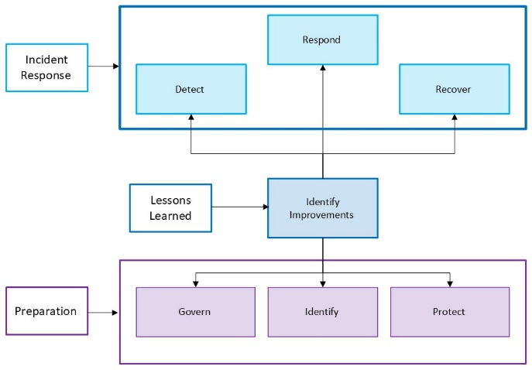
To fully understand the requirements of the mitigation measures, previous security risks and vulnerabilities will need assessed to allow FinSecure Ltd to achieve their goal of protecting data and employees from future attacks.
In the list below are examples of the new mitigation measures that will improve security across the FSL organization through “strengthening the efforts to prevent, detect and respond to cyber-attacks” [16].
- Phishing and Social Engineering
- Unauthorised Access Controls
- Software Management Schedule
- Implementation of Firewalls and Antivirus Software
- Technical and Physical Security Controls
To make certain that the mitigation measures remain effective and successful, regular risk assessments will be conducted while carefully monitoring network traffic to identify any anomalies to help FSL understand if any security incidents have occurred and if any new trends are found [16]. Any findings from these assessments will support FSL in further developing their guidance and training materials for employees along with revising company policies and procedures where necessary.

5. Monitoring and Responses
To ensure FSL have an effective system in place for monitoring and responding to incidents, the NIST Cybersecurity Framework will be used to make sure incidents are handled efficiently [13]. This method focuses on six functions which all have vital roles when responding to incidents [14].
Figure 3. Monitoring and Responses

The first group of functions govern, identify and protect allow companies to prepare for common threats to make sure they have suitable preventive measures in place to reduce the impact. The second group of functions detect, respond and recover encourage organizations to find new threats to “manage, prioritize, contain and eradicate” cyberattacks [14].
Applying the NIST framework to future incidents will help FSL with the preparation of responses while supporting them in reducing the volume and impact of possible threats [13]. The framework can also “improve efficiency and effectiveness of detection, response and recovery times” [13]. This is because it encourages organizations to work towards continuous development in terms of monitoring and response strategies by using past experiences to understand how incident response and risk management processes can be improved.
6. Training and Awareness
Supporting employees in developing their understanding and awareness of security risks is a crucial part of protecting any organisation. Having the right tools, support and resources available will help employees understand the potential security risks involved in everyday tasks and the precautions they can take to prevent incidents like data breaches or phishing attacks [10].
Making employees aware of their responsibilities will ensure FSL are compliant with security regulations and will promoting security awareness throughout the organisation. To achieve this, new training programs will be implemented to focus on topics such as social engineering, phishing, ransomware, password management, two factor authentication, software management, working remotely and safe internet habits.
To support FSL in meeting their goal of improving security awareness, there will be mandatory training for all staff to complete during the onboarding process to evaluate the knowledge and awareness of employees. This mandatory training must be completed again every 6 to 12 months to ensure employees are aware of changes to FSL policies and procedures and the latest trends in cyberattacks. Encouraging employees to check the expiry date of their training and if they have access to new modules will support the team with this.
The company will arrange monthly meetings to share announcements, lesson learnt and new training materials/resources that are beneficial for the development of the team. Reminding staff that simple things such as wearing identification cards around the office, locking laptop screens, clearing desks of sensitive information and keeping software and operating systems up to date with the latest versions are all examples of security precautions [4].
To assess the knowledge and awareness of the team, FSL will use phishing simulations and questionnaires to better understand where improvements are needed for our cyber security training programs.

7. Conclusion
Throughout this report, the cyber threats that target FinSecure Ltd have been identified along with the essential changes that are needed to the security policies, mitigation measures, monitoring processes to create a safter working environment that has addressed previous vulnerabilities and developed suitable precautions to reduce the volume of cyber-attacks in the future.
The security training materials have been revised to ensure the right information is available to support colleagues in spreading awareness of safe security practices to prevent security incidents and identify common cyber threats attempts such as phishing and social engineering.
Regularly analysing the latest trends in cyber-attacks will allow FSL to identify potential vulnerabilities within the organisation’s systems, meaning they can plan for changes to mitigation measures while also testing the effectiveness of their monitoring and response strategies.

References
[1] A. J. Nash, “External Threats vs. Internal Threats in Cybersecurity,” ZeroFox, May 25, 2023. https://www.zerofox.com/blog/external-threats-vs-internal-threats-in-cybersecurity/ (accessed May 13, 2025).
[2] Blogs by Cyril , “Internal vs External Threats- Here’s All You Need to Know,” Secure Triad, Jun. 21, 2021. https://securetriad.io/internal-vs-external-threats/ (accessed May 13, 2025).
[3] E. Etheridge, “Cyber security measures: Secure your business with digital signatures,” Dataguard.co.uk, vol. 1, no. 1, Accessed: May 13, 2025. [Online]. Available: https://www.dataguard.co.uk/blog/what-is-a-digital-signature-and-how-it-can-secure-your-business/#which-industries-need-digital-signatures-most
[5] A. Kuzior, I. Tiutiunyk, A. Zielińska, and R. Kelemen, “Cybersecurity and cybercrime: Current trends and threats,” Journal of international studies (Kyiv), vol. 17, no. 2, pp. 220–239, 2024, doi: 10.14254/2071-8330.2024/17-2/12.
[6] M. Brho, A. Jazairy, and A. V. Glassburner, “The finance of cybersecurity: Quantitative modeling of investment decisions and net present value,” International journal of production economics, vol. 279, pp. 109448-, 2025, doi: 10.1016/j.ijpe.2024.109448.
[7] R. van der Kleij, J. M. Schraagen, B. Cadet, and H. Young, “Developing decision support for cybersecurity threat and incident managers,” Computers & security, vol. 113, pp. 102535-, 2022, doi: 10.1016/j.cose.2021.102535.
[8] W. He and Z. (Justin) Zhang, “Enterprise cybersecurity training and awareness programs: Recommendations for success,” Journal of organizational computing and electronic commerce, vol. 29, no. 4, pp. 249–257, 2019, doi: 10.1080/10919392.2019.1611528.
[9] A. Alyami, D. Sammon, K. Neville, and C. Mahony, “Critical success factors for Security Education, Training and Awareness (SETA) programme effectiveness: an empirical comparison of practitioner perspectives,” Information and computer security, vol. 32, no. 1, pp. 53–73, 2024, doi: 10.1108/ICS-08-2022-0133.
[10] CybSafe, “Security awareness: 7 reasons why security awareness training is important in 2023,” CybSafe, 2023. https://www.cybsafe.com/blog/7-reasons-why-security-awareness-training-is-important/ (accessed May 13, 2025).
[11] S. Pan, “8 Cybersecurity Topics to Include in Your Training Program | Proofpoint US,” Proofpoint, Nov. 27, 2023. https://www.proofpoint.com/us/blog/security-awareness-training/cybersecurity-topics-to-include-in-your-program (accessed May 13, 2025).
[12] F. Imam, “Top 10 security awareness training topics for your employees in 2023 and beyond | Infosec Resources,” www.infosecinstitute.com, Jul. 25, 2023. https://www.infosecinstitute.com/resources/security-awareness/top-10-security-awareness-training-topics-for-your-employees/ (accessed May 13, 2025).
[13] NIST, “Incident Response | CSRC | CSRC,” CSRC | NIST, Feb. 29, 2024. https://csrc.nist.gov/Projects/incident-response (accessed May 13, 2025).
[14] A. Nelson, “Incident Response Recommendations and Considerations for Cybersecurity Risk Management”:, Incident Response Recommendations and Considerations for Cybersecurity Risk Management A CSF 2.0 Community Profile, 2025, doi: https://doi.org/10.6028/nist.sp.800-61r3.
[15] SecurityScorecard, “8 Top Strategies for Cybersecurity Risk Mitigation in 2024,” SecurityScorecard, Jul. 12, 2021. https://securityscorecard.com/blog/8-top-strategies-for-cybersecurity-risk-mitigation/ (accessed May 13, 2025).
[16] E. Etheridge, “Cyber security measures: Secure your business with digital signatures,” Dataguard.co.uk, vol. 1, no. 1, 2024, Accessed: May 13, 2025. [Online]. Available: https://www.dataguard.co.uk/blog/what-is-a-digital-signature-and-how-it-can-secure-your-business/#which-industries-need-digital-signatures-most
[17] National Security Agency, “NSA’S Top Ten Cybersecurity Mitigation Strategies,” National Security Agency, Mar. 2018. Accessed: May 13, 2025. [Online]. Available: https://www.nsa.gov/portals/75/documents/what-we-do/cybersecurity/professional-resources/csi-nsas-top10-cybersecurity-mitigation-strategies.pdf

9. Appendices

