Student: Ionela Madalina Saiz (1605699)
Lecturer: Tushara Balendran
L’Oreal – Innovation and Marketing strategy

Marketing Management(LCMB7001)
University Trinity Saint David

Executive Summary
Marketing strategy contributes a significant impact on the ongoing process of an organisation as it helps to discover the areas that are being affected by the organisational growth. It also helps to develop effective promotional or marketing plans to cater the needs and demands of the target audience in a more effective and systematic manner. Thus, in this report discussion about the concept and effectiveness of innovative marketing strategy has been outlined by interlinking it with customer satisfaction. This report has considered one of the leading personal care companies L’Oreal in the UK to evaluate their innovative marketing strategy that allows them to interact with their customers effectively and maintain their brand equity in the UK and global market. Importance of communication in business has been outlined by considering the suitable communication model concept of Schramm Communication Model (SCM). Other than this, an explanation about Integrated Marketing Communication (IMC) has been provided in the context of aforementioned companies and their present promotional strategy has been considered. Furthermore, Keller’s Brand equity Model, Total Customer engagement model, the touch points for L’Oreal and the new promotional strategy based on competitor’s analysis has also been mentioned in this report briefly.

Table of Contents
Introduction 2
Company Background 2
Business communication 4
Communication model 6
Integrated Marketing Communication of L’Oreal 7
Present promotional strategy of L’Oreal 8
Recommendations for promotional strategy 10
New promotional strategy 10
Branding and brand equity 11
Keller’s Brand equity Model 13
Customer journey and customer touch point 15
Customer touch point utilized by L’Oreal 17
Recommendations 17
Conclusion 17
References 18

Introduction
Innovative strategies for marketing allow marketers of an organization to detect its performance and alter its ongoing strategies in such a way so that they could better cater the needs of their target customers. Thus, this report aims to provide in depth analysis about the effectiveness behind innovative marketing strategies and customer satisfaction by considering global renowned personal care company L’Oreal in the UK. Evaluation about the concept of communication in business by utilization of suitable communication models will be outlined. Other than this, integrated marketing communication, and the present promotional strategy that are being utilized by the aforementioned organization will also be determined. Other than this, competitors’ analysis, new promotional strategy, customer touch-point, and brand equity effectiveness for the selected company will also be highlighted through suitable model concepts in this report briefly.

Company Background
L’Oreal is found to be one of the leading and renowned personal multinational companies that are recognized as the largest cosmetic brands over the world. It expanded its business activities in the field of sun protection, skin care, hair care, hair colour, perjure and make-up range respectively. Having 88,000 employees, the company in 2019 was able to increase its revenue by €29.87 billion within an operating income of €5.54 billion respectively. Additionally, the company also received increased growth in their net income, total asset and total equity by €3.75 billion, €43.81 billion, and €29.42 million respectively (loreal-finance.com, 2020).
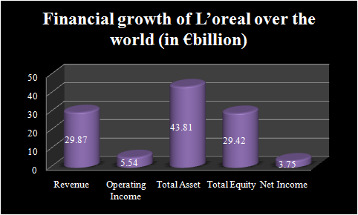
Figure 1: Financial growth of L’Oreal over the world
(Source: loreal-finance.com, 2020)
In the UK, the company has received an effective customer base with 4.8 million of women and 2.2 million of men make the popularity of the brand. In 2029, the company was able to sell 29.8 billion Euros over the world and by continuously launching new product ranges; they grab the UK cosmetic market effectively (statista.com, 2020). However, there are involved with different types of scandals, fake news and fake followers that minimize their brand reputation in the UK due to which they are trying to improve its marketing strategy through “marketing 3.0” to maintain customer satisfaction and brand equity in the UK as well as global market (Hammett, 2019).
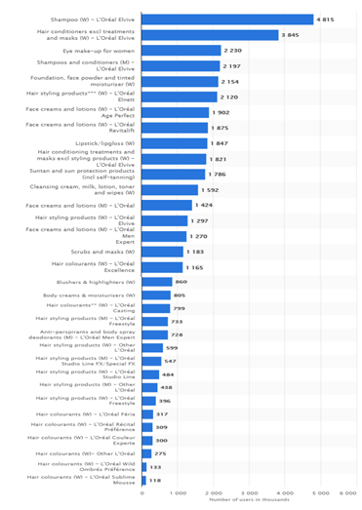
Figure 2: Number of customer’s base in UK
(Source: statista.com, 2020)

Business communication
Innovation in marketing activities allows maximizing customer’s loyalty by minimizing costs and churn of gaining attention from new customers. Customer satisfaction plays a significant role for any organisation to increase its growth and prosperity within the target market. As mentioned by Clohessy et al. (2019), keeping an effective level of communication with customers helps any business organization to boost their growth and helps them to obtain customer loyalty. In this context, the concept of VOC (Voice of Customer) can be aligned as it is also an organisation to acuminate its service and products into a particular thing that customers are willing to have as well as will continue investing time and money into that product or services.
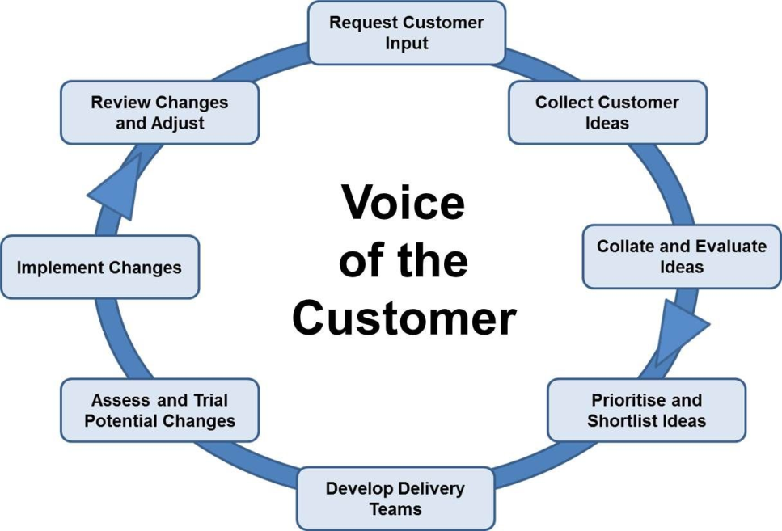
Figure 3: Voice of Customer in business
(Source: Aguwa et al. 2017)
In relation to the above figure, it can be mentioned that the voice of customers in business communication plays a significant role for understanding, capturing, and engaging internal and external stakeholders within organisational functional and operational activities. While interacting with customers there are certain aspects such as request input of customers, ideas of customers, shortlist and prioritise, and others as mentioned in the figure requires to be considered. It helps to meet the needs of the target audience and maximize the level of customer satisfaction (Aguwa et al. 2017).
In the context of L’Oreal, it is seen that the company has been struggling hard to provide customers with voice search provision. The company has incorporated Augmented Reality for their digital activities however; it did not work as much as the company anticipated and this minimizes its ROI (Return on Investment) on some digital activities (Roderick, 2017). In the context of communication issues, it is identified that are transforming customer service facilities digitally, L’Oreal has been experiencing issues like retargeting, bombardment, fake followers, fake news, lack of customer acceptance and others that minimize brand trust and attention among the target audience in the UK market (Hammett, 2019). Digital communication is considered as a pillar of the business marketing strategies. It allows monitoring and understanding the perspective and expectation of the target audience over particular products, services or brands closely (Flew, 2019). The key effectiveness of communication for maximizing customer’s satisfaction can be highlighted by considering the communication namely Schramm's Model of Communication. Thus, in the next adjoining section, the concept of the mentioned model will be outlined with the communication strategy utilized by L’Oreal to intricate within the target customers.

Communication model
The concept of Schramm Communication Model (SCM) is found to be a cyclical communication model (CCM) that involves entire basic principles considered in communication. The mentioned models offer a class explanation and approach in relation to communication. As mentioned by this model can be utilized for determining how communication, information, ideas or attitudes will be exchanged between two people (Zhai, 2017).
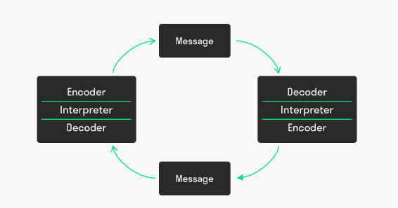
Figure 4: Schramm Communication Model (SCM) of communication
(Source: Zhai, 2017)
In relation to the above figure, it can be mentioned that the model is composed of three primary elements such as source or encoder, recipient or decoder and message respectively. In relation to this communication model concept, it can be mentioned that L’Oreal utilizes digital platforms and social media networks such as Facebook, Instagram, YouTube, Twitter and others to reach maximum number of target audience (Umeozor, 2020).
Without involving any kind of intermediaries, digital platforms serve as a message decoder for the company and social media platforms such as Facebook, Twitter, Instagram and others serve as a message encode of L’Oreal. From the annual report of L’Oreal, it is seen that the company has invested about 38% in digital platforms and they reached approximately 250 million of followers on the mentioned social network sites. Additionally, with the change in customer preference and their expectation towards obtaining animated content, they took the advantages of visual codes of Boomerangs and GIFs for creating “billboards in motion” (loreal-finance.com, 2020). In this regard, it can be mentioned that the company identified the touch point of their target customers based on which they change their communication and marketing strategies.
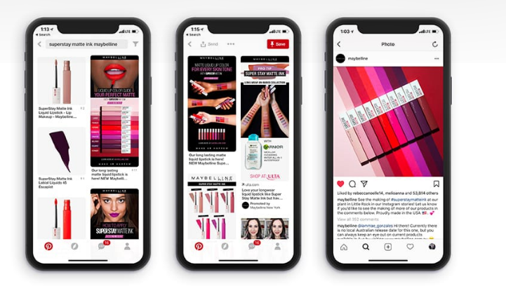
Figure 5: Presence of L’Oreal in different digital platform
(Source: loreal-finance.com, 2020)

Integrated Marketing Communication of L’Oreal
Integrated Marketing Communication or IMC is recognized as the systematic concepts under which an organisation systematically coordinates and integrates its different communication channels for delivering consistent and transparent messages (Salvation, 2018). In the context of L’Oreal, it is seen that they have successfully implemented IMC through its social media platforms such as Facebook, Instagram and YouTube. The company has a clear overview about the target audience and acknowledges their psychographic and demographics. For instance, the video uploaded by L’Oreal in social media reflects different languages and cultures. Additionally, their Viral Marketing strategy allows them to interact and communicate with their target audience in a more effective and systematic manner. This further allows them to sustain their brand loyalty and reputation in the UK as well as in the international market (Allanson, 2016).
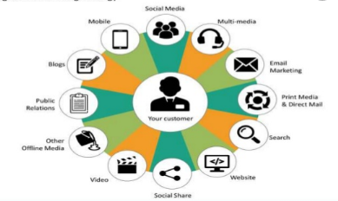
Figure 6: IMC strategy for L’Oreal
(Source: Allanson, 2016)

Present promotional strategy of L’Oreal
Online promotions
Precision marketing is found to be incorporated and followed by the brand L’Oreal. The key reasons behind following this strategy are that consumers over the world are willing to have personalized content that matches their aspirations in all beauty categories (Godey et al. 2016). Considering this marketing connote as a promotional strategy helps L’Oreal to offer personalized content towards their target audience and enables them to draw attention by sending the right message at the right time. In the context of promotional strategy, the company provides personalized email, advertisements, “product landing pages” and websites that help them to maximize consumer engagement with the brand in a significant and effective manner (loreal-finance.com, 2020). This also helps them to identify the touch point of customers and restrict the occurrence of issues in “customer’s end-to-end journey”.
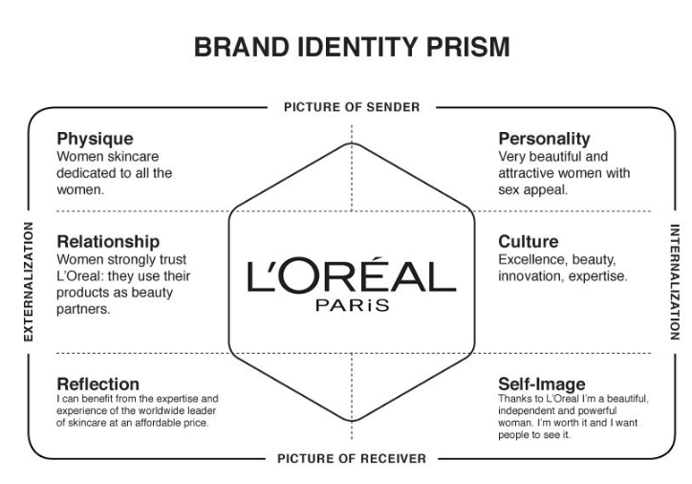
Figure 7: Brand image of L’Oreal to target customers
(Source: Godey et al. 2016)
Other than this, the company is also investing in digital promotional activities presently to reach maximum number of target audience within expected time of span. For example, in 2013, the company was allocated 15% in the media budget for digital channels and this perspective of investment is found to be increased to 30% in 2016 (forbes.com, 2020). In this context, it can be mentioned that the company adopts a strategy that matches with the social media platform along with its brands for creating and significant strategy for targeting right consumers.
For example, they have Snapchat for Maybelline and at the same time, they have a presence on WeChat to attract Chinese customers (loreal-paris.co.uk, 2020). Other than this, they also established partnerships with digital giant eBay and Amazon for expanding their ecommerce offerings. In 2017, the company launched its eBay store to provide online service facilities over the world (Roderick, 2017). This promotion strategy enables them to expand their customer base and helps them to communicate with their customers in a more effective and systematic manner. The promotional strategy can be interlinked with pull strategy of marketing as they bring their target customers instead of pushing their brand upon them. They utilize different mentioned communication channels and incorporate tactical contents to attract their customers, which helps them to sustain an effective customer base for a longer time (Au and Tucker, 2016).
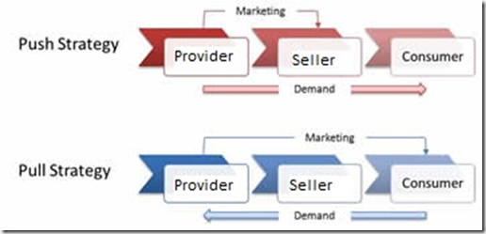
Figure 8: Pull marketing communication strategy
(Source: Au, A. and Tucker, 2016)

Recommendations for promotional strategy
Online promotion
Utilisation of social media platforms and collaborating with social media influencers can greatly benefit online promotional strategy of L'Oreal in terms of product distribution and sales. There are a large number of social media influencers who provide product reviews and these people can be greatly effective in order to promote the new launches of the organisation. furthermore having such a large number of followers they can effectively influence the potential customers in order to increase the sales.
Offline promotion
In terms of offline promotions the company can conduct events as well as sponsor other events in order to increase awareness of the new launches. Adding to that, advertisements on magazines newspapers as well as well holdings can effectively benefit the offline promotions of the company. Providing sample products to customers at different retail stores is another offline promotion strategy that the company can adopt so that customers can become familiar with the product before or without purchasing.

New promotional strategy
Based on the latest development of the company where L’Oreal was found to be entangled within false news spreading around its products and services. The new promotional Strategy would focus on a direct selling and relationship building strategy with customers ruling out the possibility of any intermediaries. The company needs to promote the security of data over the digital platforms regarding the information they collect of their customers. In the digital age, customers are greatly concerned about the personal data collected by companies and therefore this can be a remarkable way to attract the attention of the customers (Shi, 2020). Improving the data storage facility of the company and promoting it alongside their existing marketing 3.0 strategy of the organisation can be a great promotional strategy to get out of the negative image people have about the company.
Furthermore, establishing direct contact stores is another way through which the company can remove the possibility of any intermediaries indulging into the company's production services. Social media platforms upon which the company has been promoting its products also needs change in management regarding the identification of false followers and false news that has been spreading lately. The prime focus should be given to the social media platforms on which the company is active presently that is Instagram, Facebook and YouTube in order to gain an influence. Increasing the social media engagement and greatly benefit the company’s willingness to engage directly with customers (Costa and Santos, 2017). This would not only help the organisation to provide legitimate news and updates about the company's products and services but would also help in reducing the number of false information over the internet. Following these strategies is greatly going to benefit the company's awareness program as a part of the promotional strategy that would definitely benefit L'Oreal and its sales.

Branding and brand equity
Branding is referred to creating a communication line with the customers that can help in communicating between propositions and selling points of particular product or service. On the other hand, brand equity refers to the value that is generated due to the branding strategy adopted by the organisation, which can help it to be more recognisable and familiar with customers as compared to another market substitute. Therefore, the companies that sell consumer product give specific focus to branding of the products and services, as the number of substitute products in the market is much higher than any other industry (Datta et al. 2017).
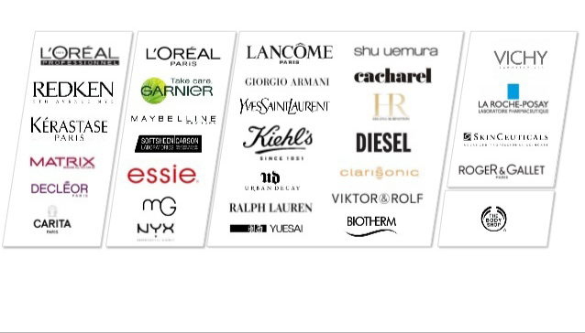
Figure 9: L’Oreal brand portfolio
(Source: irinsider.org, 2020)
In order to increase the competitiveness of the organisation in the consumer goods industry L'Oreal has divided their organisation into several brands. These brands are segmented into three major categories.

- Premium priced products
  - LANCŌME
  - Diesel
  - Biotherm
  - Ralph Lauren
- Professional range of products
  - L’Oreal Professional
  - Matrix
  - REDKEN
  - CARITA
- Consumer range products
  - L’Oreal Paris
  - Garnier
  - Maybelline
  - Essie
The idea behind segregating the organisation into several brands is to meet the demands of the customers present in different segments. This also helps your organisation to diversify their range of products and compete with major competitors in the market feeling it with a wide variety of substitutes where its own products compete against themselves (Godey et al. 2016).
The branding of the products needs to effectively improves which can help in creating a new brand equity model for the organisation’s products and services. The majority of the products that are sold by L’Oreal need to have a colour combination which customers can relate and easily identify. The designing and packaging of all the products of the company also needs to effectively follow this pattern in order to fall in line with the new brand equity model. The prime concern about creating brand equity is making the products more recognisable and popular among the customers. In order to do that the company can rebrand its products and start promotional offers where customers can get their hands on the samples of the products that L’Oreal sells.

Keller’s Brand equity Model
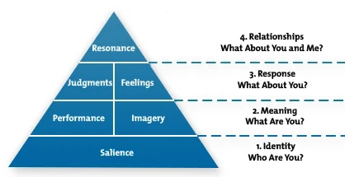
Figure 10: Keller's Brand Equity Model
(Source: Keller and Brexendorf, 2019)
Keller's brand equity model effectively reflects how an organisation successfully builds a brand image in the market. The model also distinguishes the different factors and requirements that are essential to be present in the organisation's products and services and its approach to develop a successful brand image.
To Start with, a company needs to identify themselves into the market, which is the primary requirement to build a strong brand image and reputation among the customers. L’Oreal does it very effectively by defining the products services they provide and their objectives to serve the needs of the customers. Thereafter, a performance and imagery of the organisation came, which requires to install the objectives of the products and services the company provides and how it serves the needs of the customers (Keller and Brexendorf, 2019). In order to do that L’Oreal has segregated the organisation into different brands, which serves to different needs of the customers in the market. Majority of the brands held by L’Oreal operate in different segments which cater to the different needs of the customers depending upon the requirement they possess in terms of the consumer goods and services provided by the company.
The judgement and feelings are a third step of Keller's brand equity model, which requires the response of the customers based on the products and services provided by the company. In order to do that, L’Oreal frequently conducts market surveys in order to get the feedback of the customers, which is an effective way to identify the response of the customers. The presence in social media platforms is a great way to collect the response of the customers by directly engaging with them and therefore the promotional strategies offered by L’Oreal can greatly benefit by this (Keller and Brexendorf, 2019).
The final step of building successful brand equity is reflecting upon the resonance, which directly implicates the relationship that the car company has with its customers. Building relationships with the customers is a very essential criterion in the consumer goods industry and in order to do that successfully engaging with customers is quite necessary. Before increasing social media, presence is greatly going to improve the relationship the company has with its customers by directly reaching out to them and vice versa.
Advantages
Some of the key advantages of Keller brand equity model is that it allows the company to generate a more personal relationship with the customers. As a result the brand value and brand equity of the organisation greatly increases.
Disadvantages
Among the major disadvantages of Keller’s brand equity model is increasing the customer expectation. It has often been seen that products that increases the expectations of the customers before launching but fails to meet their actual expectation and greatly reduces the reputation and also hampers customer loyalty (Datta et al. 2017).

Customer journey and customer touch point
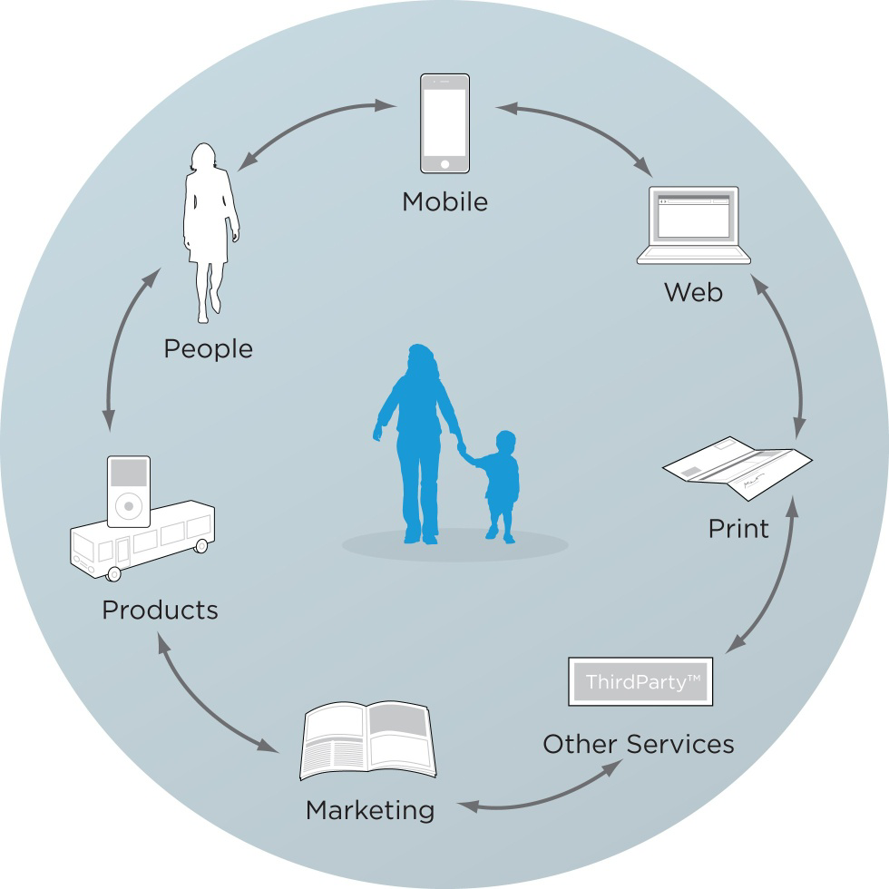
Figure 11: Customer Touch points
(Source: Bascur et al. 2018)
Customer journey refers to the study of an individual who is presently not a customer of an organisation however with evaluation comparing different products in the market mix the decision to become a customer of the company (Rosenbaum et al. 2017). Customer touch points refers to the different medium through which a customer engages with the company its products and services. Increasing the customer touch point is a very crucial factor that determines a positive customer journey for any organisation. Customer touch points friend greatly benefit in terms of problem awareness which increases the chances of sales. Therefore, organisations like L'Oreal consistently increase their touch points in order to gain positive results from a customer journey from being a prospect customer to a potential customer of the organisation. Furthermore evaluation and consideration of the consumer buying behaviour can also be influenced by increasing the number of customer touch points. Additionally the purchase decision of the customers is also dependent upon the kind and number of customer touchpoint company creates. Based on that the post purchase evaluation of the products and services can be conducted by the company. Adding to that, the customer services of the company can be improved in order to provide a better customer advocacy experience. This also benefits a lot during the post purchase stages as well as written in the number of customers in future.
Total engagement model
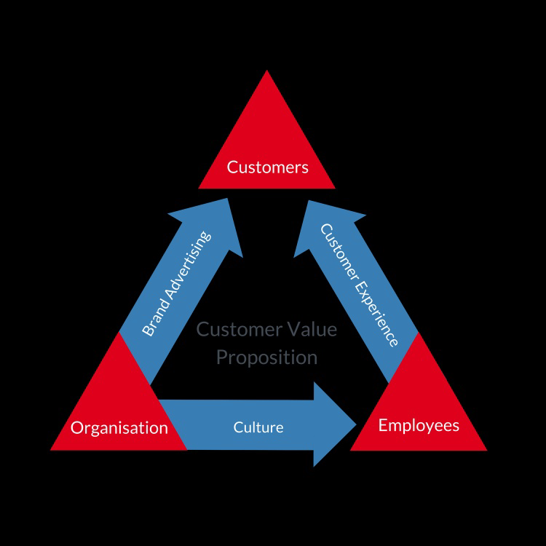
Figure 12: Total engagement model
(Source: Salau et al. 2018)
The total engagement model is a customer centric model, which prioritises the rule of the organisation in two ways. In order to increase the engagement of the customers the organisation needs to carry out brand advertisement along with that it also needs to develop the culture within the organisation to motivate employees in order to enhance customer experiences. Brand advertisement along with an enhanced customer experience is one of the major factors that increase customer engagement rates.
With the help of social media and digitalization, which the organisation presently carries out, both advertisement and customer experiences can be enhanced at the same time (Nguyen, 2019). Engaging with customers directly on social media platforms is another way of increasing engagement and marginalising the possibilities of false news, which has been hampering the company's brand image. Furthermore, the organisations advertisement campaigns are also going to get a lot more cost effective by increasing the presence of the company over social media networks and digital platforms.

Customer touch point utilized by L’Oreal
There are several touch points that are presently being utilised by L’Oreal in order to increase the engagement of the customer with the company in positively affecting the customer's journey. Some of the key touch points utilised by L’Oreal are
- Beauty salons
- Social media pre purchase and post purchase stage
- Company events
- Peer referral
- eCommerce websites
- Social media platforms
- Marketing and advertising
- Brick and mortar Stores
The majority of the marketing strategy that are adopted by the organisations are focused upon these touch points which enable the company to increase their engagement with their potential and prospect customers. Therefore the new promotional strategy of the organisation needs to specifically focus upon there are social media platforms and all the digital means through which they can communicate and engage with their customers (Roto et al. 2016).

Recommendations
- Increase the number of retail stores operated by the company
- Increasing social media presence
- Promoting different events
- Providing samples to customers at different retail stores

Conclusion
Concluding from the above analysis L'Oreal is one of the most successful consumer goods companies operating in the UK as well as in the global market. The company has been facing the opposition of false news, which has some extent affected their brand image. Based on that, the above study reflects the importance of business communication, and the way they utilize this in order to develop their promotional strategies. Furthermore, the study also discusses the development of a new promotional strategy, which can help the company to improve further their existing market 3.0 strategies. With the help of different models, the importance of brand equity for the organisation has been discussed along with ways through which the engagement with customers can be improved and enhanced. This study also discusses the different touch points that are utilised by the organisation which also play a major role in formulating their promotional strategies.

References
Aguwa, C., Olya, M.H. and Monplaisir, L., 2017. Modeling of fuzzy-based voices of customers for business decision analytics. Knowledge-Based Systems, 125, pp.136-145. Available at https://www.researchgate.net/profile/Mohammad_Hessam_Olya/publication/315977723_Modeling_of_fuzzy-based_voice_of_customer_for_business_decision_analytics/links/5a0f398faca27287ce27398e/Modeling-of-fuzzy-based-voice-of-customer-for-business-decision-analytics.pdf
Allanson, S., 2016. IMC Plan for L’Oreal Paris. Available at: https://shannonswinburneportfolio.wordpress.com/2016/05/23/imc-plan-for-loreal-paris/ [Accessed on 2 November 2020]
Au, A. and Tucker, J., 2016. Push and pull marketing strategies: A blueprint for microenterprises. Journal of Global Economics, Management and Business Research, pp.105-114. Available at: http://ikprress.org/index.php/JGEMBR/article/view/2508
Bascur, C., Rusu, C. and Quiñones, D., 2018, October. User as customer: touchpoints and journey map. In International Conference on Human Systems Engineering and Design: Future Trends and Applications (pp. 117-122). Springer, Cham. Available at: https://link.springer.com/chapter/10.1007/978-3-030-02053-8_19
Clohessy, T., Acton, T. and Morgan, L., 2019. (De) Mystifying the information and communication technology business model concept. International Journal of Networking and Virtual Organisations, 20(4), pp.377-399. Available at: https://www.academia.edu/download/54492683/Demystify_BM.pdf
Costa, R. and Santos, L., 2017. Delivery systems for cosmetics-From manufacturing to the skin of natural antioxidants. Powder technology, 322, pp.402-416. Available at: https://www.sciencedirect.com/science/article/pii/S0032591017306320
Datta, H., Ailawadi, K.L. and Van Heerde, H.J., 2017. How well does consumer-based brand equity align with sales-based brand equity and marketing-mix response?. Journal of Marketing, 81(3), pp.1-20. Available at: https://pure.uvt.nl/ws/portalfiles/portal/19561009
Flew, T., 2019. Digital communication, the crisis of trust, and the post-global. Communication Research and Practice, 5(1), pp.4-22. Available at: https://eprints.qut.edu.au/127256/2/Flew%20paper%20for%20CRP.pdf
forbes.com, 2020. L'Oreal Is Benefitting From A Higher Digital Spending. Available at: https://www.forbes.com/sites/greatspeculations/2017/02/08/loreal-is-benefitting-from-a-higher-digital-spending/?sh=39176a0e43c1 [Accessed on 2 November 2020]
Gijsenberg, M.J. and Nijs, V.R., 2019. Advertising spending patterns and competitor impact. International Journal of Research in Marketing, 36(2), pp.232-250. Available at: https://www.researchgate.net/profile/Maarten_Gijsenberg/publication/329781178_Advertising_spending_patterns_and_competitor_impact/links/5c80e495458515831f8b4171/Advertising-spending-patterns-and-competitor-impact.pdf
Godey, B., Manthiou, A., Pederzoli, D., Rokka, J., Aiello, G., Donvito, R. and Singh, R., 2016. Social media marketing efforts of luxury brands: Influence on brand equity and consumer behavior. Journal of business research, 69(12), pp.5833-5841. Available at: https://www.researchgate.net/profile/Joonas_Rokka2/publication/304493675_Social_media_marketing_efforts_of_luxury_brands_Influence_on_brand_equity_and_consumer_behavior/links/577a4ba508aec3b743356345/Social-media-marketing-efforts-of-luxury-brands-Influence-on-brand-equity-and-consumer-behavior.pdf
Godey, B., Manthiou, A., Pederzoli, D., Rokka, J., Aiello, G., Donvito, R. and Singh, R., 2016. Social media marketing efforts of luxury brands: Influence on brand equity and consumer behavior. Journal of business research, 69(12), pp.5833-5841. Available at: https://www.researchgate.net/profile/Joonas_Rokka2/publication/304493675_Social_media_marketing_efforts_of_luxury_brands_Influence_on_brand_equity_and_consumer_behavior/links/577a4ba508aec3b743356345/Social-media-marketing-efforts-of-luxury-brands-Influence-on-brand-equity-and-consumer-behavior.pdf
Hammett, E., 2019. Marketing 3.0: How L’Oréal is embracing new marketing codes. Available at: https://www.marketingweek.com/loreal-is-embracing-new-marketing-codes/ [Accessed on 2 November 2020]
irinsider.org, 2020. L'Oreal global growth strategy. Available at: https://www.irinsider.org/economics-business-1/2018/9/29/loral-global-growth-strategy [Accessed on 2 November 2020]
Keller, K.L. and Brexendorf, T.O., 2019. Measuring brand equity. In Handbuch Markenführung (pp. 1409-1439). Springer Gabler, Wiesbaden. Available at: https://link.springer.com/chapter/10.1007/978-3-658-13342-9_72
loreal-finance.com, 2020. Annual report of L'oreal 2019. Available at: https://www.loreal-finance.com/system/files/2020-03/LOREAL_2019_Annual_Report_3.pdf [Accessed on 2 November 2020]
loreal-finance.com, 2020. Digital communications: a pillar of marketing strategies. Available at: https://www.loreal-finance.com/en/annual-report-2017/digital/pillar-marketing-strategies
loreal-paris.co.uk, 2020. About Us. Available at: https://www.loreal-paris.co.uk/about-us [Accessed on 2 November 2020]
Nguyen, X.T., 2019. Factors impacting on Korean consumer goods purchase decision of Vietnam's generation Z. The Journal of Distribution Science, 17(10), pp.61-71. Available at: https://www.koreascience.or.kr/article/JAKO201915658235101.pdf
Roderick, L., 2017. L’Oréal prioritises voice search as AR struggles to ‘ramp up’. Available at: https://www.marketingweek.com/loreal-prioritises-voice-search/ [Accessed on 2 November 2020]
Rosenbaum, M.S., Otalora, M.L. and Ramírez, G.C., 2017. How to create a realistic customer journey map. Business Horizons, 60(1), pp.143-150. Available at: https://isidl.com/wp-content/uploads/2017/08/E4735-ISIDL.pdf
Roto, V., Väätäjä, H., Law, E. and Powers, R., 2016, October. Experience design for multiple customer touchpoints. In Proceedings of the 9th Nordic conference on human-computer interaction (pp. 1-3). Available at: https://www.academia.edu/download/60313093/Experience_Design_for_Multiple_Customer_Touchpoints20190816-3671-vidtkl.pdf
Salau, O., Oludayo, O., Falola, H., Olokundun, M., Ibidunni, S. and Atolagbe, T., 2018. Integrated datasets on transformational leadership attributes and employee engagement: The moderating role of job satisfaction in the Fast Moving Consumer Goods (FMCG) industry. Data in brief, 19, pp.2329-2335. Available at: https://www.sciencedirect.com/science/article/pii/S2352340918306838
Salvation, M.D., 2018. The relationship between product match-up in advertisement and consumers' purchase intention of personal care products. Computational Methods in Social Sciences, 6(1), pp.55-64. Available at: http://cmss.univnt.ro/wp-content/uploads/vol/split/vol_VI_issue_1/CMSS_vol_VI_issue_1_art.005.pdf
Shi, Z., 2020. Research on College Students' Cosmetics Consumer Market and Marketing Strategy. Revista Argentina de Clínica Psicológica, 29(4), p.613. Available at: https://revistaclinicapsicologica.com/data-cms/articles/20200928103524pmSSCI-161.pdf
statista.com, 2020. L'Oréal products ranked by number of users in Great Britain in 2019 (in 1,000s)*. Available at: https://www.statista.com/statistics/312587/l-oreal-leading-products-in-the-uk/ [Accessed on 2 November 2020]
Umeozor, S.N., 2020. Information Retrieval: A Communication Process in the 21st Century Library. International Journal of Knowledge Content Development & Technology, 10(2), pp.7-18. Available at: http://www.ijkcdt.net/xml/22689/22689.pdf
Zhai, M., 2017. The Generation Mechanism of Internet Rumors—Based on Consideration of Information Philosophy. Multidisciplinary Digital Publishing Institute Proceedings, 1(3), p.114. Available at: https://www.mdpi.com/2504-3900/1/3/114

