The Impact of Product Recalls on Businesses and Projects

Lecturer: Phil Holden

Module Title:
Mechanism of Materials Failure

Module Code: ACEA7010
Programme: MSc Motorsport Engineering

Name: Charles T Randall
Student Number: 1922822

Table of Contents
Introduction 1
The Component 1
Historical Design Factors 2
Current Issues 3
Engineering Principles 5
Mechanical Properties 5
Fatigue 5
Fast Fracture 6
Creep 6
Surface Finish 7
Product Recall & Manufacturing Process 8
Recall Instances 8
Manufacturing Process 8
Bearing Testing 10
Hydraulic Loading Fatigue Testing 10
Dynamic Loading Fatigue Test 11
Conclusion 12
Bibliography 13

Introduction

Component analysis has become a critical and essential method of practise in product improvement. To ensure the advancement of critical components, many material failure practices are used, such as modifications to the design to reduce the concentration of stress points, surface coatings with low friction properties which can be applied in numerous ways, even changing the main material to provide better material characteristics for the intended use. Therefore, for the purpose of this report, the writer will choose a critical component to evaluate. Historical developments of the component will be considered as well as the engineering principles used for the selection of the materials, coatings, fatigue properties and wear properties.

The Component

For this report, the component chosen to evaluate is a crankshaft bearing. The purpose for these bearings is to provide a low friction surface between the rotating parts of the engine. Specifically, the crank case and the crank shaft. (Know Your Parts, 2021) As these parts of the engine rotate with tremendous speed and have to deal with the result of multiple controlled explosions from the combustion chamber above, which cause huge amounts of force and stress on the components, the material for the bearing should be exceptionally strong. (Know Your Parts, 2021)

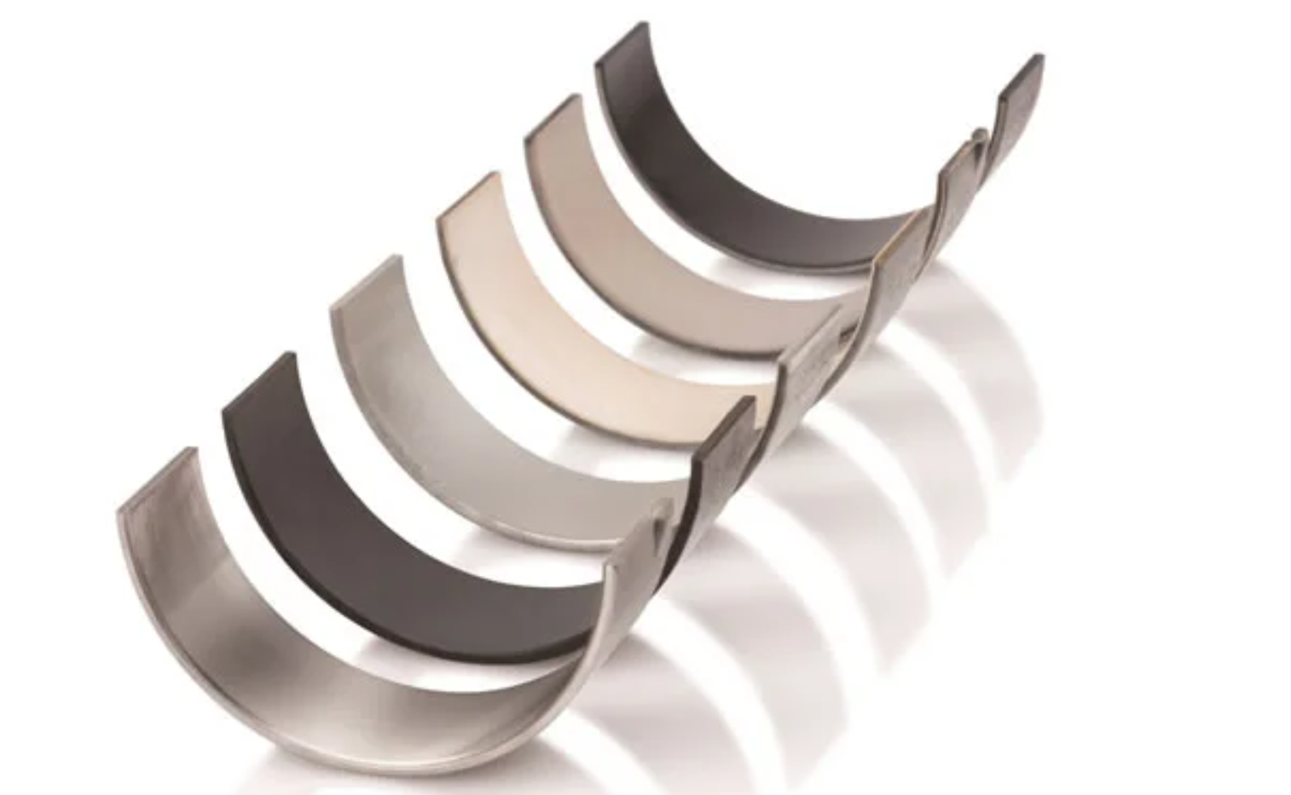
Figure 1 - Big end bearings, (ENGINE PARTS (UK) LTD, 2021)

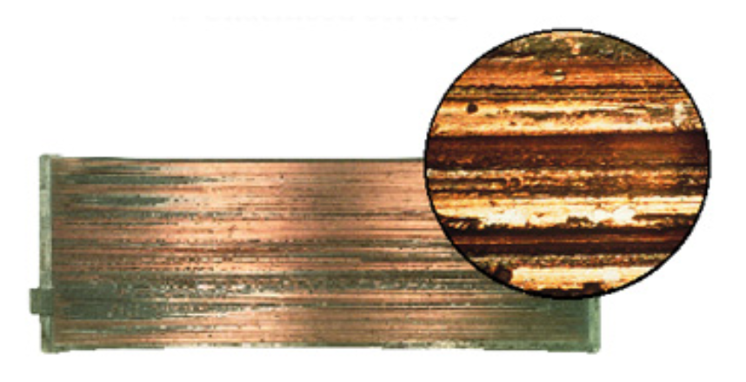
Figure 2 - Worn Bearing Example, (Know Your Parts, 2021)

It can be said that sliding two similar metals against each other will have more friction compared to two metals with dissimilar properties. A good example of this is shown in Kuznetsoz’s book, “Metal Transfer and Build-up in Friction and Cutting”. Kuznetsoz explains that when a slider made of platinum slides over a surface of silver, the coefficients of friction is initially low, around 0.5. However, once the slider shifts a little distance, the two metals begin to act as metals with similar properties and the coefficient of friction increases to around 1.3. once this phenomenon was analysed, the analysts found that some silver was essentially welded to the platinum surface, therefore the process was more similar to a silver surface rubbing on another silver surface. (Kuznetsoz, 2013) However, Kuznetsoz goes on to say that different results were obtained when sliding a steel surface over another steel surface. The results were expected to be similar to the results from the silver sliders, they were not. This is due to how homogenous the metal or alloy is. He found that when metals, particularly harder metals, have very similar characteristics, for example cast iron. The coefficient of friction can be as low as 0.3 and any damage from sliding the surfaces over each other is small. Kuznetsoz states that if two metals are extremely homogenous, say austenitic stainless steel or iron with high purity, a “torn track” is achieved and increases the coefficient of friction to around 1-1.5. (Kuznetsoz, 2013)

Historical Design Factors

Unfortunately, when looking back in history, engineers often see the crank bearings as a secondary design process. This is due to the fact that the main focus of the engine design engineers was the combustion chamber, making power while attempting to not compromise engine efficiency was mostly important. (DeHart & Harwick, 1984) This essentially caused the bearings to take more damage than was necessary due to the lack of design development, causing them to be one of the most compromised parts of an engine.
A bearing shell named AISI M-50 was created in the 1950s for use in fast rotating aerospace engines. It cosisted of 0.8% carbon, 4% chromum, 0.1% nickel, 0.25% manganese, 0.25% silicone and 4.25% molybdenum. It was made due to its characteristics of operating at high temperatures, up to 315 degrees. This was primarily due to its high carbon content steel, where previous bearings were not up to the task. The fatigue life was much greater than earlier bearings made of steel, although AISI M-50 was better than previous bearings, the demand from high operating temperatures and large centrefugal forces still caused fractures and cracks. (Harnoy, 2002) To obtain a bearing that was better suited for high temperatures and forces, much research was completed, this led to the development of the alloy case-hardened M50NiL steel bearing which had much better fatigue properties while having a less brittle structure due to a softer inner core as well as having tougher fracture resistance and higher operating temperatures. This led to M50NiL slowly replacing the use of the previous AISI M-50 bearing. M50NiL consisted of 0.15% carbon, 4% chromium, 3.5% nickel, 0.15% manganese, 1% vanadium and 4% molybdenum. (Harnoy, 2002) It can be seen that M50NiL has a lower carbon content when compared to AISI M-50. This meant M50NiL required a process called carburizing to increase the surface hardness, where the metal is heated to a high temperature in the prescence of carbon to harden the surface. With this, and having a more vanadium and nickel content, in comparison to AISI M-50 allowed for increased hardness at high temperatures and formed hard carbides spread evenly on the surface which reduced wear and fatigue cracks. Evidently this increased the fatigue factor by two. (Harnoy, 2002)

The automotive industry utilized the developments from the aerospace sector and began to move away from cast iron or steel bearings in engines, and used alloy bearings instead. This does not mean the current bearings used do not have issues. Many factors contribute to bearing failure in an engine, some of which are listed below.

Current Issues

- Debris and dirt
The damage caused to a bearing shell from debris can be substantial. The usual culprit for this can be something as simple as not servicing the engine oil at the proper intervals, which can cause sludge or carbon build up, which can get stuck in the bearing surface. Another reason could be a dirty air filter letting dust, for example, pass through into the combustion chamber, making its way into the crank area, mixing in with the oil, then eventually getting stuck in the bearing oil channel, slowly wearing away at the bearing surface. (Chenevey, 2021) Figure 3 shows an example of a bearing shell with fine surface scratches.

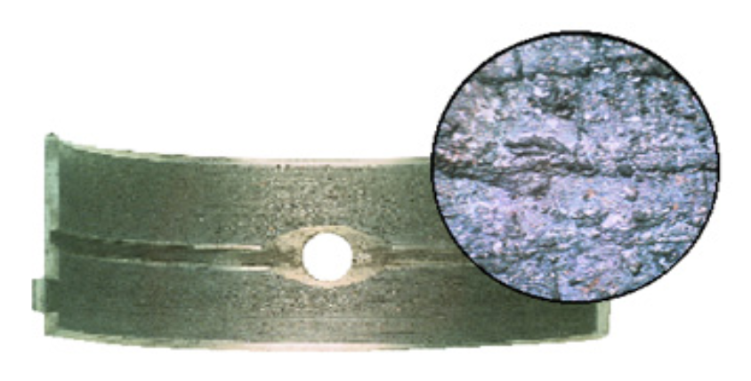
Figure 3 - Fine scratches on bearing surface, (Know Your Parts, 2021)

- Lubrication starvation
Starving an engine of lubricant (oil) is possibly the worst issue an engine can encounter. Every moving part of an engine ether moves or rotates at tremedous speed, which then get hot due to friction. It should be clear that sufficient oil is essential for a engine to operate smoothly, due to its lubricating and cooling effects. Oil starvation can happen for a couple of reasons. It could be lack of care, again ignoring the service intervals and allowin the oil to collect so many deposits it turns into sludge, therefore thickening in the sump and other cavities in the engine. It could be that the engine is burning oil due to a tired head gasket, there could be a leak, or it coud simply be there is a kink in an oil line causing starvation to only some parts of the engine. No matter what the cause of oil starvation is, the result will be the same if left long enough, complete engine failure. More commonly known as engine seize. Nowadays, where modern cars come equiped with turbo chargers, which spool up to speeds of 240,000 rpm and reach temperatures of around 1000 degrees celcius, having the correct amount of oil is absolutely essential to prevent turbo shaft scoring. (BTN Turbo, 2018) An example of a crank bearing and turbo failure after oil starvation is shown in figures 4 and 5.
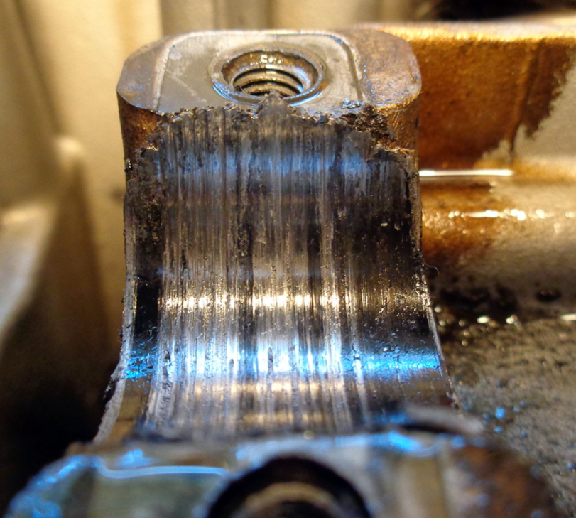
Figure 4 - Crank bearing after oil starvation, (Fernie, 2016)

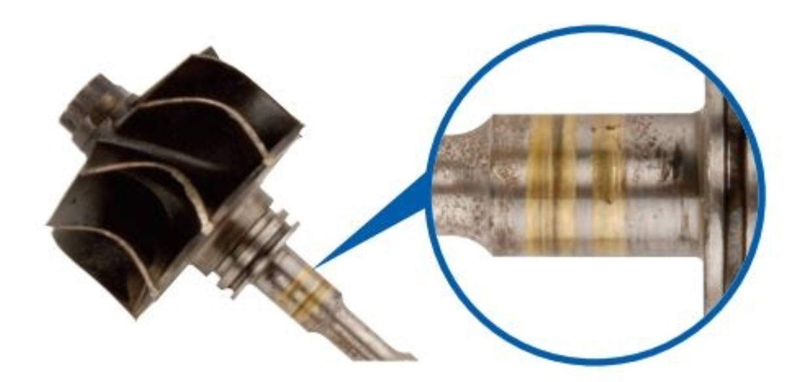
Figure 5 - Turbo shaft after oil starvation, (Darkside Developments, 2021)

- Improper Instalation
Improper instalation of the crank bearing shells can once more, cause oil starvation. This can happen for example, if the half of the bearing without a oil feed hole in installed in the position where there should be a oil feed hole. This would starve that journal of oil, causing excessive wear and big increases in temperature local to that journal. This would quickly become a major issue with big expense, causing premeture failure of the bearing. (MAHLE, 2021) Examples of this are shown below in figure 6.

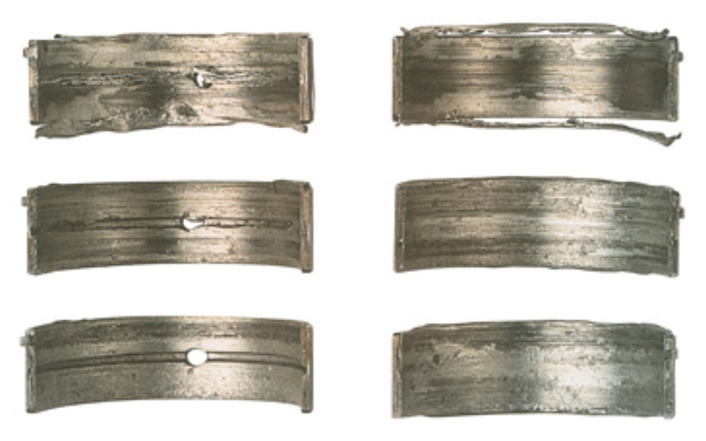
Figure 6 - Bearing Failure as a Result of Improper Installation, (MAHLE, 2021)

Engineering Principles

Mechanical Properties

For a crankshaft bearing shell, there are many mechanical properties which are vital for a long-lasting bearing, which should last the life of the vehicle as long as other factors such as servicing at the correct mileage or time intervals. These are listed below.
  - High mechanical strength, to help with fatigue and load forces
  - Respectable resistance to corrosion, not excluding cavitation
  - Relatively low coefficient of friction, with lubrication
  - Relatively high conductivity of heat, with reasonable thermal expansion properties
(Krzymien, 2004)

Fatigue

As the crankshaft bearing need to withstand huge loads which evidently come hand in hand with high forces. Bearing material fatigue is commonly known as the second reason of bearing failure, with metal-to-metal contact generally known as the main reason. Fatigue usually presents itself as cracks along the surface of the bearing, which then increase in size and spread into the linings, eventually reaching the steel back. This ultimately leads to parts of the bearing lining flaking off, causing too much clearance between the crankshaft and engine block, resulting in engine failure. (MAHLE, 2021)

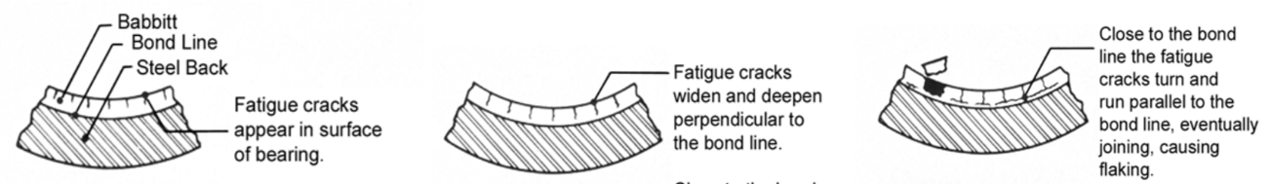
Figure 7 - Example of Fatigue Fractures on Crankshaft Bearing, (MAHLE, 2021)

There are a number of possible causes for fatigue cracks, generally they are due to four reasons.
  - Overloading forces from over fuelling or pre-detonation
  - Misaligned crankshaft causing uneven loading
  - Inadequate bearing materials for the application
  - Similar to point 3, life span of bearing is exceeded from surface fatigue
(MAHLE, 2021)

Fast Fracture

Fast fracture in the instance of crankshaft bearing would be very similar to the section above (See Fatigue Cracks). However fast fracture can also occur from the manufacturing process used to create the part. If fast fracture does occur in this instance, the bearing would become unstable under applied loads causing the bearing to fail. (Gall, 2009) Nowadays, the resistance the material has to fast fracture is measured by means of fracture toughness (the critical stress factor or ability of the material to resist fractures), it is used to quantitatively foretell the tolerances of the material, for maximum loading and crack sizing. (Chua & Yeong, 2017)

Creep

Creep is when a clearance between two fitting surfaces happens due to the phenomenon of slippage. The result is usually surface scoring, or the material may have a shiny appearance with signs of wear. This is common in crankshaft bearings but if often seen as general wear. (NSK, 2021) The main reason creep usually occurs in bearings is due to fitting a shell with a loose tolerance between the bearing and crankshaft. This can be counteracted by checking tolerances properly, studying the crankshaft to see if there is excessive wear, or simply applying a film of oil/lubricant to the fitting surfaces during assembly. (NSK, 2021)

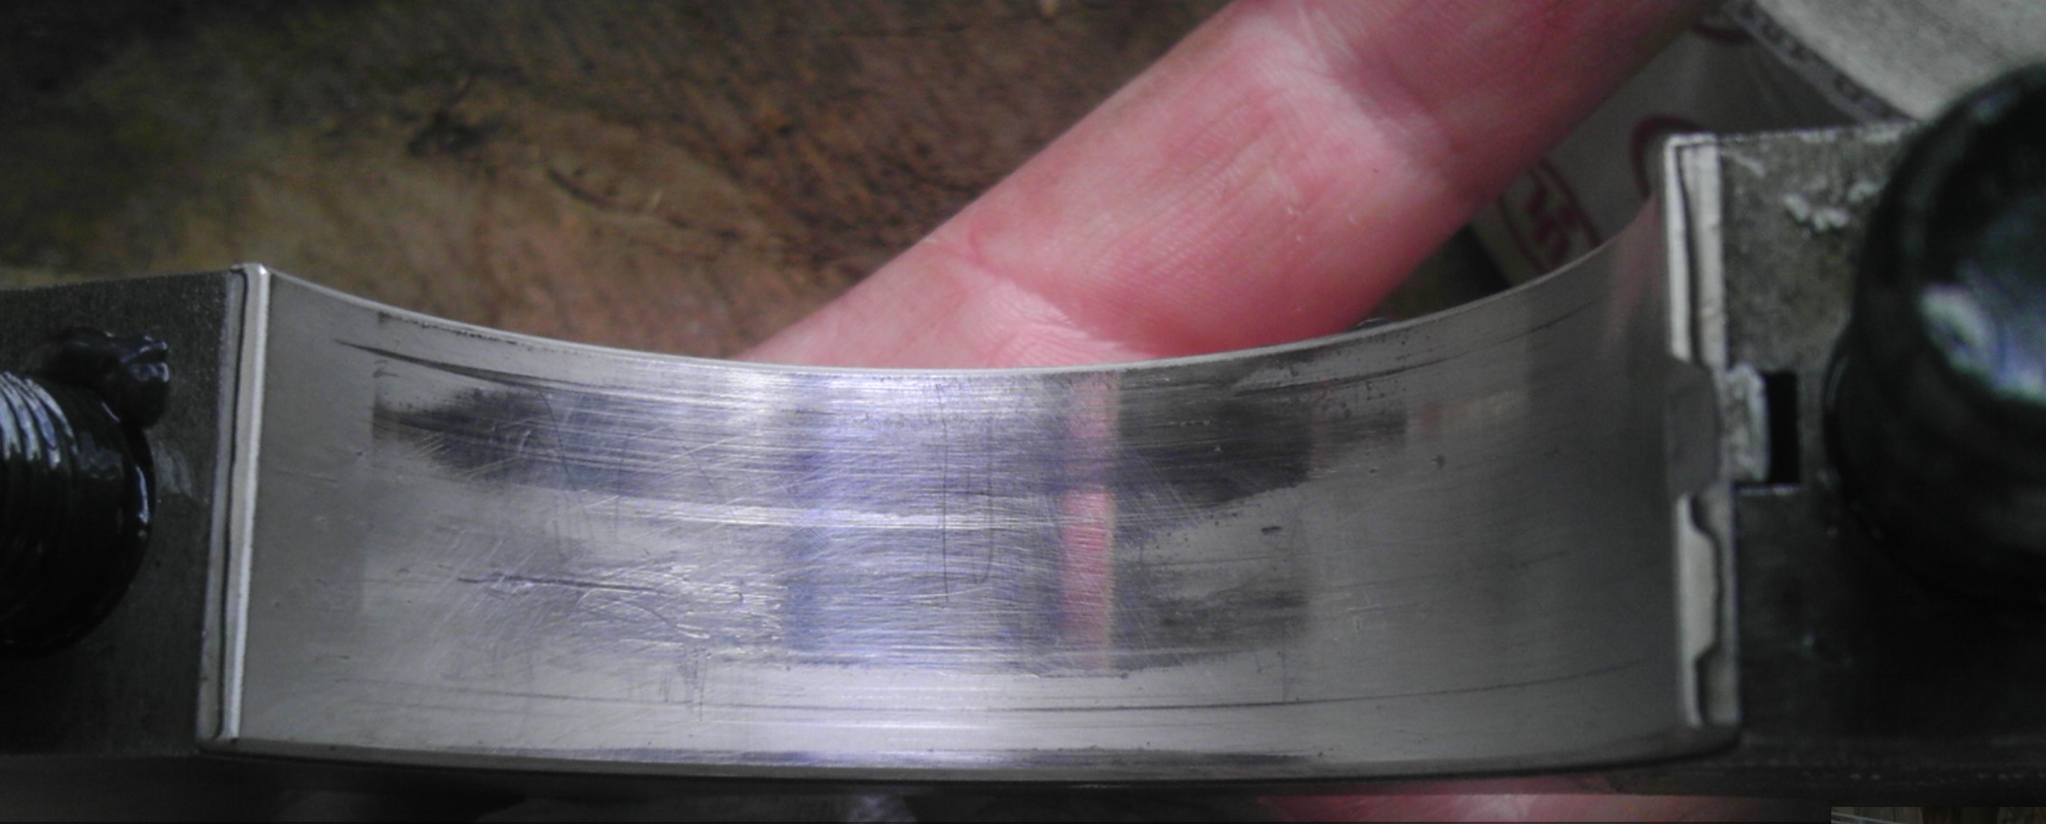
Figure 8 - Example of bearing with shiny surface caused by creep, (Hot Rodders, 2016)

Surface Finish

Before mentioning the surface finish of the bearing shell itself, it is important understand that the crankshaft bearings operate in a hydrodynamic manor of lubrication, which means there is a separation between the crank journal and the bearing due to pressurised oil, produced from the rotating crank shaft. This separation can be as small as 1/100th of a human hair, or 0.00002” which supports the importance of keeping the surface quality and fitment tolerances of the bearing and crank journal as accurate as possible. (kopeliovich D. , 2020)
Looking at the sections above, it is obvious to see that bearings do suffer with wear and tear. One of the ways automotive manufacturers and engineers have overcome some of the limitations of wear is to implement the use of surface coatings. Without going into too much depth of the many coatings that are used, the focus will be on Calico’s CT-1 Dry Film Lubricant coating. This coating is applied by spraying process and requires surface preparations by different methods which are appropriate for the bearing surface, depending on the materials used. The coating is typically applied for a thickness between 6-7.5 microns. The benefits of using this coating on the bearing surface is that it reduces friction, which in turn reduces wear, prolonging the life of the bearing. Another benefit of this coating is that it has resistance to debris (dirt and dust) and can withstand extreme temperatures whilst at the same time has been shown to reduce the temperature of the engine oil by as much as 20 degrees. (ACL, 2020) An example of a coated bearing is shown below. (See figure 9)

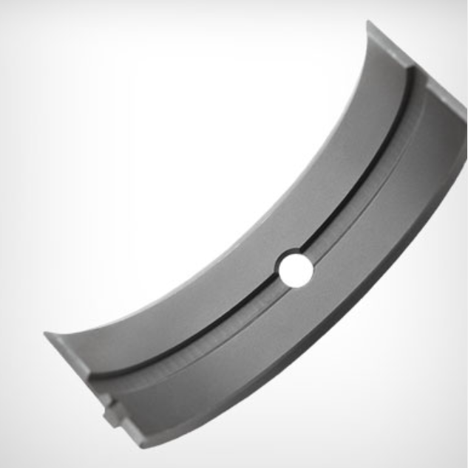
Figure 9 - Example of Bearing Coated with Calico’s CT-1 Dry Film Lubricant Coating, (Calico Coatings, 2021)

Product Recall & Manufacturing Process

Recall Instances

It is difficult to find any instances where automotive manufacturers have held up their hands and taken the blame for instances where there have been multiple cases of engine failure due to bearing failures. One of the widely know examples of this is with BMW’s N55 engine, with multiple sources and threads on the internet based on bearing failure, for high and low mileage engines. Possibly the biggest issue with this is that the customer was normally stuck with a repair bill of around £10,000 to replace and fix all of the damage caused. (ULTIMATE BIMMER SERVICE, 2021)

The Mini Cooper F55/F56 engine is another instance where this has occurred, however in this instance, the customers were contacted for a recall. Unfortunately, there is no legitimate information available on exactly what was wrong with these engines, just that it was a crank bearing issue. There is speculation however, that the longitudinal forces on the crank shaft from the clutch being engaged and disengaged caused the majority of the failures.

Manufacturing Process

King Engine Bearing Specialist manufacture high quality, OEM engine bearings. To maintain their leading development position, they have launched TechLab which is a research and development sector dedicated to transforming the future of engine bearings. The accomplish this by their systematic design of new bearing designs using new materials along with their in-depth development process (See figure 10) which uses the latest technology to optimise quality and production. (King , 2018) From the application requirements of the bearing, the optimum configurations can be determined by utilising this system.

King’s development process consists of five steps, first an engine simulation system is used to test for thermodynamic, hydrodynamic, dynamic and press fit calculations properties. If everything is within the tolerances at this point, the bearing is then made into a 3-D file where it can be milled into a prototype part. These prototype bearings are then tested on an engine dynamometer and ran through many different cycles where factors such as load, RPM and run time. If all is well after these initial tests, King then complete on track testing to validate the bearings use, from real world testing. (King , 2018)
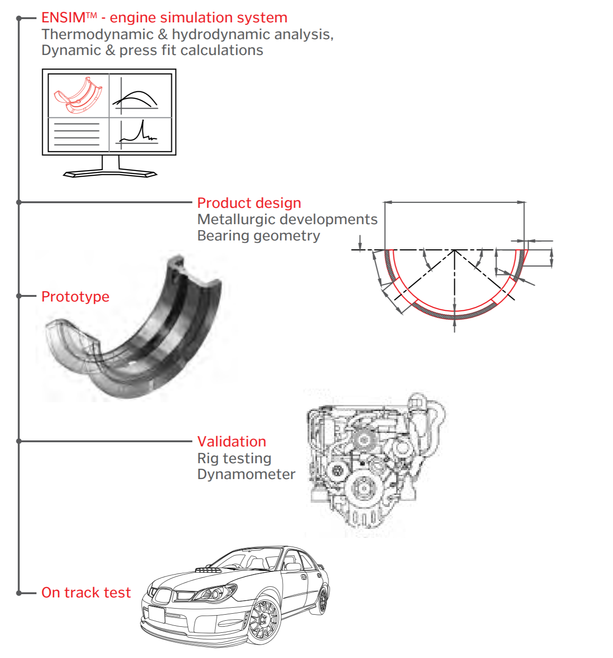
Figure 10 - king's Development Process, (King , 2018)

Bearing Testing

Hydraulic Loading Fatigue Testing

To tests a bearings fatigue strength by use of a rig, the rig must simulate the effects of an internal combustion engine. This means it needs to generate high, almost instantaneous pressures to treat the bearing as it would be during an engine cycle. The rig manages an eccentric shaft which is positioned in the middle of two concentric shaft. The inertia forces generated from these shafts are negligible as they are so small. The eccentric shaft along with the bearing are then put onto the connecting rods big end. The eccentric shaft then rotates to reciprocate the action of the con rod. This unit is then rotated up to speeds between 3000-5000 rotations per minute to simulate real driving conditions. This cycle continues for a set amount of time, sometimes up to 72 hours. The rig is then disassembled, and the bearing is checked for it wear characteristics, as well as analysing the strain gauge. (kopeliovich, 2020)

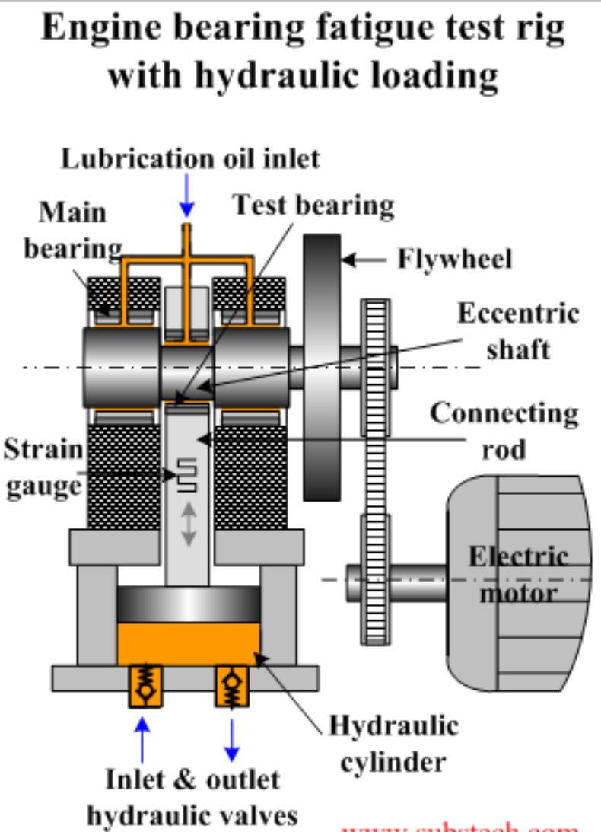
Figure 11 - Hydraulic Loading Fatigue Testing Rig, (kopeliovich, 2020)

Dynamic Loading Fatigue Test

This fatigue test is based on the principle of the inertia forces generated by an internal combustion engine. The rotating shaft has counterweights, off-centre webs, and crank pins similar to a normal crankshaft. The test bearings are mounted, the shaft is rotated via an electric motor and ran to simulate real driving situations with lubrication being delivered to the bearings. Again, the rig is disassembled, then the test bearings are checked for wear characteristics. (kopeliovich, 2020)

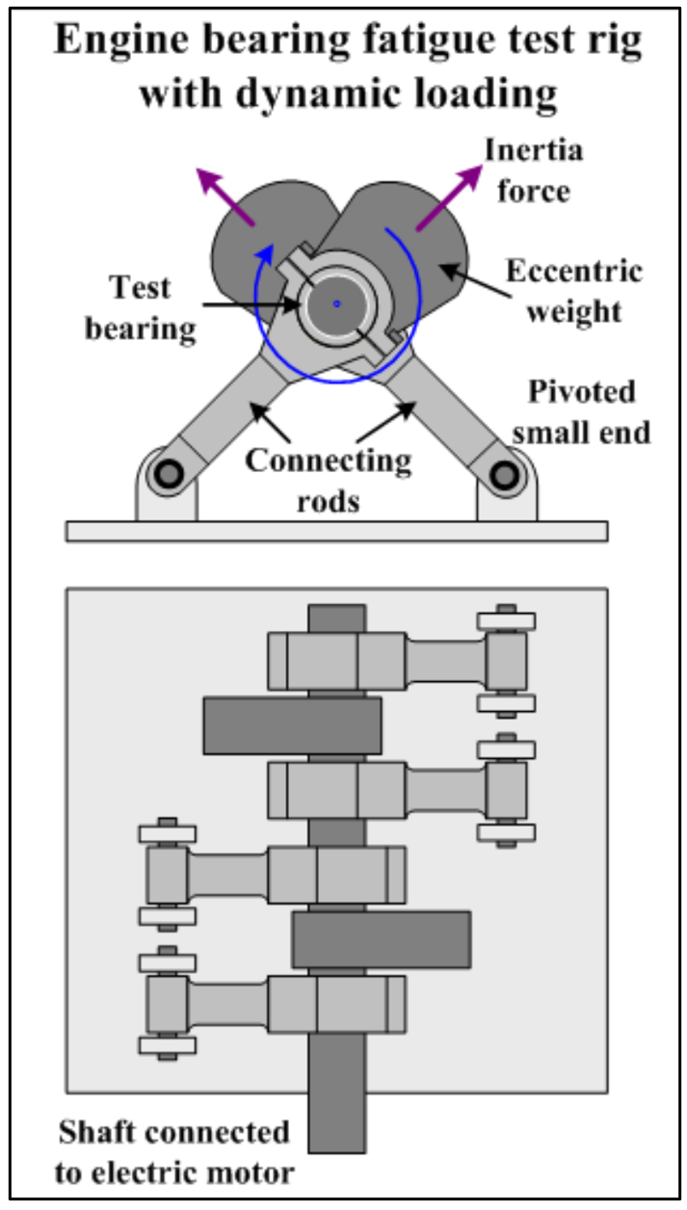
Figure 12 - Dynamic Loading Fatigue Testing Rig, (kopeliovich, 2020)

Conclusion

To conclude, testing and analysis of critical components of internal combustion engines such as crankshaft bearings is vital if the company or engineer wishes to improve the lifespan of the bearings. Product development does not happen overnight, bearings have taken decades to improve as much as they have, through means of alloy development and surface coatings as well as understanding what causes the wear characteristics in general. Fine tuning the manufacturing process does not only ensure better quality products, but also reduces manufacturing times, leading to higher profits for bearing manufacturers. Coating a bearing surface with low friction properties has meant that the longevity of an engine has increased drastically as well as permitting higher performance engines due to the bearing characteristics such as anti-seizure properties and surface hardening. (King , 2018) The writer would recommend that more research and development is completed in the field of surface coatings as coating technology so far has made big improvements on bearing properties. This would also be a good area for further research.

Bibliography
ACL. (2020). COATED PERFORMANCE ENGINE BEARING APPLICATION GUIDE 2020. Retrieved from ACL Race Series: https://aclraceseries.com/images/Coated_Brochure_2020.pdf
BTN Turbo. (2018). TURBO FAILURE:. Zodiac.
Calico Coatings. (2021, January 9). CT-1 Dry Film Lubricant. Retrieved from Calico Coatings: https://www.calicocoatings.com/coating-data-sheets/ct-1-dry-film-lubricant/
Chenevey, B. (2021, January 6). Analyzing Wear Debris in Engine Oils. Retrieved from Machinery Lubrication: https://www.machinerylubrication.com/Read/30122/analyzing-wear-debris
Chua, C. K., & Yeong, W. Y. (2017). Fracture Toughness. Retrieved from Scinece Direct: https://www.sciencedirect.com/topics/engineering/fracture-toughness
Darkside Developments. (2021, January 7). TURBO FAILURE. Retrieved from Darkside Developments: https://www.darksidedevelopments.co.uk/Blog/turbo-failure/
DeHart, A., & Harwick, D. (1984). Engine Bearing Design. SAE International.
ENGINE PARTS (UK) LTD. (2021, January 4). LOOKING TO PURCHASE ENGINE BEARINGS? Retrieved from ENGINE PARTS (UK) LTD: https://www.enginepartsuk.net/engine-bearings-conrod-mains-thrust-washers-bushes-shells
Fernie, M. (2016, April 30). Dry Sump Systems Explained And Why You Need One. Retrieved from Car Throttle: https://www.carthrottle.com/post/dry-sump-systems-explained-and-why-you-need-one/
Gall, K. (2009). Fast Fracture. Retrieved from Science Direct: https://www.sciencedirect.com/topics/engineering/fast-fracture
Harnoy, A. (2002). Bearing Design in Machinery. New Jersey: Taylor & Francis.
Hot Rodders. (2016, June 8). Rod bearing wear. Retrieved from Hot Rodders: https://www.hotrodders.com/threads/pictures-rod-bearing-wear-your-opinion.437857/#lg=thread-437857&slide=3
King . (2018). King Catalog. Retrieved from King Engine Bearing Specialist: https://www.kingbearings.com/wp-content/uploads/2017/03/King-catalog-201-2018-Europe-2.pdf
Know Your Parts. (2021, Jan 4). Types of Engine Bearing Damage. Retrieved from Know Your Parts: https://www.knowyourparts.com/technical-resources/engine/types-of-engine-bearing-damage/
kopeliovich. (2020). Engine bearing fatigue test. Retrieved from SubsTech: https://www.substech.com/dokuwiki/doku.php?id=engine_bearing_fatigue_test#fatigue_test_rig_with_hydraulic_loading
kopeliovich, D. (2020). GEOMETRICAL PARAMETERS OF ENGINE BEARINGS. SubsTech.
Krzymien, A. (2004). PROPERTIES OF THE BEARING ALLOYS USED FOR SLIDE BEARINGS OF CRANK MECHANISM. KONES, 393-394.
Kuznetsoz, V. D. (2013). Metal Transfer and Build-up in Friction and Cutting. Elsevier Science.
MAHLE. (2021, January 7). ENGINE BEARING: FAILURE ANALYSIS AND CORRECTION. Retrieved from MAHLE Driven By Performance: https://www.mahle-aftermarket.com/media/local-media-north-america/pdfs-&-thumbnails/catalogs-and-literature/engine-bearings/ceb-2-1114-engine-bearing-failures-brochure.pdf
NSK. (2021). Creep. Retrieved from Motion & Control, NSK: https://www.nskeurope.com/en/services/troubleshooting/damage-by-type/creep.html
ULTIMATE BIMMER SERVICE. (2021, January 9). What to Know About N55 Bearing Failure. Retrieved from ULTIMATE BIMMER SERVICE: https://www.ultimatebimmerservice.com/what-to-know-about-n55-bearing-failure/#:~:text=The%20Problem,all%20of%20the%20damages%20caused.

