
MSc Public Health and Social Care in Practice

Social Epidemiology and Public Health Development

LCHS7000

Component 2

Analytical Report

Submitted By:
Sanjay Odedara
ID - 2519105

Table of Contents
Task 1: Social Epidemiological Analysis 3
Introduction 3
Higher prevalence of type 2 diabetes 4
Increased mortality from cardiovascular disease 5
Mental health inequalities 6
Poverty and socioeconomic deprivation 6
Healthcare access and linguistic barriers 8
Housing condition and overcrowding 9
National response to reduce health inequalities 10
Supporting organisations for South Asian Communities 10
Conclusion 11
Task 2: Epidemiological Analysis 12
Introduction 12
Prevention, protection, and health promotion 13
Hazards and determinants 14
Epidemiological research 15
Evaluation of health needs 16
Recognition of at-risk population 16
Surveillance and monitoring 16
Public health impact 17
Design of intervention programme and assessment 17
Strengths and weaknesses of the epidemiological approach 17
Conclusion 18
References 19

Task 1: Social Epidemiological Analysis
Ethnicity and health inequality (Target group- South Asian Communities in the UK)

Introduction
Health inequalities are described as unfair and avoidable differences in health outcomes between different population groups. People from South Asian communities in the UK, especially Bangladeshi and Pakistani populations, generally experience a disproportionate burden of disease and poor social determinants of health in comparison to the native white British population (Patel and Hanif, 2022). Ethnic minorities are 18% of the population in the UK (GOV.UK, 2021). However, improvement of health outcomes has not been distributed equally across each ethnic group. Such disparities are largely illustrated by various social determinants like housing, income, education, and access to healthcare, rather than ethnicity only. The study provides an analysis of the ethnicity-based healthcare disparities present in the UK, with a focus on the most substantial inequalities.

Higher prevalence of type 2 diabetes
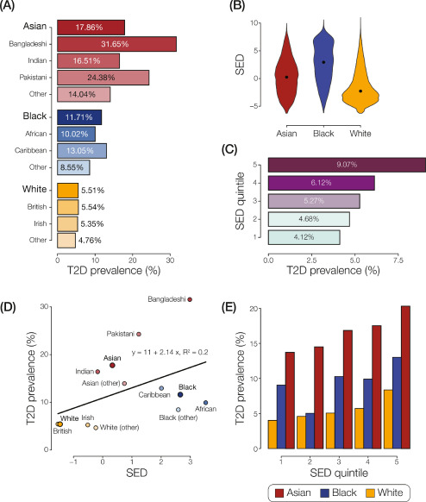
Figure 1: Prevalence of type 2 diabetes by ethnicity in the UK, Source: (Nagar et al., 2021)
Type 2 diabetes is one of the most significant health inequalities, leaving a negative impact on people from South Asian populations in the UK. People from South Asia are almost 2 to 4 times more likely (5.54% among the British population and 17.86% among the Asian population) to develop type 2 diabetes compared to the native British population (Nagar et al., 2021). In addition, people are found to develop this disease almost 5 to 10 years earlier and at lower body mass indices (Nagar et al., 2021). This hazard is particularly severe among Bangladeshi and Pakistani individuals. The earlier onset of the disease elevates the expose are true long-term complications, including cardiovascular diseases, renal diseases, and visual impairment.
Genetic predisposition offers a partial explanation for the disparity in healthcare. However, biological explanations alone are inadequate. Dietary transition after migration, depression, sedentary employment, and decreased scope for physical activity have also contributed largely to the high prevalence of type 2 diabetes. Considering diabetes only as an individual lifestyle issue, the structural situations that influence behaviours (Hayanga, Stafford, and Bécares, 2023). Therefore, the NHS introduced targeted prevention processes for diabetes in particular areas where the South Asian population lives in large numbers. The intervention plan also includes data advice, considering cultural adoption, and community screening programmes.

Increased mortality from cardiovascular disease
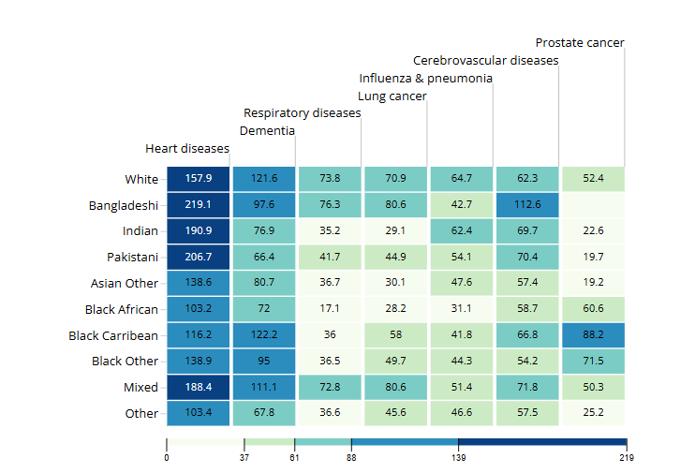
Figure 2: Mortality rate from cardiovascular disease by ethnicity in the UK, Source: (ONS, 2021)
Cardiovascular disease is a major determinant of premature mortality among South Asian populations in the UK. Especially, Bangladeshi and Pakistani people are found to experience higher mortality rates from coronary heart disease. For example, ischaemic heart disease among Pakistani women was 109.6 deaths per 100,000 population (ONS, 2021). It is quite higher than that of white women, with a mortality rate of 70.5 deaths in 100,000 population (ONS, 2021).
Other than the identification of the genetic susceptibility to insulin resistance and obesity, lower penetration of healthcare services and socioeconomic deprivation are also significant determinants of cardiovascular diseases in the South Asian population. Apart from that, lower participation of the South Asian people in public screening programs further elevated the outcomes. The NHS health check program has tried to address such health inequality through earlier identification of cardiovascular risk factors like hypertension among people from 40 to 74 years (NHS, 2023). However, lower acceptance and attendance in the screening among the South Asian population have disrupted such programs, with the suggestion that universal programmes might not be available for people with the highest need.

Mental health inequalities
South Asian people in the UK report lower attendance in psychological therapies despite high prevalence of depression and anxiety, due to factors like discrimination, depression, and stressors related to migration (Prajapati and Liebling, 2021). Evidence consistently demonstrates that people from ethnic minority groups seldom enter psychological health services via crisis pathways rather than through early intervention. Hence, it results in poorer outcomes and a higher cost of treatment.
The Inverse Care Law of Tudor Hart is helpful to explain this phenomenon, as an argument that access to healthcare is likely to differ inversely with need. The population experiencing the heaviest burden of Illness generally encounters the greatest constraints to access support (Bansal et al., 2022). Stereotypes associated with mental illness, concerns about family, reputation, and linguistic barriers also delay help-seeking behaviours. The talking therapy program of the NHS has tried to increase accessibility of mental healthcare through multilingual services and interventions designed for cultural adoption. However, significant inequalities remain a great concern.

Poverty and socioeconomic deprivation
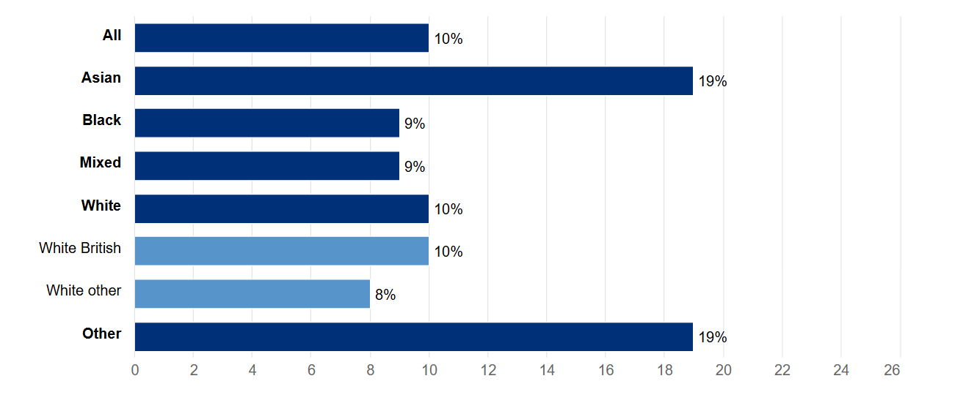
Figure 3: Percentage of people living in households in persistent low income before housing costs, by ethnicity, Source: (GOV.UK, 2023)
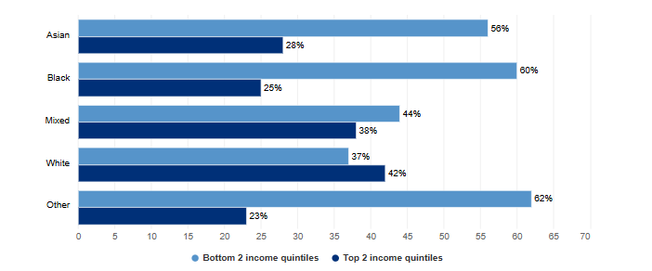
Figure 4: Percentage of households in the bottom 2 and top 2 income quintiles (after housing costs), by ethnicity, Source: (Kingdom, 2025)
Poverty is the most notable driver of health inequality based on ethnicity. Persistent low income before housing costs has been found in 19% of Asian households in the country (GOV.UK, 2023).
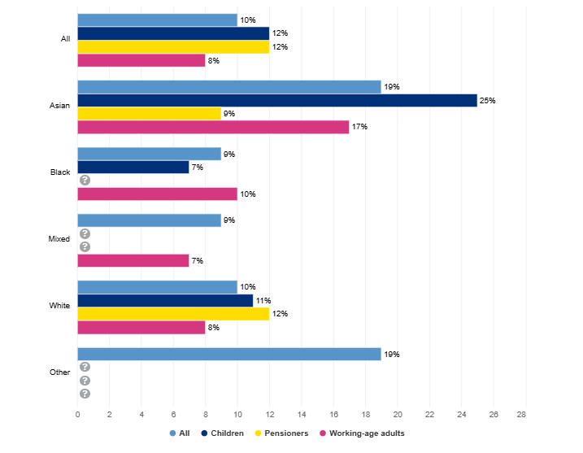
Figure 5: Percentage of people living in households in persistent low income before housing costs, by ethnicity and age group, Source: (GOV.UK, 2023)
Especially, 25% of children from Asian communities live in households with consistently insufficient income, which shows their less likeliness to get an education or nutritious food (GOV.UK, 2023).
ONS data indicates that Pakistani households experience 42% low-income rates and Bangladeshi households experience 47%, which is quite higher than 17% among the British households (Francis-Devine, 2026). Additionally,75% of Bangladeshi and 72% of Pakistani households are within the two lowest income quantiles in the country (Francis-Devine, 2026).
Poverty increases exposure of the population to poor nutrition, an unhealthy environment, and chronic stress, resulting in higher vulnerability to issues like cardiovascular disease. In addition, poverty also restricts employment or educational opportunities, resulting in more exposure to healthcare issues. Therefore, along with healthcare interventions, wider social policies are required to address income, security, education, and employment.

Healthcare access and linguistic barriers
Regardless of universal healthcare coverage offered by the NHS, healthcare inequality still persists. Lower health literacy and limited proficiency in English among the South Asian population resulted in lower engagement in public screening programs, preventive healthcare services, and medication attendance (Gkiouleka et al., 2023).
South Asian populations with greater health needs frequently experience longer waiting times at the NHS. The government has tried to decrease such barriers through interpreter services and culturally competent training for healthcare employees. However, the implementation has been inconsistent across local authorities, which contributes to the persistent healthcare inequality.

Housing condition and overcrowding
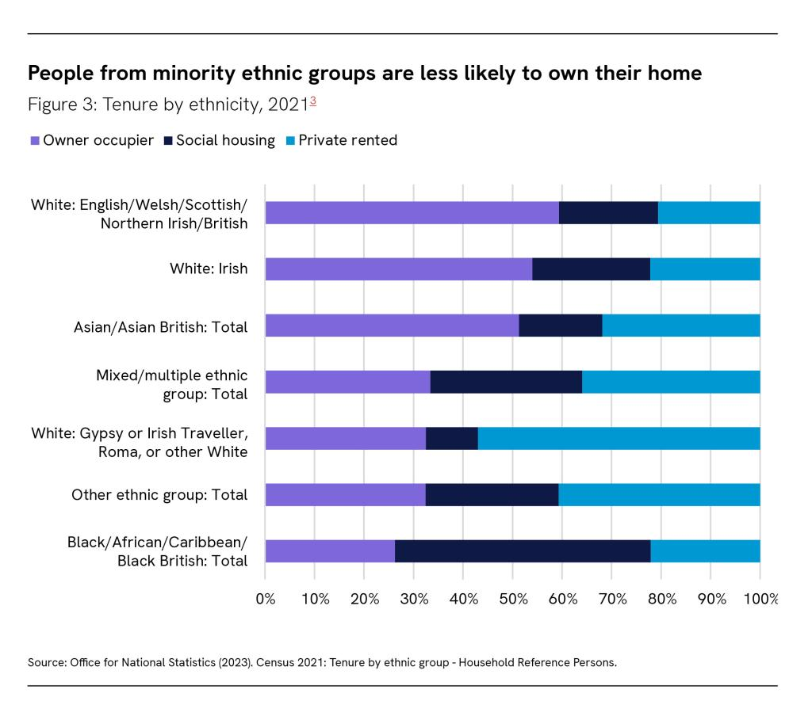
Figure 6: Housing ownership in the UK by ethnicity, Source: (Gov. UK, 2023)
The housing crisis is another social determinant of the health inequality experienced by the South Asian population in the UK. 14% of Pakistani households and 18% of Bangladeshi households experience over private situation, which is significantly higher than the average of British people of 3% (Gov. UK, 2023). The overcrowded housing condition elevates the chances of transmission of infectious diseases, which has contributed to poorer psychological health and decreased chances of educational attainment for children. During the COVID-19 pandemic, the higher transmission rate in the overcrowded households of the South Asian people shows clear evidence of health inequality as a public health issue.

National response to reduce health inequalities
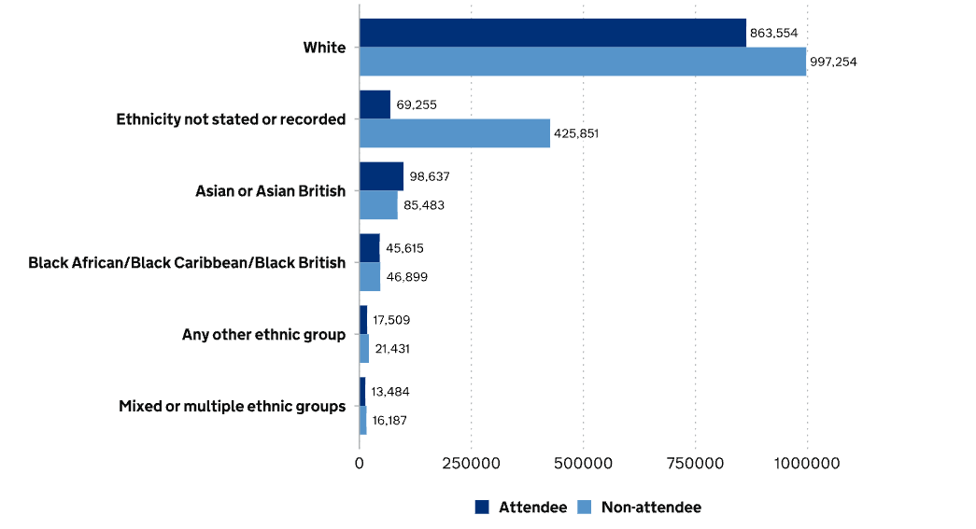
Figure 7: National attendance in public health screening in the UK by ethnicity, Source: (Kingdom, 2025)
Various initiatives have been taken at the national level to reduce health inequalities based on ethnicity. The Core20PLUS5 strategy of the NHS recognises these ethnic minority groups as populations with high priority to reduce the prevalence of diabetes, cardiovascular disease, and cancer through early diabetes (NHS England, 2021). In addition, the diabetes prevention program of the NHS included culturally personalised interventions, particularly designed for vulnerable communities, like the South Asian people, through interventions like multilingual educational sessions and programmes for community outreach. However, the persistence of inequality shows that the approach has been a one-size-fits-all tactic, which is inadequate to address ethnic inequalities, and low attendance at public health screening programs among Asian people (nearly 98,000 only) has elevated the concern (Kingdom, 2025).

Supporting organisations for South Asian Communities
The South Asian Health Foundation plays a significant role in reducing health inequalities within the South Asian communities in the UK. The organisation conducts market research and develops medical guidance for people (Nagar et al., 2021). It also provides public education regarding the concerning situations disproportionately affecting the ethnic minorities, particularly cardiovascular disease and diabetes. The charity organisation also works closely with healthcare professionals and policymakers to decrease avoidable health disparities and to improve culturally competent healthcare.

Conclusion
People from South Asian origin living in the UK have experienced significant health inequalities. The prevalence of cardiovascular disease, mental illness, and diabetes is higher among this population compared to white People. Despite national-level initiatives, persistent health inequalities show evidence of the need for further intervention.

Task 2: Epidemiological Analysis
Epidemiological analysis of type two diabetes among the adult population within the South Indian community in London (Tower Hamlets)

Introduction
Type 2 diabetes is one of the most chronic metabolic disorders that is characterised by impaired glucose metabolism and insulin resistance. Almost 4.6 million people in 2025 were diagnosed with diabetes in the UK, and it is assumed that almost 1.3 million people are undiagnosed (Loft, 2018).
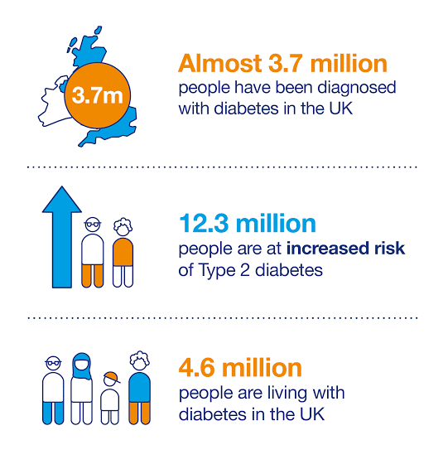
Figure 8: Diabetes related statistics in the UK, Source: (Loft, 2018)
90% of all such cases are type to diabetes. Globally, it is also a public health concern, with an estimate from the International Diabetes Federation of 589 million adults living with diabetes in 2024, which is expected to grow to 853 million by 2050 (International Diabetes Federation, 2025).
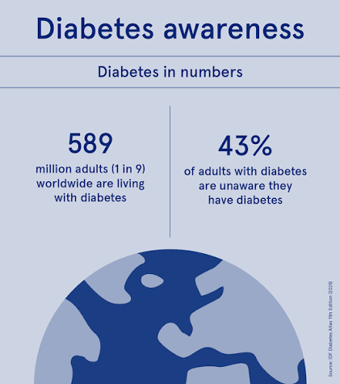
Figure 9: Statistics of diabetes globally, Source: (International Diabetes Federation, 2025)
This study emphasises adults living in Tower Hamlets in London from the South Asian community. Almost 39% of the population of the region is from the Asian or Asian British community and predominantly of Bangladeshi origin. Prevalence of diabetes in Tower Hamlets is almost 8.6%, which is significantly higher than the national average of 7.1% (Chowdhury and Huda, 2026). Hence, diabetes in the target population is both a social and clinical epidemiological concern.

Prevention, protection, and health promotion
Mass health responses to diabetes are commonly included in three categories: prevention, protection, and promotion. For type 2 diabetes, primary prevention has the objective to decrease disease incidence before actual onset via lifestyle modification. The NHS Diabetes Prevention Program (NDPP) aims to target individuals recognised as high risk through organised education delivery on physical activity, diet, and weight management. Almost 900,000 people have been referred to this program across the country (NHS England, 2023).
Secondary prevention emphasises early diagnosis and detection. The NHS Health Check Program offers risk assessments for diabetes and cardiovascular disease to adults between 40 and 74 years once every five years (NHS, 2023). Early diagnosis of the diabetic stage allows more effective intervention before the occurrence of any irreversible complications. Tertiary prevention emphasises decreasing the rate of morbidity among diagnosed people through foot examinations, retinal screening, and glycaemic control.
In Tower Hamlets, health promotion has been dependent on community-based approaches. The interventions are offered through community centres, mosques, and local charity organisations to improve engagement of South Asian people, especially from Bangladeshi households.

Hazards and determinants
There are multifactorial causes of type 2 diabetes that involve interaction between behavioural, social, and biological determinants. Ethnicity has been a key determinant. For example, South Asians have almost 2 to 4 times greater risk of developing the disease compared to white British people, even at a lower body mass index (Nagar et al., 2021). The recommended intervention threshold of NICE from a BMI of 23 KG/ m² is quite lower than that of the white population with 30 KG/ m² because of elevated metabolic risk (Katzmarzyk et al., 2011).
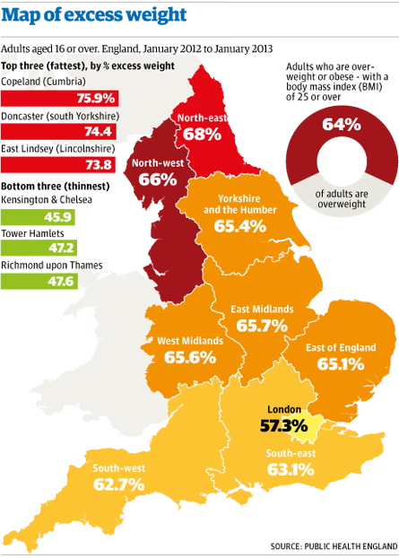
Figure 10: Obesity -related statistics in the UK, Source: (Boseley, 2014)
Obesity is another significant contributor, particularly in the UK, where almost 64% of the population is overweight or obese (Boseley, 2014). For South Asian people, this is also a central contributor due to the tendency of visceral fat gain.
Socio-economic deprivation is also a key contributor, especially in Tower Hamlets, which is one of the most underserved local authorities in the UK.
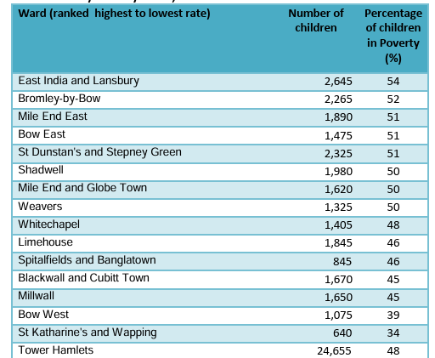
Figure 11: Children living under poverty in Tower Hamlets, Source: (ONS, 2021)
Around 48% of children in this region live in poverty (ONS, 2021). Hence, deprivation has limited their access to a healthy diet and opportunities for education or physical exercise.

Epidemiological research
Various epidemiological studies have contributed to understanding the distribution and risk factors related to diabetes. Cross-sectional research works have been highly useful to measure prevalence and to identify disease distribution among different populations. Cohort studies offer stronger evidence regarding mortality rate (Katzmarzyk et al., 2011). In contrast, longitudinal studies have recurrently illustrated earlier onset and greater incidence of type 2 diabetes among South Asian people compared to white British people. The case-control studies have recognised an important relationship between obesity, dietary habits, and risk of diabetes. However, such studies are often considered susceptible to recall bias. Despite more robust evidence provided by the cohort studies, the expense, time-intensiveness, and not considering participant attrition are the weaknesses. Therefore, epidemiologists tend to combine results from different kinds of studies for improved reliability.

Evaluation of health needs
Health needs assessment (HNA) is a widely used systematic approach to recognise unfulfilled requirements in healthcare and to allocate resources efficiently. In the context of Tower Hamlets, HNA would recognise the adults from the South Asian community aged above 40 years as a priority population due to their elevated disease burden and earlier onset (Pardhan et al., 2025). Data sources would include hospital episode statistics, mortality data, national diabetes audit results, and GP records. The evaluation would have the potential to recognise lower uptake of preventive measures, delayed diagnosis, and inequalities in health literacy as significant requirements not yet fulfilled. HNA also assists proportionate universalism, where planned interventions are universal. However, resources are allocated according to the requirement rather than equal distribution among all populations with various disease incidence rates.

Recognition of at-risk population
The recognition of the groups with high vulnerability is a basic need in epidemiological practice. In Tower Hamlets, populations with higher exposure to type 2 diabetes include adults from South Asian ethnicity aged above 40 years, obese people, individuals with a family history of diabetes, residents living in deprived environments, such as overcrowded houses, and females with previous gestational diabetes.
The National Diabetes Audit Committee estimates that almost 33% of adults in the UK are at elevated risk of developing type 2 diabetes (McManus et al., 2022). Therefore, targeted interventions are required to improve cost-efficiency with a close focus on populations with high disease burden.

Surveillance and monitoring
In the UK, surveillance of diabetes is primarily conducted through the National Diabetes Audit (NDA). In addition, the Quality and Outcomes Framework (QOF), National Statistics Mortality records, and hospital episode statistics are used for the survey process. More than 98% of GP practises in the UK are included in the NDA, making it one of the most efficient and largest clinical audits globally (NHS, 2026). This system offers detailed insight into complications, healthcare, inequalities, and glycaemic control.
Surveillance data have also identified management gaps. In the UK, only 37% of the population diagnosed with diabetes receive all eight suggested care processes and achieve the target of treatment suggested by NICE (NHS, 2026a).

Public health impact
The burden of type 2 diabetes is beyond individual morbidity or mortality. Individuals living with type 2 diabetes experience almost 2 times more risk of experiencing cardiovascular mortality compared to non-diabetic people (Save The Children, 2023). Additionally, it is also a key reason for chronic kidney disease and blindness. Moreover, it also leaves a severe financial impact, as the NHS has an expenditure of almost 10 billion GBP per year to treat diabetes, which is equivalent to almost 10% of the overall spending (NHS England, 2022). However, 80% of the expenditure is on avoidable complications. Diabetes also contributes substantially to reduced productivity and disability. Diabetes related complications in the UK result in almost 184 lower-limb amputations per week (NHS England, 2022). However, most of the cases are preventable through early diagnosis and intervention.

Design of intervention programme and assessment
The intervention programme needs to offer culturally tailored lifestyle modification-related education. General practitioners should offer education delivery through community organisations and mosques in the selected region. Community health workers, particularly from South Asian backgrounds, will be effective in improving spontaneous participation and trustworthy relationship building. Similar community-based strategies for intervention integrated in East London illustrated improved audience attendance (Gelding, 2005). The evaluation process should include measurable indicators like a decrease in HbA1c levels, increased attendance in public screening, weight reduction, and reduced admissions to hospitals. Economic assessment using cost-efficiency analysis would determine whether the health improvement received through the program justifies the expenditure. However, poverty and housing inequalities will also need to be considered to further improve the lifestyle and socio-economic factors contributing to diabetes.

Strengths and weaknesses of the epidemiological approach
Strengths of Epidemiology | Weaknesses of Epidemiology
Provides objective and evidence-based measurement of disease prevalence, incidence, and trends. | Often focuses primarily on measurable biomedical factors while underestimating cultural and social influences on health.
Identifies high-risk populations, enabling targeted interventions and efficient resource allocation. | Statistical associations identify correlations but may not fully explain the underlying causes of health inequalities.
Surveillance systems such as the National Diabetes Audit allow monitoring of outcomes and evaluation of interventions over time. | Quantitative data alone cannot capture patient experiences, healthcare barriers, or cultural beliefs influencing disease management.

Conclusion
In Tower Hamlets, South Asian adults have been exposed to type 2 diabetes significantly. The high exposure is driven by different social determinants, like poverty, lack of education, and biological susceptibility. Therefore, culturally appropriate tactics to address healthcare access, deprivation, and community engagement will be vital, along with effective disease management.

References
Bansal, N., Karlsen, S., Sashidharan, S.P., Cohen, R., Chew-Graham, C.A. and Malpass, A. (2022). Understanding Ethnic Inequalities in Mental Healthcare in the UK: A meta-ethnography. PLOS Medicine, [online] 19(12), pp.1–36. DOI: 10.1371/journal.pmed.1004139.
Boseley, S. (2014). Almost two-thirds of adults in England classed as overweight by the health body. [online] The Guardian. Available at: https://www.theguardian.com/society/2014/feb/04/two-thirds-adults-overweight-england-public-health [Accessed 17 July 2026].
Chowdhury, T.A. and Huda, B. (2026). View of A decade of change in diabetes services in a deprived multiethnic inner-city area: Diabetes in Tower Hamlets | British Journal of Diabetes. [online] Bjd-abcd.com. Available at: https://www.bjd-abcd.com/index.php/bjd/article/view/204/345 [Accessed 17 July 2026].
Francis-Devine, B. (2026). Poverty in the UK: Statistics - House of Commons Library. [online] House of Commons Library. Available at: https://commonslibrary.parliament.uk/research-briefings/sn07096/? [Accessed 17 July 2026].
Gelding, S.V. (2005). Community diabetes: An East London perspective. Journal of the Royal Society of Medicine, [online] 98(3), pp.96–100. DOI:10.1258/jrsm.98.3.96.
Gkiouleka, A., Wong, G., Sowden, S., Bambra, C., Siersbaek, R., Manji, S., Moseley, A., Harmston, R., Kuhn, I., and Ford, J. (2023). Reducing health inequalities through general practice. Reducing health inequalities through general practice, 8(6), pp.e 463-e472. DOI:10.1016/s2468-2667(23)00093-2.
Gov. UK (2023). Chapter 1: 20 Charts to understand London’s homes today. [online] Centreforlondon.org. Available at: https://centreforlondon.org/reader/londons-homes-today/chapter-1/ [Accessed 17 July 2026].
GOV.UK (2021). Ethnicity Facts and Figures. [online] Service.gov.uk. Available at: https://www.ethnicity-facts-figures.service.gov.uk/ [Accessed 17 July 2026].
GOV.UK (2023). Persistent low income. [online] Www.ethnicity-facts-figures.service.gov.uk. Available at: https://www.ethnicity-facts-figures.service.gov.uk/work-pay-and-benefits/pay-and-income/low-income/latest/ [Accessed 17 July 2026].
Hayanga, B., Stafford, M., and Bécares, L. (2023). Ethnic inequalities in multiple long-term health conditions in the United Kingdom: A systematic review and narrative synthesis. BMC Public Health, [online] 23(1). DOI:10.1186/s12889-022-14940-w.
International Diabetes Federation (2025). Diabetes Facts & Figures. [online] International Diabetes Federation. Available at: https://idf.org/about-diabetes/diabetes-facts-figures/ [Accessed 17 July 2026].
Katzmarzyk, P.T., Bray, G.A., Greenway, F.L., Johnson, W.D., Newton, R.L., Ravussin, E., Ryan, D.H., and Bouchard, C. (2011). Ethnic‐Specific BMI and Waist Circumference Thresholds. Obesity, [online] 19(6), pp.1272–1278. DOI:10.1038/oby.2010.319.
Kingdom, U. (2025). Income distribution. [online] Service.gov.uk. Available at: https://www.ethnicity-facts-figures.service.gov.uk/work-pay-and-benefits/pay-and-income/income-distribution/latest/? [Accessed 17 July 2026].
Loft, R. (2018). Diabetes diagnosis has more than doubled in 20 years. [online] Kidney Research UK. Available at: https://www.kidneyresearchuk.org/2018/02/28/diabetes-diagnosis-has-more-than-doubled-in-20-years/ [Accessed 17 July 2026].
McManus, E., Meacock, R., Parkinson, B., and Sutton, M. (2022). Population Level Impact of the NHS Diabetes Prevention Programme on Incidence of Type 2 Diabetes in England: An Observational Study. The Lancet Regional Health - Europe, 19(100420), p.100420. DOI: 10.1016/j.lanepe.2022.100420.
Nagar, S.D., Nápoles, A.M., Jordan, I.K. and Mariño-Ramírez, L. (2021). Socioeconomic Deprivation and Genetic Ancestry Interact to Modify Type 2 Diabetes Ethnic Disparities in the United Kingdom. EClinicalMedicine, [online] 37(100960), p.100960. DOI: 10.1016/j.eclinm.2021.100960.
NHS (2023). NHS Health Check. [online] Nhs.uk. Available at: https://www.nhs.uk/tests-and-treatments/nhs-health-check/ [Accessed 17 July 2026].
NHS (2026a). Care processes and treatment targets: National summary, 2021-22. [online] NHS Digital. Available at: https://digital.nhs.uk/data-and-information/publications/statistical/national-diabetes-audit/report-1-care-processes-and-treatment-targets-2021-22-full-report/cp-and-tt-1718-2122 [Accessed 17 July 2026a].
NHS (2026b). Methodology. [online] NHS England Digital. Available at: https://digital.nhs.uk/data-and-information/publications/statistical/national-diabetes-audit/report-1-care-processes-and-treatment-targets-2021-22-full-report/methodology-copy [Accessed 17 July 2026b].
NHS England (2021). Core20PLUS5 an Approach to Reducing Health Inequalities. [online] Www.england.nhs.uk. Available at: https://www.england.nhs.uk/about/equality/equality-hub/national-healthcare-inequalities-improvement-programme/core20plus5/ [Accessed 17 July 2026].
NHS England (2022). NHS Prevention Programme cuts chances of Type 2 diabetes for thousands. [online] Www.england.nhs.uk. Available at: https://www.england.nhs.uk/2022/03/nhs-prevention-programme-cuts-chances-of-type-2-diabetes-for-thousands/ [Accessed 17 July 2026].
NHS England (2023). NHS Diabetes Prevention Programme (NHS DPP). [online] NHS England. Available at: https://www.england.nhs.uk/diabetes/diabetes-prevention/ [Accessed 17 July 2026].
ONS (2021). Mortality from leading causes of death by ethnic group, England and Wales. [online] Ons.gov.uk. Available at: https://www.ons.gov.uk/peoplepopulationandcommunity/birthsdeathsandmarriages/deaths/articles/mortalityfromleadingcausesofdeathbyethnicgroupenglandandwales/latest? [Accessed 17 July 2026].
Pardhan, S., Sehmbi, T., Wijewickrama, R., Onumajuru, H., and Piyasena, M.P. (2025). Barriers and facilitators for engaging underrepresented ethnic minority populations in healthcare research: An umbrella review. International Journal for Equity in Health, [online] 24(1), p.70. DOI:10.1186/s12939-025-02431-4.
Patel, K.C.R. and Hanif, W. (2022). Ethnic health inequalities in the NHS. BMJ, [online] 376(376), p.o607. DOI:10.1136/bmj.o607.
Prajapati, R. and Liebling, H. (2021). Accessing Mental Health Services: A Systematic Review and Meta-ethnography of the Experiences of South Asian Service Users in the UK. Journal of Racial and Ethnic Health Disparities, [online] 9(2), pp.598–619. DOI:10.1007/s40615-021-00993-x.
Save The Children (2023). Tower Hamlets. [online] Save the Children UK. Available at: https://www.savethechildren.org.uk/what-we-do/child-poverty/uk-child-poverty/england/tower-hamlets [Accessed 17 July 2026].
Siam, N.H., Nayla Nuren Snigdha, Noushin Tabasumma, and Parvin, I. (2024). Diabetes Mellitus and Cardiovascular Disease: Exploring Epidemiology, Pathophysiology, and Treatment Strategies. Reviews in Cardiovascular Medicine, 25(12). DOI:10.31083/j.rcm2512436.

