Advanced Physics of OME Assignment 2021- Design and Comparison of Shaped Charge Models
L5 - Advanced Physics of OME (ACDA5015)
Thomas A Harwood (1906968)
University of Wales Trinity Saint David

Abstract
This report utilities simulation software to evaluate the computer modelling of shaped charges, it takes a brief look into the background and history of shaped charges along with the materials used and the where shaped charges are used. This report then gives a detailed description of a shaped charge model and the materials used for it, which then allows for a comparison between multiple types of explosives which were simulated to find a superior compound to the TNT used in the base model. The report then discusses the results and gives a conclusion to the findings presented.
Contents
- Introduction

- Literature Review

2.1 Shaped Charges

2.2 Energetic Substances used in Shaped Charges

2.3 Shaped Charge Modelling

- Model Design and Selected Materials

- Results

  - TNT

  - RDX

  - HMX

  - AN/FO

- Discussion

- Conclusion

References

- Introduction
The use of simulation modelling within design engineering has exponentially increased over recent years allowing engineers to simulate real world conditions and scenarios without leaving their office chair. An industry which is utilising technology within its design and testing phase is the explosives industry, this industry sector makes use of simulation modelling to test everything from bullet penetration to high explosive blast radius. One of the common uses of modelling within the explosive industry is for the penetration and blast effects of a shaped charge device. A basic shaped charge device consists of a rigid metal casing, a malleable liner and then an explosive filling. Shaped charges were originally used for mining and demolition with the first patent for a shaped charged style device was granted in 1886, later in the 1940’s German soldiers were said to be using shaped charge devices in an attack on Fort Eben-Emael in Belgium. A shaped Charge is an explosive device that comes in a variety of different shapes and sizes, shaped charge style devices are used in many different industries from demolition and mining to the military and the oil and gas industry. One of the military uses of shaped charges is in an RPG which uses a high explosive charge to propel a copper jet after an impact or initiation has occurred. Whereas the oil and gas industry use a shaped charge style devices to create the initial hole or well which is then drilled to retrieve the desired substance. The brief for this report was to run a base model simulation of a shaped charge, then with the results try and improve on the model’s jet formation and performance. In order to fulfil the brief, the explosive compound’s performance was selected as the component of the shaped charge that needed to be improved upon. To complete this experiment a simulation software was required to run the models and produce the data, Abaqus was the software chosen for this simulation experiment. Abaqus is a software package that allows for total customisation for your simulations as you can add and remove different parameters enabling a wide range of testing capability. With the report brief in mind a literature review was undertaken to find any relevant sources of information that could help improve the model and simulations performance.

- Literature Review
For the literature review section of this report three specific subject matters were selected for review, the first subject selected was the uses of shaped charges. This subject was chosen in order to learn about the way shaped charges are currently being utilised and how they have been used in the past, the second subject area that was selected was the materials used in shaped charges. This topic was chosen as it would be beneficial to gain some knowledge on what materials are used in for shape charges, this would allow for an accurate representation when creating the base model and the test models. The final subjected selected for this literature review was shaped charge modelling, this was selected to achieve background knowledge on previous reports and journals that discus a similar subject area to this report. The main platforms utilised for this literature search were Google Scholar and Science Direct, these platforms produced many results for all three of the sections. A general Google search was also completed for all three sectors this was done to try and find any papers or journals not available on the two other platforms that were used.

2.1 Shaped Charges
This was section of the literature review produced a larger number of results compared to the other two sections, this was due to the larger scope of search terms that were applicable to this topic. The initial search term was “The uses of shaped charges” this search was then filtered to streamline the results. In order to produce a wide spread of results across all available industries the search results were filtered into two categories military and Non-military applications, from the results produces it become apparent that shaped charges had major uses in non-military industries playing a key part in both the oil and excavation industry. Chapter 25 of the Book titled “Rock Fracture and Blasting theory and applications” discusses “Special Blasting techniques” with Section 25.3 referencing “Shaped charges and applications” in the industry with technical drawings of the style of shaped charges that are utilised and how they are applied. The section of this book as well as a few others reports and journals that can be found in the references section of this report gave great insight into the history and uses of Shaped Charges. [1] [2] [3] [4]

2.2 Energetic Substances used in Shaped Charges
This section of the literature review produced the lowest number of results from the initial search term compared to the other two sections, the initial term that was searched was “Explosive materials used in shaped Charges” but then when using more specific search terms many more results were found. The general google search for this section produced the most relevant results compared to the other two platforms. This section of the literature review was a part of a key role in this report as it became an information and data parameter search for the test explosives used in the simulation models. This topic area in the literature review produced all the information and test data required to run the simulations, therefore all the reports and journals found in this section are referenced later in this report. [4] [5] [6] [7] [8] [9] [10] [13][14]

2.3 Shaped Charged modelling
This section of the literature review produced a mediocre number of results from the initial search term, the initial term used was “Modelling shaped charges”. After going through the results, it was determined that the search may have been too specific so the term “Modelling explosives” was searched. This found a larger number of results compared to the initial search term, there were a few useful articles found on both Google Scholar and Science Direct which proved inciteful for this report. This section allows for the gain of background know on similar subject and software packages enabling thoughts of improvement that could be made the model and potential changes to the simulation parameters. [4] [5] [11] [12]

- Model Design and Selected Materials
The model created for the simulation has similar characteristics to that of the NATO standard for shaped charges. The NATO standard drawings illustrate a conical shaped liner with a circular base which is inserted nose down into a cylinder, the brim of the cone sits flush to the edge of the cylinder. The empty space between the nose of the liner and the bottom of the cylinder is filled with the explosive compound. One of the main differences between the NATO standard and the model used was lack of detonator in the model, a detonator was not included in the creation of the model in order to simplify the simulations and reduce the run time for each model.
The compound selected for the control model for this experiment was TNT as it’s a common form of high explosive which is widely known and used in the explosive industry. A further three explosive compounds were selected in an attempt to produce a better performing jet than that of the control model. To ensure a fair and true comparison of each different explosive compound all other parameters relating to the cylindrical casing and conical liner were kept the same. The material selected for the cylindrical casing was steel, during the simulation runs the casing was not given any damage characteristics as its only purpose was to allow the explosive the best chance of creating an explosively formed jet. The material chosen for the conical liner was copper, the reason for this choice of material was due to it being a malleable and durable metal as well as its popularity in real life shaped charges. To allow for the best possible jet production on each simulation the liner material was assigned with the following parameters Youngs modulus, Yield Stress, density, and elasticity. These parameters give an indication to the software on how the conical liner should react when the explosive initiates functions and subsequently forms the jet.
The three other explosive compounds chosen for this simulation experiment were RDX, Composition B and HMX. All three of these compounds are high explosives similar to TNT but they all have their own unique differences which set them apart.
RDX was selected as part of this simulation as it can be found in many current and historical military weapons, RDX has a comparable density to that of TNT but a considerable higher detonation speed. RDX can be found in Fragmentation grenades, land mines and is often found in shaped charges, RDX’s popularity could be down to its explosive performance and cheap production system. Composition B was the second compound selected for this simulation, this explosive was selected as it is a combination of both TNT and RDX.
Comp B is manufactured by mixing 40% TNT and 60% RDX, Comp B was commonly used over the last 100 years in fragmentation grenades and other military explosive devices. Comp B is popular as it has a higher detonation velocity than TNT and is more stable and less sensitive than RDX.

The last explosive material that was tested in this simulation was HMX, HMX is a plastic explosive that is produced by modifying the process used to manufacture RDX. HMX is similar to RDX, but it has a higher detonation velocity and is more sensitive and not as stable as RDX. HMX is commonly used by the United States in their nuclear explosives devices and is one of the compounds that is used in the composition of Semtex.
As a side section of this simulation an extra explosive compound was simulated, this compound is not commonly found in NATO munitions but has been used as a form of home-made explosive. This explosive is AN-FO which stands for Ammonium Nitrate-Fuel Oil, this explosive was simulated as a wild card experiment as its detonation velocity and density is considerably lower than that of the other explosives simulated.
All of the data used for the parameters of the explosive compound was found through the literature review completed earlier in this report and all the references for the data can be found in the references section of this report.

- Results
The results produced by the simulations are displayed both Visually in a diagram and on a velocity-time graph. The diagram shows the effect of the explosive on the shape charge illustrating the jet Formation along with the experienced by the device, the pressure is displayed with differing colours which match to a key shown in the top left of each window. The velocity-time graph indicates the velocity produced by the explosive from the time of ignition to the end of the simulation, for this graph the velocity is measured in metres per second and the time is measured in seconds.

4.1 TNT
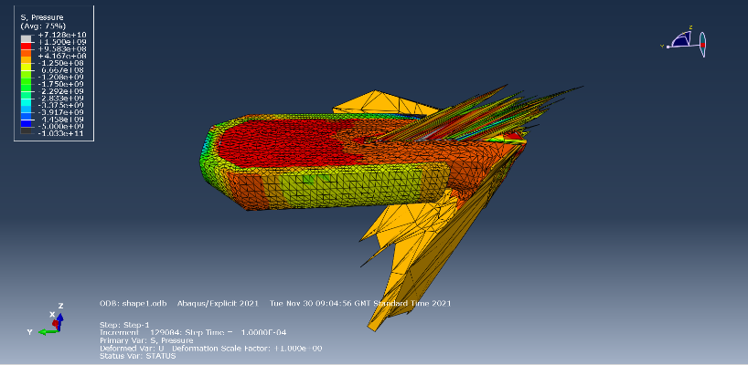
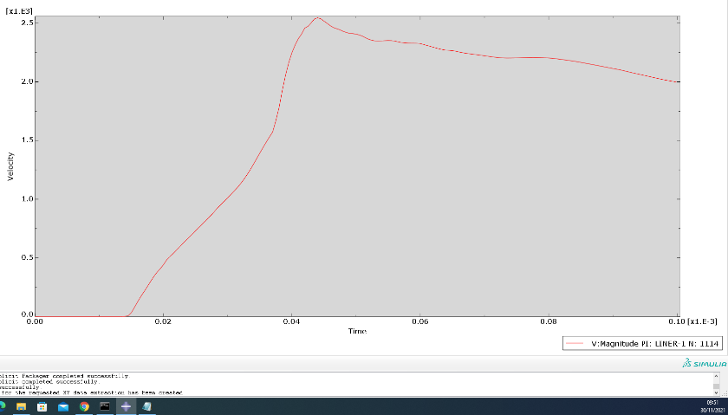
Figure 1- Simulation Diagram for TNT
Figure 2- V-T Graph for TNT

4.2 RDX
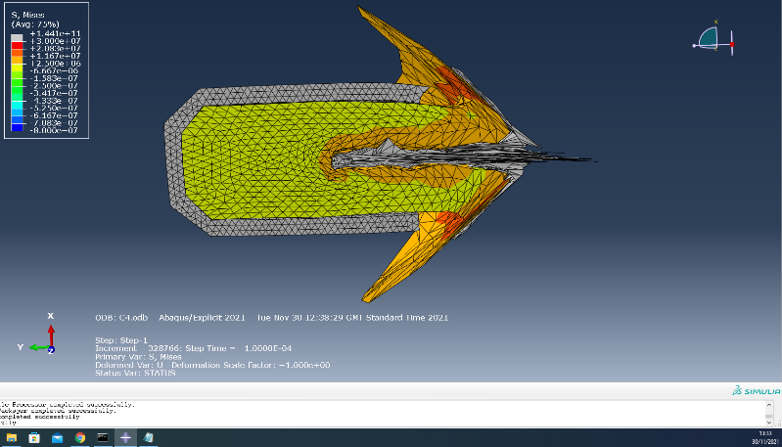
Figure 3- Simulation Diagram for RDX

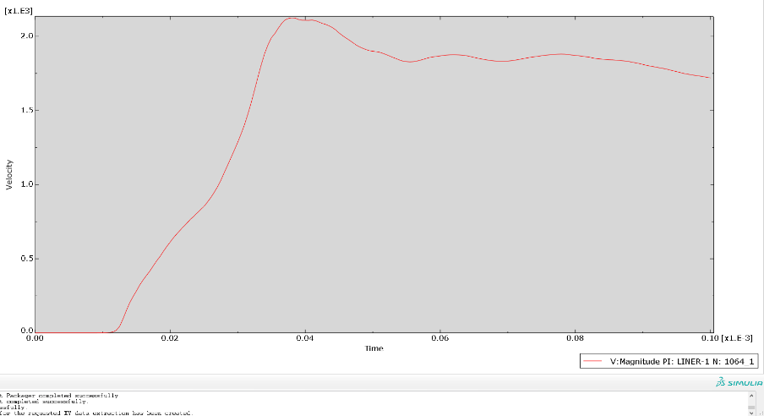
Figure 4- V-T Graph for RDX

4.3 Compound B

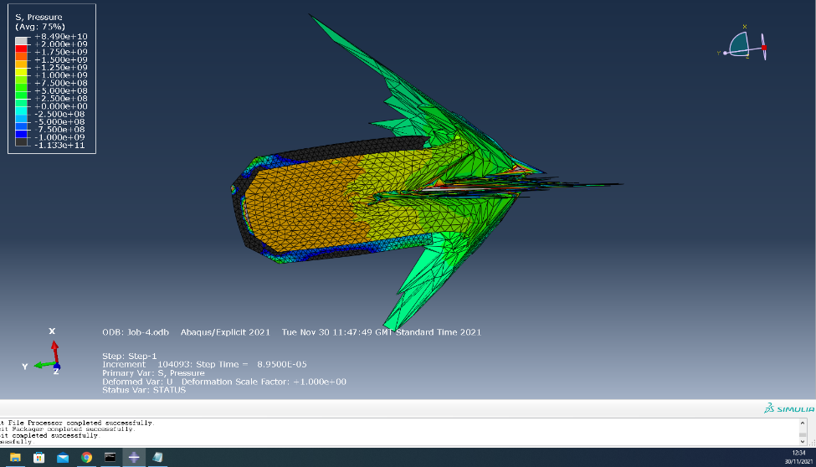
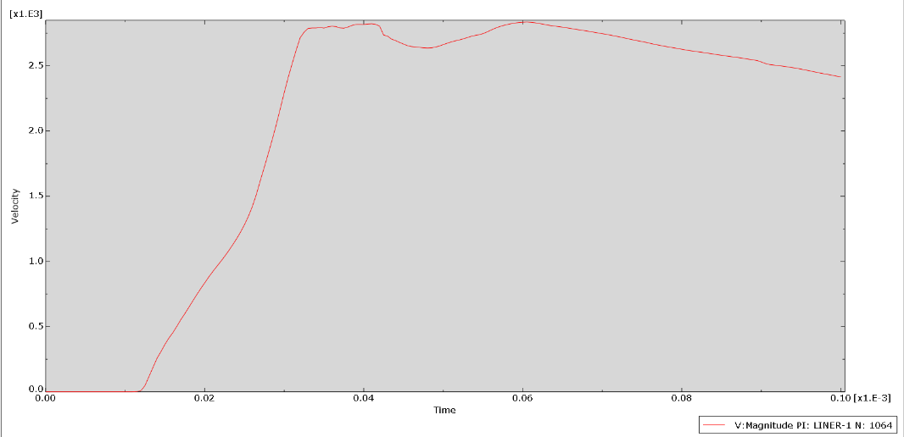
Figure 5- Simulation Diagram for Comp B
Figure 6- V-T graph for Comp B

4.4 HMX
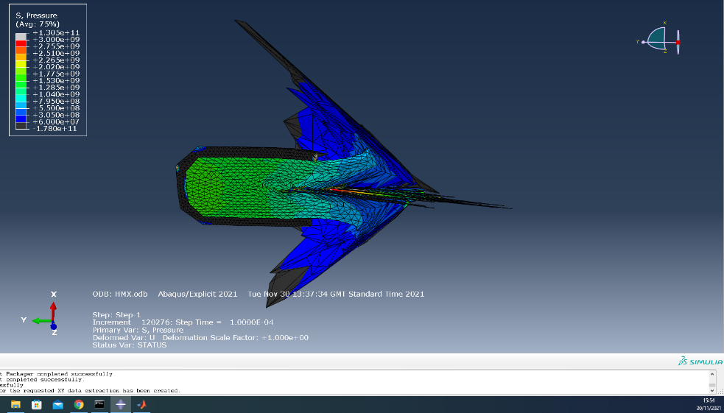
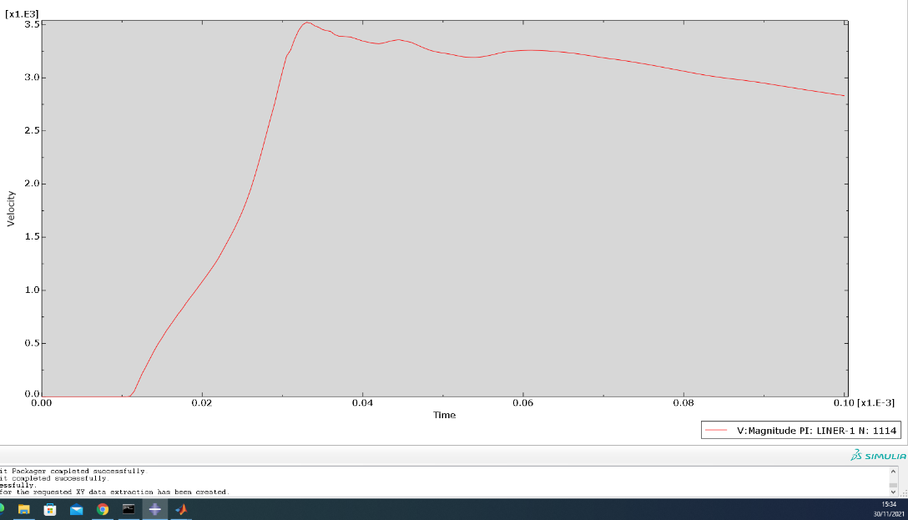
Figure 7- Simulation Diagram for HMX
Figure 8- V-T graph for HMX

4.5 AN/FO
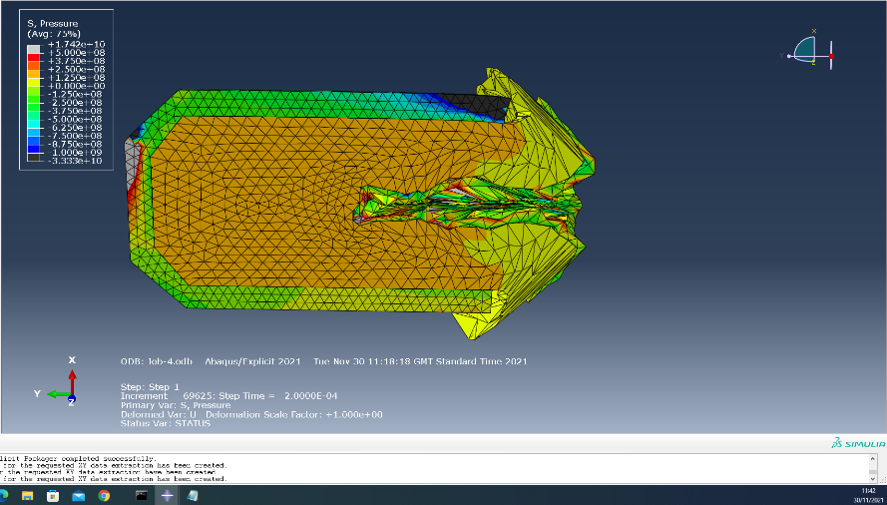
Figure 9- Simulation Diagram for AN/FO

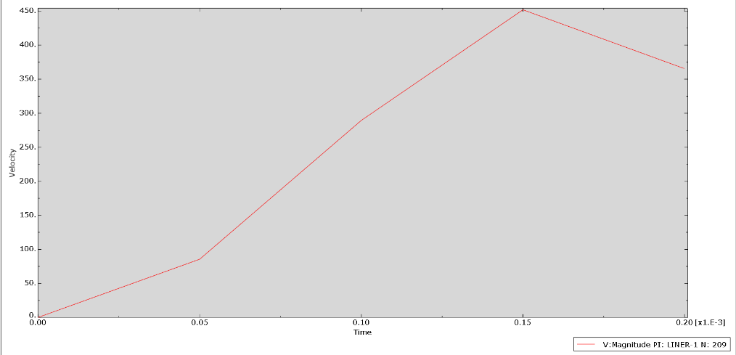
Figure 10- V-T graph for AN/FO

- Discussion
From the results presented by the simulations it shows that the TNT model produced a peak velocity of 2.5m/s after 0.045 seconds, the TNT results also displays a wide and short jet formation with the highest pressure be found in back section of the explosive with the highest pressure being 1.3e+09. The results presented by the RDX model indicate a peak velocity of around 2.2 m/s after 0.039 seconds, the diagram displayed in figure 3 illustrates a wide jet but with a thing longer jet forming at the point of the shaped charge with the maximum pressure point being found at the point of the jet displaying a pressure of around 1.4e+11. The results produced by the Compound B model show a peak velocity of 3.0m/s after 0.06m/s although the velocity-time graph does show a peak earlier in the run time, but the first peak doesn’t quite reach the heights of the second peak. Figure 5 is the simulation diagram for Compound B which displays a wide jet with a long narrow jet at the front point of the shaped charge, The maximum pressure is presented as 1.5e+09 which appears at the back section of the model. The graph produced by the HMX simulation indicates a peak velocity of 3.5 m/s after around 0.034 seconds of run time, the simulation diagram for HMX displays a narrower jet with a long narrow jet point at the front of the shaped charge which produced a peak pressure of around 2.3e+09 towards the back of the device. Comparing the results produced by the three simulation models along with the TNT base model, it is apparent that two of the simulations produced some success in producing a better model than the base model. The RDX simulation produced a significantly higher peak pressure than that of the base model but with a lower peak velocity, whereas the Compound B simulation produced both a higher peak pressure and a quicker peak velocity than that of the base model which would imply that Comp B is a better alternative to TNT. The only drawback of the Compound B simulation was that it took a slightly longer time to reach its Peak velocity, The simulation that produced significantly better results than that of the base model was the HMX simulation. This simulation produced a significantly faster peak velocity and a better shaped jet than that of the base model along with only a slightly higher peak pressure. The side section of this report was the AN/FO simulation model which disappointingly produced poor results when simulation, this model didn’t produced results which were significantly worse than the TNT base model.
- Conclusion
To conclude the four simulation models that were tested display various results, the two simulations that showed improved results were the compound B and HMX models. Both simulations delivered better peak velocities and improved jet formation when compared to the TNT base model, but the simulation that showed the most improvement was the HMX model. Overall, this simulation outperformed the base model in every aspect, but would need further testing and simulation in order for it to be consider the best replacement. The one thing that should be tested again is the RDX simulation model this is because its performance wasn’t what was expected, a reason for this may have been the quality of the data parameters that was inputted into the system for this model.

References

[1] | P. Nardone, "Chapter 2 - Well Test Services," in Well Testing Project Management, n/a, Elsevier, 2009, pp. Pages 31-72.
[2] | Z.-X. Zhang, Rock Fracture and Blasting, Svalbard: Imprint, 2016.
[3] | D. H. M. M. Joe DeGeare, The Guide to Oilwell Fishing Operations, n/a: Gulf Professional Publishing, 2003.
[4] | J. L. Q. W. Tian-bao Ma, Defence Technology, Beijing: Elsevier, 2021.
[5] | C. W. D. C. Wenlong Xu, International Journal of Impact Engineering, Beijing: Elsevier, 2019.
[6] | U. N. G. K. K. N. Samson S. Samudre, "Studies on an Improved Plastic Bonded Explosive (PBX) for Shaped Charges," Propellant, Explosive and Pyrotechnics, vol. 34, no. 2, pp. 145-150, 2009.
[7] | j. Y. Z. W. G. B. Yakun Liu, "The EFP Formation and Penetration Capability of Double-Layer Shaped Charge with Wave Shaper," Unkown, Taiyuan, 2020.
[8] | P. &. D. V. &. J. S. &. M. D. Elek, "Determination of detonation products equation of state from cylinder test: Analytical model and numerical analysis," University of Belgrade, Belgrade, 2013.
[9] | J. C. J. Q. J. G. João Pimentaa, "SMALL EXPLOSION CHAMBER DESIGN AND OPTIMIZED CONSTRUCTION BASED IN BLAST PARAMETERS," University of Coimbra, Coimbra, 2016.
[10] | S. C. I. L. e. a. Abadin H, "Toxicological Profile for RDX," Agency for Toxic Substances and Disease Registry, Atlanta, GA, 2012.
[11] | L. A. B. Mircea D. Botez, "Numerical Study of a RC Slab Subjected to Blast: A Coupled Eulerian-Lagrangian Approach," IOP Publishing, n/a, 2019.
[12] | J.F.Molinari, "Finite element simulation of shaped charges," 921-936, vol. 38, no. 10, pp. 921-936, 2002.
[13] | L. A. B. Mircea D. Botez, "Numerical Study of a RC Slab Subjected to Blast: A Coupled Eulerian-Lagrangian Approach," IOP Publishing, unkown, 2019.
[14] | the National Academies and the Department of Homeland Security, IED Attack- Improvised Explosive Devices, n/a: the National Academies and the Department of Homeland Security, n/a.
[15] | L. K. J. W. W. Andrzej Morka, "Assessment of Passenger Security in Paratransit Buses," Florida State University, Dearborn, MI, 2005.

