
APPENDIX GA36c

LEVEL 6 ASSESSMENT SPECIFICATION

Student name: |  | Student ID number: | 1703513
Programme: | Primary
Module: | Principles of Pedagogy
Module code: | M6X01438/C | Contribution to Overall Module Assessment (%): | 100%
Lecturer: | Siân Brooks | Internal Verifier: | Siân Brooks
Assignment Title: | ‘Describe a learning event which has happened during your recent school experience. Reflect upon what took place, connecting events to theories of learning and teaching. Make recommendations about how you could improve your own practice in the light of this. Produce a poster to illustrate how you would develop the elements of an effective learning environment.’ | Word count (or equivalent): | 5,000 or equivalent.
Submission deadline: | 17/10/18 (23.59) | Return date of provisional marks & written feedback: | 14/11/18
Submission method: | All written assessments, where practical and possible, must be submitted via Turnitin unless otherwise instructed by the Lecturer. (Please DO NOT put this assessment specification into Turnitin or it will match many similarities with other students’ submissions.)  Alternative submission method (if applicable):  Late submission of the assessment will result in a late penalty mark. Penalties for late submission: Up to one week late, maximum mark of 40%. Over one week late, 0%. Only the Extenuating Circumstances Panel may approve a change to submission dates.
Academic honesty / referencing: | Academic honesty is required. In the main body of your submission you must give credit to authors on whose research and ideas your work is based. Append to your submission a reference list that indicates the books, articles, etc. that you have used, cited or quoted in order to complete this assessment.

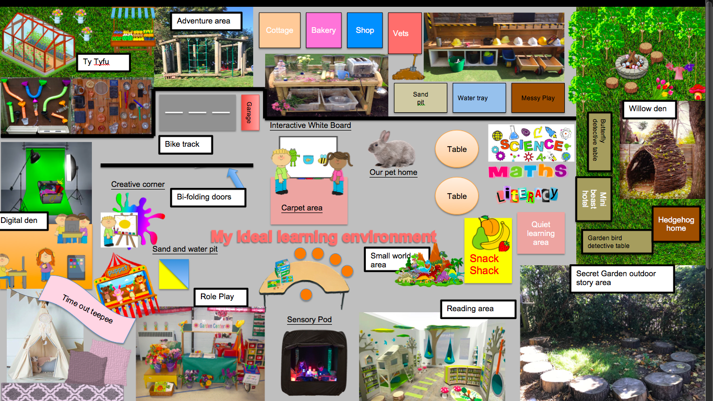
‘Describe a learning event which has happened during your recent school experience. Reflect upon what took place, connecting events to theories of learning and teaching. Make recommendations about how you could improve your own practice in the light of this. Produce a poster to illustrate how you would develop the elements of an effective learning environment.’

Throughout this assignment I will reflect on a distinctive learning event I witnessed during a recent school experience that took place in a primary school in the East of the city of Swansea, but the name of the school will not be referred to ensuring anonymity, references will also be removed. The school opened in April 2007 as the result of an amalgamation. There are 353 pupils aged three to eleven who attend the school, including around 53 pupils in the two part-time nursery classes. There are 12 full-time classes and two classes have pupils from mixed age groups. There is a higher than the average (21% in Wales) ratio of pupils with free school meal entitlement at 35%.It has been identified by the school that around 16% of its pupils have additional learning needs although only a few of them have been statement. Around 18% of pupils come from ethnic minority backgrounds and about 16% speak English as an additional language and no pupils speak Welsh as their first language. The individual school budget per pupil is £3,148. With the maximum per pupil in the primary schools in Swansea is £7,839 and the minimum is £2,665. During the school’s first Estyn inspection in 2015, the school’s current performance was rated as Good, with the school’s prospects for improvement also rating as Good. A main point highlighted during the Estyn inspection was that the ethos of the school is positive, caring and entirely child centred.
During my time at the school I completed a series of observations but feel compelled to reflect on a holistic learning event that I felt was truly effective and captured the very point made by Estyn (2018) that “the ethos of the school is positive, caring and entirely child centred”. I found this learning event personally intriguing due to the holistic learning methods involved, such methods of the child being at the centre of their own learning were originally pioneered by John Dewey (1931). Somehow over the decades, particularly since the Education Reform Act (1988) when the National Curriculum was enforced, this ethos has been slowly replaced by target setting and achieving in the classroom environment (stem.org.uk).

I was sure to meet all ethical guidelines established by the British Educational Research Association (BERA, 2011) before the observation was undertaken, I familiarised myself with the schools safe guarding policy and all guidelines were explained to participants and I had voluntary consent from practitioners to take notes specific scenarios and take photographs within the learning environment.

The learning event I’m going to discuss is Mindfulness Practice. “Mindfulness is a whole body-mind state of awareness that involves being undistracted and focussing attention whilst ‘tuning in’ to the present moment. It develops the whole brain and helps children to understand their emotions and feelings, reducing their risk of mental health issues such as anxiety and depression. Practicing Mindfulness helps children to notice the positives, and develop a sense of appreciation, gratitude and contentment” (www.kidsmatter.edu.au).

Observation
The mindfulness practice took place in the positive surroundings of the classroom on return from lunch break. It was a sunny afternoon providing the perfect environment for an active playtime so the pupils were still very lively and excitable. The class teacher explained how she has incorporated the use of mindfulness practice into Class 5’s (which consists of 9 and 10 year olds) daily routine and how every afternoon session begins with a few minutes of silent meditation. She elaborated it’s a wonderful way of enhancing pupil’s focus and calming them down after a lively playtime session. It is a whole class approach that aims to bring the attention of pupils back to the classroom setting and has each individual more fully in the present. “Preliminary research in this emerging field suggests that mindfulness has the potential to improve classroom management, teacher-student relationships and instructional strategies”(Eric.ed.gov ) .
The teacher pulled the meditation box out and placed it on her desk that was positioned at the front of the class. On return each child took to their seats and waited patiently for everyone to enter. The class teacher explained how the pupils actually look forward to the mindfulness practice as it’s the only time for tranquillity. The only resource used through out the mindfulness practice was a chime bar, this indicated to pupils when they were to change movement.
Figure 1.Transcript of language used by class teacher during mindfulness practice.

Teacher - Lets take 5 minutes to pause, sit solidly on your chairs and bring attention to your bodies
Close your eyes if that’s comfortable for you
You can notice your body seated, feeling the weight of your body on the chair’
Take a few deep breaths, Breathe in 1 2 3, Breathe out 3 2 1
Notice your feet on the floor. Notice the sensations of your feet on the floor.
Is it heavy? Or light? Cold? Or warm?
Notice your legs against the chair; again, you can feel any pressure or pulsations or lightness
It is ok if you do not notice anything at all
Just observe without judgement
Now, notice your back against the chair and look for sensations, if at all
Bring your attention into your stomach area if your stomach is tense or tight soften it
Take a breath, Breathe in 1 2 3, and breathe out 3 2 1
Notice your hands; are your hands tense or tight? Let them be softened
Notice your arms and shoulders and feel any sensation there
Notice your neck and throat let them be soft
Relax, Observe your face and soften your jaw
Let your face and facial muscles be soft, Then notice your whole body present
Take one more breathe, Be aware of your whole body as best you can
Take a breath, and then when you’re ready you can open your eyes

“To observe is to take notice, to watch attentively, to focus on one particular aspect of all of the massive stimulus in the environment” (Ramsay,2002)
I used a written observation method with the use of field notes to capture the sequence of the mindfulness practice. I chose this method because I felt it was the best way to obtain all information and immediately note down the teacher’s dialogue whilst enabling me to participate in the moment and carefully pay attention to detail of all behaviours. I didn’t want the children to become aware of my note taking so wanted the observation to be as covert as possible not to trigger the ‘Observer effect’, where the behaviour of those under study may alter (RIP.co.uk). I wanted the children to behave naturally and to ensure their behaviour didn’t change due to my presence, so as not to interrupt the calm atmosphere or distract anyone involved. No names were mentioned in the notes to ensure confidentiality to the child. I initially considered bullet pointed notes of the session but then decided to write everything down word for word that the teacher said to ensure accuracy and reliability for my reflective account. This I believe was achieved although I feel the negatives to the method was that the speech of the teacher is very quick paced compared to the speed at which I could write.

Even though note taking is beneficial in this environment I do feel it would have been useful to video record the class during the mindfulness practice session as each child responded uniquely to the practice and engaged with the class teacher in individual ways. Details like this are difficult to capture in notes and a recording could have enhanced the detail available for my reflection. However a negative of this technique would be needing to gain consent from all parents and this could have been both problematic and time consuming (Hobart and Frankel 2009) and it was only with hindsight I realised the impression the session would have on me.

I was enthralled by the reaction of the children to such a practice, I had never witnessed mindfulness used in a primary school setting before and I was so absorbed that I asked the class teacher to explain to me in more depth what it was and how it worked. I felt this was pedagogy at its best with instructional approaches implemented in the classroom, positive interactions between teachers, students, and the learning environment and the learning tasks. The class teacher explained to me how she is currently one of few qualified to deliver the practice, but that very quickly schools are discovering how it may improve academic performance. She explained how beneficial she felt the practice was for her class and explained how her and the school’s head were in discussion to start running after school mindfulness classes for parents and guardians of pupils within the school so they could beneficially learn to use the technique at home.
“The best thing parents can do to help their children become more mindful is to commit to some regular mindfulness practises themselves! Research shows that parents and carers who practice being mindful around their children contribute to improving their child’s sense of self-worth and self-esteem. The more present and mindful you are with your children, the more happy, mindful and resilient they will be”. (kidsmatter.edu.au)

While most studies have focused on adults, new research is surfacing on the power of mindfulness as an intervention for a number of behavioural challenges that children face as mindfulness can improve the mental, emotional, social and physical health and wellbeing of children, contributing to reduced stress, improved sleep and heightened focus (Gregoire, 2014). It is because of this that mainstream schools around the world are now actively implementing programs that recognise the importance of nurturing a child’s social, emotional, mental, spiritual and cognitive wellbeing. Over the past five years, mindfulness has been spreading rapidly through schools, where more than 1,700 people have attended courses run by the Mindfulness in Schools Project, to introduce mindfulness curriculums and training to young people and their teachers and it is estimated that it has reached 18,000 pupils through people trained on these courses (Guardian.com 2016). Greenberg and Harris (2012) however suggest that there is not yet sufficient scientific grounding that supports the merits attributed to such practices, to account for the enthusiasm with incorporating them in the curriculum.
“Whilst scientific grounding is lacking, Randomised control trials (RCTs) with adults and young people have shown moderate impacts on mental and physical health, social and emotional competences, and performance of various kinds, and on many indicators of quality of life and wellbeing. MRI (brain scan) studies suggest that mindfulness meditation reliably and profoundly alters the structure and function of the brain to improve the quality of both thought and feeling” (Mindfulnessinschools.org). This can only be positive with growing concerns around recent statistics by the Children’s and Young People’s Task Force (2015) suggesting that 1 in 10 children and young people need support for mental health difficulties (Gov.UK 2015). Over the last decade, there has been a growing interest in school-based interventions that promote resilience, improve emotional health and prevent mental health problems from arising (Department for Education, 2010; The Children and Young People’s Mental Health Taskforce, 2015).
Such interventions have recently been recognised in the Donaldson Report (2015) where a continuing theme in the evidence was the importance of wellbeing, and in particular mental health. “Schools need to care both for children and young people’s physical and emotional needs and help them to take responsibility for their own lives, understanding the importance of, for example, diet and fitness and being confident in managing their own affairs. Independence, self-reliance and respect for others should be fostered throughout the teaching and learning process”(Donaldson Review, page 28).
Learning theories

Learning theories are conceptual frameworks that describe how information is absorbed, processed, and retained by individuals. Each learning theory has its own perspective on how human beings learn. Pragmatists such as John Dewey suggested that for learning to take place, reality must be experienced. He promoted progressive and child centred education through teaching based on integrated learning . Such ideas are in line with Vygotsky and Montesouri who promoted ideas of child centred education of activity and interaction as part of the social world of children and their communities. This encouraged a more holistic approach to learning ideas that were first raised by Rousseau, Pestalozzi and Froebel (Nuttbrown and Clough 2014). For Pestalozzi, education was rooted in human nature; a matter of head, hand and heart. As Brühlmeier (2010) has commented, ‘Pestalozzi has shown that there is more to education than attaining prescribed learning outcomes; it is concerned with the whole person, with their physical, mental and psychological development’.
Behaviourism, Cognitivist-Constructivism and Humanistic approaches to learning also help to explain the process of how children think, develop and learn. Amongst notorious learning theory pioneers are Carl Rogers, Ivan Pavlov, Jean Piaget and Vygotsky. Humanistic learning is a person centred approach that sees the individual having free will to make their own decisions in life and according to Maslow (1962) striving to reach self actualisation or to be the best they can be when all their needs are met (McCleod 2018). Humanistic educators consider the whole child, including moods, feelings and thoughts. Carl Rogers was a pioneering psychotherapist during the 1950s—1980s and a founder of humanistic, client centred psychology. In 1969, Rogers published a book that adapted his humanistic approach to education called Freedom to Learn: A View of What Education Might Become. Out of this came the “learner-centred model” where Rogers attacked traditional education in favour of a classroom atmosphere that is student-centred with “an unstructured or non-directive approach… to build a more exciting and stimulating classroom" (Smith, 2002). This student-centred model empowers individuals to take part in their learning. Rogers states “Humanistic education is all for the sharing of power and empowering individuals to make decisions and choices for themselves” (as cited in Robinson, 1985, pp. 100-101). Rogers firmly believed that relevancy to the student was critical for learning: if students cant see the importance in what they’re learning, they will not learn it. He believed that when students feel that they are being forced to learn they become disengaged and the learning environment is destroyed. Instead they should be supported and feel free to explore concepts and connections in their own way with the teacher as a facilitator of learning who provides a wealth of resources (Rogers, 2001).

Behaviourism refers to the psychological approach which focuses on the connection between stimulus and response and believes when children are born as a ‘blank slate’ and behaviours are learned through interaction with the environment, through classical conditioning as were Pavlov’s dogs (1927) operant conditioning as were Skinner’s rats(1948) and observational learning as was Bandura’s bobo doll (1963). Behaviourism is primarily concerned with observable measurable behaviour, as opposed to internal events such as thinking and emotion. Behaviourists believe there’s no fundamental distinction between humans and animal behaviour and that research can be carried out on animals as well and humans and will provide the same results. Behaviourists are criticised for their work as it is maintained that the theory is deterministic as it ignores individual free will and is reductionist in that it does not give enough attention to biological factors, the thinking process and innate feelings (McCleod 2017).

Such criticisms led many to a constructivist view on how children learn, originally pioneered by Jean Piaget (1896-1980) who is considered to be one the most influential psychologist of the 20th century and described as “the great pioneer of the constructivist theory of knowing”, cognitive constructivism derives from his work. He saw learning as a process, which evolves as the result of children interacting with the environment and moving through certain stages of development (Piaget 1976). Piaget proposed that children learnt through cognitive conflict, where knowledge that already exists, is challenged by new experiences (Pritchard 2015). He explained children should then use this to reconfigure their own mental schema, and they must go through this process completely independently so they will be able to formulate their own ideas and understanding. He favoured the expression ‘construction rather than instruction’ as he felt children learn best through doing things for themselves (Piaget, 1976). Piaget labelled children as ‘lone scientists’ as he was convinced they learn best when they do things for themselves, rather than receive instructions from adults. Recently critics have questioned the basis of Piaget’s theories as they felt his experiments were too abstract for children to perform well in and that many conclusions do not have enough credibility so do not accurately reflect the intellectual accomplishments of which many young children are capable (Clough and Nutbrown 2014).

Where as Piaget saw children as ‘lone scientists’ Lev Vygotsky (1896-1934) saw them as ‘little apprentices’. He challenged the idea that child development is a universal, natural process and was one of the first theorists to disagree with Piaget. Where as Piaget focused on the individual, Vygotsky emphasised the social and central role of language in cognitive development. His notion of the zone of proximal development (ZPD), which is used to described the gap between what a child could do alone and what they could potentially do with the help of a more knowledgeable other whether an adult or a child. Vygotsky believed it is better to have learners working alongside someone at a level slightly higher because children should always be challenged by some activities that are just beyond them, as this would motivate them and move their learning forward. This is referred to as ‘scaffolding learning’ where children can move from the actual zone of development to the proximal zone of development (Vygotsky, 1978). This contrasts with Piagets view that children should be left to pass through the stages of development naturally with little intervention.

Mindfulness practice within the classroom lends itself well to the humanistic approach. The humanistic approach to learning revolves around child centred learning, meeting the emotional needs of learners and places well being, emotional factors and personal growth as the highest values within education. Carl Rogers (1902-1987) used a therapeutic technique known as client-centred therapy in helping individuals deal with problematic issues this transpires in a classroom environment as child centred learning. This student-centred model embraces student differences and empowers individuals to take part in their learning, preventing disassociation from learning that was recognised in the Donaldson Report (2015). He recognised that currently the curriculum experienced by children and young people is too focused on the short term and the mission of primary schools can almost be reduced to the teaching of literacy and numeracy and of secondary schools to prepare for qualifications. Implementing external expectations has diminished the enjoyment of the classroom environment, the learning process and creativity, disconnecting children from the educational journey. Disengagement from the classroom environment is not a new issue, Whitehead (1929) wrote of inert ideas being a perennial problem in education. “Our primary connection with the physical world is through our body and senses but when we become preoccupied with the activities of the cognitive mind such as reading, writing, thinking and talking our sensory awareness moves into the mode of semi consciousness and we do not fully experience what greets our senses”.Bai (2001) also writes of disembodiment in educational practice and how this poses the inability for learners to translate knowledge into action. He further proposed the practice of mindfulness as a tool to recover the ability to value the world intrinsically enabling us to embody the knowledge we gain. The translation of knowledge into action is what education is for and what pedagogy is all about. Students must put their knowledge into action and interact with their environment if they are to adapt and learn.

Mindfulness practice puts the wellbeing of the child at the centre of the learning experience giving the opportunity to engage in the present moment, helping them to regulate their emotions, manage impulsivity, focus better, resolve conflict with themselves and others whilst learning how to become compassionate and empathetic (mindfulnessinschools.org). Finally, incorporating mindfulness into daily routine there is a sound basis for situating work on emotional health and wellbeing within the context of pedagogical practices, supporting pupil autonomy and self efficacy through promoting greater pupil choice and focusing on mastery of learning tasks rather than performance outcomes and social comparison goals.

Based on the information gathered and the knowledge I have gained on the beneficial effects mindfulness has on children, it will certainly be incorporated into my future practice. The modern world is extremely chaotic for many children, with a recent study from the Mindfulness in School Project (2018) showing that children as young as six are now suffering from stress. Its’ growing more evident that the modern child needs new coping skills for addressing worries that are detrimental to their overall well being. Evidence suggests that children as young as 5 are unable to hold concentration for more than ten to twenty five minutes which indicates they are disengaged with learning. As a practitioner I would take a child centred approach and take responsibility to incorporate these skills into the children’s daily routines and encourage the use of mindfulness. I will be sure to conduct a silent meditation session every day to ensure pupils engage tranquillity and are able to stay on task. For this to be successful, I will need to create a positive haven of learning within my learning environment.
.My Ideal Learning Environment
The work of Maria Montessori (1870-1952) emphasised the cognitive importance of children’s environments. Pickett and Fraser (2010) state that effective learning environments are inspirational areas that celebrate excellence. They focus on high quality learning, that ensure everyone has access to prompts and learning cues to strengthen independence and continuously further development. Tassoni (2008) states a rich and varied environment supports children’s learning and development. Within this section insight into my ideal learning environment and facilitation of a positive learning experience will be explored. My mission as a Foundation Phase practitioner is to create a safe, exciting and happy haven for learning ensuring all pupils are given the support respect and opportunities they need to learn, grow and achieve.

A Pupils voice is crucial. It is extremely important for pupils to feel they are active participants within their learning environment and because of this ‘pupil participation’ and involvement will be a key area within my ideal learning environment. The Estyn Report (2018) highlights how effective participation benefits pupils and helps them improve in all areas. It suggests pupils should have a breadth of opportunity to participate within the classroom, contributing to debate and influencing decisions as this encourages and benefits pupils to develop the skills needed to become active citizens.

There is great emphasis on children actively participating in experiential learning through outdoor play. . Waite (2017) stressed the importance of learning outside the traditional classroom.The Foundation Phase Framework for Wales 2018 (Gov.Wales 2018) places a great emphasis on outdoor learning promoting discovery and independence and experiential learning. The outdoors offers unique opportunities to enrich and enhance learning, to be creative, move around, to be noisy and to take risks. Natural stimuli such as weather, textures, sounds, smells enable children (according to Soebel (2008) ) to “discover the world through their senses as wonder and curiosity guide their outdoor experience”. Children reflect and learn about themselves and the environment through firsthand experience. Dowling (2014) stresses the importance of an outdoor learning environment as children in the early years have an inborn affinity, curiosity and fascination with the natural world, and they need to explore the outdoors in order to build up valuable information about the world outside. “The outdoor area is a complete learning environment, which caters for all children’s needs, cognitive, linguistic, emotional, social and physical ” (Bilton, 2010, p.1)
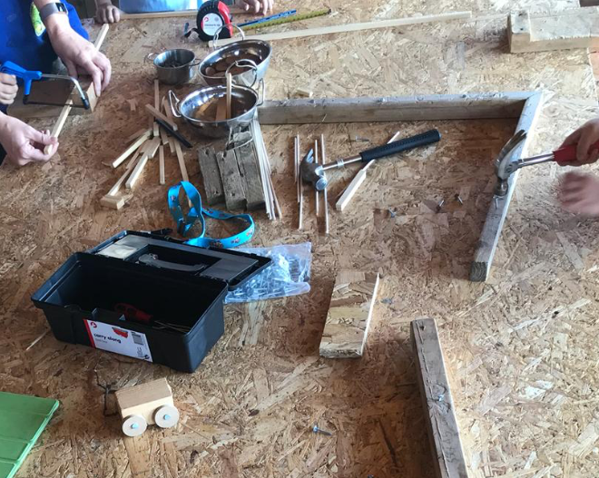
In pursuit of this experiential learning I have placed a number of learning resources within the outdoor area of my ideal learning environment. There is a ‘Secret Garden’ an area dedicated entirely to the acts of outdoor story telling providing children with a sense of admiration towards nature, motivating them to engage in story time whilst encouraging them to connect with the wonder of the world around them (Thinking Child, 2014). The Secret Garden will include a ‘tinker table’ (Figure 2) in which with guidance children will be given the opportunity to use hammers, saws and screws to create their own artefacts. Walker et al (2008) state that physical risk and challenge often add excitement to learning tasks, taking part in activities they think include risk can be excellent for children’s learning. The Royal Society for the Prevention of Accidents (RoSPA) argues that children need challenges as it’s healthy for their development; they need to learn about risk, their own capabilities and to develop the mechanism for judging in a controlled setting.

Figure 2. Pupils creating artefacts with the use of multiple tools on the outdoor ‘tinker table’. Image taken by myself with consent of the school.

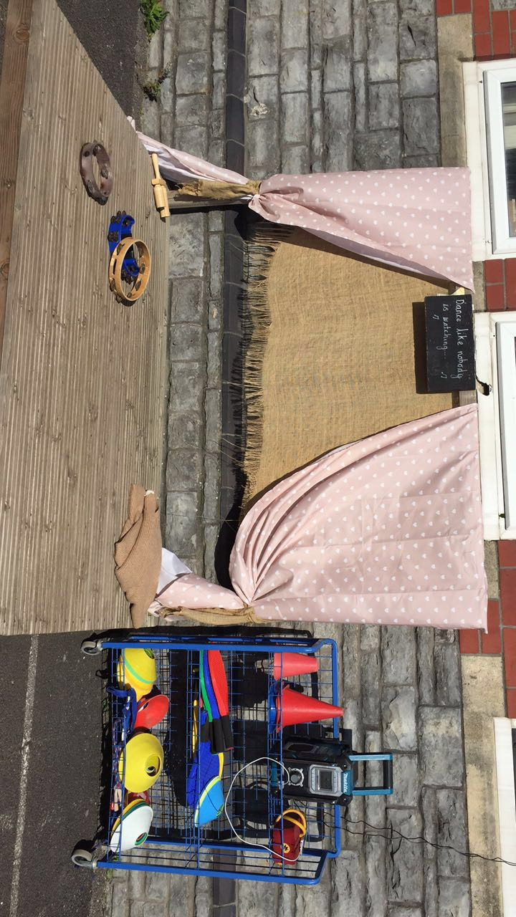
One of the four purposes of the new curriculum in Wales is to create enterprising, creative contributors who are able to think creatively and express ideas and emotion through different media (Donaldson, 2015). This has prompted the idea of a role play area both inside and out of my ideal learning environment that will link to class topics. A puppet theatre to encourage children through the use of puppets to express their emotions will also have a place. Historically role-play has been seen as a great tool to enhance learning with the Regio Emilia approach encouraging expressive arts and dramatic play as an excellent way to teach children about the world. Through imaginary role-play, they are able to be creative and imaginative whilst encouraging self- expression. Friedrich Froebel (1782-1852) also highlighted the importance of free self expression and the development of children, alongside maths and literacy. He encouraged children to explore their creativity through expressive arts such as music and dramatic play he promoted the idea of exposing children to nature and beautiful objects in order for them to do so. He proposed that children think at their highest level when they play imaginatively (as cited in Beaver et al 2008). To support Froebel’s ideas, the outdoor area of my ideal learning environment will include a variety of resources including a mud kitchen, small world garden, music wall and dramatic stage so that the children’s imaginations can be developed fully.

Rossett House Nursery in Wrexham have developed innovative outdoors learning experiences that engage children and help them develop literacy and numeracy through role-play offering many excellent learning opportunities for children (Estyn, 2018). Taking this on board, the outdoor area of myideal learning environment will include a role play with a cottage and cafe, a shop, a bakery, a garage and a builder’s yard. Each area within the village will include authentic resources. The garage will include a toolbox, the shop will provide a till with coins and weighing scales, the mud kitchen and outdoor café will include pots pans, cutlery and food and the builder’s yard will include a receipt book, tape measures and rulers. I have decided to use real resources as I have seen them used first hand in a recent bridging experience and its evident that dealing with legitimate resources such as ten pence coins and a till have more meaning to pupils, there is a sense of reality incorporated with their imaginary play and through this pupil’s life skills will be enhanced and developed in real life context. There will be pens and paper within each area so children are able to develop their writing skills freely through their play. Children’s numeracy and literacy skills will be transferred throughout each area of the village, they will count coins in the shop, write letters in the cottage and pay for their purchases in the bakery.
A ‘Ty tyfu’ greenhouse where children can go to plant flowers and grow fruit and vegetables, and an area where they can create their own pumpkin patch will be included. There will also be bird and butterfly detective tables where children can sit and explore the creatures whilst using resources such as magnifying glasses and binoculars. There will be a cycling area and a climbing frame in the outdoor learning area so children can develop and improve both fine and gross motor skills.
Stephenson (2002) claims evidence from her study suggests that whilst learning outside children where more involved in projects and could hold their concentration for longer periods of time. This is supported by Bird (2009) who discuss the powerful effect of the natural environment on a child’s learning and suggest children become less hyperactive and can concentrate better whilst learning outdoors and that children with outdoor experience show greater skills in concentration, play, motor ability and control.

I have included a ‘digital den’ within my ideal learning environment as ICT is becoming increasingly intertwined with everyday life, especially within schooling and education. Digital competency has a major role within my teaching experience, as it is one of three cross-curricular responsibilities. The new digital competence framework is committed to ensuring that all learners in Wales become more digitally competent, to evolve into enterprising, creative and critical thinkers. It encapsulates the skills that will help learners thrive in an increasingly digital world (Learning Wales, 2018).
Donaldson (2015) explains how today’s children already inhabit a digital world and their personal, social and educational lives are increasingly intertwined with technology and the need will only progress as time evolves. Responsibility is on practitioners to ensure children are more than consumers of ICT and develop the knowledge and skills required to use that technology creatively as future members of a digital competent world. Allen, Potter and Sharp (2012) support this and suggest ICT prepares pupils to participate in a rapidly changing world and we would be failing the children if we didn’t encourage digital competency and equip them for their future. It is crucial that practitioners confidently implement ICT into pupil’s daily routine ensuring its being used effectively across all areas of the curriculum. Selmi et al (2015) state “the effectiveness of technology within lessons does not depend on the product, rather, it depends on how that product is being integrated”. Johnstown Primary School in Carmarthen encourage online resources and through doing so, pupils develop their digital competence skills in lessons. Social skills through using ICT are also developed as they work together to implement a variety of online resources into their work. Through the use of ICT the school is able to engage with parents whilst building positive relationships throughout, as pupils enhance their numeracy and literacy skills as their confidence blossom (Estyn, 2018).

My digital den will be equipped variety of digital resources such as laptops, iPad’s, QR Codes, earphones, virtual learning headsets and a green screen. I have chosen to add virtual reality headphones as Sternig et al (2017) conducted research that suggest they increase pupil’s motivation and engagement. ICT will be used throughout my ideal learning environment to enhance communication, not replace it. I will provide a dress up box with the green screen of my digital den so pupils can freely explore their creativity and get into character using a background setting of their choice, whilst other pupils develop their ICT skills by filming them with the use of I pad’s and cameras.

A ‘time out tent’ will be present as a calming corner of the classroom for pupils to get some space if they feel they need to take a break and briefly get away from a frustrating task or over stimulating activity as this will help prevent negative behaviour from occurring. It will be set up in a quiet corner of the room with enough privacy for the students whilst still allowing them to engage in classroom activity if they want to. It will be a tepee tent equipped with soft furnishings and soothing materials as well as a set of visual calming strategies to provide self-managing reminders for distressed pupils.

WAG (2018) state that 29% of children in Wales live in poverty and hunger is a barrier to learning. A ‘snack shack’ area within the learning environment is provided offering fresh fruit or vegetable snacks to pupil’s every day, that pupils have grown themselves in the Ty tyfu With wellbeing at the heart of my ideal learning environment this will ensure that children are able to focus throughout the day.

A horse shoe shaped table is also present where pupils will participate in focused tasks. The practitioner sits in the middle and the pupils will sit on colourful flexi-stools that gently rock, grouped along the outside allowing pupils to see each other as well as the teacher. This format may increase student participation with increased on-task behavior and fewer disruptions.
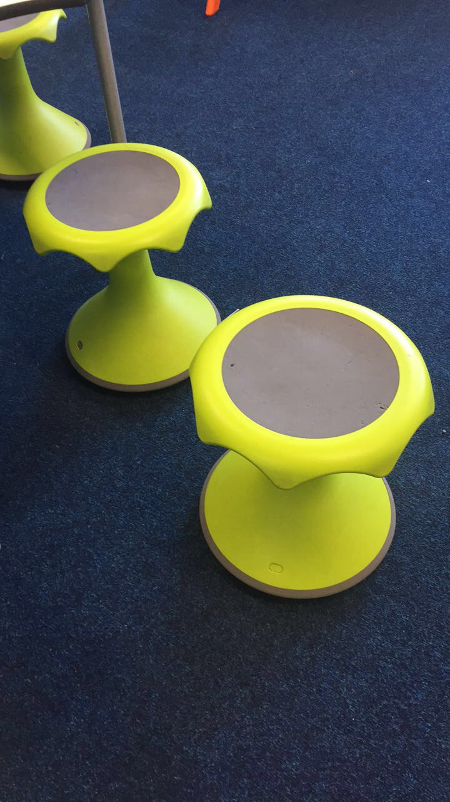

Figure 3. Flexi Stools used within a learning environment. Image taken by myself with consent of the school

Sanger, Thierry and Dorjee (2018) believe that creating opportunities for children to actively use their senses as they explore their world through sensory play is vital for brain development and the nervous system. Because of this, my ideal learning environment will include a sensory pod filled with soft spotlights and plenty of sensory materials that will create a relaxing and calming yet stimulating environment helping to sustain children’s concentration.

References
- Allen, J., Potter, J. and Sharp, J. (2002). Primary ICT. SAGE Publications.
- Bai, H. (2001). “Beyond Educated Mind: Towards a Pedagogy of Mindfulness,” in Unfolding Bodymind: Exploring Possibilities Through Education, eds. B. Hockings, J. Haskell, & W. Linds (Brandon, VT: The Foundation for Educational Renewal), 86 - 99.

- Beaver, M. (2008). CACHE Level 3 Child care and education. Cheltenham: Nelson Thornes.
- Bilton, H. (2010). Outdoor Play in the Early Years. London: David Fulton. Bradshaw, J. (2016). The well-being of children in the UK. Bristol: The Policy Press.
- Bradshaw, J. (2016). The Well-Being of Children in the UK. Bristol: The Policy Press.
- Brühlmeier, A. (2010). Head, Heart and Hand. Education in the spirit of Pestalozzi. Cambridge: Sophia Books.

- Dowling, M. (2014). Young Children's Personal, Social and Emotional Development.
- Epstein, R. (2003). Mindful Practice in Action (II): Cultivating Habits of Mind. Families, Systems, & Health, 21(1), pp.11-17.
- Erwin, E. and Robinson, K. (2015). The Joy of Being: Making Way for Young Children's Natural Mindfulness. Early Child Development and Care, 186(2), pp.268-286.
- Guardian.com (2016)https://www.theguardian.com/education/2016/jan/26/mindfulness-craze-schools-university-near-you-cambridge Accessed on 14/10/16.
- Grigg, R. (2015). Becoming an Outstanding Primary School Teacher. 2nd ed. P.17.
- Hobart,C & Frankel,J (2009) Child Observation and Assessment. 4th Edition.
- Nutbrown,C & Clough,P (2014) Early childhood Education (History, Philosophy and Experience) 2nd Edtion. Sage. London
- Pickett, L. and Fraser, B. (2010). Creating and Assessing Positive Classroom Learning Environments. Childhood Education, 86(5), pp.321-326.
- Ramsay, et al. (2002) Essentials of behavioural assessment, New York : J. Wiley & Sons.

- Robison, E.H. (1985). Education for the 1980s and beyond: An interview with Carl Rogers. The Journal of Humanistic Education and Development, 23(3), 98-110. Accessed at https://onlinelibrary.wiley.com/doi/abs/10.1002/j.2164-4683.1985.tb00262. On 10.10.18.

- Rogers, C.R. (2001). ‘Client-Centred Therapy: Its Current Practices, Implications and Theory’ London, UK: Constable.

- Schaffer, H.R. (2004) Introducing Child Psychology. Blackwell. Oxford.

- Schnack, K. (2010). Childhood and Nature: Design Principles for Educators; David Sobel, Portland, Maine, USA: Stenhouse Publishers, 2008, 174 pp. ISBN: 978-1-57110-741-1. Australian Journal of Environmental Education, 26, pp.107-109.
- Schonert-Reichl, K. and Lawlor, M. (2010) ‘The Effects of a Mindfulness-Based Education Program on Pre- and Early Adolescents’ Well-Being and Social and Emotional Competence Mindfulness, 1(3), pp.137-151.
- Selmi, A., Gallagher, R. and Mora-Flores, E. (2015). Early Childhood Curriculum for all Learners.
- Smith, L. M. (2002). Rogers, Carl (1902-1987). In Encyclopedia of Education. (Vol. 6, pp. 2076-2079). New York, NY: Macmillan Reference USA.
- Tassoni, P. (2012). Penny Tassoni's Practical EYFS handbook. Oxford: Pearson Education.
- Waite, S. (2011). Teaching and Learning Outside the Classroom: Personal Values, Alternative Pedagogies and Standards. Education 3-13, 39(1), pp.65-82.
- Walker, M., Brewster, J., Neaum, S. and Tallack, J. (2008). Childcare and Education. Cheltenham: Nelson Thornes.
- Whitehead, A. N. (1929). The aims of education and other essays. London: The Free Press.

Websites
- https://www.bera.ac.uk/
- https://www.estyn.gov.wales/language
- Gov.wales. (n.d.). Welsh Government|Foundation Phase. [online] Available at: https://gov.wales/topics/educationandskills/foundation-phase/?lang=en [Accessed 17 Oct. 2018].
- Mental Health Foundation. (2018) Children and Young People. [online] Available at: https://www.mentalhealth.org.uk/a-to-z/c/children-and-young-people [Accessed 17 Oct. 2018].
- Mindfulness in Schools Project. (2018). Why Do It - Mindfulness in Schools Project. [online] Available at: https://mindfulnessinschools.org/mindfulness-in-education/why-do-it/ [Accessed 17 Oct. 2018].
- https://www.simplypsychology.org/saul-mcleod.html
- US, M. (2018). Classroom Pets Aren't Just for Fun: New Research Reveals Animals' Positive Impact on Students. [online] Prnewswire.com. Available at: https://www.prnewswire.com/news-releases/classroom-pets-arent-just-for-fun-new-research-reveals-animals-positive-impact-on-students-300510881.html [Accessed 17 Oct. 2018].
- Wildernessawareness.org. (n.d.). Storytelling and Nature Education | Wilderness Awareness School. [online] Available at: https://www.wildernessawareness.org/articles/storytelling-and-nature-education [Accessed 17 Oct. 2018].
- Robinson, E.H. (1985). Education for the 1980s and Beyond: An Interview with Carl Rogers ‘The Journal of Humanistic Education and Development’ 23(3), 98-110. Accessed at https://onlinelibrary.wiley.com/doi/abs/10.1002/j.2164-4683.1985.tb00262. On 10.10.18.

