Module Title:
personnel resourcing and development
Module Code:
BMIH5005

Assignment: Essay
How to engage employees through employee lifecycle

Lecturer’s Name:
Emma Roberts
Student Name:
Wahidur rahman
Student ID:
1908557

Introduction
People who devote their full selves to their work are more likely to produce excellent results and to go above and beyond what is expected of them. All companies must have effective plans in place to increase employee engagement because it affects productivity, company culture, employee turnover, output, relationships with customers, and long-term profits (Osborne & Hammoud, 2017). When this does take place, there is a subsequent rise in both productivity and the number of tasks that are completed. Employee engagement, in its broadest sense, refers to a workplace strategy that is used to increase workers' enthusiasm for and commitment to their positions, teams, co-workers, and the company (Gupta & Sharma, 2016). This essay will use a model of the employee lifecycle to further investigate the concept of employee engagement. The essay will also investigate HR's part in the driving forces behind employee motivation. The essay also recommends a model that includes instructions on how to motivate employees to actively participate in their jobs be followed, along with the advice on how to do so. The essay illustrates its points of view by referring to several different experiences that involve hotels. The study ends with a conclusion that restates the essay's main point.

Human Resources' Role in Employee Engagement
Employee engagement is more complex than it initially appears since it influences every component of human resources management. In other words, engaged employees are those who enjoy their jobs, have supportive managers and co-workers, and believe that their careers are on the right track (Raziq&Maulabakhsh, 2015). To engage workers successfully, human resources have to have a comprehensive understanding of the employment agreement. HR must make sure employees have access to the right resources, training, and working conditions in order for them to perform their tasks efficiently (Albrecht et al., 2015). Additionally, HR needs to keep up with employee training and development to maintain their enthusiasm for coming to work. Ensure that employees have clear paths for professional development. Employees that take pride in their job are aware of their responsibilities. Whether it be a personal or professional goal, everyone is working toward something.
The hotel industry employs a wide range of people. The demands of housekeepers and wait staff are very different from those of secretaries, distributors, and managers. However, since they all reflect the hotel's hospitality culture, it is crucial that you train every employee (Casey &Sieber, 2016). In the service industry, many individuals start at the bottom and work their way up. Training and growth are therefore essential in the hotel industry. It is advantageous to have a constant temperament and method of operation. There are several educational options in the hotel industry (Armstrong, and Taylor, 2020). Strong communicators in the workplace are extremely beneficial to both businesses and employees. For that purpose, it is essential that every hotel employee speak English well. It's possible that your staff won't be familiar with the visitor's past. Therefore, it is essential to develop the abilities required to get along with people from a variety of cultural backgrounds. In addition, the workforce is frequently perceived by outsiders as a single, unified entity. Collaboration and diversity education must be prioritised to achieve this. By fostering a sense of unity, the human resources division may also increase teamwork. Two ways to improve teamwork and communication at work are to hold friendly competitions and give out freebies like cookies and cold drinks.

Employee Lifecycle
An employee's time spent working with your company will always be limited. In the employee engagement lifecycle, employment is viewed as a cyclical phase (Kwon & Park, 2019). Former employees continue to have sway over others who may recruit them in the future. The six stages of the employee engagement lifecycle route are attraction, recruiting, on-boarding, development, retention, and separation (Cattermole, 2019). At any point in the life cycle, you cannot afford to stop talking with your personnel. All of these stages are necessary for the organization's and its workers' success. The six phases of an employee's lifespan are as follows:
- Attraction: Prior to recruiting, attraction frequently takes place when a candidate is still simply a possible possibility. They are presumably asking their friends, relatives, and co-workers about the reputation of the company and if they have ever worked with, collaborated with, or purchased from them. By speaking to potential employees' real motivations and interests through your employer and consumer branding during the attraction phase, you may pique their interest (Kashive et al., 2020). To do this, you must understand both their personal goals and what they want to achieve by working for your business. Be the same on all platforms, whether it's social media, live events, your website, or word of mouth. There are some differences due to the understanding of different generations such as milennials and Gen z. Milennials have an average of 29% of engagement therefore needing to boost this by 75%, therefore companies need to adjust workforces in order to keep up with the skills by candidates from the Gen z.
- Recruitment: The time spent locating and persuading excellent applicants to join your team is known as recruitment, and it is the second stage of an employee's life cycle. Recruitment takes place when a position is either vacant or freshly created (Torrington,et al; 2020)The best recruitment strategies enhance the candidate experience, enable collaborative hiring based on predetermined standards and guidelines, and provide useful information that can be used by organisations to make future hiring choices (Van Zyl et al., 2017). One of the best ways to fill a position is through word-of-mouth recommendations from current employees. They will have connections among their peers who would be excellent candidates for the position you are offering because they are working professionals (Cloutier et al., 2015). Unspecific job advertising is a certain way to lower your chances of getting the top applicants. It's good to be general so you can get more applicants, but it's also important to be clear about what qualities you want in a candidate so you can make the most of both of your time.
- Onboarding: The following stage of the employee life cycle model is onboarding new employees. After selecting the finest candidates, this step is to ensure that they are familiar with the workplace culture and are capable of doing their duties well. This is the process of on-boarding. New recruits learn the ins and outs of their positions, the corporate culture, and the attitudes, knowledge, skills, and behaviours they'll need to succeed throughout the on-boarding process (Cascio & Graham, 2016). During the onboarding process, it is crucial to take the time to thoroughly explain the organization's values and objectives to the new hire and respond to any questions they may have. By responding to any inquiries they may have and learning more about what the values mean to them, you can ensure that their point of view is consistent with success (Maylett and Wride, 2017). After the first week of training, leaving the new hire to fend for themselves is a proven way to cause a sharp decline in output. After a couple of weeks, schedule in-person catch-ups with each new hire to check in on how they're coping, inquire about any issues they've had adjusting to the team dynamic, etc.
- Development: This stage in the employee life cycle concept is employee development. At this stage, you should begin actively supporting the professional development of your staff. This will help them develop their talents and prepare them for future promotion within the company. It is impossible to exaggerate the advantages of sending team members to pertinent conferences and seminars for skill development. It is crucial for managers to work closely with staff members to identify their areas of expertise (Wang et al., 2022). They may determine what needs to be improved and how by using their own understanding of how they are performing. It's likely that a large portion of your staff members regularly participate in informal development activities away from the workplace (Bammems et al., 2015). When you hear of a staff member going above and beyond, make it a point to investigate the circumstances and, when you do, to thank and appreciate them.
- Retention: employee retention enters the lifecycle model at stage five. Here, you focus your time and energy on keeping your top workers by ensuring that they feel valued and challenged in their existing roles (Pradhan et al., 2016). The influence of the company's culture could now be more apparent than ever. You should anticipate a high turnover rate if your business culture is poisonous, which will require you to continually spend money on new personnel. By concentrating on retention, you may reduce this risk and increase employee longevity and work satisfaction (Yarbrough et al., 2017). Make sure that everyone on your team understands the company's aims and objectives as a first step to better employee retention. You must let them know where they stand in the company and how their work fits in with the overall goals of the business.
- Separation: The end of an employee's life cycle occurs when they leave their workplace. Most employees leave their jobs at some point throughout their careers, whether it's for retirement, professional advancement, or other personal reasons. It's crucial to be just as strategic while quitting a job as when you were recruited. The rest of you will be impacted if a team member leaves. The management team and HR division of the organisation should assist the departing employee in organising a seamless exit that won't negatively affect operations (Davis, 2015). Exit interviews ought to be conducted after employees leave a company since they offer a rare chance to hear open feedback on the employees' experiences working there.

The Employee Engagement Model
Employee engagement is increased when employees are rewarded for their efforts (via gifts or a points-based reward system). The hotel should appreciate their employees for their hard work and dedication.
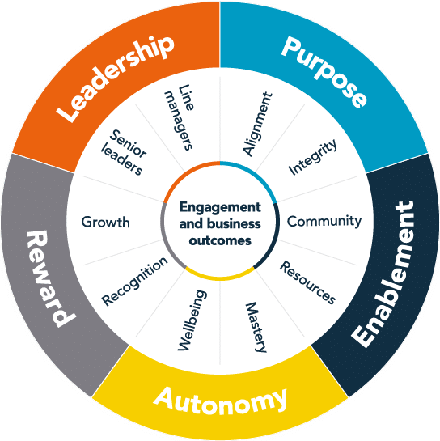
PEARL employee engagement model (Albrecht et al., 2018).
There should be constant training. Employees who have received the necessary training are more likely to execute an excellent job and perhaps go above and beyond. On the other hand, the hotel should Syncing personal objectives with organisational ones will help employees feel accomplished by letting them know how their particular objective contributes to the attainment of overall objectives. Employee engagement models are centred on how to inspire employees to perform their best job by making them feel valued, engaged, and appreciated (Albrecht et al., 2018). It acts as the cornerstone of the company's whole culture. Implementing policies effectively requires adequate managerial and senior leadership initiatives. Businesses in the hotel sector must put an emphasis on employee engagement because it is a customer service-driven sector. By putting employees first, engagement helps businesses grow and succeed. The employees then benefit by giving the best service to customers.
People may be driven to behave in an effort to satisfy their physiological, safety, social, self-esteem, and self-actualization needs, according to Maslow's hierarchy of needs theory (Van Zyl et al., 2017). A person's degree of intrinsic motivation rises in direct proportion to how well these conditions are satisfied. The theory suggests that a person's capacity to satisfy these expectations determines how engaged and content they are in their work. When a regular salary and a secure workplace are promised to employees, their most basic requirements are met (Kumar and Pansari, 2015). The workplace must also provide the workers a sense of gratitude and belonging. Employees also want to get better at their jobs, move up, be creative, and be free to do what they want.
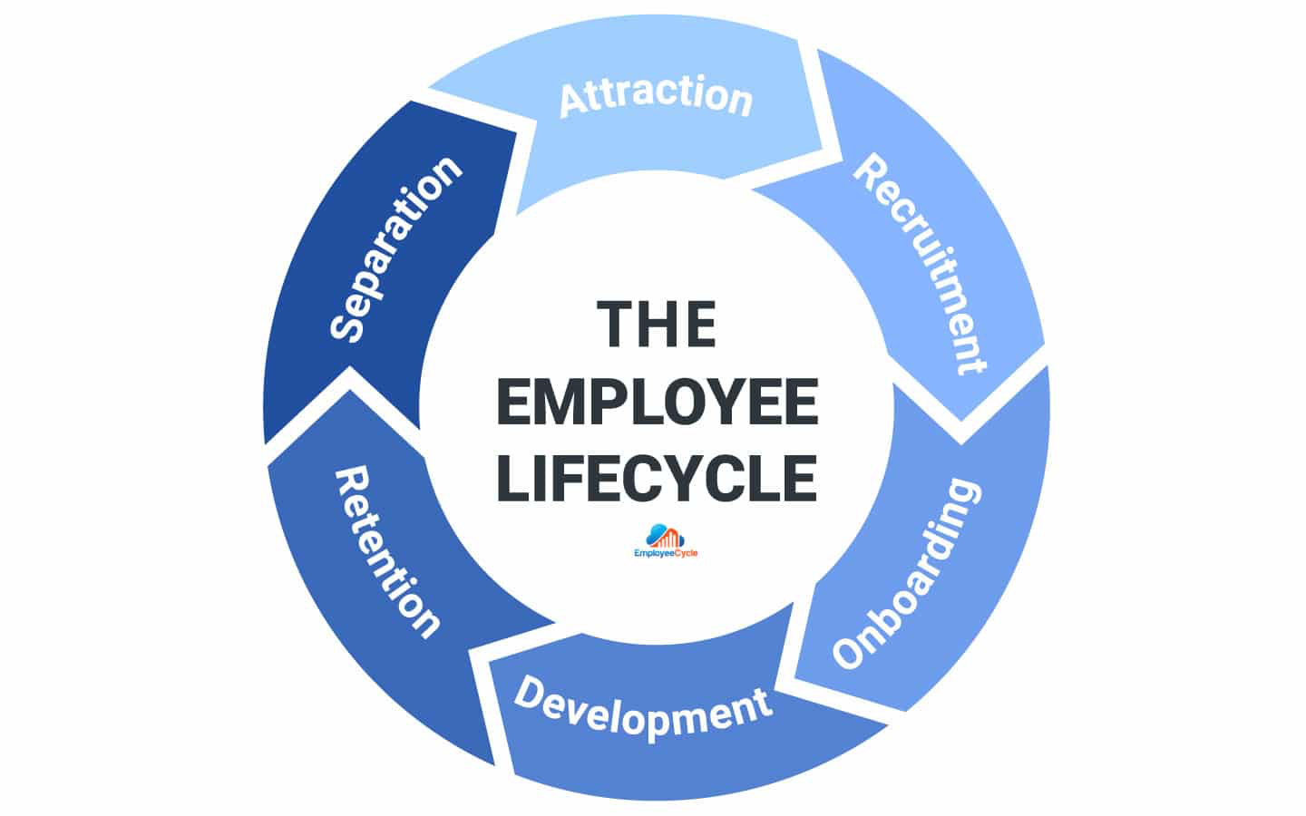

Figure 1 : The employee life cycle (Cattermole, 2019.)
An organisational technique used to illustrate how an employee interacts with the company they work for is the employee lifecycle. The entire period that an employee spends working for a firm is divided into seven stages by the employee lifecycle: attraction, recruiting, onboarding, development, retention, separation, and advocacy.While I used to work at the St. Davis hotel in Cardiff as a kitchen assistant, I had a tremendous opportunity to serve food to the guests of the hotel. I was constantly working hard for the customer's satisfaction. On the day after my day off, I went back to work. I found in my desk an envelope with an appreciation card from the guest, saying "The food was so lovely and we really enjoyed it. We want to thank you for your delicious food." I was greatly motivated, and I feel so good. It is my own experience.Figure number 1 above.
Everyone in the hotel business, from the front desk to the cleaning staff, and everything in between, must cooperate. Promoting transparency and honesty in communication is the key to getting all the numerous cogs to work properly (Chandani et al., 2016). An important component of a successful engagement programme is to anonymously inquire about any issues or recommendations for improvement. Then you can see issues fast and obtain suggestions for potential fixes from front-line staff. Quarterly surveys give clear insight into which maintenance, upgrade, and repair requirements are most affecting a significant property's bottom line (and should be addressed the fastest). Anything from slow lobby software to out-of-date vacuums that only move the dust around without actually purifying the air might be the cause of this. You'll be able to assess the issue precisely and swiftly. If employees were asked for suggestions on how they may be assisted in their work, employees frequently offer helpful information, such as the best type of training. You can also promote a growth-focused culture in your company by always showing that you want it to grow.

Conclusion
We can conclude that employee engagement is a more complex and complicated topic than it may initially appear to be. The employment contract must be thoroughly understood by human resources. The responsibility for ensuring that staff members have adequate equipment, training, and working conditions falls on human resources. Employees that take pleasure in their work are aware of expectations. There is no doubt that the employee life cycle model is one of the most helpful tools for arranging an employee's interactions with your company because it offers you a clear picture of what to expect at each step and the information you need to make that stage as productive as possible. Finding and sustaining a strong team is difficult, but if you put up the effort to give every task your all, you'll have a far better chance.

Reference List

- Albrecht, S., Breidahl, E. and Marty, A., 2018. Organizational resources, organizational engagement climate, and employee engagement. Career Development International.
- Albrecht, S.L. et al. (2015) “Employee engagement, Human Resource Management Practices and competitive advantage,” Journal of Organizational Effectiveness: People and Performance, 2(1), pp. 7–35. Available at: https://doi.org/10.1108/joepp-08-2014-0042.
- Armstrong, M. and Taylor, S. (2020) Armstrong’s handbook of human resource management practice. 15th edition. London, United Kingdom ;: KoganPage.
- Bammens, Y., Notelaers, G. and Van Gils, A., 2015. Implications of family business employment for employees’ innovative work involvement. Family Business Review, 28(2), pp.123-144.
- Cascio, W.F. and Graham, B.Z. (2016) “New strategic role for HR: Leading the employer-branding process,” Organization Management Journal, 13(4), pp. 182–192. Available at: https://doi.org/10.1080/15416518.2016.1244640.
- Casey, D. and Sieber, S. (2016) “Employees, sustainability and motivation: Increasing employee engagement by addressing sustainability and corporate social responsibility,” Research in Hospitality Management, 6(1), pp. 69–76. Available at: https://doi.org/10.2989/rhm.2016.6.1.9.1297.
- Cattermole, G., 2019. Developing the employee lifecycle to keep top talent. Strategic HR review.
- Cattermole, G., 2019.Developing the employee lifecycle to keep top talent. Strategic HR review.
- Chandani, A., Mehta, M., Mall, A. and Khokhar, V., 2016. Employee engagement: A review paper on factors affecting employee engagement. Indian Journal of Science and Technology, 9(15), pp.1-7.
- Cloutier, O., Felusiak, L., Hill, C. and Pemberton-Jones, E.J., 2015. The importance of developing strategies for employee retention. Journal of Leadership, Accountability & Ethics, 12(2).
- Davis, P.J., 2015. Implementing an employee career-development strategy: How to build commitment and retain employees. Human Resource Management International Digest.
- Gupta, N. and Sharma, V. (2016) “Exploring employee engagement—a way to better business performance,” Global Business Review, 17(3_suppl). Available at: https://doi.org/10.1177/0972150916631082.
- Kashive, N., Khanna, V.T. and Bharthi, M.N., 2020. Employer branding through crowdsourcing: understanding the sentiments of employees. Journal of Indian Business Research.
- Kumar, V. and Pansari, A., 2015. Measuring the benefits of employee engagement. MIT Sloan Management Review, 56(4), p.67.
- Kwon, K. and Park, J. (2019) “The life cycle of employee engagement theory in HRD Research,” Advances in Developing Human Resources, 21(3), pp. 352–370. Available at: https://doi.org/10.1177/1523422319851443.
- Maylett, T. and Wride, M., 2017. The employee experience: How to attract talent, retain top performers, and drive results. John Wiley & Sons.
- Osborne, S. and Hammoud, M.S. (2017) “Effective employee engagement in the Workplace,” International Journal of Applied Management and Technology, 16(1). Available at: https://doi.org/10.5590/ijamt.2017.16.1.04.
- Pradhan, R.K., Jena, L.K. and Kumari, I.G., 2016. Effect of work–life balance on organizational citizenship behaviour: Role of organizational commitment. Global Business Review, 17(3_suppl), pp.15S-29S.
- Raziq, A. and Maulabakhsh, R. (2015) “Impact of working environment on job satisfaction,” Procedia Economics and Finance, 23, pp. 717–725. Available at: https://doi.org/10.1016/s2212-5671(15)00524-9.
- Suyono, J. and Mudjanarko, S.W. (2017) “Motivation Engineering to employee by employees Abraham Maslow theory,” JETL (Journal Of Education, Teaching and Learning), 2(1), p. 86. Available at: https://doi.org/10.26737/jetl.v2i1.141.
- Torrington, D, Hall, L, Atkinson, C, & Taylor, S 2020, Human Resource Management PDF EBook, Pearson Education, Limited, Harlow. Available from: ProQuest Ebook Central
- Van Zyl, E.S., Mathafena, R.B. and Ras, J. (2017) “The development of a talent management framework for the private sector,” SA Journal of Human Resource Management, 15. Available at: https://doi.org/10.4102/sajhrm.v15i0.820.
- Wang, Y., Rafferty, A., Sanders, K. and Kim, S., 2022. Birds of a feather flock together: The relationship between managers’ and employees’ perceptions of HR practices. The International Journal of Human Resource Management, 33(12), pp.2564-2595.
- Yarbrough, S., Martin, P., Alfred, D. and McNeill, C., 2017. Professional values, job satisfaction, career development, and intent to stay. Nursing Ethics, 24(6), pp.675-685.

